ROV Dive Summary, EX-21-03, Dive 11, June 26, 2021

General Location Map
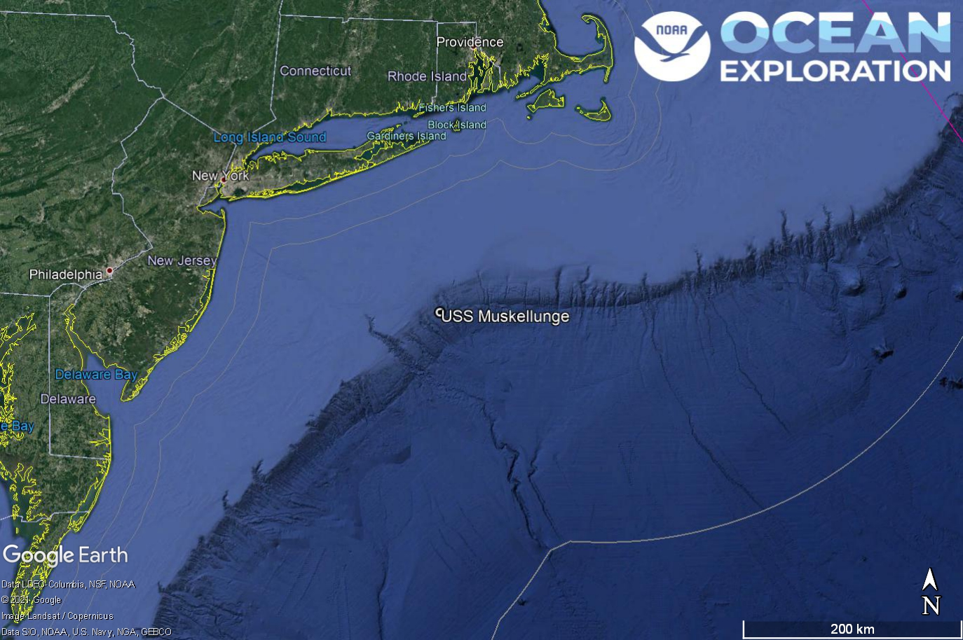
Dive 11 named USS Muskellunge. This site is near Ryan Canyon off of New York and New Jersey.

Dive Information
Site Name | USS Muskellunge
General Area Descriptor | Mid-Atlantic Canyons
Science Team  Leads | Karl McLetchie
Expedition  Coordinator | Kasey Cantwell/Matt Dornback
ROV Dive Supervisor | Karl McLetchie
Mapping Lead | Shannon Hoy
Dive Purpose
Was the dive restricted for Underwater Cultural Heritage? | Yes
ROV Dive Summary Data | Dive Summary: EX2103_DIVE11  ^^^^^^^^^^^^^^^^^^^^^^^^^^^^^^^^^^^^^^^^  Dive Type: Normal  In Water: 2021-06-26T13:25:53.364867  39.715700199735906 ; -71.71476388681772  On Bottom: 2021-06-26T14:07:18.052017  39.71468518251268 ; -71.71520536502538  Off Bottom: 2021-06-26T19:56:34.847739  39.716066185224854 ; -71.71545669129192  Out Water: 2021-06-26T20:44:05.089337  39.71145159090909 ; -71.71899836363636  Dive Duration: 7:18:11  Bottom Time: 5:49:16  Max Vehicle Depth: 634.9 m  Min Seafloor Depth: 619.2 m  Distance Travelled: 440.9 m
Dive Description | In coordination with the Naval History and Heritage Command and NOAA National Marine Sanctuaries Maritime Heritage, the last coordinates for the USS Muskallunge and the USS Snowden were suggested as targets of interest. Dive 11 was on two sonar anomalies on the seafloor in the proximity of the sinking location of the USS Muskallunge. After an initial dive delay of about an hour due to ROV software issues, the dive reached bottom at 1007 in a depth of 632 m of water. Guided by scientists ashore (Jim Delgado, Joe Hoyt, Alicia Caporaso and Mike Brennan), the ROV traversed 50m of sediment towards the target and found few piping pieces. Guided by the Blueview sonar the ROVs moved to the next larger target that ended up being the bow section of the USS Muskellunge. The identifying marking of S14 and the Brazilian flag were present on the conning tower. This is due to the vessel being sold to the Brazilian navy and subsequently returned to the US to be used as a live fire target. The bow section was covered in flytrap anemones, hydroids, and paragorgia corals. The corals were particularly abundant on top of the conning tower, making a great visual display.  After the circumnavigation of the bow section the ROVs proceeded to the next large sonar anomaly. The Blueview sonar once again showed it’s value by picking up a debris field that was not in the path to the next target. The ROVs diverted to fly through the debris field and make quick observations of the small sections of the submarine before moving on to the larger stern section. The ROVs came upon the end of the stern section where the propellers and propeller guards are located. The ROVs proceeded to image the stern section of the submarine before returning to the surface.
Notable Observations
Community and habitat observations | Corals and Sponges - Present  Chemosynthetic Community - Absent  High biodiversity Community - Absent  Active Seep or Vent - Absent  Extinct Seep or Vent - Absent  Hydrates - Absent
CMECS Feature Type(s) | Wreck, Flat
SeaTube Link (science annotation system) | https://data.oceannetworks.ca/SeaTubeV3?resourceTypeId=600&resourceId=2243

Equipment Deployed
ROV |  | Deep Discoverer
Camera Platform |  | Seirios
ROV Measurements |  | The following ROV measurements, data streams and equipment are used on each ROV deployment: CTD, depth, scanning sonar, USBL position, altitude, heading, attitude, high-resolution cameras, low resolution cameras, manipulator arms, suction sampler, sample drawers and thrusters. The section below notes if any of these sensors were malfunctioning or not operational
Equipment Malfunctions |  | Turbidity sensor

Close-up Map of Main Dive Site
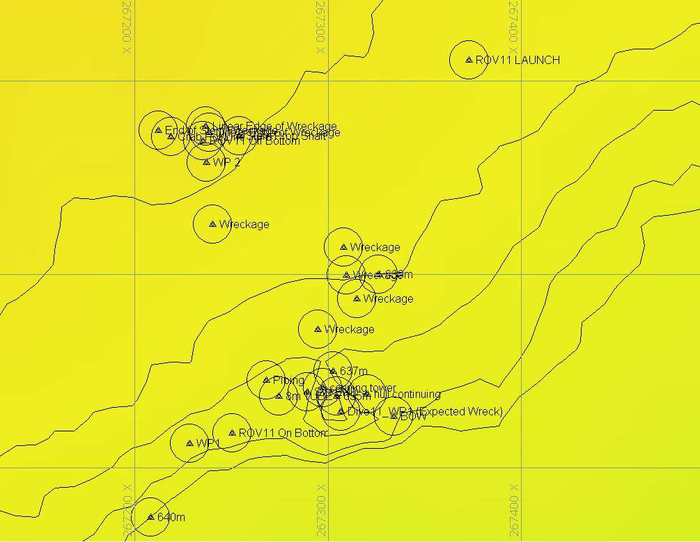
Hypack map of the Dive 11 waypoints. Depth is displayed by contour lines at 10 meter increments and by colors. Warm colors are shallower and cool colors are deeper.

Representative Photos of the Dive
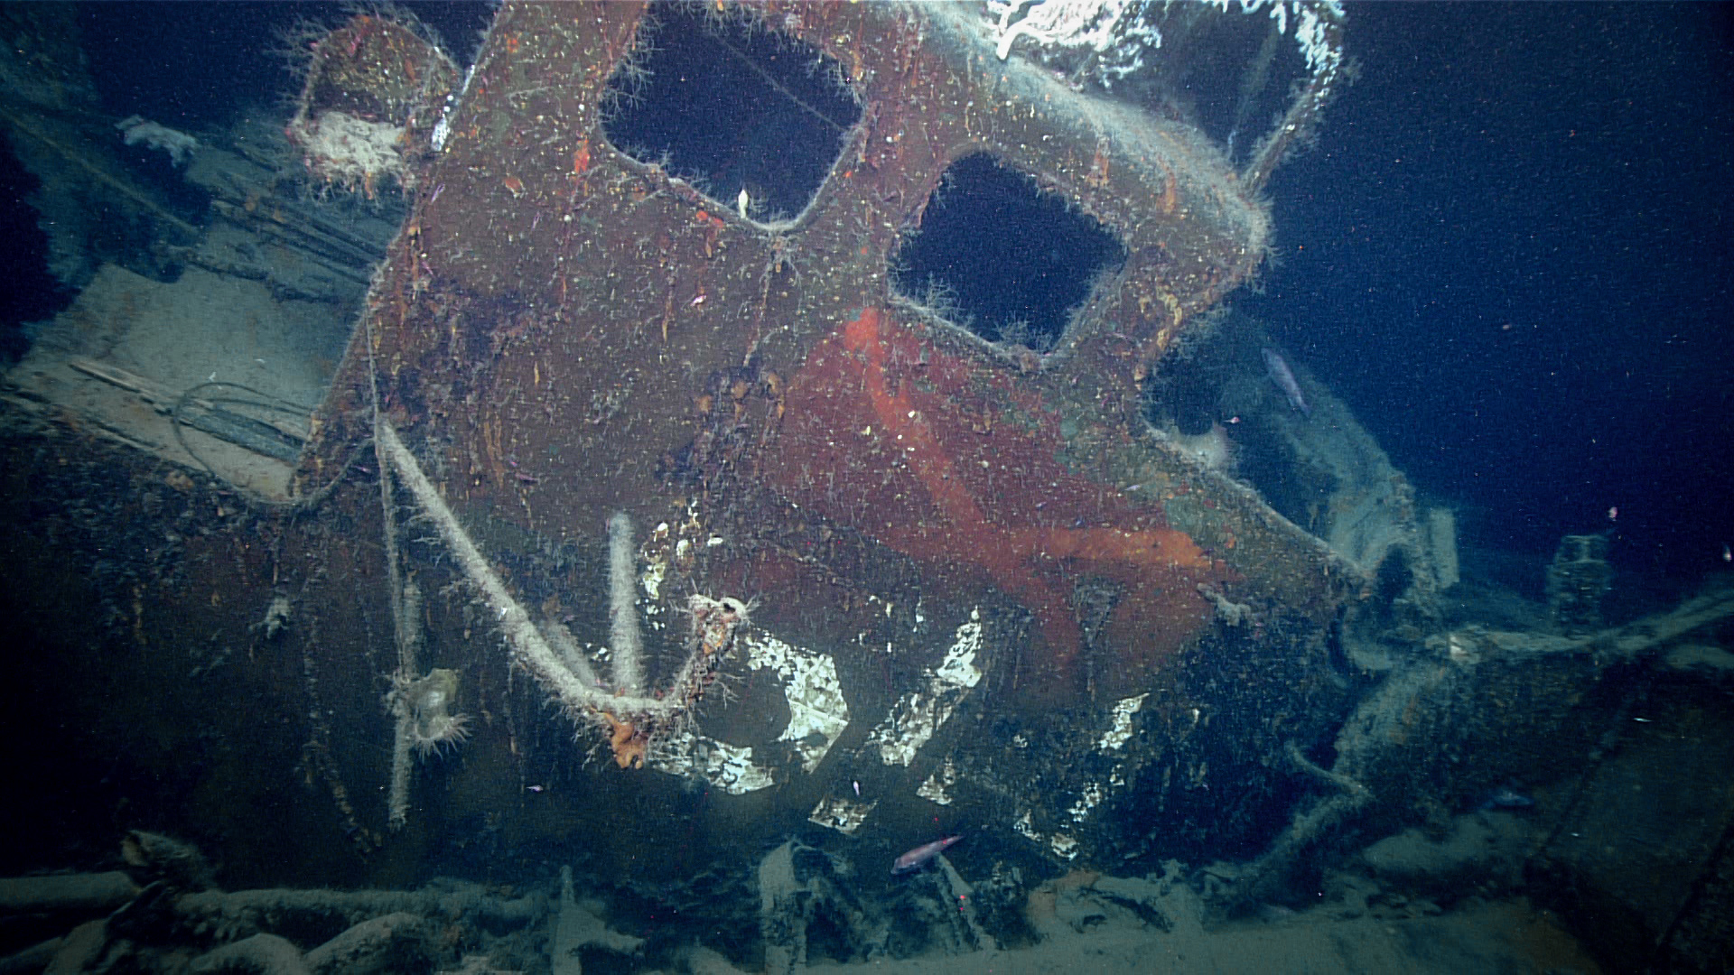
Conning tower of the USS Muskellunge. The S14 and Brazilian flag are visible from its short service with the Brazilian navy.
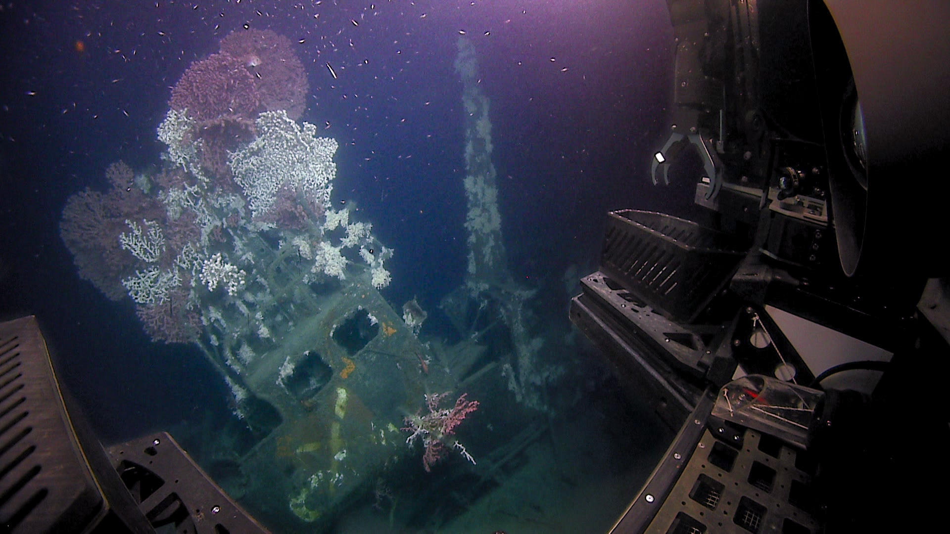
Upper conning tower with abundant corals present.

Samples Collected -
No samples were collected

Niskin Sampling Summary
No Niskin bottles were used

Scientists Involved (provide name, email, affiliation)
Name | Email | Affiliation
Jim Delgado | James.Delgado@searchinc.com | SEARCH Inc.
Joe Hoyt | joe.hoyt@noaa.gov | NOAA Office of National Marine Sanctuaries
Alicia Caporaso | Alicia.Caporaso@boem.gov | Bureau of Ocean Energy Management
Mike Brennan | mike.brennan@searchinc.com | SEARCH Inc.
Kelsey Viator | ksviator2000@gmail.com | University of Louisiana at Lafayette
Dhugal Lindsay | dhugal@jamstec.go.jp | JAMSTEC

Please direct inquiries to:
NOAA Office of Ocean Exploration & Research
1315 East-West Highway, SSMC3 RM 10210
Silver Spring, MD 20910
oceanexplorer@noaa.gov

