ROV Dive Summary, EX-21-03, Dive 10, June 25, 2021

General Location Map
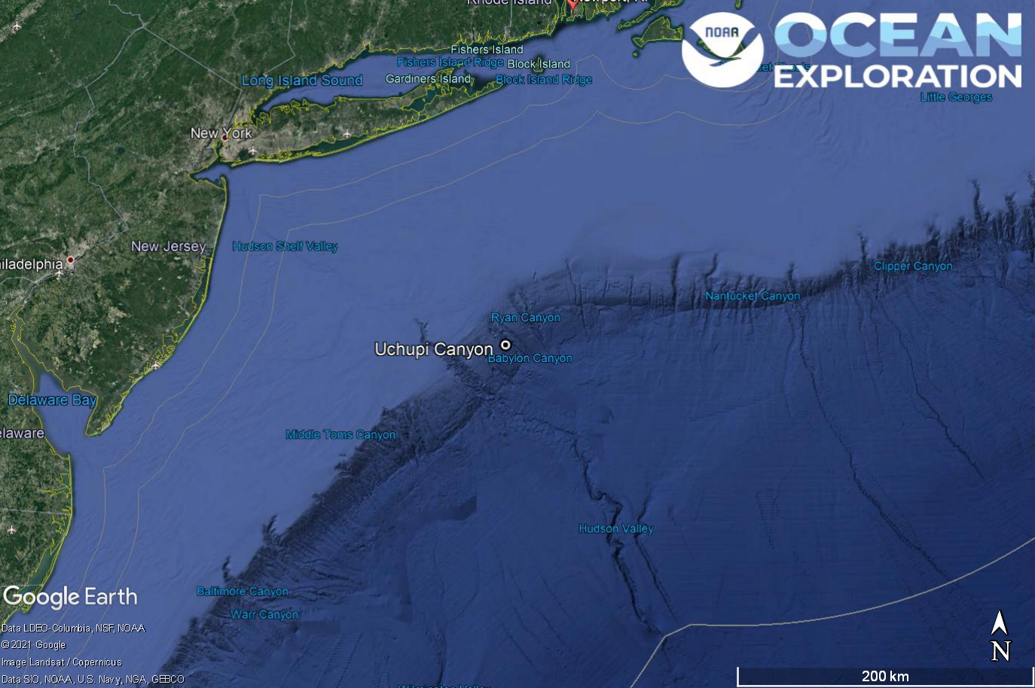
Dive 10 named Uchupi Canyon. This site is in Uchupi Canyon off of New York and New Jersey.

Dive Information
Site Name | Uchupi Canyon
General Area Descriptor | Mid-Atlantic Canyons
Science Team  Leads | Karl McLetchie
Expedition  Coordinator | Kasey Cantwell/Matt Dornback
ROV Dive Supervisor | Karl McLetchie
Mapping Lead | Shannon Hoy
Dive Purpose | The tenth engineering dive of the ROV Shakedown. Primary objectives include pilot training, testing new motors, motor controllers, lights, cameras, and hydraulic systems on the ROVs.  Secondary objectives include exploring the central area of Uchupi Canyon and collecting characteristic geological and biological samples.
Was the dive restricted for Underwater Cultural Heritage? | No
ROV Dive Summary Data | Dive Summary: EX2103_DIVE10  ^^^^^^^^^^^^^^^^^^^^^^^^^^^^^^^^^^^^^^^^  Dive Type: Normal  In Water: 2021-06-25T12:31:01.021160  39.544834571127616 ; -71.79154749684005  On Bottom: 2021-06-25T13:27:53.605485  39.542909425804574 ; -71.79292804193973  Off Bottom: 2021-06-25T20:09:28.044946  39.53934779246253 ; -71.80182858086877  Out Water: 2021-06-25T20:38:06.410574  39.53432208178928 ; -71.8024252627831  Dive Duration: 8:7:5  Bottom Time: 6:41:34  Max Vehicle Depth: 1286.3 m  Min Seafloor Depth: 1047.4 m  Distance Travelled: 714.3 m  Mid Water Transects Summary  ^^^^^^^^^^^^^^^^^^^^^^^^^^^^^^^^^^^^^^^^  Number of Transects: 3  Transect 1  Start: 18:44:44  39.541000868020355 ; -71.79944667005088  End: 19:06:46  39.54072861623938 ; -71.79978170427357  Duration: 0:22:2  Depth: 500.0 m  Transect 2  Start: 19:17:40  39.540289409426535 ; -71.79999472704898  End: 19:38:07  39.54030960599953 ; -71.80067574250059  Duration: 0:20:27  Depth: 450.0 m  Transect 3  Start: 19:46:50  39.54042800137336 ; -71.80098799896996  End: 20:09:08  39.539371493922964 ; -71.80180700486164  Duration: 0:22:18  Depth: 375.0 m
Dive Description | Dive 10 was successfully completed on Uchupi Canyon. The ROV reached bottom at a depth of 1287m and proceeded to ascend the south canyon wall to 1020m. The slope was mostly soft bottom. Many fish were observed including synaphobranchid eels, blue hake, sol, scorpion fish, and a great interaction between a curious dogfish and D2. Urchins, hydroids, cup coral, anemones, crabs, shrimp, holothurians, and squid were seen.  At 1400, the ROVs concluded the benthic portion of the dive and switched to “simulating” water column exploration. The ROVs did three 20 minute transects, one each at 500, 450, and 375. Numerous ctenophores were seen as well as chaetognath worms, lobate jellies, siphonophores, and laternfish. The low light camera was used to attempt to see bioluminescence. No bioluminescence was observed.
Notable Observations
Community and habitat observations | Corals and Sponges - Present  Chemosynthetic Community - Absent  High biodiversity Community - Absent  Active Seep or Vent - Absent  Extinct Seep or Vent - Absent  Hydrates - Absent
CMECS Feature Type(s) | Submarine Canyon, Slope
SeaTube Link (science annotation system) | https://data.oceannetworks.ca/SeaTubeV3?resourceTypeId=600&resourceId=2233

Equipment Deployed
ROV |  | Deep Discoverer
Camera Platform |  | Seirios
ROV Measurements |  | The following ROV measurements, data streams and equipment are used on each ROV deployment: CTD, depth, scanning sonar, USBL position, altitude, heading, attitude, high-resolution cameras, low resolution cameras, manipulator arms, suction sampler, sample drawers and thrusters. The section below notes if any of these sensors were malfunctioning or not operational
Equipment Malfunctions |  | Turbidity sensor

Close-up Map of Main Dive Site
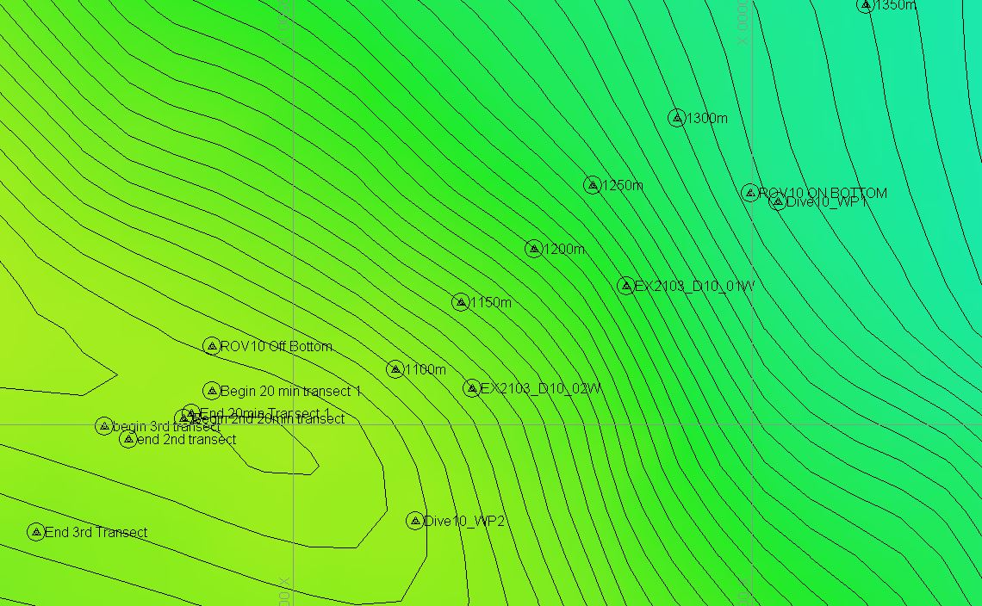
Hypack map of the Dive 10 waypoints. Depth is displayed by contour lines at 10 meter increments and by colors. Warm colors are shallower and cool colors are deeper.

Representative Photos of the Dive
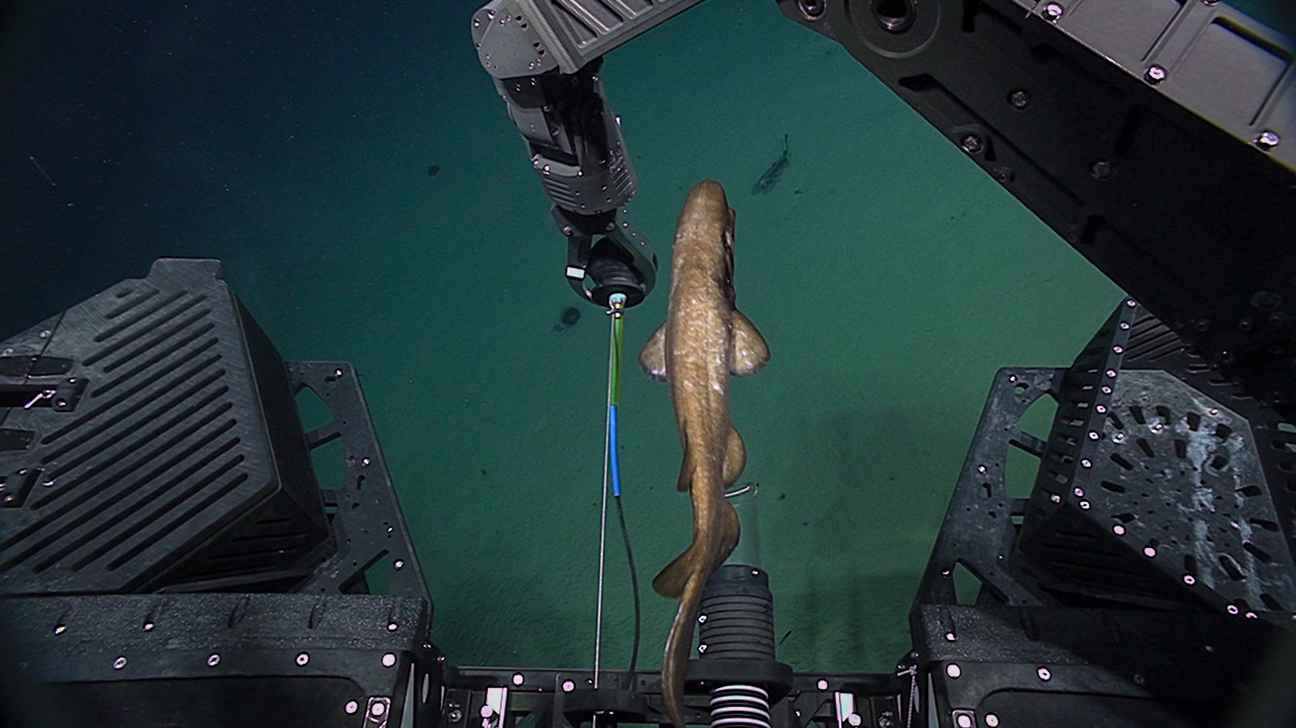
A dogfish interacting with the ROV.
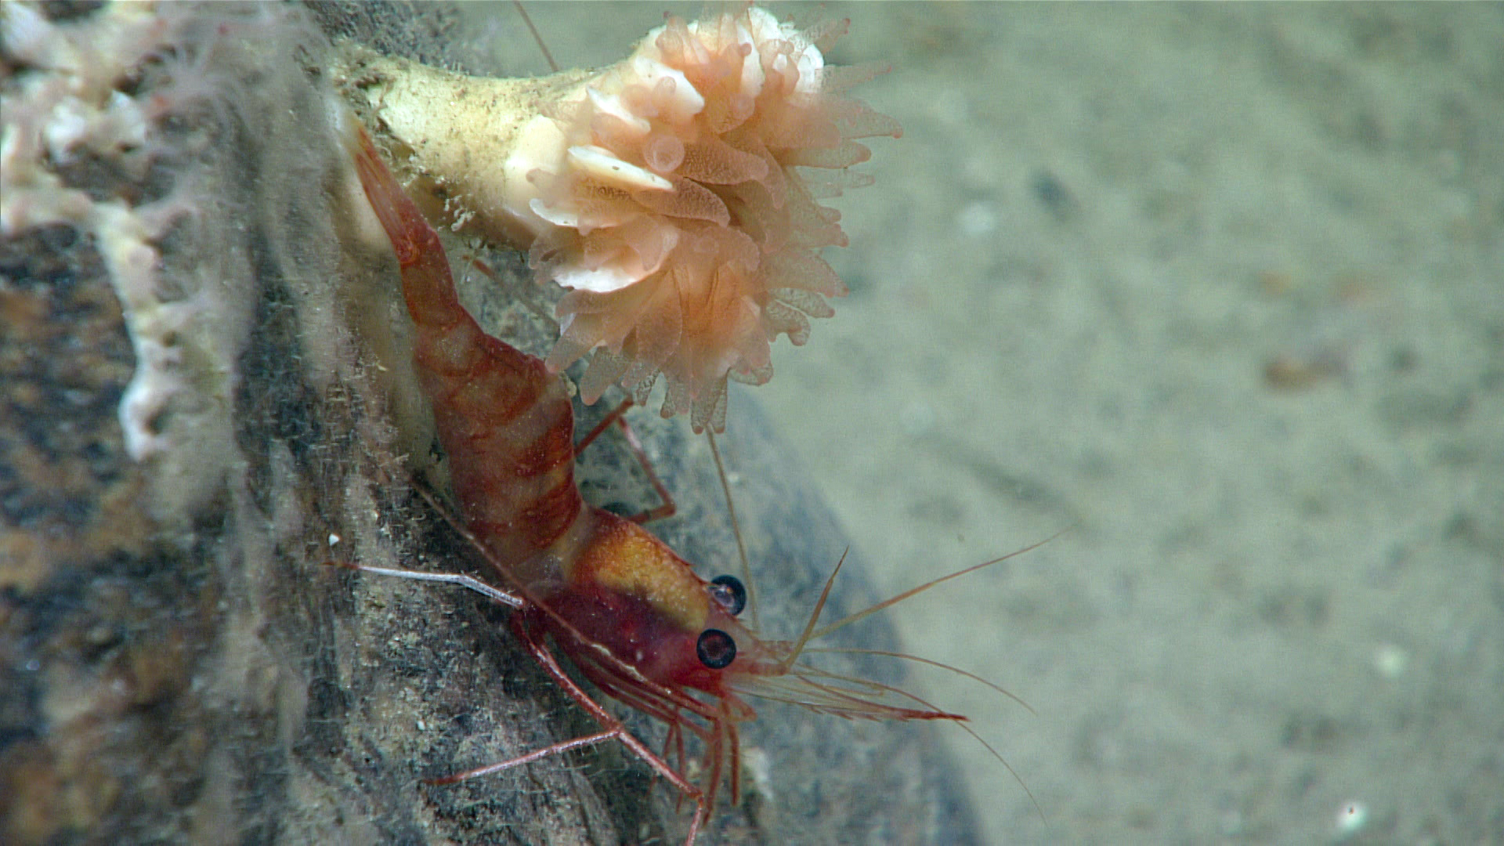
A solitary cup coral and a shrimp on a small boulder.

Samples Collected -
No samples were collected

Niskin Sampling Summary
No niskin samples were taken.

Scientists Involved (provide name, email, affiliation)
Name | Email | Affiliation
Quinn Girasek | quinn.girasek@noaa.gov | NOAA Ocean Exploration
Allen Collins | allen.collins@noaa.gov | NOAA & NMNH
Nick Beaseo | nickbezio@gmail.com | University of Maryland
Rene Martin | rpmartin@ku.edu | Kansas University
Michael Vecchione | vecchiom@si.edu | NOAA & NMNH
Steve Haddok | haddock@mbari.org | MBARI
Dhugal Lindsay | dhugal@jamstec.go.jp | JAMSTEC
Kelsey Viator | ksviator2000@gmail.com | University of Louisiana at Lafayette

Please direct inquiries to:
NOAA Office of Ocean Exploration & Research
1315 East-West Highway, SSMC3 RM 10210
Silver Spring, MD 20910
oceanexplorer@noaa.gov

