ROV Dive Summary, EX-21-03, Dive 09, June 24, 2021

General Location Map
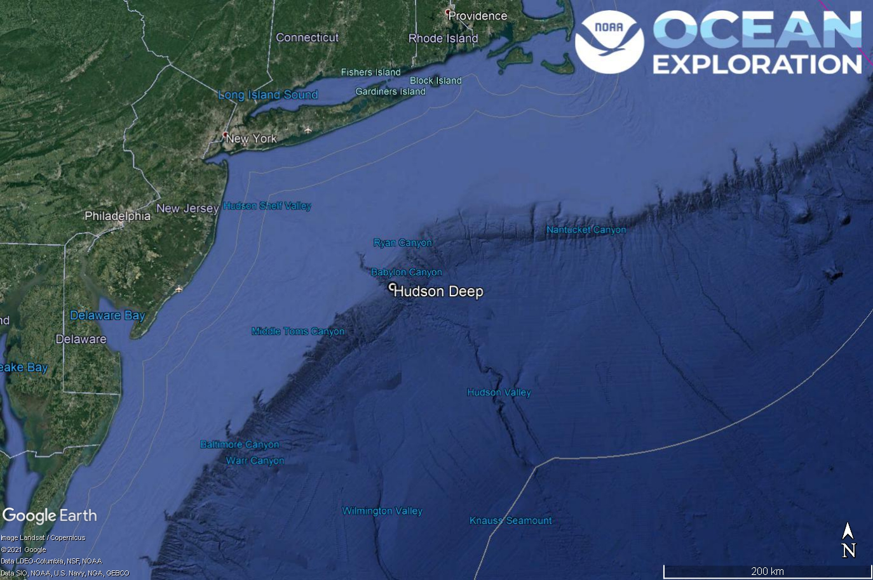
Dive 09 named Hudson Deep. This site is in Hudson Canyon off of New York and New Jersey.

Dive Information
Site Name | Hudson Deep
General Area Descriptor | Mid-Atlantic Canyons
Science Team  Leads | Karl McLetchie
Expedition  Coordinator | Kasey Cantwell/Matt Dornback
ROV Dive Supervisor | Karl McLetchie
Mapping Lead | Shannon Hoy
Dive Purpose | The ninth engineering dive of the ROV Shakedown. Primary objectives include pilot training, testing new motors, motor controllers, lights, cameras, and hydraulic systems on the ROVs.  Secondary objectives include exploring the lower area of Hudson Canyon and collecting characteristic geological and biological samples.
Was the dive restricted for Underwater Cultural Heritage? | No
ROV Dive Summary Data | Dive Summary: EX2103_DIVE09  ^^^^^^^^^^^^^^^^^^^^^^^^^^^^^^^^^^^^^^^^  Dive Type: Normal  In Water: 2021-06-24T12:39:21.978606  39.374224004896725 ; -72.08323420881409  On Bottom: 2021-06-24T13:39:18.042315  39.373881596148145 ; -72.08035078844443  Off Bottom: 2021-06-24T19:47:49.873472  39.374981685513866 ; -72.07706692227305  Out Water: 2021-06-24T20:31:51.972303  39.37454468446772 ; -72.07450974598059  Dive Duration: 7:52:29  Bottom Time: 6:8:31  Max Vehicle Depth: 1401.8 m  Min Seafloor Depth: 1198.4 m  Distance Travelled: 387.5 m
Dive Description | Dive 9 descended to 1310m on Hudson Canyon and ascended a steep portion of the canyon wall to a depth of 791. Sedimentary rock layers were visible and many corals, sponges, hydroids, sea stars, squid, pycnogonid, holothurians, and fish were seen. There were at least five octopods observed today. Three samples taken, anthomastus, antipatharian, and rock sample. The anthomastus and antipatharian are animals requested for ASPIRE connectivity studies.
Notable Observations | Numerous octopods seen in dens.
Community and habitat observations | Corals and Sponges - Present  Chemosynthetic Community - Absent  High biodiversity Community - Absent  Active Seep or Vent - Absent  Extinct Seep or Vent - Absent  Hydrates - Absent
CMECS Feature Type(s) | Submarine Canyon, Slope
SeaTube Link (science annotation system) | https://data.oceannetworks.ca/SeaTubeV3?resourceTypeId=600&resourceId=2223

Equipment Deployed
ROV |  | Deep Discoverer
Camera Platform |  | Seirios
ROV Measurements |  | The following ROV measurements, data streams and equipment are used on each ROV deployment: CTD, depth, scanning sonar, USBL position, altitude, heading, attitude, high-resolution cameras, low resolution cameras, manipulator arms, suction sampler, sample drawers and thrusters. The section below notes if any of these sensors were malfunctioning or not operational
Equipment Malfunctions |  | Turbidity Sensor

Close-up Map of Main Dive Site
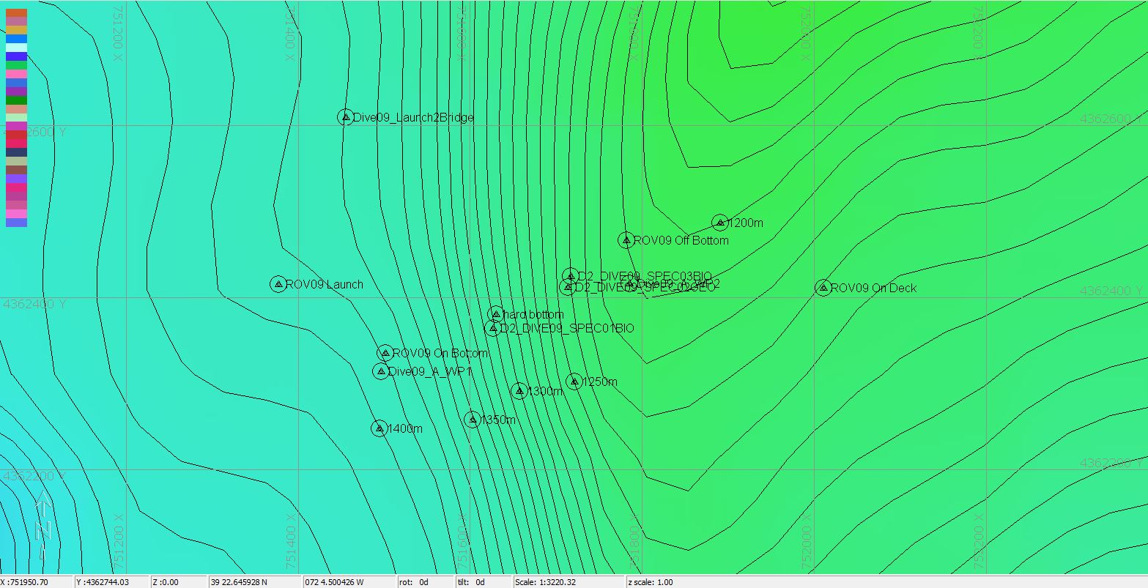
Hypack map of the Dive 09 waypoints. Depth is displayed by contour lines at 10 meter increments and by colors. Warm colors are shallower and cool colors are deeper.

Representative Photos of the Dive
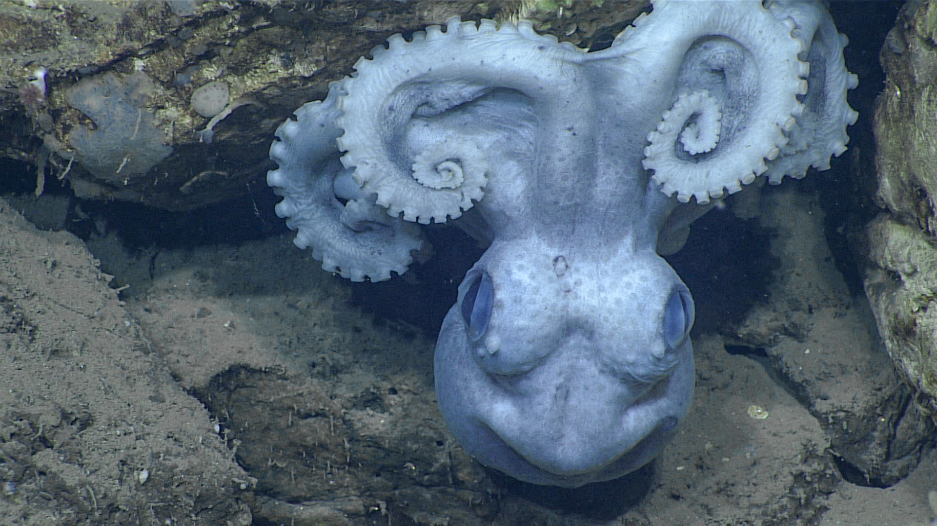
An octopod in its den.
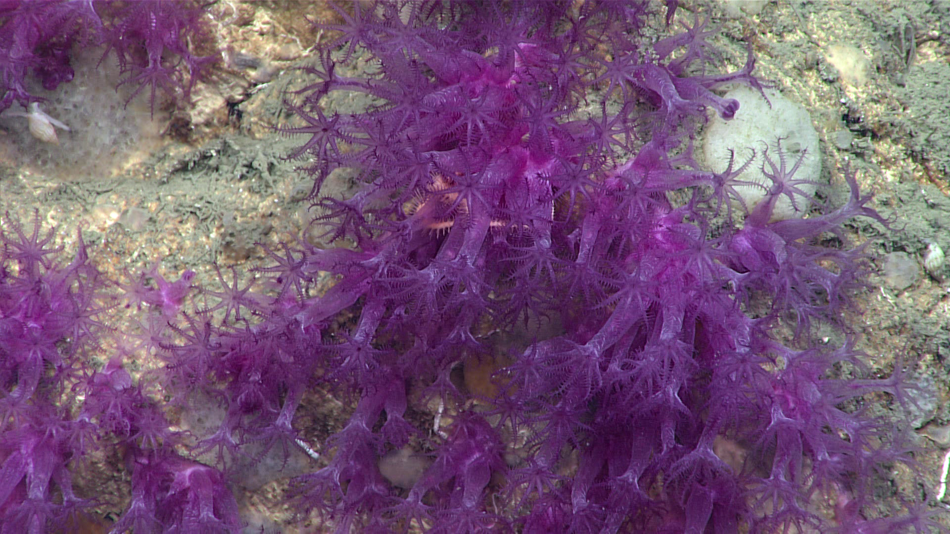
Hydroids on the canyon wall.

Samples Collected -
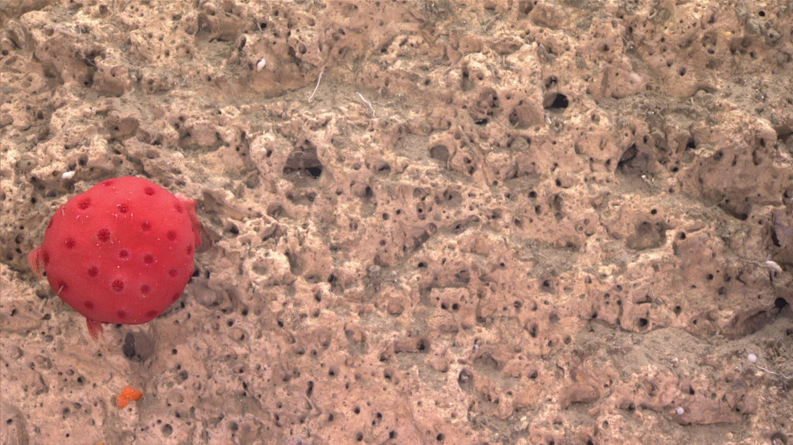
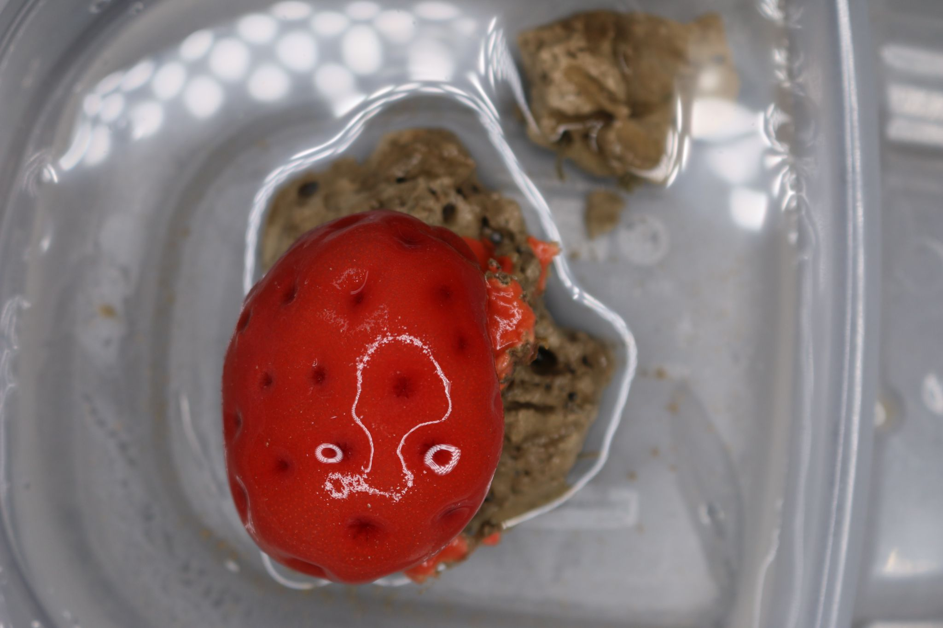
Sample ID | EX2103_D09_01B
Date (UTC) | 6/24/2021
Time (UTC) | 155118
Depth (m) | 1344.77
Latitude (decimal degrees) | 39.3742
Longitude (decimal degrees) | -72.0788
Temp. (°C) | 4.254
Field ID(s) | Cnidaria Anthomastus
Comments | approx 6cm x 3 cm; on a mudstone that will be removed; good condition; some discussion if this was sudoanthomastus; collected with the suction sampler; might be tissue damage; not immediately apparent

Associates Sample ID | Field Identification | Count
Ex2103_D09_01B_A01 | Mudstone | 1

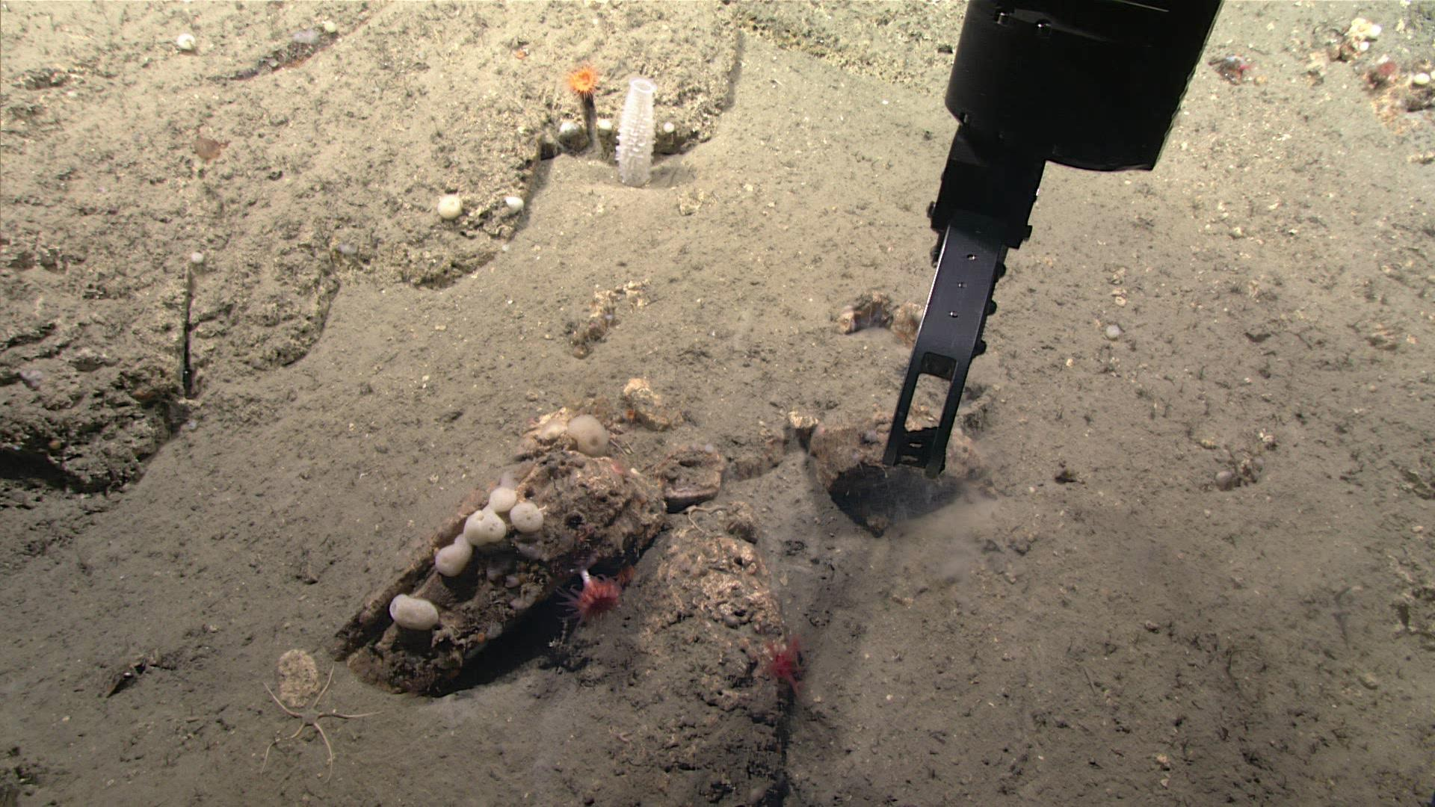
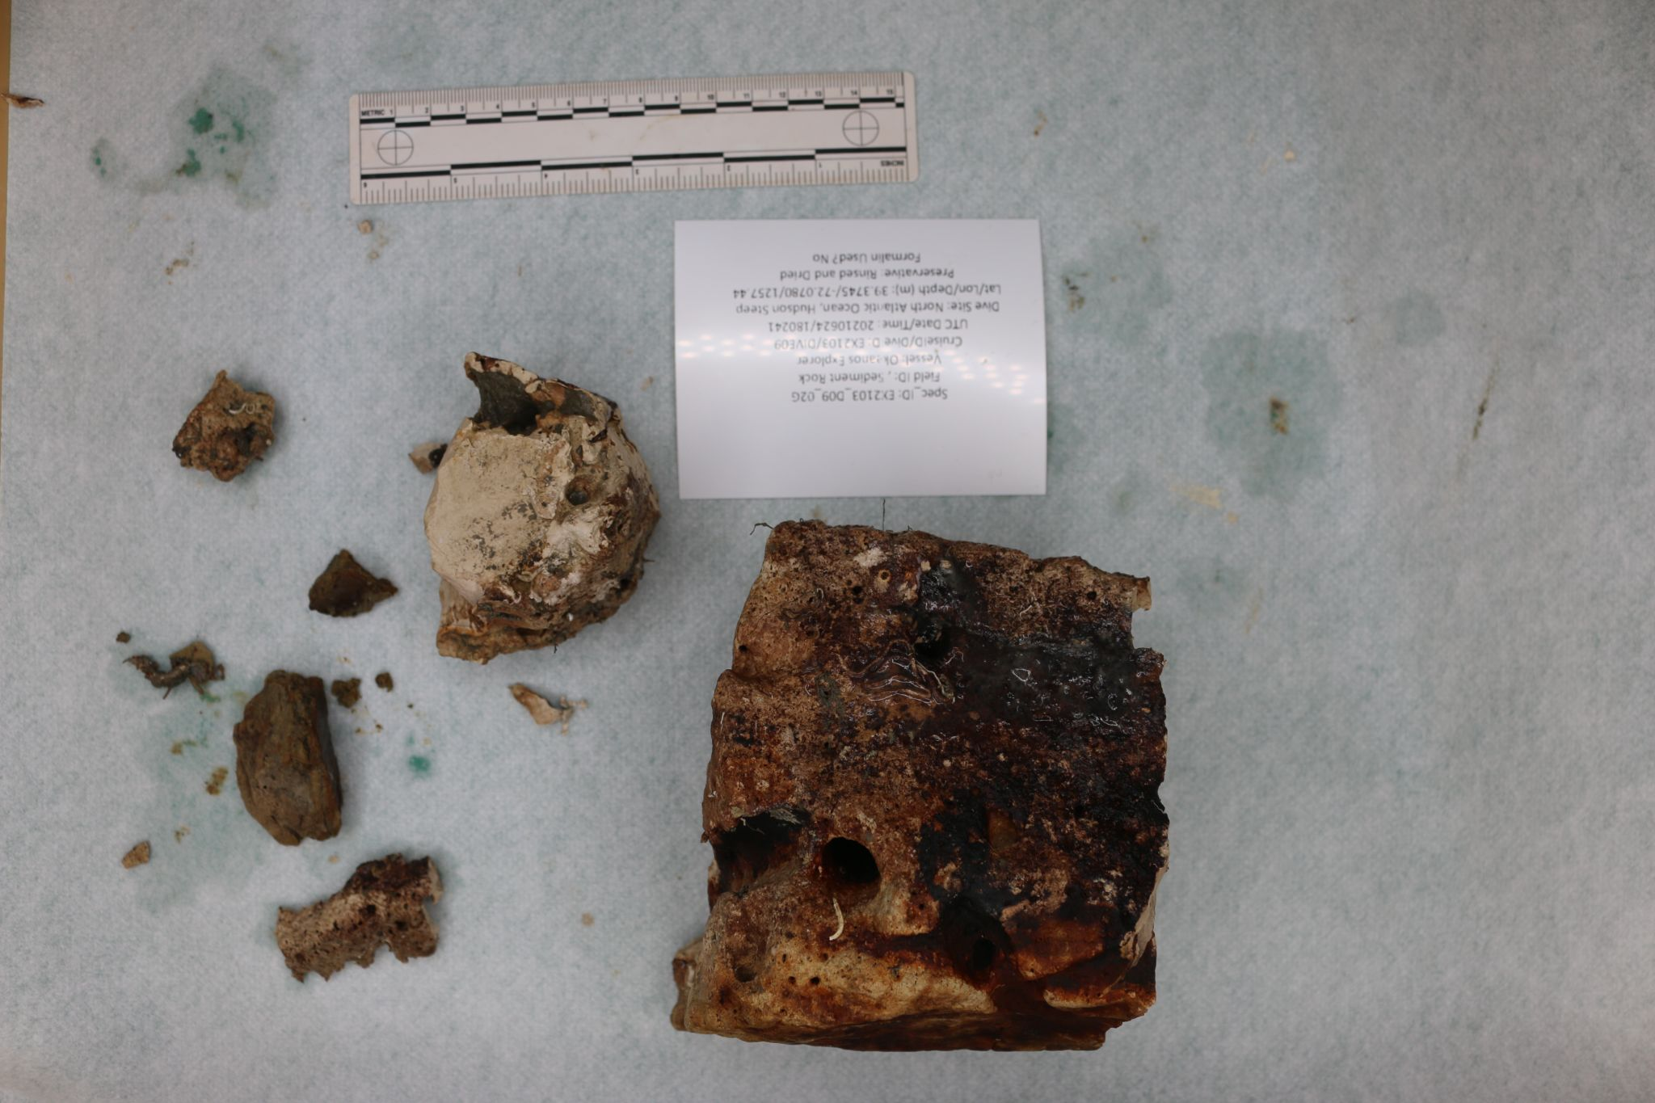
Sample ID | EX2103_D09_02G
Date (UTC) | 6/24/2021
Time (UTC) | 180241
Depth (m) | 1257.441
Latitude (decimal degrees) | 39.3745
Longitude (decimal degrees) | -72.078
Temp. (°C) | 4.326
Field ID(s) | Sediment Rock
Comments | One large chunk; pretty angular rock; bunch of smaller pieces with it. Will put all in one rock bag; 11cm x 12cm x 9cm

Associates Sample ID | Field Identification | Count
EX2103_D09_02G_A01 | Cnidaria Dendrophylliidae (cup coral) | 1
EX2103_D09_02G_A02 | Cnidaria Actiniaria (sea anemone) | 1
EX2103_D09_02G_A03 | Porifera (sponges) | 2

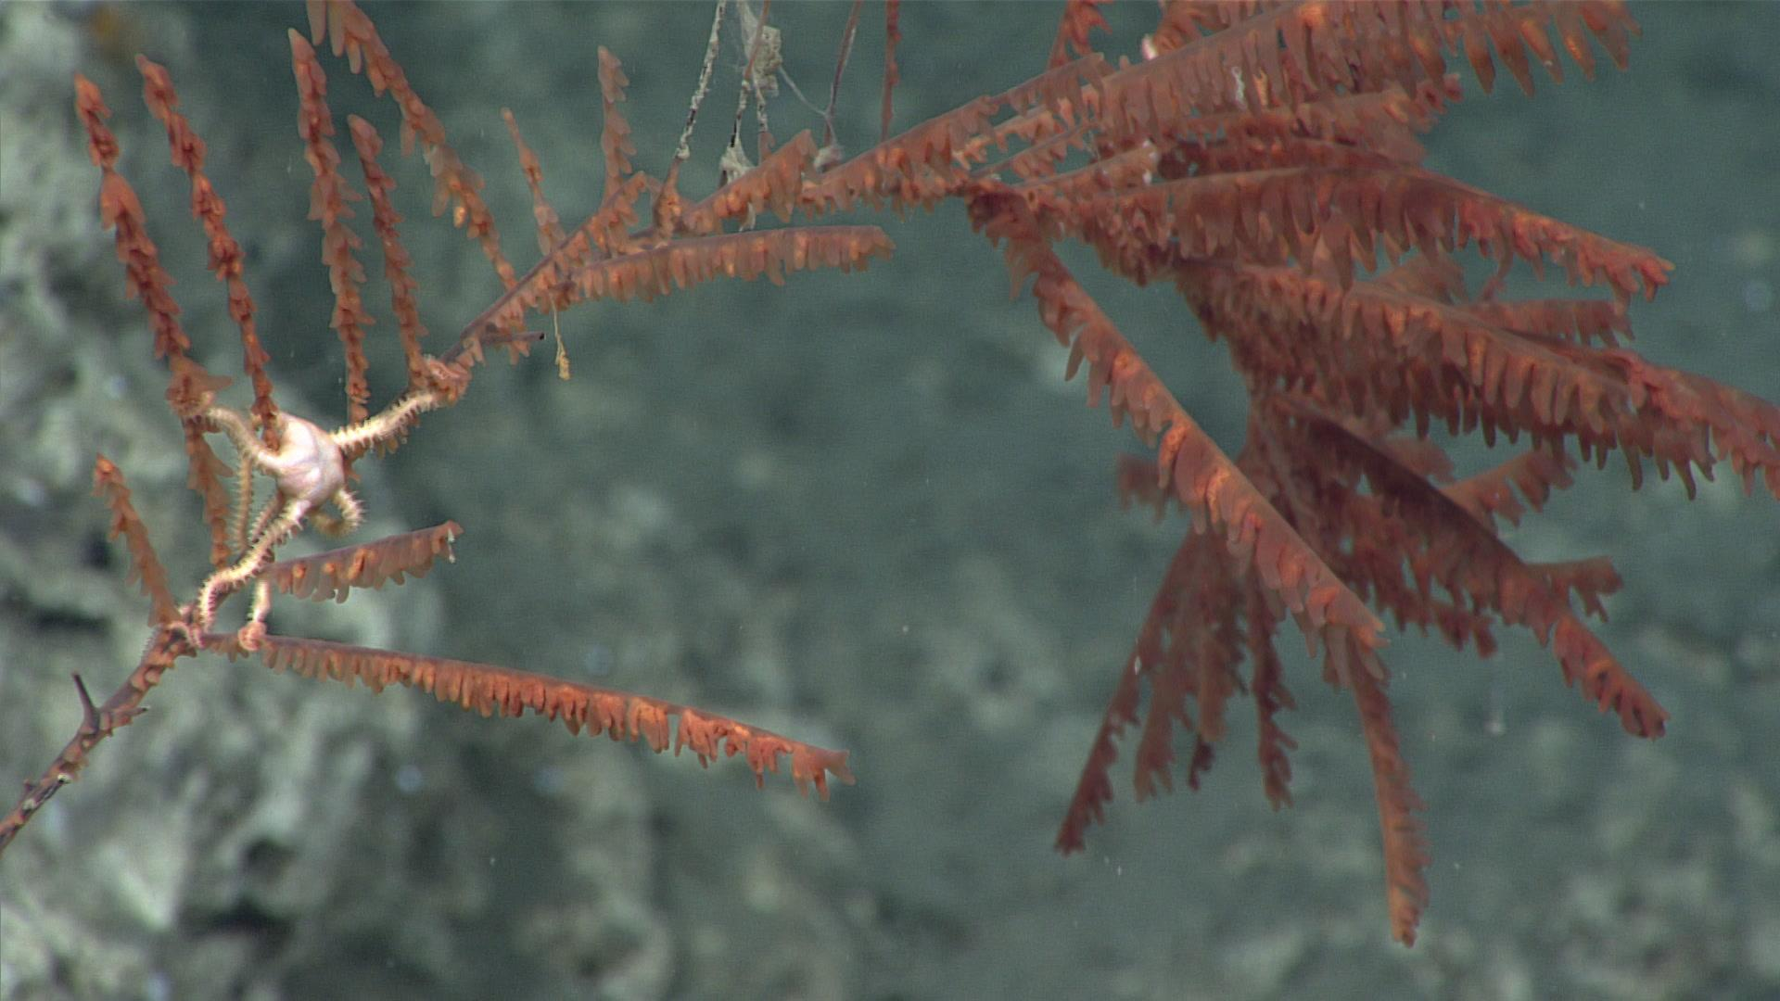
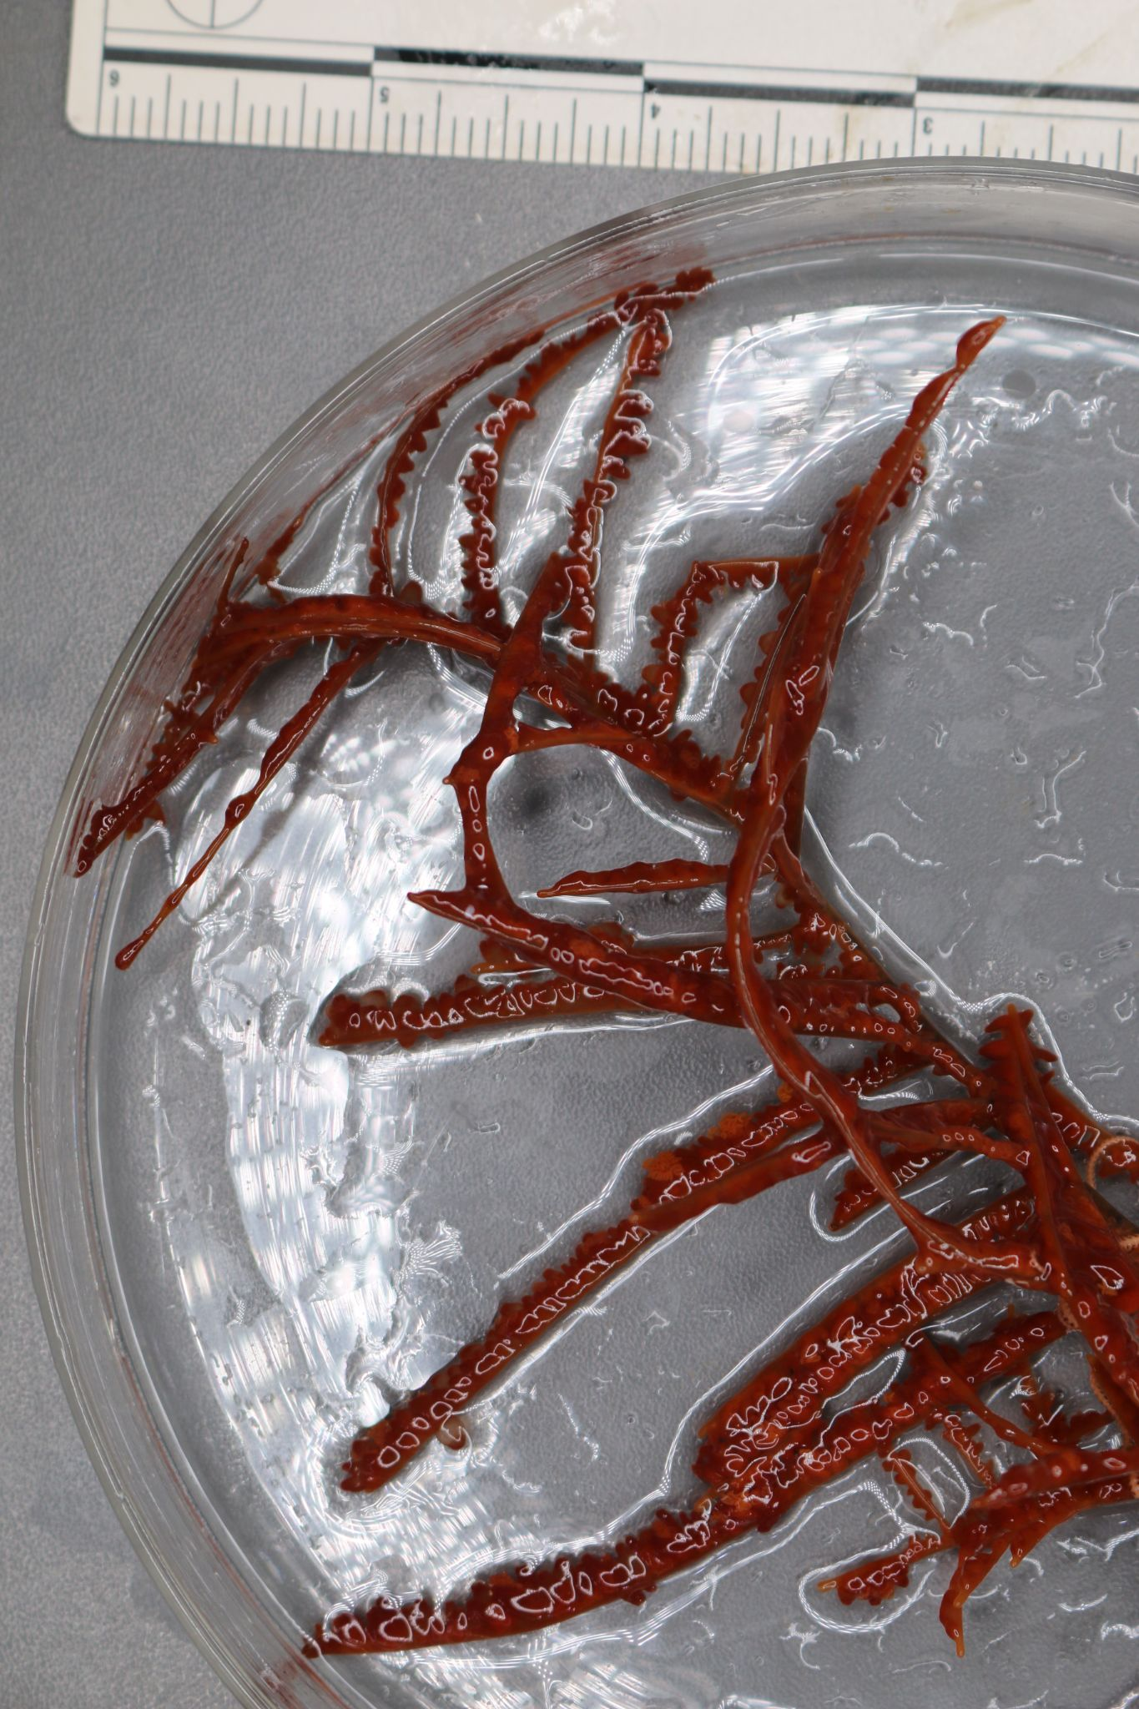
Sample ID | EX2103_D09_03B
Date (UTC) | 6/24/2021
Time (UTC) | 183704
Depth (m) | 1241.464
Latitude (decimal degrees) | 39.3746
Longitude (decimal degrees) | -72.0778
Temp. (°C) | 4.406
Field ID(s) | Cnidaria Antipatharia (thorny corals)
Comments | approx 18 cm; a couple of branches towards the bottom that are denuded, opiuroid associate wrapped in branches

Associates Sample ID | Field Identification | Count
EX2103_D09_03B_A01 | Echinodermata Ophiuroidea (brittle star) | 1

Niskin Sampling Summary
No niskin samples were taken.

Scientists Involved (provide name, email, affiliation)
Name | Email | Affiliation
Upasana Ganguley | upasana.ganguly1@louisiana.edu | University of Louisiana at lafayette
Kelsey Viator | ksviator2000@gmail.com | University of Louisiana at Lafayette
Michael Vecchione | vecchiom@si.edu | NOAA & NMNH
Ken Sulak | jumpingsturgeon@yahoo.com | USGS
Jason Chaytor | jchaytor@usgs.gov | USGS
Asako Matsumoto | amatsu@gorgonian.jp | Chiba Institute of Technology

Please direct inquiries to:
NOAA Office of Ocean Exploration & Research
1315 East-West Highway, SSMC3 RM 10210
Silver Spring, MD 20910
oceanexplorer@noaa.gov

