# ROV Dive Summary, EX-21-03, Dive 08, June 23, 2021

## General Location Map

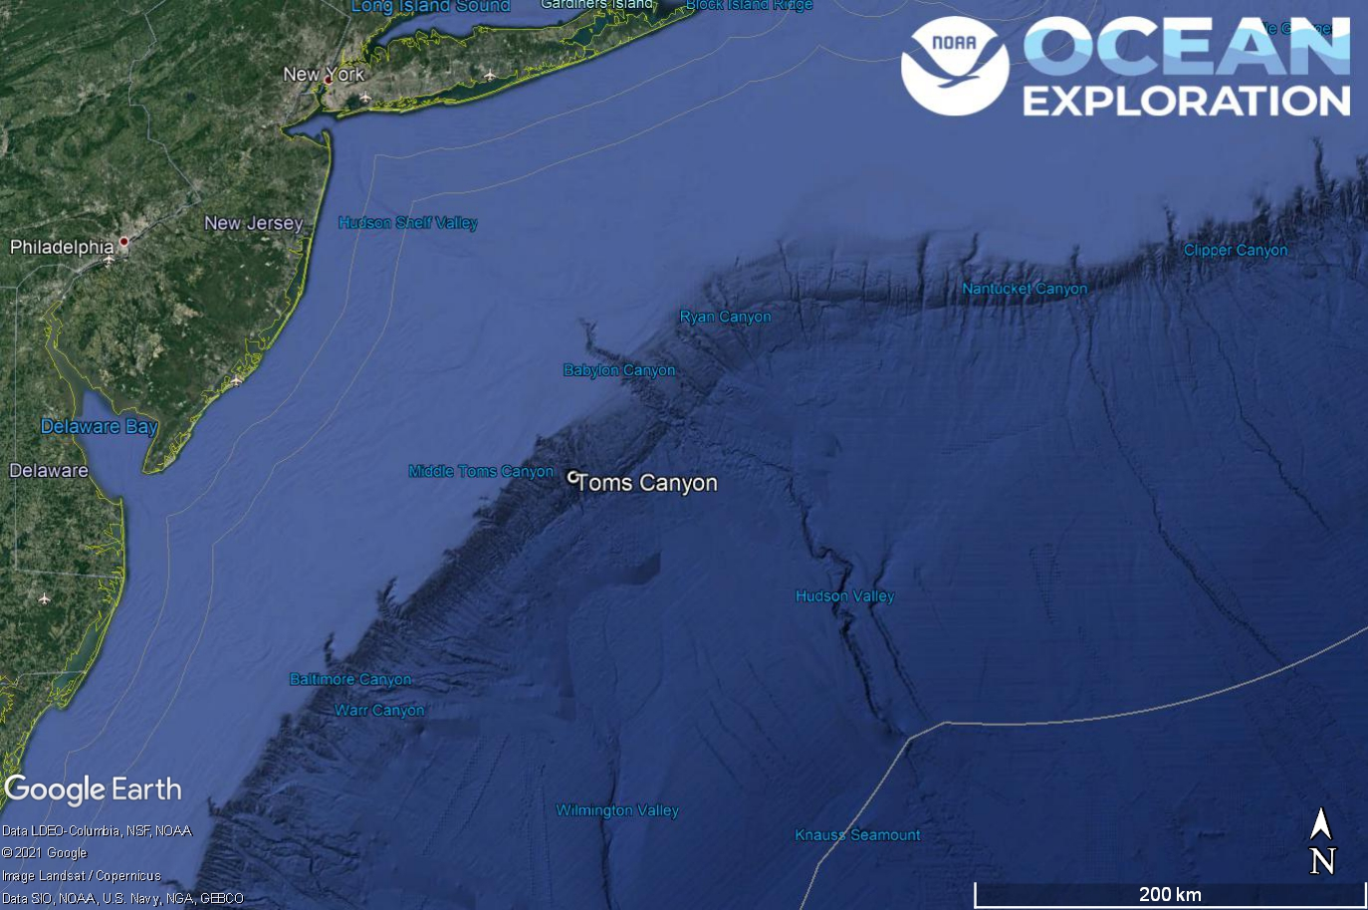

Dive 08 named Toms Canyon. This site is in Toms Canyon off of New York and New Jersey.

## Dive Information

| Site Name | Toms Canyon |
| --- | --- |
| General Area Descriptor | Mid-Atlantic Canyons |
| Science Team  Leads | Karl McLetchie |
| Expedition  Coordinator | Kasey Cantwell/Matt Dornback |
| ROV Dive Supervisor | Karl McLetchie |
| Mapping Lead | Shannon Hoy |
| Dive Purpose | The eighth engineering dive of the ROV Shakedown. Primary objectives include pilot training, testing new motors, motor controllers, lights, cameras, and hydraulic systems on the ROVs.  Secondary objectives include exploring the mid-canyon area of central Toms Canyon and collecting characteristic geological and biological samples. |
| Was the dive restricted for Underwater Cultural Heritage? | No |
| ROV Dive Summary Data | Dive Summary: EX2103_DIVE08  ^^^^^^^^^^^^^^^^^^^^^^^^^^^^^^^^^^^^^^^^  Dive Type: Normal  In Water: 2021-06-23T12:46:05.279990  38.979286035960115 ; -72.49214094605985  On Bottom: 2021-06-23T14:05:47.899872  38.98267178722948 ; -72.49481961886883  Off Bottom: 2021-06-23T19:30:32.383616  38.984342623309885 ; -72.49262390786174  Out Water: 2021-06-23T20:41:16.019436  38.98692827563648 ; -72.49298368088947  Dive Duration: 7:55:10  Bottom Time: 5:24:44  Max Vehicle Depth: 1838.0 m  Min Seafloor Depth: 1694.6 m  Distance Travelled: 180.3 m |
| Dive Description | Today’s dive (Dive 8) deployed at 0830 on Toms Canyon and descended to a depth of 1830m. The ROV immediately found mudstone protrusions from the sediment and consistent coverage of brittle stars on the sedimented areas. The ROV proceeded to climb the northern canyon wall observing numerous different types of corals, fish, sponges, sea urchins, on rocky walls, ledges, and talus slopes. This was the first dive of EX2103 that has significant science participation from shore. Scientists from shore logged into the chat to discuss the geology and biology of the area and requested samples.  The team observed bioluminescence on a bamboo coral using the new ME-20 low light camera. The team set up the ROV’s manipulator arm near the bamboo coral and proceeded to turn down the ROV lights and turn up the light gain on the ME-20 camera. When the coral was bumped by the arm the videographer observed faint illumination from the coral. The Figures 1 and 2 below show the setup with the manipulator arm and the flash of bioluminescence with all of the ROV lights off.  Two samples were taken, a rock that was characteristic of the Toms Canyon substrate and an unknown biological that was resting on the sediment. After ROV recovery the scientist’s best guess is that the sample was some type of jellyfish. The sampling SOP was tested with the unknown jellyfish and working with Rhian Waller from shore. The procedures outlined for the jellyfish in the Okeanos Sampling guide from the Smithsonian were confirmed to be the best practice. Having this guide has been exceptionally helpful. |
| Notable Observations | Potential bioluminescence in a bamboo coral  A pycnogonid was observed consuming a gelatinous cnidarian |
| Community and habitat observations | Corals and Sponges - Present  Chemosynthetic Community - Absent  High biodiversity Community - Absent  Active Seep or Vent - Absent  Extinct Seep or Vent - Absent  Hydrates - Absent |
| CMECS Feature Type(s) | Submarine Canyon, Slope, Terraces, Ledge |
| SeaTube Link (science annotation system) | https://data.oceannetworks.ca/SeaTubeV3?resourceTypeId=600&resourceId=2213 |

### Equipment Deployed

| ROV | | *Deep Discoverer* | | |
| --- | --- | --- | --- | --- |
| Camera Platform | | *Seirios* | | |
| ROV Measurements | | The following ROV measurements, data streams and equipment are used on each ROV deployment: CTD, depth, scanning sonar, USBL position, altitude, heading, attitude, high-resolution cameras, low resolution cameras, manipulator arms, suction sampler, sample drawers and thrusters. The section below notes if any of these sensors were malfunctioning or not operational | | |
| Equipment Malfunctions | | Turbidity Sensor | | |

### Close-up Map of Main Dive Site

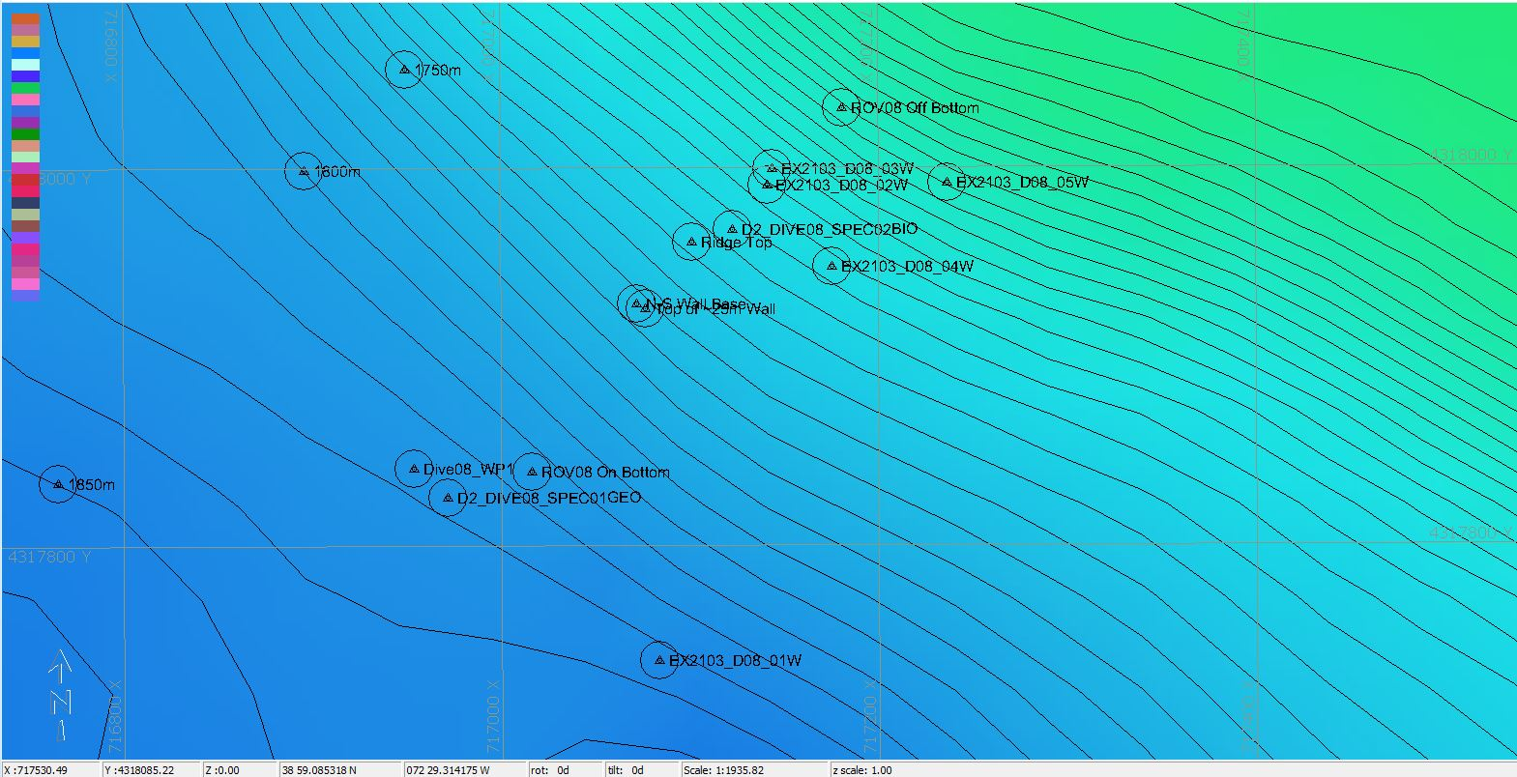

Hypack map of the Dive 08 waypoints. Depth is displayed by contour lines at 10 meter increments and by colors. Warm colors are shallower and cool colors are deeper.

### Representative Photos of the Dive

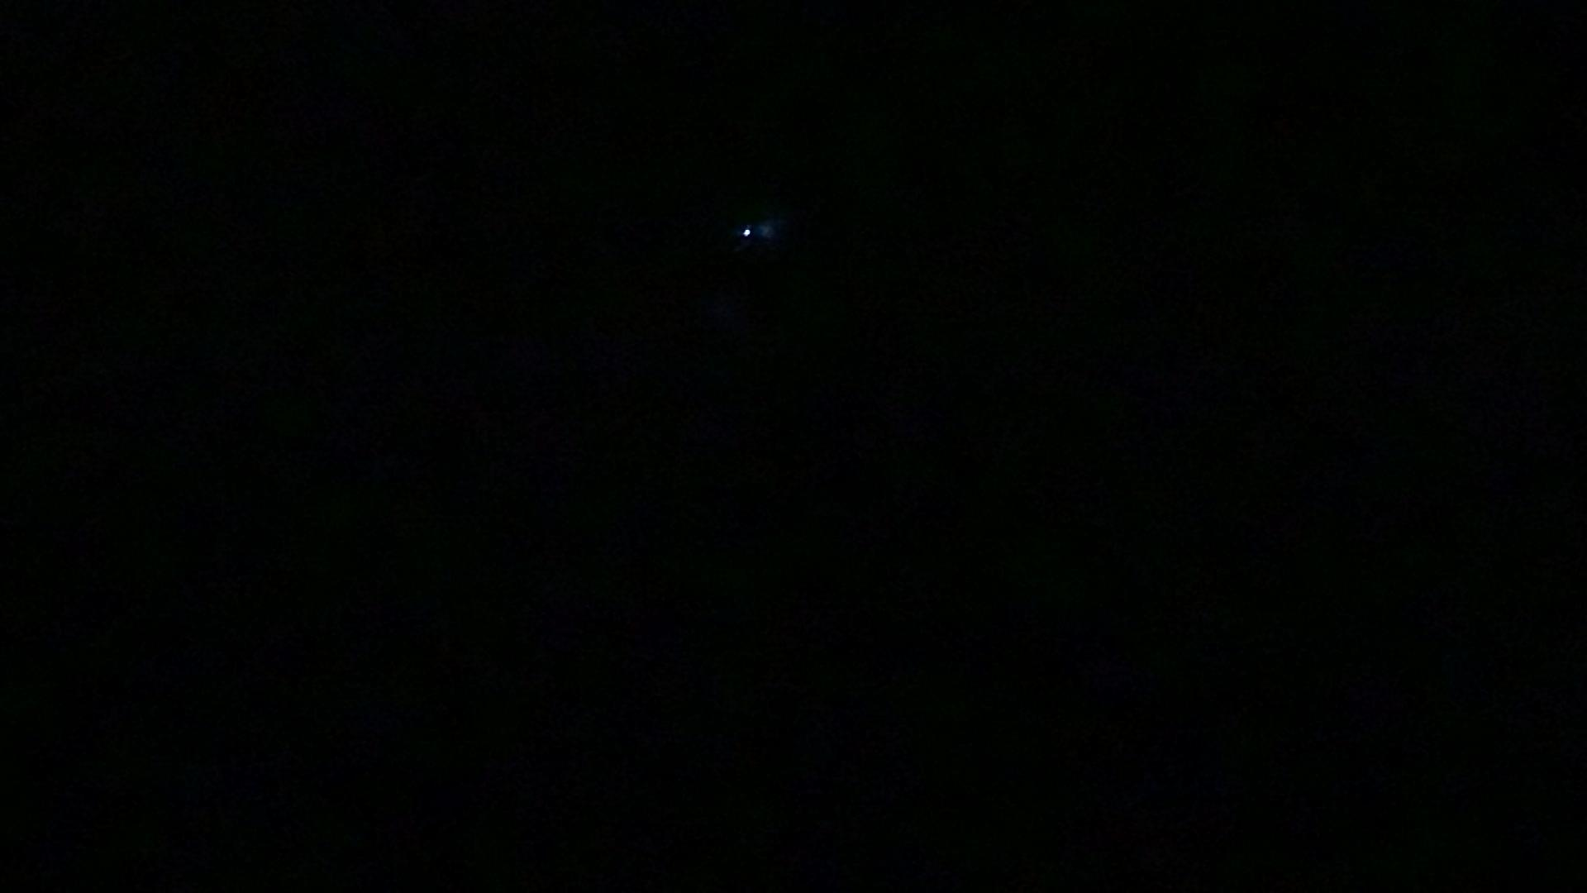

Some small flashes picked up by the low light camera in the upper center of the image.

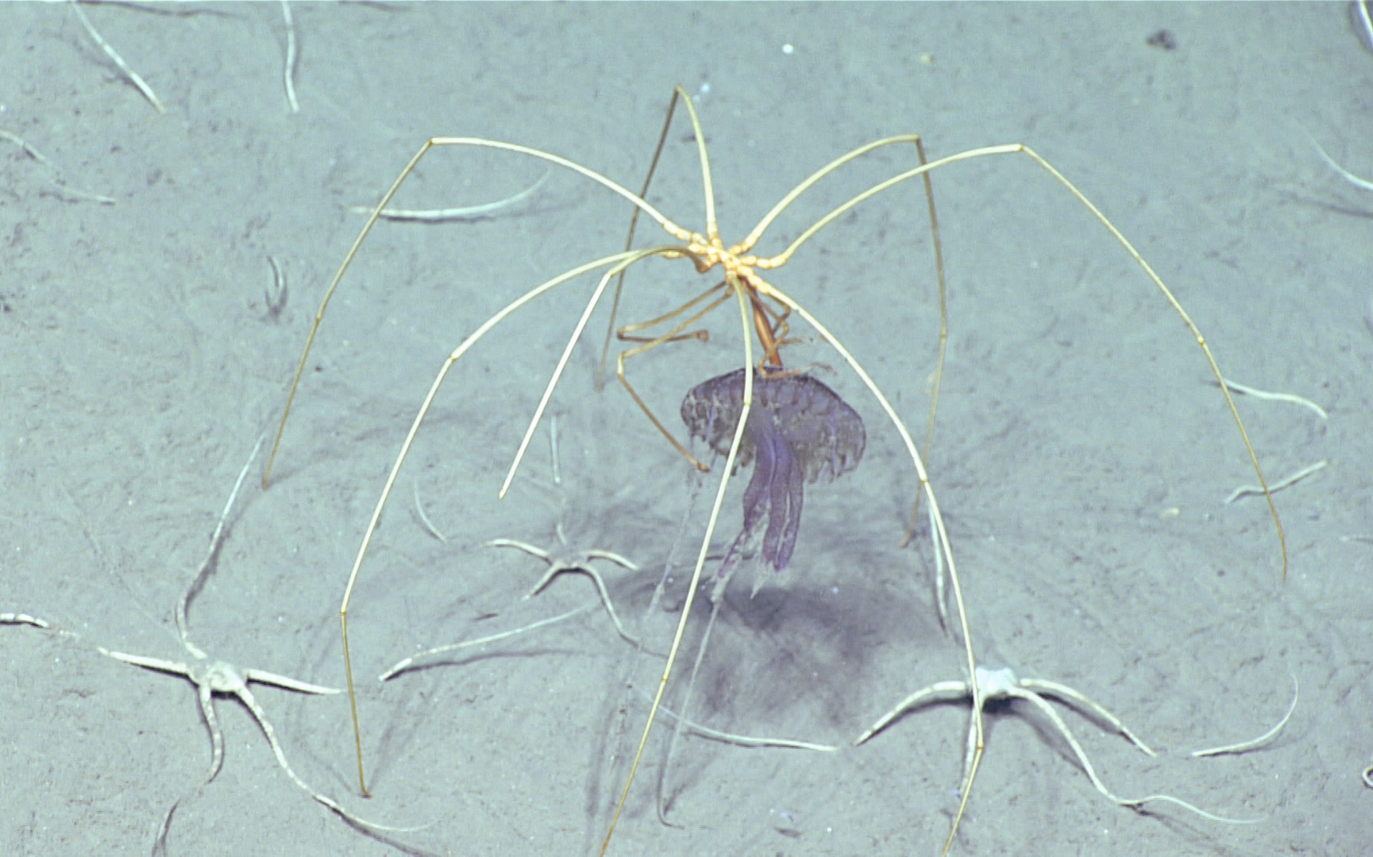

A pycnogonid sea spider observed consuming a gelatinous cnidarian among brittle stars.

[CAPTION]

## Samples Collected -

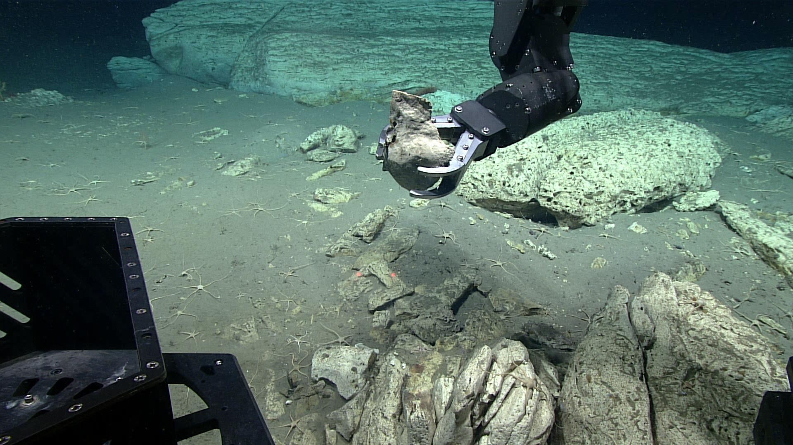

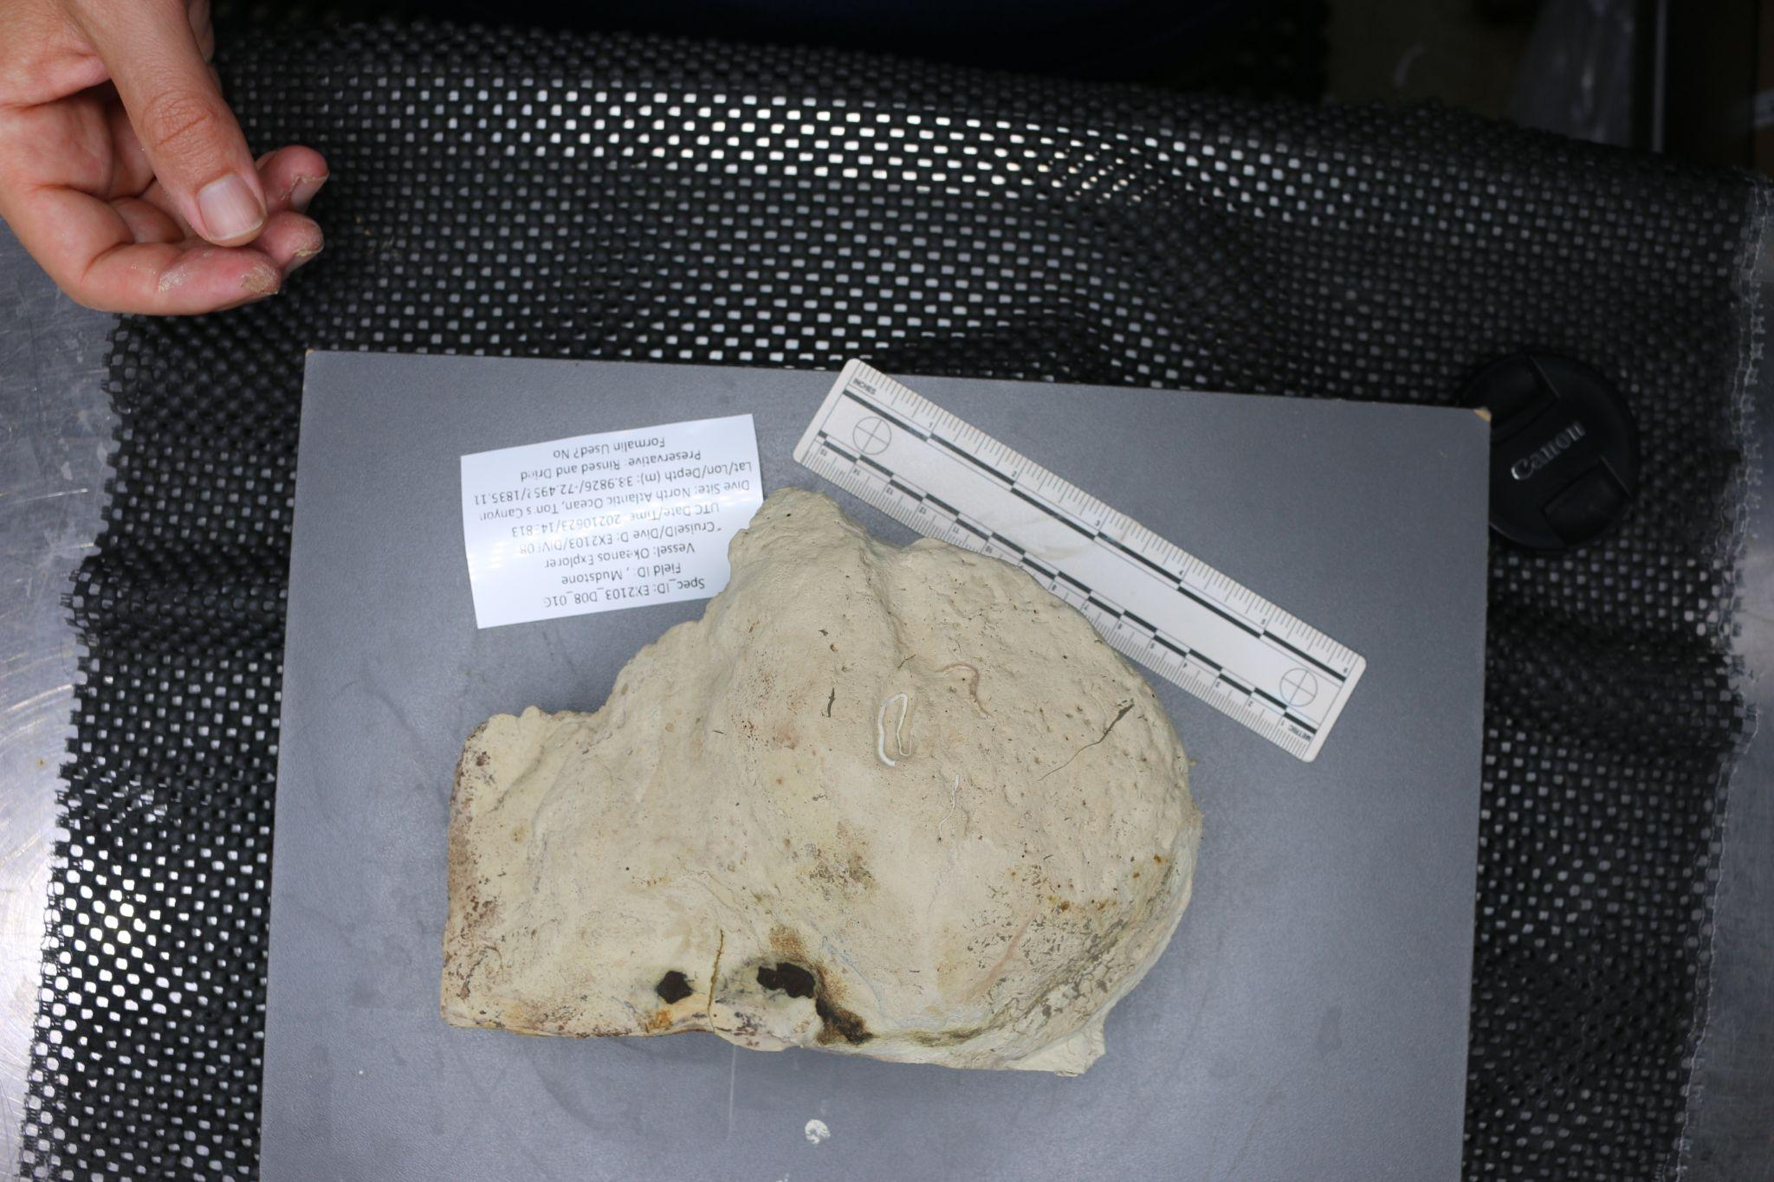

| Sample ID | EX2103_D08_01G |
| --- | --- |
| Date (UTC) | 6/23/2021 |
| Time (UTC) | 143813 |
| Depth (m) | 1835.111 |
| Latitude (decimal degrees) | 38.9826 |
| Longitude (decimal degrees) | -72.4952 |
| Temp. (°C) | 3.465 |
| Field ID(s) | mudstone |
| Comments | might have biologic worm activity present, silky texture, porous, held up against manipulator arm; weight 0.73 kg, 11-50 cm size category |

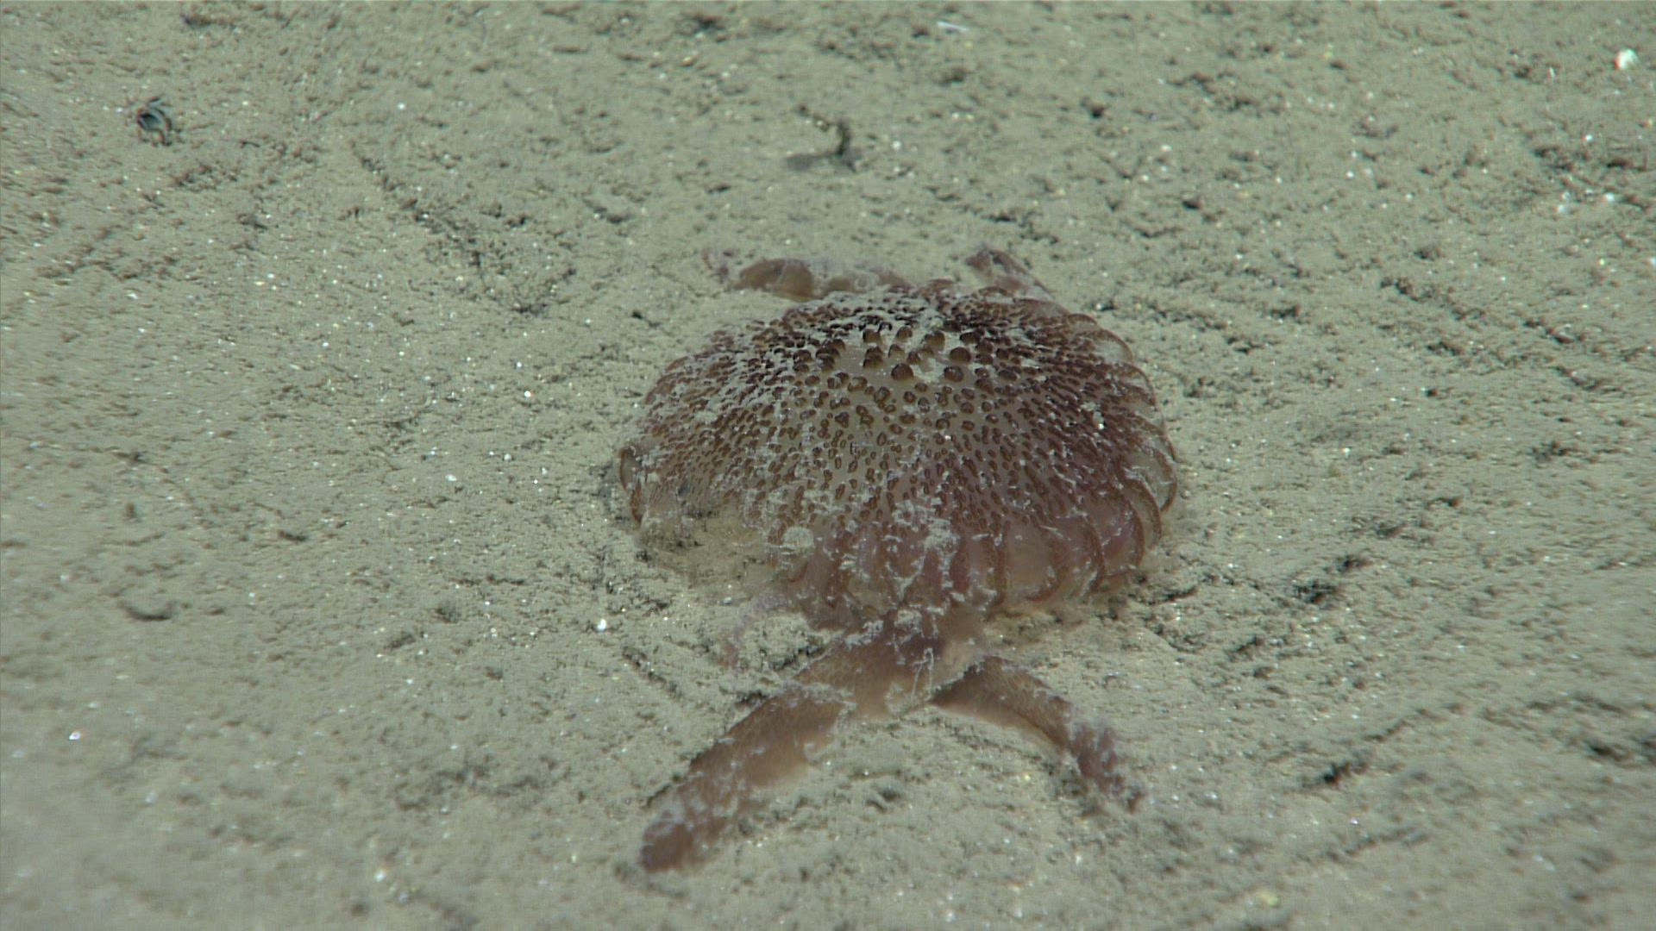

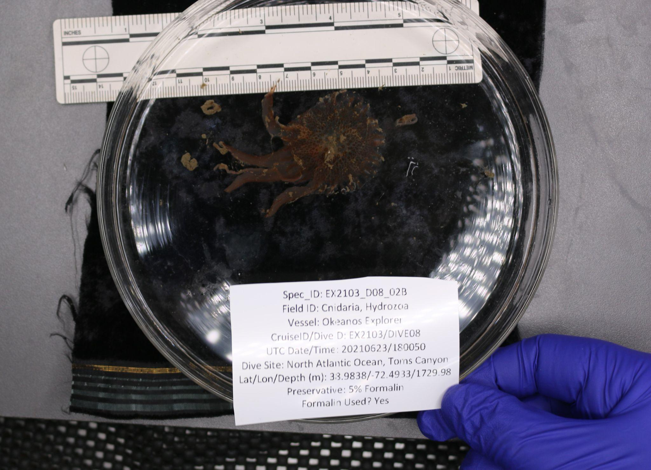

| Sample ID | EX2103_D08_02B |
| --- | --- |
| Date (UTC) | 6/23/2021 |
| Time (UTC) | 180050 |
| Depth (m) | 1729.982 |
| Latitude (decimal degrees) | 38.9838 |
| Longitude (decimal degrees) | -72.4933 |
| Temp. (°C) | 3.598 |
| Field ID(s) | Cnidaria Hydrozoa (hydroids) |
| Comments | deteriorated condition, 7cm x 4cm wide, collected on bottom, solid bell, frilled edges, hydrozoan possibly, center is firm outside is squishier, four tentacles currently, some seem to have fallen off |

### Niskin Sampling Summary

No niskin samples were collected

### Scientists Involved (provide name, email, affiliation)

| **Name** | **Email** | **Affiliation** |
| --- | --- | --- |
| Upasana Ganguley | upasana.ganguly1@louisiana.edu | University of Louisiana at lafayette |
| Michael Vecchione | vecchiom@si.edu | NOAA & NMNH |
| Thomas Morrow | thomas.morrow@bc.edu | Boston College |
| Jason Chaytor | jchaytor@usgs.gov | USGS |
| Les Watling | watling@hawaii.edu | University of Hawaii at Manoa |
| Ken Sulak | jumpingsturgeon@yahoo.com | USGS |
| Asako Matsumoto | amatsu@gorgonian.jp | Chiba Institute of Technology |
| Noelle Helder | noelle.helder@noaa.gov | NOAA Ocean Exploration |
|  |  |  |
|  |  |  |
|  |  |  |
|  |  |  |
|  |  |  |
|  |  |  |
|  |  |  |
|  |  |  |
|  |  |  |
|  |  |  |

### Please direct inquiries to:

NOAA Office of Ocean Exploration & Research

1315 East-West Highway, SSMC3 RM 10210

Silver Spring, MD 20910

[oceanexplorer@noaa.gov](mailto:oceanexplorer@noaa.gov)