ROV Dive Summary, EX-21-03, Dive 07, June 22, 2021

General Location Map
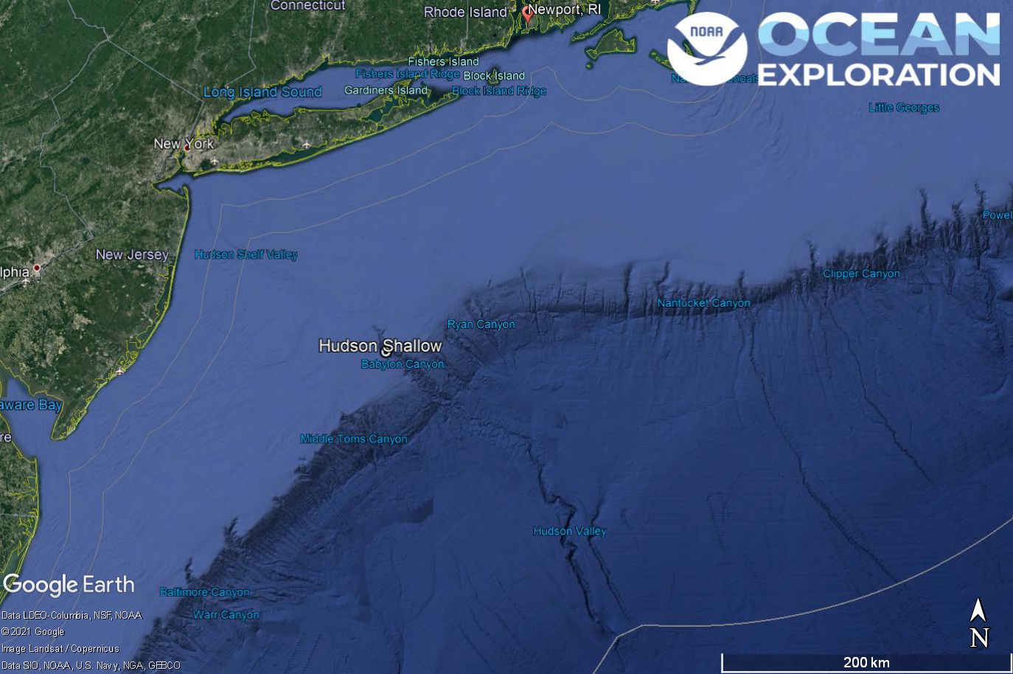
Dive 07 named Hudson Shallow. This site is in Hudson Canyon off of New York and New Jersey.

Dive Information
Site Name | Hudson Shallow
General Area Descriptor | Mid-Atlantic Canyons
Science Team  Leads | Karl McLetchie
Expedition  Coordinator | Kasey Cantwell/Matt Dornback
ROV Dive Supervisor | Karl McLetchie
Mapping Lead | Shannon Hoy
Dive Purpose | The seventh engineering dive of the ROV Shakedown. Primary objectives include pilot training, testing new motors, motor controllers, lights, cameras, and hydraulic systemson the ROVs.  Secondary objectives include exploring the upper area of Hudson Canyon and collecting characteristic geological and biological samples.
Was the dive restricted for Underwater Cultural Heritage? | No
ROV Dive Summary Data | Dive Summary: EX2103_DIVE07  ^^^^^^^^^^^^^^^^^^^^^^^^^^^^^^^^^^^^^^^^  Dive Type: Normal  In Water: 2021-06-22T16:47:51.327113  39.53018213775482 ; -72.3773614112248  On Bottom: 2021-06-22T17:23:54.439750  39.52977251645905 ; -72.37732892393338  Off Bottom: 2021-06-22T21:03:11.315254  39.53103870837962 ; -72.37715922502778  Out Water: 2021-06-22T21:28:24.334029  39.53461656611496 ; -72.38049405822777  Dive Duration: 4:40:33  Bottom Time: 3:39:16  Max Vehicle Depth: 560.2 m  Min Seafloor Depth: 391.5 m  Distance Travelled: 284.7 m
Dive Description | With the delayed deployment of the ROV, a later recovery was planned for 18:30. The ROVs were deployed at 13:00 and found bottom at 560m in a high turbidity environment on the heavily sedimented canyon floor. Euphausid shrimp swarmed the vehicle lights. Crabs, brittlestars, and anemones were dispersed across the seafloor. Around 15:00 the ROV started ascending the canyon wall. The wall was composed of a sedimentary rock that formed terraces. The terraces were abundant with anemones, sponges, and a single paragorgia covered in royal red shrimp. A goosefish, numerous skates, a flounder, and numerous other fish were seen too.  One sample was attempted but was aborted due to a squall that forced the ship to make moves and the ROVs off the bottom around 17:30. Due to strong winds with gusts over 40 knots the rest of the dive was cancelled and ROV recovery began.  The ME20 was tested on a flytrap anemone that can sometimes bioluminesce. With all lights off except the aft pole lights at 5% there was a good image of the anemone. Although the anemone did not bioluminise when prodded with the Kraft, a blue streak did pass through the camera; likely a luminescent shrimp/krill. We will keep testing it on likely biology.
Notable Observations
Community and habitat observations | Corals and Sponges - Present  Chemosynthetic Community - Absent  High biodiversity Community - Absent  Active Seep or Vent - Absent  Extinct Seep or Vent - Absent  Hydrates - Absent
CMECS Feature Type(s) | Submarine Canyon, Slope, Terraces
SeaTube Link (science annotation system) | https://data.oceannetworks.ca/SeaTubeV3?resourceTypeId=600&resourceId=2203

Equipment Deployed
ROV |  | Deep Discoverer
Camera Platform |  | Seirios
ROV Measurements |  | The following ROV measurements, data streams and equipment are used on each ROV deployment: CTD, depth, scanning sonar, USBL position, altitude, heading, attitude, high-resolution cameras, low resolution cameras, manipulator arms, suction sampler, sample drawers and thrusters. The section below notes if any of these sensors were malfunctioning or not operational
Equipment Malfunctions |  | Turbidity sensor

Close-up Map of Main Dive Site
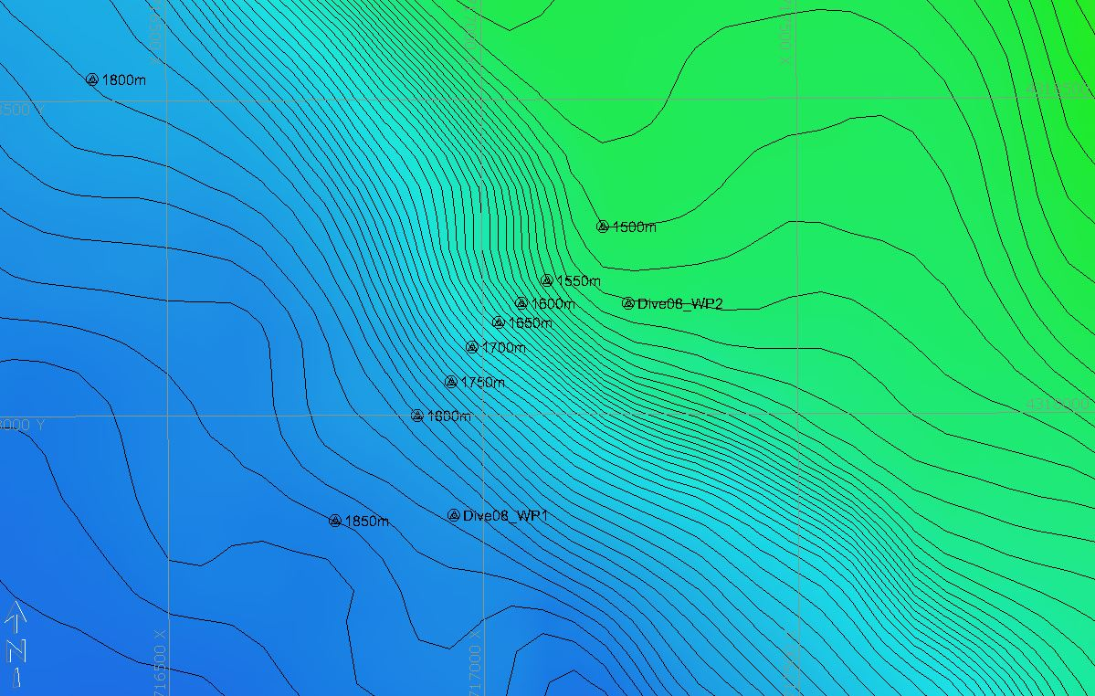
Hypack map of the Dive 07 waypoints. Depth is displayed by contour lines at 10 meter increments and by colors. Warm colors are shallower and cool colors are deeper.

Representative Photos of the Dive
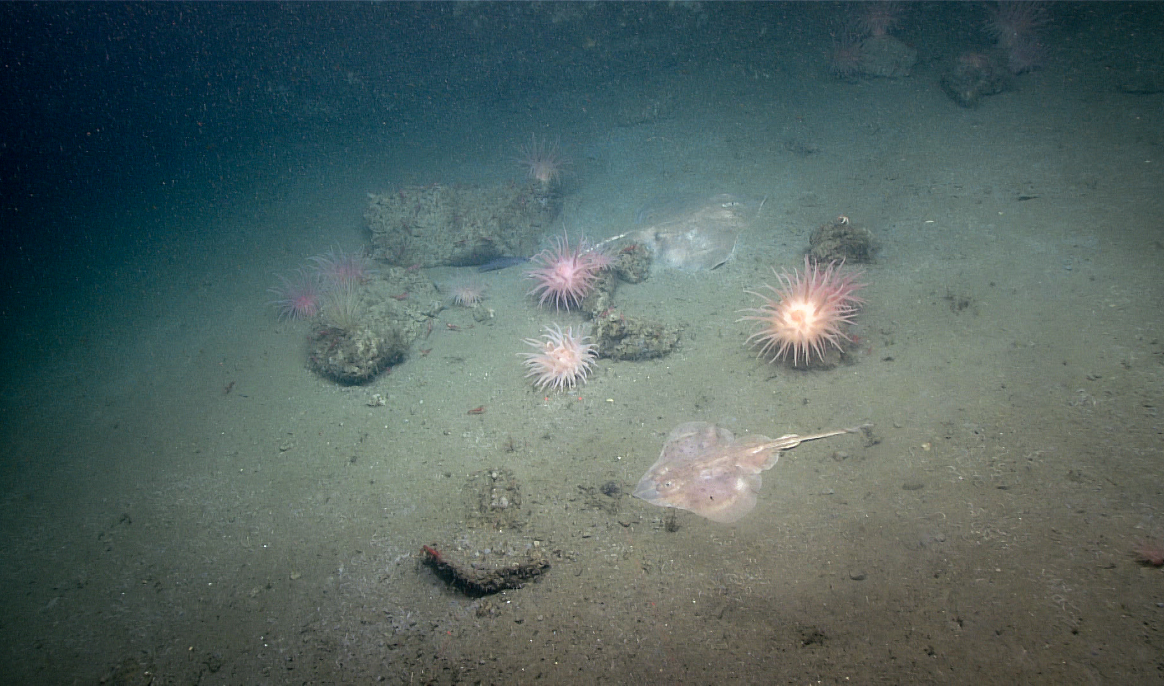
Skates and anemones congregating around rocky rubble.
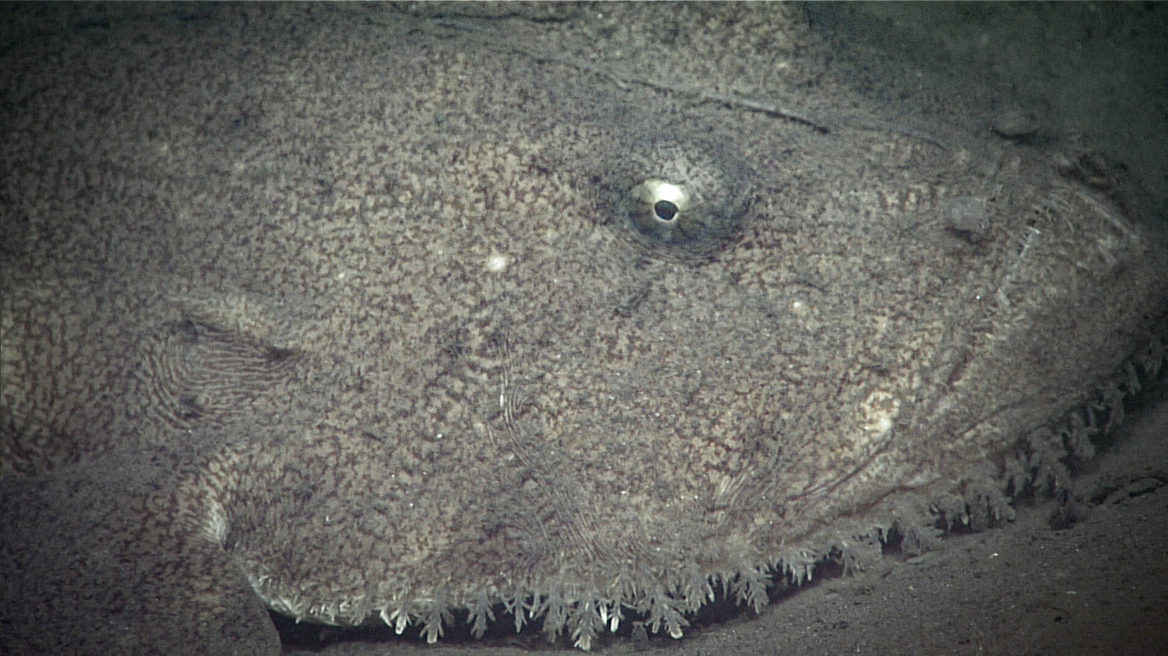
A Goosefish.

Samples Collected -
No samples were collected

Niskin Sampling Summary
No Niskin bottles were used

Scientists Involved (provide name, email, affiliation)
Name | Email | Affiliation
Upasana Ganguley | upasana.ganguly1@louisiana.edu | University of Louisiana at lafayette
Dhugal Lindsay | dhugal@jamstec.go.jp | JAMSTEC
Kelsey Viator | ksviator2000@gmail.com | University of Louisiana at Lafayette
Michael Vecchione | vecchiom@si.edu | NOAA & NMNH

Please direct inquiries to:
NOAA Office of Ocean Exploration & Research
1315 East-West Highway, SSMC3 RM 10210
Silver Spring, MD 20910
oceanexplorer@noaa.gov

