ROV Dive Summary, EX-21-03, Dive 06, June 19, 2021

General Location Map
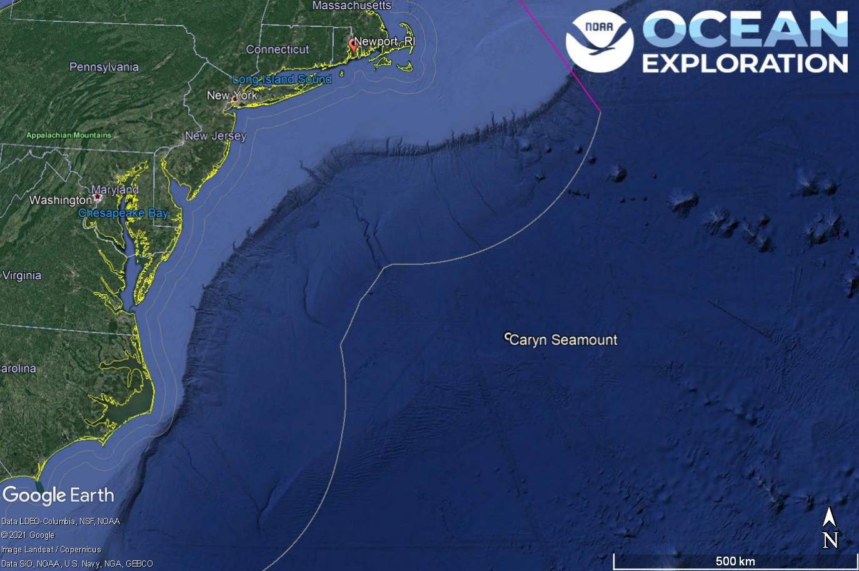
Dive 06 named Caryn Seamount. This site is on Caryn Seamount outside of the U.S. Exclusive Economic Zone.

Dive Information
Site Name | Caryn Seamount
General Area Descriptor | An isolated seamount with volcanic origin rising out of the Sohm Abyssal Plain
Science Team  Leads | Karl McLetchie
Expedition  Coordinator | Kasey Cantwell/Matt Dornback
ROV Dive Supervisor | Karl McLetchie
Mapping Lead | Shannon Hoy
Dive Purpose | The sixth engineering dive of the ROV Shakedown. Primary objectives include pilot training, testing new motors, motor controllers, lights, cameras, and hydraulic systems on the ROVs.  Secondary objectives include exploring Caryn Seamount and collecting characteristic geological and biological samples.
Was the dive restricted for Underwater Cultural Heritage? | No
ROV Dive Summary Data | Dive Summary: EX2103_DIVE06  ^^^^^^^^^^^^^^^^^^^^^^^^^^^^^^^^^^^^^^^^  Dive Type: Normal  In Water: 2021-06-19T12:24:46.076705  36.66883664795508 ; -67.92760693520448  On Bottom: 2021-06-19T14:38:05.459955  36.668942568193714 ; -67.92861380123425  Off Bottom: 2021-06-19T18:10:54.960449  36.669588201078014 ; -67.92902245622362  Out Water: 2021-06-19T20:21:43.534606  36.66115593094224 ; -67.94041954204027  Dive Duration: 7:56:57  Bottom Time: 3:32:49  Max Vehicle Depth: 3796.6 m  Min Seafloor Depth: 3764.0 m  Distance Travelled: 234.3 m
Dive Description | Successful first ROV dive on Caryn Seamount. We started on a ridge arm at 3797 m and traversed upslope. An objective of the dive was to introduce topography with increased complexity for pilot training, ROV systems testing, and calibration. The dive started in an area with rubble and soft sediment. Several dead sponge stalks with brittle stars on top in addition to other sponges were present. A few corals were seen throughout the dive as well as a diversity of sponges. Two sponges (Hexactinellid sp. and Geodia sp.) and a rock sample were collected. Dive was called ~ 15 minutes early due to increased sustained winds and seas.  The clear water gave the video team a chance to dial in the ME-20 camera from Seirios to see the tether and surrounding terrain, try different D2 lighting settings for shots from the main HD, and demonstrate how well the new camera controls work. The ME-20 will be moved to D2 once in the shelter of Block Island on Tuesday morning.  The rocky terrain allowed the pilots to verify functionality of the SeaKing scanning sonars on D2 and Seirios and to test out the Blueview multibeam sonar on D2. The Bueview worked very well, painting a picture of the seafloor out to 90m.  Auto altitude & heading continued to work very well. Auto XY seemed to hold position well. Moves in Auto XY were done in all directions and the associated data was collected for analysis.  The D2 DVL was adjusted to pick up the seafloor at 90m altitude.  The Seirios altimeter worked well.  The Seirios USBL stopped tracking below 3,000m. It is suspected that the head needs oil. A spare head was swapped on for the next dive. If it is the head then it may need to be sent to Linkquest. We would still have one spare for EX2104.
Notable Observations | Many corals and sponges present
Community and habitat observations | Corals and Sponges - Present  Chemosynthetic Community - Absent  High biodiversity Community - Absent  Active Seep or Vent - Absent  Extinct Seep or Vent - Absent  Hydrates - Absent
CMECS Feature Type(s) | Seamount, Ledge, Slope
SeaTube Link (science annotation system) | https://data.oceannetworks.ca/SeaTubeV3?resourceTypeId=600&resourceId=2193

Equipment Deployed
ROV |  | Deep Discoverer
Camera Platform |  | Seirios
ROV Measurements |  | The following ROV measurements, data streams and equipment are used on each ROV deployment: CTD, depth, scanning sonar, USBL position, altitude, heading, attitude, high-resolution cameras, low resolution cameras, manipulator arms, suction sampler, sample drawers and thrusters. The section below notes if any of these sensors were malfunctioning or not operational
Equipment Malfunctions |  | Turbidity sensor, Seirios USBL

Close-up Map of Main Dive Site
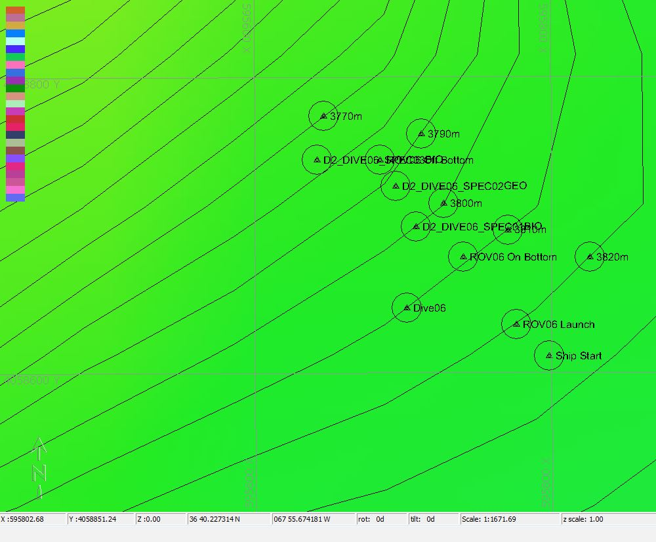

Hypack map of the Dive 06 waypoints. Depth is displayed by contour lines at 10 meter increments and by colors. Warm colors are shallower and cool colors are deeper.

Representative Photos of the Dive
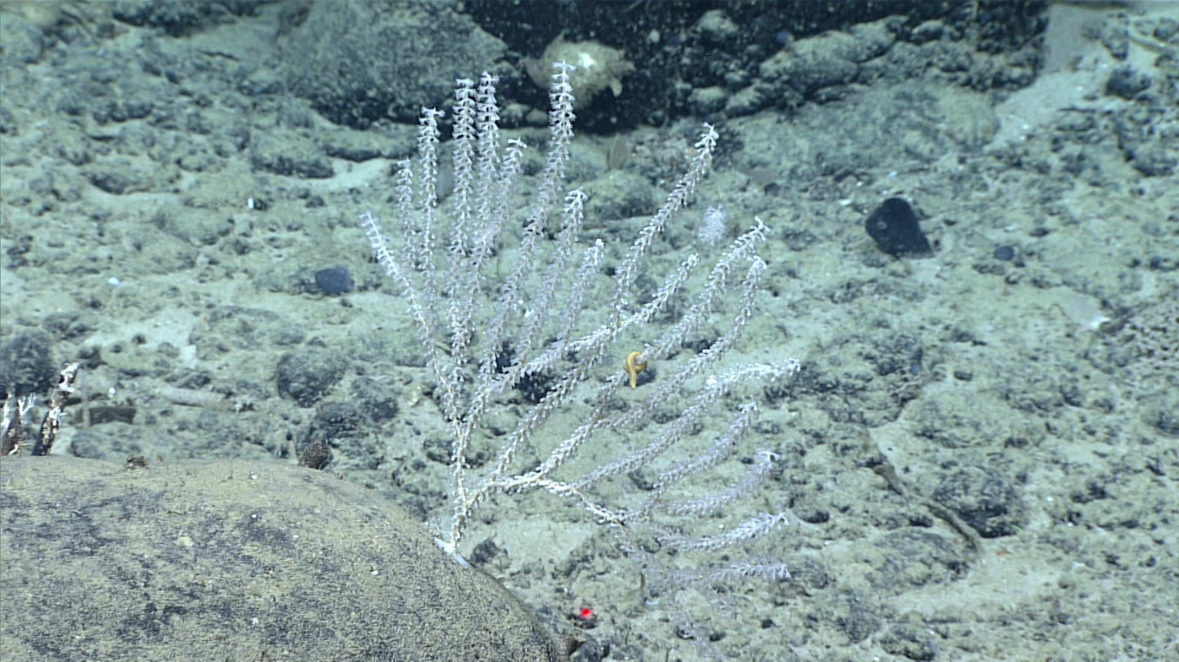
A coral with a worm associate

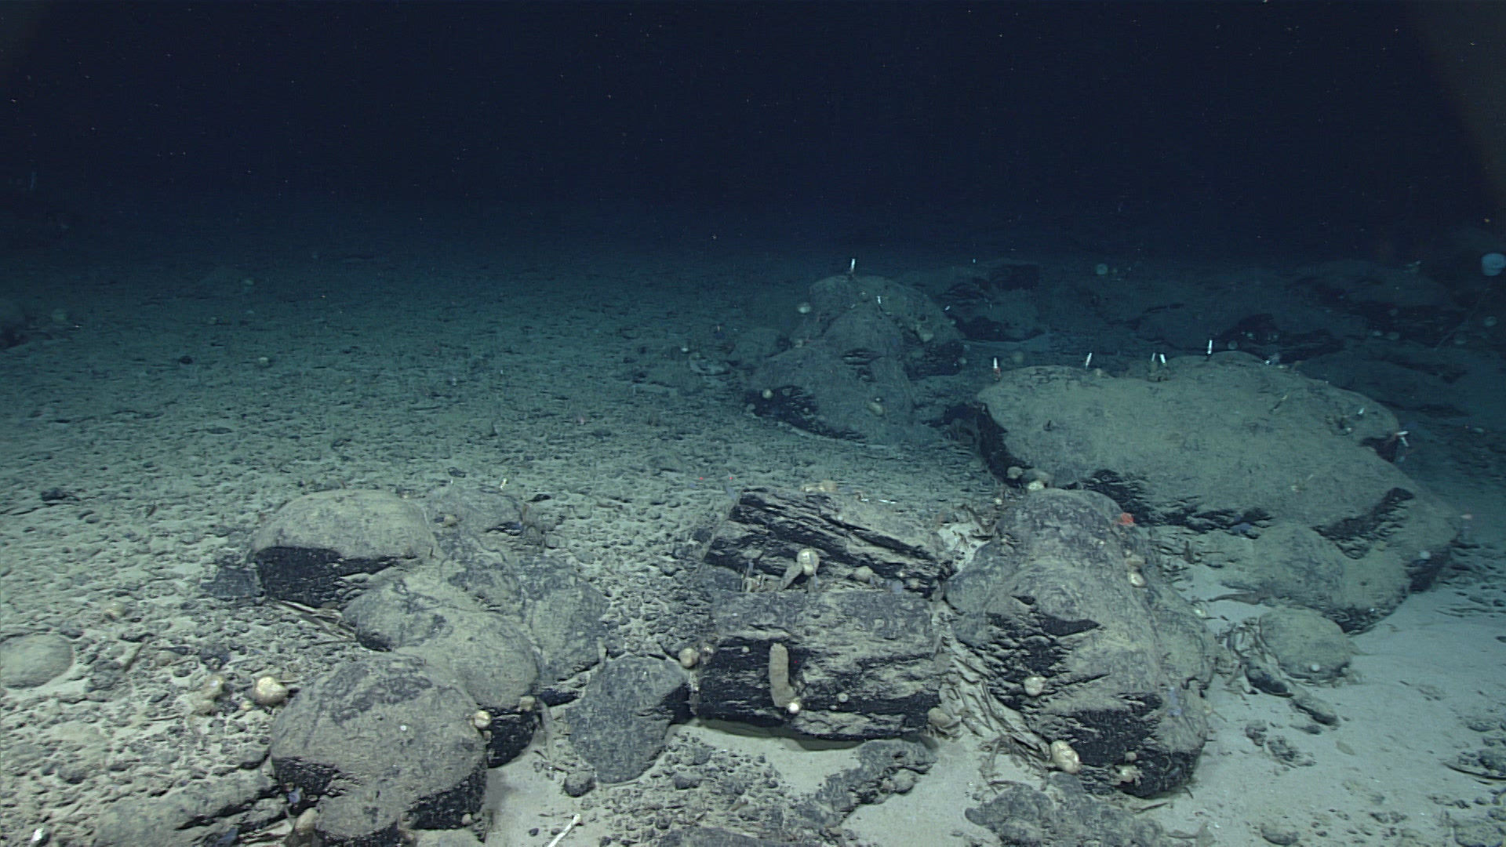
A rocky slope with sponges attached.

Samples Collected -
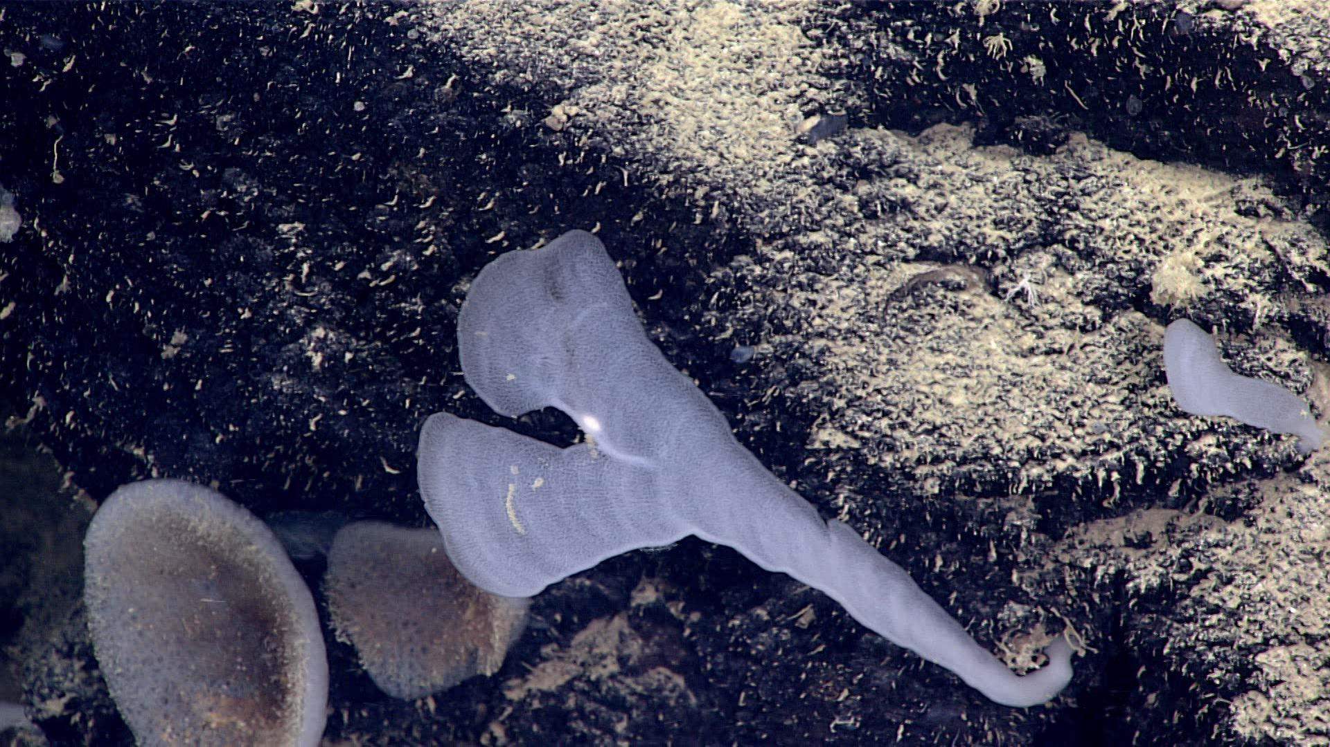
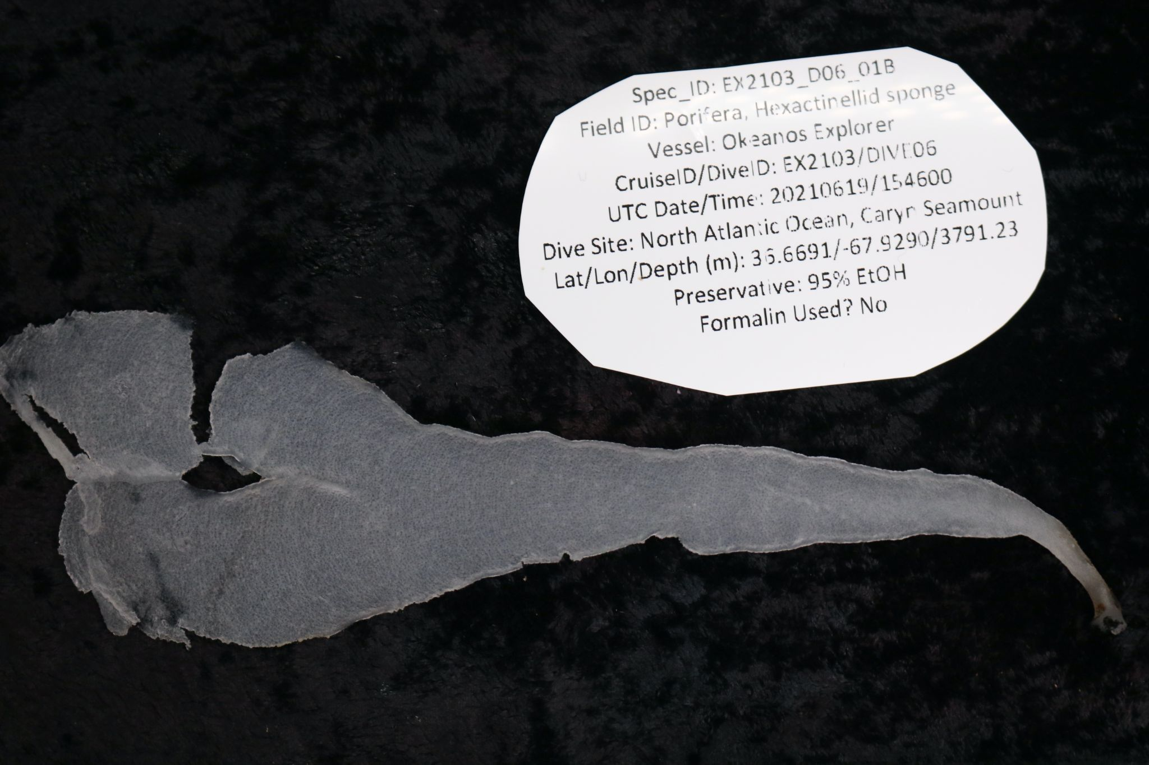
Sample ID | EX2103_D06_01B
Date (UTC) | 06/19/2021
Time (UTC) | 15:46
Depth (m) | 3791.227
Latitude (decimal degrees) | 36.669140
Longitude (decimal degrees) | -67.929
Temp. (°C) | 2.451
Field ID(s) | Hydrozoa
Comments

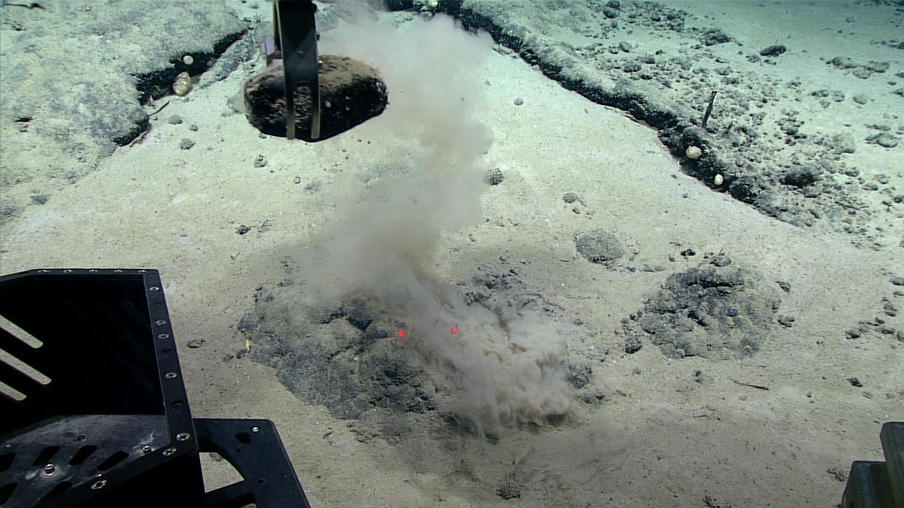
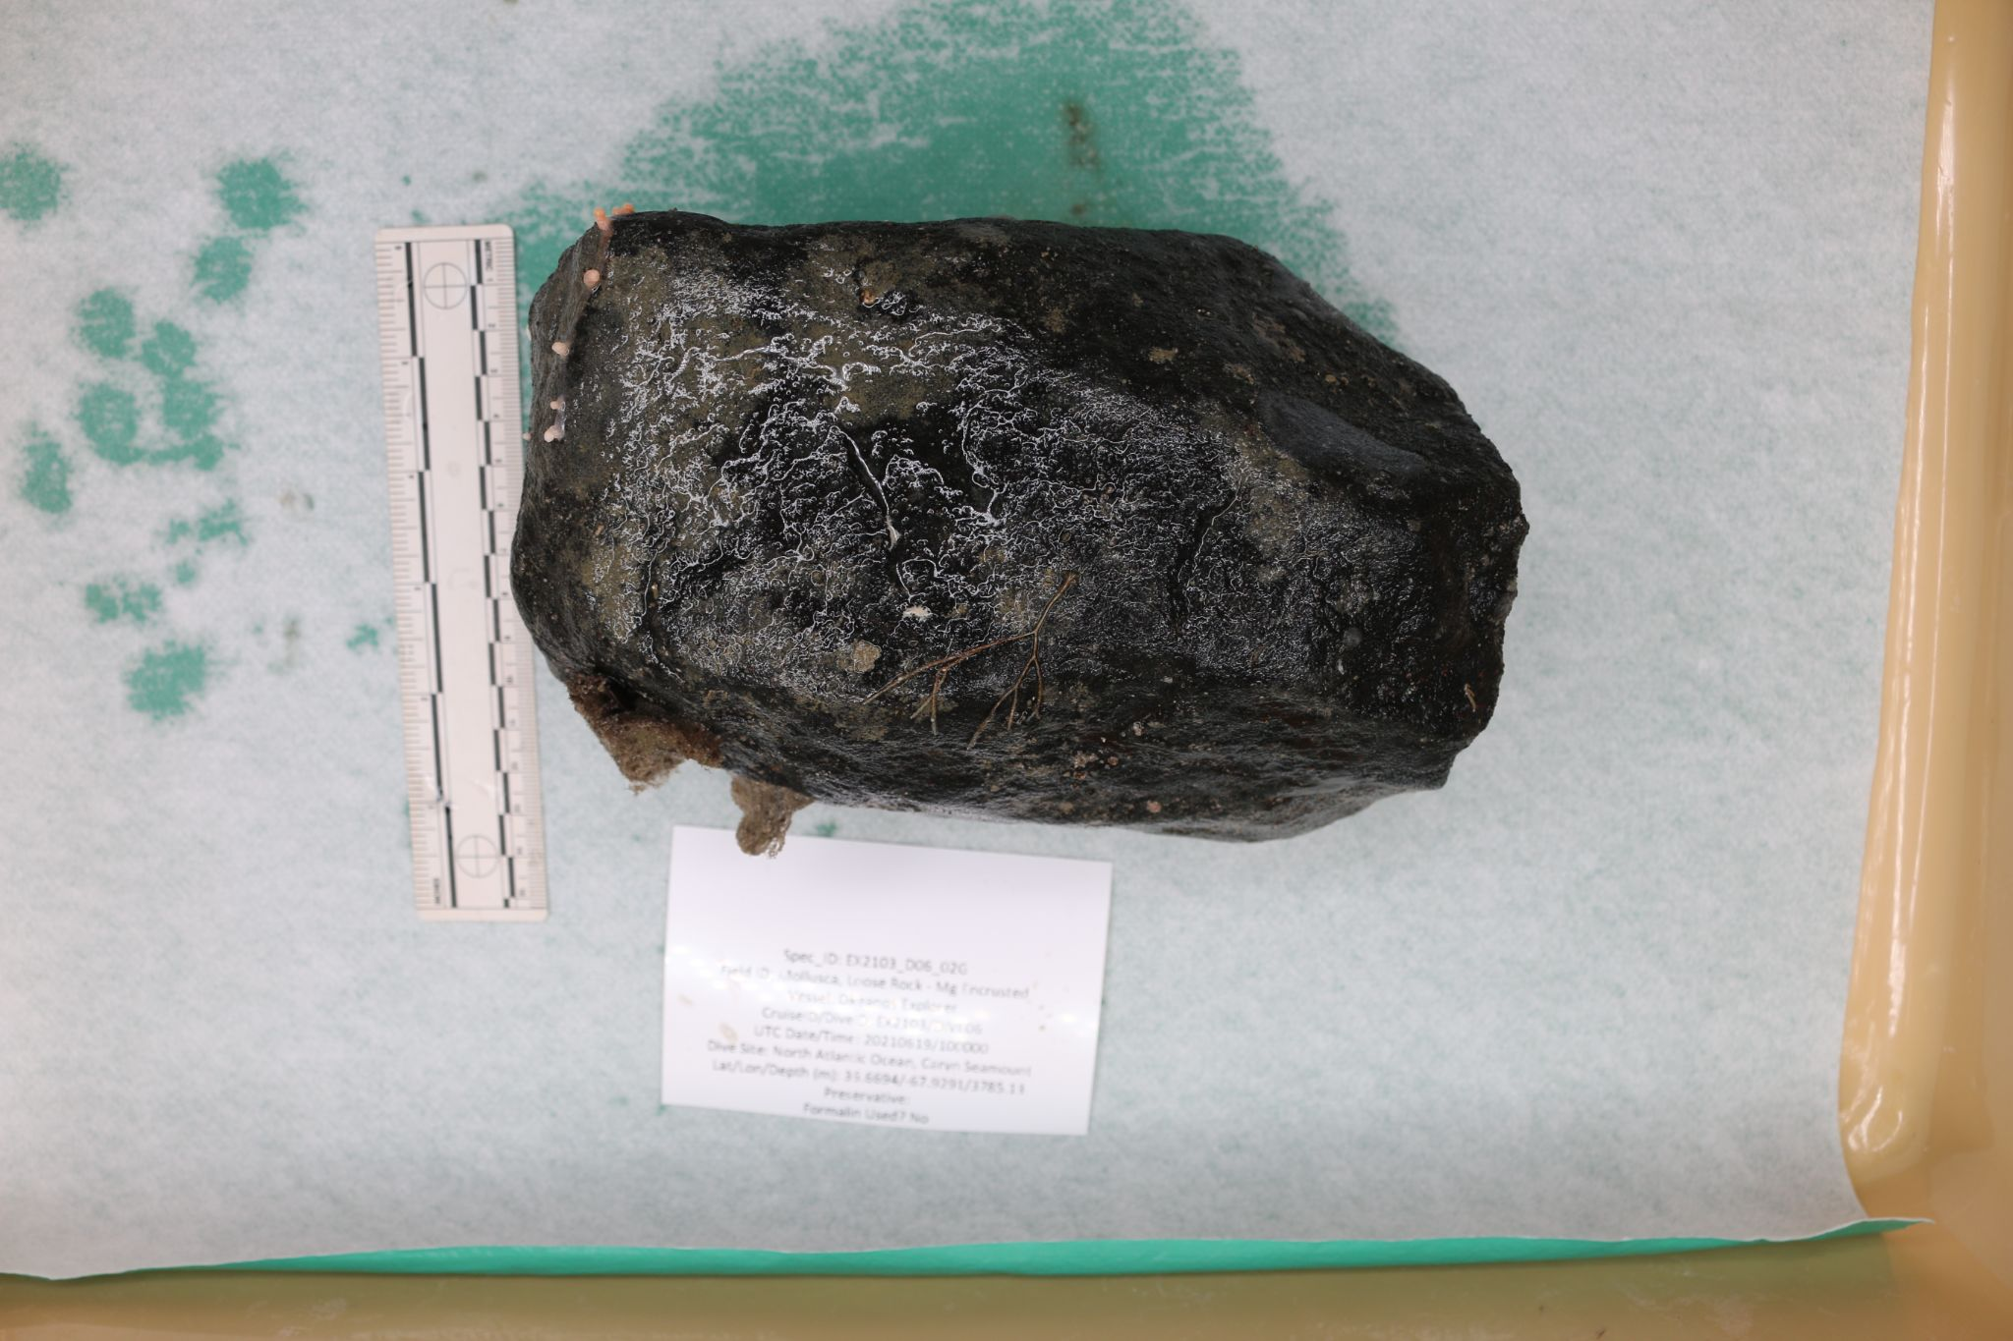
Sample ID | EX2103_D06_02G
Date (UTC) | 6/19/2021
Time (UTC) | 1655
Depth (m) | 3785.131
Latitude (decimal degrees) | 36.66936
Longitude (decimal degrees) | -67.9291
Temp. (°C) | 2.53244
Field ID(s) | Loose Rock - Mg Encrusted
Comments

Associates Sample ID | Field Identification | Count
EX2103_D06_02G_A01 | Cnidaria Actinea | 1
EX2103_D06_02G_A02 | Bryozoa (lace corals) | 1
EX2103_D06_02G_A03 | Bryozoa (lace corals) | 1

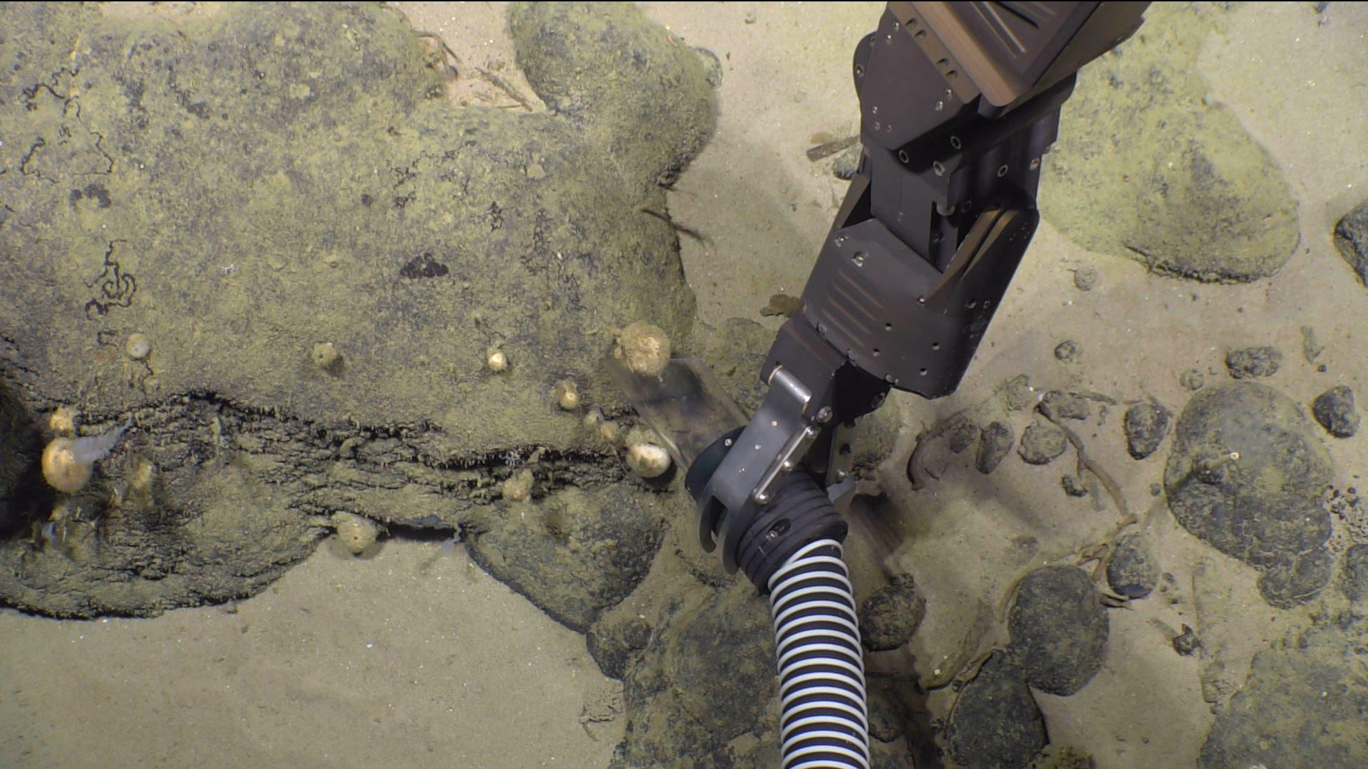
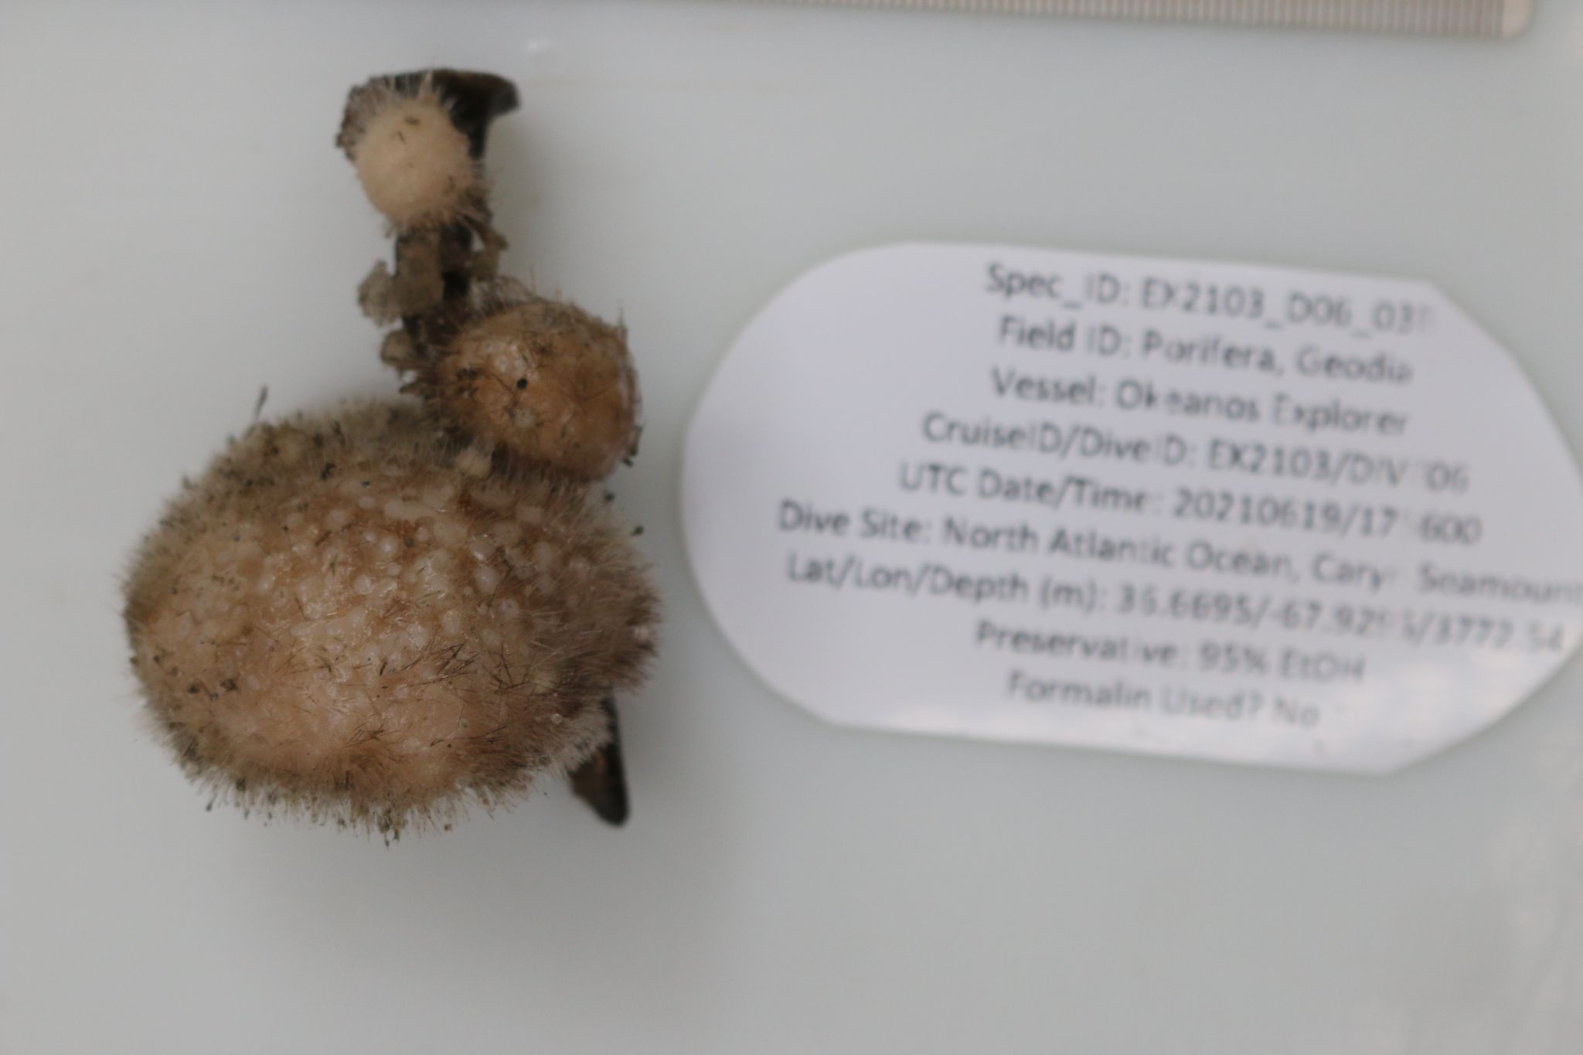
Sample ID | EX2103_D06_03B
Date (UTC) | 6/19/2021
Time (UTC) | 1756
Depth (m) | 3772.538
Latitude (decimal degrees) | 36.66954
Longitude (decimal degrees) | -679295
Temp. (°C) | 2.18375
Field ID(s) | Porifera Geodia
Comments

Niskin Sampling Summary
No Niskin bottles were used

Scientists Involved (provide name, email, affiliation)
No scientists were involved in this dive

Please direct inquiries to:
NOAA Office of Ocean Exploration & Research
1315 East-West Highway, SSMC3 RM 10210
Silver Spring, MD 20910
oceanexplorer@noaa.gov

