ROV Dive Summary, EX-21-03, Dive 05, June 18, 2021

General Location Map
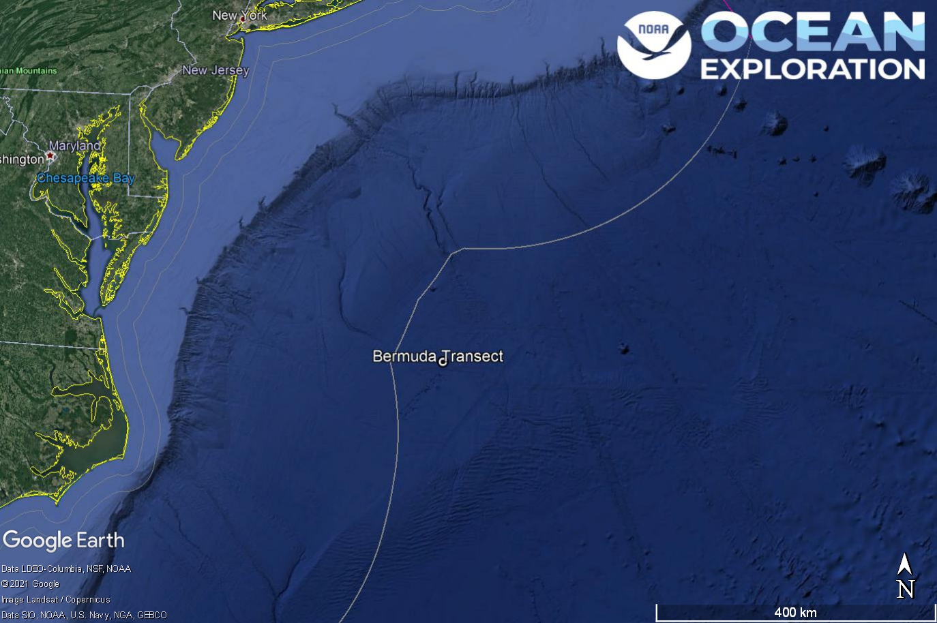
Dive 05 named Bermuda Transect. This site is on the Sohm Abyssal Plain outside of the U.S. Exclusive Economic Zone.

Dive Information
Site Name | Bermuda Transect
General Area Descriptor | Abyssal Plain, On historic Bermuda/Gay Head seafloor and water column sampling transect.
Science Team  Leads | Karl McLetchie
Expedition  Coordinator | Kasey Cantwell/Matt Dornback
ROV Dive Supervisor | Karl McLetchie
Mapping Lead | Shannon Hoy
Dive Purpose | The fifth engineering dive of the ROV Shakedown. Primary objectives include pilot training, testing new motors, motor controllers, lights, cameras, and hydraulic systems on the ROVs.
Was the dive restricted for Underwater Cultural Heritage? | No
ROV Dive Summary Data | Dive Summary: EX2103_DIVE05  ^^^^^^^^^^^^^^^^^^^^^^^^^^^^^^^^^^^^^^^^  Dive Type: Normal  In Water: 2021-06-18T12:59:17.036990  36.54376794359633 ; -70.69524991670299  On Bottom: 2021-06-18T15:26:57.978349  36.54374977395716 ; -70.69629734460449  Off Bottom: 2021-06-18T17:59:02.781079  36.545082241831814 ; -70.69573165239578  Out Water: 2021-06-18T20:27:54.763666  36.5566780193537 ; -70.69367692495888  Dive Duration: 7:28:37  Bottom Time: 2:32:4  Max Vehicle Depth: 4370.9 m  Min Seafloor Depth: 4363.3 m  Distance Travelled: 280.1 m
Dive Description | Dive 5 descended to a depth of 4370m for the deepest dive of this expedition. This achieved the engineering object of a pressure squeeze on D2 and Seirios. The bottom was composed of sandy/silty soft sediment. Sea stars, brittle stars, holothurians, sponges, and fish were observed during the dive.  The ME-20 low light camera was mounted on Seirios and tested in low light conditions looking down at D2. The results for seeing into the distance in low light were mixed.
Notable Observations
Community and habitat observations | Corals and Sponges - Present  Chemosynthetic Community - Absent  High biodiversity Community - Absent  Active Seep or Vent - Absent  Extinct Seep or Vent - Absent  Hydrates - Absent
CMECS Feature Type(s) | Flat
SeaTube Link (science annotation system) | https://data.oceannetworks.ca/SeaTubeV3?resourceTypeId=600&resourceId=2183

Equipment Deployed
ROV |  | Deep Discoverer
Camera Platform |  | Seirios
ROV Measurements |  | The following ROV measurements, data streams and equipment are used on each ROV deployment: CTD, depth, scanning sonar, USBL position, altitude, heading, attitude, high-resolution cameras, low resolution cameras, manipulator arms, suction sampler, sample drawers and thrusters. The section below notes if any of these sensors were malfunctioning or not operational
Equipment Malfunctions |  | Turbidity sensor

Close-up Map of Main Dive Site
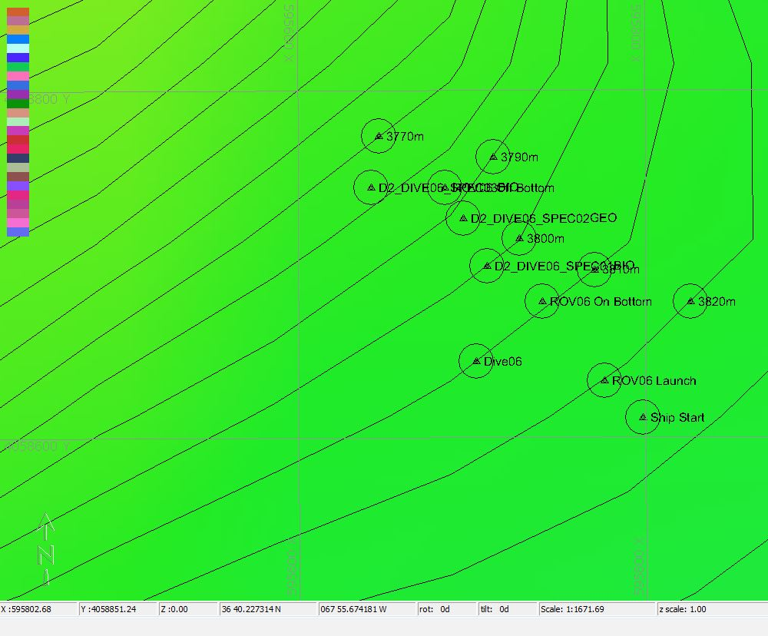

Hypack map of the Dive 05 waypoints. Depth is displayed by contour lines at 10 meter increments and by colors. Warm colors are shallower and cool colors are deeper.

Representative Photos of the Dive

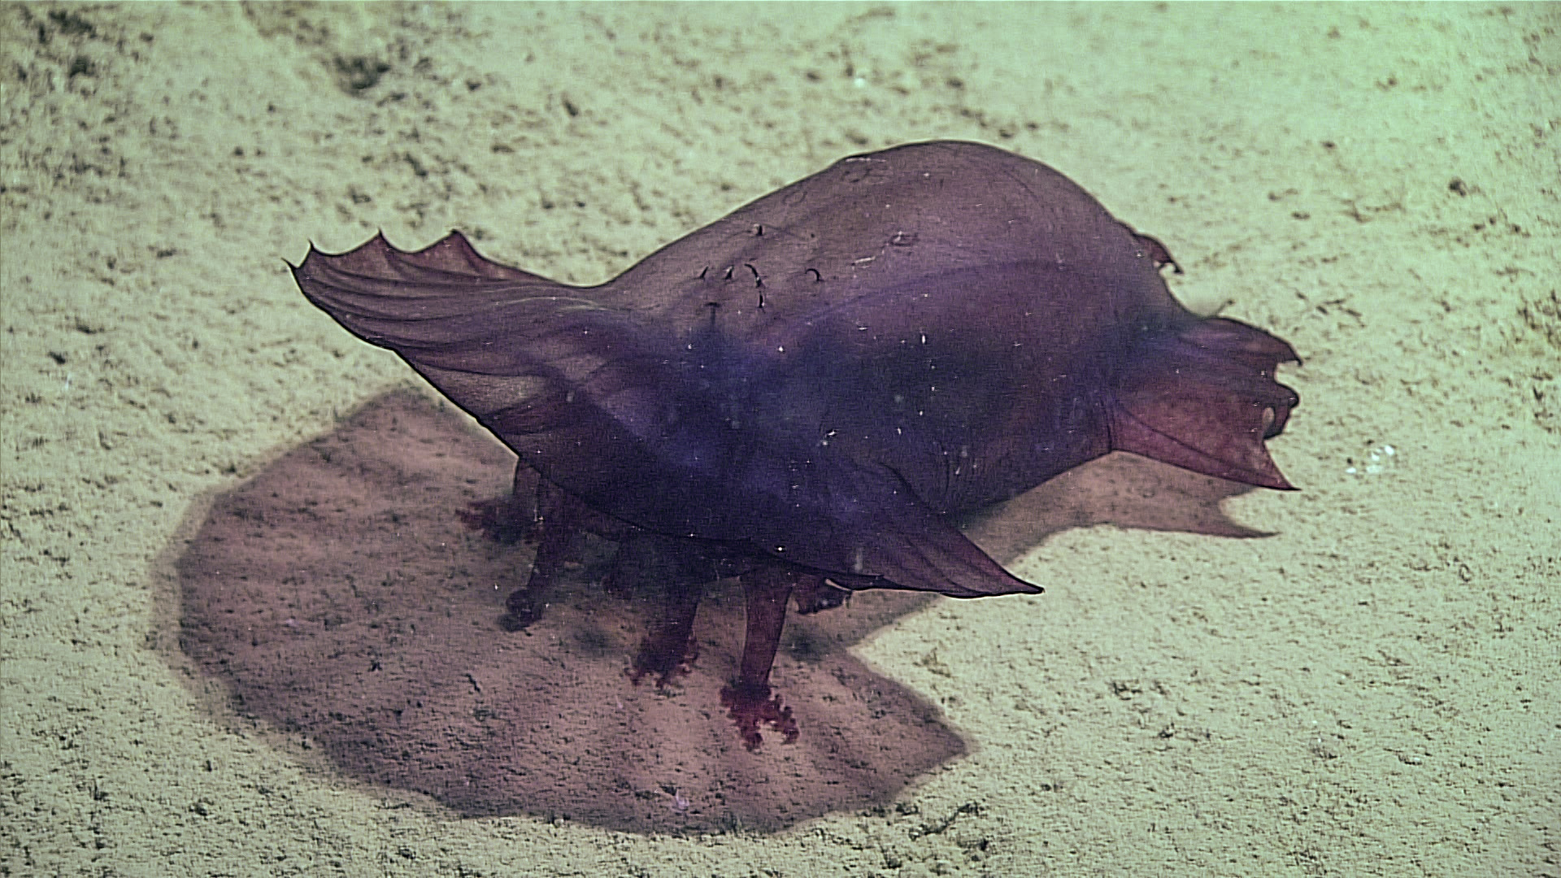
A holothurian extending it’s feet and grabbing sediment to ingest.

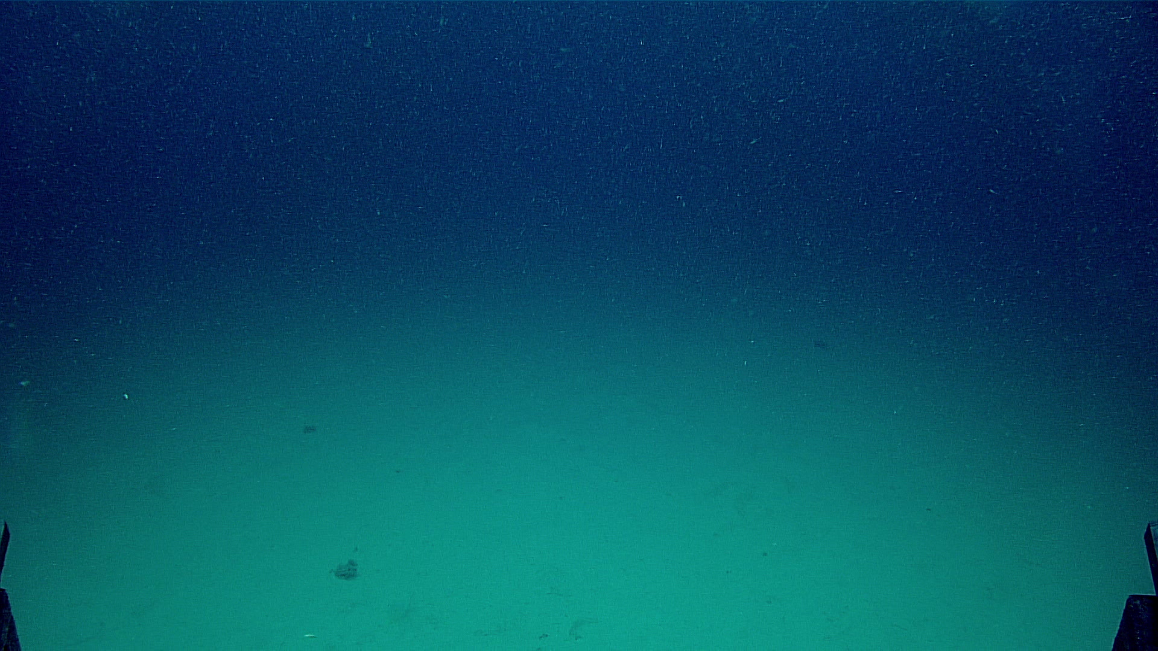
Flat seafloor of the Sohm Abyssal Plain.

Samples Collected -
No samples were collected

Niskin Sampling Summary
No Niskin bottles were used

Scientists Involved (provide name, email, affiliation)
No scientists were involved in this dive

Please direct inquiries to:
NOAA Office of Ocean Exploration & Research
1315 East-West Highway, SSMC3 RM 10210
Silver Spring, MD 20910
oceanexplorer@noaa.gov

