ROV Dive Summary, EX-21-03, Dive 01

June 15,2021

General Location Map
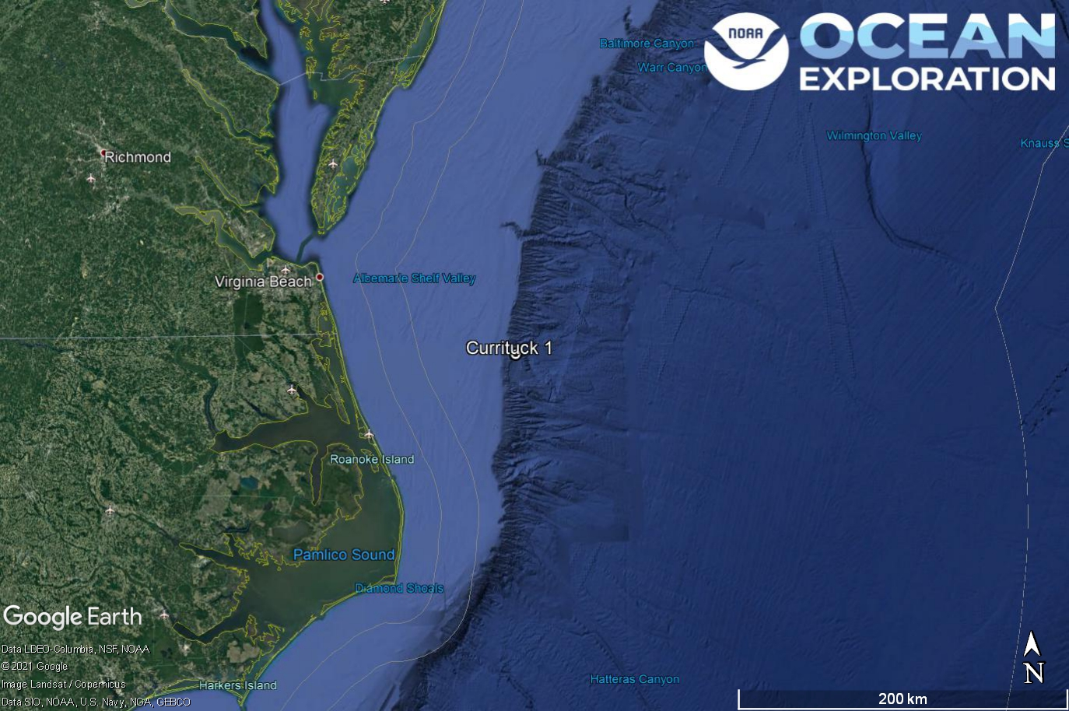
Dive 01 named Currituck 1 on the shelf off of the North Carolina coast.

Dive Information
Site Name | Currituck 1 (Engineering)
General Area Descriptor | US Mid-Atlantic, Currituck Landslide
Science Team  Leads | Karl McLetchie
Expedition  Coordinator | Kasey Cantwell/Matt Dornback
ROV Dive Supervisor | Karl McLetchie
Mapping Lead | Shannon Hoy
Dive Purpose | The first engineering dive of the ROV Shakedown. Primary objectives include testing new motors, motor controllers, lights, cameras, and hydraulic systems on the ROVs.
Was the dive restricted for Underwater Cultural Heritage? | No
ROV Dive Summary Data | Dive Summary: EX2103_DIVE01  ^^^^^^^^^^^^^^^^^^^^^^^^^^^^^^^^^^^^^^^^  Dive Type: Normal  In Water: 2021-06-15T14:28:06.018530  36.42318896679038 ; -74.75313700799491  On Bottom: 2021-06-15T15:34:45.385618  36.413076641378815 ; -74.75137260689709  Off Bottom: 2021-06-15T18:52:06.889336  36.412851063291114 ; -74.75110113923999  Out Water: 2021-06-15T19:33:13.807068  36.40951123073365 ; -74.75003209315052  Dive Duration: 5:5:7  Bottom Time: 3:17:21  Max Vehicle Depth: 670.4 m  Min Seafloor Depth: 665.2 m  Distance Travelled: 15.9 m
Dive Description | This was an engineering dive on the Currituck landslide feature. Due to a lateral thruster issue on Deep Discoverer, the ROV made a soft landing on the seafloor and did not move anywhere else until ascent. The seafloor was a muddy silty texture. Crabs, worms, shrimp, and various fish were seen.
Notable Observations | Many decapod crabs, some feeding.
Community and habitat observations | Corals and Sponges - Absent  Chemosynthetic Community - Absent  High biodiversity Community - Absent  Active Seep or Vent - Absent  Extinct Seep or Vent - Absent  Hydrates - Absent
CMECS Feature Type(s) | Flat, Submarine Slide Deposit
SeaTube Link (science annotation system) | https://data.oceannetworks.ca/SeaTubeV3?resourceTypeId=600&resourceId=2143

Equipment Deployed
ROV |  | Deep Discoverer
Camera Platform |  | Seirios
ROV Measurements |  | The following ROV measurements, data streams and equipment are used on each ROV deployment: CTD, depth, scanning sonar, USBL position, altitude, heading, attitude, high-resolution cameras, low resolution cameras, manipulator arms, suction sampler, sample drawers and thrusters. The section below notes if any of these sensors were malfunctioning or not operational
Equipment Malfunctions |  | Turbidity Sensor, CTD (ROV)

Close-up Map of Main Dive Site
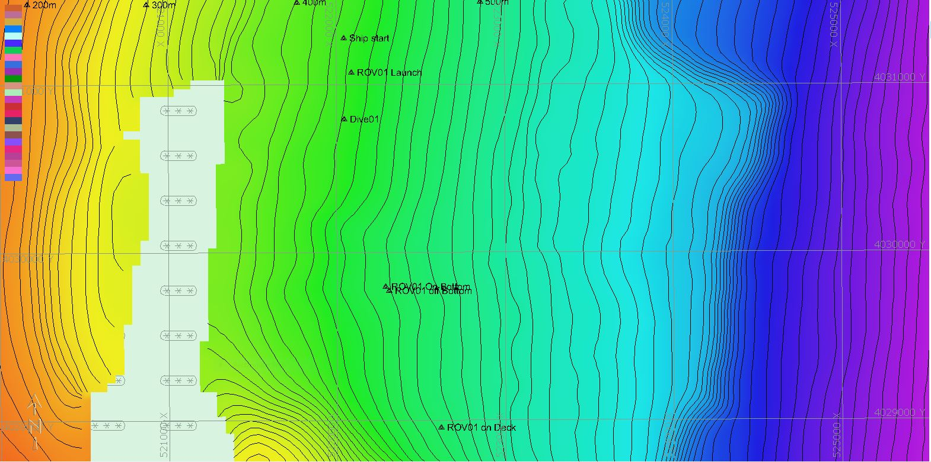

Hypack map of the Dive 01 waypoints. Depth is displayed by contour lines at 10 meter increments and by colors. Warm colors are shallower and cool colors are deeper.

Representative Photos of the Dive
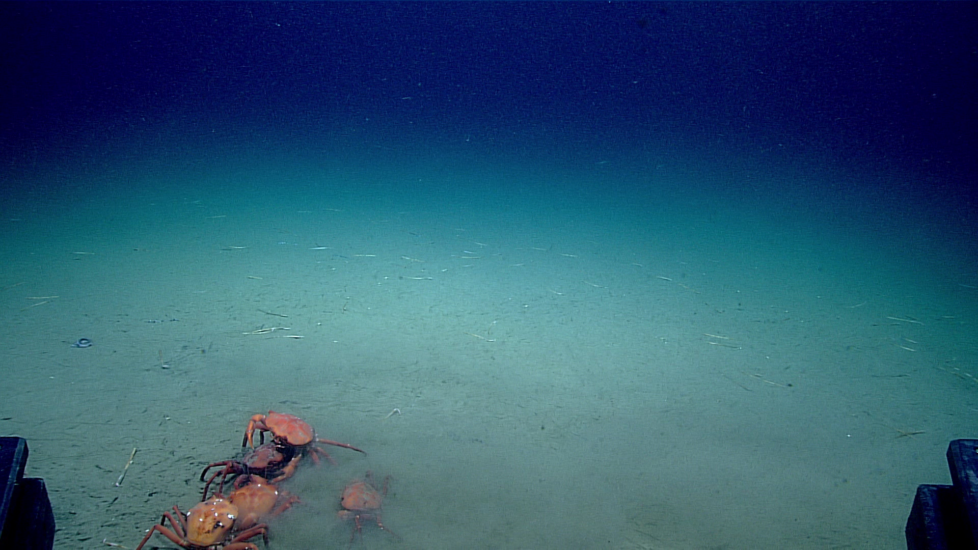
Various crabs and worms seen at the Dive 01 landing site.

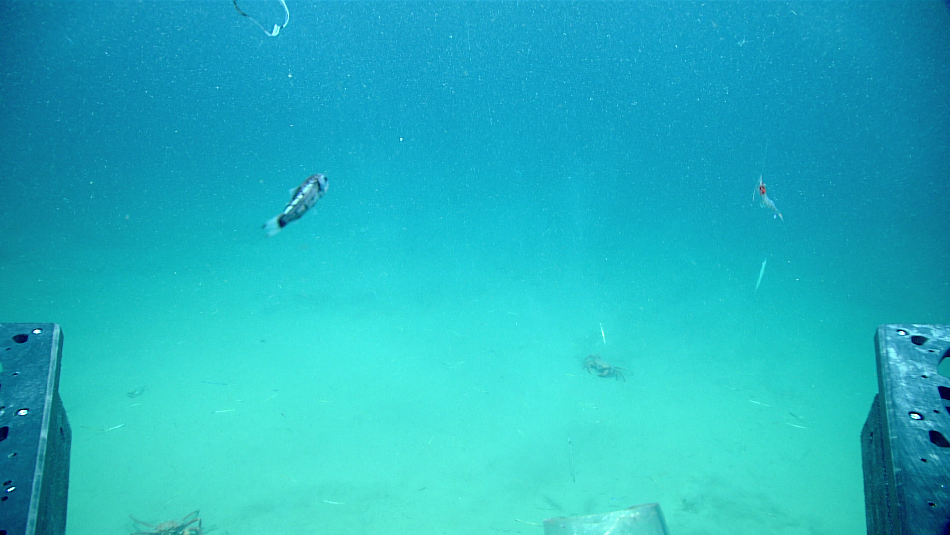
A fish and shrimp seen during ascent of the ROV.

Samples Collected -
No samples were collected

Niskin Sampling Summary
No Niskin bottles were used

Scientists Involved (provide name, email, affiliation)
Name | Email | Affiliation
Jason Chaytor | jchaytor@usgs.gov | USGS

Please direct inquiries to:
NOAA Office of Ocean Exploration & Research
1315 East-West Highway, SSMC3 RM 10210
Silver Spring, MD 20910
oceanexplorer@noaa.gov

