


MAPPING DATA ACQUISITION
AND PROCESSING SUMMARY REPORT

CRUISE EX-19-03 Leg 1 Windows to the Deep 2019, Mapping

Michael P. White1

Neah Baechler²

Jason Meyer²

Allisa Dalpe³

Katharine Egan⁴

Marcel M. Peliks³

Kitrea M. L. P. Takata-Glushkoff³

June 16th, 2019

1Cherokee Nation Strategic Programs, NOAA Ocean Exploration and Research
²University Corporation for Atmospheric Research
³Explorer in Training, NOAA Office of Ocean Exploration and Research through University Corporation for Atmospheric Research
⁴Sea Grant Knauss Fellow, NOAA Office of Ocean Exploration and Research

1. Introduction

The NOAA Office of Ocean Exploration and Research (OER) is the only federal program dedicated to exploring our deep ocean, closing the prominent gap in our basic understanding of U.S. deep waters and seafloor and delivering the ocean information needed to strengthen the economy, health, and security of our nation.
Using the latest tools and technology, OER explores previously unknown areas of our deep ocean, making discoveries of scientific, economic, and cultural value. Through live video streams, online coverage, training opportunities, and real-time events, OER allows scientists, resource managers, students, members of the general public, and others to actively experience ocean exploration, expanding available expertise, cultivating the next generation of ocean explorers, and engaging the public in exploration activities. From this exploration, OER makes the collected data needed to understand our ocean publicly available, so we can maintain the health of our ocean, sustainably manage our marine resources, accelerate our national economy, and build a better appreciation of the value and importance of the ocean in our everyday lives.

Contents
CRUISE EX-19-03 Leg 1 Windows to the Deep 2019, Mapping 1
1. Introduction 2
2. Report Purpose 4
3. Cruise Objectives 4
4. Summary of Mapping Results 4
5. Mapping Statistics 17
6. Mapping Sonar Setup 18
7. Data Acquisition Summary 19
8. Multibeam Sonar Data Quality Assessment and Data Processing 22
9. Data Archival Procedures 24
10. Cruise Calendar 26
11. Daily Cruise Log Entries 28
12. CTD Cast 33
13. References 34
Appendix A: CTD Summary Form 35

2. Report Purpose
The purpose of this report is to briefly describe the acoustic seafloor and water column mapping data collection and processing methods used during exploration expedition EX-19-03 Leg 1, and to present a summary of the overall mapping results and mapping related cruise activities. A detailed description of the Okeanos Explorer’s mapping capabilities is available in the 2019 NOAA Ship Okeanos Explorer Survey Readiness Report, available in the NOAA Central Library.

3. Cruise Objectives
The objectives for this cruise are fully detailed in the EX-19-03 Leg 1 Project Instructions, which are archived in the NOAA Central Library. Following is a brief summary of objectives as executed, with focus on mapping data acquisition and processing.
EX-19-03 Leg 1 operations commenced on May 30th, 2019 in Key West, Florida and concluded on June 14, 2019 in Cape Canaveral, Florida (Figure 1). Operations included a combination of acoustic seabed, water column, and sub-seafloor mapping and one conductivity temperature depth (CTD) cast. Operations focused in the South Atlantic Bight, off the coasts of Florida, Georgia and South Carolina all within the U.S. EEZ. Priority areas were defined with input from the OER ASPIRE 2019 workshop, Bureau of Ocean Energy Management, NOAA Southeast Deep Sea Coral Initiative, NOAA Office of Coast Survey, Seabed 2030 efforts, and the South Atlantic Fisheries Management Council. Strategic mapping objectives included sub-bottom data collection over key features, multibeam data collection over priority areas requiring coverage development, and multibeam holiday lines completing previous coverage on the Blake Plateau. Mapping objectives also focused on priority areas in order to optimize Remotely Operated Vehicle Dives planned for EX-19-03-Leg02 that followed this cruise. Mapping operations were broken into four priority polygons Alpha, Bravo, Charlie and Delta as seen below and were surveyed chronologically in that order (Figure 2).
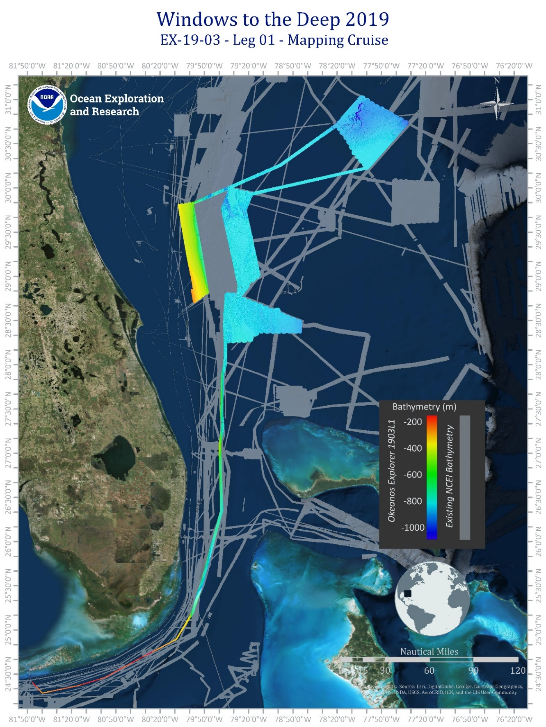
Figure 1. Cruise map showing overall EX-19-03 Leg 1 bathymetry coverage gridded to 25x25 meter cell resolution. Generated in ArcMap.

4. Summary of Mapping Results
During EX1903L1 5342 linear kilometers and 21,724 square kilometers of EM302 data were collected. In addition to bathymetry, these numbers also include multibeam backscatter and multibeam water column data. The cruise was broken into 4 priority polygons, Alpha, Bravo, Charlie and Delta as shown in Figure 2. In Alpha 1244 linear kilometers and 3760 square kilometers of EM302 data were collected as shown in Figures 3 and 4. In polygon Bravo 1099 linear kilometers and 3640 square kilometers of EM302 data were collected as shown in Figures 5 and 6. In Charlie 1234 linear kilometers and 4170 square kilometers of EM302 data were collected as shown in Figures 7 and 8. In polygon Delta, 1204 linear kilometers and 2283 square kilometers of data were collected as shown in Figures 9 and 10. Figures 11 through 16 display examples of interesting features from the EM302 data.

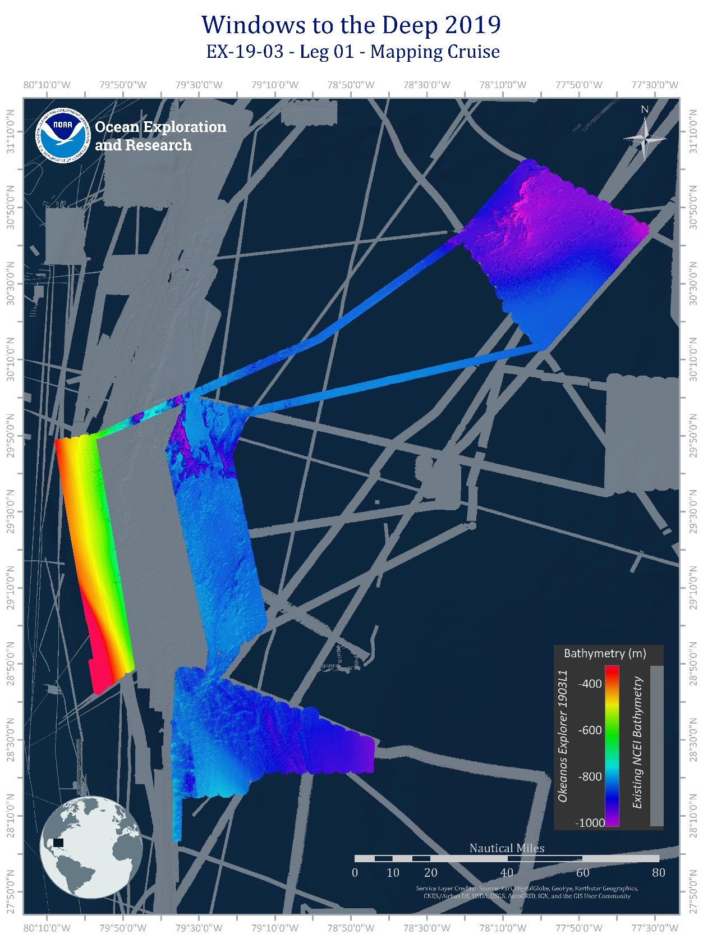
Alpha
Bravo
Charlie
Delta

Figure 2: Focus map showing the four priority areas mapped during EX-19-03 Leg 01. Image generated in ArcMap.
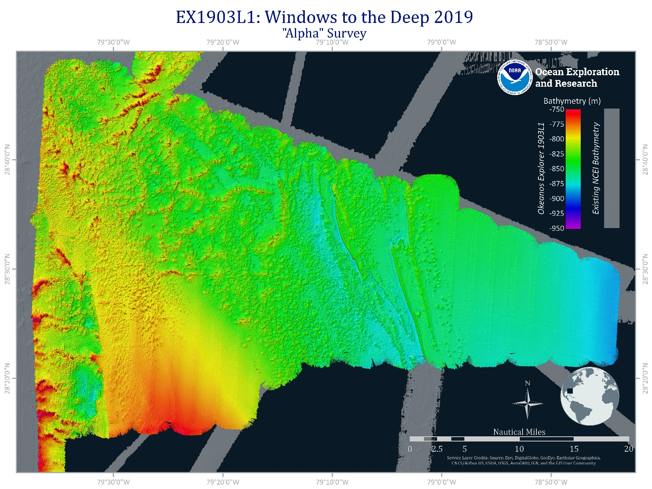
Figure 3: Focus map showing priority area ‘Alpha’ EM 302 bathymetry in rainbow color scale mapped during EX-19-03 Leg 01. EM302 bathymetry gridded to 25x25 meter cell resolution. Image generated in ArcMap

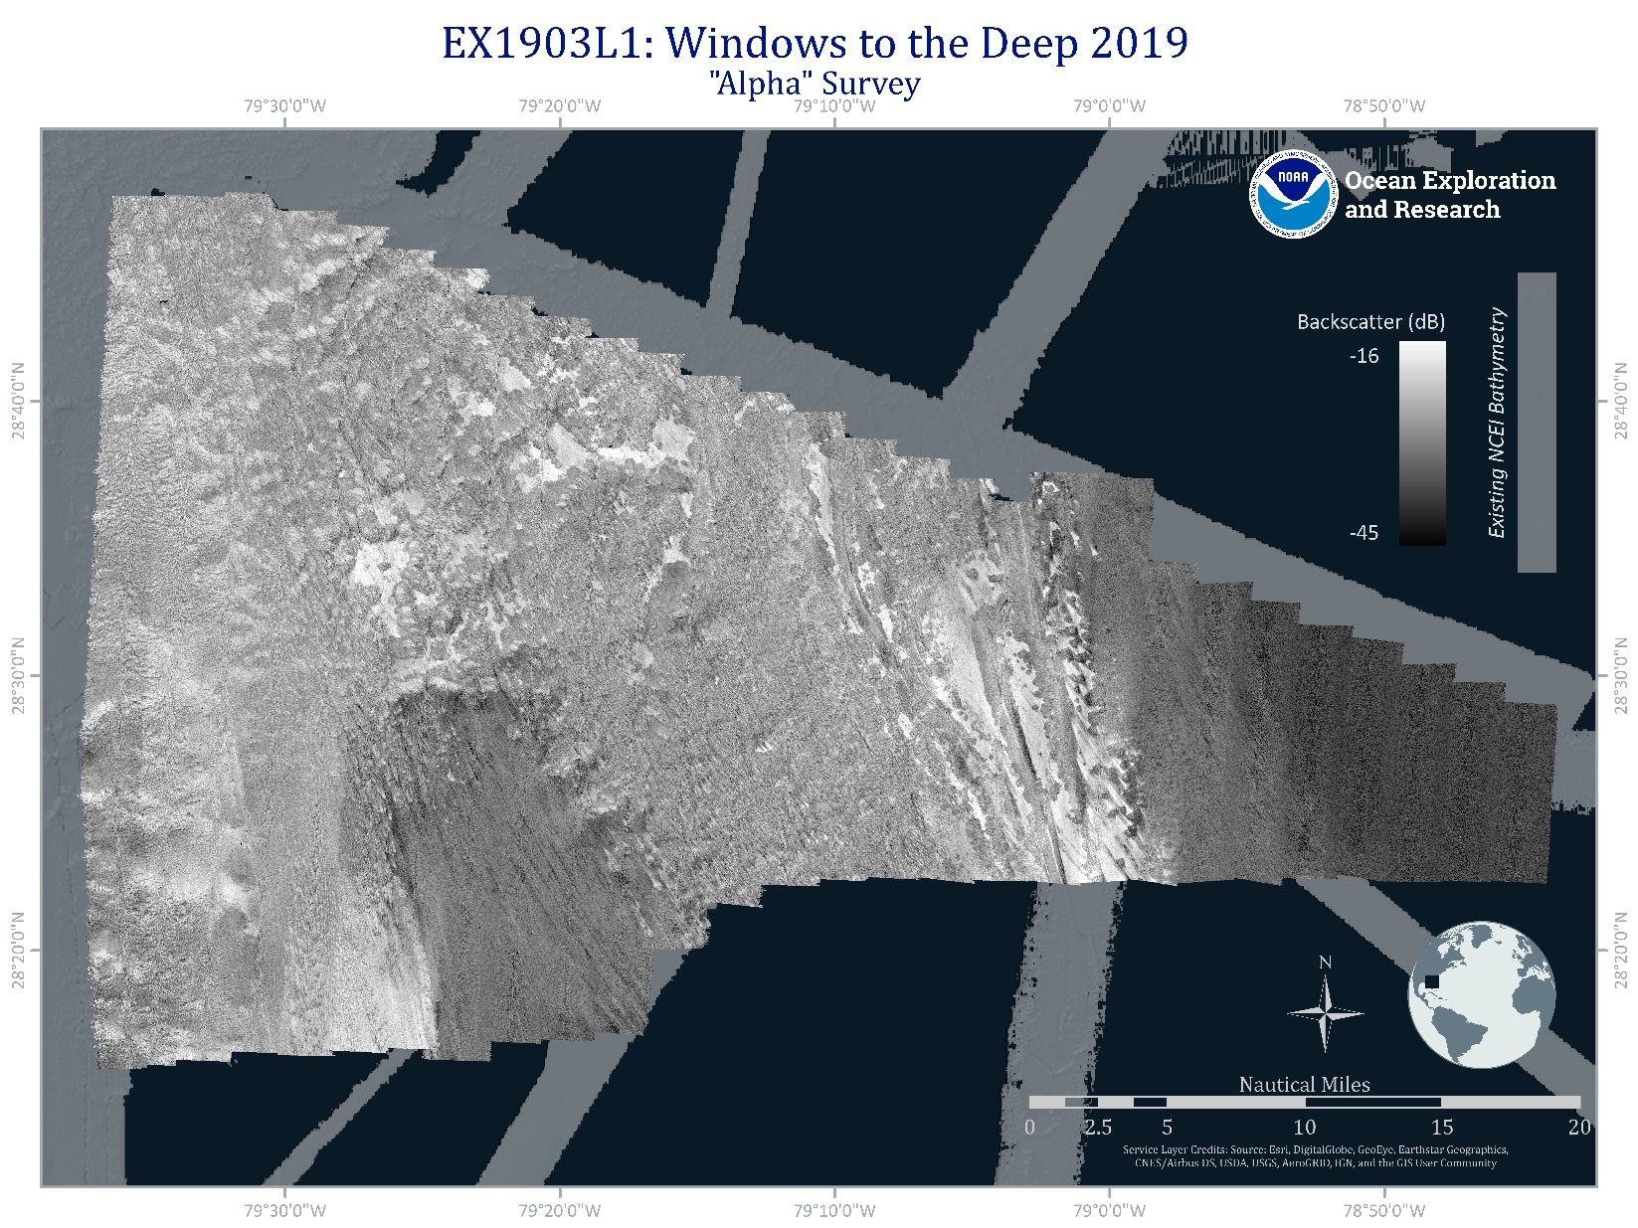
Figure 4: Focus map showing priority area ‘Alpha’ EM 302 backscatter in grey scale mapped during EX-19-03 Leg 01. Image generated in ArcMap.

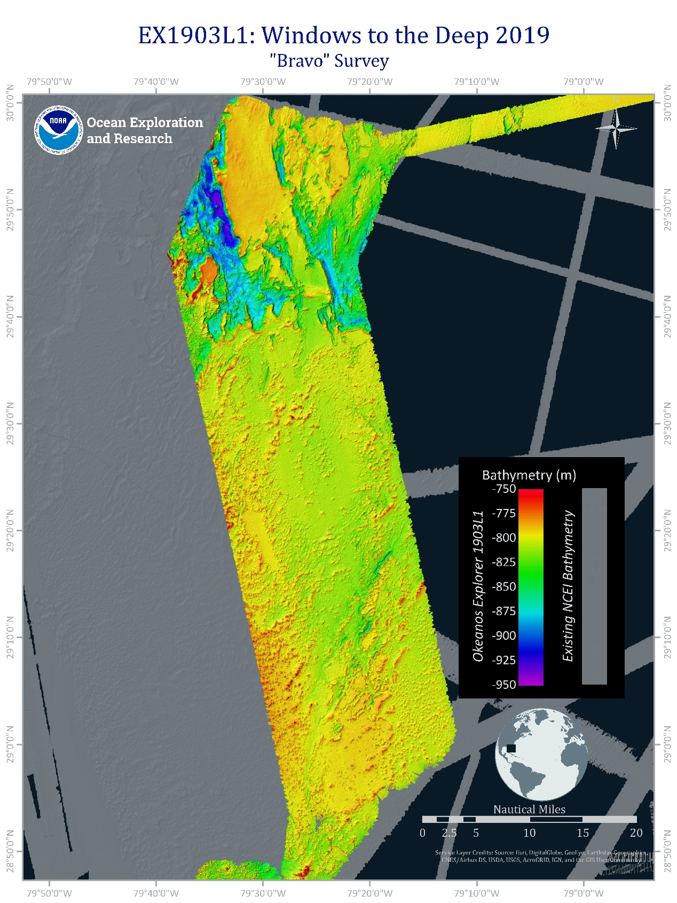
Figure 5: Focus map showing priority area ‘Bravo’ EM 302 bathymetry in rainbow color scale mapped during EX-19-03 Leg 01. EM302 bathymetry gridded to 25x25 meter cell resolution. Image generated in ArcMap.

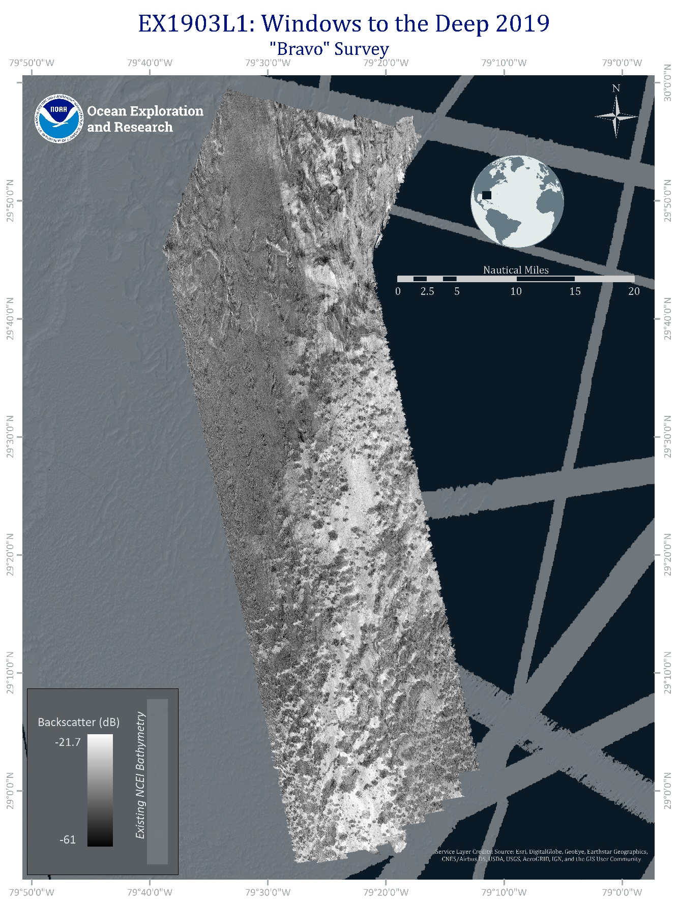
Figure 6: Focus map showing priority area ‘Bravo’ EM 302 backscatter in grey scale mapped during EX-19-03 Leg 01. Image generated in ArcMap.

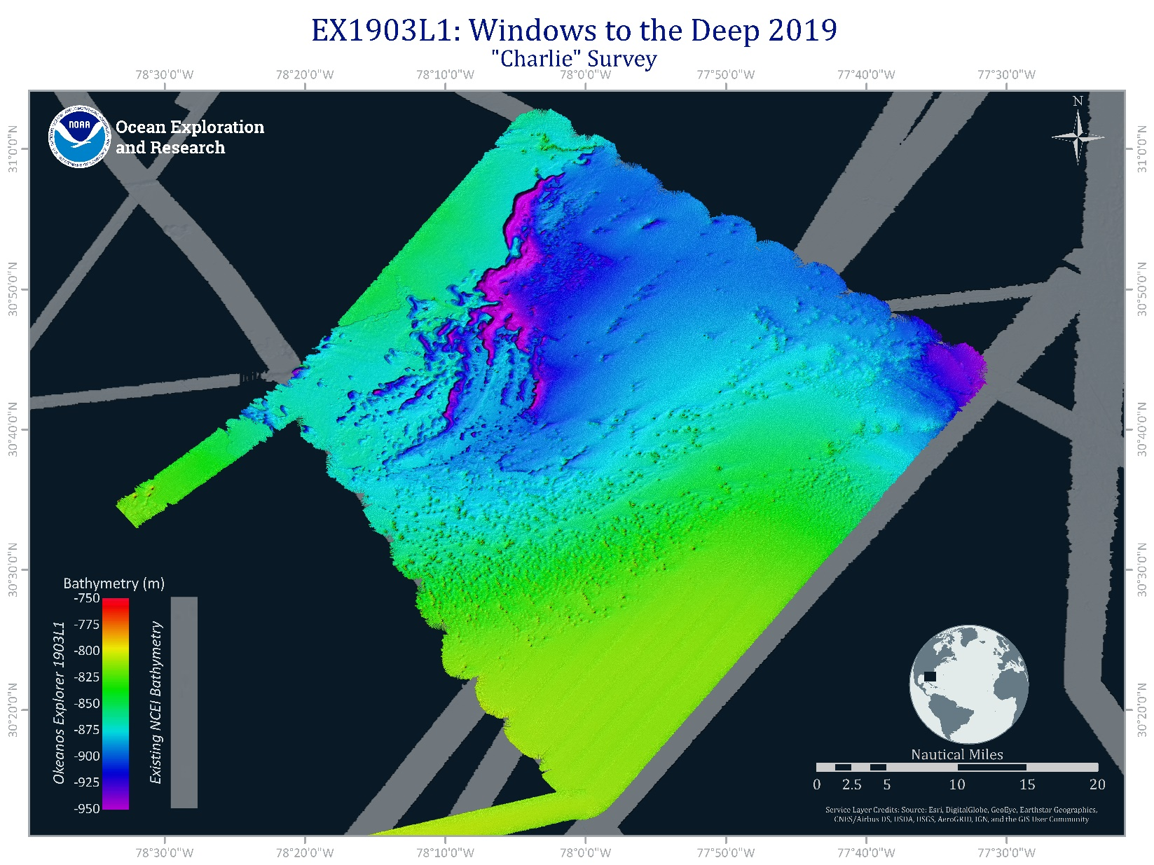
Figure 7: Focus map showing priority area ‘Charlie’ EM 302 bathymetry in rainbow color scale mapped during EX-19-03 Leg 01. EM302 bathymetry gridded to 25x25 meter cell resolution. Image generated in ArcMap.

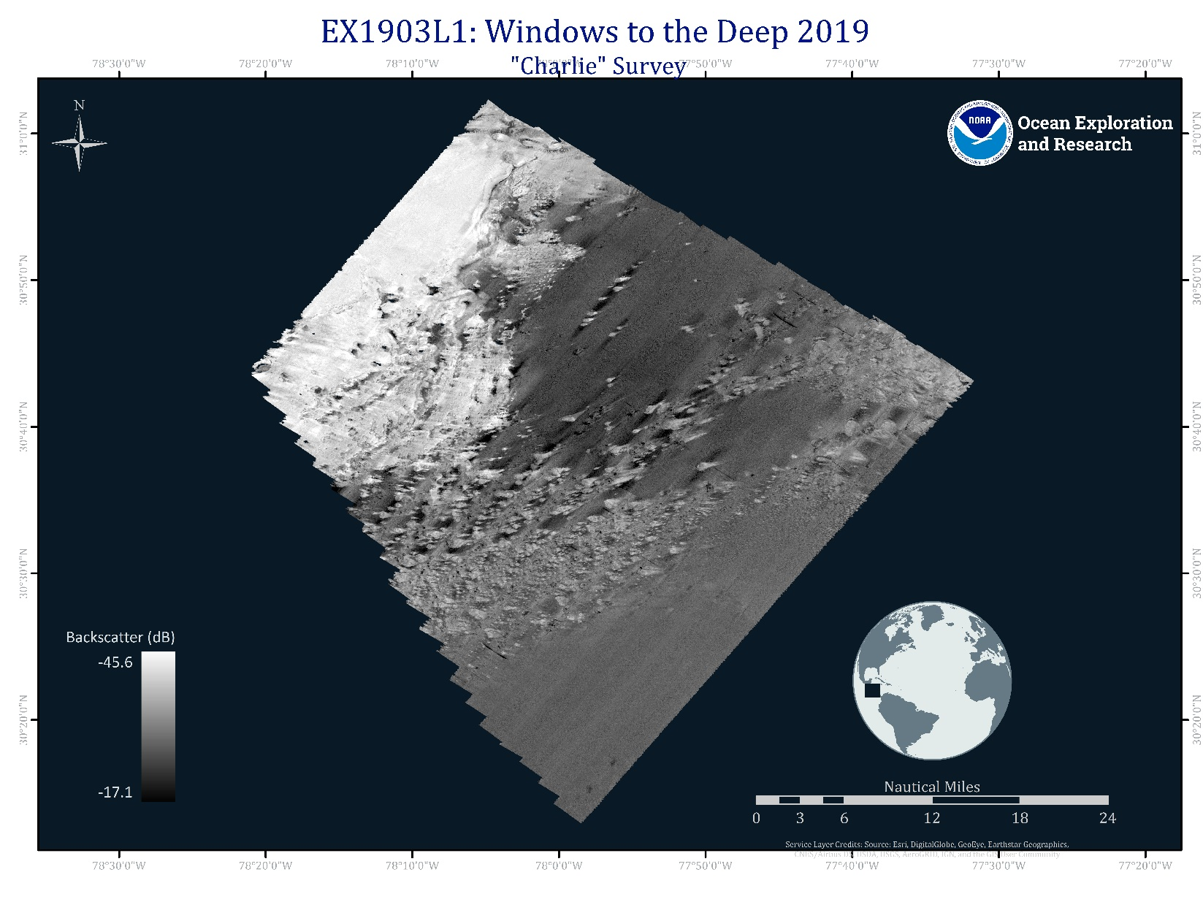
Figure 8: Focus map showing priority area ‘Charlie’ EM 302 backscatter in grey scale mapped during EX-19-03 Leg 01. Image generated in ArcMap.
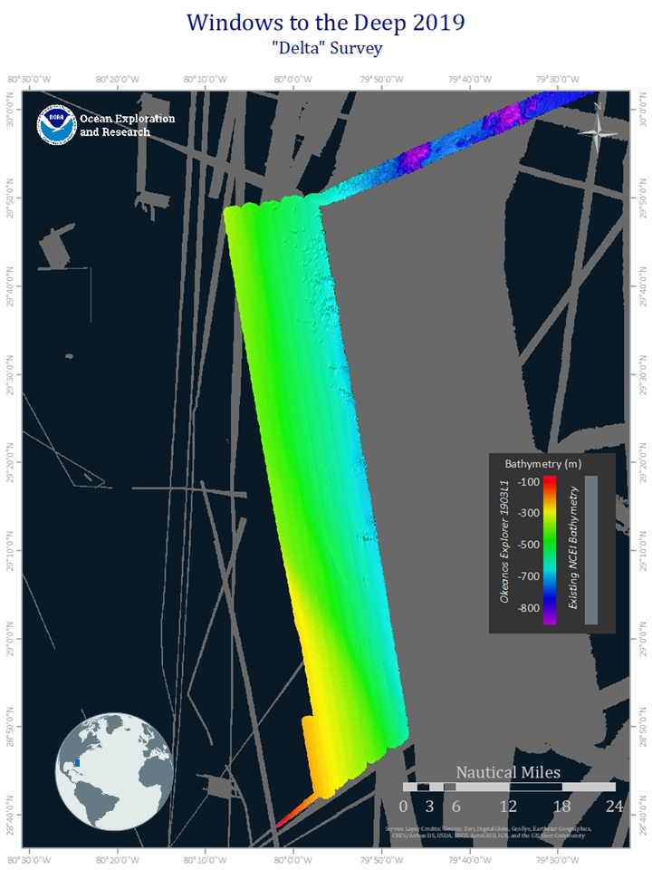
Figure 9: Focus map showing priority area ‘Delta’ EM 302 bathymetry in rainbow color scale mapped during EX-19-03 Leg 01. EM302 bathymetry gridded to 25x25 meter cell resolution. Image generated in ArcMap.
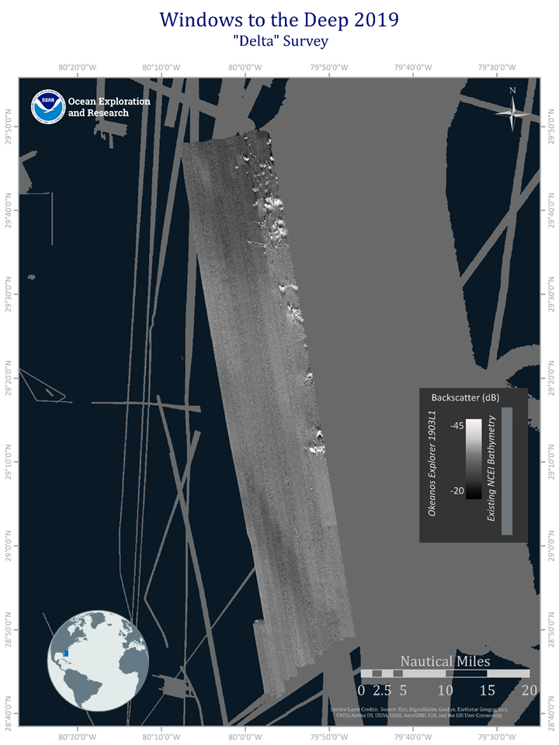
Figure 10: Focus map showing priority area ‘Delta’ EM 302 backscatter in grey scale mapped during EX-19-03 Leg 01. Image generated in ArcMap.

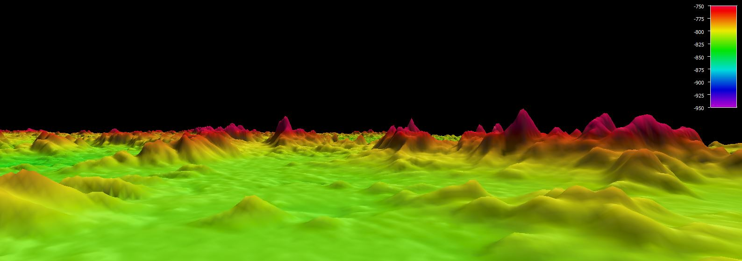
Figure 11. Screenshot looking southwest into 40 meter (tallest) mounds on 'Alpha' surface. This region may extend the “Million Mounds” area as it presents many distinct mounds. EM302 bathymetry gridded to 25x25 meter cell resolution, image generated in QPS Feldermaus. Vertical exaggeration 6. Color Bar units in meters.

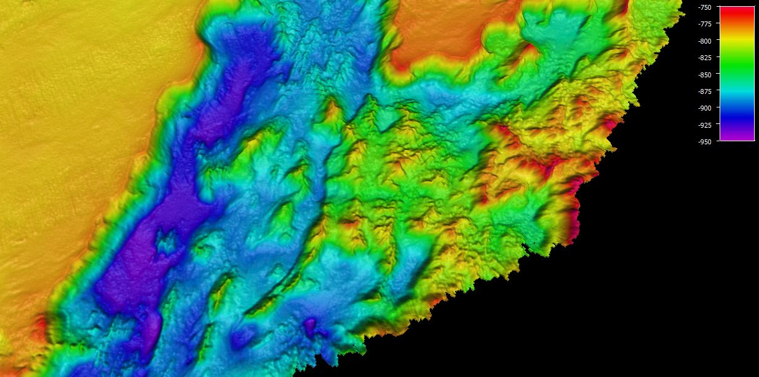
Figure 12. Screenshot of bird’s eye view of channel pictured in Fig. 1 with surrounding features. Image is looking southwest. EM302 bathymetry gridded to 25x25 meter cell resolution, image generated in QPS Feldermaus. Vertical exaggeration 6. Color bar units in meters.

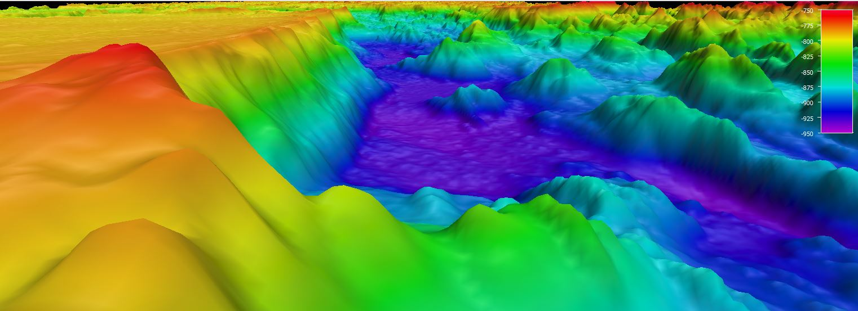
Figure 13. Screenshot of perspective view looking Southwest at an unnamed channel (150m deep and 600m wide) over a small ridge. The area contains many features of note including a plateau, mounds, and the channel pictured. EM302 bathymetry gridded to 25x25 meter cell resolution, image generated in QPS Feldermaus. Vertical exaggeration 6. Color Bar units in Meters.

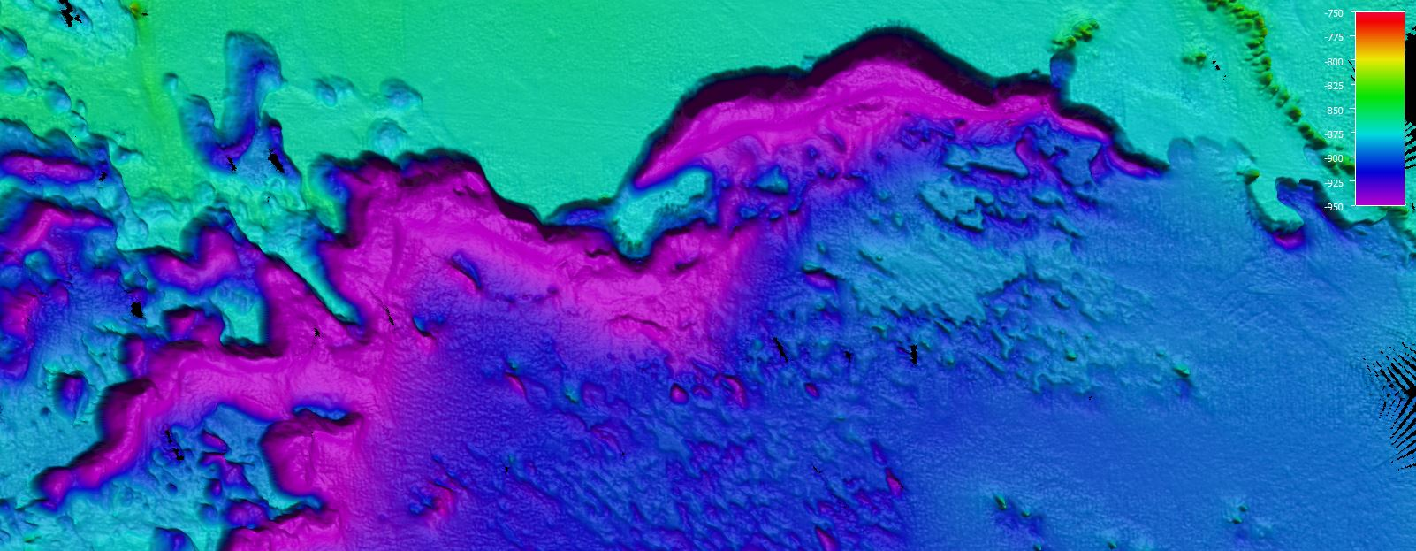

Figure 14. Screenshot of bird’s eye view of channel feature on 'Charlie' surface. Image is up west, and features the unique terrain seen throughout the area. EM302 bathymetry gridded to 25x25 meter cell resolution, image generated in QPS Feldermaus. Vertical exaggeration 6. Color Bar units in Meters.

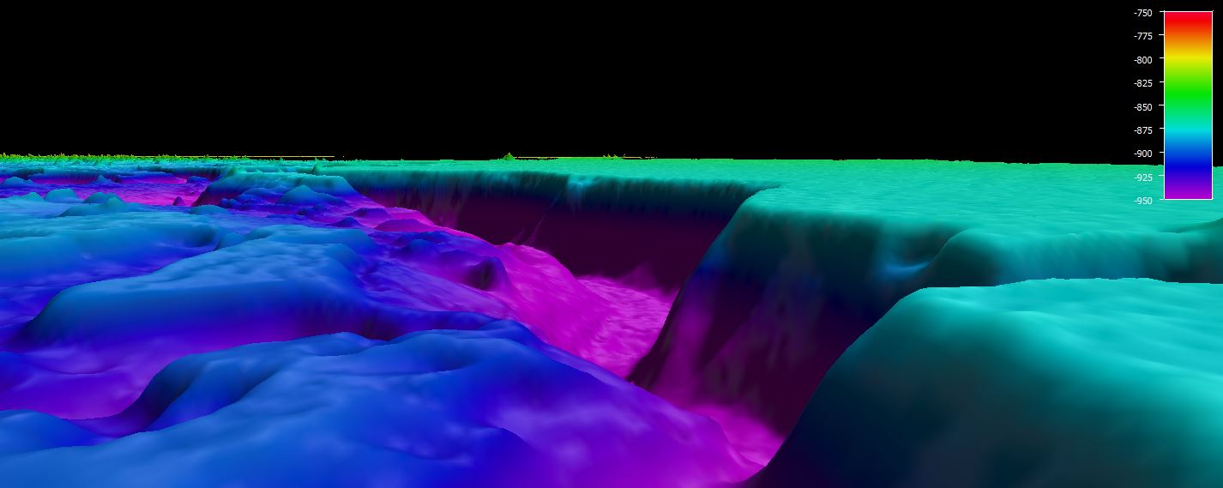

Figure 15. Screenshot looking south over abrupt 120 meter channel on 'Charlie' surface. Channel is 200m wide and presents a temperature/oxygenation anomaly which may have contributed to its formation. CTD data is shown later in the report. EM302 bathymetry gridded to 25x25 meter cell resolution, image generated in QPS Feldermaus. Vertical exaggeration 6. Color Bar units in Meters.

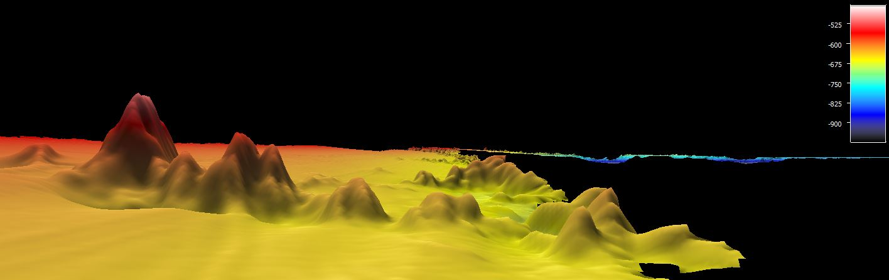

Figure 16. Screenshot looking North at 85m (tallest) mounds on 'Delta' surface. EM302 bathymetry gridded to 25x25 meter cell resolution, image generated in QPS Feldermaus. Vertical exaggeration 6. Color Bar units in Meters.

5. Mapping Statistics
Table 1 below summarizes the key mapping statistics generated from E1903L1, including total linear kilometers and total square kilometers mapped by the EM302.
Dates of cruise | May 31 to June 14, 2019
Ship’s draft Start of cruise  End of cruise | Fore: 15' 2”, Aft: 13' 10"  Fore: 14’ 9”; Aft: 13’ 8.5”
Linear kilometers of survey with EM 302 | 5342
Square kilometers mapped with EM 302 | 21724
Number / Data Volume of EM 302 raw bathymetric / bottom backscatter multibeam files (.all) | 609 files / 49.5 GB
Number / Data Volume of EM 302 water column multibeam files (.wcd) | 609 files / 92.7 GB
Number / Data Volume of EK 60 water column split beam files (.raw) | 1113 files / 253 GB
Number / Data Volume of sub-bottom sonar files (.segy, .kea, .keb) | 246 files / 3.25 GB (.segy)  159 files / 84.7 MB  159 files / 676 MB (.keb)
Number of XBT casts (.txt) | 146
Number of ship’s CTD casts (including test casts) (.hex) | 1
Table 1: EX1903L1 mapping statistics.

6. Mapping Sonar Setup

Kongsberg EM 302 Multibeam Sonar
The NOAA Ship Okeanos Explorer is equipped with a 30 kilohertz (kHz) Kongsberg EM 302 multibeam sonar capable of detecting the seafloor in up to 10,000 meters of water and conducting productive mapping operations in 8,000 meters of water. The system generates a 150° beam fan containing up to 432 soundings per ping in waters deeper than 3300 meters. In waters less than 3300 meters, the system is operated in multi-ping, or dual swath mode, and obtains up to 864 soundings per ping, by detecting two swaths per ping cycle. The multibeam sonar is used to collect seafloor bathymetry, seafloor backscatter, and water column backscatter. Backscatter represents the strength of the acoustic signal reflected from a target, such as the seafloor or bubbles in the water column.

Simrad EK 60 / EK 80 Split-Beam Sonars
The ship is also equipped with five Simrad EK 60 /EK 80 split-beam fisheries sonar. The 18 kHz transducer transmits a 7° beam fan. This sonar is a quantitative scientific echosounder calibrated to identify the target strength of water column acoustic reflectors, typically biological scattering layers, fish, or gas bubbles, providing additional information about water column characteristics and anomalies. The ship is also equipped with 38, 120, and 200 kHzEK 60s. The 38 kHz is not run during normal mapping operations since was not calibrated and the transducer is suspected to be failing. During this cruise the 38 kHz was run in passive mode, therefore there is uncalibrated passive 38 kHz data present in the EK files. There is also a 70 kHz EK 80 on the ship, newly installed during the 2019 shakedown on EX-19-02. The 70 kHz is capable in operating in narrowband or broadband mode with a frequency modulated ping. During EX-19-03 Leg 1, the 70 kHz was operated in broadband mode from May 30 to June 6, 11:02 UTC when it was switched back to narrowband mode with a controlled wavelength pulse due to the constant presence of interference.

Knudsen 3260 Sub-bottom Profiler
Additionally, the ship is equipped with a Knudsen 3260 sub-bottom profiler that produces a frequency-modulated chirp signal with a central frequency of 3.5 kHz. This sonar is used to provide echogram images of shallow geological layers underneath the seafloor to a maximum depth of approximately 80 meters below the seafloor. The sub-bottom profiler is normally operated to provide information about sub-seafloor stratigraphy and features. The data generated by this sonar is fundamental to helping geologists interpret the shallow geology of the seafloor.

7. Data Acquisition Summary
Mapping operations included EM 302 multibeam, EK 60/80 split-beam, and Knudsen 3260 sub-bottom profile data collection as displayed in Figures 17 and 18 respectively.
Survey lines were planned to maximize either bathymetry edge matching of existing data or data gap filling in areas with existing bathymetry coverage. In regions with no existing data, lines were planned to optimize potential exploration discoveries.
Throughout the cruise, multibeam data quality was monitored in real-time by acquisition watch standers. Ship speed was adjusted to maintain data quality as necessary and line spacing was planned to ensure at least ¼ swath width overlap between lines. Cutoff angles in SIS were generally left wide open (70 – 75 degrees on each side) for maximum exploration data collection, and were adjusted on both the port and starboard side to ensure the best data quality and coverage. Data were corrected for sound velocity in real-time using the Reson SVP-70 data at the sonar head, and profiles from Expendable Bathythermographs (XBTs) that were conducted every 2 to 4 hours, or as dictated by local oceanographic conditions.
Simrad EK 60/80 18, 70, 120, and 200 kHz split-beam water column sonar data were collected continuously during the cruise. Data were monitored in real time for quality but were not post-processed.
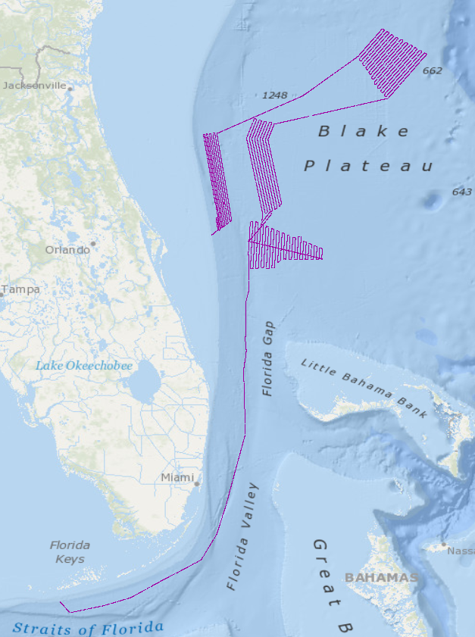
Figure 17. Map of split-beam sonar data track lines in red collected during EX-19-03 Leg 1.
Knudsen 3260 sub-bottom profiler data were collected during normal mapping operations. Data were monitored in real-time for quality. Data were converted to ArcGIS shapefiles and JPGs using the free SegyJp2Viewer software from Geological Survey of Canada, Natural Resources Canada.
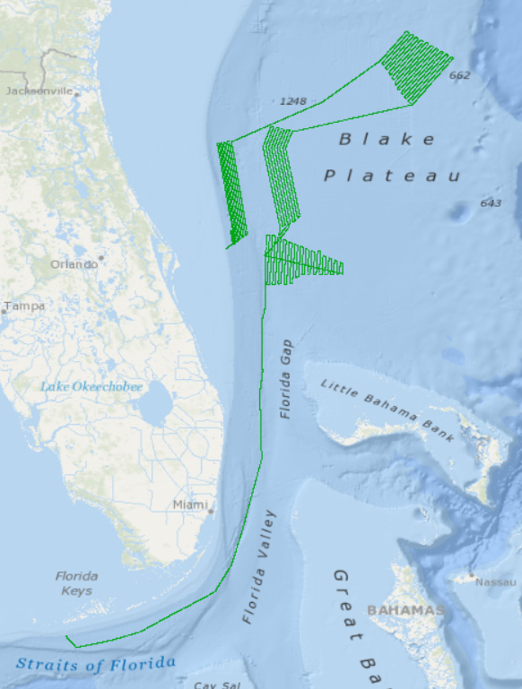
Figure 18. Map of sub-bottom profiler data track lines in green collected during EX-19-03 Leg 1.

8. Multibeam Sonar Data Quality Assessment and Data Processing
EM 302 Built-in Self Tests (BISTs) were run throughout the cruise to monitor multibeam sonar system status and are available as ancillary files in the sonar data archives. Raw multibeam bathymetry data files were acquired by SIS, then imported into Qimera (QPS) Version 1.7.6, 64 bit for processing as shown in Figure 19. In Qimera, attitude and navigation data stored in each file were checked, and erroneous soundings were flagged off. Gridded digital terrain models were created and posted to the ship’s file transfer protocol (FTP) site for daily transfer to shore. Final bathymetry QC was completed post-cruise onshore at the Center for Coastal and Ocean Mapping at the University of New Hampshire. With the vast majority of surveying completed in deep water, depth measurements were not adjusted for tides, as they are an essentially insignificant percent of the overall water depth.

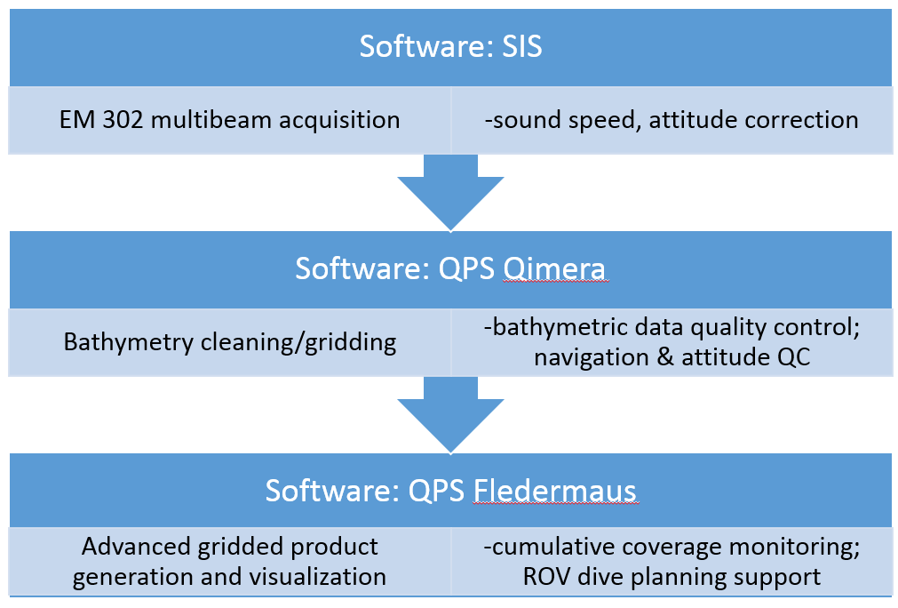

Figure 19. Shipboard multibeam data flow

Crosslines
Comparing depth values from orthogonal survey lines is a standard hydrographic quality control measure to evaluate the consistency of the multibeam sonar data being collected during a cruise. Crossline analysis was conducted using the Crosscheck Tool in QPS Qimera software.
One crossline (Figure 20) was run on June 3, 2019 and was comprised of three files: 0184, 0185, and 0186. The main scheme lines that it crossed were 0160, 0155, 0150, 0142, 0137, 0131, 0126, 0120, 0115, 0109, 0105, 0100, 0093, 0087, and 0080. The Crosscheck results below in table 2 show the data met the requirements for an International Hydrographic Order 1 survey, with depth values (z) in meters.
Statistic | Value
# of Points | 2603095
Difference Mean | 0.532680
Difference Median | 0.120156
Difference Std. Dev | 3.520208
Difference Range | [-35.90, 42.00]
Mean + 2*Stddev | 7.573097
Median + 2*Stddev | 7.160572
Data Mean | -835.041621
Reference Mean | -835.574301
Data Z-Range | [-879.11, -739.01]
Reference Z-Range | [-873.70, -750.00]
Order 1 Error Limit | 10.873967
Order 1 # Rejected | 57379
Order 1 P-Statistic | 0.022043
Order 1 Test | ACCEPTED
Table 2: Results of crossline analysis from QPS Qimera.
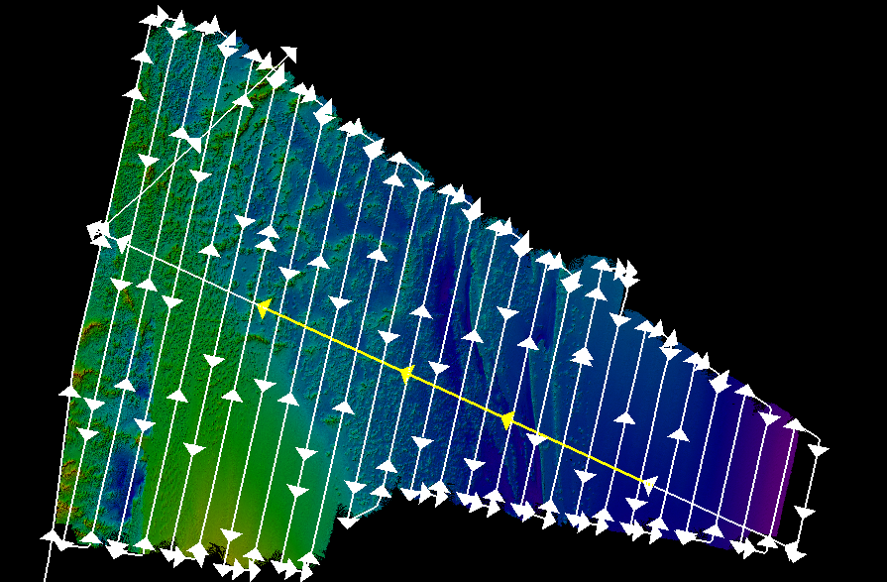
Figure 20. Bathymetry with EM 302 tracklines with cross lines in yellow from priority area ‘Alpha.’
EM 302 Patch Test
A multibeam patch test was conducted during EX-19-02. The results are briefly described in the mapping data report for that cruise, as well as in the 2019 Okeanos Explorer Survey Readiness Report.

9. Data Archival Procedures
All mapping data collected by the NOAA Ship Okeanos Explorer are archived and publicly available within 90 days of the end of each cruise via the National Centers for Environmental Information (NCEI) online archives. The complete data management plan, which describes the raw and processed data formats produced for this cruise, is available as an appendix in the EX-19-03 Leg 1 project instructions which is available in the NOAA Central Library.
Ancillary and supporting files are archived with the sonar datasets. These include:
EM 302 Multibeam bathymetry and bottom backscatter dataset:
- Mapping watch stander log
- Weather log
- Sound velocity profile log
- Multibeam acquisition and processing log
- Built-In-System-Tests (BISTs)
- Processor Unit Parameters
- Text files of telnet sessions on the EM 302 transceiver unit
Simrad EK split-beam water column dataset:
- Mapping watch stander log
- Weather log
- EK data log
Knudsen 3260 Sub-bottom Profiler dataset:
- Mapping watch stander log
- Weather log
- Sub-bottom data log
EM 302 Multibeam water column dataset:
- Mapping watch stander log
- Weather log
- Sound velocity profile log
- Multibeam acquisition and processing log
- Built-In-System-Tests (BISTs)
- Processor Unit Parameters
- Text files of telnet sessions on the EM 302 transceiver unit
- MB WCD review log if data were reviewed for presence of seeps in QPS Fledermaus
Sub-bottom data, supporting data, and informational logs are available in the NCEI Data Archives accessible at https://www.ngdc.noaa.gov/ (last accessed 6/26/2019).
EM 302 bathymetry data, supporting informational logs, and ancillary files are available in the NCEI Data Archives accessible at https://www.ngdc.noaa.gov/ (last accessed 6/26/2019).

10. Cruise Calendar

May 2019
Sun | Mon | Tues | Wed | Thur | Fri | Sat
 |  | 28. Mobilization in Key West. | 29. Mobilization in Key West. Ship ORT training. | 30. Ship departed Key West, F at 1000. | 31. Arrived on station for our first mapping priority polygon. Data quality is excellent with 12-13 knot transit speeds.
June 2019
 |  |  |  |  |  | 1. Data quality is excellent. Mapping of area ‘Alpha’ continues
2. Data quality remains excellent. XBTs are being conducted every 3 hours. | 3. Completed first mapping polygon south of the Stetson Mesa/Million Mounds area | 4. Mapping continues east of Stetson Mesa/Million Mounds area. Data quality remains excellent. | 5. Mapping continues in the polygon east of Million Mounds. Data quality is excellent. | 6. Completed priority polygon east of Million Mounds and are transiting to the Richardson Hills polygon. | 7. Mapping in the Richardson Hill polygon continues. XBTs are being completed every 2 hours. Data quality continues to be high | 8. Mapping continue over the Richardson Hills polygon.
9. Completed third mapping polygon ‘Charlie.’ Data quality remains high. | 10. Mapping continue over the Richardson Hills polygon. | 11. Commence mapping operations fourth polygon, ‘Delta.’ | 12. Mapping operations in polygon ‘Delta’ west of Stetson Mesa continues. | 13. Survey operations continue on polygon ‘Delta’ west of Stetson Mesa. | 14. Ship arrived alongside in Port Canaveral, USCG

11. Daily Cruise Log Entries

Generated from the daily expedition situation reports. All times listed are in local ship time which was Eastern Daylight Savings Time (EDT) (-4 hours from Universal Coordinated Time (UTC)).

May 28 and 29
Mobilization was completely successfully. Mission personnel arrived successfully despite some travel delays. Mission rooms were clean and stocked upon arrival. Ship completed an Operational Readiness Training on May 30th all day, during which Mission personnel were requested to remain in the Control Room and Dry Lab. A hull dive was scheduled for late in the day on May 29th.
The EM 302 transceiver unit (TRU) was left powered on between EX-19-02 and EX-19-03-L1. The mapping team has been leaving the TRU on during short in-ports to reduce internal system issues which seem to manifest when the TRU is turned off, turned on and not given enough time to warm-up. This strategy continues to be successful as the first BIST on May 30 was a full pass. It was also left on during the hull dive during which the acquisition machine was turned off.

Mission team, led by mapping watch lead Baechler, went through a walkthrough of the K-sync. The SOP assembled on EX1902 continues to be an excellent resource and we are identifying areas which can be further detailed.

All sonars started normally and were pinged alongside.

Onboard engineers from Global Foundation for Ocean Exploration O’Brien and Wright continue to help successfully troubleshoot minor network issues, namely communication between hosts and the network.

Mission team has a list of SOPs that will be updated.

From Senior Survey Technician (SST) Wilkins: All Teledyne UnderwayCTD (UCTD) components have been accounted for, then palletized and prepared for shipping. The pallet is currently temporarily stored at the Florida Keys National Marine Sanctuary warehouse. Derek, EX Ops and the Teledyne rep. are conferring for its next movement, hopefully shipping out in the next few business days.

The stand for the UCTD is still aboard EX, as it is not Teledyne equipment. It will travel aboard the ship to Davisville and then stored in the warehouse until it can be repurposed.

All XBTs borrowed from AOML have been loaded on board, thanks to SST and ship’s operations officer for organizing.
May 30
Ship got underway at 1000. Some seasickness was experienced by the mission team, a big thank you to Lieutenant Commander LCDR Kelly Fath (Medical Officer) who responded quickly. Training continues with Explorers in Training (EiTs) and Knauss Fellow.
Mission team is experiencing complications in the automatic data workflow and file synchronization with the extension, “L1” or “L01” for EX1903 Leg 1. From a data management perspective, this just adds extra steps to all of our data workflows.

Mission team continues to refine workflows for the K-Sync. In very shallow <100 meters of water, we observed the EKs, namely the 18 kHz, throttles the EM 302, resulting in lower ping rates. In turn, the bottom detection on the 18 kHz has to be monitored, ensuring that it is not receiving false echoes due to penetration or that it is picking the deep scattering layer (DSL) as the bottom. In dynamic areas, bottom detection for the 18 kHz in the future will need to be monitored.

The EK 70 kHz is in frequency modulated (FM)/Broadband mode

Training of EiTs continues.

Data quality is excellent. Transit speed is12-13 knots.
May 31
We arrived on station for our first mapping priority polygon. Data quality is excellent with 12-13 knot transit speeds. All systems are functioning as expected. As we move into deeper waters, the EK 70 kHz in FM mode is picking up more and more noise.
June 01
Data quality is excellent. Ship driving is excellent, with consistent quality survey line driving.
Data quality remains excellent. There are some refraction/sound velocity artifacts present in overlap between lines, but impact on the data quality is limited.

EK 70 kHz in FM/broadband mode continues to record systematic interference we believe is associated with deeper depths. The EM 302 remains in continuous wave (CW) mode.

Training continues successfully. EiTs are performing XBTs and loading the XBT Autolauncher.

We have been collecting the EK 70 kHz in FM mode since departing Key West and are about 15 gigabytes (GBs) behind with data transfer to shore. Theoretically on a mapping cruise, if we were to collect EK 70 kHz data in FM mode over a seep for a limited time and then transfer back to CM mode, we might be able to push that data to shore.
June 02
We are maintaining a five nautical mile buffer zone with the U.S/Bahama EEZ boundary as requested. Data quality remains excellent. XBTs are being completed every 3 hours. Profiles are fairly similar.
Data quality remains excellent. SST Wilkins is updating the, ‘Starting a Survey in SIS,’ SOP. We using the new TU Delft Sound Speed Inversion Tool in Qimera. Training continues smoothly, EiTs and OER Knauss Fellow are working on processing in Qimera, backscatter processing, sun photometer measurements and XBT processing.

EK 70 kHz continues to record systematic interference.
June 03
We have completed our first mapping polygon south of the Stetson Mesa/Million Mounds area. We have completed a crossline for data quality and will commence mapping our next polygon east of Stetson Mesa/Million Mounds area. Data quality remains excellent with some sound velocity artifacts on the outer swath.

All systems are functioning normally, data quality is excellent. The EM 302 is performing very well over mound features.
June 04
Mapping continues east of Stetson Mesa/Million Mounds area. Data quality remains excellent. We are completing XBTs every 2 hours. Mapping systems continue to operate normally.
Training continues with EiTs and Knauss Fellow.
June 05
Mapping continues in the polygon east of Million Mounds. Data quality is excellent.
The multibeam processing computers continue to freeze every so often. We believe it may be related to the new fiber boards that were put in to support the Storage Area Network (SAN) connection, troubleshooting continues. After one such freeze, the Multibeam Processing Log had to be restored from a mirror back up.
June 06
We completed the priority polygon east of Million Mounds and are transiting to the Richardson Hills polygon. Ship took a few hours in the morning to complete aft control station training with new personnel to prepare for ROV operations.

Data quality is excellent. XBTs are being conducted every 2 hours.

As requested by Shannon Hoy, we ran the EK 70 kHz in CW mode while the ship’s new Doppler speed log was on (Figure 21). Screenshots were sent to shore and all agreed that the speed log does interfere with the EK 70 kHz in CW mode. This information will be used to inform collecting quality data during ROV water column transects.

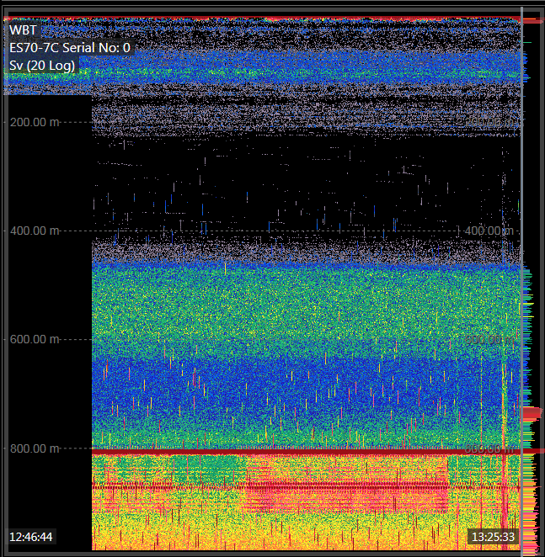
Figure 21. Echogram of EK 80 70 kHz split-beam sonar showing interference from ship’s new Doppler speed log.
Survey department continued to experience communication issues with the network data storage M: drive/SAN. After several crashes and in consultation with GFOE O’Brien and GFOE Wright, we moved the multibeam processing computers MBPROC1 and MBPROC2 back to an ethernet connection from the fiber connection that was installed prior to the start of the field season. Theoretically, the fiber connection should be faster, but with the amount of host/client drop-outs (likely the same issues reported on cruise EX-19-02) processing was significantly impacted. GFOE will follow up troubleshooting regarding the fiber connections.
June 07
Mapping in the Richardson Hill polygon continues. XBTs are being completed every 2 hours. Data quality continues to be high.

GFOE O’Brien and GFOE Wright provided a tour of the ROV systems today for the EiTs, Knauss Fellow, NOAA Teacher at Sea and NOAA Corps officers new to the ship.

June 08
Mapping continue over the Richardson Hills polygon.
Data quality continues to be excellent, XBTs are being completed every two hours. Systems continue to function normally. Products by polygon are being sent to shore via the UPLOADs folder.
June 09
Mapping operations were completed on our third polygon on the Blake Plateau, near the Richardson Hills. Data quality continues to be high. We will transit overnight the fourth and final priority polygon.

During the last half of mapping the third polygon, the on board team detected a sharp decrease in temperature recorded in the XBT casts. At around 850 meters, the temperature drops about 6 degrees Celsius over a vertical change of about 40 meters. These temperature anomalies were recorded near deep channels in the bathymetry. Survey operations were paused to complete CTD cast to 952 meters to further explore the temperature anomaly.
We completed our third mapping polygon ‘Charlie.’ Data quality remains high. During our transit to our fourth polygon ‘Delta,’ we noticed very interesting seafloor features that would make excellent mapping targets for future cruises.
June 10
Bottom detection quality in the multibeam remains high with significant sound velocity artifacts between survey lines with 5-6 knots max mapping speeds heading south as we operate in the main axis of the Gulf Stream.

We are mapping our fourth polygon, ‘Delta.’ We are operating near the main axis of the Gulf Stream. On southbound lines we are making 5-6 knots at full engine RPMs, and on northbound lines we are experiencing significant crab angles. Sound velocity artifacts are present and significant. We will utilize Qimera’s Delft Sound Speed Inversion Tool at the end of the survey; until then we are leaving in the overlapping outer swath.

June 11
Mapping operations in polygon ‘Delta’ west of Stetson Mesa continues. We are only making 5-6 knots heading sounds. Sound velocity artifacts between lines remain.

June 12
Mapping operations in polygon ‘Delta’ west of Stetson Mesa continues. We are only making 5-6 knots heading south. Sound velocity artifacts between lines remain. Line spacing is being adjusted as we shoal. No additional updates, systems continue to function well.
June 13
Survey operations continue on polygon ‘Delta’ west of Stetson Mesa. We are adjusting survey line spacing as we shoal. The EM 302 TRU will be left powered on while in port between EX-19-03-L1 and EX-19-03-L2.
June 14
Ship arrived alongside in Port Canaveral, United States Coast Guard Base.
Data was exported to hard drives to take back to CCOM. Morning was spent on final cleaning, QCing log sheets, cleaning and creating summary products.

12. CTD Cast
While surveying priority polygon ‘Charlie’ mission personnel noted a temperature anomaly in the XBT data, as shown in Figure 22 below. CTD cast 001 confirmed that the anomaly was real. A CTD summary form can be found in Appendix A. This site was recommended for additional exploration on later EX cruises.
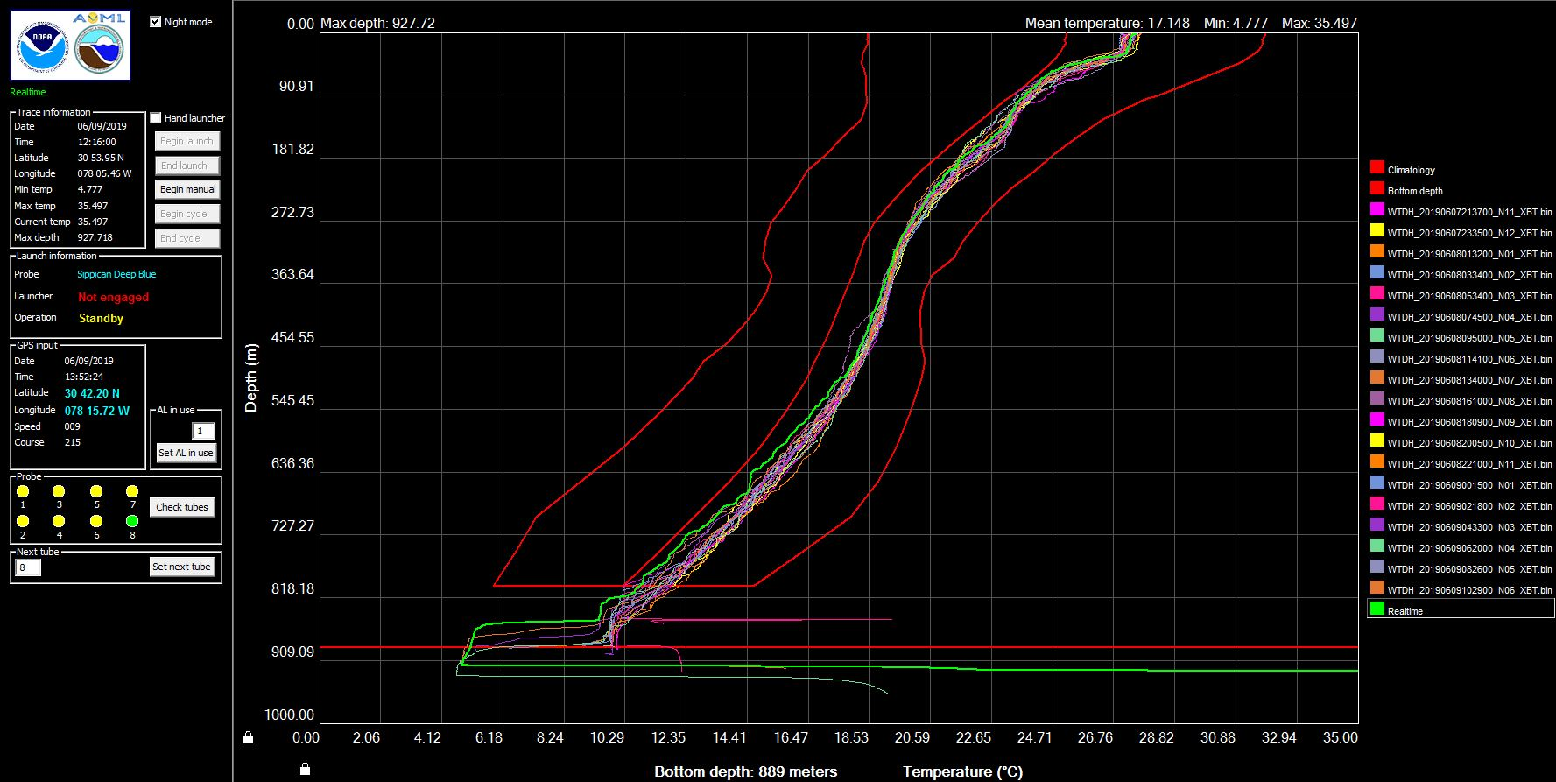
Figure 22: Screenshot from AOML Amvereas software of XBTs completed while mapping polygon ‘Charlie.’ Note the rapid decrease in temperature around 840 meters in depth.

13. References
The 2019 NOAA Ship Okeanos Explorer Survey Readiness Report can be obtained in the NOAA Central Library or by contacting the NOAA OER mapping team at oar.oer.exmappingteam@noaa.gov.
The EX-19-03 Leg 1 Project Instructions can be obtained from the NOAA Central Library. The EX-19-03 Leg 1 Data Management Plan is an appendix of the project instructions.
The following was used for reference throughout the cruise:
Sandwell, D. T., and W. H. F. Smith, Global marine gravity from retracked Geosat and ERS-1 altimetry: Ridge Segmentation versus spreading rate, J. Geophys. Res., 114, B01411, doi:10.1029/2008JB006008, 2009.
NOAA Nautical Charts

Appendix A: CTD Summary
Below are summaries and images of a CTD cast completed on June 9, 2019. The CTD was completed during mapping of polygon ‘Charlie’ after a temperature anomaly was identified in XBT casts.
CTD cast name | Cruise |  | CTD number | Date
EX1903L1 CTD001 | EX1903L1 |  | CTD001 | 06/09/2019
Expedition coordinator | Michael White (NOAA OER/CNSP) |  | Map of general location of site:  See Figure 1.
Mapping lead | Michael White (NOAA OER/CNSP)
Science Team Leads | Charles Wilkins (NOAA OMAO)  Katharine Egan (NOAA OER)
General area | 170 miles east of St. Simons, FL, SE Atlantic Ocean
Site name | Richardson Hills
Type of CTD operation | - Vertical Cast  - Po-Go  - Tow-Yo  - Combination
Target deployment position & depth | Latitude | 30.9104
 | Longitude | -78.08292
 | Depth | 950 meters
Deployment time &  location | Date (UTC) | 06/09/2019
 | Time (UTC) | 17:27
 | Latitude | 31.0416666
 | Longitude | -78.1894444
Time & location at  maximum depth | Time (UTC)
 | Latitude
 | Longitude
 | Depth | 952 meters
Recovery Time & Location | Time (UTC) | 18:00
 | Latitude | 31.0722222
 | Longitude | -78.0988888
CTD sensor data  acquired & calibration coefficients | - CTD P 0905 T1 5001 T2 5017 C1 3449 C2 3451  - ORP Voltage Channel 7  - LSS (Turbidity) Voltage Channel 2  - Dissolved oxygen Voltage Channel 0  - Altimeter Voltage Channel 4  - Other Voltage Channel 0*
Water samples  collected? | - Yes  - No If Yes, number of bottles collected:
Sample Processing | - None  - Room Temp Storage  - -80 Freezer  - -20 Freezer  - Refrigerator
Data Archival | No water samples collected. CTD data will be archived at the NOAA National Centers for Environmental Information.

Equipment malfunctions | Equipment malfunction on the upcast. Voltage spiked on the conductivity sensor and oxygen sensor for unknown reasons. No issues on the downcast.
Special Notes | Ship did not hold position and drifted southeast approximately 200 m from deployment position. Time and location at the maximum CTD depth were not recorded. Turbidity sensor was not yet operation so data were not collected.
Scientists involved  (name / location / affiliation / email) | - Katharine Egan, Sea Grant Knauss Fellow, NOAA Office of Ocean Exploration and Research, Silver Spring, MD, katharine.egan@noaa.gov  - Michael White, Physical Scientist, NOAA Office of Ocean Exploration and Research/Cherokee Nation Strategic Programs, Durham, NH, michael.white@noaa.gov  - Charles Wilkins, Senior Survey Technician, NOAA Ship Okeanos Explorer, charles.e.wilkins@noaa.gov
Purpose of the CTD operation: XBT casts in the area were showing a sharp decrease in temperature at approximately 850 m where the temperature dropped about 6°C over a vertical change of about 40 meters. The mission personnel conducted a CTD cast to better observe and capture this thermocline. See Figure 2.
Description of the Data/Results:
There was a rapid decrease in temperature from 9.4°C to 4.9°C in just 36 meters between 857 and 893 meters of depth. The quickest change occurred between 859 and 863 meters from 9.2°C to 5.59°C. Additionally, there was a sharp decrease in sound velocity, following a pattern similar to temperature.

There was a decrease in dissolved oxygen, which then sharply increases associated with the decrease in temperature. There was an oxygen minimum at 850 meters to be followed by a very sharp increase. Conductivity does decrease and then remained constant to the seafloor. Salinity remained relatively constant throughout the cast, and did not show any markedly drastic changes.
Overall Map of CTD Cast Area |  | Screen grab of Data
See Figure 1. |  | See Figures 3, 4, and 5.
Overview of Cast site |  | SeaSave Data Acquisition Screen

Please direct inquiries to:  Katharine Egan  katharine.egan@noaa.gov | NOAA Office of Ocean Exploration & Research 1315 East-West Highway (SSMC3 10th Floor)  Silver Spring, MD 20910 (301) 734-1014

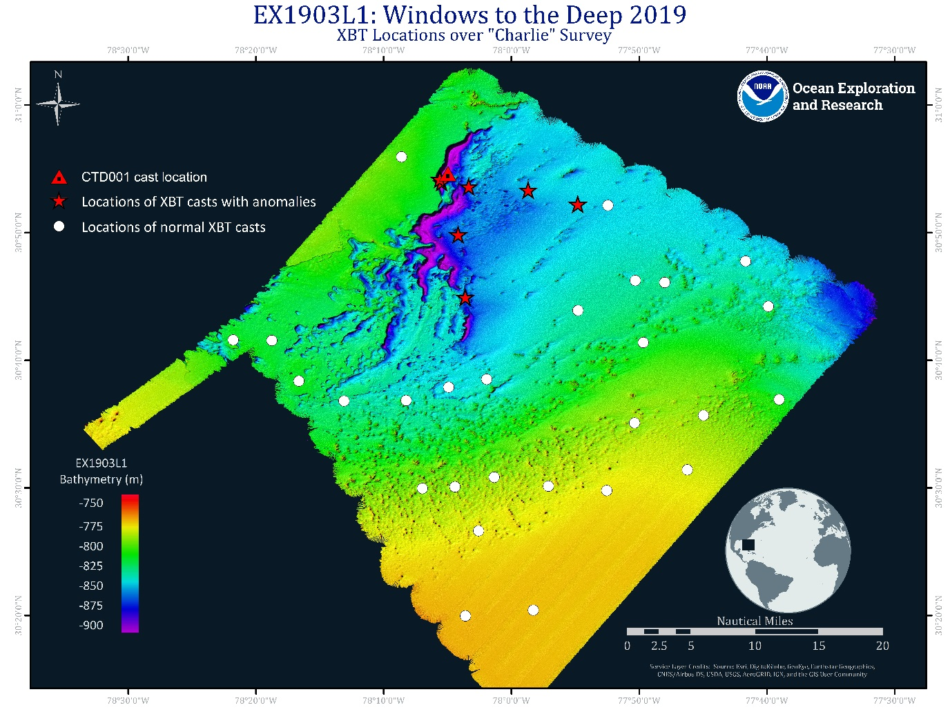
Figure 1a. Overall map of cast site showing the seafloor topography of the survey area “Charlie”. White dots represent the location of “normal” XBT casts, and red stars indicate areas where XBT casts showed anomalies. The red triangle is the location of the CTD cast.

Figure 2a. XBT casts in the area.

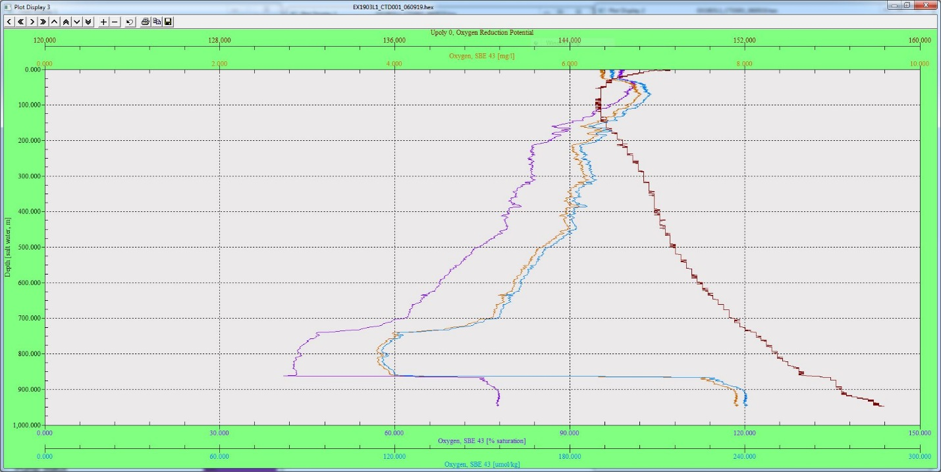
Figure 3a. SeaSave graph of oxygen reduction potential and dissolved oxygen (x-axis) against depth (y-axis).

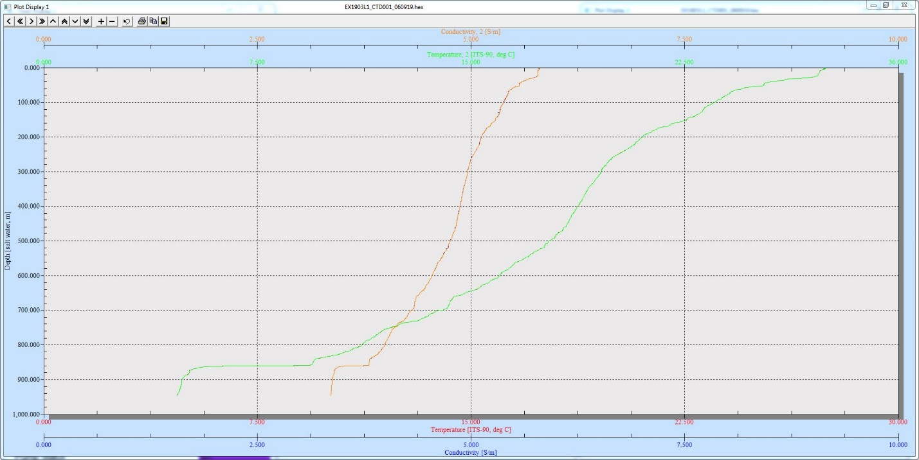
Figure 4a. SeaSave graph of temperature and conductivity (x-axis) against depth (y-axis).

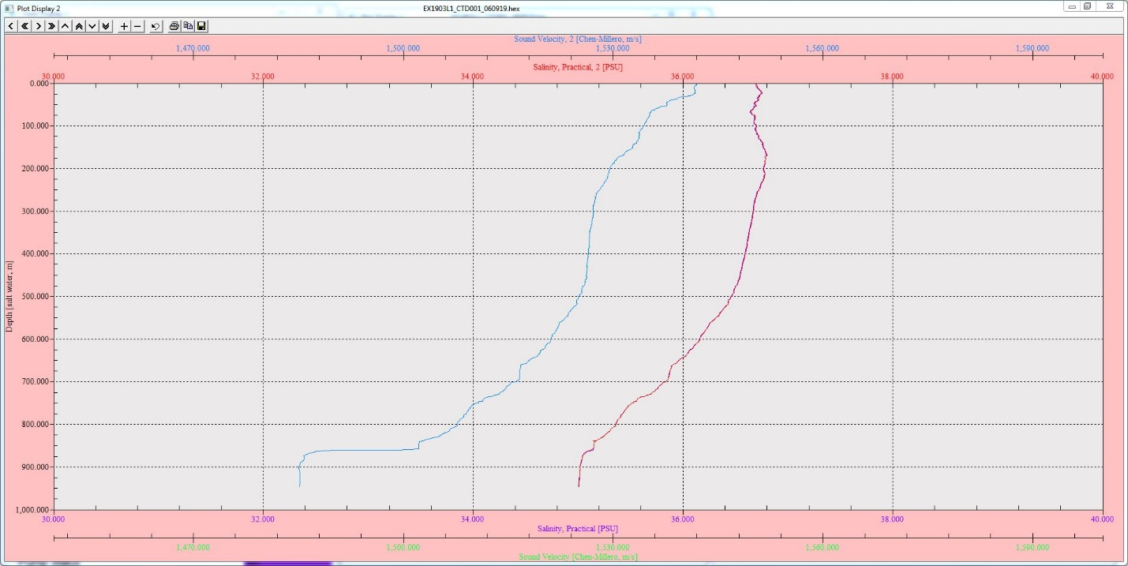
Figure 5a. SeaSave graph of salinity and sound velocity (x-axis) against depth (y-axis).

