*Okeanos Explorer* CTD Summary

|  |  |  |  |  |
| --- | --- | --- | --- | --- |
| **CTD cast name** | **Cruise** | | **CTD number** | **Date** |
| EX1903L1 CTD001 | EX1903L1 | | CTD001 | 06/09/2019 |
| **Expedition coordinator** | Michael White (NOAA OER/CNSP) | | **Map of general location of site:**  See Figure 1. | |
| **Mapping lead** | Michael White (NOAA OER/CNSP) | |
| **Science Team Leads** | Charles Wilkins (NOAA OMAO)  Katharine Egan (NOAA OER) | |
| **General area** | 170 miles east of St. Simons, FL, SE Atlantic Ocean | |
| **Site name** | Richardson Hills | |
| **Type of CTD operation** | * Vertical Cast * Po-Go * Tow-Yo * Combination | |
|
| **Target deployment position & depth** | ***Latitude*** | 30.9104 | | |
| ***Longitude*** | -78.08292 | | |
| ***Depth*** | 950 meters | | |
| **Deployment time &**  **location** | ***Date (UTC)*** | 06/09/2019 | | |
| ***Time (UTC)*** | 17:27 | | |
| ***Latitude*** | 31.0416666 | | |
| ***Longitude*** | -78.1894444 | | |
| **Time & location at**  **maximum depth** | ***Time (UTC)*** |  | | |
| ***Latitude*** |  | | |
| ***Longitude*** |  | | |
| ***Depth*** | 952 meters | | |
| **Recovery Time & Location** | ***Time (UTC)*** | 18:00 | | |
| ***Latitude*** | 31.0722222 | | |
| ***Longitude*** | -78.0988888 | | |
| **CTD sensor data**  **acquired & calibration coefficients** | * CTD **P** 0905 **T1** 5001 **T2** 5017 **C1** 3449 **C2** 3451 * ORP **Voltage Channel** 7 * LSS (Turbidity) **Voltage Channel** 2 * Dissolved oxygen **Voltage Channel** 0 * Altimeter **Voltage Channel** 4 * Other **Voltage Channel** 0* | | | |
| **Water samples**  **collected?** | * Yes * No **If Yes, number of bottles collected:** | | | |
| **Sample Processing** | * None * Room Temp Storage * -80 Freezer * -20 Freezer * Refrigerator | | | |
| **Data Archival** | No water samples collected. CTD data will be archived at the NOAA National Centers for Environmental Information. | | | |

|  |  |  |
| --- | --- | --- |
| **Equipment malfunctions** | Equipment malfunction on the upcast. Voltage spiked on the conductivity sensor and oxygen sensor for unknown reasons. No issues on the downcast. | |
| **Special Notes** | Ship did not hold position and drifted southeast approximately 200 m from deployment position. Time and location at the maximum CTD depth were not recorded. Turbidity sensor was not yet operation so data were not collected. | |
| **Scientists involved**  ***(name / location / affiliation / email)*** | * Katharine Egan, Sea Grant Knauss Fellow, NOAA Office of Ocean Exploration and Research, Silver Spring, MD, katharine.egan@noaa.gov * Michael White, Physical Scientist, NOAA Office of Ocean Exploration and Research/Cherokee Nation Strategic Programs, Durham, NH, michael.white@noaa.gov * Charles Wilkins, Senior Survey Technician, NOAA Ship *Okeanos Explorer*, charles.e.wilkins@noaa.gov | |
| **Purpose of the CTD operation:** XBT casts in the area were showing a sharp decrease in temperature at approximately 850 m where the temperature dropped about 6°C over a vertical change of about 40 meters. The mission personnel conducted a CTD cast to better observe and capture this thermocline. See Figure 2. | | |
| **Description of the Data/Results:** | | |
| There was a rapid decrease in temperature from 9.4°C to 4.9°C in just 36 meters between 857 and 893 meters of depth. The quickest change occurred between 859 and 863 meters from 9.2°C to 5.59°C. Additionally, there was a sharp decrease in sound velocity, following a pattern similar to temperature.  There was a decrease in dissolved oxygen, which then sharply increases associated with the decrease in temperature. There was an oxygen minimum at 850 meters to be followed by a very sharp increase. Conductivity does decrease and then remained constant to the seafloor. Salinity remained relatively constant throughout the cast, and did not show any markedly drastic changes. | | |
| **Overall Map of CTD Cast Area** | | **Screen grab of Data** |
| See Figure 1. | | See Figures 3, 4, and 5. |
| *Overview of Cast site* | | *SeaSave Data Acquisition Screen* |

|  |  |
| --- | --- |
| **Please direct inquiries to:**  Katharine Egan  katharine.egan@noaa.gov | **NOAA Office of Ocean Exploration & Research 1315 East-West Highway (SSMC3 10th Floor)**  **Silver Spring, MD 20910 (301) 734-1014** |

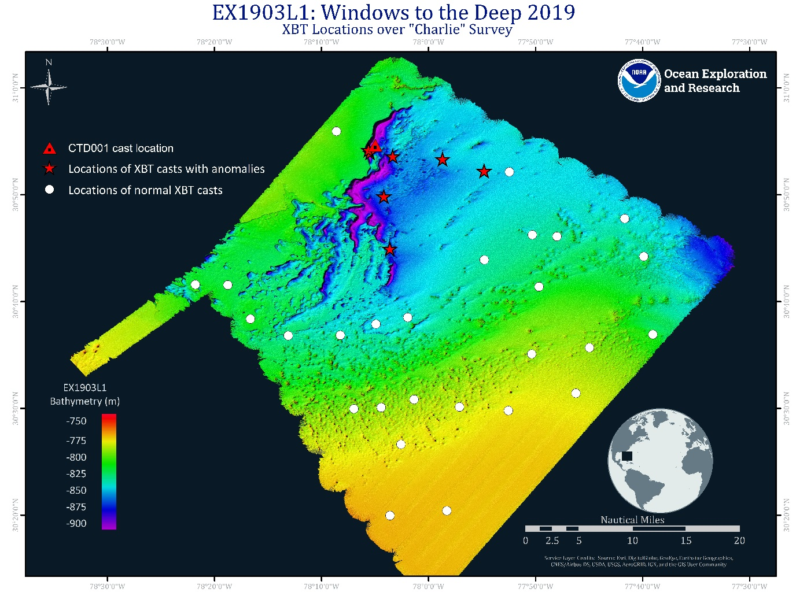

**Figure 1.** Overall map of cast site showing the seafloor topography of the survey area “Charlie”. White dots represent the location of “normal” XBT casts, and red stars indicate areas where XBT casts showed anomalies. The red triangle is the location of the CTD cast.

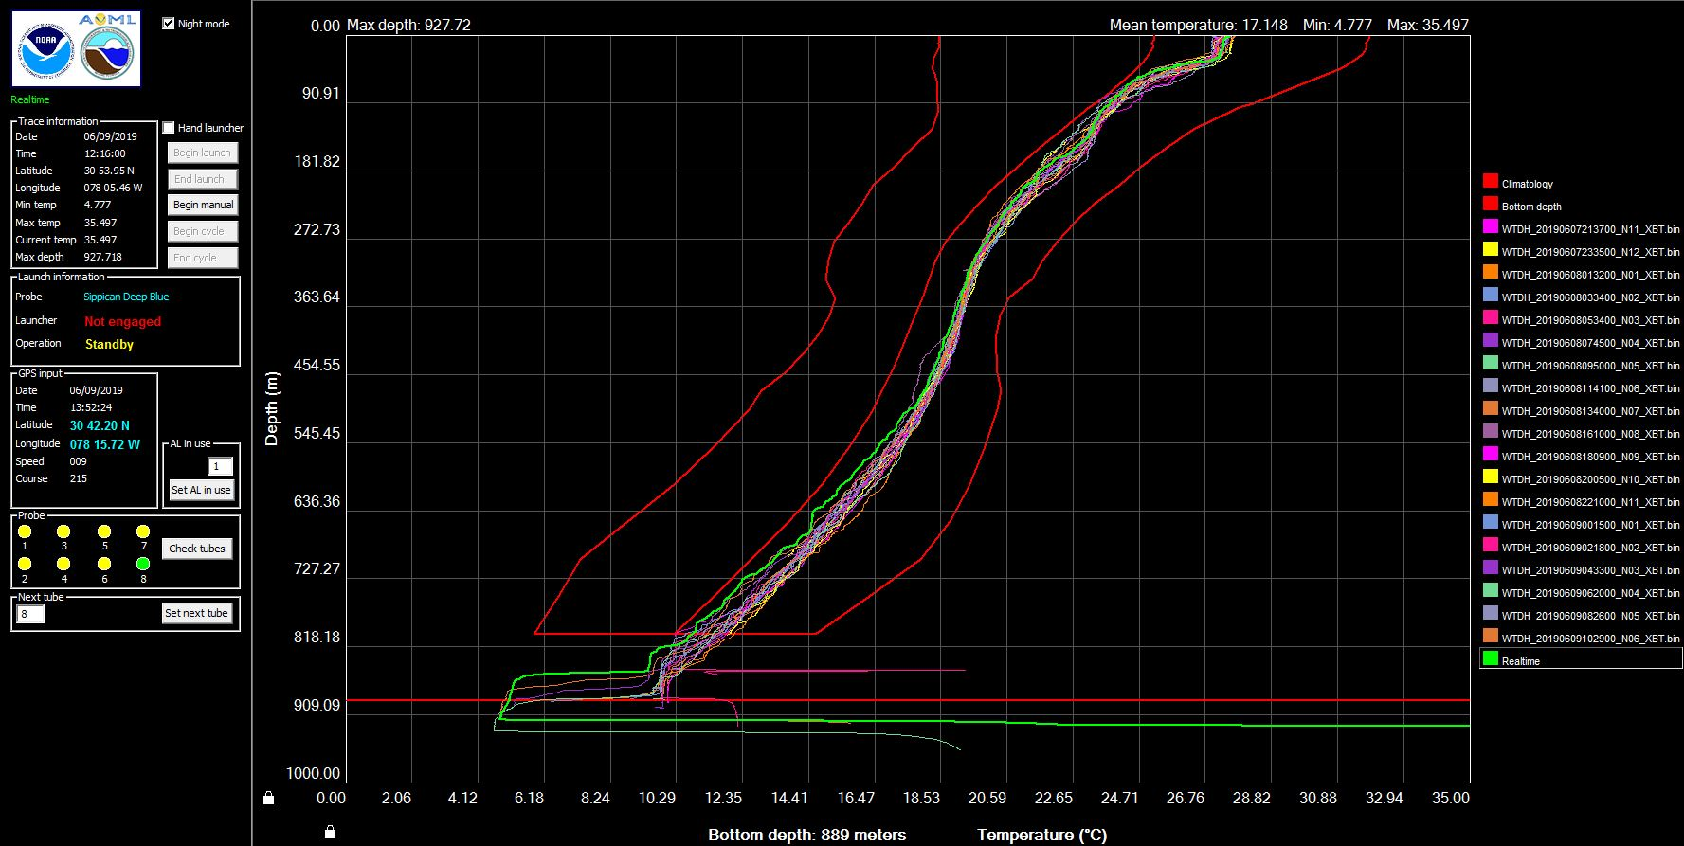

**Figure 2.** XBT casts in the area.

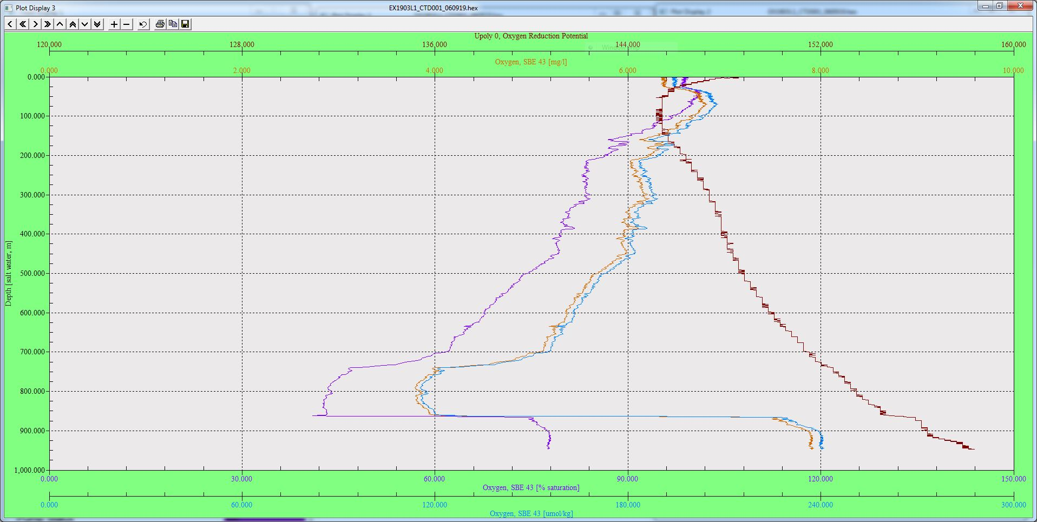

**Figure 3.** SeaSave graph of oxygen reduction potential and dissolved oxygen (x-axis) against depth (y-axis).

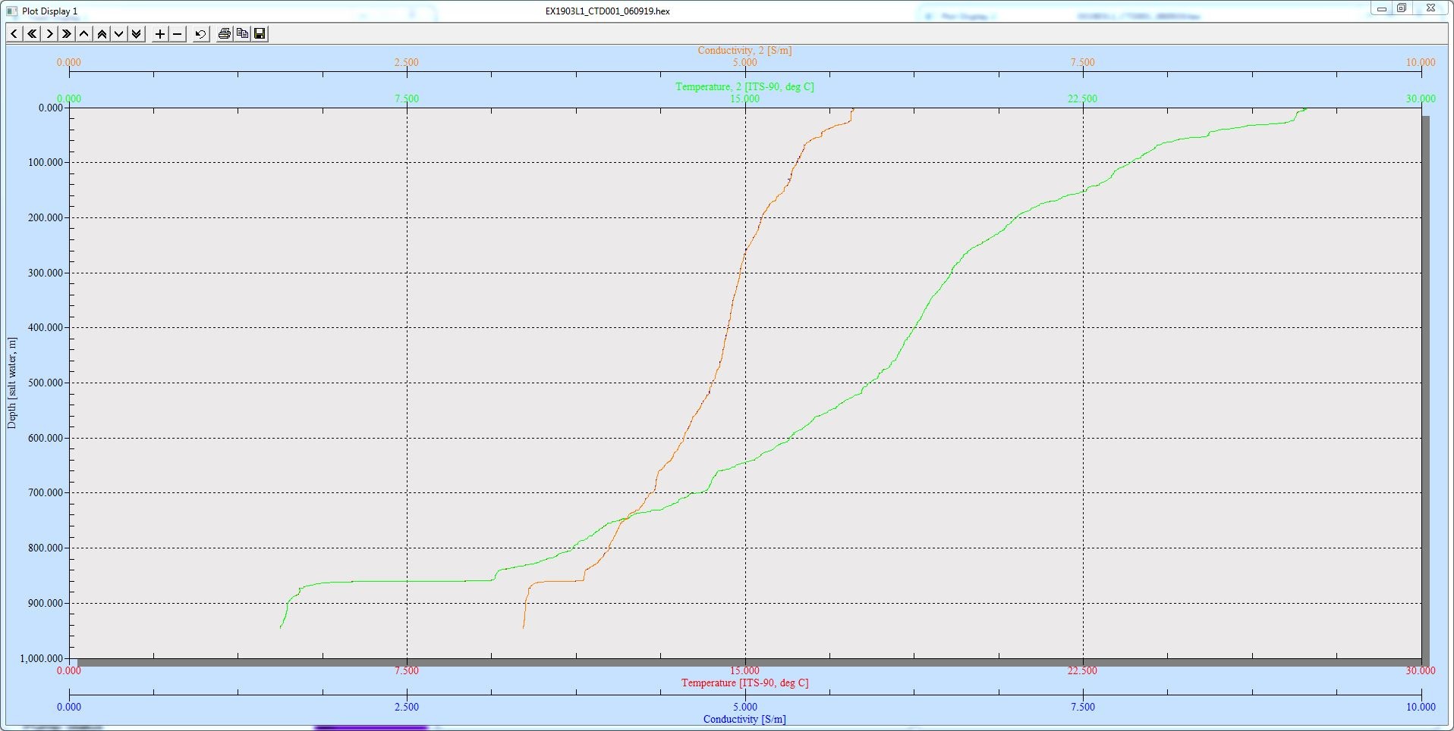

**Figure 4.** SeaSave graph of temperature and conductivity (x-axis) against depth (y-axis).

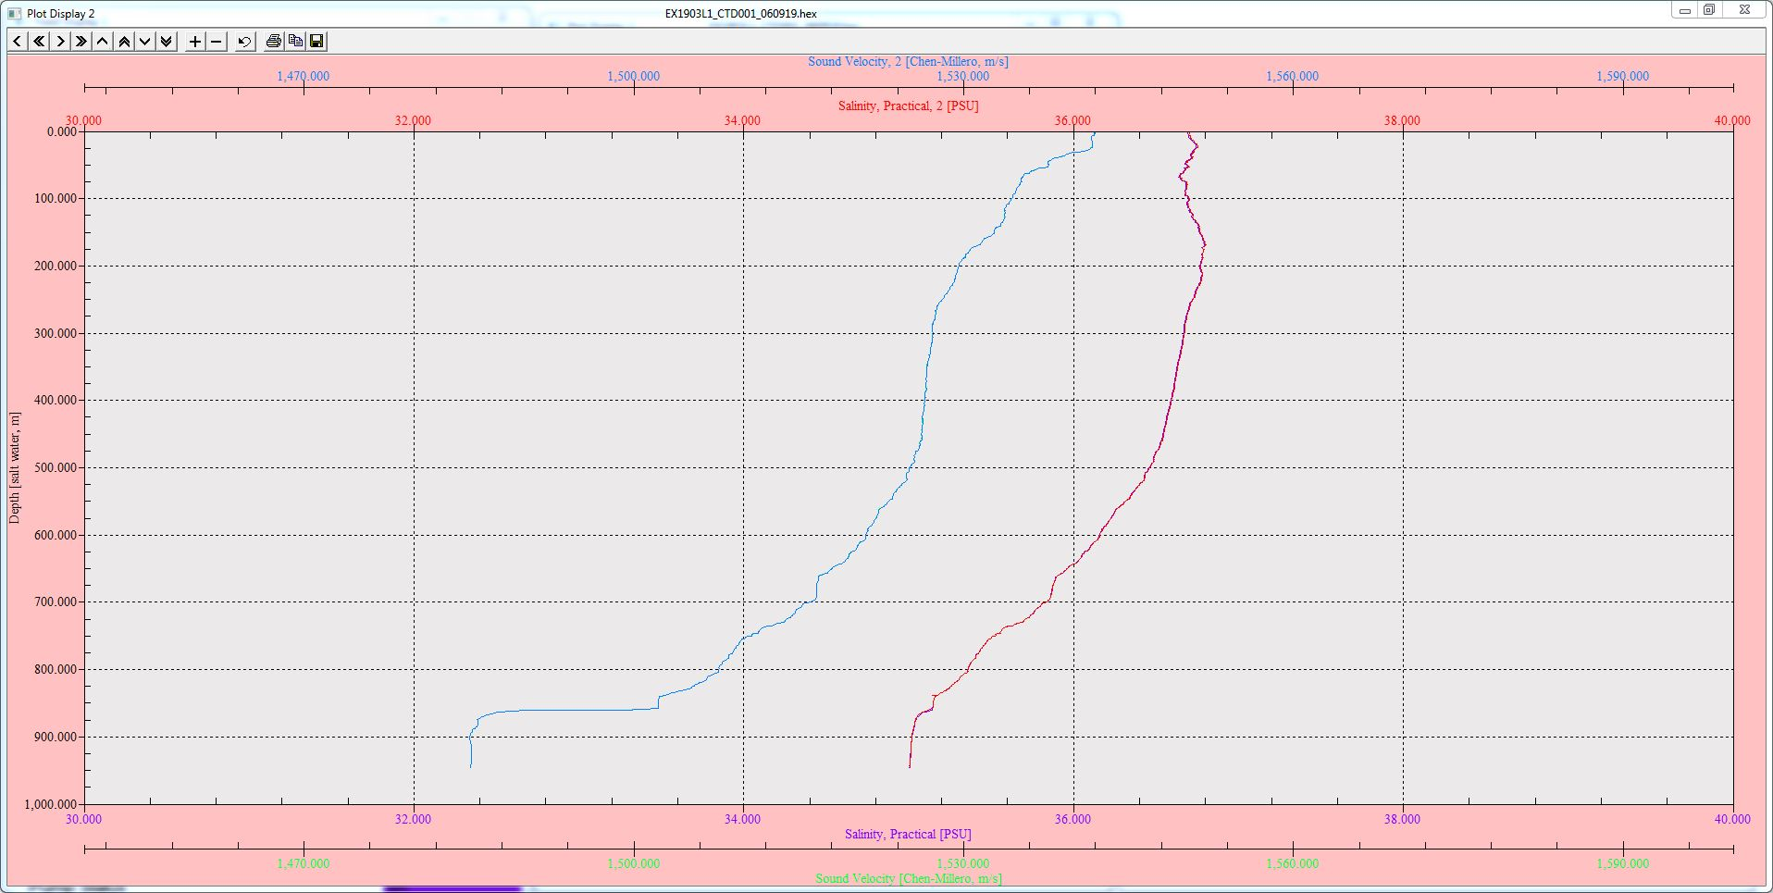

**Figure 5.** SeaSave graph of salinity and sound velocity (x-axis) against depth (y-axis).