Project Instructions

**Date Submitted:** April 17, 2019

**Platform:** NOAA Ship *Okeanos Explorer*

**Project Number:** EX-19-02

**Project Title:** 2019 Field Season Shakedown

**Project Dates:** May 12 - May 24, 2019

**Prepared by:**________________________ **Dated:** __________________ Shannon Hoy and Derek Sowers  
 Co-Expedition Coordinators  
 Office of Ocean Exploration & Research

**Approved by:**________________________ **Dated:** __________________  
 Craig Russell, NOAA  
 Program Manager  
 Office of Ocean Exploration & Research

**Approved by:**________________________ **Dated:** __________________  
 Captain David Zezula, NOAA  
 Commanding Officer  
 Marine Operations Center - Atlantic

I. Overview

“America’s future depends on understanding the ocean. We explore the ocean because its health and resilience are vital to our economy and to our lives. We depend on the ocean to regulate weather and climate; sustain a diversity of life; for maritime shipping and national defense; and for food, energy, medicine, and other essential services to humankind.”

*- NOAA Office of Ocean Exploration and Research Strategic Plan*

# A. Brief Summary and Project Period

This document contains project instructions for EX-19-02. This cruise will be conducted 24 hours/day to perform shakedown operations of the deep-sea mapping and ROV systems in preparation for the 2019 field season. The expedition will commence on May 12, 2019 in Pascagoula, Mississippi (30° 20.355'N, 88° 34.499'W) and conclude on May 24, 2019 in Key West, Florida (24° 33.304'N, 81° 46.799'W). Operations are planned in the northeastern Gulf of Mexico along the edge of the west Florida escarpment and off the coast of Key West, FL.

Shakedown of ROV equipment will include a calibration of the ultra short baseline (USBL) positioning system, testing of a new suction sampler device, and three ROV engineering dives. Mapping shakedown will focus on calibrating the EM302 multibeam sonar (including backscatter calibration), calibrating the EK60/EK80 sonars, installing and testing the new Kongsberg K-Sync device, and troubleshooting the UnderwayCTD (UCTD) with the manufacturer’s representative. Some testing may also be completed on the ship’s dynamic positioning (DP) system. This expedition will be divided into 3 transit legs: May 12 - May 18, May 18 - May 22, and May 22 -May 24 (separated by small boat transfers). The first small boat transfer is needed to transfer off ROV Team members and to transfer on mission personnel needed to support EK60/EK80 calibration and Kongsberg equipment testing. The second small boat transfer is needed to drop off the Kongsberg technician and pick up a Teledyne technician.

NOAA’s Office of Ocean Exploration and Research (OER) is the only federal organization dedicated to exploring the global ocean. OER works with partners to identify priority areas for exploration; support innovations in exploration tools and capabilities; and encourage the next generation of ocean explorers, scientists, and engineers to pursue careers in ocean exploration and related fields. The data and information collected during our expeditions and the research we fund gives resource managers, the academic community, and the private sector the information they need to identify, understand, and manage ocean resources for this and future generations of Americans.

NOAA Ship *Okeanos Explorer* is the only U.S. federal vessel dedicated to exploring our largely unknown ocean for the purpose of discovery and the advancement of knowledge. America’s future depends on understanding the ocean. We explore the ocean to make valuable scientific, economic, and cultural discoveries; we explore because ocean health and resilience are vital to our economy and to our lives. Exploration supports NOAA mission priorities and national objectives by providing high-quality scientific information about the deep ocean to anyone who needs it.

In close collaboration with government agencies, academic institutions, and other partners, OER conducts deep-ocean expeditions using advanced technologies on the *Okeanos Explorer*. From mapping and characterizing previously unseen seafloor to collecting and disseminating information about ocean depths, this work helps to establish a foundation of information and to fill data gaps. Data collected on the ship follow federal open-access data standards and are publicly available shortly after an expedition ends. This ensures the delivery of reliable scientific data needed to identify, understand, and manage key elements of the ocean environment.

# B. Days at Sea (DAS)

Of the 13 DAS scheduled for this project, 8 DAS are funded by an OMAO allocation and 5 DAS are funded by OAR allocation. This project is estimated to exhibit a High Operational Tempo due to 24-hour-per-day ship and science shakedown operations.

C. Operating Area

EX-19-02 is a 24-hour a day mapping and ROV shakedown cruise that will focus operations in the U.S. Gulf of Mexico. The general operating area, approximate ship tracklines, and estimated locations of major testing operations are shown in Figure 1. All locations are approximate and will be adjusted as needed during the cruise to account for weather, vessel traffic, infrastructure safety zones, safety concerns, mapping coverage optimization, and other real-time operational considerations. All daily operational plans will be developed and shared with the Operations Officer and CO to maximize safety and efficiency.

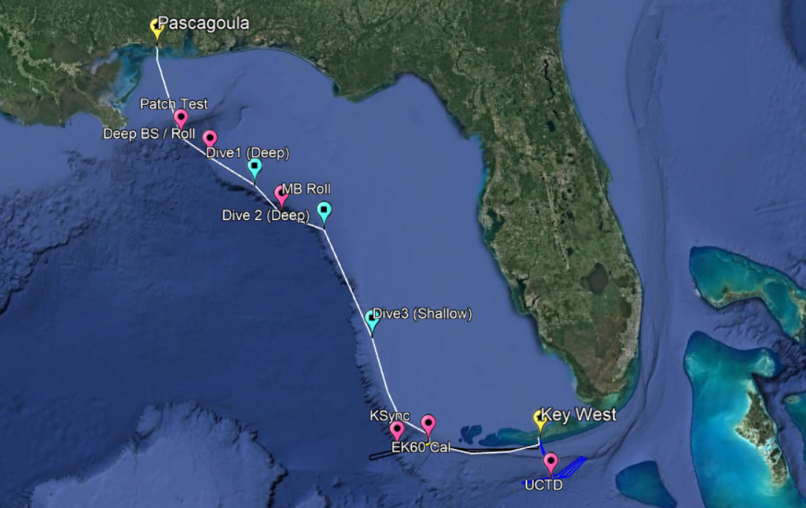

**Figure 1:** Map showing the general expedition operating area. The lines represent the three informal legs of the cruise: May 12-18 (white), May 18-22 (black), May 22-24 (blue). The yellow placemark demarks ports, pink shows multibeam sonar shakedown locations, and blue shows ROV shakedown locations.

|  |  |  |
| --- | --- | --- |
| Potential Locations (SUBJECT TO CHANGE) | | |
| ID | **Latitude** | **Longitude** |
| Pascagoula, MS | 30° 20.63’N | 88° 34.02'W |
| MB Patch Test | 28° 59.04'N | 88° 01.63'W |
| Deep BS Cal | 28° 40.88'N | 87° 30.05'W |
| USBL/ROV 1 | 28° 17.23'N | 86° 42.08'W |
| MB Deep Roll | 27° 53.03'N | 86° 13.05'W |
| ROV 2 | 27° 39.45'N | 85° 29.06'W |
| ROV 3 | 26° 02.70'N | 84° 37.29'W |
| EK60 Cal/ Shallow BS | 24° 28.26'N | 83° 39.08'W |
| KSync | 24° 22.52'N | 84° 10.14'W |
| UCTD | 23° 53.75’'N | 81° 35.96'W |
| Key West, FL | 24° 33.25'N | 81° 48.63'W |

**Table 1:** Potential site locations for EX-19-02 shakedown items *(SUBJECT TO CHANGE).*

# D. Summary of Objectives

**May 12 - May 24, (Pascagoula, MS - Key West, FL.) 2019 Field Season Shakedown Cruise**

EX-19-02 operations will occur in the waters of the Gulf of Mexico. This cruise will conduct several systems calibration and shakedown operations and will include a combination of ship operations, mapping/operational, and data management objectives:

1. Ship
   1. Small boat deployment (weather permitting); Develop and maintain proficiency with small boat operations for new and long term crew.
   2. Conduct personnel transfer by small boat.
   3. Man overboard / ship handling training.
   4. Additional safety training.
   5. Conduct CTD cast(s).
2. EK60 Sonar Objectives
   1. Acceptance tests on new Kongsberg 38 kHz and 70 kHz wide band transceivers. These tests include speed noise testing of the sonar, as well as calibration using a standard target sphere suspended underneath the ship.
   2. Perform sonar calibrations. Calibration of the five operational EK 60 sonars (18, 38, 70, 120, 200 kHz) is a top priority of the cruise. Calibration can be conducted while drifting freely in an area with low vessel traffic, no navigational hazards, and a lack of fishing gear. EK60 calibration work is planned to take place during daylight hours only. Visiting OER personnel and a Field Engineer from Kongsberg will provide technical oversight of the calibration process.
   3. Update and revise the SOP for calibrating the EK sonars using the auto-calibration gear.
   4. Confirm triggering and synchronization settings.
   5. Confirm read/write permissions.
3. EM 302 Sonar Objectives
   1. Conduct multibeam patch test, including deep roll verification lines.
   2. Collect data for backscatter calibration across all ping modes. This calibration data will be collected at two different depths: around 500-750m for shallower sonar modes, and for deeper modes at 1500-2000m.
   3. Confirm triggering and synchronization settings.
   4. Confirm read/write permissions.
4. Sub-bottom profiler sonar objectives
   1. Confirm navigation and heave inputs are received.
   2. Confirm triggering and synchronization settings.
   3. Confirm read/write permissions.
5. K-Sync
   1. Fully integrate, test, and optimize the new K-Sync sonar synchronization device (with aid of the Kongsberg Technician) for the suite of scientific sonars on the ship.
   2. Determine operating settings for synchronization of all sonars over a broad range of survey depths and sonar modes.
   3. Optimize settings to minimize interference across all sonars.
6. Complete the mapping systems readiness report for the 2019 field season.
7. Mapping Sound Velocity Profiling Objectives
   1. Collect XBT casts, as data quality requires, during mapping operations.
   2. Assess the feasibility of using Sound Speed Manager to send asvp files to SIS automatically
   3. Replace the ASVP data acquisition log with the SSM acquisition log for cruise data packages.
8. Troubleshoot the Underway CTD device
   1. Host a technician from Teledyne to support UCTD system troubleshooting.
   2. Conduct UCTD casts down to the full instrument rating of about 700 meters. This work is planned to be conducted in approximately 1300 m of water south of Key West in the U.S. EEZ.
   3. Determine the best data transfer method and file formats for UCTD profiles generated by the device.
   4. Update and refine the SOP for operating the UCTD and preparing files for input in the multibeam sonar.
   5. Test using a small “Raspberry Pi” electronic device to make file transfers easier.
   6. Compare water column profiling casts from the CTD, XBT, and UCTD.
9. Video Engineering (VSAT ~15 mb/sec ship-to-shore; 5 mb/sec shore-to-ship)
   1. Test terrestrial and high-speed satellite links.
   2. Verify Global Foundation for Ocean Exploration (GFOE)-managed telepresence systems perform as expected.
   3. Test all subsea video equipment on Deep Discoverer and Seirios and ensure their proper integration into video system.
   4. Test all shipboard video equipment (hangar, deck cameras, wire camera, etc) and ensure their proper integration into video system.
10. Data Management
    1. Provide a foundation of publicly accessible data and information products to spur further exploration, research, and management activities.
    2. Verify GFOE-managed data systems perform as expected.
    3. Update SOPs to reflect GFOE-managed network changes.
    4. Confirm mapping data file throughput to shoreside FTP.
11. ROV
    1. Conduct full system checks for both vehicles - including all lights, cameras, thrusters, science equipment, navigation equipment, hydraulics, etc.
    2. Complete integration of new joyboxes in control room and test all commands and functions on both *Deep Discoverer* and *Seirios*.
    3. Test new suction sampler capabilities and simulate typical science collections with sampler.
    4. Conduct typical vehicle and ship movements to simulate normal dive operations.
    5. Calibrate and test the ultra short baseline (USBL) positioning system.

# E. Participating Institutions

* National Oceanic and Atmospheric Administration (NOAA), Office of Ocean Exploration and Research (OER)–1315 East-West Hwy, Silver Spring, MD 20910 USA
* NOAA, National Centers for Environmental Information (NCEI), Stennis Space Center MS, 39529 USA
* University Corporation for Atmospheric Research (UCAR) Cooperative Programs for the Advancement of Earth System Science (CPAESS), PO Box 3000 Boulder, CO 80307 USA
* University of New Hampshire (UNH) Center for Coastal and Ocean Mapping (CCOM) Jere A. Chase Ocean Engineering Lab, 24 Colovos Rd, Durham, NH 03824 USA
* University of Rhode Island, Graduate School of Oceanography’s Inner Space Center, 215 South Ferry Rd. Narragansett, RI 02882 USA
* Global Foundation for Ocean Exploration (GFOE), P.O. Box 417, Mystic, CT 06355
* Teledyne Marine, [Oceanscience](http://www.teledynemarine.com/oceanscience/), Poway, CA 92064
* Kongsberg Underwater Technology, Inc., 19210 33rd Avenue West, Suite A, Lynnwood, WA 98036

# F. Personnel (Mission Party)

**Table 2:** Full list of seagoing mission party members and their affiliations.

|  |  |  |  |  |  |  |  |
| --- | --- | --- | --- | --- | --- | --- | --- |
| # | Name (First, Last) | Title | Date Aboard | Date Disembark | Gender | Affiliation | Nationality |
| 1 | Derek Sowers | Co-Expedition Coordinator | 5/7/19 | 5/25/19 | M | OER (CNSP) | USA |
| 2 | Shannon Hoy | Co-Expedition Coordinator | 5/7/19 | 5/25/19 | F | OER (CNSP) | USA |
| 3 | Kevin Jerram | Mapping Watch Lead | 5/10/19 | 5/25/19 | M | UCAR | USA |
| 4 | Neah Baechler | Mapping Watch Lead | 5/10/19 | 5/25/19 | F | UCAR | USA |
| 5 | Christopher Dunn | LTJG | 5/10/19 | 5/25/19 | M | NOAA | USA |
| 6 | Adrienne Copeland | Fellow | 5/10/19 | 5/24/19 | F | OER | USA |
| 7 | Rachel Medley | E&E Director | 5/18/19 | 5/24/19 | F | OER | USA |
| 8 | Treyson Gillespie | EiT | 5/18/19 | 5/25/19 | M | UCAR | USA |
| 9 | Bobby Mohr | GFOE OPS | 5/7/19 | 5/18/19 | M | GFOE | USA |
| 10 | Fernando Aragon | Data/Software | 5/7/19 | 5/25/19 | M | GFOE | Colombia (green card) |
| 11 | Joshua Carlson | GFOE OPS | 5/7/19 | 5/18/19 | M | GFOE | USA |
| 12 | Mark Durbin | Data/VSAT | 5/7/19 | 5/18/19 | M | GFOE | USA |
| 13 | Jim Meyers | Data/Software | 5/7/19 | 5/18/19 | M | GFOE | USA |
| 14 | Levi Unema | Electrical | 5/7/19 | 5/18/19 | M | GFOE | USA |
| 15 | Sean Kennison | Mechanical / OPS Training | 5/7/19 | 5/18/19 | M | GFOE | USA |
| 16 | Karl McLetchie | Mechanical | 5/7/19 | 5/18/19 | M | GFOE | USA |
| 17 | Chris Ritter | Mechanical | 5/7/19 | 5/18/19 | M | GFOE | USA |
| 18 | Lars Murphy | Mechanical | 5/7/19 | 5/18/19 | M | GFOE | USA |
| 19 | Annie White | Video | 5/7/19 | 5/18/19 | F | GFOE | USA |
| 20 | Caitlin Bailey | Video | 5/7/19 | 5/18/19 | F | GFOE | USA |
| 21 | Roland Brian | Video/VSAT | 5/7/19 | 5/25/19 | M | GFOE | USA |
| 22 | Brian Doros | Video | 5/7/19 | 5/18/19 | M | GFOE | USA |
| 23 | Tony (Lee) Arnold | Mechanical | 5/7/19 | 5/18/19 | M | GFOE | USA |
| 24 | Tony Dalheim | Technician | 5/18/19 | 5/22/19 | M | Kongsberg | USA |
| 25 | Jason Baluyot | Technician | 5/22/19 | 5/24/19 | M | Teledyne | USA |

# G. Administrative

**1. Points of Contact:**

|  |  |
| --- | --- |
| **Ship Operations** | |
| Chief, Operations Division, Atlantic (MOA)  LCDR Fionna Matheson, NOAA  Telephone: (757) 441-6842  Telephone: (757) 441-6776  Email: [Chiefops.MOA@noaa.gov](mailto:Chiefops.MOA@noaa.gov) | Deputy Chief of Operations  LT Nathaniel Gilman, NOAA  Telephone: (757) 441-6238  Email: [DeputyOps.MOA@noaa.gov](mailto:DeputyOps.MOA@noaa.gov) |
| **Mission Operations** | |
| Derek Sowers  Co-Expedition Coordinator  NOAA Office of Ocean Exploration and Research (CNSP)  C: (714) 321-6084  Email: [derek.sowers@noaa.gov](mailto:derek.sowers@noaa.gov)  Shannon Hoy  Co-Expedition Coordinator  NOAA Office of Ocean Exploration and Research (CNSP)  C: (469) 265-2908  Email: [shannon.hoy@noaa.gov](mailto:shannon.hoy@noaa.gov) | CDR Eric Johnson, NOAA  Commanding Officer  NOAA Ship *Okeanos Explorer*  Phone: (401) 378-8284  Email: [CO.Explorer@noaa.gov](mailto:CO.Explorer@noaa.gov)  LT Rosemary Abbitt  Operations Officer  NOAA Ship Okeanos Explorer  Phone:  808-659-9179 x221  Email: [ops.explorer@noaa.gov](mailto:ops.explorer@noaa.gov)  Bobby Mohr  GFOE Operations Manager  Global Foundation for Ocean Exploration  Phone: (813) 334-6657  Email: [bobby.mohr@tgfoe.org](mailto:bobby.mohr@tgfoe.org) |
| **Other Mission Contacts** | |
| Craig Russell  Program Manager  NOAA Ocean Exploration & Research  Phone: (206) 526-4803 / (206) 518-1068  Email: [Craig.Russell@noaa.gov](mailto:Craig.Russell@noaa.gov) | Rachel Medley  Chief, Expeditions and Explorations  NOAA Ocean Exploration & Research  Phone: (301) 789-3075  Email: Rachel.Medly@noaa.gov |
| Alan Leonardi, Director  NOAA Ocean Exploration & Research  Phone: 301-734-1016  Mobile: 202-631-1790  Email: [alan.leonardi@noaa.gov](mailto:alan.leonardi@noaa.gov) |  |
| **Vessel Shipping Address** | |
| **1. Shipments**  Send an email to the *Okeanos Explorer* Operations Officer at [OPS.Explorer@noaa.gov](mailto:OPS.Explorer@noaa.gov) indicating the size and number of items being shipped.  NOAA Ship Okeanos Explorer  ATTN: Operations Officer  Gulf Marine Support Facility  151 Watts Ave  Pascagoula, MS 39567-4102 | |

**2. Diplomatic Clearances**

None required

**3. Licenses and Permit**

Pursuant to the National Environmental Policy Act (NEPA), NOAA OER is required to include in its planning and decision-making processes appropriate and careful consideration of the potential environmental consequences of actions it proposes to fund, authorize and/or conduct. NOAA’s Administrative Order (NAO) 216-6A Companion Manual describes the agency’s specific procedures for NEPA compliance.  Among these is the need to review all proposed NOAA-supported field projects for their environmental effects. An Environmental Review Memorandum has been completed for this survey, in accordance with Section 4 of the Companion Manual.  (Appendix C).

II. Operations

The Expedition Coordinators are responsible for ensuring the scientific staff are trained in planned operations and are knowledgeable of project objectives, priorities and environmental compliance procedures. The Commanding Officer is responsible for ensuring all operations conform to the ship’s accepted practices and procedures.

1. Project Itinerary   
   All times and dates are subject to prevailing conditions and the discretion of the Commanding Officer. Locations are approximate. Final dive sites will be delivered to the bridge at night for the next day’s dive. Time zone changes from US Central to US Eastern on 5/17.

|  |  |
| --- | --- |
| Date | Activities |
| 5/7 | Cruise mobilization day. GFOE Team and Expedition Coordinators arrive. *Deep Discoverer*, *Seirios*, and the ROV storage container plan to be loaded onto the *Okeanos* on the morning. Standard preparation for ROV expeditions is anticipated, which includes hydraulic use, the ability to ping the USBL, and high voltage operations. Roger Davis from UH onboard to set up real-time backscatter mosaic software. K-Sync installation will require ET support, dockside sonar pinging may be requested. Pre-cruise meeting with ECs, OPS, and Command. |
| 5/8 | Cruise mobilization day. ROV mobilization will require multiple ROV dockside dives, both tied to the crane and free to extend the length of the tether (beginning May 8th and continuing for the duration of the dockside period). Deck and ROV teams will practice ROV launches, recoveries, and emergency recoveries prior to leaving port. This training schedule is flexible, but all deck crew should be present for at least one launch with pull pin, one recovery with daisy chain, and one emergency recovery. Attendance by all personnel involved with launch and recovery operations (deck, bridge) is encouraged. Roger Davis from UH onboard to set up real-time backscatter mosaic software. K-Sync installation will require ET support, dockside sonar pinging may be requested. |
| 5/9 | Cruise mobilization day. Deck and ROV continue training ops as needed. Roger Davis from UH onboard to set up real-time backscatter mosaic software if needed. Dockside sonar pinging may be requested. |
| 5/10 | Cruise mobilization day. Deck and ROV continue training ops as needed. Dockside sonar pinging may be requested. |
| 5/11 | Cruise mobilization day. Deck and ROV continue training ops as needed. Dockside sonar pinging may be requested. Mission team orientation meeting. Vessel familiarization meeting for any new mission team members and OPS. |
| 5/12 | First day underway. Depart Pascagoula, MS. Transit to patch test location. Overnight EM302 patch test. |
| 5/13 | 0800 CTD Cast, transit to deep backscatter calibration site, another CTD cast upon arrival (~1300). Deep backscatter calibration overnight and transit to USBL/ROV Dive 1 location. |
| 5/14 | USBL calibration (0600), followed by ROV Dive 1 (on deck by 1700). Overnight EM302 deep roll verification and transit to ROV Dive 2 site. |
| 5/15 | ROV Dive 2 (0800 - 1700). Overnight transit to ROV Dive 3. |
| 5/16 | ROV Dive 3 (0800 - 1830). Extended Ops to 18:30 to maximize bottom time. Overnight transit to shallow backscatter calibration location. |
| 5/17 | 0800 CTD Cast, followed by shallow backscatter calibration. Overnight transit to Key West. ROV demobilization. Minimal de-mobilization is expected. The ROV team will follow normal de-mobilization procedures and will secure all ROV spaces, including high voltage and the winch, before small boat departure on the 18th. Change time zone to EST. Setup EK60 calibration gear as possible given weather conditions (no gear overboard or as tripping hazard). |
| 5/18 | AM Weather-dependent small boat transfer of personnel. Departing 12 members of GFOE, pick up Kongsberg technician, Treyson Gillespie, and Rachel Medley. Transit to K-Sync testing location. Overnight K-Sync test and transit to EK60 calibration site. Setup EK60 calibration gear as possible given weather conditions (no gear overboard or as tripping hazard). |
| 5/19 | EK60/80 Calibration. Calibration work requires calm seas, low vessel traffic, gear in the water, and a drifting vessel. Overnight K-Sync testing. |
| 5/20 | EK60/80 Calibration. Calibration work requires calm seas, low vessel traffic, gear in the water, and a drifting vessel. Overnight K-Sync testing. Possible EM302 transmit array impedance testing concurrent with EK calibrations. |
| 5/21 | EK60/80 Calibration. Calibration work requires calm seas, low vessel traffic, gear in the water, and a drifting vessel. Overnight transit to Key West. Possible EM302 transmit array impedance testing concurrent with EK calibrations. |
| 5/22 | AM weather-dependent small boat transfer of personnel. Departing one Kongsberg technician, arriving one Teledyne technician. Transit to UCTD testing location, followed by UCTD testing. Overnight speed noise testing or mapping. |
| 5/23 | UCTD testing. Overnight opportunistic mapping and transit to Key West. Post-cruise meeting with ECs, OPS, and Command. |
| 5/24 | Arrive at Key West. Demobilization. Data/Video/VSAT demobilization will take place once the ship docks, and will require rack room and drylab power. If necessary, any items will be removed from the ship as support is available from the deck crew. Crane support is not anticipated, but may be required. Departure of some mission personnel. |
| 5/25 | Departure of remaining mission personnel. |

**Table 5:** Detailed Cruise Itinerary. This is an approximate itinerary and is subject to change based on objective completion.

B. Staging and Destaging

*Deep Discoverer*, *Seirios*, and the ROV storage container plan to be loaded onto the *Okeanos* on the morning of May 7th. Standard preparation for ROV expeditions is anticipated, which includes hydraulic use, the ability to ping the USBL, and high voltage operations. Additionally, mobilization will require multiple ROV dockside dives, both tied to the crane and free to extend the length of the tether, likely beginning May 8th and continuing for the duration of the dockside period. Deck and ROV teams will practice ROV launches, recoveries, and emergency recoveries prior to leaving port. This training schedule is flexible, but all deck crew should be present for at least one launch with pull pin, one recovery with daisy chain, and one emergency recovery. Attendance by all personnel involved with launch and recovery operations (deck, bridge) is encouraged.

Minimal de-mobilization is expected. The ROV team will follow normal de-mobilization procedures and will secure all ROV spaces, including high voltage and the winch, before small boat departure on the 18th. Data/Video/VSAT demobilization will take place once the ship docks, and will require rack room and drylab power. If necessary, any items will be removed from the ship as support is available from the deck crew. Crane support is not anticipated, but may be required. As well, work aloft is not expected, but may be required should VSAT issues arise during the shakedown.

**C. Operations to be Conducted**

1. **Telepresence / Outreach Events**
   1. No live events are expected

1. **In-Port Events**
2. No port events are expected.

# D. SCUBA Dive Plan

All dives are to be conducted in accordance with the requirements and regulations of the [NOAA Diving Program](http://www.ndc.noaa.gov/dr.html) and require the approval of the ship’s Commanding Officer. No science dives are planned during EX-19-02, but the ship may plan training, safety drill, or maintenance dives.

# E. Applicable Restrictions

**Sonar Operations**

EM 302, EK 60/80, ADCP, and sub-bottom profiler data acquisition is planned for this cruise. All data acquisition will be conducted in accordance with established standard operating procedures under the direction of the mapping team lead. These operating procedures will include protection measures when operating in the vicinity of marine mammals, sea turtles or Endangered Species Act-listed species as described in the appendices of this document. The final decision to operate and collect 24-hour sub-bottom profiler data will be at the discretion of the Commanding Officer.

III. Equipment

# A. Equipment and capabilities provided by the ship

* Kongsberg Simrad EM302 Multibeam Echosounder (MBES)
* Kongsberg Simrad EK60 Deepwater Echosounders (18, 38, 70, 120, 200 kHz) and GPTs (18, 120, 200 kHz)
* Knudsen Chirp 3260 Sub-bottom profiler (SBP)
* Teledyne RDI Workhorse Mariner (300 kHz) ADCP
* Teledyne RDI Ocean Surveyor (38 kHz) ADCP
* LHM Sippican XBT Mark21 System (Deep Blue probes)
* AOML Automated XBT Launcher (Deep Blue probes)
* Seabird SBE 911Plus CTD and deck box
* Seabird SBE 32 Carousel and 24 2.5 L Niskin Bottles
* Light Scattering Sensor (LSS)
* Oxidation – Reduction Potential (ORP)
* Dissolved Oxygen (DO) sensor
* Altimeter Sensor and battery pack
* MarineStar GPS with satellite corrections serial data feeds provided for GFOE network
* POS/MV with serial data feeds provided for the GFOE network
* Seabird SBE-45 (Micro TSG) data feeds provided for GFOE network
* Kongsberg Dynamic Positioning-1 System
* ECDIS
* Met/Wx Sensor Package with serial data feeds provided for GFOE network
* Three VoIP telephone lines
* 1 functioning and seaworthy SOLAS approved fast rescue boat
* 1 functioning and seaworthy work boat to support ROV operations and personnel transfers

# B. Equipment and capabilities provided by the OER and partners

* Microtops II Ozone Monitor Sun photometer and handheld GPS required for NASA Marine Aerosols Network supplementary project.
* NOAA OER 6000 m *Deep Discoverer* ROV NOAA *Seirios* Camera Platform
* Teledyne Underway CTD
* Simrad EK80 38 kHz and 70 kHz Wide Band Transceivers
* QPS Fledermaus Software suite
* SIS Software and Kongsberg acquisition computer
* EK 60/80 acquisition computer
* Sub bottom profiler acquisition computer
* CTD acquisition computers
* Hypack Software
* Sound Speed Manager
* GFOE provided VSAT High-Speed link (15 Mbps ship to shore; 5 Mbps shore to ship)
* Backscatter Mosaic computer
* GFOE exploration operations networking infrastructure
* Scientific Computing System (SCS)
* Telepresence System
* NCEI Cruise Information Management System (CIMS)
* GFOE VOIP system
* GFOE provided data storage

IV. Hazardous Materials

# A. Policy and Compliance

The Expedition Coordinators are responsible for complying with FEC 07 Hazardous Materials and Hazardous Waste Management Requirements for Visiting Scientific Parties (or the OMAO procedure that supersedes it). The Expedition Coordinator and Science Team Lead will be responsible for transporting all samples and HAZMAT on and off the ship. By Federal regulations and NOAA Marine and Aviation Operations policy, the ship may not sail without a complete inventory of all hazardous materials by name and quantity, MSDS, appropriate spill cleanup materials (neutralizing agents, buffers, or absorbents) in amounts adequate to address spills of a size equal to the amount of chemical brought aboard, and chemical safety and spill response procedures. Documentation regarding those requirements will be provided by the Chief of Operations, Marine Operations Center, upon request.

Per OMAO procedure, the scientific party will include with their project instructions and provide to the CO of the respective ship 30 days before departure:

* List of chemicals by name with anticipated quantity
* List of spill response materials, including neutralizing agents, buffers, and absorbents
* Chemical safety and spill response procedures, such as excerpts of the program’s Chemical Hygiene Plan or SOPs relevant for shipboard laboratories
* For bulk quantities of chemicals in excess of 50 gallons total or in containers larger than 10 gallons each, notify ship’s Operations Officer regarding quantity, packaging and chemical to verify safe stowage is available as soon as chemical quantities are known.

Upon embarkation and prior to loading hazardous materials aboard the vessel, the scientific party will provide to the CO or their designee:

* An inventory list showing actual amount of hazardous material brought aboard
* An MSDS for each material
* Confirmation that neutralizing agents and spill equipment were brought aboard sufficient to contain and cleanup all of the hazardous material brought aboard by the program
* Confirmation that chemical safety and spill response procedures were brought aboard

Upon departure from the ship, scientific parties will provide the CO or their designee an inventory showing that all chemicals were removed from the vessel. The CO’s designee will maintain a log to track scientific party hazardous materials. MSDS will be made available to the ship’s complement, in compliance with Hazard Communication Laws.

Scientific parties are expected to manage and respond to spills of scientific hazardous materials. Overboard discharge of hazardous materials is not permitted aboard NOAA ships.

# B. Inventory

|  |  |  |
| --- | --- | --- |
| Item | Use | Approx. locations |
| Aqua Shield | Underwater Lubricant | ROV Workshop Fire Cabinet, Pit |
| Dow Corning 4 | Electrical insulating compound | ROV Workshop Fire Cabinet, Pit |
| Fluid Film Spray | Silicone Lubricant | ROV Workshop Fire Cabinet |
| Isopropanol Alcohol (35 gallons) | Solvent | ROV Workshop Fire cabinet |
| Scotchkote | Electrical insulating compound | ROV Workshop Fire cabinet |
| 3M Silicone Spray | Silicone Lubricant | ROV Workshop Fire cabinet |
| Synthetic AW Hydraulic Oil, ISO-22 | Amsoil (AWG-05) | Hanger, Pit, Vehicles |
| Tap Magic Cutting Fluid | Cutting/Machining Lubricant | ROV Workshop Fire cabinet |
| Tap Magic Heavyweight Cutting Fluid | Cutting/Machining Lubricant | ROV Workshop Fire cabinet |
| Tuff Coat M | Marine Lubricant | Winch room |
| Dow Corning Molykote 111 | Valve Lubricant and Sealant | ROV Workshop Fire cabinet, Pit |
| WD40 | Lubricant | ROV Workshop Fire cabinet |
| Loktite | Bolt adhesive | ROV Workshop Fire cabinet |
| Mineral Oil | Vitrea | Hanger, Vehicles |
| Por-15 | Paint Kit | ROV Workshop Fire cabinet |
| Univis HVI 13 | Hydraulic Fluid | Hanger, ROV *D2* |
| Ultratane | Butane fuel | ROV Workshop fire cabinet |
| Rust-oleum | Protective Enamel | ROV Workshop fire cabinet |
| Flux-Off | Soldering Flux remover | ROV Workshop fire cabinet |
| Propane | Torch Fuel | ROV Workshop fire cabinet |
| Adhesive Pliobond 25 | General adhesive | Tool room |
| AP 120 Metal Prep | Degreaser/cleaner for metal surfaces | Pit |
| Butane Fuel | Torch refill | Tool Room |
| PVC cement | Adhesive for PFV plastic piping | Tool Room |
| Phosphoric Acid | Ferrous metal rust removal | Tool room |
| Pipetite Paste | Plumbing sealant | Tool room/pit |
| Spindle Oil 10, ROS PT | Lubricant/compensation oil | Tool room |
| DC557 | Silicon grease | Tool room/pit |
| Tether Potting Catalyst | Two part epoxy catalyst | Pit |
| Tether Potting Compound | Two part epoxy ingrediant | Pit |
| ThermaPlex Bearing Grease | Lubricant | Pit |
| Tritech Seaking | Compensator oil for sonar head | Pit |

# C. Chemical safety and spill response procedures

All safety and spill response procedures will be handled according to OMAO guidelines and following the manufacturer's MSDS which has been provided to the ship’s ECO.

# D. Radioactive Materials

NOT APPLICABLE TO THIS CRUISE

V. Additional Projects

# A. Supplementary Projects

**NASA Maritime Aerosol Network**

During the cruise the marine aerosol layer observations will be collected for the NASA Maritime Aerosol Network (MAN). Observations will be made by mission personnel (as time allows) with a sun photometer instrument provided by the NASA MAN program. Resulting data will be delivered to the NASA MAN primary investigator Alexander Smirnov by the expedition coordinator. All collected data will be archived and publically available at: <http://aeronet.gsfc.nasa.gov/new_web/maritime_aerosol_network.html>

Equipment resides on the ship and is stewarded by the Expedition Coordinators.

See Appendix G for full Survey of Opportunity Form.

# B. NOAA Fleet Ancillary Projects

No NOAA Fleet Ancillary Projects are planned.

VI. Disposition of Data and Reports

# A. Data Responsibilities

All data acquired on *Okeanos Explorer* will be provided to the public archives without proprietary rights. All data management activities shall be executed in accordance with [NAO 212-15, Management of Environmental and Geospatial Data and Information](http://www.corporateservices.noaa.gov/ames/administrative_orders/chapter_212/212-15.html)

**Ship Responsibilities**

The Commanding Officer is responsible for all data collected for missions until those data have been transferred to mission party designees. Data transfers will be documented on NOAA Form 61-29. Reporting and sending copies of project data to NESDIS (ROSCOP form) is the responsibility of OER.

**NOAA OER Responsibilities**

The Expedition Coordinators will work with the *Okeanos Explorer* Operations Officer to ensure data pipeline protocols are followed for final archive of all data acquired on *Okeanos Explorer* without proprietary rights. See Appendix B for detailed data management plans.

**Deliverables**

1. At sea
2. Daily plans of the Day (POD)
3. Daily situation reports (SITREPS)
4. Summary forms for each CTD rosette cast
5. Daily summary bathymetry data files
6. Raw sonar files (EM 302, EK 60, Sub-bottom, ADCP)
7. Post cruise
8. Refined SOPs for all pertinent operational activities
9. Assessments of all activities
10. Science
    1. Multibeam raw and processed data (see appendix B for the formal cruise data management plan)
    2. XBT raw and processed data
    3. EK 60 raw data
    4. Knudsen 3260 sub-bottom profiler raw data
    5. ADCP raw data
    6. Mapping data report
    7. Cruise report

**Archive**

OER and ship will work together to ensure documentation and stewardship of acquired data sets in accordance with NAO 212-15. The Cruise Information Management System is the primary tool used to accomplish this activity.

VII. Meetings, Vessel Familiarization, and Project Evaluations

# A. Shipboard Meetings

A safety brief and overview of POD will occur on the Bridge each morning at 0800. Daily Operations Briefing meetings will be held at a time and location determined by Operations Officer based on watch schedule, to review the current day, and define operations, associated requirements, and staffing needs for the following day. A Plan of the Day (POD) will be posted each evening for the next day in specified locations throughout the ship. Daily Situation Reports (SITREPS) will be posted as well and shared daily through email.

**1. Pre-Project Meeting:**

The Expedition Coordinators and Commanding Officer will conduct a meeting of pertinent members of the scientific party and ship’s crew to discuss required equipment, planned operations, concerns, and establish mitigation strategies for all concerns. This meeting shall be conducted before the beginning of the project with sufficient time to allow for preparation of the ship and project personnel. The ship’s Operations Officer usually is delegated to assist the Expedition Coordinator in arranging this meeting.

**2. Vessel Familiarization Meeting:**

The Commanding Officer is responsible for ensuring scientific personnel are familiarized with applicable sections of the standing orders and vessel protocols, e.g., meals, watches, etiquette, drills, etc. A vessel familiarization meeting shall be conducted in the first 24 hours of the project’s start and is normally presented by the ship’s Operations Officer.

**3. Post-Project Meeting:**

The Commanding Officer is responsible for conducting a meeting no earlier than 24 hours before or seven days after the completion of a project to discuss the overall success, challenges, and shortcomings of the project. Concerns regarding safety, efficiency, and suggestions for future improvements shall be discussed and mitigations for future projects will be documented for future use. This meeting shall be attended by the applicable ship’s officers, applicable crew, the Expedition Coordinator, and members of the scientific party and is normally arranged by the Operations Officer and Expedition Coordinator.

**4. Project Evaluation Report:**

Within seven days of the completion of the project, a Customer Satisfaction Survey is to be completed by the Expedition Coordinator. The form is available at <https://docs.google.com/a/noaa.gov/forms/d/1a5hCCkgIwaSII4DmrHPudAehQ9HqhRqY3J_FXqbJp9g/viewform> and provides a “Submit” button at the end of the form. Submitted form data is deposited into a spreadsheet used by OMAO management to analyze the information. Though the complete form is not shared with the ship, specific concerns and praises are followed up on while not divulging the identity of the evaluator.

VIII. Miscellaneous

# A. Meals and Berthing

The ship will provide meals for the scientists listed above. Meals will be served 3 times daily beginning one hour before scheduled departure, extending throughout the project, and ending two hours after the termination of the project. Since the watch schedule is split between day and night, the night watch may often miss daytime meals and will require adequate food and beverages (for example a variety of sandwich items, cheeses, fruit, milk, juices) during what are not typically meal hours. Special dietary requirements for scientific participants will be made available to the ship’s command at least twenty-one days prior to the survey (e.g., Expedition Coordinator is allergic to fin fish).

Berthing requirements, including number and gender of the scientific party, will be provided to the ship by the Expedition Coordinators. The Expedition Coordinator and Operations Officer will work together on a detailed berthing plan to accommodate the gender mix of the scientific party taking into consideration the current makeup of the ship’s complement. The Expedition Coordinators are responsible for ensuring the scientific berthing spaces are left in the condition in which they were received; for stripping bedding and linen return; and for the return of any room keys which were issued. The Expedition Coordinators are also responsible for the cleanliness of the laboratory spaces and the storage areas utilized by the scientific party, both during the cruise and at its conclusion prior to departing the ship.

All NOAA scientists will have proper travel orders when assigned to any NOAA ship. The Expedition Coordinator will ensure that all non-NOAA or non-Federal scientists aboard also have proper orders. It is the responsibility of the Expedition Coordinator to ensure that the entire scientific party has a mechanism in place to provide lodging and food and to be reimbursed for these costs in the event that the ship becomes uninhabitable and/or the galley is closed during any part of the scheduled project.

All persons boarding NOAA vessels give implied consent to comply with all safety and security policies and regulations which are administered by the Commanding Officer. All spaces and equipment on the vessel are subject to inspection or search at any time. All personnel must comply with OMAO's Drug and Alcohol Policy dated May 7, 1999 which forbids the possession and/or use of illegal drugs and alcohol aboard NOAA Vessels.

# B. Medical Forms and Emergency Contacts

The NOAA Health Services Questionnaire (NHSQ, NF 57-10-01 (3-14)) must be completed 30 days in advance by each participating scientist. The NHSQ can be obtained from the Expedition Coordinator or the NOAA website <http://www.corporateservices.noaa.gov/noaaforms/eforms/nf57-10-01.pdf>.

All NHSQs submitted must be accompanied by [NOAA Form (NF) 57-10-02 - Tuberculosis Screening Document](http://www.moc.noaa.gov/all-ships/NOAA%20Form%2057-10-02%20(1-14)%20Tuberculosis%20Screening%20Document.pdf) in compliance with OMAO Policy 1008 (Tuberculosis Protection Program).

The completed forms should be sent to the Regional Director of Health Services at the applicable Marine Operations Center. The NHSQ and Tuberculosis Screening Document should reach the Health Services Office no later than four weeks prior to the start of the project to allow time for the participant to obtain and submit additional information should health services require it, before clearance to sail can be granted. Please contact MOC Health Services with any questions regarding eligibility or completion of either form. Ensure to fully complete each form and indicate the ship or ships the participant will be sailing on. The participant will receive an email notice when medically cleared to sail if a legible email address is provided on the NHSQ.

The participant can mail, fax, or email the forms to the contact information below. Participants should take precautions to protect their Personally Identifiable Information (PII) and medical information and ensure all correspondence adheres to DOC guidance (<http://ocio.os.doc.gov/ITPolicyandPrograms/IT_Privacy/PROD01_008240>).

The only secure email process approved by NOAA is Accellion Secure File Transfer which requires the sender to setup an account. Accellion’s Web Users Guide is a valuable aid in using this service, however to reduce cost the DOC contract doesn’t provide for automatically issuing full functioning accounts. To receive access to a “Send Tab,” after your Accellion account has been established send an email from the associated email account to [accellionAlerts@doc.gov](mailto:accellionAlerts@doc.gov) requesting access to the “Send Tab” function. They will notify you via email, usually within one business day of your approval. The “Send Tab” function will be accessible for 30 days.

**Contact Information:**

Regional Director of Health Services  
Marine Operations Center – Atlantic  
439 W. York Street  
Norfolk, VA 23510  
Telephone: (757) 441.6320  
Fax: (757) 441.3760  
Email: [MOA.Health.Services@noaa.gov](mailto:MOA.Health.Services@noaa.gov)

Please make sure the [medical.explorer@noaa.gov](mailto:medical.explorer@noaa.gov) email address is cc’d on all medical correspondence.

Prior to departure, the Expedition Coordinators must provide a listing of emergency contacts to the Operations Officer for all members of the scientific party, with the following information: name, address, relationship to member, and telephone number.

Emergency contact form is included as Appendix A.

# C. Shipboard Safety

Hard hats are required when working with suspended loads. Work vests are required when working near open railings and during small boat launch and recovery operations. Hard hats and work vests will be provided by the ship when required.

Wearing open-toed footwear or shoes that do not completely enclose the foot (such as sandals or clogs) outside of private berthing areas is not permitted. Steel-toed shoes are required to participate in any work dealing with suspended loads, including CTD deployments and recovery. The ship does not provide steel-toed boots. Hard hats are also required when working with suspended loads. Work vests are required when working near open railings and during small boat launch and recovery operations. Hard hats and work vests will be provided by the ship when required.

Operational Risk Management: For every operation to be conducted aboard the ship (NOAA-wide initiative), risk management procedures will be followed. For each operation, risks will be identified and assessed for probability and severity. Risk mitigation strategies/measures will be investigated and implemented where possible. After mitigation, the residual risk will have to be assessed to make Go-No Go decisions for the operations. Particularly with new operations, risk assessment will be ongoing and updated as necessary. This does not only apply to over-the-side operations, but to everyday tasks aboard the vessel that pose risk to personnel and property.

* CTD, ROV (and other pertinent) ORM documents will be followed by all personnel working onboard *Okeanos Explorer*.
* All personnel onboard are in the position of calling a halt to operations/activities in the event of a safety concern.

# D. Communications

A daily situation report (SITREP) on operations prepared by the Co-Expedition Coordinators will be relayed to the program office. Sometimes it is necessary for the Expedition Coordinators to communicate with another vessel, aircraft, or shore facility. Through various modes of communication, the ship is able to maintain contact with the Marine Operations Center on an as needed basis. These methods will be made available to the Expedition Coordinator upon request, in order to conduct official business. The ship’s primary means of communication with the Marine Operations Center is via email and the Very Small Aperture Terminal (VSAT) link. VSAT bandwidth at 15Mbps will be paid by OER and provided by OMAO.

Specific information on how to contact NOAA Ship *Okeanos Explorer* and all other fleet vessels can be found at <https://www.omao.noaa.gov/learn/marine-operations/ships/okeanos-explorer/contact>

**Important Telephone and Facsimile Numbers and E-mail Addresses**

Ocean Exploration and Research (OER):

OER Program Administration  
Phone: (301) 734-1010  
Fax: (301) 713-4252  
Email: Firstname.Lastname@noaa.gov

University of New Hampshire, Center for Coastal and Ocean Mapping

Phone: (603) 862-3438  
Fax: (603) 862-0839

NOAA Ship *Okeanos Explorer* - Telephone methods listed in order of increasing expense:

*Okeanos Explorer* Cellular: (401) 713-4114  
*Okeanos Explorer* Iridium:(808) 659-9179  
OER Mission Iridium (dry lab): (808) 851-3827

EX INMARSAT B  
Line 1: 011-870-764-852-328  
Line 2: 011-870-764-852-329

Voice Over IP (VoIP) Phone:   
(541) 867-8932  
(541) 867-8933  
(541) 867-8934

Email: [Ops.Explorer@noaa.gov](mailto:Ops.Explorer@noaa.gov)- (mention the person’s name in SUBJECT field)

Email: [expeditioncoordinator.explorer@noaa.gov](mailto:expeditioncoordinator.explorer@noaa.gov) for dissemination of all hands emails by Expedition Coordinator while onboard. See ET for password.

# E. IT Security

1. Any computer that will be hooked into the ship's network must comply with the OMAO Fleet IT Security Policy 1.1 (November 4, 2005) prior to establishing a direct connection to the NOAA WAN. Requirements include, but are not limited to: Installation of the latest virus definition (.DAT) file on all systems and performance of a virus scan on each system.
2. Installation of the latest critical operating system security patches.
3. No external public Internet Service Provider (ISP) connections.

Completion of these requirements prior to boarding the ship is required.

Non-NOAA personnel using the ship's computers or connecting their own computers to the ship's network must complete NOAA’s IT Security Awareness Course within three days of embarking.

# F. Foreign National Guests Access to OMAO Facilities and Platforms

There will be no Foreign National Guests on this cruise.

Appendix A

**EMERGENCY CONTACT DATA SHEET–NOAA SHIP *OKEANOS EXPLORER***

Scientists sailing aboard *Okeanos Explorer* shall fill out the form found at the following link location: <https://docs.google.com/forms/d/e/1FAIpQLSfuDrKAdhyvlthnmrZMdL-Qtz-vFT4lff5TnJlagi0PRI9eIQ/viewform?c=0&w=1> with their emergency contact information

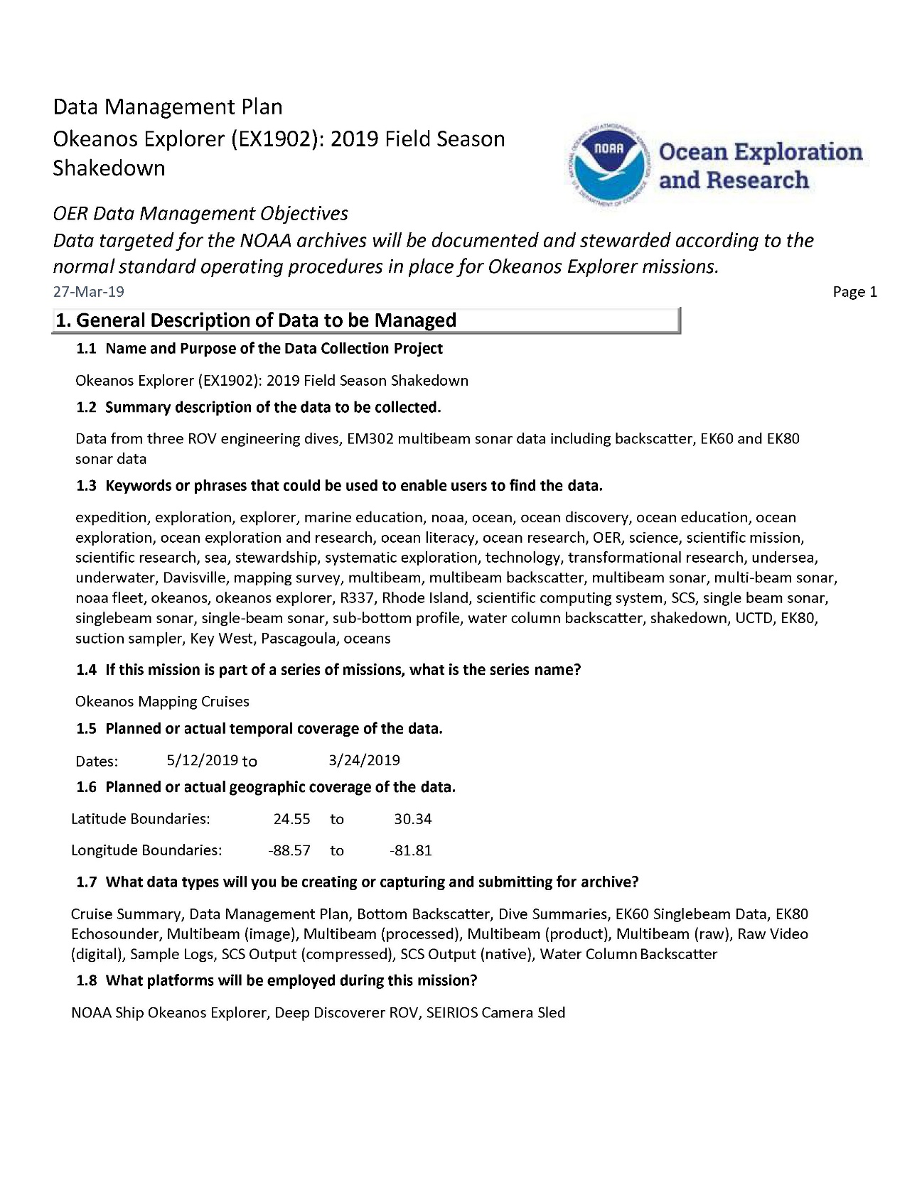Appendix B: Data Management Plan

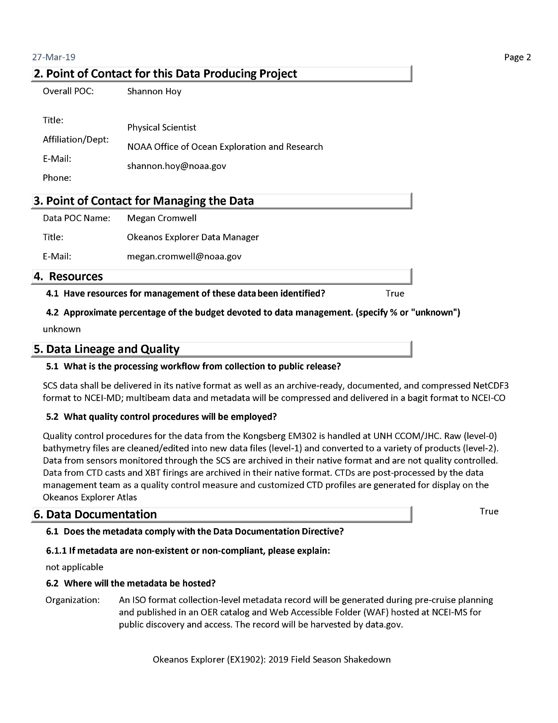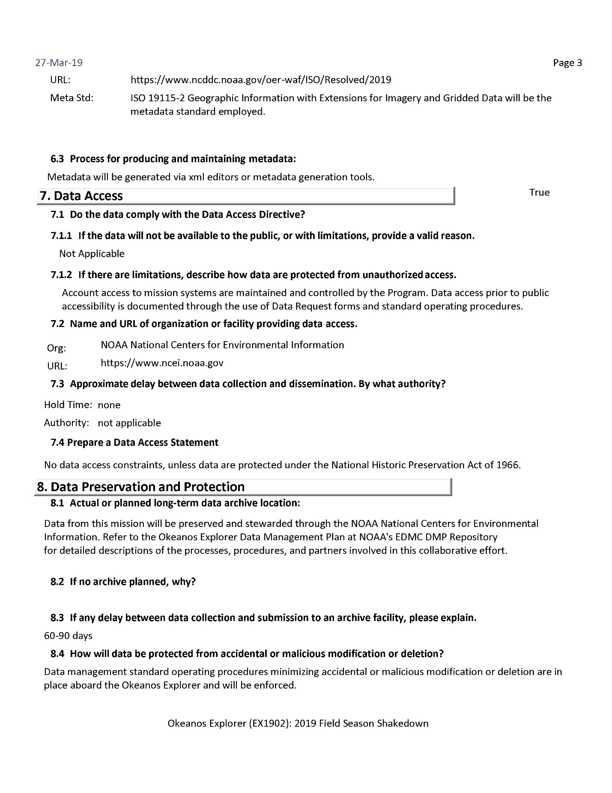

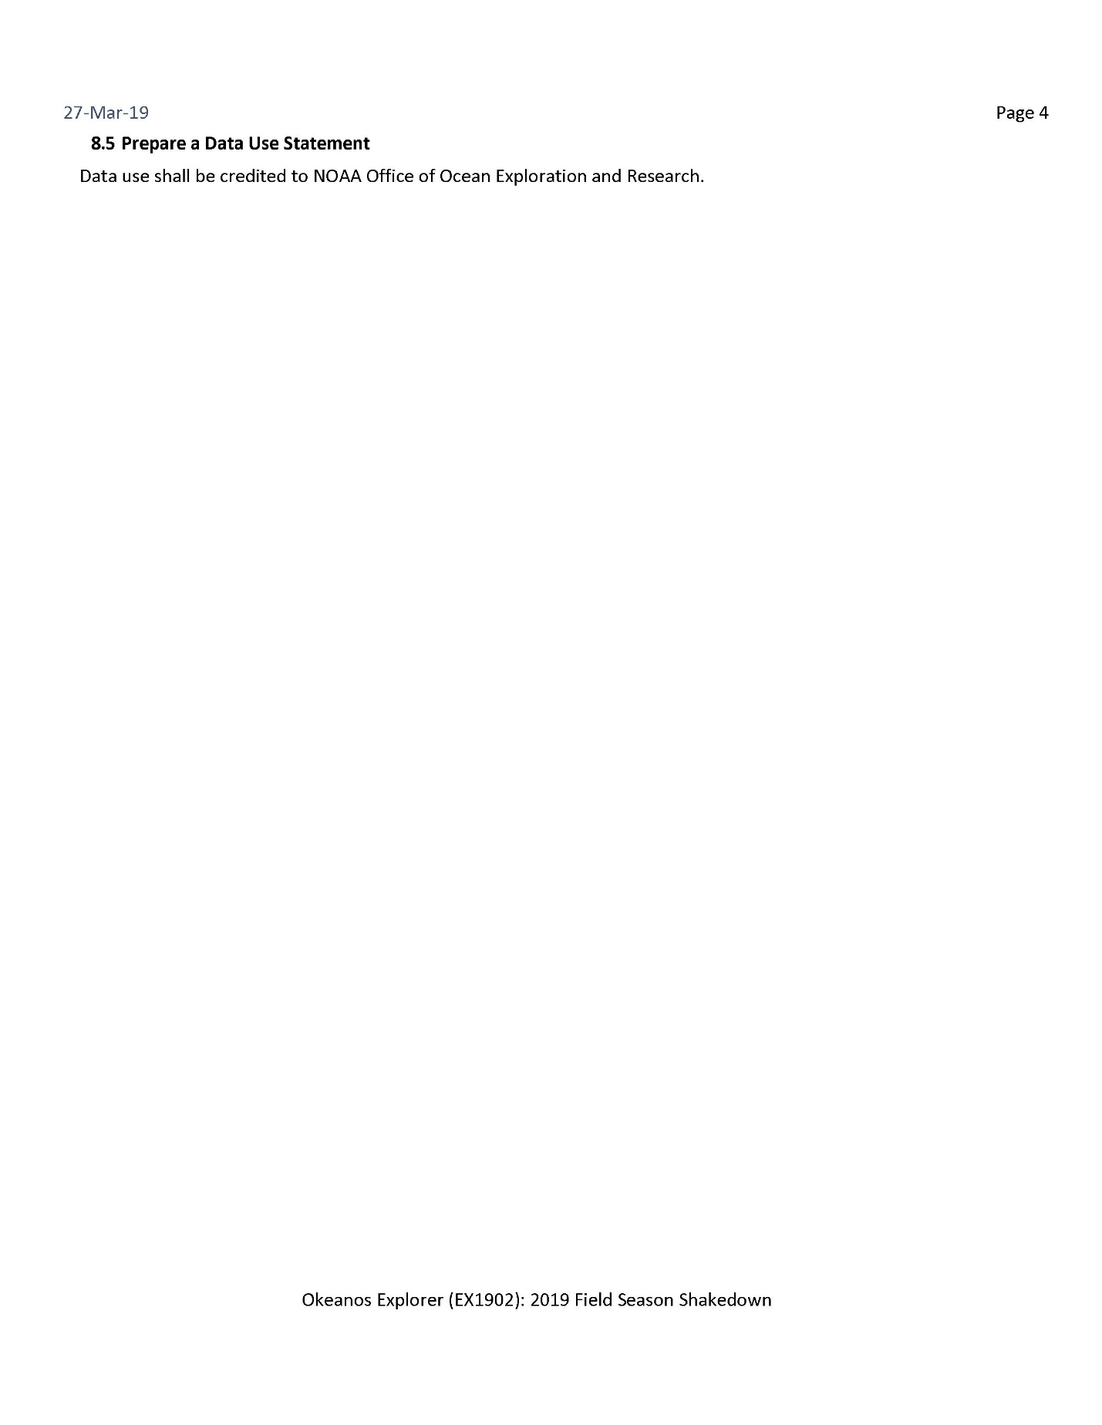

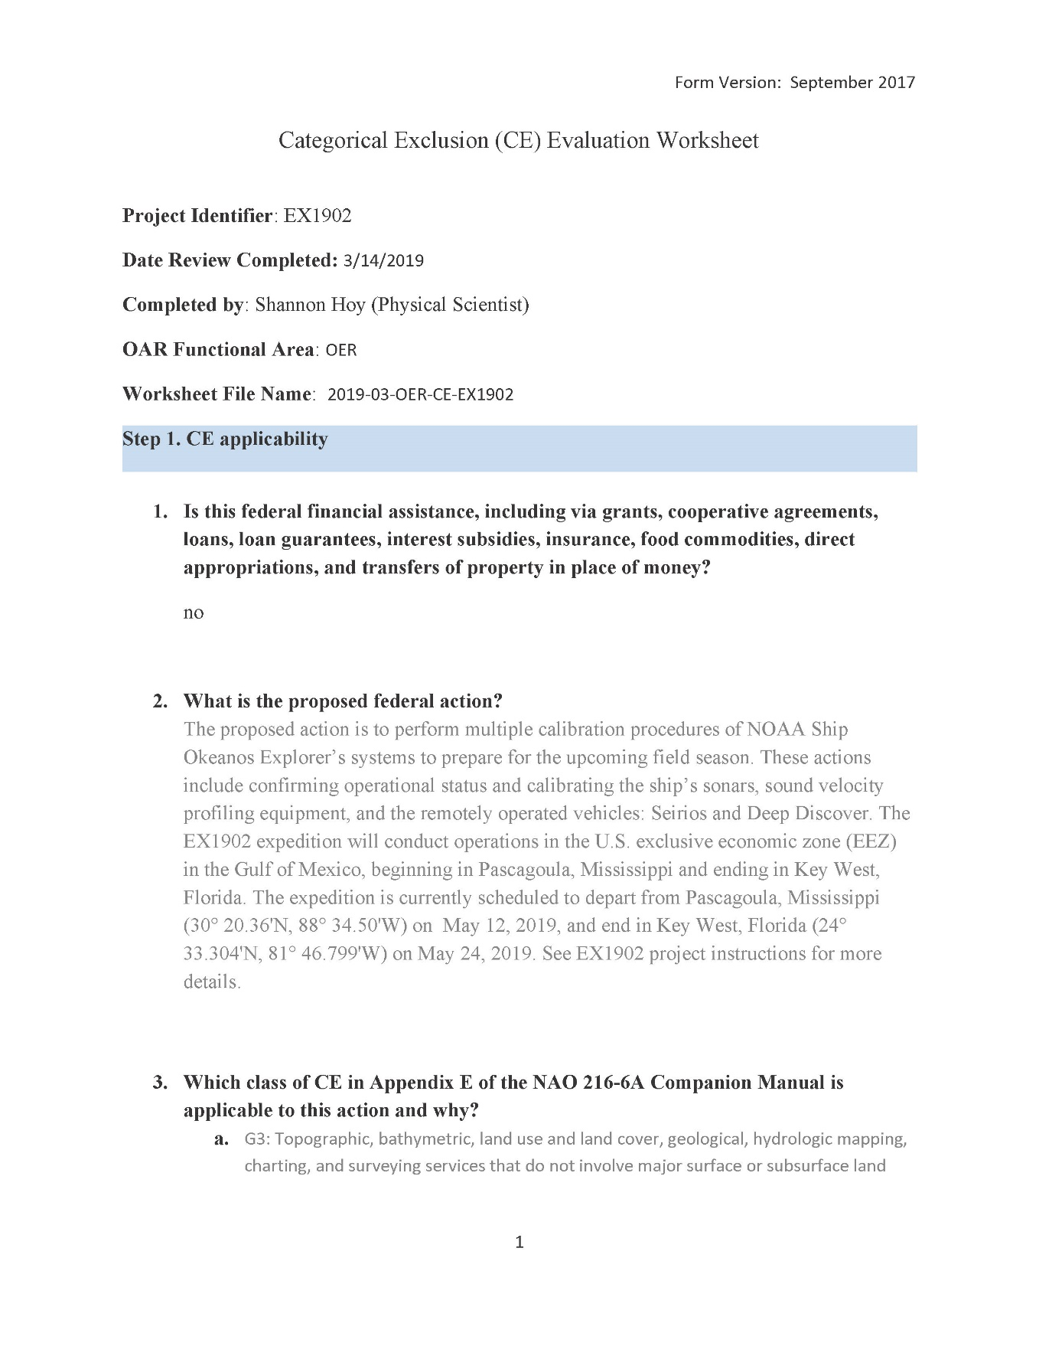Appendix C: Categorical Exclusion

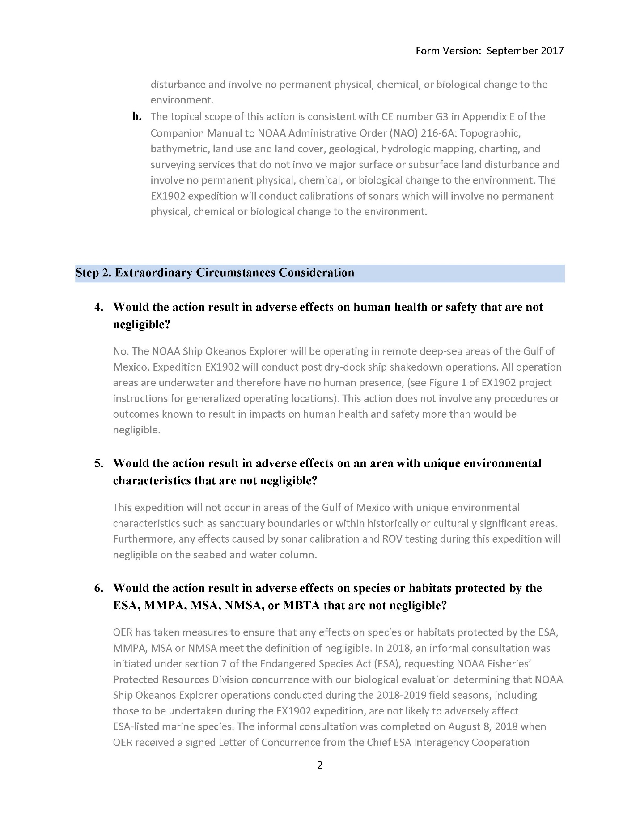

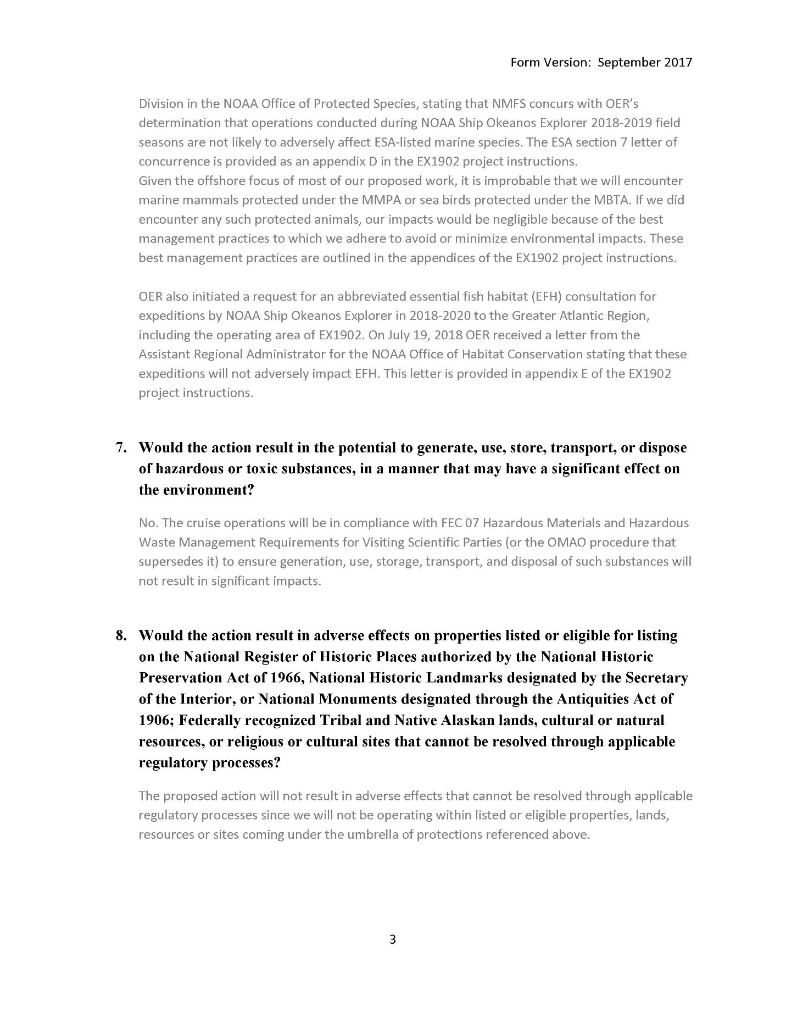

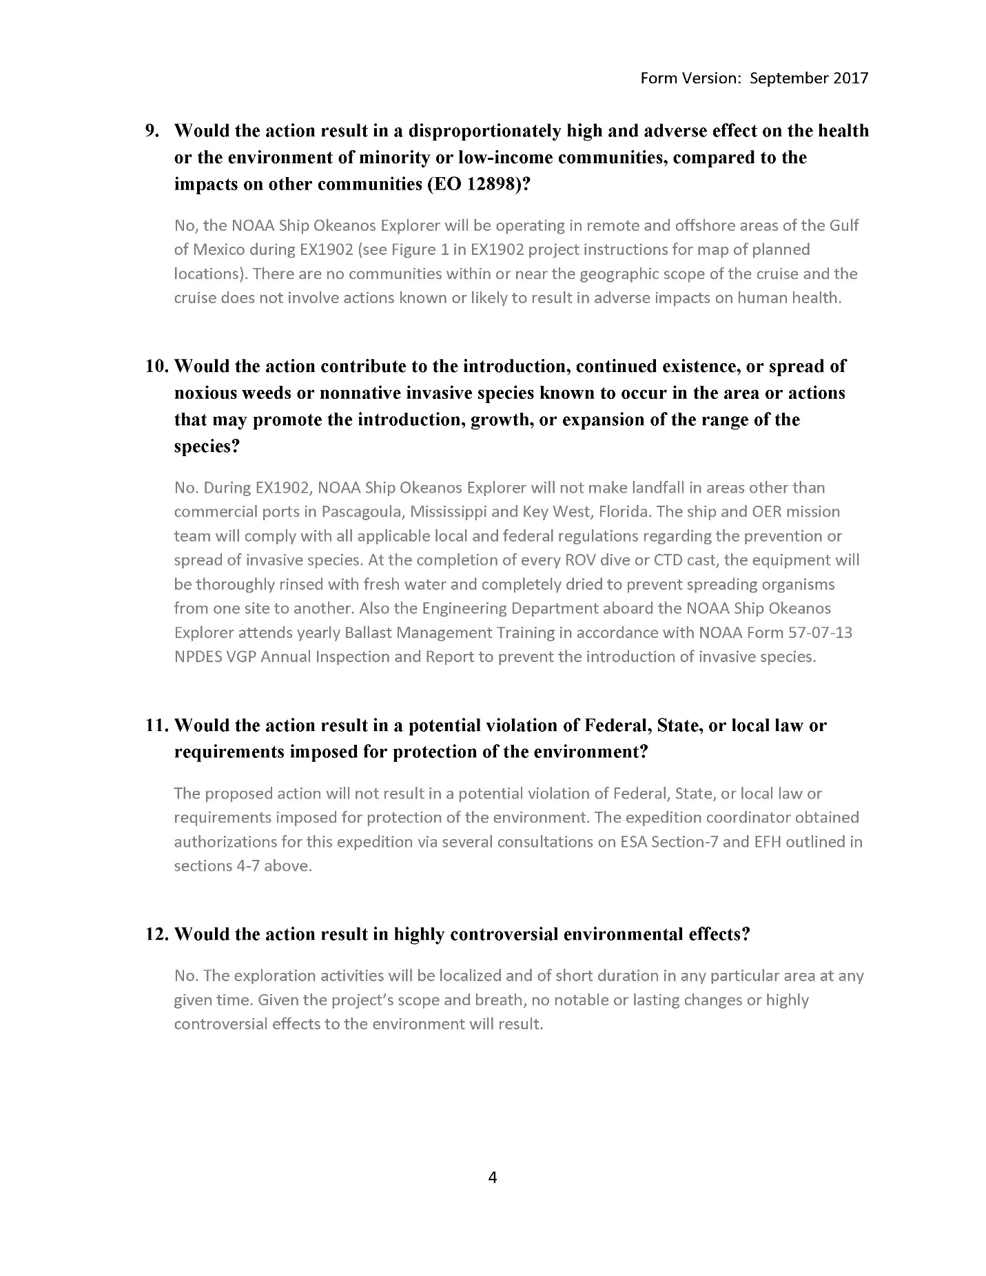

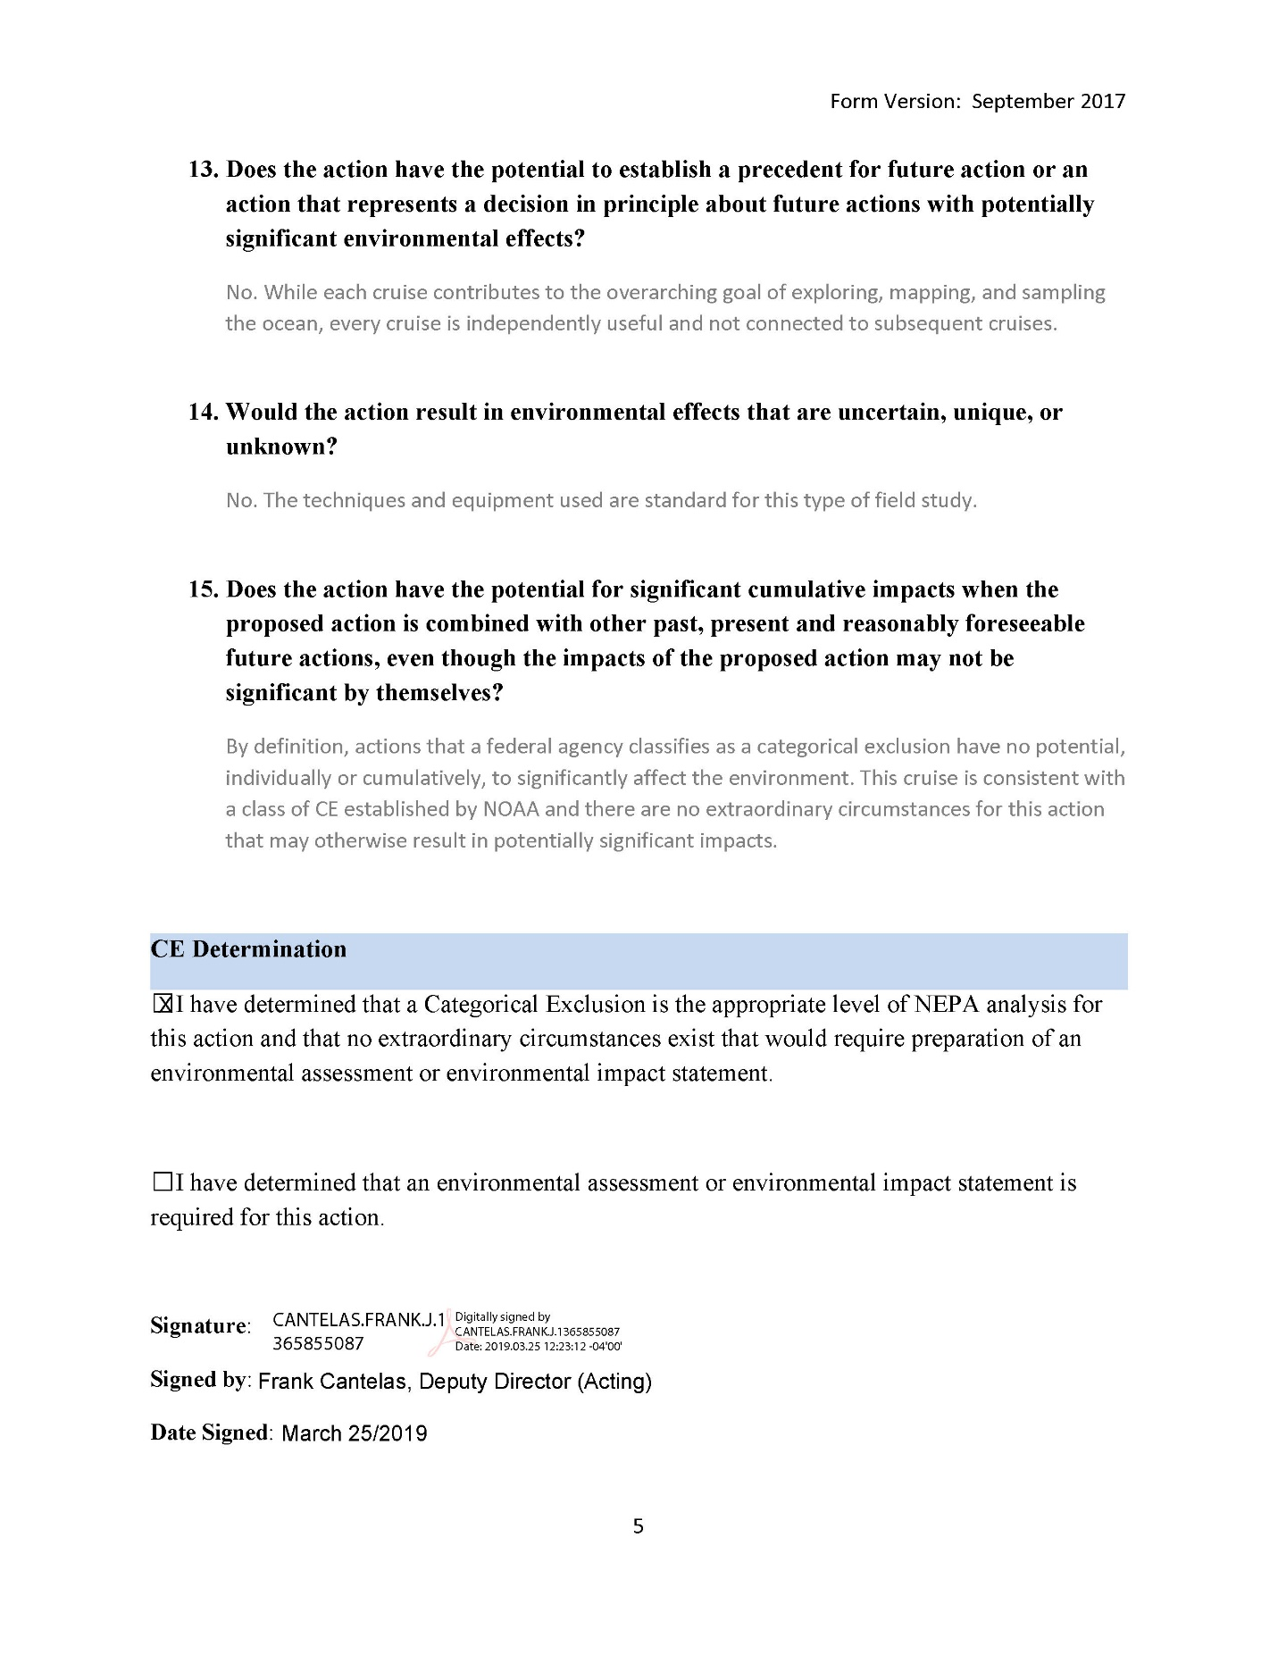

Appendix D: ESA Section 7 Concurrence Letter

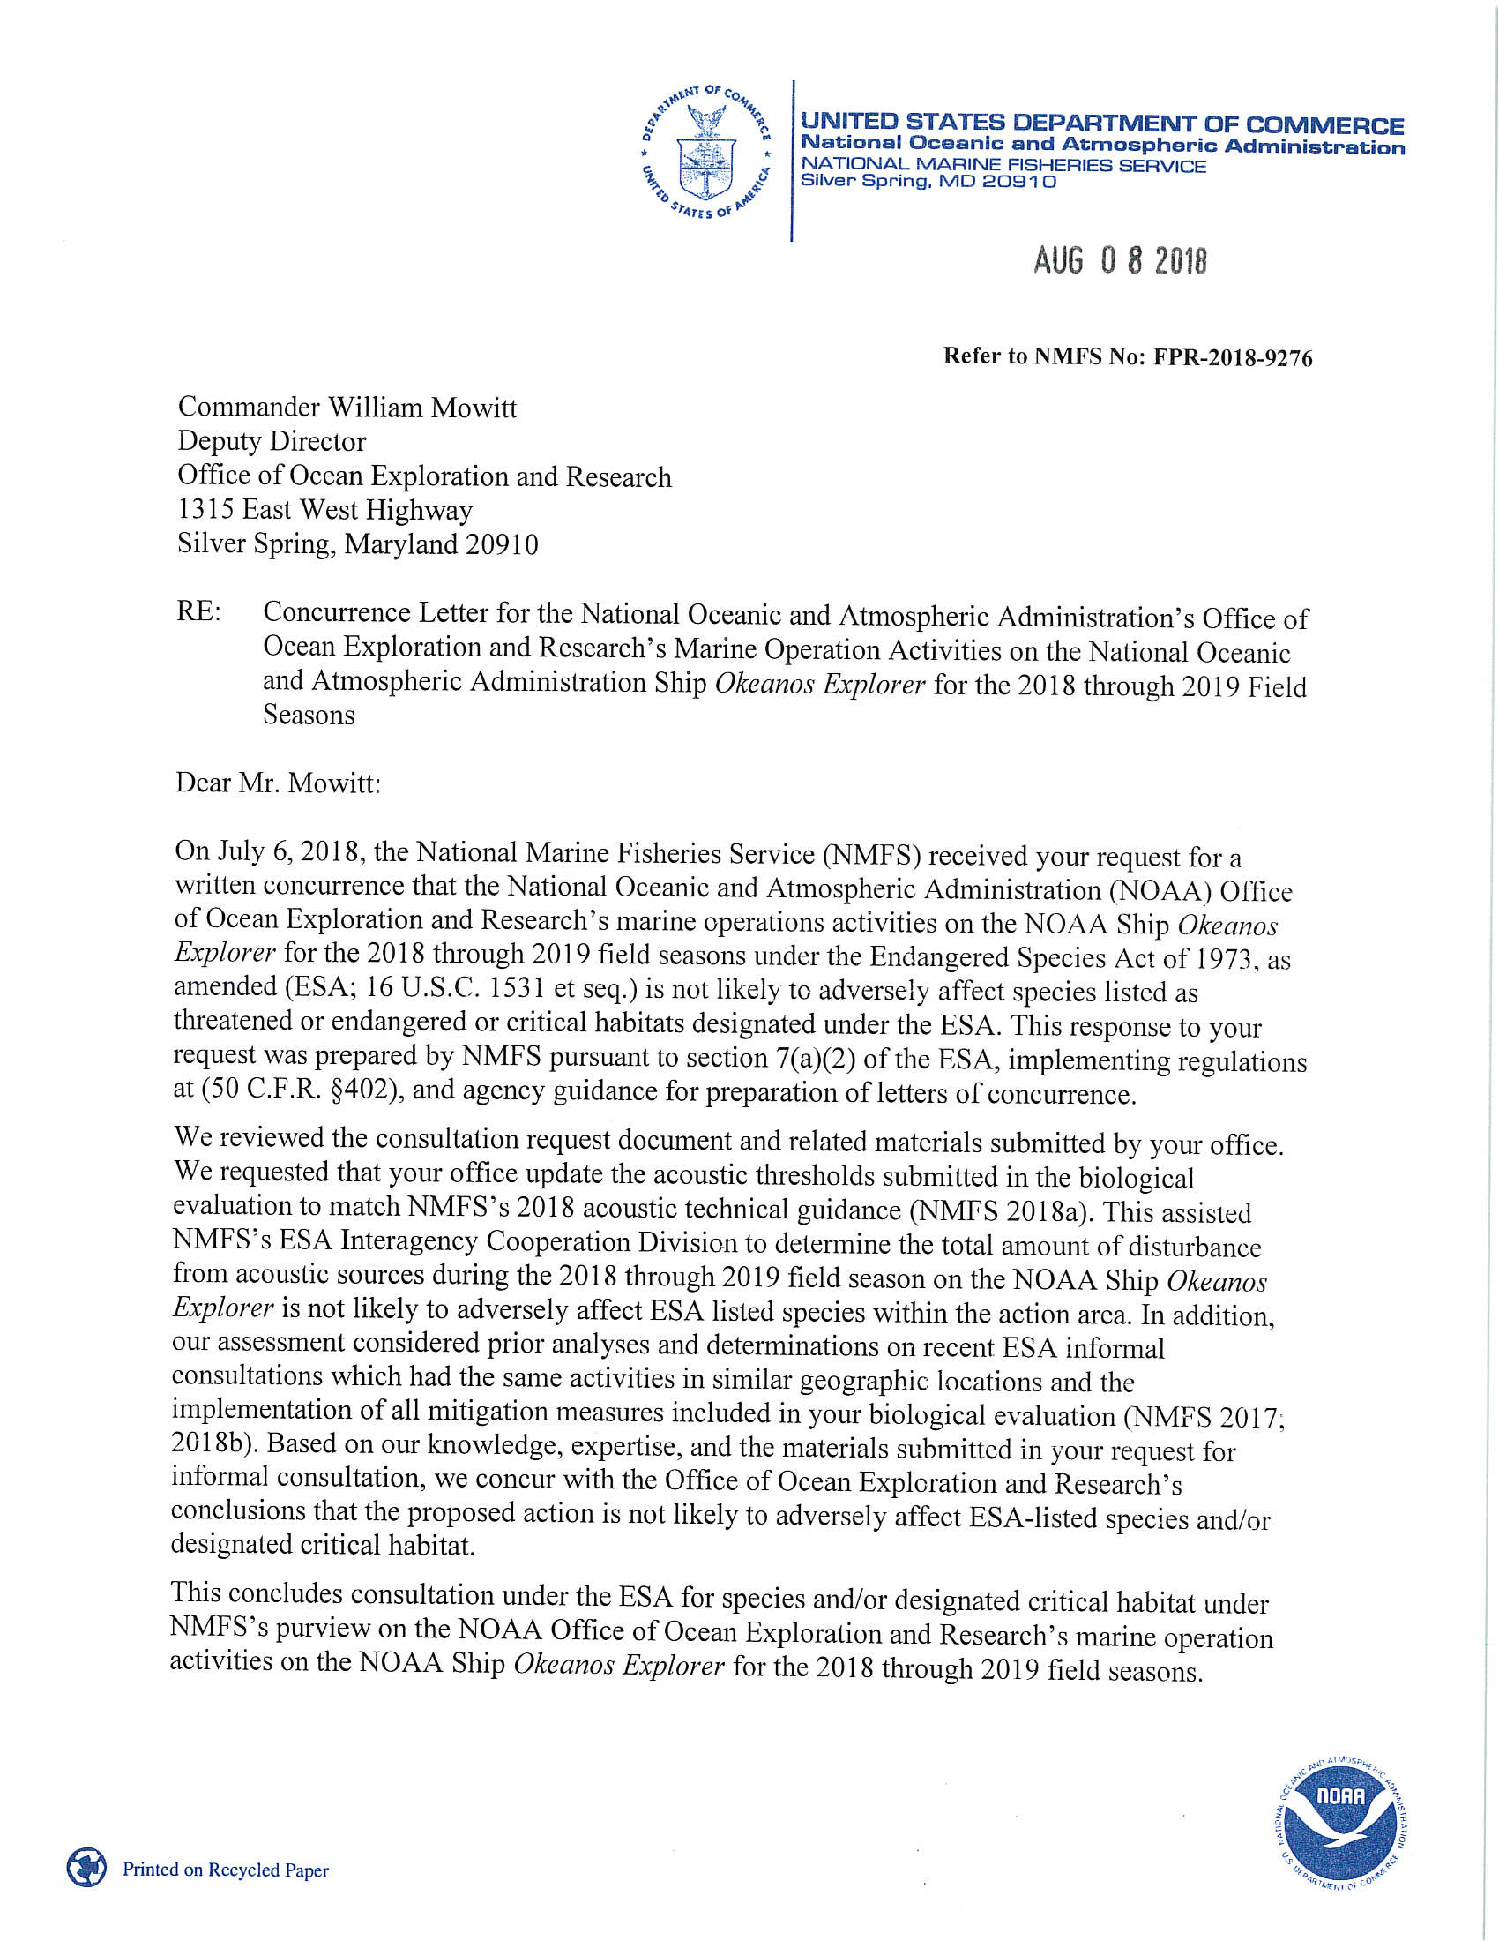

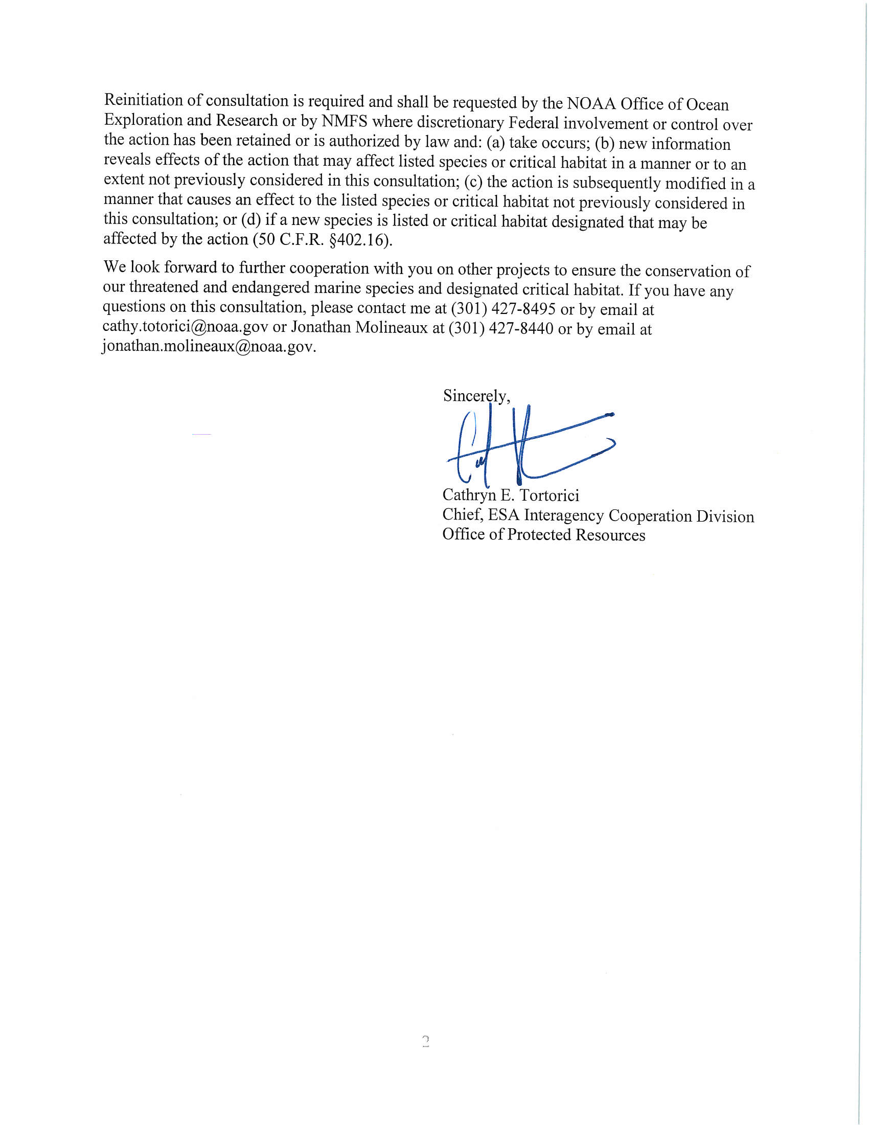

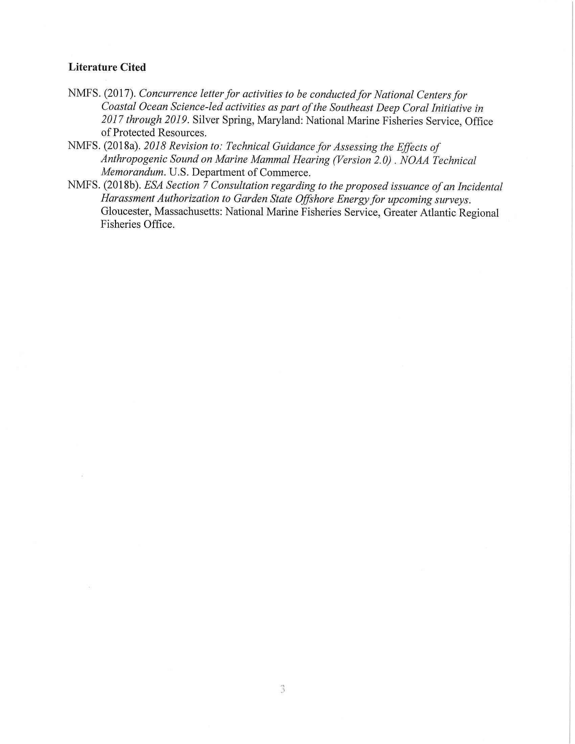

Appendix E: EFH Concurrence Letter

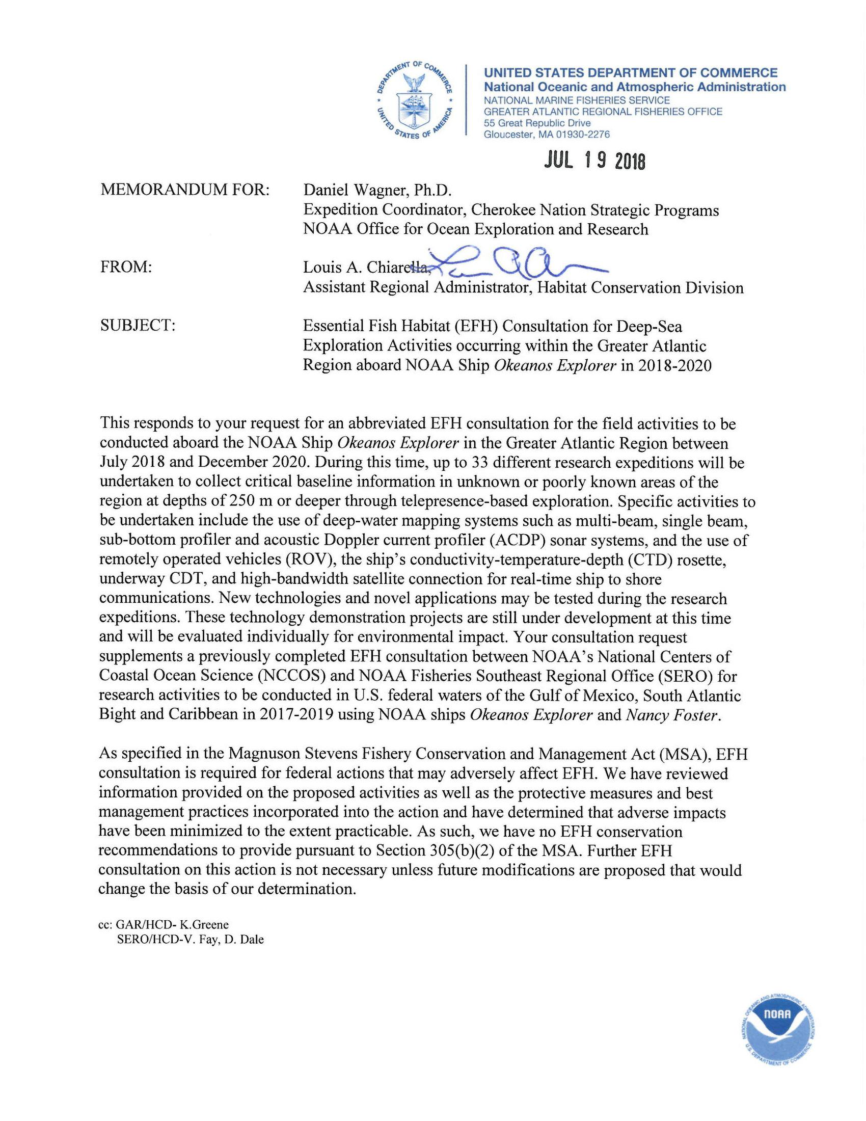

Appendix F: Summary of Mitigation Measures and Best Management Practices

Protective Measures and Best Management Practices (BMPs) Incorporated into the Action. BMPs are required to be incorporated within project instructions, cruise plans and NEPA documentation including financial assistance awards and environmental review memoranda. All applicable BMPs must be communicated to the science leads, boat operators and field staff, and as necessary between ship’s crew (Commanding Officer/Master or designee(s), as appropriate) and scientific party in order to explain responsibilities, communication procedures, marine mammal monitoring protocol, and operational procedures.

Bridge Watchstanders on the *Okeanos Explorer’s* bridge will carefully monitor for the presence of marine protected species, and permitted personnel would follow established best management practices (BMPs) to minimize disturbance.

1. **Minimize Exposure to Elevated Noise Levels**
   1. Maintain watch for the presence of marine protected species. Immediately notify the survey department of the proximity of cetaceans and sea turtles.When marine mammals are able to be identified by Bridge Officers or Watch Standers, these observations are noted in the NOAA fleet marine mammal observation log as part of standard practice.
      1. If a sea turtle is present within 400 m of the ship, the survey department will respond by stopping the pinging of the sub-bottom sonar. The sub-bottom shall remain off until the sea turtle has departed the 400 m safety zone.
      2. If cetaceans are present within 400 m of the ship (460 m/500 yards for North Atlantic Right Whales), the vessel would stop if the animal is in danger of colliding with the ship but the mapping sonars would continue transmitting to avoid startle responses. If an observed animal is unable or unwilling to depart the immediate area, sonars will be secured and the ship will slowly move away from the area if feasible.
      3. If the cetacean is within 400 m (460 m/500 yards for North Atlantic Right Whales) and is not in danger of collision, reduce speed and seek to avoid the animal as much as possible.
      4. The Survey Department will respond by stopping the pinging of the sub-bottom sonar and switching the multibeam sonar into “mammal protection” mode (keeps it pinging but at a source level reduced by 20 decibels). No change will occur to the EK 60s. Note: the ADCPs are never run simultaneously with the multibeam and sub-bottom, so they would already be off. The ADCPs are mostly run when the ship is stationary at a dive site and risk to marine mammals is minimal.
   2. Minimize turning all sonar sound sources on and off as a precautionary measure to avoid possible startling of animals.
   3. When the systems have been shut down for any reason, the multibeam mammal protection mode would be used to turn the multibeam back on first. Only after the multibeam has been brought from mammal protection mode to full power would the sub-bottom profiler and EK 60 sonars then be turned back on.
   4. If the multibeam sonar is not being used, but other sonar systems are being turned on, they will be started in lower power settings and will gradually (over a 15 minute time period) be adjusted to higher power settings as appropriate for the water depths to essentially mimic the approach of the “mammal protection” mode of the multibeam.
2. **Minimize Temporary Disturbance from Human Activity**
   1. All in-water work will be postponed when whales are within 100 yards, or other protected species are within 50 yards;
      1. This includes posposting start-up of the USBL in preparation for an ROV dive.
   2. Should a marine protected species enter the area while in-water work is already in progress, the activity may continue only when that activity has no reasonable expectation to adversely affect the animal(s); and
   3. No attempts will be made to feed, touch, ride, or otherwise intentionally interact with any marine protected species.
3. **Minimize Entanglement**
   1. Maintain watch for and avoid the presence of marine protected species. Notify the department heads of the proximity of animals;
   2. All in-water work will be postponed when whales are within 100 yards, or other protected species are within 50 yards of the vessel;
   3. Should a marine protected species enter the area while in-water work is already in progress, the activity may continue only when that activity has no reasonable expectation to adversely affect the animal(s); and
   4. Individuals participating in the activity will closely monitor the instrument cables at all times while they are deployed.
4. **Minimize Collisions with Vessels**

The [following guidelines](http://sero.nmfs.noaa.gov/protected_resources/section_7/guidance_docs/documents/copy_of_vessel_strike_avoidance_february_2008.pdf) for vessel operation in the presence of marine protected species and other marine wildlife are provided by the Bureau of Ocean Energy Management in a Notice to Lessees and Operators, and NOAA Fisheries as part of a Biological Opinion:

* 1. *Vessel Strike Avoidance*

Vessel operator and crew must maintain a vigilant watch for all marine mammals and sea turtles and slow down or stop the vessel or alter course, as appropriate, to avoid striking any marine mammal. These requirements apply when the vessel is in transit and do not apply in any case where compliance will create an imminent and serious threat to a person or vessel or to the extent that a vessel is restricted in its ability to maneuver and, because of the restriction, cannot comply. A visual observer aboard the vessel must monitor a vessel strike avoidance zone around the vessel according to the parameters stated below. Visual observers monitoring the vessel strike avoidance zone can be either third-party visual protected species observers or crew members, but crew members responsible for these duties must be provided sufficient training to distinguish marine mammals from other phenomena. Vessel strike avoidance measures shall be followed during sonar surveys and while in transit.

Vessel personnel should do the following in order to avoid causing injury or death to marine mammals and sea turtles:

* + 1. Maintain a vigilant watch for marine mammals and sea turtles and slow down or stop their vessel to avoid striking protected species.
    2. When whales are sighted, maintain a distance of 100 yards (91 meters) or greater from the whale. If the whale is believed to be a North Atlantic right whale, vessel personnel should maintain a minimum distance of 500 yards (460 meters) from the animal (50 CFR 224.103).
    3. When sea turtles or small cetaceans are sighted, attempt to maintain a distance of 50 yards (45 meters) or greater whenever possible.
    4. When cetaceans are sighted while a vessel is underway, attempt to remain parallel to the animal's course. Avoid excessive speed or abrupt changes in direction until the cetacean has left the area.
    5. Reduce vessel speed to 10 knots or less when mother/calf pairs, pods, or large assemblages of cetaceans are observed near an underway vessel when safety permits. A single cetacean at the surface may indicate the presence of submerged animals in the vicinity of the vessel; therefore, precautionary measures should always be exercised.
    6. Whales may surface in unpredictable locations or approach slowly moving vessels. When vessel personnel sight animals in the vessel's path or in close proximity to a moving vessel, reduce speed and shift the engine to neutral. Do not engage the engines until the animals are clear of the area.

The vessel must maintain a minimum separation distance of 100 m (328.1 ft) from large whales (i.e. sperm and baleen whales). The following avoidance measures must be taken if a large whale is within 100 m (328.1 ft) of the vessel.

* The vessel must reduce speed and shift the engine to neutral, and must not engage the engines until the whale has moved outside of the vessel’s path and the minimum separation distance has been established.
* If the vessel is stationary, the vessel must not engage engines until the whale(s) has moved out of the vessel’s path and beyond 100 m (328.1 ft).
  1. *Additional Requirements for the North Atlantic Right Whale*
     1. If a sighted whale is believed to be a North Atlantic right whale, federal regulation requires a minimum distance of 500 yards be maintained from the animal (50 CFR 224.103 ©).
     2. Vessels entering North Atlantic right whale critical habitat are required to report into the Mandatory Ship Reporting System.
     3. Mariners shall check with various communication media for general information regarding avoiding ship strikes and specific information regarding North Atlantic right whale sighting locations. These include NOAA weather radio, U.S. Coast Guard NAVTEX broadcasts, and Notices to Mariners. Commercial mariners calling on United States ports should view the most recent version of the NOAA/USCG produced training CD entitled “A Prudent Mariner’s Guide to Right Whale Protection” (contact the NMFS Southeast Region, Protected Resources Division for more information regarding the CD).
     4. Injured, dead, or entangled right whales should be immediately reported to the U.S. Coast Guard via VHF Channel 16.
     5. Adherence to seasonal vessel speed restrictions of 10 knots or less as [designated locations](http://www.nmfs.noaa.gov/pr/pdfs/shipstrike/map_sma.pdf) along the U.S. east coast.
     6. Adherence to NOAA Compliance Guide for Right Whale Ship Strike Reduction Rule.

1. **Minimize Vessel Waste and Discharge & Prevent Invasive Species**
   1. All vessels operating in areas where ESA-listed species are present will continue to follow MARPOL discharge protocols, but will postpone any authorized discharge if any protected species are within 100 yards of the vessel.
   2. Meet all EPA Vessel General Permits and Coast Guard requirements.
   3. Avoid discharge of ballast water in designated critical habitat.
   4. Use anti-fouling coatings.
   5. Clean hull regularly to remove aquatic nuisance species.
   6. Avoid cleaning of hull in critical habitat.
   7. Avoid cleaners with nonylphenols.
2. **Avoid or Minimize Impacts to Essential Fish Habitat**
   1. The vessel would employ the use of dynamic positioning during ROV dives (no anchoring);
   2. ROVs would be operated in a manner to avoid seafloor disturbance, and setting the ROV on the seafloor will be held to a minimum. For those situations when the ROV does make contact with the seafloor, visual observations will be made to confirm that the area the ROV is set down on does not include corals or other fragile animals that can reasonably be avoided;
   3. Sample collections would be limited (typically 4 - 6 total rocks and primary biological specimens per dive) that represent new species, new records, the dominant morphotype animal in a community, or species to support connectivity studies. These specimens would be collected using the ROV’s manipulator arms or scoop. Whenever possible, sample collections will be made using the cutting implementation tool on the ROV, and only portions of organisms (<50 cm) will be collected to avoid mortality. Clonal biological specimens (corals, sponges) would be subsampled;
   4. When possible, rock samples will be selected in a way to minimize disturbance to the surrounding environment and to minimize the take of attached organisms.;
   5. After each ROV dive, the vehicles are brought back onboard and thoroughly sprayed with freshwater and allowed to air dry before the next dive. Though marine organisms should not survive this process, the ROV is thoroughly inspected prior to every dive and checked for the presence of biological organisms to prevent the spread of invasive or non-endemic species from one location to another;
   6. Instruments deployed to collect water samples and current data (except for expendable instruments) would not be allowed to contact the seafloor;
   7. The use detergents and other pollutants which may be washed into the marine environment will be avoided or held to a minimum;
   8. The vessel will adhere to MARPOL discharge regulations at all times during the proposed cruises;
   9. Except in an emergency, the vessel will not anchor while at sea.

Appendix G: NASA Maritime Aerosols Network Survey of Opportunity

# Survey or Project Name

Maritime Aerosol Network

# Lead POC or Principle Investigator (PI & Affiliation)

POC: Dr. Alexander Smirnov

# Supporting Team Members Ashore

# Supporting Team Members Aboard (if required)

# Activities Description(s)(Include goals, objectives and tasks)

The Maritime Aerosol Network (MAN) component of AERONET provides ship-borne aerosol optical depth measurements from the Microtops II sun photometers. These data provide an alternative to observations from islands as well as establish validation points for satellite and aerosol transport models. Since 2004, these instruments have been deployed periodically on ships of opportunity and research vessels to monitor aerosol properties over the World Oceans.