Project Instructions
Date Submitted: 10/19/2018

Platform: NOAA Ship Okeanos Explorer

Project Number: EX-18-11

Project Title: Puerto Rico and U.S. Virgin Islands (ROV & Mapping)

Project Dates: October 30 - November 20, 2018

Prepared by:________________________ Dated: __________
Daniel Wagner
Expedition Coordinator
NOAA Office of Ocean Exploration & Research

Approved by:________________________ Dated: __________
Craig Russell
Program Manager
NOAA Office of Ocean Exploration & Research

Approved by:________________________ Dated: __________
Captain David Zezula
Commanding Officer
NOAA Marine Operations Center - Atlantic

I. Overview
“America’s future depends on understanding the ocean. We explore the ocean because its health and resilience are vital to our economy and to our lives. We depend on the ocean to regulate weather and climate; sustain a diversity of life; for maritime shipping and national defense; and for food, energy, medicine, and other essential services to humankind.”
- NOAA Office of Ocean Exploration and Research Strategic Plan

A. Brief Summary and Project Period
This document contains project instructions for EX-18-11. Operations for this cruise will be conducted 24 hours/day and consist of daily remotely operated vehicle (ROV), overnight mapping and CTD operations, and full shore-based participation via telepresence. The expedition will commence on October 30, 2018 in San Juan, Puerto Rico (U.S. Coast Guard Sector San Juan, 5 Calle La Puntilla, San Juan, Puerto Rico 00901) and conclude on November 20, 2018 in San Juan, Puerto Rico (Puerto Rico Port Authority Pier 1, San Juan, Puerto Rico 00901). Operations will include the use of the ship’s deep-water mapping systems (Kongsberg EM302 multibeam sonar, EK60 split-beam fisheries sonars, Knudsen 3260 chirp sub-bottom profiler sonar, and Teledyne Acoustic Doppler Current Profiler), XBTs in support of multibeam sonar mapping operations, CTD casts, OER’s two-body ROV system (Deep Discoverer and Seirios), and the ship’s high-bandwidth satellite connection for continuous ship-to-shore communications. Operations will focus on exploring deep waters (>250 m) in the U.S. exclusive economic zone (EEZ) of the Caribbean Sea, as well as in territorial waters surrounding surrounding Puerto Rico and the U.S. Virgin Islands.

NOAA’s Office of Ocean Exploration and Research (OER) is the only federal organization dedicated to exploring the global ocean. OER works with partners to identify priority areas for exploration, support innovations in exploration tools and capabilities, and encourage the next generation of ocean explorers, scientists, and engineers to pursue careers in ocean exploration and related fields. The data and information collected during our expeditions and the research we fund gives resource managers, the academic community, and the private sector the information they need to identify, understand, and manage ocean resources for this and future generations.

NOAA Ship Okeanos Explorer is the only U.S. federal vessel dedicated to exploring our largely unknown ocean for the purpose of discovery and the advancement of knowledge. America’s future depends on understanding the ocean. We explore the ocean to make valuable scientific, economic, and cultural discoveries, and because ocean health and resilience are vital to our economy and to our lives. Exploration supports NOAA mission priorities and national objectives by providing high-quality scientific information about the deep ocean to anyone who needs it.
In close collaboration with government agencies, academic institutions, and other partners, OER conducts deep-sea exploration expeditions using advanced technologies on NOAA Ship Okeanos Explorer. From mapping and characterizing previously unseen seafloor to collecting and disseminating information about ocean depths, this work helps to establish a foundation of information and to fill data gaps. Data collected on the ship follow federal open-access data standards and are publicly available shortly after an expedition ends. This ensures the delivery of reliable scientific data needed to identify, understand, and manage key elements of the ocean environment.

EX-18-11 will be one of several NOAA Ship Okeanos Explorer expeditions in 2018-2020 that will contribute to NOAA’s Atlantic Seafloor Partnership for Integrated Research and Exploration (ASPIRE), a major multi-year, multi-national, collaborative ocean exploration program focused on raising our collective knowledge and understanding of the North Atlantic Ocean. The North Atlantic Ocean, including the Caribbean Sea, plays a pivotal role to humankind, providing biological and geological resources, ecosystem services such as seafood production and climate regulation, and a route for trade and travel between Europe and the Americas. However, we have only begun to understand the North Atlantic Ocean’s ecosystems, resources and oceanography, as much about the seabed bathymetry, geology, mineralogy, and trans-Atlantic connectivity of biological communities remains unknown.

Building on previous work in the North Atlantic, NOAA’s ASPIRE campaign will provide data to inform research planning and management decisions in the region, by broadening both the geographic focus to include more of the U.S. Atlantic and the high seas, and the scope of partnerships to include U.S. federal agencies, such as U.S. Geological Survey (USGS) and Bureau of Ocean Energy Management (BOEM), as well as international partners from the European Union and Canada. Aside from ASPIRE, the EX-18-11 expedition will also contribute to the ongoing collaborations with several NOAA offices, such as the NOAA’s Deep-Sea Coral Research and Technology Program and its partners for the Southeast Deep Coral Initiative (SEDCI), which include the NOAA National Centers for Coastal Ocean Science, the NOAA National Marine Fisheries Service, and the Caribbean Fishery Management Council. Geographic and thematic priority areas for EX-18-11 were all identified by the resource management and scientific community, in response to a call for community input that was disseminated widely in July-August 2018.

B. Days at Sea (DAS)
All 22 DAS scheduled for this project are funded by Oceanic and Atmospheric Research (OAR) Allocation. This project is estimated to exhibit a high operational tempo due to 24 hour operations consisting of daily ROV dives, overnight mapping operations and CTD rosette casts, and continuous shore-side participation via telepresence.

C. Operating Area
EX-18-11 is a combined ROV and mapping expedition, with operations being conducted in the U.S. EEZ of the Caribbean Sea (<200 nm from shore), as well as in territorial waters surrounding both Puerto Rico (<9 nm from shore) and the U.S. Virgin Islands (<3 nm from shore). Mapping, ROV, and CTD rosette operations will focus in exploring depths generally between 250 and 6,000 meters (Figure 1).

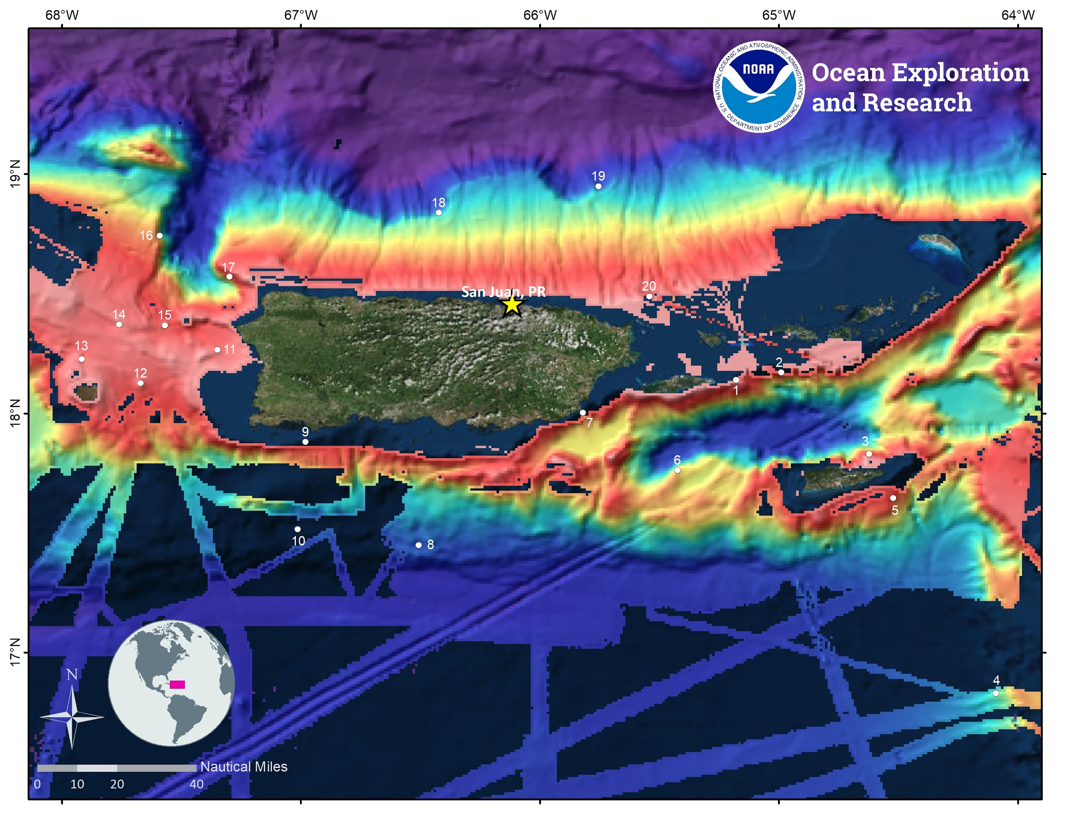
Figure 1: Overview map for the EX-18-11 expedition showing priority areas ROV operations (white circles) overlaid onto existing multibeam mapping data of the region. The labels correspond to the ROV dive number in the draft cruise itinerary (see Table 2). Mapping will be done in the vicinity of all dive sites to support ROV operations, as well as in nearby areas where no high-resolution multibeam data exists.

Table 1: Bounding coordinates of the EX-18-11 operating area. Operations are planned within the U.S. EEZ of the Caribbean Sea, as well as in territorial waters surrounding Puerto Rico and the U.S. Virgin Islands.
Generalized operating area coordinates
ID | Latitude | Longitude
SW corner | 16° 49.740’N | 68° 15.423'W
SE corner | 16° 49.740’N | 64° 5.635'W
NE corner | 20° 21.583’N | 64° 5.635'W
NW corner | 20° 21.583 ’N | 68° 15.423'W

D. Summary of Objectives
October 30- November 20, 2018 (San Juan, Puerto Rico - San Juan, Puerto Rico) Telepresence-enabled ROV, CTD rosette, and mapping operations.
EX-18-11 operations will occur in deep (>250 m) U.S. federal waters of the Caribbean Sea, as well as in territorial waters off Puerto Rico (<9 nm from shore) and the U.S. Virgin Islands (<3 nm from shore). This expedition will collect critical baseline information to support priority NOAA science and management needs, including in multiple marine protected areas (MPAs) and other priority management areas of the U.S. Caribbean region.

Mission objectives for EX-18-11 include a variety of objectives focused on science, mapping, education, outreach, and data management:
- Science
  - Acquire data on deepwater habitats to support science and management needs in Caribbean waters off Puerto Rico, the U.S. Virgin Islands, and in support of ASPIRE.
  - Explore areas relevant to resource managers such as essential fish habitat (EFH), habitat areas of particular concern (HAPC), national marine monuments, MPAs, or other priority areas for management or conservation.
  - Identify, map and explore the diversity and distribution of benthic communities, including deep-sea coral and sponge communities, fish habitats, and chemosynthetic communities.
- Collect data on habitat size, animal diversity and density;
- Focus close-up imaging operations on potential new, rare and poorly documented species, as well as dominant members of these communities.
- Collect, document and preserve biological specimens of potential new species, new records, numerically dominant members of the community (if not easily recognized), animals to support connectivity studies, other animals to aid in site characterization, and any animals requested and identified as high priority collections by the scientific community.
- Document substrate types as it relates to characterizing habitat suitability of various deep-sea benthic species.
- Support transatlantic connectivity studies through collection of biological specimens.
- Investigate biogeographic patterns and connectivity of deep-sea organisms for use in broader comparisons of deep-water habitats across the Atlantic Basin.
  - Map, survey, and sample geologic features to better understand the geological context of the region and improve knowledge of past and potential future geohazards.
- Collect, document and preserve geologic specimens that can be used to age a feature, provide additional insight into the geological context of the region, or improve knowledge of potential geohazards.
  - Identify, map, and explore the diversity and distribution of midwater communities and organisms.
- Collect data on habitat size and extent, animal diversity and density.
- Focus close-up imaging operations on potential new, rare and poorly documented species, as well as dominant members of these communities.
  - Acquire ROV, sonar, and oceanographic data as a foundation to better understand the characteristics of the water column and the pelagic fauna that live there.
  - Continue to refine specimen collection procedures, including testing of components of the new ROV suction sampler, as well as collection of water samples via ROV-mounted Niskin bottles.
  - Ground-truth acoustic mapping data using ROV video imagery in order to further characterize seafloor habitats.
  - Engage a broad spectrum of the scientific and the management community, as well as the general public in telepresence-based exploration.
  - Conduct operations in conjunction with shore-based exploration command centers and remote science team participants.
  - Create and provide input into standard science products to provide a foundation of publicly accessible data and information products to spur further exploration, research, and management activities.

- Remote Science/ Exploration Command Centers
  - Provide operational support and training to scientists and managers to enable remote participation in at-sea operations.
  - Continue to test best practices for hosting live interactions.
  - Facilitate outreach and engagement activities and events at ECCs and other facilities that host interactions.
  - Test and refine ship-to-shore communications procedures that engage multiple ECCs and other remote participants.
  - Test and refine operating procedures and products.
  - Test a new version of SeaTube (SeaTubeV2) to conduct real-time science annotations during ROV dives.

- ROV Engineering
  - Conduct calibration of the USBL navigation system on the first ROV dive, which will be conducted over a flat sandy bottom to a target depth of 500-1000 m.
  - Daytime ROV dives on exploration targets.
  - Ongoing training of engineers and pilots.
  - Ongoing system maintenance, documentation, and training.
  - Continue refining methods for collecting water samples using the ROV-mounted Niskin bottles.
  - Limited testing on components of the new ROV suction sampler; components of the suction sampler will be installed for testing during the cruise, but the ROV-suction sampler will not be operational during the cruise.

- Video Engineering (VSAT ~15 mb/sec ship-to-shore; 5 mb/sec shore-to-ship)
  - Test terrestrial and high-speed satellite links.
  - Support telepresence-enabled ROV operations.
  - Collect standard video products.
  - Facilitate live outreach events between ship and shore (see list of scheduled live interactions under outreach section below).

- Mapping
  - Collect high-resolution mapping data from sonars in priority areas as dictated by operational needs, as well as input received from the scientific and resource management community.
  - Collect mapping data in support of Seabed 2030, ASPIRE, and to support mapping priorities in the Caribbean Region.
  - Collect high-resolution multibeam bathymetry and backscatter data in areas with no (or low quality) sonar data.
  - Support and guide ROV operations with mapping products and expertise.
  - Map areas suspected to contain archaeological resources in order to identify potential underwater cultural heritage (UCH) sites.
  - Conduct mapping operations during transit, with possible further development of exploration targets.
  - Collect XBT casts at regular intervals (no longer than 3-4 hours apart) during multibeam surveying operations to collect sound velocity profiles required to ensure high-quality multibeam sonar data collection. CTD casts may also be required to obtain sound velocity profiles if unexpected problems occur with the ship’s XBT system, or if additional information about the water column is requested by the scientific community.
  - Create daily standard mapping products.
  - Participate and provide mapping support in daily ROV dive planning calls.
  - Collect sun photometer measurements as part of surveys of opportunity.

- Data Management
  - Provide a foundation of publicly-accessible data and information products to spur further exploration, research, and management activities.
  - Provide daily products to shore for operational decision-making purposes.
  - Cross train existing ROV dedicated personnel.
  - Formalize data management SOPs.
  - Follow underwater cultural heritage (UCH) SOPs for any archaeological sites that may be documented and explored during the expedition (Appendix K).
  - Continue to work on the GFOE network integration and develop SOPs.
  - Prepare file manifest with checksums for data transfers to shore.
  - Complete sensor reports for each dive.
  - Test and implement the new naming convention for collected physical samples (i.e. biological, geological and water samples):
- Primary Samples: CRUISEID_D##_##B/G/W (e.g. EX1811_D01_01B)
- Associates: CRUISEID_D##_##B/G/W_A## (e.g. EX1811_D01_01B_A02)
- Subsamples: CRUISEID_D##_##B/G/W_S## (e.g. EX1811_D01_01B_S01)
- Samples collected with shipbased CTDs: CRUISEID_C##_B## (e.g. EX1811_C01_B03 for third bottle).

- Outreach (see section II.C.1 for more)
  - Engage the general public in ocean exploration through live video and timely content (daily updates, topical essays and web logs, highlight videos, video clips, still imagery and mapping products) posted on the Ocean Explorer website, including some content in Spanish.
  - Host live events and interactions with shore (see II.C.1 for list of live interactions).
  - Host media, VIP and partner ship tours while in port in San Juan at the start of the expedition on Monday, October 29, 2018; limited tours may also be given at the end of expedition on Wednesday, November 21, 2018.

- Ship
  - Support training ship personnel training by providing one mission berth for new XO in training.
  - Continue training new deck department personnel in ROV launch and recovery.
  - Develop and maintain proficiency with small boat operations for new and long-term crew.
  - Conduct CTD operations as requested and able.
  - Conduct aft conn training.
  - Follow UCH SOPs as identified in Appendix K.
  - Review ROV emergency procedures.
  - Allocate time for man over board and other maneuvering drills (weather permitting).
  - Conduct SCUBA dive operations (weather permitting).
  - Conduct additional safety training.

E. Participating Institutions
- National Oceanic and Atmospheric Administration (NOAA), Office of Ocean Exploration and Research (OER)–1315 East-West Highway, Silver Spring, MD 20910
- University Corporation for Atmospheric Research Cooperative Programs for the Advancement of Earth System Science (CPAESS), P.O. Box 3000 Boulder, CO 80307
- University of New Hampshire (UNH) Center for Coastal and Ocean Mapping (CCOM) Jere A. Chase Ocean Engineering Lab, 24 Colovos Road, Durham, NH 03824
- Global Foundation for Ocean Exploration, P.O. Box 417, Mystic, CT 06355
- University of Rhode Island Inner Space Center, 215 South Ferry Road
Narragansett, RI 02882
- Institute for Socio-Ecological Research, P.O. Box 3151, Lajas, PR 00667
- Temple University, Bio-Life Science Building, 1900 N 12th St., Philadelphia, PA 19122

F. Personnel (Mission Party)
Table 2: Full list of seagoing mission party members and their affiliations. The list below is tentative until final travel is booked. Any deviations from the list will be communicated to the OPS Officer. Note that only 22 mission personnel will sail on EX-18-11, as the ship has requested one mission personnel berth to accommodate XO in training Faith Knighton.
# | Name | Title | Date aboard | Date disembark | Gender | Affiliation | Nationality
1 | Daniel Wagner | Expedition Coordinator | 10/26/18 | 11/22/18 | M | OER/CNSP | Germany (green card holder)
2 | Stacey Williams | Science Co-Lead | 10/28/18 | 11/20/18 | F | ISER | USA
3 | Steven Auscavitch | Science Co-Lead | 10/28/18 | 11/21/18 | M | TU | USA
4 | Derek Sowers | Mapping Lead | 10/27/18 | 11/21/18 | M | OER/CNSP | USA
5 | Neah Baechler | Mapping Watch Lead | 10/28/18 | 11/21/18 | F | UCAR | USA
6 | Megan Cromwell | Sample Data Manager | 10/27/18 | 11/21/18 | F | NCEI/MSU | USA
7 | Chris Ritter | GFOE Operations Manager | 10/26/18 | 11/22/18 | M | GFOE | USA
8 | Karl McLetchie | Dive Supervisor | 10/26/18 | 11/21/18 | M | GFOE | USA
9 | Jeff Laning | Engineering | 10/26/18 | 11/22/18 | M | GFOE | USA
10 | Fernando Aragon | Engineering | 10/26/18 | 11/23/18 | M | GFOE | Colombia (green card holder)
11 | Levi Unema | Engineering | 10/27/18 | 11/22/18 | M | GFOE | USA
12 | Sean Kennison | Engineering | 10/26/18 | 11/22/18 | M | GFOE | USA
13 | Andy Lister | Engineering | 10/26/18 | 11/23/18 | M | GFOE | USA
14 | Lee Arnold | Engineering | 10/26/18 | 11/21/18 | M | GFOE | USA
15 | Dan Rogers | Engineering | 10/26/18 | 11/22/18 | M | GFOE | USA
16 | Lars Murphy | Engineering | 10/28/18 | 11/21/18 | M | GFOE | USA
17 | Emily Narrow | Engineering | 10/28/18 | 11/21/18 | F | GFOE | USA
18 | Caitlin Bailey | Engineering | 10/27/18 | 11/21/18 | F | GFOE | USA
19 | Art Howard | Engineering | 10/26/18 | 11/21/18 | M | GFOE | USA
20 | Roland Brian | Engineering | 10/28/18 | 11/22/18 | M | GFOE | USA
21 | Bob Knott | Engineering | 10/27/18 | 11/21/18 | M | GFOE | USA
22 | Debi Blaney | Web Coordinator | 10/28/18 | 11/22/18 | F | OER/CL | USA

G. Administrative
1. Points of Contact:
Ship Operations
Marine Operations Center, Atlantic (MOA)  439 West York Street  Norfolk, VA 23510-1145  Telephone: (757) 441-6776  Fax: (757) 441-6495 | Chief, Operations Division, Atlantic (MOA)  LT Joe Carrier, NOAA  Telephone: (757) 441-6842  E-mail: Chiefops.MOA@noaa.gov
Mission Operations
Daniel Wagner  Expedition Coordinator  NOAA Office of Ocean Exploration and Research, CNSP  Cell: (808) 256-5014  E-mail: daniel.wagner@noaa.gov  Derek Sowers  Mapping Lead  NOAA Office of Ocean Exploration and Research, CNSP  Office: (603) 862-0369  Cell: (714) 321-6084  E-mail: derek.sowers@noaa.gov | CDR Eric Johnson, NOAA  Commanding Officer  NOAA Ship Okeanos Explorer  Phone: (401) 378-8284  Email: CO.Explorer@noaa.gov  LT Rosemary Abbitt  Operations Officer  NOAA Ship Okeanos Explorer  Phone: (434) 249-5892  E-mail: ops.explorer@noaa.gov  Chris Ritter  GFOE Operations Manager  Global Foundation for Ocean Exploration  Cell: (443) 340-5168  E-mail: chris@ritterdesigns.com
Other Mission Contacts
Craig Russell  Program Manager  NOAA Ocean Exploration & Research  Phone: (206) 526-4803 / (206) 518-1068  E-mail: Craig.Russell@noaa.gov | CAPT William Mowitt, Deputy Director  NOAA Ocean Exploration & Research  Phone: (301) 734-1023  E-mail: William.Mowitt@noaa.gov
Dr. Alan Leonardi, Director
NOAA Ocean Exploration & Research
Phone: 301-734-1016
Mobile: 202-631-1790
E-mail: alan.leonardi@noaa.gov

2. Shipments
Send an email to the Okeanos Explorer Operations Officer at OPS.Explorer@noaa.gov indicating the size and number of items being shipped.

For shipments to arrive while in port in San Juan, Puerto Rico at the start of the expedition from 10/24-10/29, shipments should arrive no later than 10/29/2018 and be mailed to the following address:

United States Coast Guard San Juan
NOAA Ship Okeanos Explorer
Name or Department
#5 Calle La Puntilla
ATTN: Tito Gonzalez
San Juan, Puerto Rico 00901

For shipments to arrive while in port in San Juan, Puerto Rico after the expedition from 11/20-11/27, shipments should arrive no later than 11/27/2018, so they can be placed on board for EX-18-12. These should also be mailed to same address noted above.

3. Diplomatic Clearances
While all the priority areas of this project lie within the U.S. EEZ, limited operations may occur within adjacent waters of the Dominican Republic and British Virgin Islands in the unlikely event that weather conditions do not allow for operations in U.S. waters. In order to address the requirements of such a scenario, a request to conduct marine scientific research (MSR) in the waters of the Dominican Republic and the British Virgin Islands was submitted to the U.S. Department of State on July 30, 2018, and is currently pending approval.

4. Licenses and Permits
Pursuant to the National Environmental Policy Act (NEPA), NOAA OER is required to include in its planning and decision-making processes appropriate and careful consideration of the potential environmental consequences of actions it proposes to fund, authorize and/or conduct. NOAA’s Administrative Order (NAO) 216-6A Companion Manual describes the agency’s specific procedures for NEPA compliance. Among these is the need to review all proposed NOAA-supported field projects for their environmental effects. A environmental review analysis has been completed for this expedition in accordance with Section 4 of the Companion Manual. Based on this review we determined that a categorical exclusion is the appropriate level of NEPA analysis for this expedition and that no extraordinary circumstances exist that would require preparation on an environmental assessment or environmental impact statement (Appendix C).

Informal consultation was initiated under section 7 of the Endangered Species Act (ESA), requesting NOAA Fisheries’ Protected Resources Division concurrence with our biological evaluation determining that NOAA Ship Okeanos Explorer operations conducted during the 2018-2019 field seasons are not likely to adversely affect, ESA-listed marine species. The informal consultation was completed on August 8, 2018 when NOAA OER received a signed letter from the Chief ESA Interagency Cooperation Division in the NOAA Office of Protected Species, stating that NMFS concurs with OER’s determination that operations conducted during NOAA Ship Okeanos Explorer 2018-2019 field seasons are not likely to adversely affect ESA-listed marine species (Appendix D).

OER has completed consultation with NOAA's Habitat Conservation Division on potential impacts of our operations to Essential Fish Habitat (EFH) in the Greater Atlantic Region, including the Caribbean Sea. They concurred that our operations would not adversely affect EFH provided adherence to our proposed procedures and their guidance stated in the letter (Appendix E).

Additionally, a request for a letter of acknowledgement (LOA) from the NOAA Southeast Regional Office (SERO) covering all activities to be conducted as part of this expedition was submitted on September 11, 2018. A signed LOA from the SERO Regional Administrator stating that expedition activities are all in accordance with NMFS regulations was received on September 18, 2018 (Appendix F).

This project will include operations within deep waters (>250 m) of the Buck Island Marine National Monument. A permit application covering these activities was submitted to the National Park Service, and was approved on October 2, 2018 (Appendix G). Finally, this project will also include limited operations within territorial waters of Puerto Rico (<9 nm from shore) and the U.S. Virgin Islands (<3 nm from shore). A permit application was submitted to the Department of Planning and Natural Resources of the U.S. Virgin Islands, and approved on October 3, 2018 (Appendix H). Finally, a permit application was submitted to the Department of Natural Resources of Puerto Rico, and approved on October 9, 2018 (Appendix I).

II. Operations
The Expedition Coordinator is responsible for ensuring that mission personnel are trained in planned operations and are knowledgeable of project objectives, priorities and environmental compliance procedures. The Commanding Officer is responsible for ensuring all operations conform to the ship’s accepted practices and procedures.

- Project Itinerary
All times and dates are subject to prevailing conditions and the discretion of the Commanding Officer. Locations are approximate. Final ROV dive sites will be delivered to the bridge at night for the next day’s dive.

Additional items to be added to the schedule below as cruise plans are further developed include: dedicated time requested for drills and training, CTD operations, OPS briefings, numbers and schedules of partner tours while in port, finalized arrival dates, final dive locations, and extended dive requests.

Table 2: Cruise itinerary for EX-18-11. Note that this is an approximate itinerary and is subject to change based on community input, survey results, field conditions, and discretion of the CO. Please note that the position information for each dive is tentative until the dive planning call, which will be held one day before each scheduled ROV dive.
Date | Activities
10/26 | Mission personnel begin to arrive. Underway preparations and training.
10/27 | More mission personnel arrive. Underway preparations and training. Mobilization. Mission personnel will need laptop computers added to the wireless network. High voltage and hydraulics needed by ROV team to roll D2 out of hangar and conduct pre-cruise testing. GFOE personnel will potentially also need to ping the USBL.
10/28 | Mobilization. Remaining mission personnel arrive. More mission personnel will need laptop computers added to the wireless network. High voltage and hydraulics needed by ROV team to roll D2 out of hangar and conduct pre-cruise testing. GFOE personnel will potentially also need to ping the USBL.
10/29 | Mobilization. Mission personnel will need laptop computers added to the wireless network. High voltage and hydraulics needed by ROV team for full power-on, high voltage pre-cruise checklist. Media tour at 8:30-9:30. Ship tours for VIPs and partners at 9:00-13:00. GFOE and will conduct ROV emergency recovery training with CB at 12:00-15:00 ET.
10/30 | Vessel familiarization meeting (~45 min) with mission personnel that have not sailed with EX within last year at 8:15. Depart San Juan, Puerto Rico at 1000 and transit through Virgin Passage. Pre-project meeting to be held with ship at 14:30 ET. Welcome aboard briefings, drills and underway mapping, conduct ROV USBL calibration if time permits.
10/31 | East of Vieques Island (18° 6.344’N, 65° 9.763’W): USBL calibration followed by Dive 1, overnight mapping.
11/1 | East of Vieques Island (18° 9.961’N, 64° 59.710’W): Dive 2, overnight mapping.
11/2 | Buck Island (17° 49.902’N, 64° 36.605’W): Dive 3, overnight mapping.
11/3 | Unnamed Ridge South of St. Croix (17° 23.632’N, 64° 8.393’W): Dive 4, overnight mapping.
11/4 | South of St. Croix (17° 38.763’N, 64° 31.643’W): Dive 5, overnight mapping.
11/5 | St. Croix Ridge (17° 45.419 ’N, 65° 25.822’W): Dive 6, CTD cast and overnight mapping.
11/6 | Off Embajagua (17° 59.096’N, 65° 49.318’W): Dive 7, overnight mapping.
11/7 | South Puerto Rico (17° 27.976’N, 66° 31.381’W): Dive 8, overnight mapping.
11/8 | La Parguera (17° 51.266’N, 66° 59.445’W): Dive 9, overnight mapping.
11/9 | South Puerto Rico (17° 36.794’N, 67° 15.434’W): Dive 10, overnight mapping.
11/10 | Off Rincon (18° 15.594’N, 67° 20.945’W): Dive 11 as an extended dive (10 h) to complete midwater surveys, overnight mapping.
11/11 | East of Mona Island (18° 7.670’N, 67° 40.489’W): Dive 12, overnight mapping.
11/12 | Mona Island (18° 13.509’N, 67° 54.965’W): Dive 13, overnight mapping.
11/13 | West of Desecheo Island (18° 22.121’N, 67° 45.895°’W): Dive 14, overnight mapping.
11/14 | Desecheo Island (18° 23.320’N, 67° 24.923’W): Dive 15, overnight mapping.
11/15 | West Mona Canyon(18° 44.423’N, 67° 35.259’W): Dive 16, overnight mapping.
11/16 | East Mona Canyon (18° 34.203’N, 67° 17.837’W): Dive 17, overnight mapping.
11/17 | North Puerto Rico (18° 50.390’N, 66° 25.071’W): Dive 18 as an extended dive (10 h) to complete midwater surveys, overnight mapping.
11/18 | North Puerto Rico (18° 57.058’N, 65° 45.862’W): Dive 19, overnight mapping.
11/19 | Off Fajardo (18° 31.073’N, 65° 32.592’W): Dive 20, overnight mapping.
11/20 | Arrive in San Juan, Puerto Rico. Demobilization. Some mission personnel depart.
11/21 | Demobilization. Some mission personnel depart. Limited ship tours for VIPs and partners.
11/22 | Demobilization. Remaining mission personnel depart. Thanksgiving day.

B. Staging and De-staging
Minimal staging is expected as all mission equipment will be onboard already. Standard preparation for ROV expeditions is anticipated, which includes hydraulic use, the ability to ping the USBL, and high voltage operations.

Minimal de-mobilization is expected. Standard de-mob for ROV expeditions is anticipated, which may include hydraulic crane use and high voltage operations.

C. Operations to be Conducted
- Telepresence / Outreach Events
  - Three live video feeds will be used throughout the cruise to provide situational awareness for onshore personnel.
  - Live interactions will be conducted during the following dates and times:
- 11/02/2018: Buck Island Reef National Marine Monument in St. Croix (10:00 ET)
- 11/03/2018: Eco-Exploratorio in San Juan, PR (14:30-15:00 ET)
- TBD: Gulf and Caribbean Fisheries Institute Conference in San Andres, Colombia (November 5-9, 2018; time TBD)
- 11/09/2018: National Ocean Exploration Forum in Boston, BA (14:15-14:30 ET)
- 11/10/2018: Boston Aquarium IMAX Theater (15:30-15:45 ET)
- 11/14/2018: Marine Options Program at University of Hawaii in Honolulu, HI (17:45-18:15 ET)
- 11/15/2018: ASPIRE Workshop in Silver Spring, MD (12:45-13:15 ET)
- 11/17/2018: South Carolina Aquarium in Charleston SC (12.15-12.45 ET)
  - Additional live events TBD.

- In-Port Events
- No major in port public events are planned for this cruise, but smaller ship tours with partners and VIPs will occur in San Juan both on the day before the start of the expedition (10/29), as well as on the day after the end of the expedition (11/21).

D. SCUBA Dive Plan
All SCUBA dives are to be conducted in accordance with the requirements and regulations of the NOAA Diving Program and require the approval of the ship’s Commanding Officer. No science SCUBA dives are planned during EX-18-11, but the ship may plan training, safety drill, or maintenance dives.

E. Applicable Restrictions
Sonar Operations
EM 302, EK 60, ADCP, and sub-bottom profiler data acquisition is planned for this cruise. All data acquisition will be conducted in accordance with established standard operating procedures under the direction of the mapping team lead. These operating procedures will include protection measures when operating in the vicinity of marine mammals, sea turtles or Endangered Species Act-listed species as described in appendices of this document. The final decision to operate and collect overnight sub-bottom profiler data will be at the discretion of the Commanding Officer.

III. Equipment

A. Equipment and capabilities provided by the ship
- Kongsberg Simrad EM302 Multibeam Echosounder (MBES)
- Kongsberg Simrad EK60 Deepwater Echosounders and GPTs (18, 38, 70, 120, 200 kHz)
- Knudsen Chirp 3260 Sub-bottom profiler (SBP)
- Teledyne RDI Workhorse Mariner (300 kHz) ADCP
- LHM Sippican XBT Mark21 System(Deep Blue probes)
- AOML Automated XBT Launcher (Deep Blue probes)
- Seabird SBE 911Plus CTD
- Seabird SBE 32 Carousel and 12 10L Niskin Bottles
- Seapoint Turbidity / Light Scattering Sensor (LSS)
- PMEL Oxidation Reduction Potential (ORP)
- Seabird SBE-43 (DO) sensor
- Altimeter Sensor and battery pack
- Applanix POS/MV V5
- Seabird SBE-45 (Micro TSG)
- Kongsberg Dynamic Positioning-1 System
- Scientific Computing System (SCS)
- ECDIS
- Met/Wx Sensor Package
- 1 functioning and seaworthy SOLAS approved fast rescue boat
- 1 functioning and seaworthy work boat to support ROV operations and personnel transfers
- Three VoIP telephone lines

B. Equipment and capabilities provided by OER and Partners
- Microtops II Ozone Monitor Sun photometer and handheld GPS required for NASA Marine Aerosols Network supplementary project.
- NOAA OER 6000 m Deep Discoverer ROV and Seirios Camera Platform Deep Submergence System
- QPS Fledermaus and Qimera Software suite
- SIS Software and Kongsberg acquisition computer
- EK 60 acquisition computer
- Sub bottom profiler acquisition computer
- CTD acquisition computer
- Hypack Software
- GFOE provided VSAT High-Speed link (15 Mbps ship to shore; 5 Mbps shore to ship)
- GFOE exploration operations networking infrastructure
- GFOE Instrument data recording and distribution system
- Telepresence System
- NCEI Cruise Information Management System (CIMS)
- GFOE VOIP system
- GFOE provided data storage
- MarineStar GPS with corrections

IV. Hazardous Materials

A. Policy and Compliance
The Expedition Coordinator is responsible for complying with FEC 07 Hazardous Materials and Hazardous Waste Management Requirements for Visiting Scientific Parties (or the OMAO procedure that supersedes it). The Expedition Coordinator, Sample Data Manager and Science Team Leads will be responsible for transporting all samples and HAZMAT on and off the ship. By Federal regulations and NOAA Marine and Aviation Operations policy, the ship may not sail without a complete inventory of all hazardous materials by name and quantity, MSDS, appropriate spill cleanup materials (neutralizing agents, buffers, or absorbents) in amounts adequate to address spills of a size equal to the amount of chemical brought aboard, and chemical safety and spill response procedures. Documentation regarding those requirements will be provided by the Chief of Operations, Marine Operations Center, upon request.

Per OMAO procedure, the scientific party will include with their project instructions and provide to the CO of the respective ship 30 days before departure:
- List of chemicals by name with anticipated quantity
- List of spill response materials, including neutralizing agents, buffers, and absorbents
- Chemical safety and spill response procedures, such as excerpts of the program’s Chemical Hygiene Plan or SOPs relevant for shipboard laboratories
- For bulk quantities of chemicals in excess of 50 gallons total or in containers larger than 10 gallons each, notify ship’s Operations Officer regarding quantity, packaging and chemical to verify safe stowage is available as soon as chemical quantities are known.
Upon embarkation and prior to loading hazardous materials aboard the vessel, the scientific party will provide to the CO or their designee:
- An inventory list showing actual amount of hazardous material brought aboard
- An MSDS for each material
- Confirmation that neutralizing agents and spill equipment were brought aboard sufficient to contain and cleanup all of the hazardous material brought aboard by the program
- Confirmation that chemical safety and spill response procedures were brought aboard
Upon departure from the ship, scientific parties will provide the CO or their designee an inventory showing that all chemicals were removed from the vessel. The CO’s designee will maintain a log to track scientific party hazardous materials. MSDS will be made available to the ship’s complement, in compliance with Hazard Communication Laws.

Scientific parties are expected to manage and respond to spills of scientific hazardous materials. Overboard discharge of hazardous materials is not permitted aboard NOAA ships.

B. Inventory
Table 3: Inventory of hazardous materials that will be brought on EX-18-11 by mission personnel.
Item | Use | Approx. locations
95% Denatured Ethanol (23 gal.) | Sample preservation | Wetlab, under the chemical hood
Formaldehyde (~12 L) to be buffered into 10% Buffered Formalin (2 gal.) | Sample preservation | Wetlab, under the chemical hood
Chaos Buffer (325 mL gallons)  (4 M guanidine thiocyanate, 0.5% N-laurosylsarcosine, 25 mMTris pH 8.0, 0.1 M beta-mercaptoethanol) | Sample preservation (genetics) | Wetlab, under the chemical hood
Aqua Shield | Underwater Lubricant | ROV Workshop Fire Cabinet, Pit
Dow Corning 4 | Electrical insulating compound | ROV Workshop Fire Cabinet, Pit
Fluid Film Spray | Silicone Lubricant | ROV Workshop Fire Cabinet
Isopropanol Alcohol (35 gallons) | Solvent | ROV Workshop Fire cabinet
Scotchkote | Electrical insulating compound | ROV Workshop Fire cabinet
3M Silicone Spray | Silicone Lubricant | ROV Workshop Fire cabinet
Synthetic AW Hydraulic Oil, ISO-22 | Amsoil (AWG-05) | Hanger, Pit, Vehicles
Tap Magic Cutting Fluid | Cutting/Machining Lubricant | ROV Workshop Fire cabinet
Tap Magic Heavyweight Cutting Fluid | Cutting/Machining Lubricant | ROV Workshop Fire cabinet
Tuff Coat M | Marine Lubricant | Winch room
Dow Corning Molykote 111 | Valve Lubricant and Sealant | ROV Workshop Fire cabinet, Pit
WD40 | Lubricant | ROV Workshop Fire cabinet
Loktite | Bolt adhesive | ROV Workshop Fire cabinet
Shell Diala S2 | Vitrea | Hanger, Vehicles
Por-15 | Paint Kit | ROV Workshop Fire cabinet
Aeroshell 41 | Hydraulic Fluid | Hanger, ROV D2
Ultratane | Butane fuel | ROV Workshop fire cabinet
Rust-oleum | Protective Enamel | ROV Workshop fire cabinet
Flux-Off | Soldering Flux remover | ROV Workshop fire cabinet
Propane | Torch Fuel | ROV Workshop fire cabinet
Adhesive Pliobond 25 | General adhesive | Tool room
AP 120 Metal Prep | Degreaser/cleaner for metal surfaces | Pit
Butane Fuel | Torch refill | Tool Room
PVC cement | Adhesive for PFV plastic piping | Tool Room
Phosphoric Acid | Ferrous metal rust removal | Tool room
Pipetite Paste | Plumbing sealant | Tool room/pit
Spindle Oil 10, ROS PT | Lubricant/compensation oil | Tool room
DC557 | Silicon grease | Tool room/pit
Tether Potting Catalyst | Two part epoxy catalyst | Pit
Tether Potting Compound | Two part epoxy ingredient | Pit
ThermaPlex Bearing Grease | Lubricant | Pit
Tritech Seaking | Compensator oil for sonar head | Pit
Bleach (1 Quart) | Sterilization and sample preservation | Cabinet under sink

C. Chemical safety and spill response procedures
All safety and spill response procedures will be handled according to OMAO guidelines and following the manufacturer's MSDS which has been provided to the ship’s ECO.

D. Radioactive Materials
No radioactive materials will be brought onboard for EX-18-11.

V. Additional Projects

A. Supplementary Projects
NASA Maritime Aerosol Network
During the cruise the marine aerosol layer observations will be collected for the NASA Maritime Aerosol Network (MAN). Observations will be made by mission personnel (as time allows) with a sun photometer instrument provided by the NASA MAN program. Resulting data will be delivered to the NASA MAN primary investigator Alexander Smirnov by the Mapping Lead. All collected data will be archived and publically available at: http://aeronet.gsfc.nasa.gov/new_web/maritime_aerosol_network.html
Equipment resides on the ship and is stewarded by the Mapping Lead.

See Appendix J for full Survey of Opportunity Form.

B. NOAA Fleet Ancillary Projects
No NOAA Fleet Ancillary Projects are planned.

VI. Disposition of Data and Reports

A. Data Responsibilities
All data acquired on NOAA Ship Okeanos Explorer will be provided to the public archives without proprietary rights. All data management activities shall be executed in accordance with NAO 212-15, Management of Environmental and Geospatial Data and Information

Ship Responsibilities
The Commanding Officer is responsible for all data collected for missions until those data have been transferred to mission party designees. Data transfers will be documented on NOAA Form 61-29. Reporting and sending copies of project data to NESDIS (ROSCOP form) is the responsibility of OER.

NOAA OER Responsibilities
The Expedition Coordinator will work with the Okeanos Explorer Operations Officer to ensure data pipeline protocols are followed for final archive of all data acquired on Okeanos Explorer without proprietary rights. See Appendix B for detailed data management plans.

Deliverables
- At sea
- Daily plan of the day (POD)
- Daily situation reports (SITREPS)
- Summary form for each ROV dive
- Database containing records for each sample collection
- Summary form for each CTD rosette cast
- Daily summary bathymetry data files
- Raw sonar files (EM 302, EK 60, Subbottom, ADCP)
- Deck to deck raw ROV video from D2 and Seirios’ main cameras
- Frame grabs from ROV video
- Highlights edited from raw ROV footage
- Operations chat room transcript (also known as eventlogs)
- Dive video annotation record
- Updated data manifest
- Instrument data stream recordings (SCS Data)
- Post cruise
- Refined SOPs for all pertinent operational activities
- Assessments of all activities
- Science
  - Multibeam raw and processed data (see appendix B for the formal cruise data management plan)
  - XBT raw and processed data
  - EK 60 raw data
  - Knudsen 3260 sub-bottom profiler raw data
  - ADCP raw data
  - Mapping data report
  - Cruise report

Archive
OER and ship will work together to ensure documentation and stewardship of acquired data sets in accordance with NAO 212-15. The Cruise Information Management System is the primary tool used to accomplish this activity.

VII. Meetings, Vessel Familiarization, and Project Evaluations

A. Shipboard Meetings
A safety brief and overview of plan of the day (POD) will occur on the Bridge each morning at 0800. Daily Operations Briefing meetings will be held at a time and location determined by Operations Officer based on watch schedule, to review the current day, and define operations, associated requirements, and staffing needs for the following day. A printout of the POD will be posted each evening for the next day in specified locations throughout the ship. Daily Situation Reports (SITREPS) will be produced by the onboard Expedition Coordinator. OMAO related information in SITREPS will be discussed during either safety or operations meetings. Additionally, Expedition Coordinator and Operations Officer will meet as needed to discuss OMAO-related information in SITREPS. The Operations Officer will be copied on emails with SITREPS sent to shore to provide additional clarification as needed.

1. Pre-Project Meeting:
The Expedition Coordinator and Commanding Officer will conduct a meeting of pertinent members of the scientific party and ship’s crew to discuss required equipment, planned operations, concerns, and establish mitigation strategies for all concerns. This meeting shall be conducted before the beginning of the project with sufficient time to allow for preparation of the ship and project personnel. The ship’s Operations Officer usually is delegated to assist the Expedition Coordinator in arranging this meeting.

2. Vessel Familiarization Meeting:
The Commanding Officer is responsible for ensuring scientific personnel are familiarized with applicable sections of the standing orders and vessel protocols, e.g., meals, watches, etiquette, drills, etc. A vessel familiarization meeting shall be conducted in the first 24 hours of the project’s start and is normally presented by the ship’s Operations Officer.

3. Post-Project Meeting:
The Commanding Officer is responsible for conducting a meeting no earlier than 24 hours before or seven days after the completion of a project to discuss the overall success, challenges, and shortcomings of the project. Concerns regarding safety, efficiency, and suggestions for future improvements shall be discussed and mitigations for future projects will be documented for future use. This meeting shall be attended by the applicable ship’s officers, applicable crew, the Expedition Coordinator, and members of the scientific party and is normally arranged by the Operations Officer and Expedition Coordinator.

4. Project Evaluation Report:
Within seven days of the completion of the project, a Customer Satisfaction Survey is to be completed by the Expedition Coordinator. The form is available at https://docs.google.com/a/noaa.gov/forms/d/1a5hCCkgIwaSII4DmrHPudAehQ9HqhRqY3J_FXqbJp9g/viewform and provides a “Submit” button at the end of the form. Submitted form data is deposited into a spreadsheet used by OMAO management to analyze the information. Though the complete form is not shared with the ship, specific concerns and praises are followed up on while not divulging the identity of the evaluator.

VIII. Miscellaneous

A. Meals and Berthing
The ship will provide meals for the scientists listed above. Meals will be served three times daily beginning one hour before scheduled departure, extending throughout the project, and ending two hours after the termination of the project. Since the watch schedule is split between day and night, the night watch may often miss daytime meals and will require adequate food and beverages (for example a variety of sandwich items, cheeses, fruit, milk, juices) during what are not typically meal hours. Special dietary requirements for scientific participants will be made available to the ship’s command at least twenty-one days prior to the survey (e.g., Expedition Coordinator is allergic to fin fish).

Berthing requirements, including number and gender of the scientific party, will be provided to the ship by the Expedition Coordinator. The Expedition Coordinator and Operations Officer will work together on a detailed berthing plan to accommodate the gender mix of the scientific party taking into consideration the current makeup of the ship’s complement. The Expedition Coordinators are responsible for ensuring the scientific berthing spaces are left in the condition in which they were received; for stripping bedding and linen return; and for the return of any room keys which were issued. The Expedition Coordinator is also responsible for the cleanliness of the laboratory spaces and the storage areas utilized by the scientific party, both during the cruise and at its conclusion prior to departing the ship.

All NOAA scientists will have proper travel orders when assigned to any NOAA ship. The Expedition Coordinator will ensure that all non-NOAA or non-federal scientists aboard also have proper travel orders. It is the responsibility of the Expedition Coordinator to ensure that the entire scientific party has a mechanism in place to provide lodging and food and to be reimbursed for these costs in the event that the ship becomes uninhabitable and/or the galley is closed during any part of the scheduled project.

All persons boarding NOAA vessels give implied consent to comply with all safety and security policies and regulations which are administered by the Commanding Officer. All spaces and equipment on the vessel are subject to inspection or search at any time. All personnel must comply with OMAO's Drug and Alcohol Policy dated May 7, 1999 which forbids the possession and/or use of illegal drugs and alcohol aboard NOAA Vessels.

B. Medical Forms and Emergency Contacts
The NOAA Health Services Questionnaire (NHSQ, NF 57-10-01 (3-14)) must be completed 30 days in advance by each participating scientist. The NHSQ can be obtained from the Expedition Coordinator or the NOAA website at the following link: http://www.corporateservices.noaa.gov/noaaforms/eforms/nf57-10-01.pdf.
All NHSQs submitted must be accompanied by NOAA Form (NF) 57-10-02 - Tuberculosis Screening Document in compliance with OMAO Policy 1008 (Tuberculosis Protection Program).

The completed forms should be sent to the Regional Director of Health Services at the applicable Marine Operations Center. The NHSQ and Tuberculosis Screening Document should reach the Health Services Office no later than four weeks prior to the start of the project to allow time for the participant to obtain and submit additional information should health services require it, before clearance to sail can be granted. Cruise participants should contact MOC Health Services with any questions regarding eligibility or completion of either form, as well as ensure to fully complete each form and indicate the ship or ships the participant will be sailing on. The participant will receive an email notice when medically cleared to sail if a legible email address is provided on the NHSQ.

The participant can mail, fax, or email the forms to the contact information below. Participants should take precautions to protect their Personally Identifiable Information (PII) and medical information and ensure all correspondence adheres to DOC guidance (http://ocio.os.doc.gov/ITPolicyandPrograms/IT_Privacy/PROD01_008240). The only secure email process approved by NOAA is Accellion Secure File Transfer which requires the sender to setup an account. Accellion’s Web Users Guide is a valuable aid in using this service, however, to reduce cost the DOC contract doesn’t provide for automatically issuing full functioning accounts. To receive access to a “Send Tab,” after your Accellion account has been established send an email from the associated email account to accellionAlerts@doc.gov requesting access to the “Send Tab” function. They will notify you via email, usually within one business day of your approval. The “Send Tab” function will be accessible for 30 days.

Contact Information:
Regional Director of Health Services
Marine Operations Center – Atlantic
439 W. York Street
Norfolk, VA 23510
Telephone: (757) 441.6320
Fax: (757) 441.3760
E-mail: MOA.Health.Services@noaa.gov
Please make sure the medical.explorer@noaa.gov email address is cc’d on all medical correspondence.

Prior to departure, the Expedition Coordinator must provide a listing of emergency contacts to the Operations Officer for all members of the scientific party, with the following information: name, address, relationship to member, and telephone number. Emergency contact form is included as Appendix A.

C. Shipboard Safety
Hard hats are required when working with suspended loads. Work vests are required when working near open railings and during small boat launch and recovery operations. Hard hats and work vests will be provided by the ship when required.

Wearing open-toed footwear or shoes that do not completely enclose the foot (such as sandals or clogs) outside of private berthing areas is not permitted. Steel-toed shoes are required to participate in any work dealing with suspended loads, including CTD deployments and recovery. The ship does not provide steel-toed boots. Hard hats are also required when working with suspended loads. Work vests are required when working near open railings and during small boat launch and recovery operations. Hard hats and work vests will be provided by the ship when required.

Operational Risk Management: For every operation to be conducted aboard the ship (NOAA-wide initiative), risk management procedures will be followed. For each operation, risks will be identified and assessed for probability and severity. Risk mitigation strategies/measures will be investigated and implemented where possible. After mitigation, the residual risk will have to be assessed to make “go or no go” decisions for the operations. Particularly with new operations, risk assessment will be ongoing and updated as necessary. This does not only apply to over-the-side operations, but to everyday tasks aboard the vessel that pose risk to personnel and property.
- CTD, ROV (and other pertinent) ORM documents will be followed by all personnel working onboard Okeanos Explorer.
- All personnel onboard are in the position of calling a halt to operations/activities in the event of a safety concern.

D. Communications
A daily OER situation report (SITREP) on operations prepared by the Expedition Coordinator will be relayed to the program office via email. Sometimes it is necessary for the Expedition Coordinator to communicate with another vessel, aircraft, or shore facility. Through various modes of communication, the ship is able to maintain contact with the Marine Operations Center on an as needed basis. These methods will be made available to the Expedition Coordinator upon request, in order to conduct official business. The ship’s primary means of communication with the OMAO Marine Operations Center is via e-mail and the Very Small Aperture Terminal (VSAT) link.

Specific information on how to contact NOAA Ship Okeanos Explorer and all other fleet vessels can be found at http://www.moc.noaa.gov/MOC/phone.html#EX

Important Telephone and Facsimile Numbers and E-mail Addresses
Ocean Exploration and Research (OER):
OER Program Administration
Phone: (301) 734-1010
Fax: (301) 713-4252
E-mail: Firstname.Lastname@noaa.gov
University of New Hampshire, Center for Coastal and Ocean Mapping
Phone: (603) 862-3438
Fax: (603) 862-0839
NOAA Ship Okeanos Explorer - Telephone methods listed in order of increasing expense:
Okeanos Explorer Cellular: (401) 713-4114
Okeanos Explorer Iridium:(808) 659-9179
OER Mission Iridium (dry lab): (808) 851-3827
EX INMARSAT B
Line 1: 011-870-764-852-328
Line 2: 011-870-764-852-329
Voice Over IP (VoIP) Phone:
(541) 867-8932
(541) 867-8933
(541) 867-8934
E-mail: Ops.Explorer@noaa.gov (mention the person’s name in SUBJECT field)
E-mail: expeditioncoordinator.explorer@noaa.gov for dissemination of all hands emails by Expedition Coordinator while onboard. See ET for password.

E. IT Security
Data related to the mission will be accessible to mission personnel via the GFOE network, which will be accessible via wifi connection. In the event that mission personnel require access to the ship’s network in addition to the GFOE network, computers must comply with all OMAO IT policies:
- Any computer that will be hooked into the ship's network must comply with the OMAO Fleet IT Security Policy 1.1 (November 4, 2005) prior to establishing a direct connection to the NOAA WAN. Requirements include, but are not limited to: Installation of the latest virus definition (.DAT) file on all systems and performance of a virus scan on each system.
- Installation of the latest critical operating system security patches.
- No external public Internet Service Provider (ISP) connections.

Completion of these requirements prior to boarding the ship is required.
Non-NOAA personnel using the ship's computers or connecting their own computers to the ship's network must complete NOAA’s IT Security Awareness Course within three days of embarking.

F. Foreign National Guests Access to OMAO Facilities and Platforms
No foreign national guests will sail on this cruise.

Appendix A
EMERGENCY CONTACT DATA SHEET–NOAA SHIP OKEANOS EXPLORER
Scientists sailing aboard Okeanos Explorer shall fill out the form found at the following link with their emergency contact information: https://docs.google.com/forms/d/e/1FAIpQLSeybwV9MK0DKVgGf1okc5vZelcxqe9ils4Hi51RrMdfBa1ILg/viewform

Appendix B: Data Management Plan
OER data management objectives
Operate normal data pipelines, implement latest naming convention for specimens collected, formalize data management SOPs.

1. General description of data to be managed

1.1 Name and purpose of the data collection project
Okeanos Explorer (EX1811): Puerto Rico and U.S. Virgin Islands (ROV & Mapping)

1.2 Summary description of the data to be collected
Operations will include the use of the ship’s deep-water mapping systems (Kongsberg EM302 multibeam sonar, EK60 split-beam fisheries sonars, Knudsen 3260 chirp sub-bottom profiler sonar, and Teledyne Acoustic Doppler Current Profiler), XBTs in support of multibeam sonar mapping operations, CTD casts, OER’s two-body ROV system (Deep Discoverer and Seirios), and the ship’s high-bandwidth satellite connection for continuous ship-to- shore communications. Operations will focus on exploring deep waters (>250 m) in the U.S. exclusive economic zone (EEZ) of the Caribbean Sea, as well as in territorial waters surrounding surrounding Puerto Rico and the U.S. Virgin Islands.

1.3 Keywords or phrases that could be used to enable users to find the data
expedition, exploration, explorer, marine education, noaa, ocean, ocean discovery, ocean education, ocean exploration, ocean exploration and research, ocean literacy, ocean research, OER, science, scientific mission, scientific research, sea, stewardship, systematic exploration, technology, transformational research, undersea, underwater, Davisville, mapping survey, multibeam, multibeam backscatter, multibeam sonar, multi-beam sonar, noaa fleet, okeanos, okeanos explorer, R337, Rhode Island, scientific computing system, SCS, single beam sonar, singlebeam sonar, single-beam sonar, sub-bottom profile, water column backscatter, ASPIRE

1.4 If this mission is part of a series of missions, what is the series name?
Okeanos ROV Cruises

1.5 Planned or actual temporal coverage of the data
Dates: 10/30/2018 to 11/20/2018

1.6 Planned or actual geographic coverage of the data
Latitude boundaries: 16.82 to 20.36
Longitude boundaries: -68.30 to -64.09

1.7 What data types will you be creating or capturing and submitting for archive?
Cruise Plan, Cruise Summary, Data Management Plan, Highlight Images, Quick Look Report, ADCP, Bottom Backscatter, CTD (processed), CTD (product), CTD (raw), Dive Summaries, EK60 Singlebeam Data, EK80 Echosounder, Expedition Cruise Report, HDCS, Highlight Video, Images, Multibeam (image), Multibeam (processed), Multibeam (product), Multibeam (raw), NetCDF, Raw Video (digital), Raw video inventory logs, Sample Logs, SCS Output (compressed), SCS Output (native), Sub-Bottom Profile data, Temperature data, Water Column Backscatter, XBT (raw)

1.8 What platforms will be employed during this mission?
NOAA Ship Okeanos Explorer, Seirios Camera Sled, Deep Discoverer ROV

2. Point of contact for this data producing project
Overall POC: Dr. Daniel Wagner
Title: Expedition Coordinator
Affiliation: NOAA Office of Ocean Exploration and Research
E-Mail: daniel.wagner@noaa.gov
Phone: 808-256-5014

3. Point of contact for managing the data
Data POC Name: Andrew O'Brien, Megan Cromwell
Title: Onboard/Shoreside Data Manager, Sample Data
Manager/Stewardship Data Manager
E-Mail: andrew.obrien@tgfoe.org, megan.cromwell@noaa.gov

4. Resources

4.1 Have resources for management of these data been identified? True
4.2 Approximate percentage of the budget devoted to data management. (specify % or "unknown") Unknown

5. Data lineage and quality

5.1 What is the processing workflow from collection to public release?
SCS data shall be delivered in its native format as well as an archive-ready, documented, and compressed NetCDF3 format to NCEI-MD; multibeam data and metadata will be compressed and delivered in a bagit format to NCEI-CO

5.2 What quality control procedures will be employed?

Quality control procedures for the data from the Kongsberg EM302 is handled at UNH CCOM/JHC. Raw (level-0) bathymetry files are cleaned/edited into new data files (level-1) and converted to a variety of products (level-2). Data from sensors monitored through the SCS are archived in their native format and are not quality controlled. Data from CTD casts and XBT firings are archived in their native format. CTDs are post-processed by the data management team as a quality control measure and customized CTD profiles are generated for display on the Okeanos Atlas (explore.noaa.gov/okeanosatlas).

6. Data documentation

6.1 Does the metadata comply with the data documentation directive? True
6.1.1 If metadata are non-existent or non-compliant, please explain: Not applicable

6.2 Where will the metadata be hosted?
Organization: An ISO format collection-level metadata record will be generated
during pre-cruise planning and published in an OER catalog and Web Accessible Folder (WAF) hosted at NCEI-MS for public discovery and access. The record will be harvested by data.gov.

URL: https://www.ncddc.noaa.gov/oer-waf/ISO/Resolved/2018/

Meta Std: ISO 19115-2 Geographic Information with Extensions for Imagery and
Gridded Data will be the metadata standard employed; a NetCDF3 standard for oceanographic data will be employed for the SCS data; the Library of Congress standard, MAchine Readable Catalog (MARC), will be employed for NOAA Central Library records.

6.3 Process for producing and maintaining metadata
Metadata will be generated via xml editors or metadata generation tools.

7. Data access

7.1 Do the data comply with the data access directive? True
7.1.1 If the data will not be available to the public, or with limitations, provide a valid reason. Not applicable

7.1.2 If there are limitations, describe how data are protected from unauthorized access.
Account access to mission systems are maintained and controlled by the Program. Data access prior to public accessibility is documented through the use of Data Request forms and standard operating procedures.

7.2 Name and URL of organization or facility providing data access
Org: NOAA National Centers for Environmental Information
URL: https://www.ncei.noaa.gov/access

7.3 Approximate delay between data collection and dissemination. By what authority?
Hold time: no
Authority: not applicable

7.4 Prepare a data access statement
No data access constraints, unless data are protected under the National Historic Preservation Act of 1966.

8. Data preservation and protection

8.1 Actual or planned long-term data archive location
Data from this mission will be preserved and stewarded through the NOAA National Centers for Environmental Information. Refer to the Okeanos Explorer FY18 Data Management Plan at NOAA's EDMC DMP Repository (EX_FY18_DMP_Final.pdf) for detailed descriptions of the processes, procedures, and partners involved in this collaborative effort.

8.2 If no archive planned, why? Not applicable

8.3 If any delay between data collection and submission to an archive facility, please explain
90-120 days from mission end

8.4 How will data be protected from accidental or malicious modification or deletion?
Data management standard operating procedures minimizing accidental or malicious modification or deletion are in place aboard the Okeanos Explorer and will be enforced.

8.5 Prepare a data use statement
Data use shall be credited to NOAA Office of Ocean Exploration and Research.

Appendix C: National Environmental Policy Act Categorical Exclusion
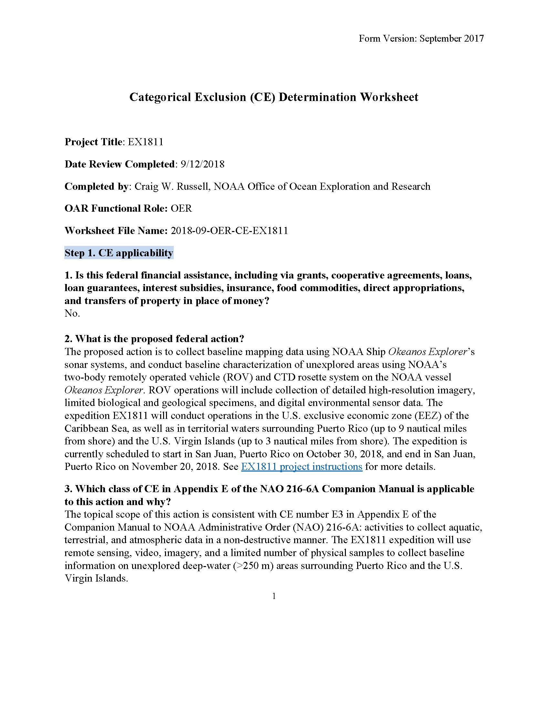
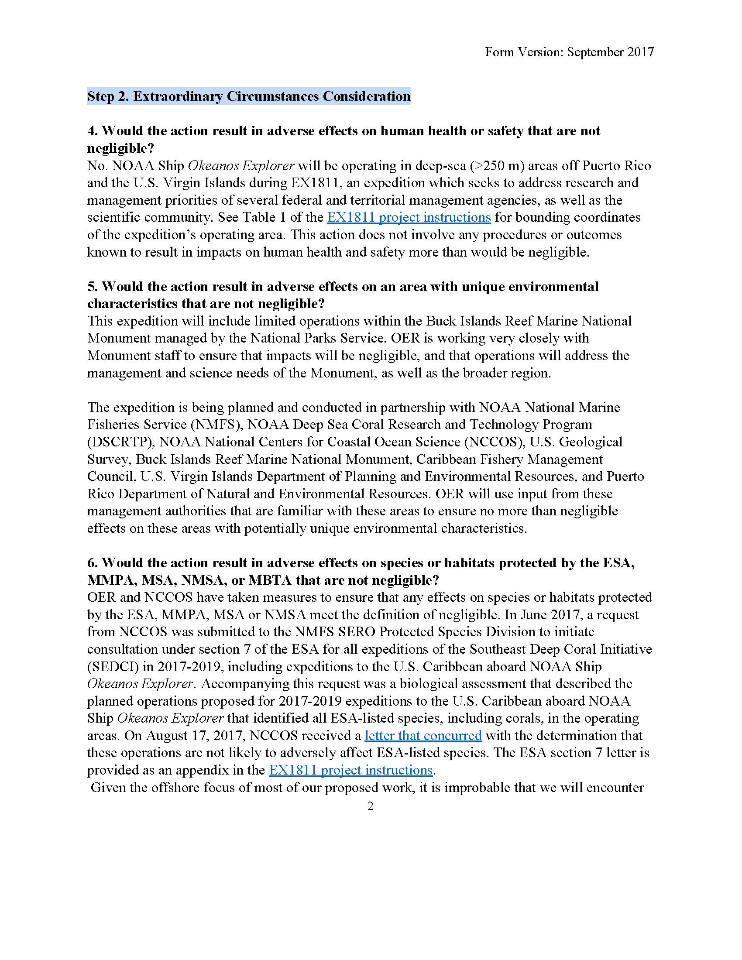

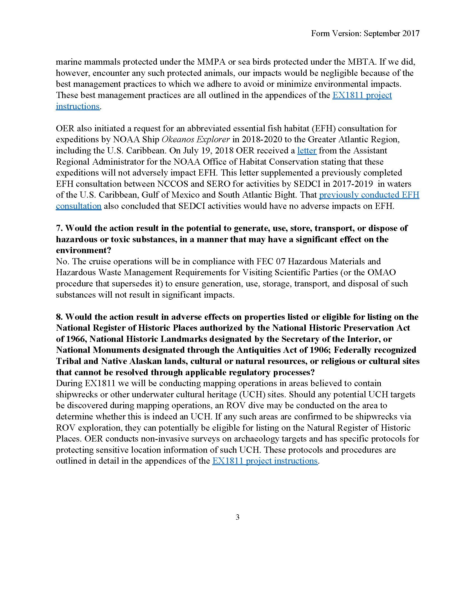

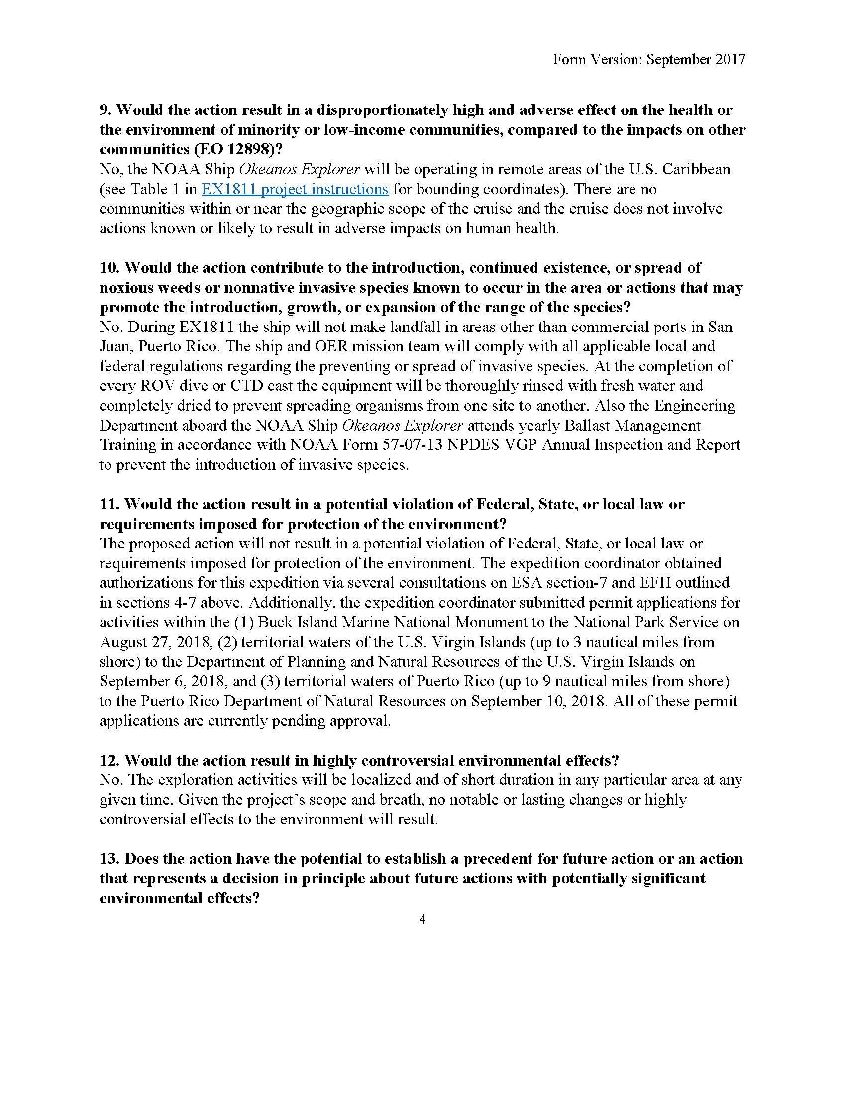
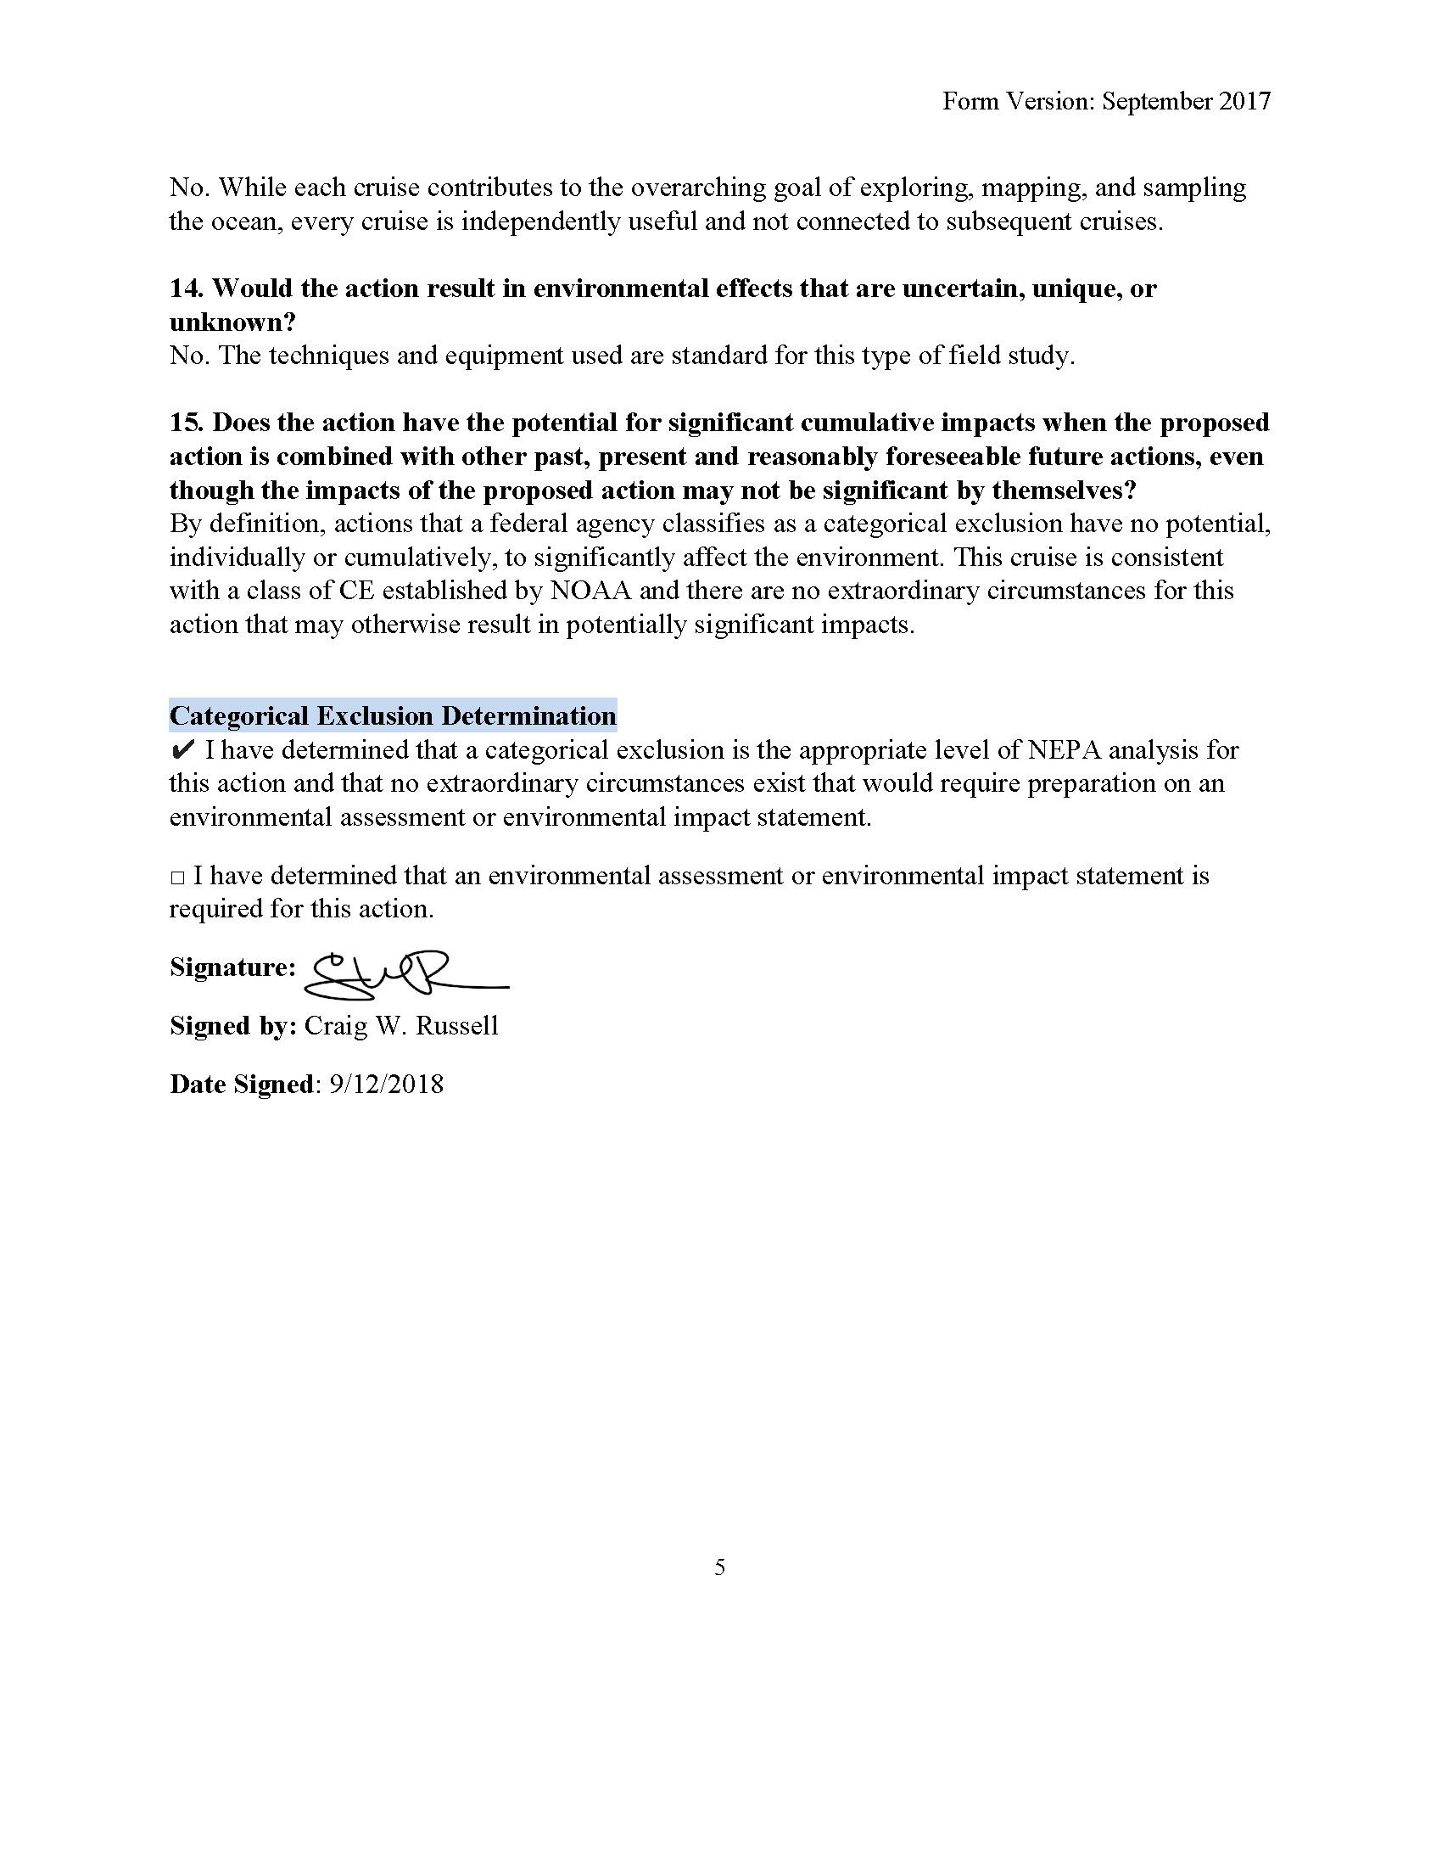
Appendix D: ESA Section 7 Concurrence Letter
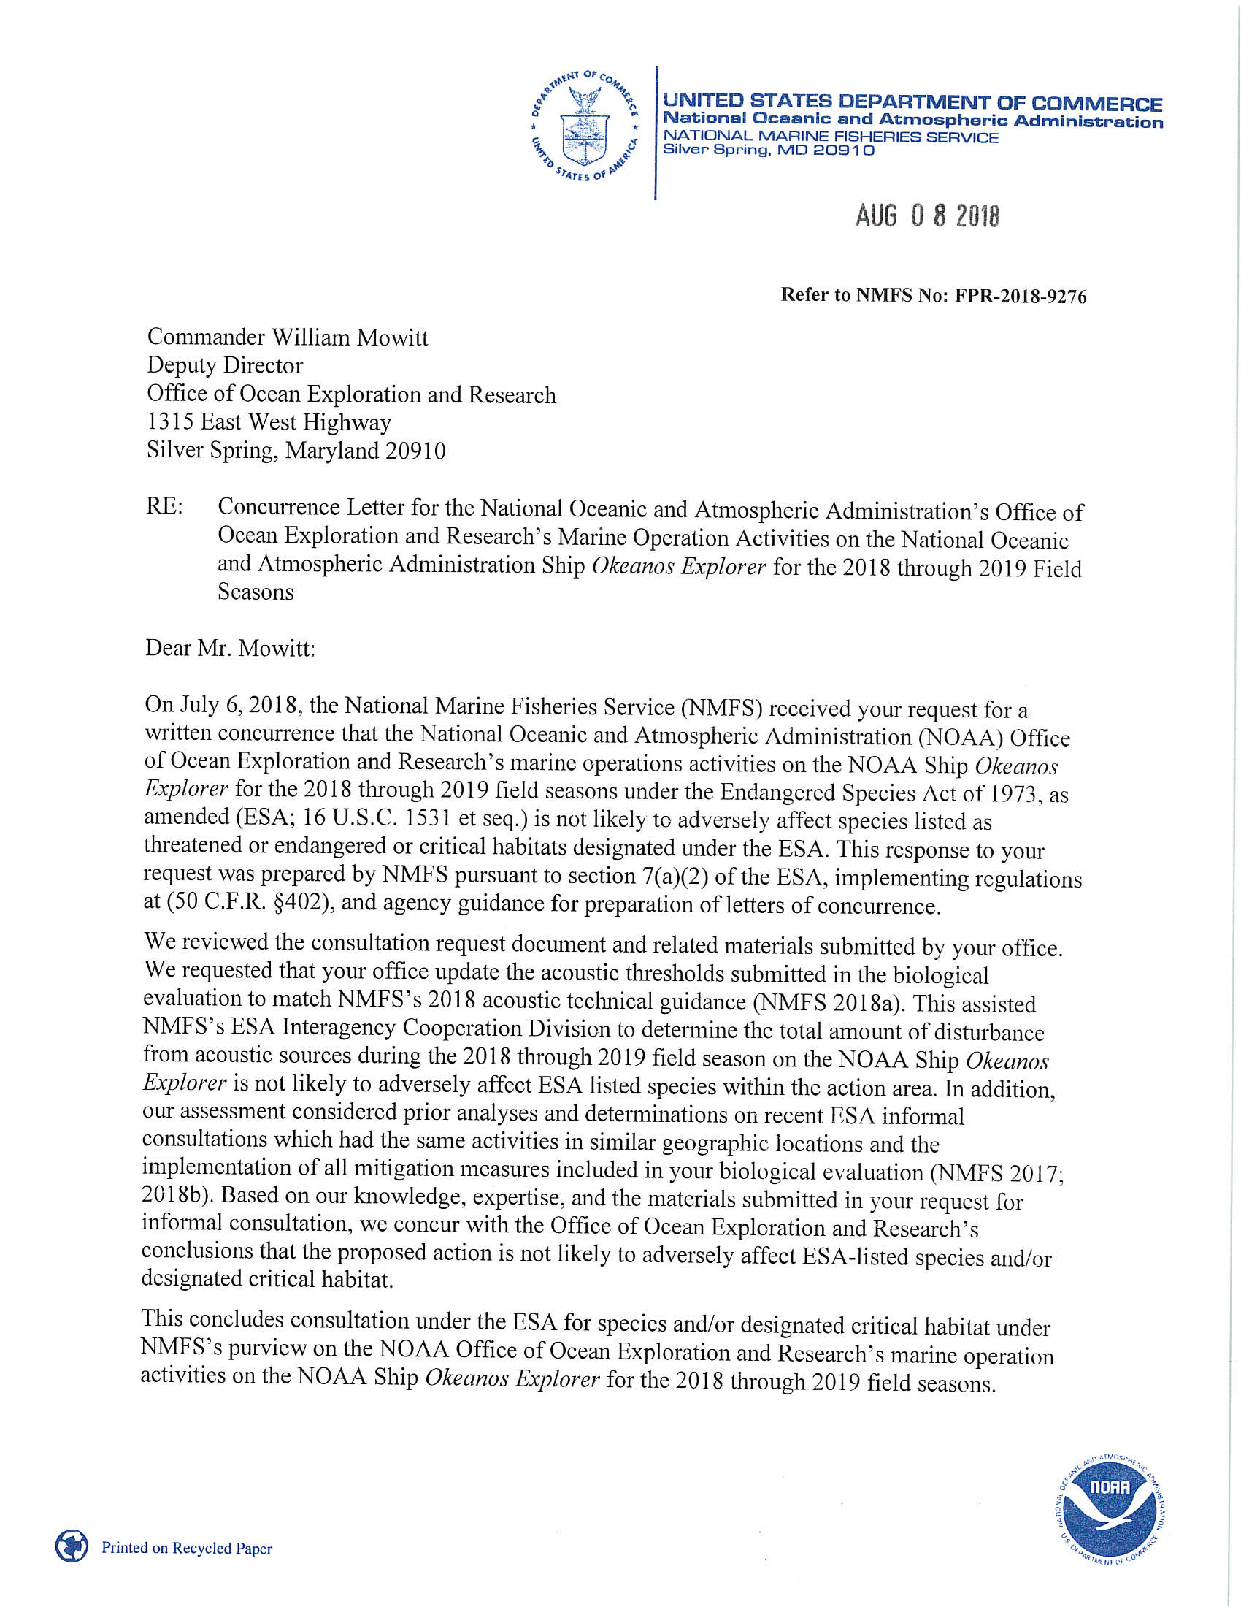
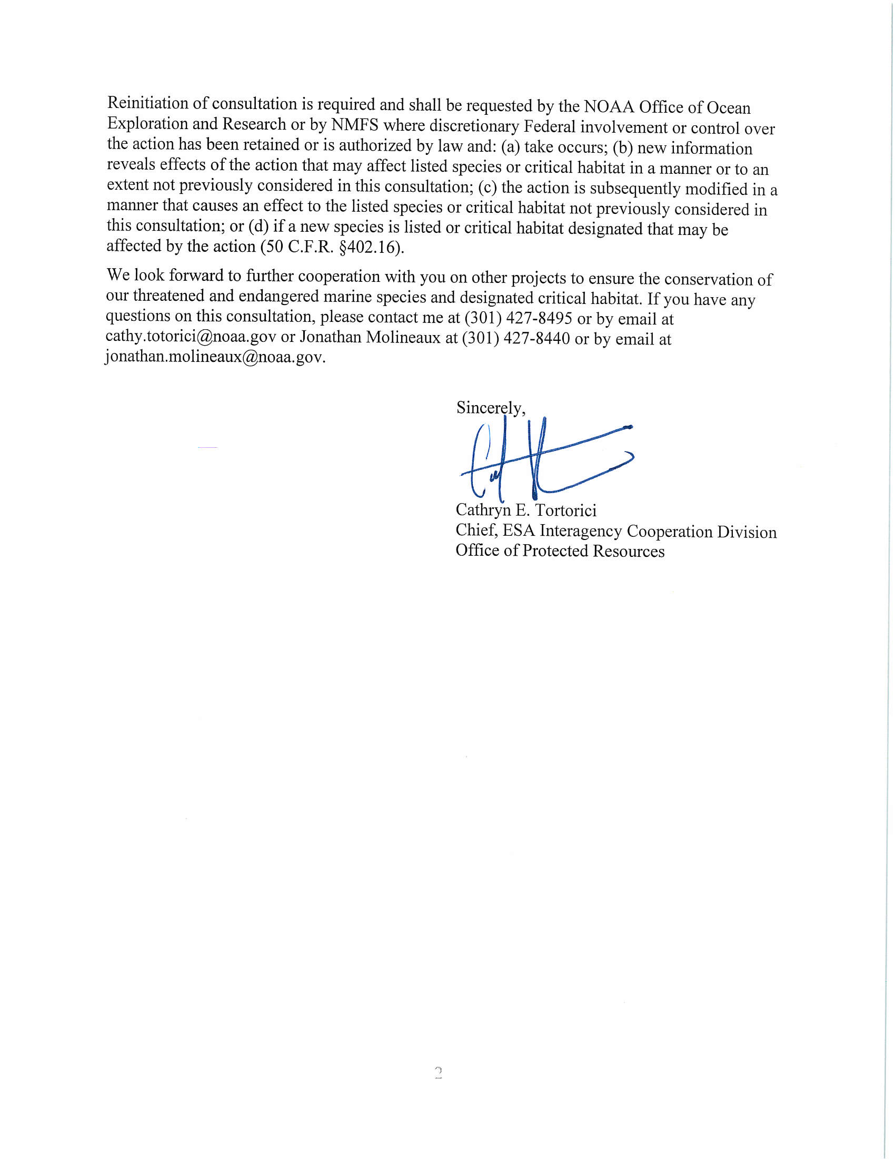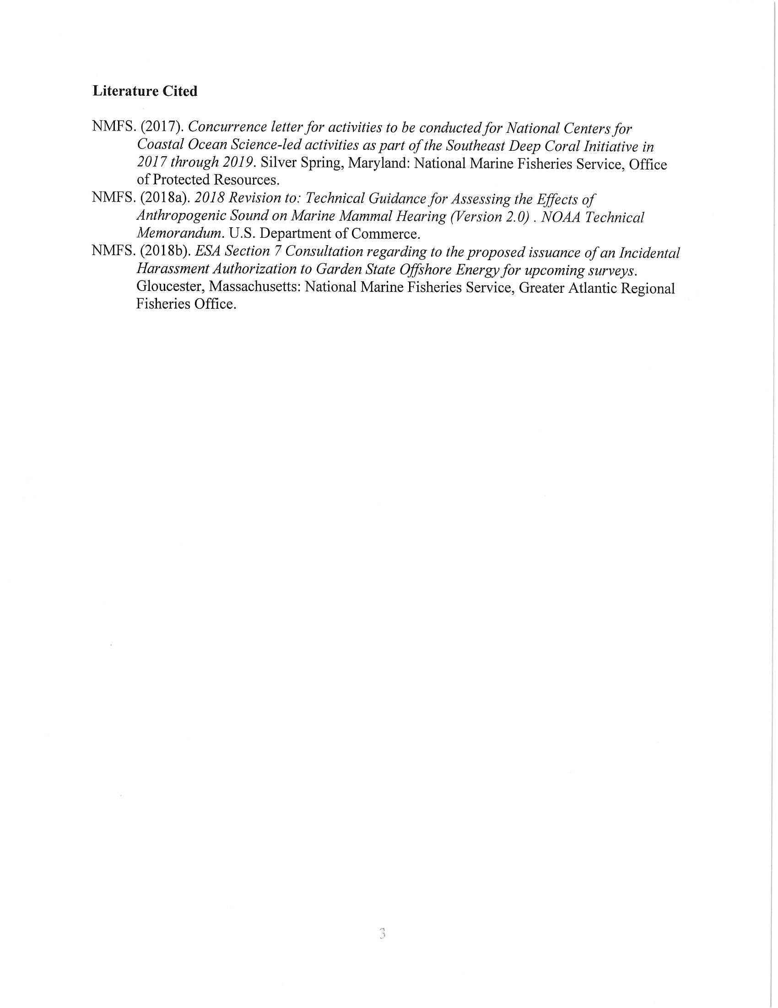
Appendix E: EFH Concurrence Letter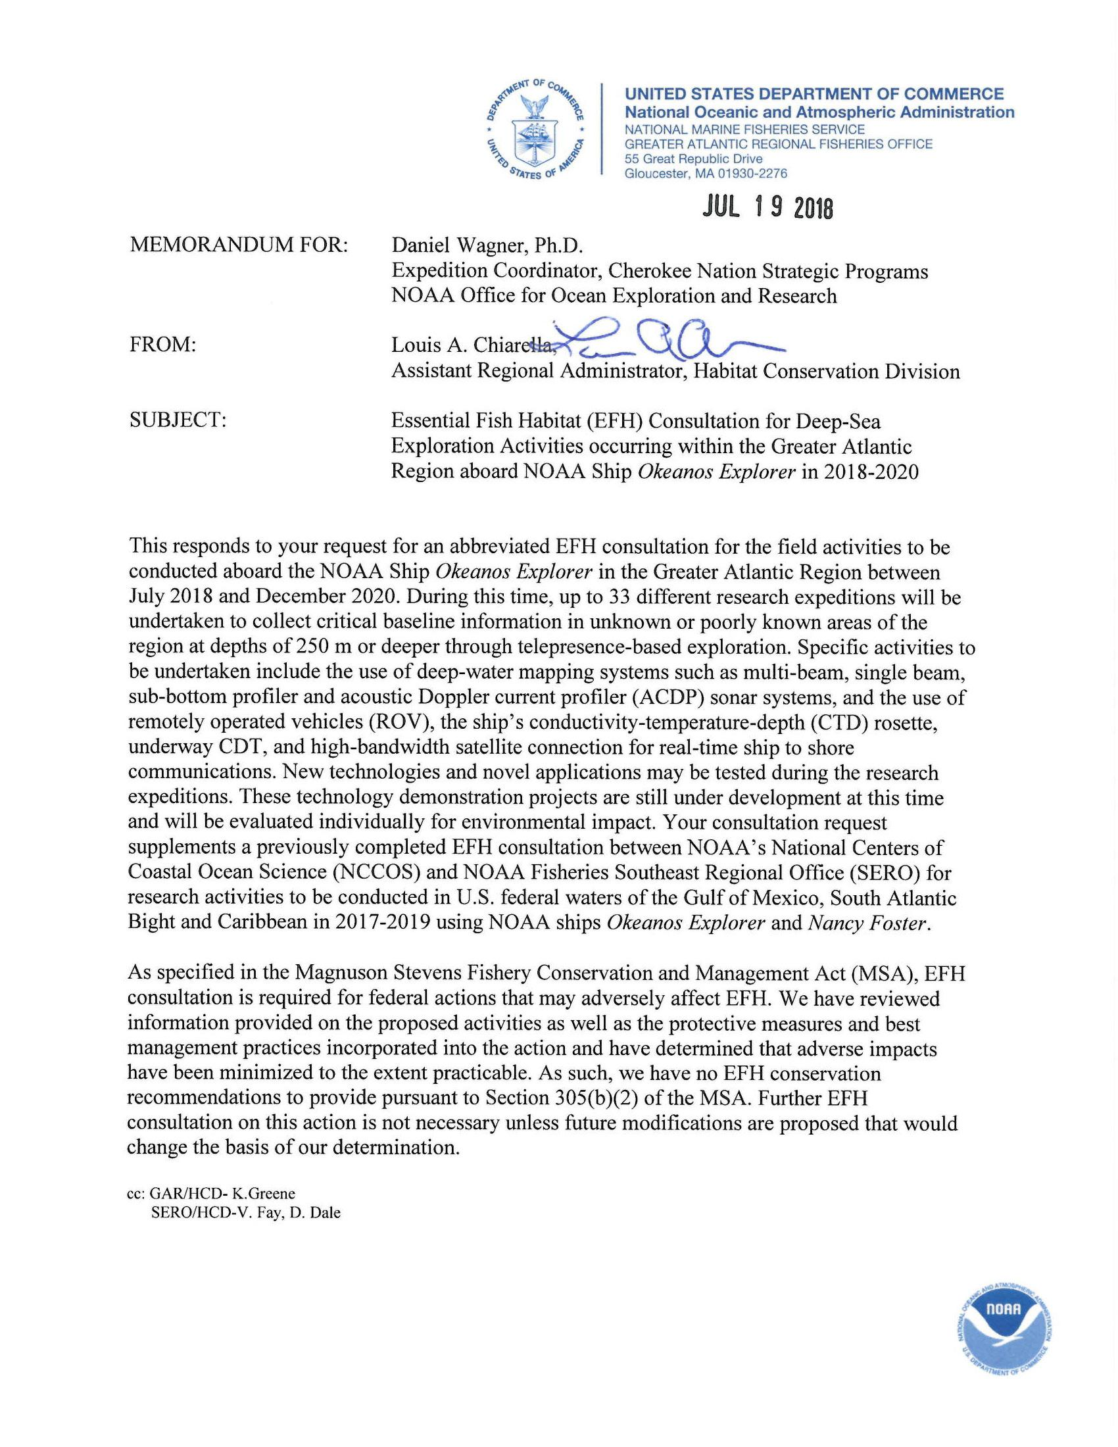
Appendix F: Southeast Regional Office (SERO) Letter of Acknowledgement (LOA)
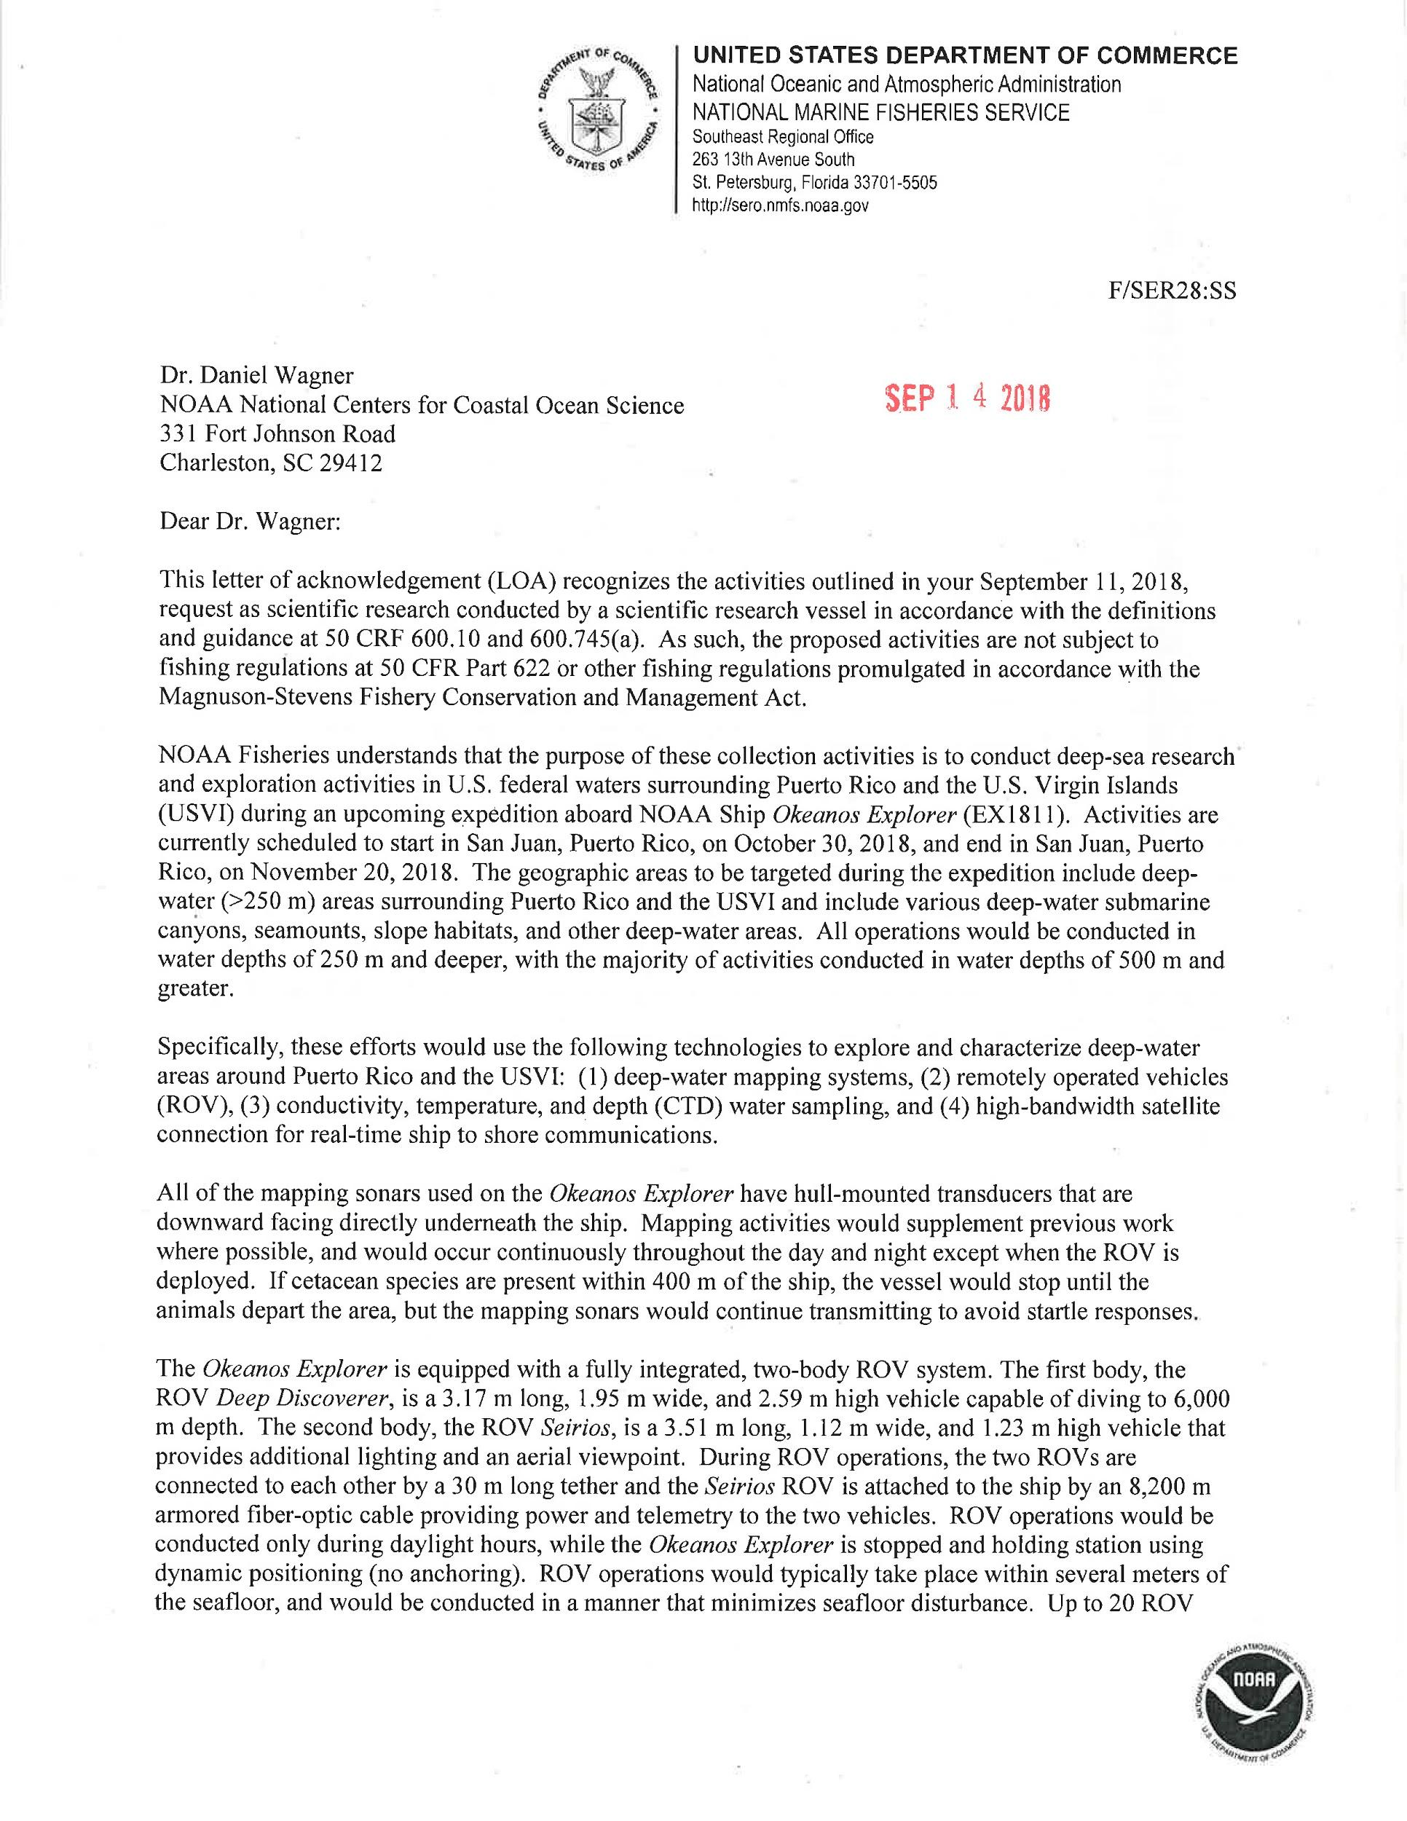
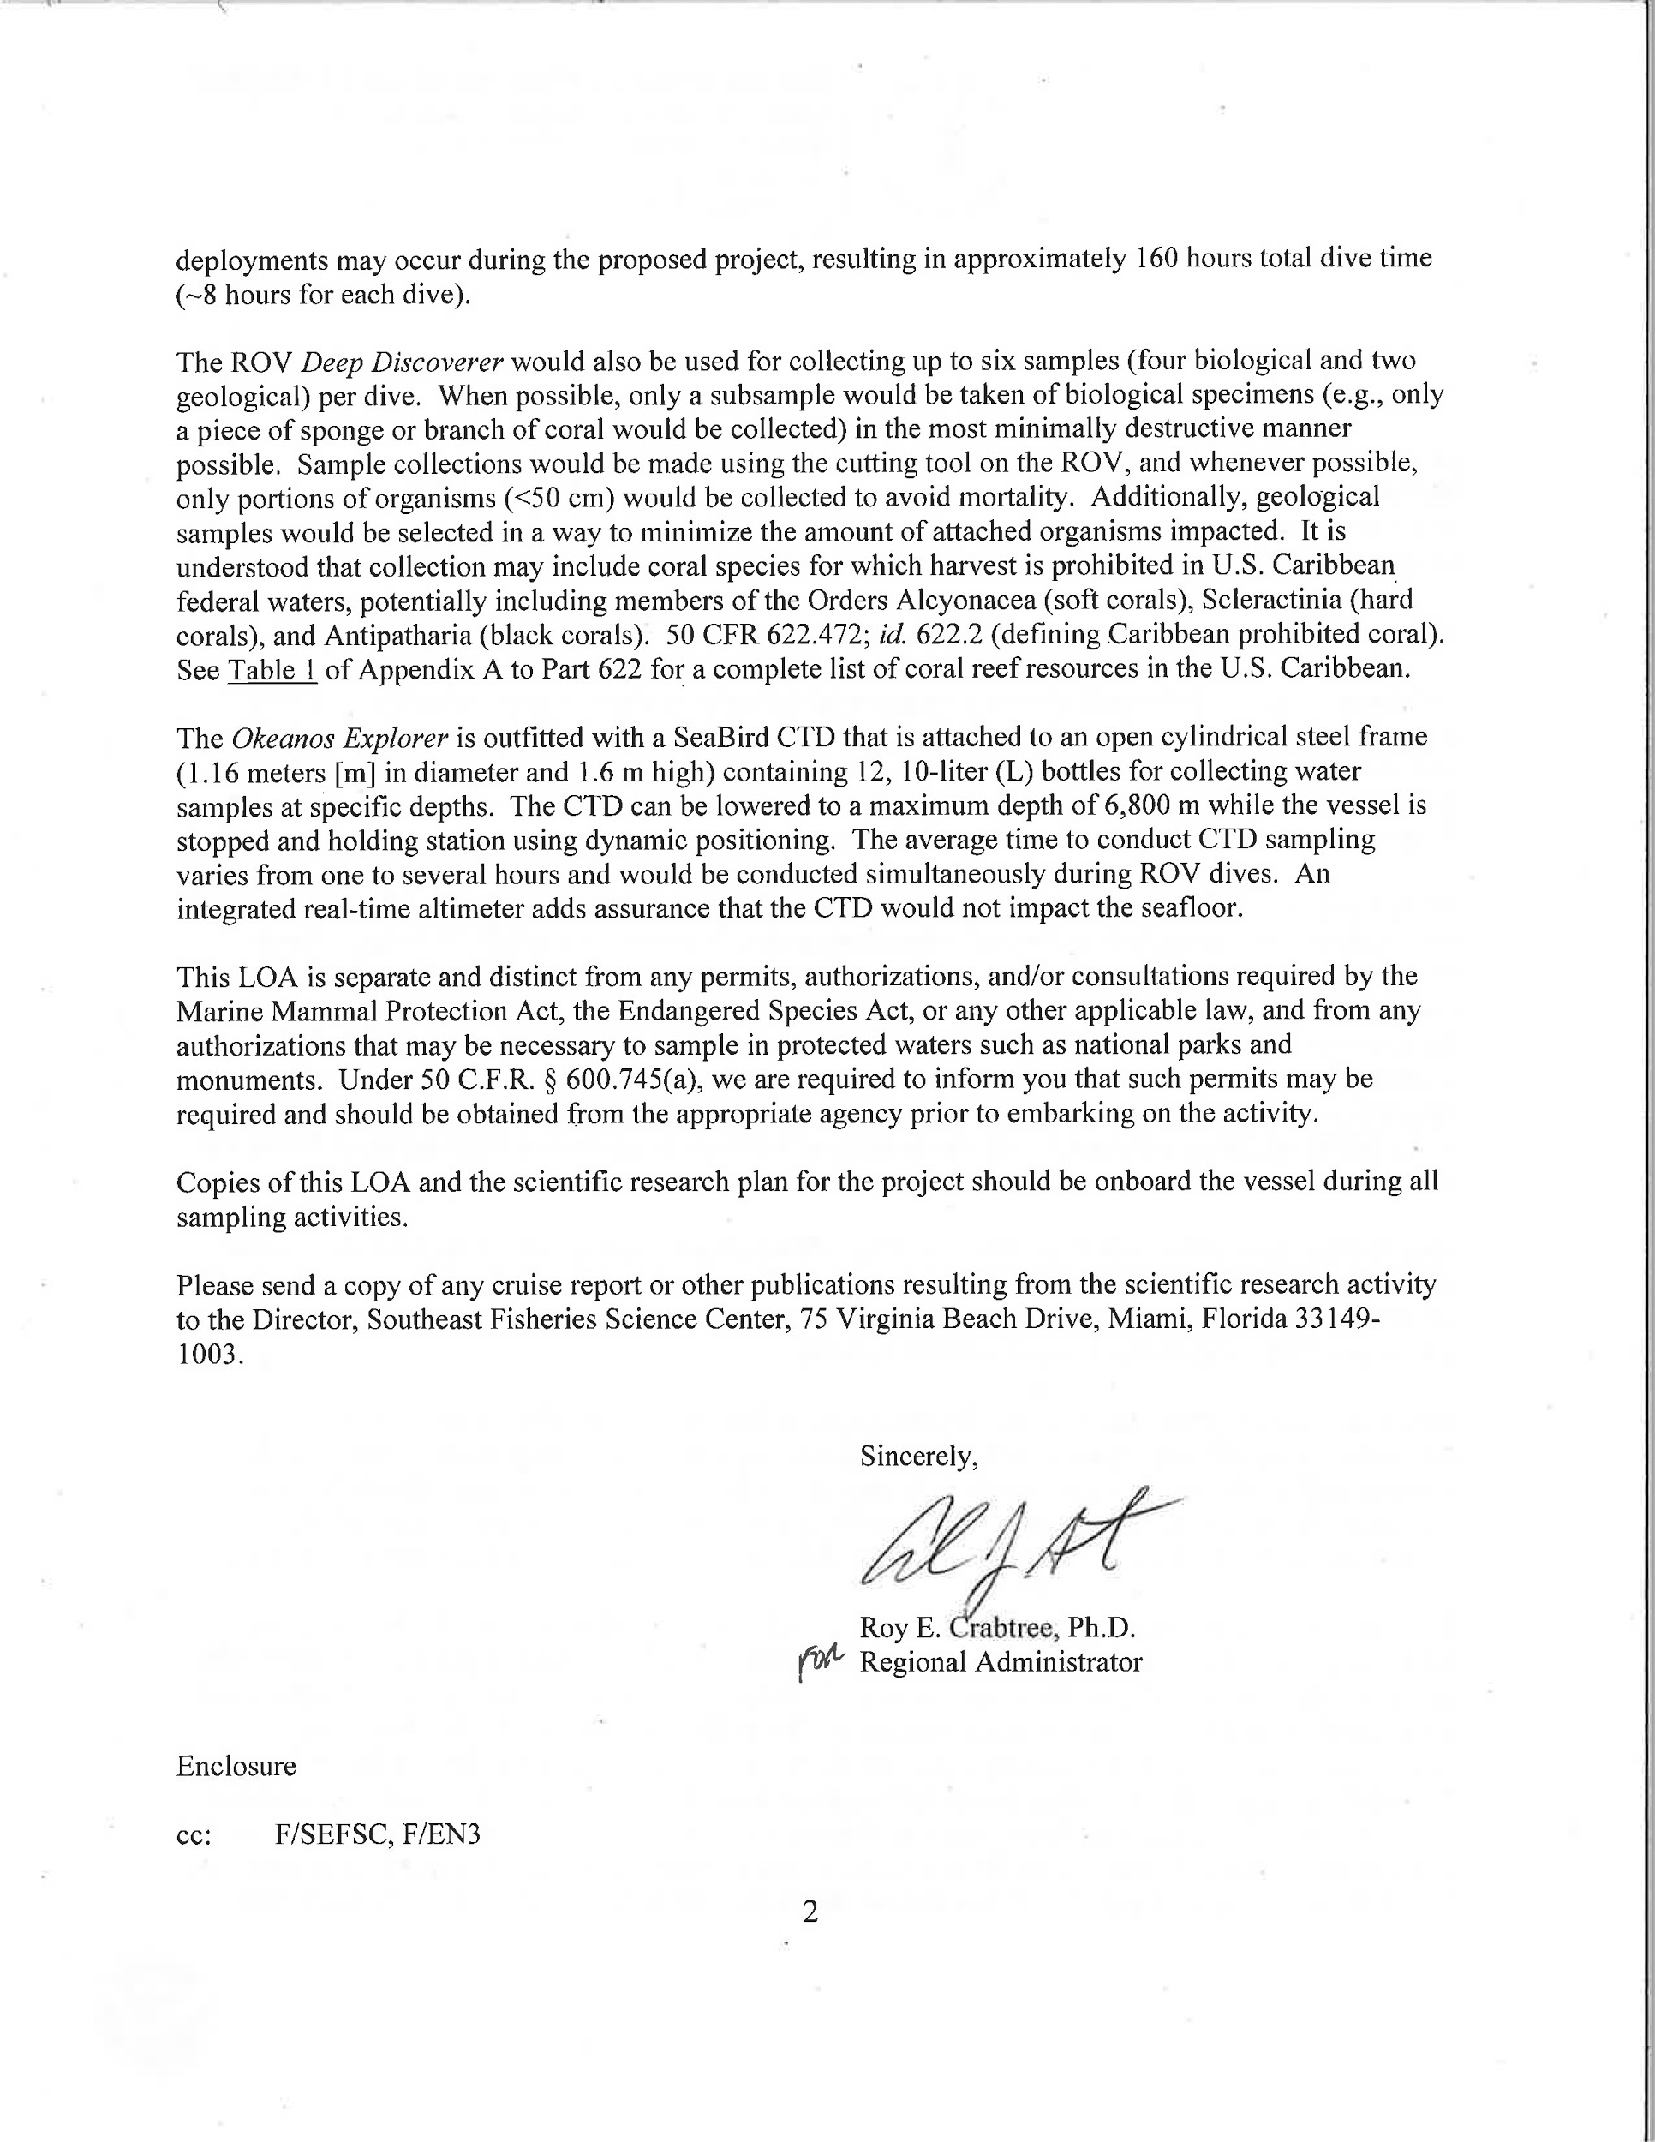
Appendix G: Buck Island Reef Marine National Monument Permit
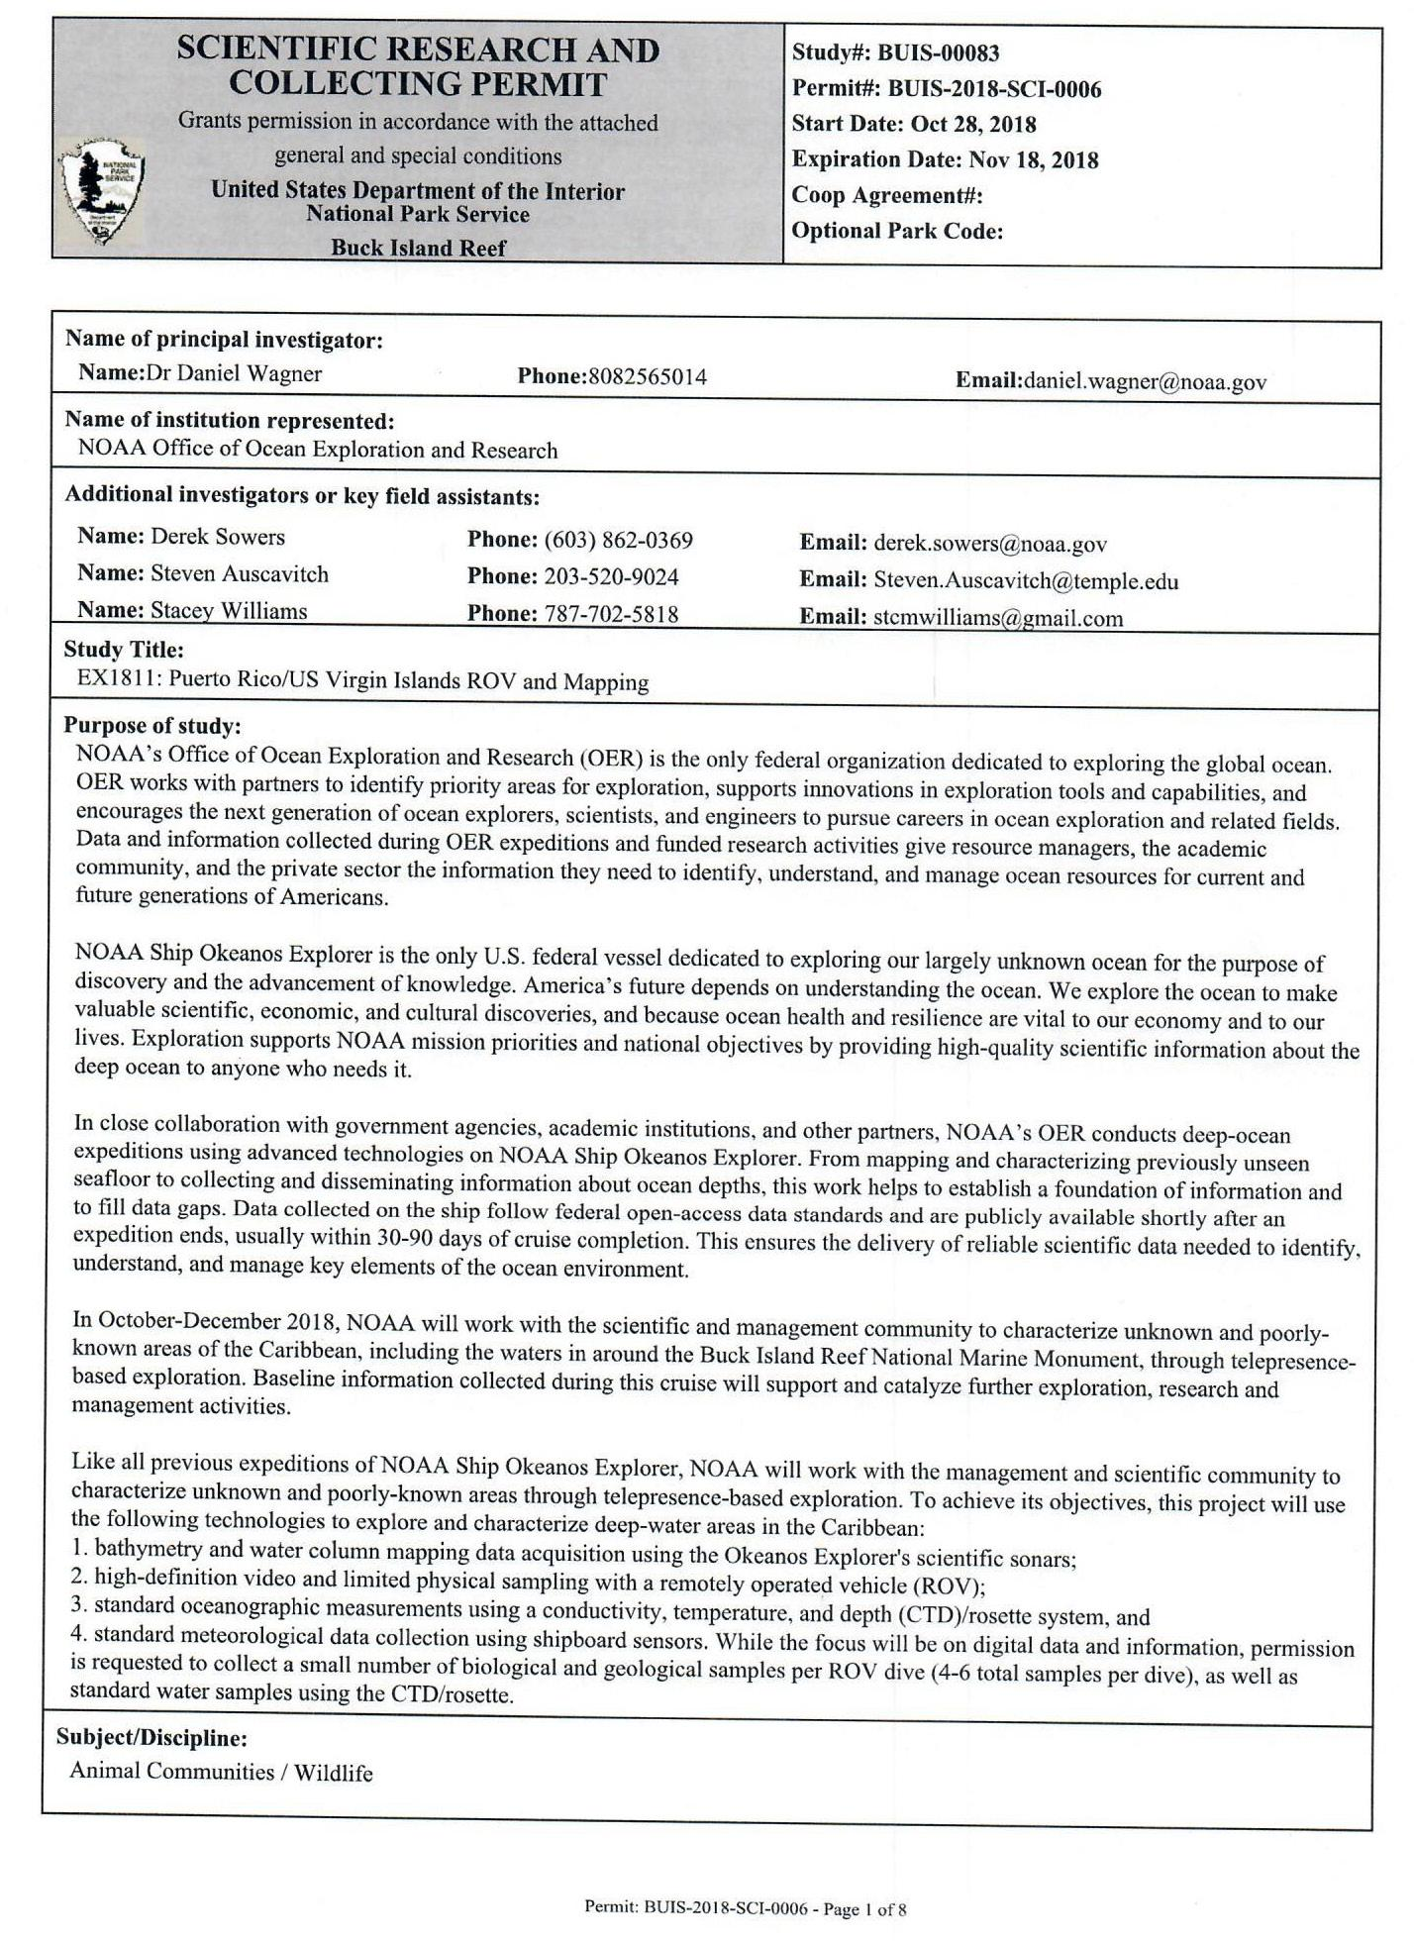
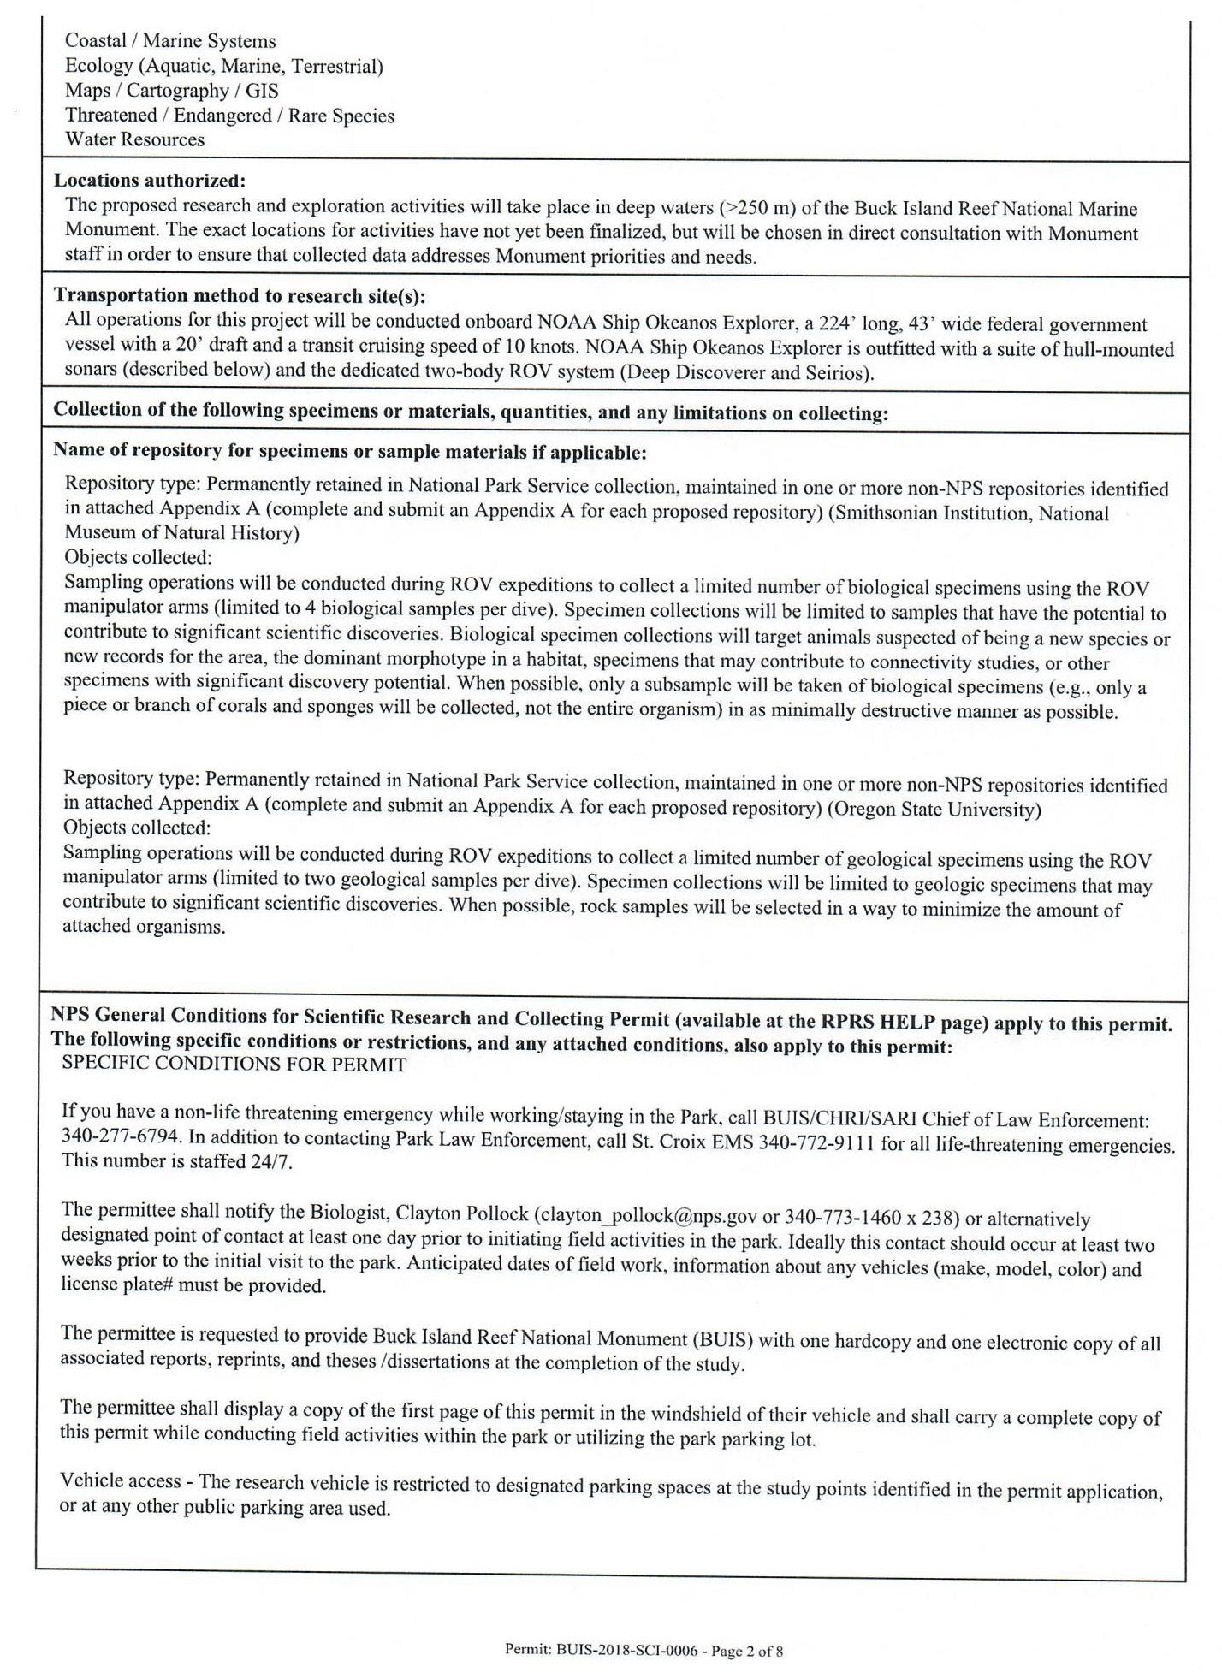
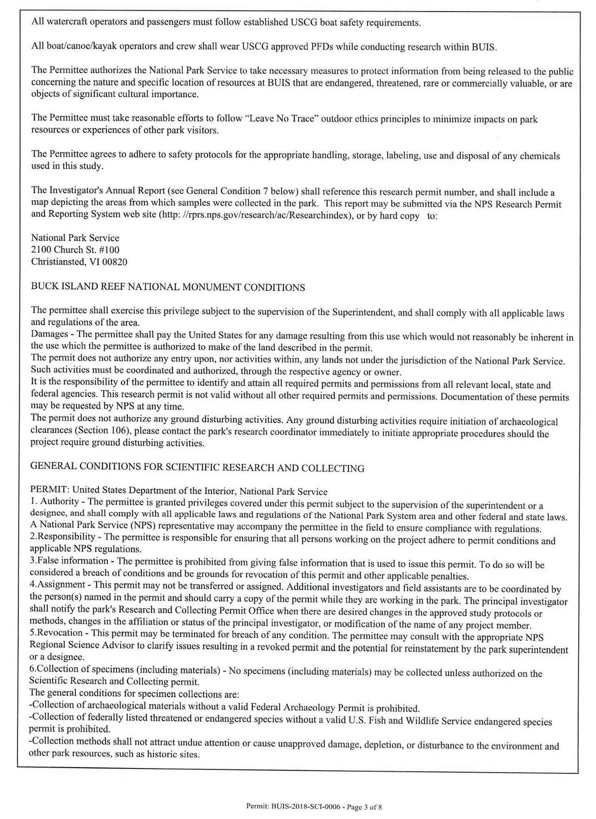
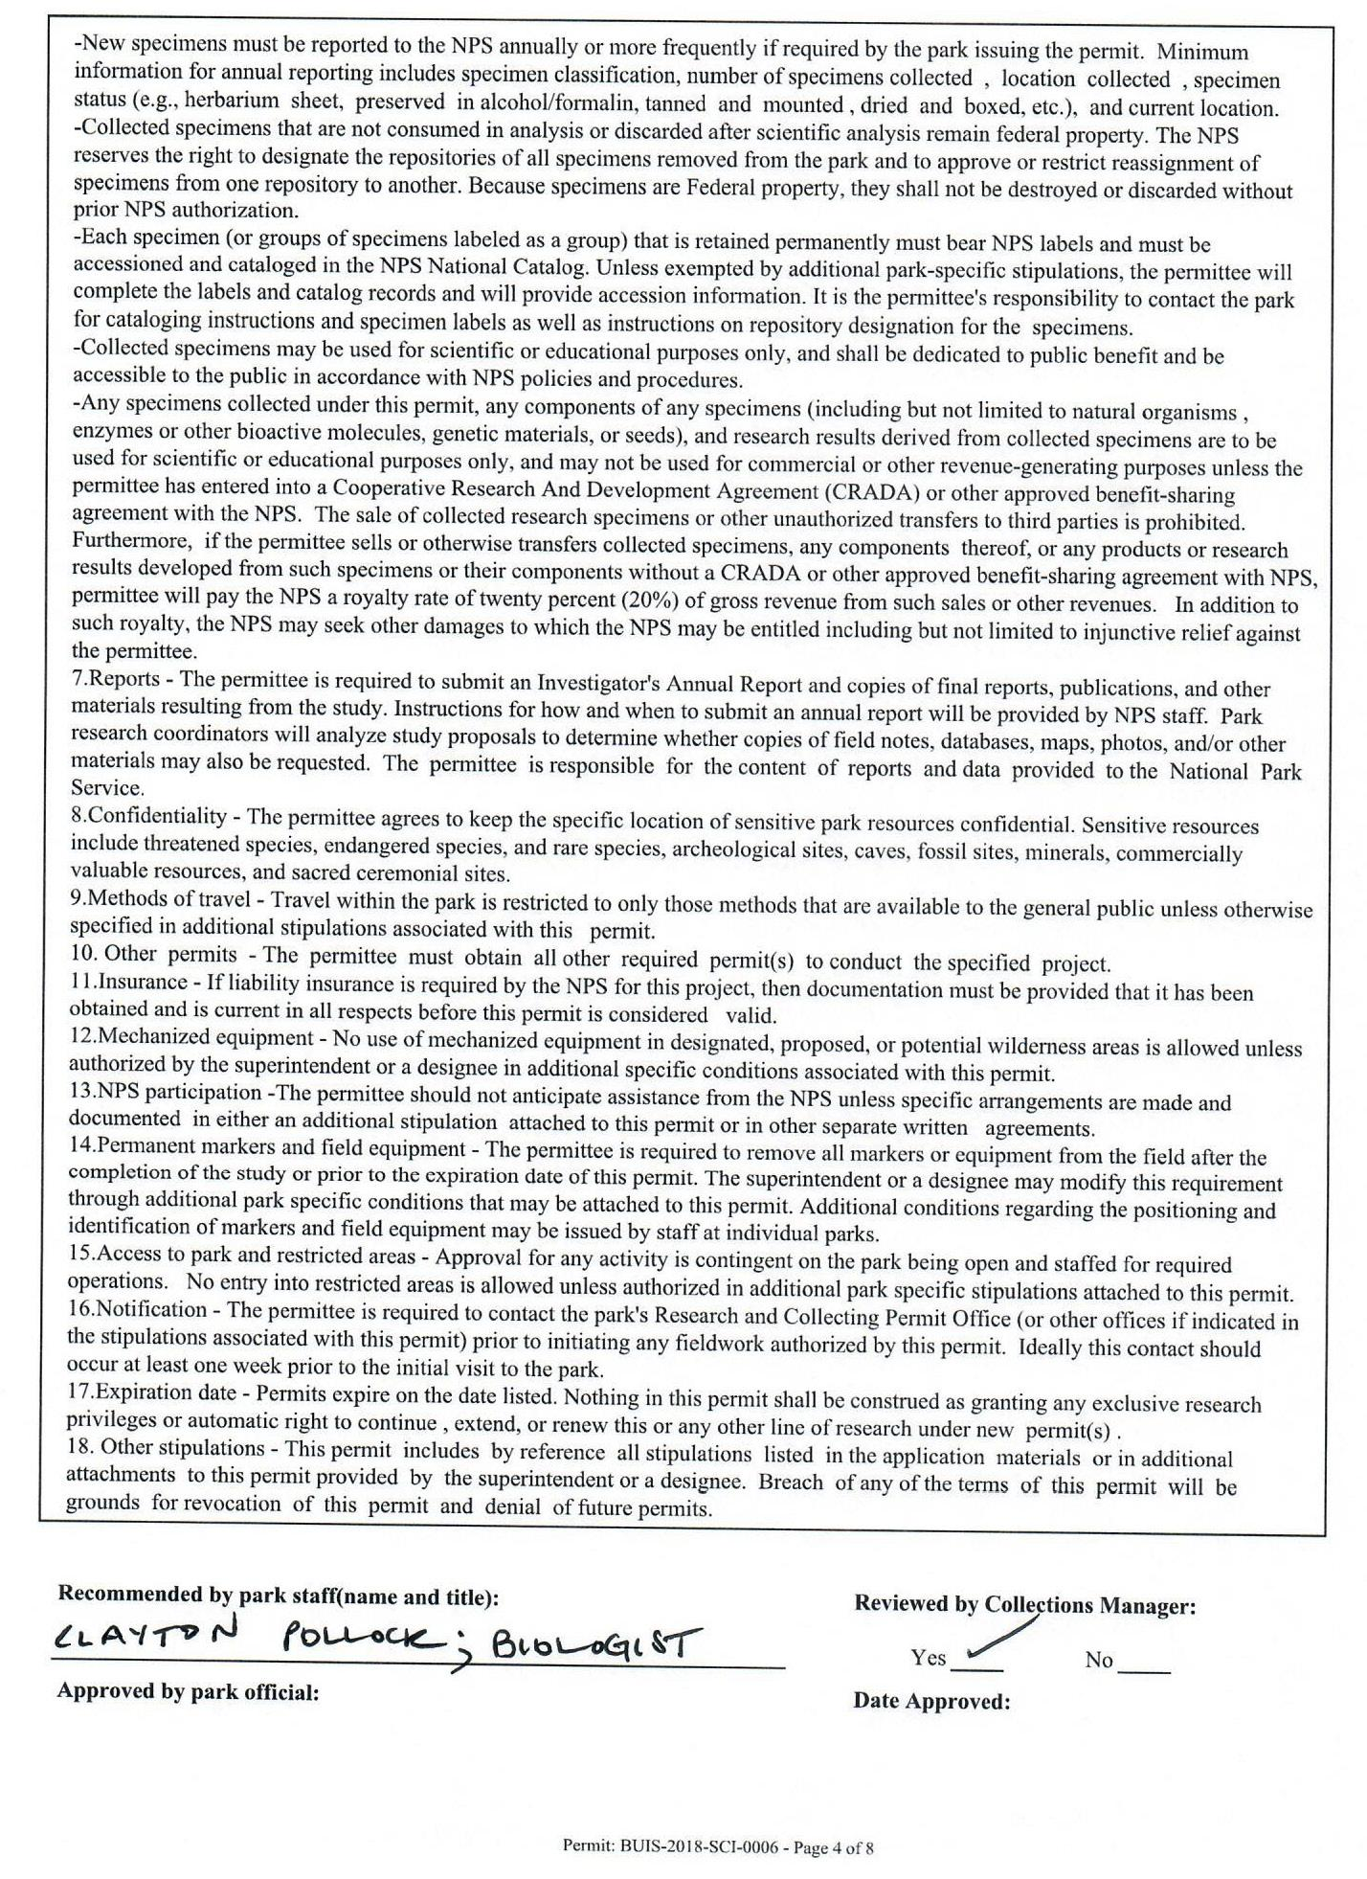
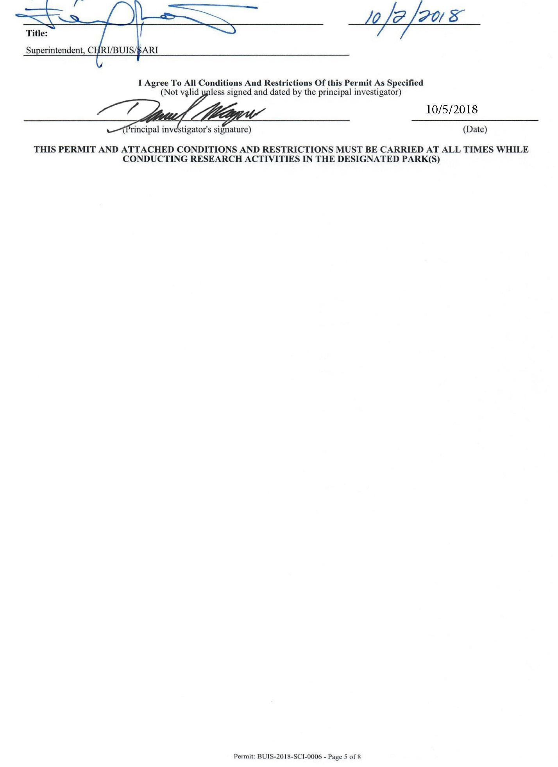
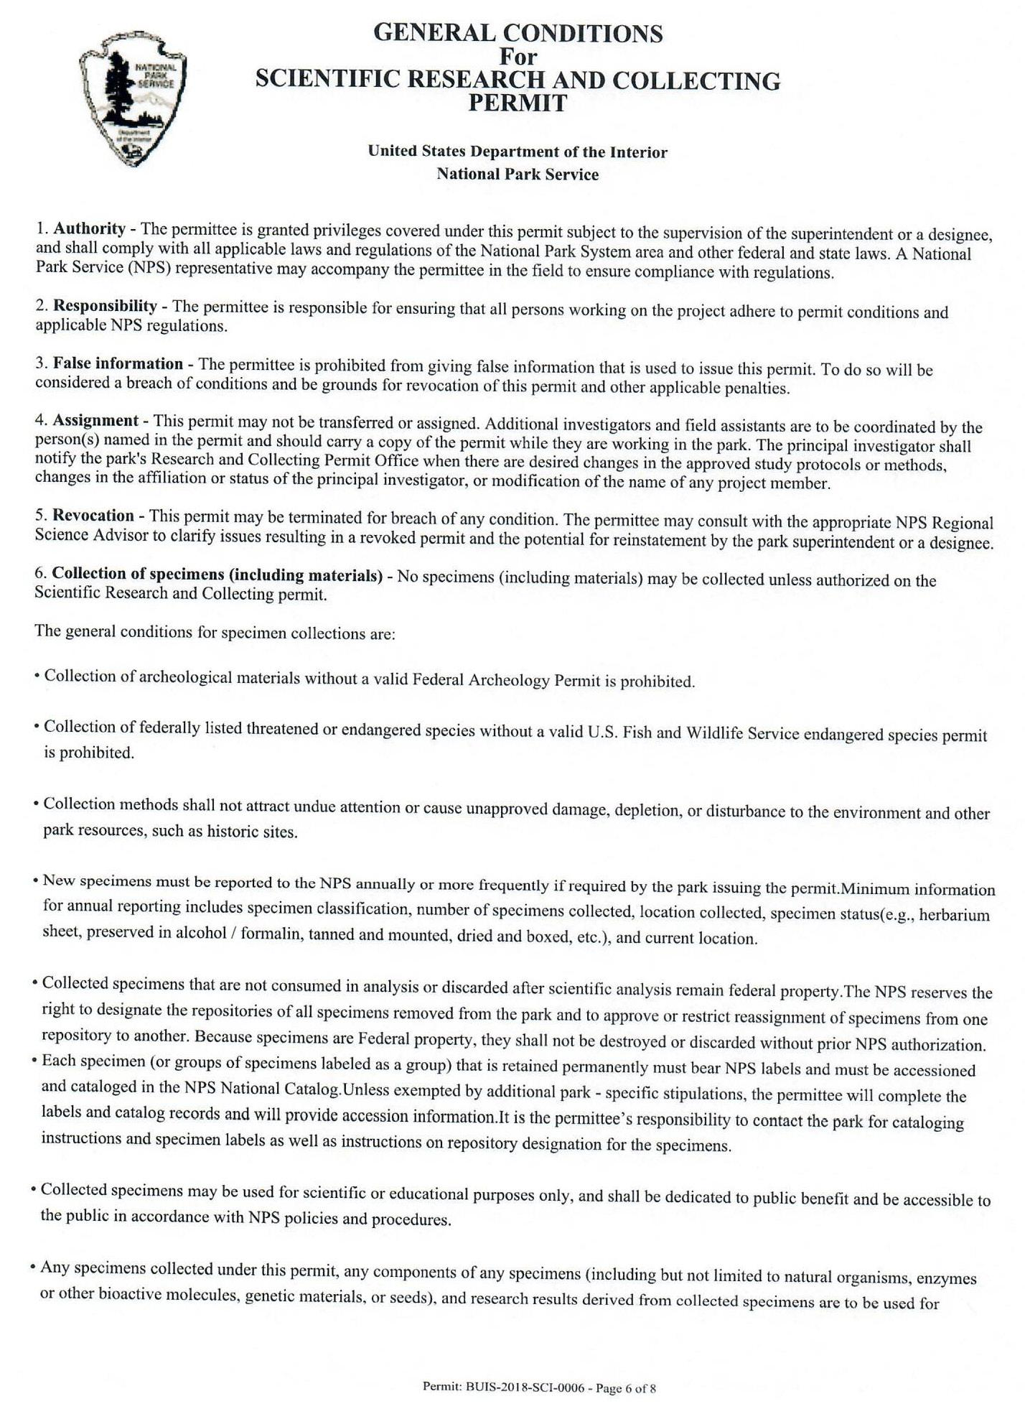
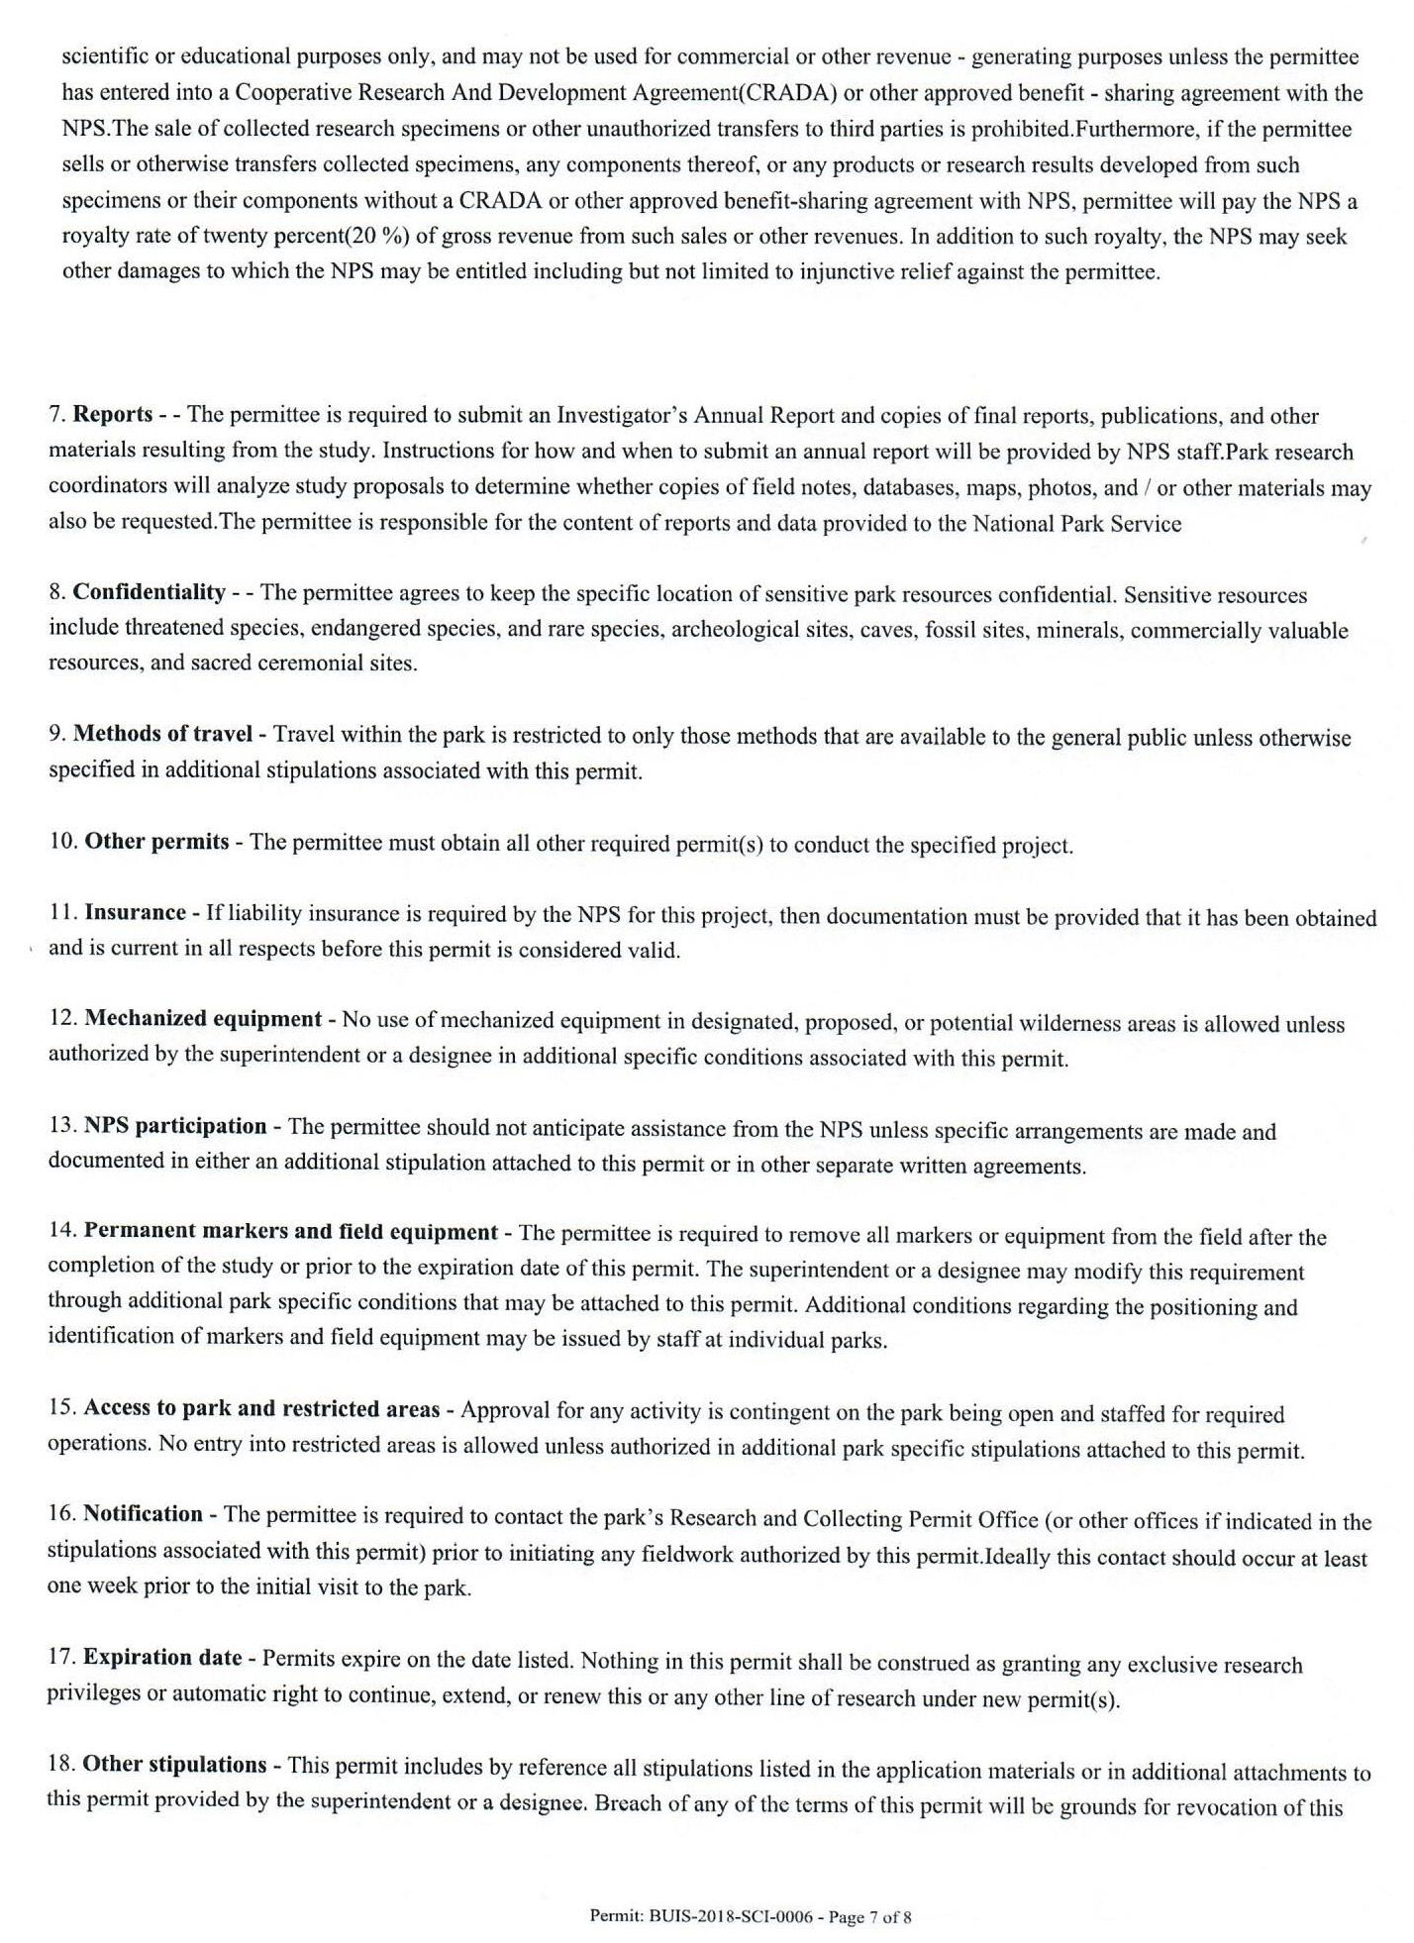

Appendix H: U.S. Virgin Islands Territorial Waters Permit
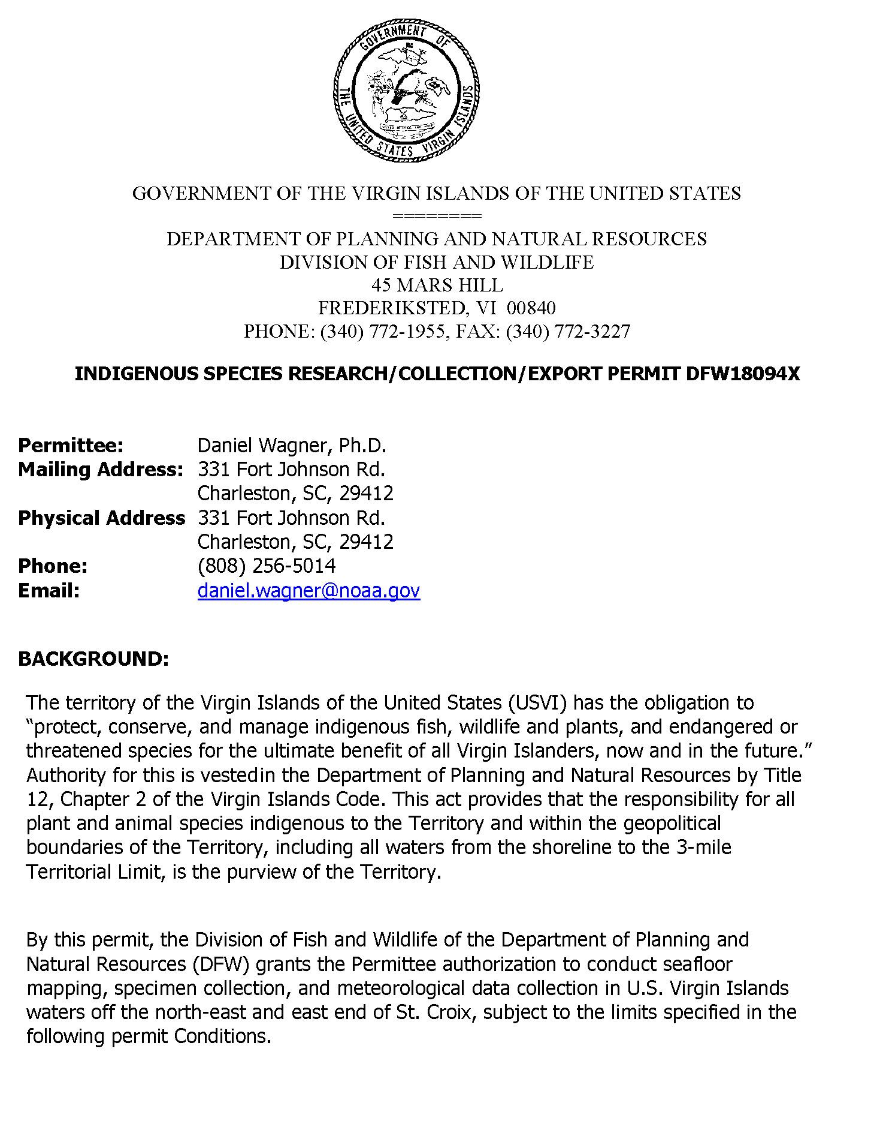
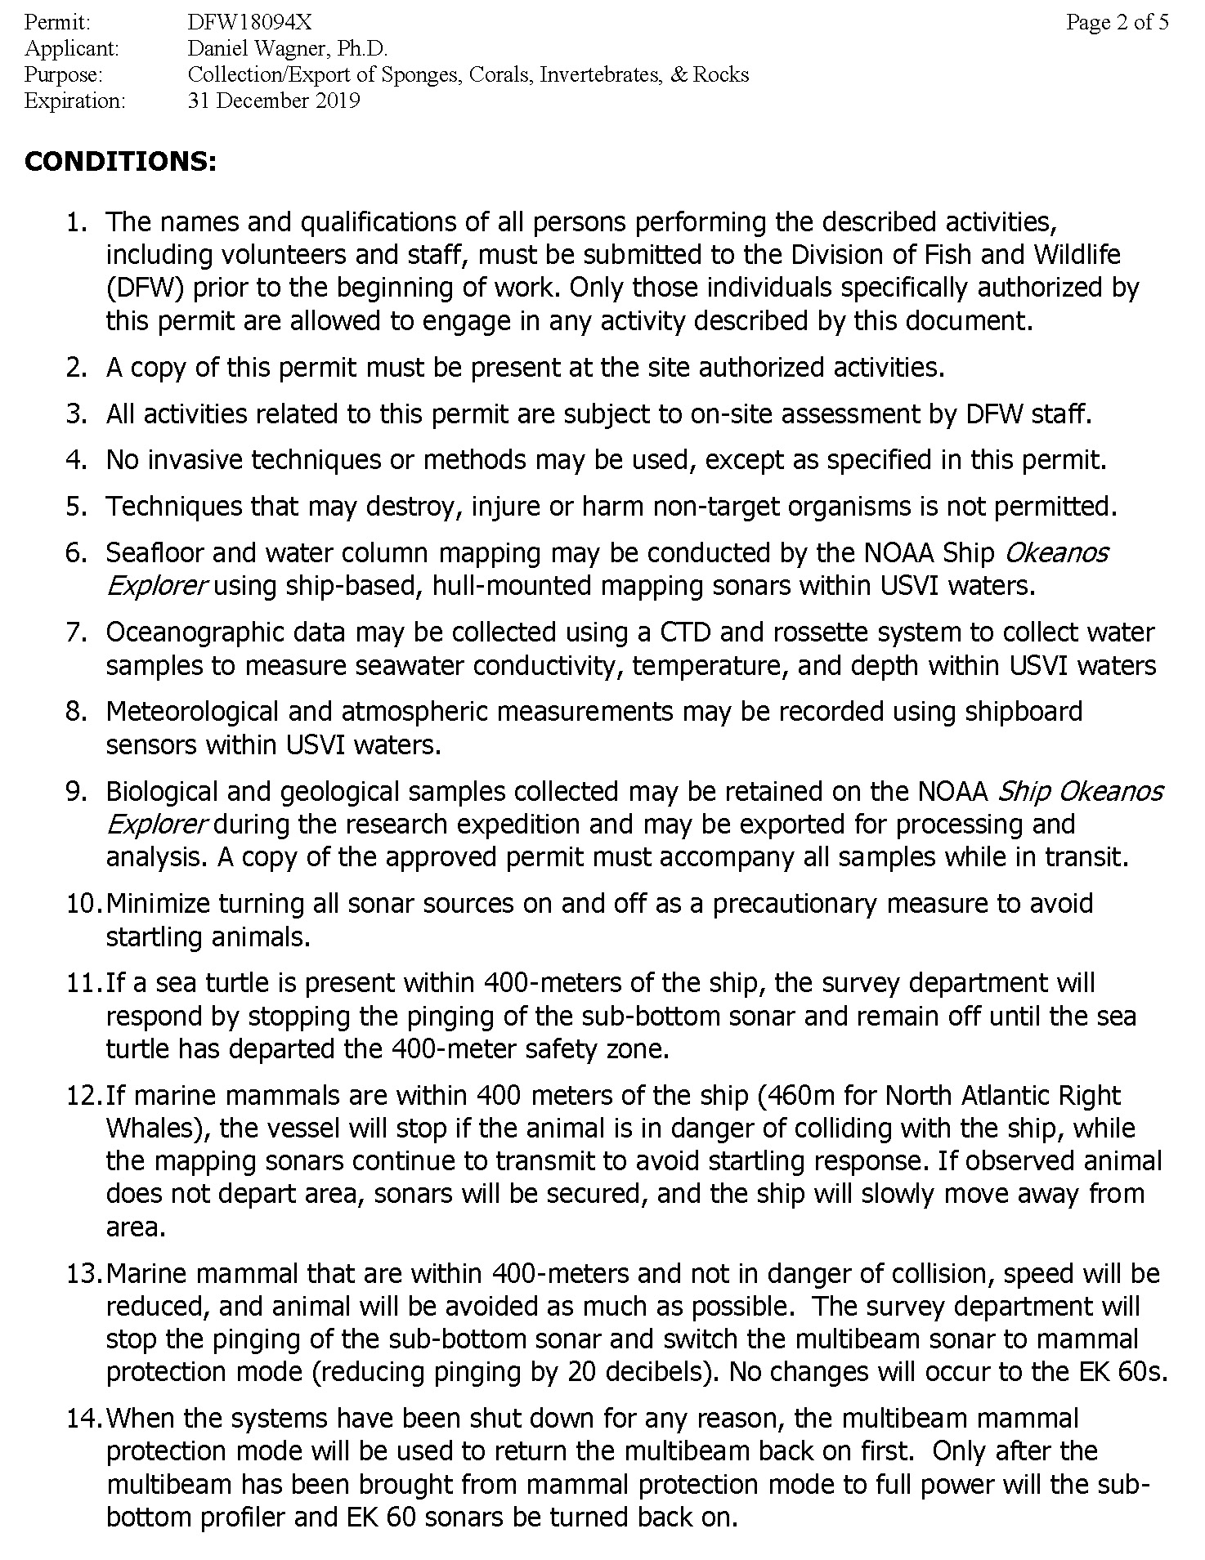
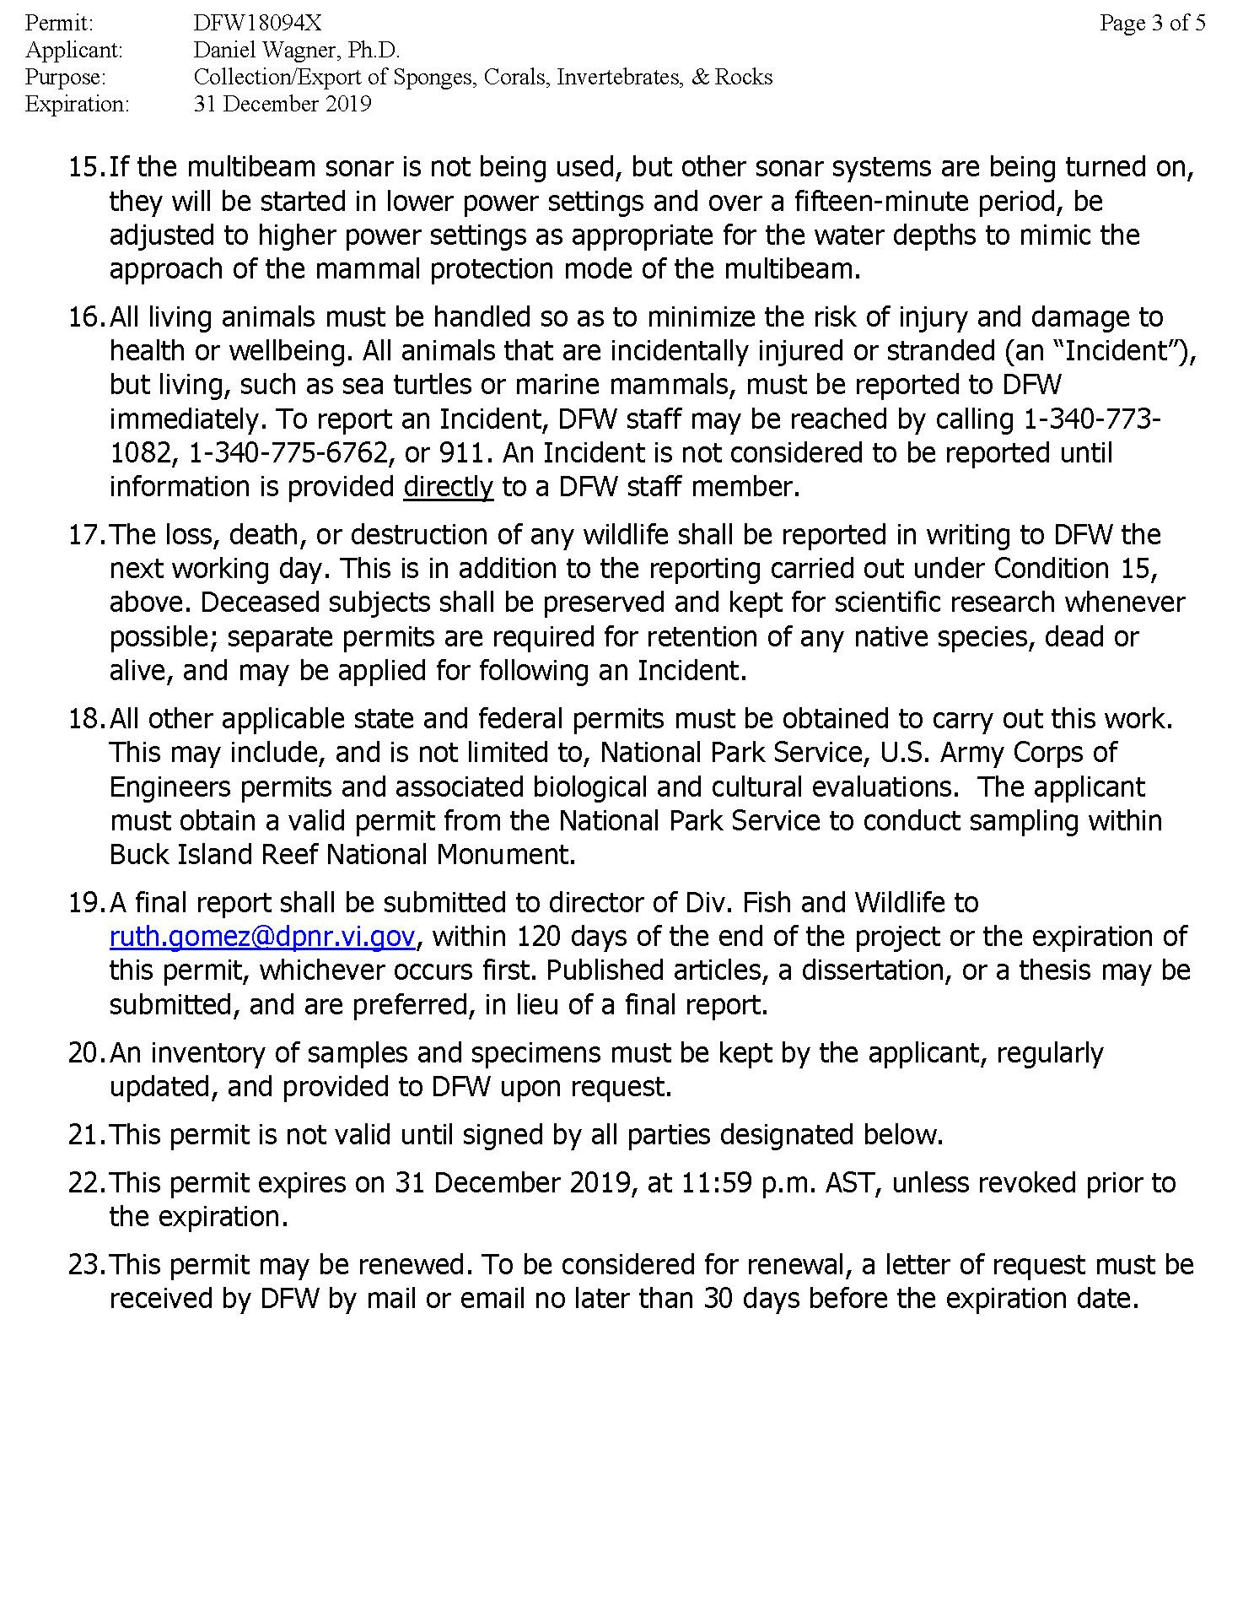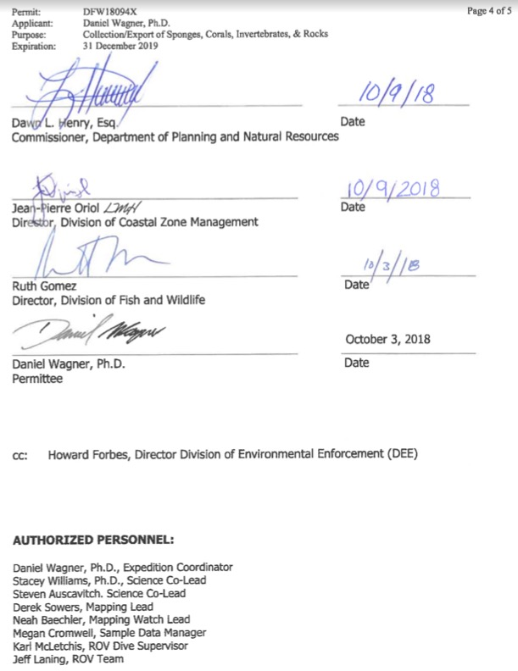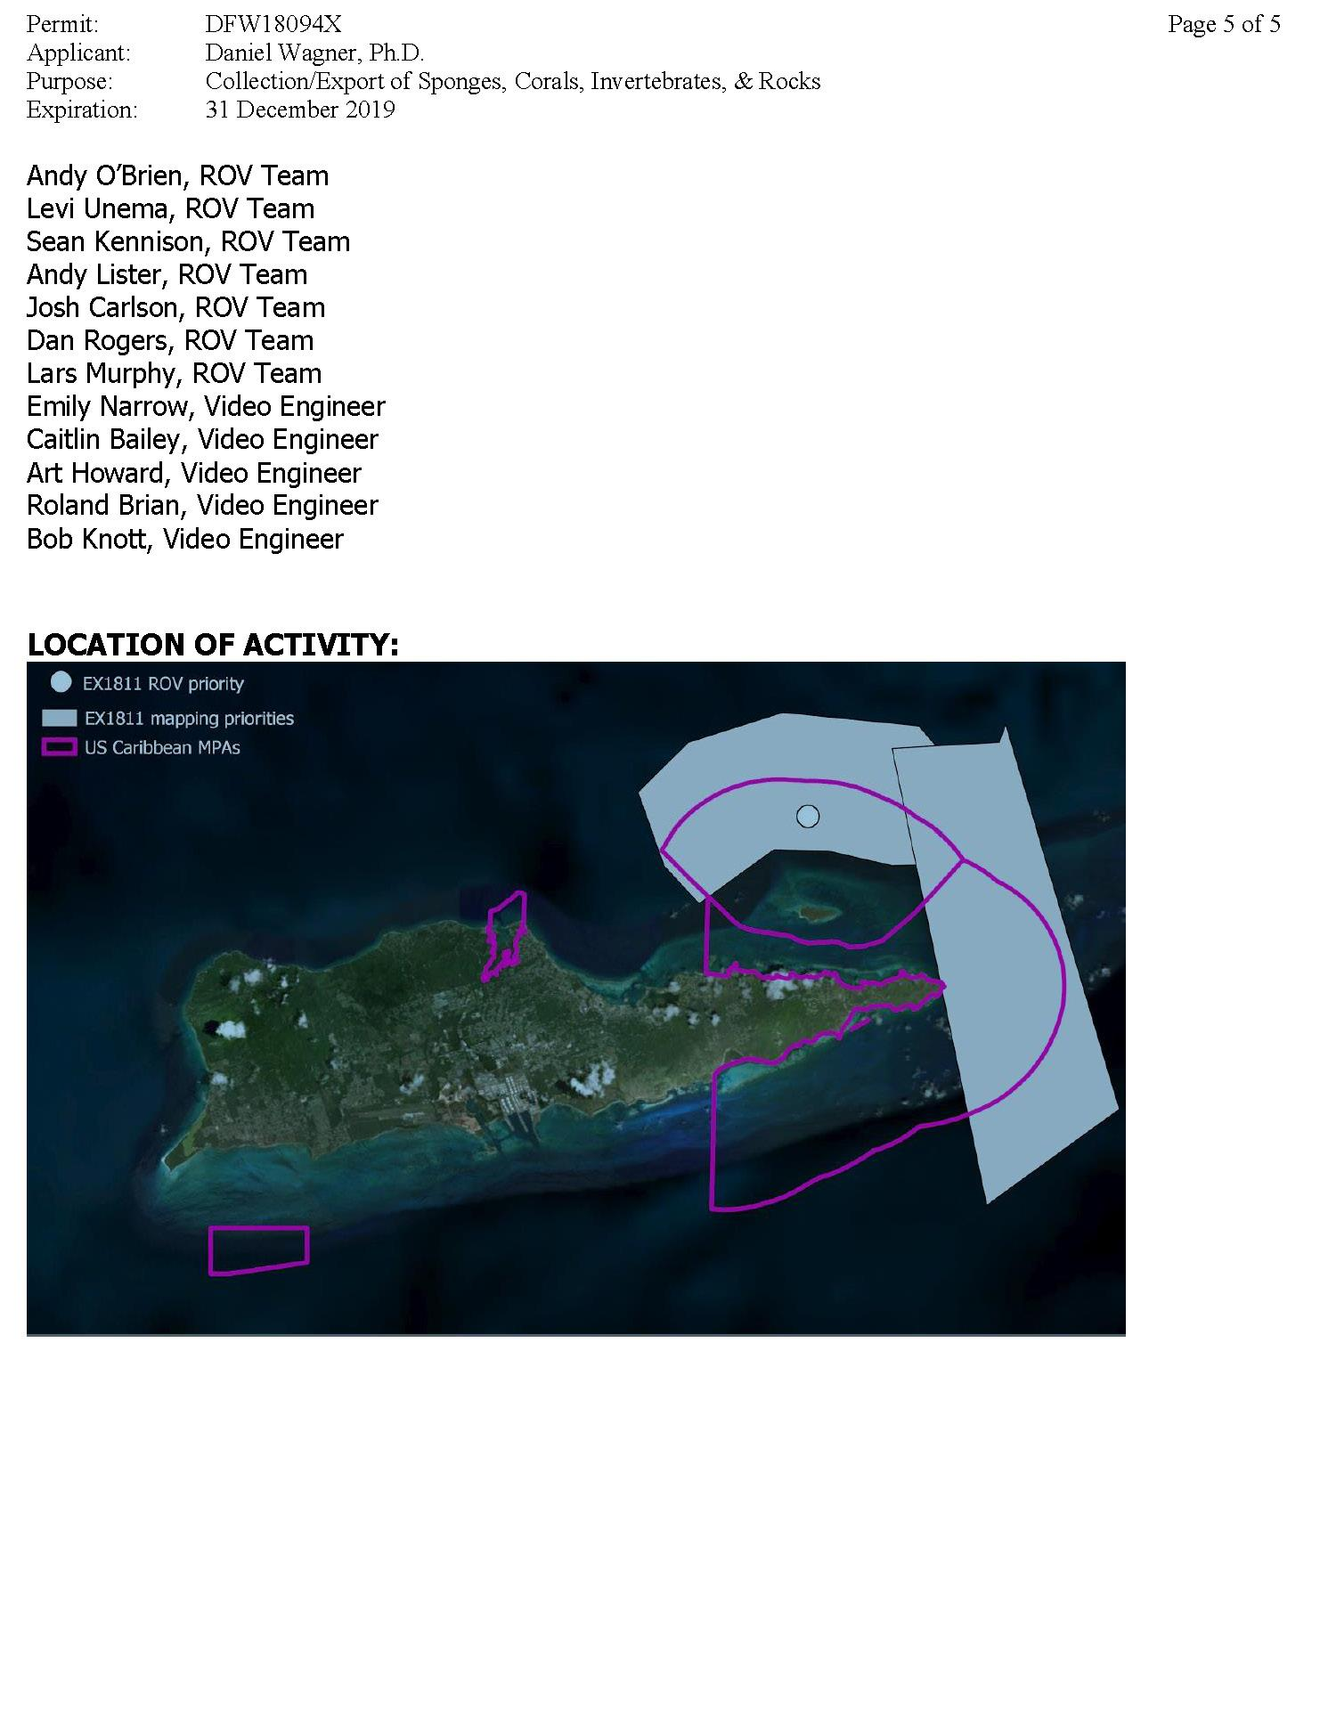
Appendix I: Puerto Rico Territorial Waters Permit
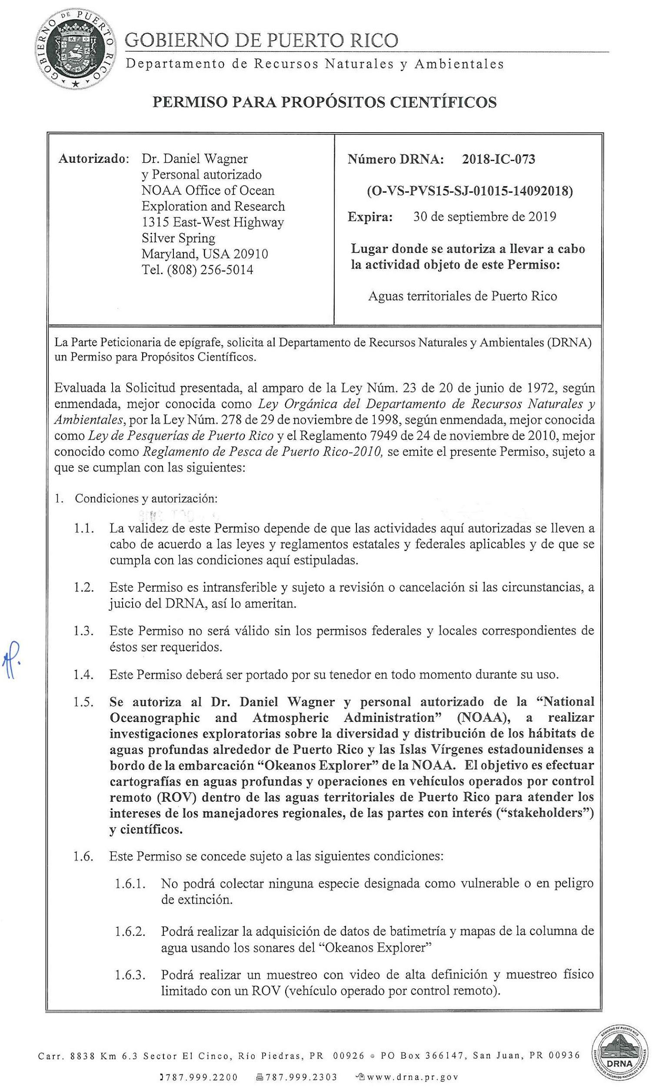
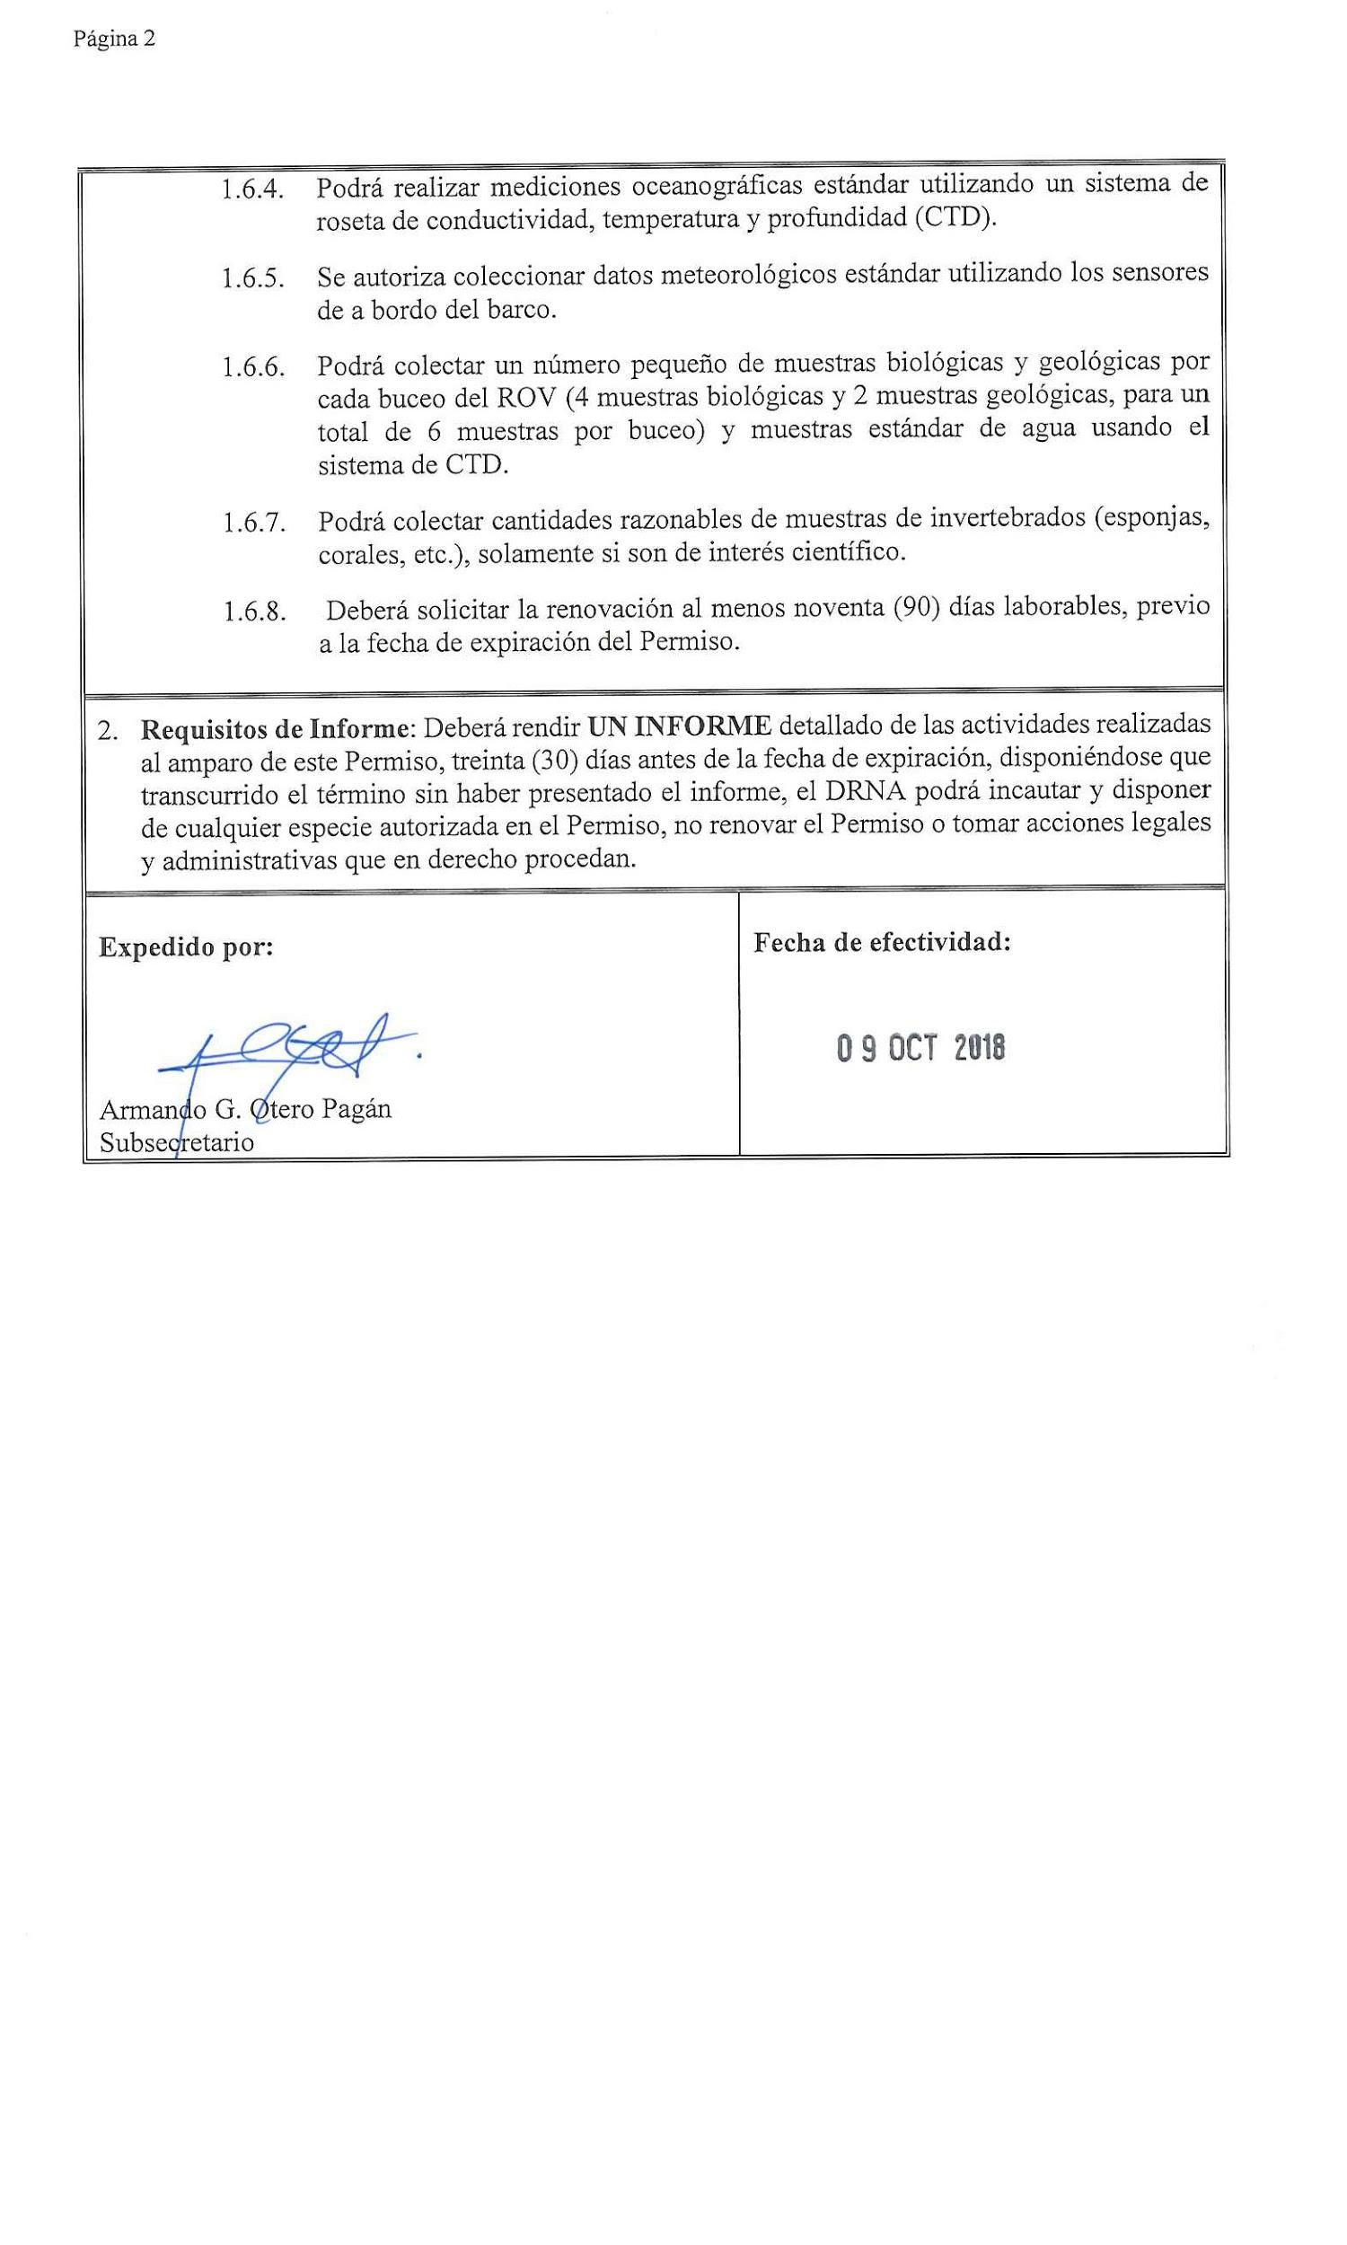
Appendix J: NASA Maritime Aerosols Network Survey of Opportunity

Survey or Project Name
Maritime Aerosol Network

Lead POC or Principle Investigator (PI & Affiliation)
Dr. Alexander Smirnov

Activities Description(s)(Include goals, objectives and tasks)
The Maritime Aerosol Network (MAN) component of AERONET provides ship-borne aerosol optical depth measurements from the Microtops II sun photometers. These data provide an alternative to observations from islands as well as establish validation points for satellite and aerosol transport models. Since 2004, these instruments have been deployed periodically on ships of opportunity and research vessels to monitor aerosol properties over the World Oceans.

Appendix K: Operational policies and procedures for explorations of underwater cultural heritage (UCH) sites

I. Purpose
The purpose of this document is to provide guidance for OER mission activities conducted aboard the NOAA Ship Okeanos Explorer, when such mission activities involve either unexpected discovery or targeted exploration of potential underwater cultural heritage (UCH) sites.

II. Background
Since the inception of NOAA’s ocean exploration program in 2000, OER data management practices have been guided by the 2000 President's Panel Report recommendations, which prioritized rapid and unrestricted data sharing as one of five critical exploration program components. More recently Public law 111-11 [Section XII Subtitle A Part 1 Exploration] reinforced and expanded OER data management objectives, continuing to stress the importance of sharing unique exploration data and information to improve public understanding of the oceans, and for research and management purposes.

OER missions conducted aboard the NOAA Ship Okeanos Explorer offer a best-case scenario for meeting program mission objectives related to data sharing:
- Dedicated shipboard and shore-side teams work in tandem to ensure near-real time data product generation from shipboard and ROV sensors;
- Telepresence is used to share data products and information in real-time with shore-side participants and the public;
- Mission information is publicly communicated in real time via Internet access to streamed video and related resources; and
- Data are managed throughout the lifecycle in accordance with all applicable policy directives and community best practices.

The nature of exploration defines the possibility of discovery, including unexpectedly exposing the location of underwater cultural resources; on some occasions, exploration targets are specifically focused on the exploration of suspected UCH sites. The need to protect the location of suspected UCH sites until they are fully understood, whether purposefully explored or fortuitously discovered, is an important statutory responsibility. In the case of OER expeditions aboard the Okeanos Explorer, a range of operational procedures must be modified to ensure this protection occurs to the fullest extent possible. The following sections of this document define the methods for ensuring protection of these sensitive data throughout the data lifecycle.

III. Authority
a) Marine Archaeology: This document is informed by: the Federal Archaeology Program; U.S. legislation on the treatment of cultural remains; and the UNESCO Convention for the Protection of the Underwater Cultural Heritage. The NOAA Office of Ocean Exploration and Research (OER) supports the standards for conducting marine archaeological activities enumerated in the Annex Rules of the UNESCO Convention on the Protection of the Underwater Cultural Heritage. Preservation and protection of prehistoric and historic cultural resources is the policy of the Federal Government and OER has a responsibility to consider the effects of its activities on these resources. If data is found to be sensitive because it reveals the location of a historically significant cultural resource, Section 304 of the National Historic Preservation Act provides that the head of a Federal agency or other public official shall withhold from public disclosure information about the location, character, or ownership of a historic property when disclosure may: cause a significant invasion of privacy; risk harm to the historic property; or impede the use of a traditional religious site by practitioners. This document will use the term underwater cultural heritage, or UCH, to refer to historic and prehistoric traces of human existence that are totally or partially underwater.

b) Data Management: Geospatial data are considered a national capital asset. National policy and international standards guide data management best practices to ensure timely and broad public accessibility to these data. Within NOAA, data management practices are informed by NOAA Administrative Order (NAO) 212-15 Management of Environmental Data and Information, which states in part:

Environmental data will be visible, accessible and independently understandable to users, except where limited by law, regulation, policy (such as those applicable to personally identifiable information or protected critical infrastructure information or proprietary trade information) or by security requirements.

Sensitive UCH data collections require special handling while determinations are made as to whether each location will be nominated and will qualify for protection under the NHPA Section 304. OER considers these data to fall within the scope of the NAO 212-15 exceptions during this period.

IV. Roles and responsibilities
Particular to the NOAA Ship Okeanos Explorer, there are many methods employed to ensure rapid and broad data access. When the goal is to restrict access to precise positional information, several operational scenarios must be considered. Alternate operating procedures are then developed for:

- Real time operations:
  - Routine data transmissions and events that broadcast the ship position
  - Seafloor mapping operations and data production
  - Telepresence-enabled ROV operations
  - Video annotations and production
  - Public broadcast operations via website and maps
- Post-cruise data management

The table below summarizes the roles and responsibilities of each Team Lead in implementing the policy through the management approaches described herein and the SOPs as defined in the Appendices.

Mission Personnel (Coordinated by: Expedition Coordinator)
Responsible Team | Accountable for these (primary) actions
Expedition Coordinator | Notification of NDA to mission personnel;ID, communicate and enforce UCH buffer zone;coordinate with team leads and key personnel; ensure SOP compliance.
Mapping Team | Segregate raw and processed data into marked files so that restricted data are held separately and are clearly marked.
Telepresence Team | Ensure broadcast data is free of any positional information.
Video Team | Ensure UCH dives and dive products are annotated as such; ensure all raw data and products are not geo-referenced.
Data Management Team | Ensure all UCH data are appropriately segregated and documented. Follow post cruise and archive procedures as specified.
Communications Team | Ensure all communications are controlled through one primary POC; ensure communications are not geo-referenced.
Okeanos Explorer Crew (Coordinated by CO or Designee)
OMAO Operations | Notification to crew of NDA responsibilities; stop SCS events (email notifications) upon entering buffer zone; start SCS events (email notifications) upon exiting buffer zone.

V. Standard Operating Procedures for UCH: Appendices

A) MAPPING OPERATIONS
The following outlines the process for pre-cruise planning, mapping field operations, post-cruise follow up, and data archival procedures for the following scenarios:
- When UCH is unexpectedly discovered on a standard, non-UCH targeted mapping cruise.
- When a cruise is specifically targeted at UCH.
- When an Isolated UCH survey is conducted as part of a broader cruise
- Large survey over UCH area with potential to contain multiple instances of UCH

Pre-Cruise Planning
1. Standard Mapping Pre-Cruise Planning
a. This section does not affect normal pre-cruise or data management
processes for standard mapping cruises that are not conducting targeted UCH mapping. During pre-cruise planning the expedition coordinator is advised to consult with the OER Marine Archaeologist to discuss possible UCH targets in the mission area. The mapping team may be requested to optimize line planning as necessary to detect UCH and to process data, when possible, to a smaller non-standard grid size to create higher resolution mapping products to provide better images of potential UCH. If so, follow guidance in the UCH Mapping Pre-Cruise Planning section below.

2. UCH Mapping Pre-Cruise Planning
a. Background information - The EX mapping team should be supplied
with information about targets in the survey area that will help in their detection and identification. This information will be supplied by OER’s marine archaeologist and collaborating archaeologists.
b. Data processing and data products - Archaeologists involved with the
survey will consult with the mapping team to discuss data processing and data products that will increase the potential to discover UCH. The cruise coordinator and mapping team lead will work with OER’s marine archaeologist to coordinate this activity.
c. Consultation and data sensitivities - Cruise planning must also include
a discussion on data sensitivity and data management/archiving. It is the appropriate time to collaborate with other Federal and state agencies that may have a legal or management interest in potential UCH in the survey area. The risks to the resources should be weighed to inform a post-cruise decision on whether or not UCH with potential historical or cultural significance should have information about their location restricted from public release. This should be a collaborative discussion that includes OER’s marine archaeologist, cruise coordinator and cruise data manager along with cultural resource managers and archaeologists from other agencies with an interest in the UCH. Agencies that may have an interest include the Office of National Marine Sanctuaries (ONMS) Maritime Heritage Program, Bureau of Ocean Energy Management, Bureau of Safety and Environmental Enforcement, U.S. Navy History and Heritage Command, National Park Service, State Historic Preservation Officers, and others. While planning expeditions in any foreign country the host government should be made aware of the potential to discover UCH.
d. In survey areas where an agency has responsibility for UCH, the data
management team should carry out a consultation process with the agency to identify any special protocols that should be put in place to conform with the policies of the agency and these should be incorporated into the data management plan. The expedition coordinator is responsible for the overall execution of the data management plan.
e. On mapping missions within the National Marine Sanctuary System,
pre-cruise discussions between the EX Cruise Coordinator and ONMS should include the ONMS Director of the Maritime Heritage Program (MHP) and the maritime heritage coordinator at the sanctuary site. They will help determine the sensitivity of data and data products.

Mapping Field Operations

1. Standard Mapping Field Operations
a. While standard mapping field operations are not affected by the
marine archaeology SOP, any features which appear to be of cultural or historical significance, and appear anthropogenic in origin, do require special consideration. Cultural features include wrecks of ships or aircraft, the recognizable debris from wrecks, evidence of previous human settlements, or other items which may appear anthropogenic in origin and have some associated cultural or historical significance.
b. The expedition coordinator will consult with OER’s marine archaeologist
immediately on the discovery of UCH in the field. The expedition coordinator should provide an image and location information by email. The OER marine archaeologist may request special data products that have higher resolutions than standard data products to aid in characterizing UCH.
c. If UCH is determined not to be historically or culturally significant or it is
determined that no harm will result by disclosing position information, no
change to standard mapping field procedures is required.
d. If UCH is historically significant or potential to be historically
significant, data and data products should be held from public release until reviewed for sensitivity as applicable under the National Historic Preservation Act and other pertinent legislation and regulations, prior to releasing data to a public archive.
e. The expedition coordinator is responsible for the overall execution of the
data management plan.
f. When appropriate, OER’s marine archaeologist will contact
relevant entities to notify them of the discovery and consult with them regarding the significance of the UCH.

2. UCH Targeted Mapping Field Operations
a. No informal information about UCH should be released to the general
public by the ship or personnel. This includes posting information and
images on social networking sites like Facebook, Twitter or personal blogs. Mapping data will be released to the public following the normal process and announcement of discoveries will be made through the appropriate offices and public affairs officials.
b. A five-mile buffer zone shall be created around the UCH isolated
survey box. The following steps will be taken just prior to entering the
buffer zone in order to stop broadcasting the ship’s location while the survey is conducted:
i. NOAA Shiptracker: Disable the SCS feed from the ship going to
Shiptracker
ii. Automated Information System (AIS): NOAA requires that the
AIS feed which broadcasts information about the ship, including position, course and speed, must remain on at all times for collision avoidance and other safety reasons. Although the International Maritime Organization's (IMO)
Maritime Safety Committee condemns the Internet publication
of AIS data, it is easily available for viewing. During the cruise planning phase the Expedition Coordinator will provide the AIS broadcast range on the EX to the chief scientist and science team. The Chief scientist, the science team, or other parties involved in a UCH mapping cruise should be made aware of this and decide whether the value of the operation merits acceptance of the potential issues/outcomes imposed.
iii. Telepresence Video Feeds: Do not stream any feeds that
include a visible ship location, for example the multi-beam acquisition screen does not high enough resolution over the video feed to see ship position. Streams include but not limited to the SCS data screen, or any active mapping data acquisition screens, or video feeds. It is acceptable to stream video feeds that do not include the ship’s location.
iv. The expedition coordinator will ensure the survey department
takes steps to distinguish and separate UCH mapping data from non-UCH mapping data as appropriate.
v. Raw Multibeam Data Acquisition: Raw data will be logged in
the standard folder structure on the multibeam acquisition computer. Raw data will be copied into a “Restricted” folder in the RAW data network folder structure. Data acquisition and processing logs will clearly state which files are restricted.
vi. Multibeam Data Field Processing: Restricted files will be
processed and gridded separately from other non-restricted data and will be clearly labeled as such in projects and filenames. The products will be created according to normal field quality-control procedures, but will not be sent to shore with the daily products, in order to not become publicly available via normal channels (e.g. FTP site, OER Digital Atlas).
vii. Raw EK 60 and Subbottom Data Acquisition: Raw data will be
logged in the standard folder structure on the acquisition
computers. Raw data will be copied into a 'Restricted' folder on
the RAW and CRUISE DATA data network folder structure.
Data acquisition and processing logs will clearly state which
files are restricted.
viii. Cruise Data Transfer (EX to UNH) Package: In the Cruise Data
Package carried from the ship by the Mapping Team Lead, a
"Restricted" top- level directory will be added in the cruise
data folder. Within the "Restricted" folder the same directory
structure as the unrestricted folder will be repeated (i.e. SCS,
CTD, Multibeam, Imagery, etc).
ix. CTD and XBT operations conducted within the buffer zone do
not need to be isolated from non-UCH data, or repressed from
the Okeanos Atlas. CTD and XBT files should follow the normal
unrestricted processing procedures and archiving.
x. Daily updates are normally linked to the location of the ship at
the time the update is posted. If daily updates are made during UCH surveys, no position shall be provided. If a position is required, the position should be posted as it makes sense, 5 miles outside of the extent of the survey area.
a. Normal transmissions from the ship shall resume after the EX finishes
UCH survey operations and exits the 5-mile buffer zone. Exiting the buffer zone should occur at approximately the same location as entry to prevent obvious data location gaps pointing to UCH location.

Post-Cruise Follow Up

1. Information Release

a. No informal information about UCH should be released to the general

public by the ship or personnel. This includes posting information and

images on social networking sites like Facebook or personal blogs.

Mapping data will be released to the public following the normal

process and announcement of discoveries will be made through the

appropriate offices and public affairs officials.

2. Standard Mapping Cruise follow-up where UCH is discovered
a. The mapping team will provide a brief summary of the survey
and target that includes a description of the survey, water depth, site location, site dimensions, bottom type, and images of the target at the best available resolution.
b. The expedition coordinator and the OER Marine Archaeologist
have an initial consultation to discuss the nature of the UCH
and its potential significance. This consultation may include
other agencies or entities.
c. If UCH is determined not to be historically significant no
change to standard data management procedures is required.
d. If UCH has the potential for historical significance but it is determined
that no harm will result by disclosing position information, such as UCH in deep water, no change to standard data management procedures is required.
e. If UCH has potential historically significance and disclosing
information about the site poses a threat, further discussions will be held on how to minimize potential harmful impacts, including data management decisions outlined in Data Archiving section of this document. The expedition coordinator, a representative from the data management team, OER’s marine archaeologist, a representative from the ONMS Maritime Heritage Program, and any parties with jurisdiction, management or other legal ties to the resource shall meet to determine what measures are needed to protect the UCH while minimizing impacts on the distribution of data and data products.

3. UCH Targeted Mapping Cruise Follow-Up
a. The mapping team will create a survey report that provides technical
details on the survey, data processing and data products. It should contain
a list of targets that includes site location, water depth, site dimensions,
bottom type/topography, and images of the target at the best available
resolution. Other helpful products include SD and kmz files.

b. The expedition coordinator, OER’s marine archaeologist, a representative
from the ONMS Maritime Heritage Program, archaeologists involved in the survey, and any parties with jurisdiction, management or other legal ties to the resource shall meet to discuss the potential historical significance of the UCH and the sensitivities of releasing data to the public that can be protected under Section 304 of the National Historic Preservation Act.
c. The outcome of this meeting will determine if it is necessary to protect site
location information from public release.
d. When data can be released:
i. If the findings determine that releasing information and data o
UCH is not a threat, development of products and data management should follow the guidelines for a standard mapping cruise.
e. When data should be protected:
i. If it is determined that a site is or has potential to be historically
significant and eligible for nomination to the National Register of Historic Places, the location and data containing the location should not be released to the public.
ii. Data products that contain position information will be forwarded
to the EX data management team where data and products will be stored in an archive with restricted access.
iii. Cruise plans, cruise reports, situation reports, mapping summary
reports and other documents that are publically available outside NOAA or freely accessible within NOAA shall not provide location information for UCH or survey areas. In certain circumstances the lead archaeologist for the cruise may request that certain UCH sites are not mentioned in the public reports.

4. UCH mapping follow-up for National Marine Sanctuaries
a. When the EX conducts UCH work inside a National Marine Sanctuary
the expedition coordinator shall inform the OER Marine Archaeologist,
ONMS Maritime Heritage Program Director, Sanctuary Superintendent
and Sanctuary Maritime Heritage Coordinator on the availability of data
products and initial results of the survey. ONMS shall determine the
sensitivity of the data and whether or not it can be disclosed to the
public. Published metadata shall indicate the point of contact to access
UCH data within the NMS system is the Director of the Office of National Marine Sanctuaries.
B) TELEPRESENCE-ENABLED ROV OPERATIONS
The following outlines the process for pre-cruise planning, field operations, post-cruise follow up, and data archival procedures for the following scenarios:
- When a cruise conducts ROV operations specifically targeted at UCH.
- When UCH is unexpectedly discovered on non-archaeological operation

Unexpected UCH Discovery
- During the Cruise: If UCH is unexpectedly discovered during an ROV dive, the onboard Expedition Coordinator should immediately contact OER’s Lead Maritime Archaeologist, and the Archaeology Doctors-on-Call identified for that expedition. Those archaeologists should be engaged in the site investigation as soon as possible to provide information to help assess the site discovered. No changes to the data, video or onboard data acquisition processes should be made. A post-dive and post-cruise discussion will be held with the OER archaeologist to determine whether any datasets should be withheld from archive. (Section 2.D.II).
- Follow-up when UCH is unexpectedly discovered
  - The EX Cruise Coordinator and the OER Marine Archaeologist will have an initial consultation to discuss the nature of the UCH and its potential significance. This consultation may include other agencies or entities.
  - If UCH is determined not to be historically significant no change to standard data management procedures is required.
  - If UCH has the potential for historical significance but it is determined that no harm will result by disclosing position information, such as UCH in deep water, no change to standard data management procedures is required.
  - If UCH is or has potential historical significance and disclosing location information about the site poses a threat, further discussions will be held on how to minimize potential harmful impacts, including data management decisions outlined in the Data Archiving section of this document. The expedition coordinator, a representative from the data management team, OER’s marine archaeologist, a representative from the ONMS Maritime Heritage Program, and any parties with jurisdiction, management or other legal ties to the resource shall meet to determine what measures are needed to protect the UCH while minimizing impacts on the distribution of data and data products.

Cruises conducted with ROV operations specifically targeted at UCH
1. Pre-Cruise Planning: ROV Exploration
a. Notifying the Team of their Responsibility to Protect Sensitive UCH
Resources Expedition members and OER personnel to have a legal responsibility to protect sensitive archaeological information (primarily location information) from untimely release. For a planned UCH cruise, the EC shall notify the CO and each shall have responsibility for ensuring personnel are aware of this responsibility. The EC shall provide an archaeology background document to familiarize personnel with the particular mission and requirements.Appendix D details the range of existing accountability mechanisms already in place.

2. Pre-dive planning
a. Archaeologists will develop a dive plan based on the best
available knowledge of the site that will maximize data recovery and
minimize any potential impact to the site. The archaeology team will
work closely with the cruise coordinator and deep submergence
vehicle manager to develop and implement the plan. The plan should
include:
- Objectives (cultural/interdisciplinary science)
- The types of sensors needed and data to be generated
b. As a rule ROV dives will not disturb or touch the shipwreck or cultural
feature. Exceptions to this rule must discuss the rationale behind such
a decision and incorporate it into the dive plan (collection of diagnostic artifacts or samples is sometimes conducted if the activity leads to better baseline characterization).
c. Prior to the cruise any permitting requirements should be identified
and if required, permits must be procured.
d. Automated Information System (AIS): NOAA requires that the AIS feed
which broadcasts information about the ship, including position,
course and speed, must remain on at all times for collision avoidance
and other safety reasons. Although the International Maritime
Organization's (IMO) Maritime Safety Committee condemns the
Internet publication of AIS data, it is easily available for viewing.
During the cruise planning phase the Expedition Coordinator will
provide the AIS broadcast range on the EX to the chief scientist and
science team. The science team, chief scientist, or other parties involved in a UCH mapping cruise should be made aware of this and decide whether the value of theoperation merits acceptance of the potential issues/outcomes imposed. A Go/No-Go decision will be made based on this information.

Field operations
Exploration dives by ROV should be planned to collect optical and acoustic images without causing physical disturbance to the UCH. Representatives and leads from operational groups including the ROV, data/video, and telepresence teams, and ship operations should meet to discuss ROV operations and data collection. The guidelines for mapping operations should be followed to ensure site locations are not disclosed during field operations. SOPs with full operational details are available on the ship. A three-mile buffer zone shall be created around the UCH target or isolateD survey box. The time at which the ship enters, and departs the three-mile buffer zone needs to be recorded and provided to the Data Team Lead for data post-processing. Following work at the site, the ship will return to the site where it first entered the three-mile buffer zone to continue operations.

The following steps will be taken just prior to entering the five-mile buffer zone in order to stop broadcasting the ship’s location while the survey is conducted:
- NOAA email events will be stopped (OMAO/ET)
- NOAA Shiptracker: Disable/stop the e-mail updates from the ship going to OMAO / Shiptracker
- Okeanos Atlas: Disable/stop the e-mail updates to NCDDC
- SAMOS: Disable/stop the e-mail update to FSU containing METOC and flow- through data, etc.
- Telepresence Video Feeds (OER Telepresence team lead): Do not stream any feeds that include the ship’s location, including but not limited to the SCS data screen, or any active mapping data acquisition screens, or video feeds. It is acceptable to stream video feeds that do not include the ship’s location.
- Redirect Live Feed as needed (OER EC or CO): If highly sensitive features (human remains, evidence of human remain such as shoes or other accoutrements, highly valuable items, etc.) are going to be investigated or are unexpectedly encountered during the course of our seafloor investigation, the lead archaeologist, ROV Team Leader, Expedition Coordinator or Commanding Officer has authority to immediately switch the live feed from the ROV and Seirios camera sled to another camera on the ship.

Daily updates on the Okeanos Atlas are normally linked to the location of the ship at the time the update is posted. If daily updates are made during UCH surveys, no position shall be provided. If a position is required, the position should be posted as it makes sense, 3 miles outside of the extent of the site or survey area. Normal transmissions from the ship shall resume after the EX finishes UCH survey operations and exits the 3-mile buffer zone. The point of exit should be as near to the point of entry as is feasible to minimize location data gaps pointing to the location of the UCH. No informal information about UCH should be released to the general public by the ship or personnel. This includes posting information and images on social networking sites like Facebook, Twitter or personal blogs. Images, video and information on UCH will be released to the public following the normal process and announcement of discoveries will be made through the appropriate offices and public affairs officials.
In addition to the items listed, the ship sends out automated weather (autoIMET) observations every hour and manual weather observations every 6 hours with positions as a voluntary ship observer. These observations are pulled onto public sites by several different websites and Google Map apps. One example is sailwx.info. This is only accurate to the nearest decimal degree (6 nm). This level of accuracy is not of concern.

Post-cruise data management

Following completion of the expedition, the Expedition COordinator should have a follow-up call with the Data Management Team & OER lead archaeologist to review the datasets collected, confirm those that need to be withheld from public archive, and provide information to the data management team for associated metadata records.

Post-cruise follow-up

1. Information Release
a. No informal information about UCH should be released to the general public
by the ship or personnel. This includes posting information and images on social networking sites like Facebook or personal blogs. Images, video, and mapping data will be released to the public following the normal process and announcement of discoveries will be made through the appropriate offices and public affairs officials.
b. Determination of whether UCH is potentially eligible for nomination to the
National Register of Historic Places, or eligible for protection under other legislation such as the Sunken Military Craft Act or National Marine Sanctuary Act, will take some time following completion of the cruise. Sensitive or potentially sensitive information about the UCH is to remain restricted until determination is complete. Following completion of the cruise, the lead Archaeologist will work with others to analyze the UCH data and conduct historical research to determine whether the UCH is eligible for nomination to the National Register of Historic Places.
I. If the UCH is determined to be eligible, the lead Archaeologist will
prepare the nomination for the NRHP process.
II. If the UCH is determined to NOT be eligible, and protection of the site
does not fall under other legislation, the Lead archaeologist will notify
the data management team that site information can be made publicly
available.

2. UCH Targeted Cruise Follow-Up

a. The EX cruise coordinator, OER’s marine archaeologist, a representative from

the ONMS Maritime Heritage Program, archaeologists involved in the survey, and any parties with jurisdiction, management or other legal ties to the resource shall meet to discuss the potential historical significance of the UCH and the sensitivities of releasing data to the public that can be protected under Section 304 of the National Historic Preservation Act. The outcome of this meeting will determine if it is necessary to protect site location information from public release.

When location data can be released: If the findings determine that releasing information and data on UCH is not a threat, development of products and data management should follow the guidelines for a standard ROV cruise.

When location data should be protected: If it is determined that a site is or has potential to be historically significant and eligible for nomination to the National Register of Historic Places, the location and data containing the location should not be released to the public.

Data products that contain position information will be forwarded to the EX data management team where data and products will be stored in an archive with restricted access.

Cruise plans, cruise reports, situation reports, mapping summary reports and other documents that are publically available outside NOAA or freely accessible within NOAA shall not provide location information for UCH or survey areas. In certain circumstances the lead archaeologist for the cruise may request that certain UCH sites are not mentioned in the public reports.

C) POST-CRUISE DATA MANAGEMENT
Data collected by OER that is considered sensitive will be protected from direct public release until such time as a final determination can be made as to permanent protection. Data in this state will be:
- Fully documented, so as to be independently understandable to users;
- Visible through publication of metadata records by OER;
- Accessible upon request to OER (controlled access by permission);
- Preserved in NOAA archives as ‘restricted’ (not available for direct public access).

These data will not be available for direct public access unless and until they are eliminated from consideration for nomination to the National Register of Historic Places (NHPA Section 304), or for protection under other legislation such as the Sunken Military Craft Act or National Marine Sanctuary Act. If data are nominated and accepted for any official protection, then the exceptional status will be made permanent, and all documentation updated and finalized as such.

Data generated by the Okeanos Explorer is archived under a data management agreement with NCEI. Only data that has potential to reveal the nature and location of UCH shall be restricted from public access. In accordance with the data management agreement, sensitive data from the EX will have restricted access at NCEI. To assist researchers in discovering sensitive data NGDC will publish a metadata record (but not the data) that identifies a point of contact for access. Requests to access the data will be made to the Director of OER who may delegate to the OER marine archaeologist. In lieu of the OER marine archaeologist, the OER Director may delegate to the Director of the ONMS Maritime Heritage Program.

If data is found to be sensitive because it reveals the location of a historically significant cultural resource, Section 304 of the National Historic Preservation Act provides that the head of a Federal agency or other public official shall withhold from public disclosure information about the location, character, or ownership of a historic property when disclosure may cause a significant invasion of privacy; risk harm to the historic property; or impede the use of a traditional religious site by practitioners. Data collected by the EX that is considered sensitive will be archived in a location where it can be withheld from public disclosure.

Data sets and associated products are housed in the appropriate NOAA archive; National Oceanographic Data Center, National Geophysical Data Center, National Coastal Data Development Center, National Climate Data Center, and the NOAA Central Library.
- OER Digital Atlas: NCEI will develop appropriate metadata records to post on the digital atlas.
- CTD and XBT data collected during mapping operations conducted within the buffer zone will not be repressed from the Okeanos Atlas and will be held in a public archive.
- Cruise reports, cruise plans, mapping summary reports and other documents that are publicly available outside NOAA or freely accessible within NOAA should not provide location information for UCH or survey areas.

Start and end times for the 3-mile buffer zone surrounding a UCH site need to be provided to the data management team. Datasets containing sensitive location information will be restricted in their entirety, unless other parsing arrangements have been made. The following datasets may contain sensitive UCH location information and need to be reviewed, post-processed as appropriate, made restricted and pertinent metadata records created and made available:
- Multibeam, sub-bottom and single beam sonar data
- SCS Data Logs are to be restricted
- All ROV dive products (including associated sensor data) need to be restricted
- CTD rosette and in situ sensor datasets collected in relation to the UCH, and within the 3 nm buffer zone, need to be restricted.
- All imagery needs to be reviewed and geospatial imagery removed before being made public. Imagery with geospatial information should be restricted.
- Ship track and other datasets within the buffer zone

D) NON-DISCLOSURE AGREEMENT (NDA) REFERENCES
Expedition members and OER personnel to have a legal responsibility to protect sensitive archaeological information (primarily location information) from untimely release. The following summarizes the types of personnel who might be engaged in an Okeanos Explorer Expedition, where their responsibility to protect sensitive location information about UCH lies, and whether this responsibility has already been addressed or signature of a Non-Disclosure Agreement (NDA) is required to allow their participation in an expedition with planned UCH operations.
- If they are federally-employed scientists, they agreed not to disclose sensitive information and to adhere to federal laws as part of the terms of their employment with the federal government.
- The crew onboard the ship are under the CO's purview. On Okeanos Explorer, all crew are federal employees, and thus agreed not to disclose sensitive information and to adhere to federal laws as part of the terms of their employment with the federal government.
- All other members of the Mission team who are not federal employees and are engaged at-sea or ashore (including technicians, vehicle operators, students, etc.) are required to sign a non-disclosure agreement to protect sensitive cultural heritage information as part of their contract agreement.
- Other OER personnel who have access to data and information on the FTP site are either federal employees or contractors and need to be similarly reminded of their responsibilities. OER contractors signed an NDA as condition of employment with the federal government (this should be confirmed annually).

At the beginning of the expedition, all personnel need to be notified of their responsibilities:

Employee type | Accountability mechanism for with-holding sensitive data | Action
Mission Personnel (Notified by Expedition Coordinator)
NOAA Federal Employees | NOAA and Federal Contract | Reminder of contract, and provide archaeology background document
Mission Contractors (UCAR, ERT Inc., 2020  Company LLC) | Non-Disclosure Agreement | Confirm all contractors signed NDA; send reminder of contract and provide archaeology background document
NOAA/Federal Scientists | NOAA and Federal Contract | Reminder of contract, and provide archaeology background document
Other Federal Scientists (BOEM, Navy, NPS, etc.) | Federal Contract | Reminder of contract, and provide archaeology background document
Other Mission Personnel and Scientists | Non-Disclosure Agreement | Get NDA signed
Employee type | Accountability mechanism for with-holding sensitive data | Action
Okeanos Explorer Crew (Notified by CO or Designee)
NOAA Federal Employees | Subject to NOAA and the  ship's communications plans and protocols for sensitive  data | CO sends out reminder of contract to ship via All Hands, and provides archaeology background document
Other Federal Employees (e.g. Public Health Service) | Subject to NOAA and the  ship's communications plans and protocols for sensitive  data | CO sends out reminder of contract to ship via All Hands, and provides archaeology background document
Wage Mariners | Subject to NOAA and the  ship's communications plans and protocols for sensitive  data | CO sends out reminder of contract to ship via all hands, and provides archaeology background document

Appendix L: Summary of Mitigation Measures and Best Management Practices

Protective Measures and Best Management Practices (BMPs) Incorporated into the Action. BMPs are required to be incorporated within project instructions, cruise plans and NEPA documentation including financial assistance awards and environmental review memoranda. All applicable BMPs must be communicated to the science leads, boat operators and field staff, and as necessary between ship’s crew (Commanding Officer/Master or designee(s), as appropriate) and scientific party in order to explain responsibilities, communication procedures, marine mammal monitoring protocol, and operational procedures.

Bridge Watchstanders on the Okeanos Explorer’s bridge will carefully monitor for the presence of marine protected species, and permitted personnel would follow established best management practices (BMPs) to minimize disturbance.

- Minimize Exposure to Elevated Noise Levels
  - Maintain watch for the presence of marine protected species. Immediately notify the survey department of the proximity of cetaceans and sea turtles.When marine mammals are able to be identified by Bridge Officers or Watch Standers, these observations are noted in the NOAA fleet marine mammal observation log as part of standard practice.
    - If a sea turtle is present within 400 m of the ship, the survey department will respond by stopping the pinging of the subbottom sonar. The subbottom shall remain off until the sea turtle has departed the 400 m safety zone.
    - If cetaceans are present within 400 m of the ship (460 m/500 yards for North Atlantic Right Whales), the vessel would stop if the animal is in danger of colliding with the ship but the mapping sonars would continue transmitting to avoid startle responses. If an observed animal is unable or unwilling to depart the immediate area, sonars will be secured and the ship will slowly move away from the area if feasible.
    - If the cetacean is within 400 m (460 m/500 yards for North Atlantic Right Whales) and is not in danger of collision, reduce speed and seek to avoid the animal as much as possible.
    - The Survey Department will respond by stopping the pinging of the sub-bottom sonar and switching the multibeam sonar into “mammal protection” mode (keeps it pinging but at a source level reduced by 20 decibels). No change will occur to the EK 60s. Note: the ADCPs are never run simultaneously with the multibeam and sub-bottom, so they would already be off. The ADCPs are mostly run when the ship is stationary at a dive site and risk to marine mammals is minimal.
  - Minimize turning all sonar sound sources on and off as a precautionary measure to avoid possible startling of animals.
  - When the systems have been shut down for any reason, the multibeam mammal protection mode would be used to turn the multibeam back on first. Only after the multibeam has been brought from mammal protection mode to full power would the sub-bottom profiler and EK 60 sonars then be turned back on.
  - If the multibeam sonar is not being used, but other sonar systems are being turned on, they will be started in lower power settings and will gradually (over a 15 minute time period) be adjusted to higher power settings as appropriate for the water depths to essentially mimic the approach of the “mammal protection” mode of the multibeam.

- Minimize Temporary Disturbance from Human Activity
  - All in-water work will be postponed when whales are within 100 yards, or other protected species are within 50 yards;
    - This includes posposting start-up of the USBL in preparation for an ROV dive.
  - Should a marine protected species enter the area while in-water work is already in progress, the activity may continue only when that activity has no reasonable expectation to adversely affect the animal(s); and
  - No attempts will be made to feed, touch, ride, or otherwise intentionally interact with any marine protected species.

- Minimize Entanglement
  - Maintain watch for and avoid the presence of marine protected species. Notify the department heads of the proximity of animals;
  - All in-water work will be postponed when whales are within 100 yards, or other protected species are within 50 yards of the vessel;
  - Should a marine protected species enter the area while in-water work is already in progress, the activity may continue only when that activity has no reasonable expectation to adversely affect the animal(s); and
  - Individuals participating in the activity will closely monitor the instrument cables at all times while they are deployed.

- Minimize Collisions with Vessels
The following guidelines for vessel operation in the presence of marine protected species and other marine wildlife are provided by the Bureau of Ocean Energy Management in a Notice to Lessees and Operators (appendix G), and NOAA Fisheries as part of a Biological Opinion:
  - Vessel Strike Avoidance
Vessel operator and crew must maintain a vigilant watch for all marine mammals and sea turtles and slow down or stop the vessel or alter course, as appropriate, to avoid striking any marine mammal. These requirements apply when the vessel is in transit and do not apply in any case where compliance will create an imminent and serious threat to a person or vessel or to the extent that a vessel is restricted in its ability to maneuver and, because of the restriction, cannot comply. A visual observer aboard the vessel must monitor a vessel strike avoidance zone around the vessel according to the parameters stated below. Visual observers monitoring the vessel strike avoidance zone can be either third-party visual protected species observers or crew members, but crew members responsible for these duties must be provided sufficient training to distinguish marine mammals from other phenomena. Vessel strike avoidance measures shall be followed during sonar surveys and while in transit.

Vessel personnel should do the following in order to avoid causing injury or death to marine mammals and sea turtles:
    - Maintain a vigilant watch for marine mammals and sea turtles and slow down or stop their vessel to avoid striking protected species.
    - When whales are sighted, maintain a distance of 100 yards (91 meters) or greater from the whale. If the whale is believed to be a North Atlantic right whale, vessel personnel should maintain a minimum distance of 500 yards (460 meters) from the animal (50 CFR 224.103).
    - When sea turtles or small cetaceans are sighted, attempt to maintain a distance of 50 yards (45 meters) or greater whenever possible.
    - When cetaceans are sighted while a vessel is underway, attempt to remain parallel to the animal's course. Avoid excessive speed or abrupt changes in direction until the cetacean has left the area.
    - Reduce vessel speed to 10 knots or less when mother/calf pairs, pods, or large assemblages of cetaceans are observed near an underway vessel when safety permits. A single cetacean at the surface may indicate the presence of submerged animals in the vicinity of the vessel; therefore, precautionary measures should always be exercised.
    - Whales may surface in unpredictable locations or approach slowly moving vessels. When vessel personnel sight animals in the vessel's path or in close proximity to a moving vessel, reduce speed and shift the engine to neutral. Do not engage the engines until the animals are clear of the area.

The vessel must maintain a minimum separation distance of 100 m (328.1 ft) from large whales (i.e. sperm and baleen whales). The following avoidance measures must be taken if a large whale is within 100 m (328.1 ft) of the vessel.
- The vessel must reduce speed and shift the engine to neutral, and must not engage the engines until the whale has moved outside of the vessel’s path and the minimum separation distance has been established.
- If the vessel is stationary, the vessel must not engage engines until the whale(s) has moved out of the vessel’s path and beyond 100 m (328.1 ft).

  - Additional Requirements for the North Atlantic Right Whale
    - If a sighted whale is believed to be a North Atlantic right whale, federal regulation requires a minimum distance of 500 yards be maintained from the animal (50 CFR 224.103 ©).
    - Vessels entering North Atlantic right whale critical habitat are required to report into the Mandatory Ship Reporting System.
    - Mariners shall check with various communication media for general information regarding avoiding ship strikes and specific information regarding North Atlantic right whale sighting locations. These include NOAA weather radio, U.S. Coast Guard NAVTEX broadcasts, and Notices to Mariners. Commercial mariners calling on United States ports should view the most recent version of the NOAA/USCG produced training CD entitled “A Prudent Mariner’s Guide to Right Whale Protection” (contact the NMFS Southeast Region, Protected Resources Division for more information regarding the CD).
    - Injured, dead, or entangled right whales should be immediately reported to the U.S. Coast Guard via VHF Channel 16.
    - Adherence to seasonal vessel speed restrictions of 10 knots or less as designated locations (Appendix H) along the U.S. east coast.
    - Adherence to NOAA Compliance Guide for Right Whale Ship Strike Reduction Rule (Appendix I)

- Minimize Vessel Waste and Discharge & Prevent Invasive Species
  - All vessels operating in areas where ESA-listed species are present will continue to follow MARPOL discharge protocols, but will postpone any authorized discharge if any protected species are within 100 yards of the vessel.
  - Meet all EPA Vessel General Permits and Coast Guard requirements.
  - Avoid discharge of ballast water in designated critical habitat.
  - Use anti-fouling coatings.
  - Clean hull regularly to remove aquatic nuisance species.
  - Avoid cleaning of hull in critical habitat.
  - Avoid cleaners with nonylphenols.

- Avoid or Minimize Impacts to Essential Fish Habitat
  - The vessel would employ the use of dynamic positioning during ROV dives (no anchoring);
  - ROVs would be operated in a manner to avoid seafloor disturbance, and setting the ROV on the seafloor will be held to a minimum. For those situations when the ROV does make contact with the seafloor, visual observations will be made to confirm that the area the ROV is set down on does not include corals or other fragile animals that can reasonably be avoided;
  - Sample collections would be limited (typically 4 - 6 total rocks and primary biological specimens per dive) that represent new species, new records, the dominant morphotype animal in a community, or species to support connectivity studies. These specimens would be collected using the ROV’s manipulator arms or scoop. Whenever possible, sample collections will be made using the cutting implementation tool on the ROV, and only portions of organisms (<50 cm) will be collected to avoid mortality. Clonal biological specimens (corals, sponges) would be subsampled;
  - When possible, rock samples will be selected in a way to minimize disturbance to the surrounding environment and to minimize the take of attached organisms.;
  - After each ROV dive, the vehicles are brought back onboard and thoroughly sprayed with freshwater and allowed to air dry before the next dive. Though marine organisms should not survive this process, the ROV is thoroughly inspected prior to every dive and checked for the presence of biological organisms to prevent the spread of invasive or non-endemic species from one location to another;
  - Instruments deployed to collect water samples and current data (except for expendable instruments) would not be allowed to contact the seafloor;
  - The use detergents and other pollutants which may be washed into the marine environment wil be avoided or held to a minimum;
  - The vessel will adhere to MARPOL discharge regulations at all times during the proposed cruises;
  - Except in an emergency, the vessel will not anchor while at sea.

