Okeanos Explorer ROV Dive Summary
Dive Information
General Location | 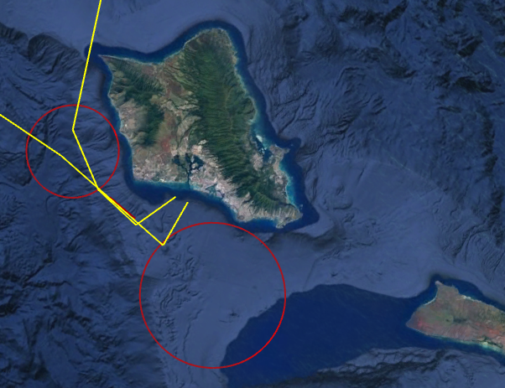
General Area Descriptor | Oahu
Site Name | USS Baltimore
Science Team Leads | John Smith/Meagan Putts
Expedition Coordinator | Kasey Cantwell
ROV Dive Supervisor | Karl McLetchie
Mapping Lead | Mike White
ROV Dive Name
Cruise | EX1708
Leg | -
Dive Number | DIVE22
Equipment Deployed
ROV | Deep Discoverer
Camera Platform | Seirios
ROV Measurements | CTD |  | Depth | Altitude
 | Scanning Sonar |  | USBL Position | Heading
 | Pitch |  | Roll | HD Camera 1
 | HD Camera 2 |  | Low Res Cam 1 | Low Res Cam 2
 | Low Res Cam 3 |  | Low Res Cam 4 | Low Res Cam 5
Equipment Malfunctions
ROV Dive Summary  (from processed ROV data) | Information withheld due to Underwater Cultural Heritage Site
Special Notes
Scientists Involved  (please provide name, location, affiliation, email) | Name Email Affiliation  Jarrod Kellogg Defense POW/MIA Accounting Agency (DPAA)  Amanda Murphy DPAA  Asako Matsumoto amatsu@gorgonian.jp Planetary Exploration Research Center, Chiba Institute of Technology  Ashley Burch Defense POW/MIA Accounting Agency (DPAA)  Bruce Mundy bruce.mundy@noaa.gov NOAA NMFS Pacific Islands Fisheries Science Center  Bruce Terrell bruce.terrell@noaa.gov NOAA  Christopher Kelley ckelley@hawaii.edu University of Hawaii  Christopher Mah brisinga@gmail.com Dept. Invertebrate Zoology, NMNH Smithsonian Institution  David Ball david.ball@boem.gov BOEM  Denise To Defense POW/MIA Accounting Agency (DPAA)  Eric Young Defense POW/MIA Accounting Agency (DPAA)  Frank Cantelas frank.cantelas@noaa.gov NOAA NOS MHP/ OER  Frederick Hanselmann fhanselmann@rsmas.miami.edu University of Miami  Hans Van Tilburg hans.vantilburg@noaa.gov NOAA ONMS  Heidi Hirsh heidi.hirsh@noaa.gov NOAA NMFS PIRO Marine National Monuments Program  Jack Irion jack.irion@boem.gov BOEM  Jim Masterson jmaster7@fau.edu FAU Harbor Branch Oceanographic ECC  John Smith jrsmith@hawaii.edu University of Hawaii  Joseph Hoyt joseph.hoyt@noaa.gov Office of National Marine Sanctuaries  Kara Davis kara.e.davis.civ@mail.mil Defense POW/MIA Accounting Agency  Kimberly Galvez kgalvez@rsmas.miami.edu University of Miami - RSMAS  Mary Megyesi Defense POW/MIA Accounting Agency (DPAA)  Meagan Putts Meagan.putts@noaa.gov University of Hawaii  Nolan Barrett barrettnh@g.cofc.edu FAU Harbor Branch Oceanographic Institute  Piotr Bojakowski Defense POW/MIA Accounting Agency (DPAA)  Richard Wills richard.k.wills.civ@mail.mil DPAA SA CIL  Robert Schwemmer Robert.Schwemmer@noaa.gov NOAA  Russ Matthews rmatthews@mor-ent.com Air Sea Heritage Foundation  Tina Molodtsova tina@ocean.ru; tina.molodtsova@gmail.com P.P.Shirshov Institute of Oceanology RAS
Purpose of the Dive | Maritime heritage dive to conduct non-invasive video survey of remains of USS Baltimore, late 19th-century USN protected cruiser scuttled near Oahu in 1944, including: documentation of specific 19th-century features; photogrammetry and mosaic data compilation; assessment of scuttling damage; assessment of preservation/deterioration status; marine species inventory.
Description of the Dive | Vessel was found upright and intact on the flat sandy bottom. A complete video survey was accomplished meeting all the main objectives: perimeter survey of main features; detailed photogrammetry compilation of iconic bow ram; detailed engineering spaces documentation; full deck photomosaic compilation; hull plate damage assessment. Data will enable interpretive products of this historic vessel.
Overall Map of the ROV Dive Area |  | Close-up Map of Main Dive Site
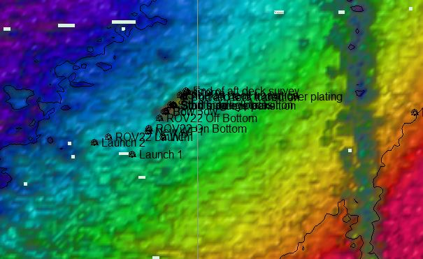 |  | 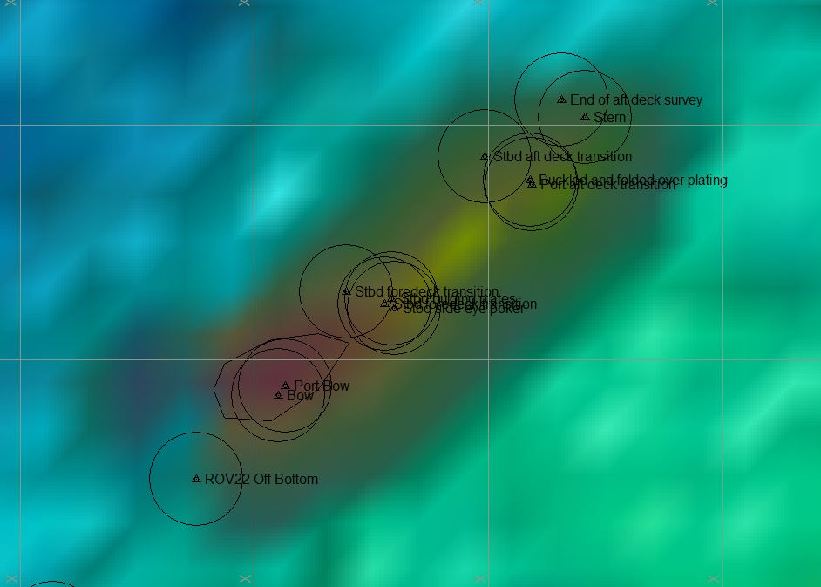
Representative Photos of the Dive
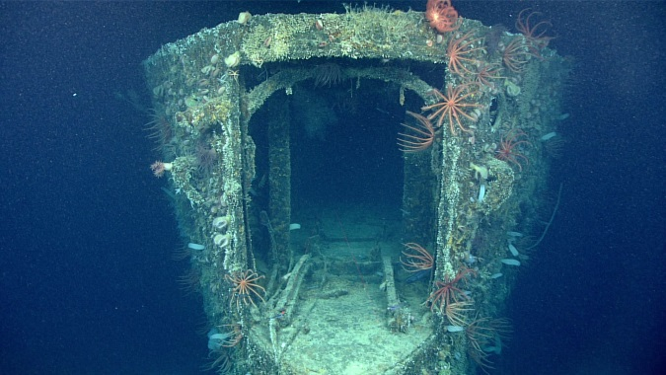 |  | 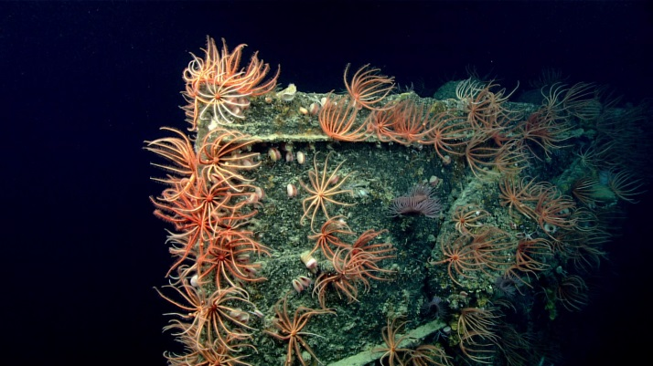
- The stern of the USS Baltimore was modified to accommodate mine laying operations. |  | - At the bow of the USS Baltimore, there was a large aggregation of Brisingid sea stars.
Samples Collected
  - No samples were collected during this dive.

Please direct inquiries to:
NOAA Office of Ocean Exploration & Research
1315 East-West Highway (SSMC3 10th Floor)
Silver Spring, MD 20910
(301) 734-1014

