Okeanos Explorer ROV Dive Summary
Dive Information
General Location | 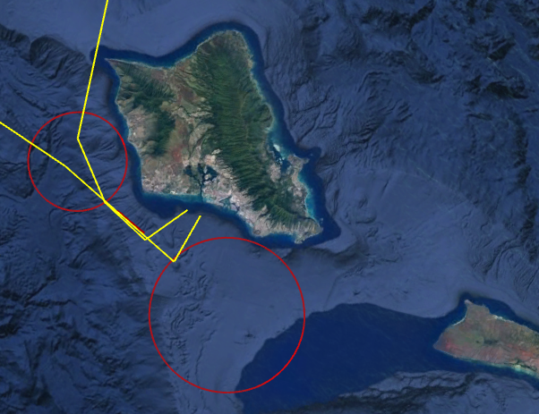
General Area Descriptor | Oahu
Site Name | Caiman Targets
Science Team Leads | John Smith/Meagan Putts
Expedition Coordinator | Kasey Cantwell
ROV Dive Supervisor | Karl McLetchie
Mapping Lead | Mike White
ROV Dive Name
Cruise | EX1708
Leg | -
Dive Number | DIVE21
Equipment Deployed
ROV | Deep Discoverer
Camera Platform | Seirios
ROV Measurements | CTD |  | Depth | Altitude
 | Scanning Sonar |  | USBL Position | Heading
 | Pitch |  | Roll | HD Camera 1
 | HD Camera 2 |  | Low Res Cam 1 | Low Res Cam 2
 | Low Res Cam 3 |  | Low Res Cam 4 | Low Res Cam 5
Equipment Malfunctions
ROV Dive Summary  (from processed ROV data) | Dive Summary: EX1708_DIVE21  ^^^^^^^^^^^^^^^^^^^^^^^^^^^^^^^^^^^^^^^^^^^^^^^^^^^  In Water: 2017-09-28T18:31:18.905000  21°, 12.989' N ; 158°, 08.196' W  Out Water: 2017-09-29T02:30:34.327000  21°, 12.985' N ; 158°, 07.141' W  Off Bottom: 2017-09-29T02:00:18.093000  21°, 12.964' N ; 158°, 07.341' W  On Bottom: 2017-09-28T19:07:38.474000  21°, 12.940' N ; 158°, 08.032' W  Dive duration: 7:59:15  Bottom Time: 6:52:39  Max. depth: 843.6 m
Special Notes
Scientists Involved  (please provide name, location, affiliation, email) | Name Email Affiliation  Ally Campo DPAA  Amanda Murphy DPAA  Amanda Netburn amanda.netburn@noaa.gov NOAA OER  Asako Matsumoto amatsu@gorgonian.jp Planetary Exploration Research Center, Chiba Institute of Technology  Ashley Burch Defense POW/MIA Accounting Agency (DPAA)  Augustine Ortiz Ortiz agustin.ortiz.ctr@navy.mil NHHC  Bruce Mundy bruce.mundy@noaa.gov NOAA NMFS Pacific Islands Fisheries Science Center  Bruce Terrell bruce.terrell@noaa.gov NOAA  Christopher Kelley ckelley@hawaii.edu University of Hawaii  David Ebert Pacific Shark Research Center  David Ball david.ball@boem.gov BOEM  Denise To Defense POW/MIA Accounting Agency (DPAA)  Diva Amon divaamon@gmail.com Natural History Museum, London  Eric Young Defense POW/MIA Accounting Agency (DPAA)  Frank Cantelas frank.cantelas@noaa.gov NOAA NOS MHP/ OER  Frederick Hanselmann fhanselmann@rsmas.miami.edu University of Miami  Hans Van Tilburg hans.vantilburg@noaa.gov NOAA ONMS  Jack Irion jack.irion@boem.gov BOEM  James Delgado james.delgado@searchinc.com SEARCH, Inc.  John Smith jrsmith@hawaii.edu University of Hawaii  Joseph Hoyt joseph.hoyt@noaa.gov Office of National Marine Sanctuaries  Ken Sulak jumpingsturgeon@yahoo.com USGS (ret.)  Kevin Kocot kmkocot@ua.edu The University of Alabama  Mary Megyesi Defense POW/MIA Accounting Agency (DPAA)  Meagan Putts Meagan.putts@noaa.gov University of Hawaii  Michael Parke michael.parke@noaa.gov NOAA PIFSC  Nolan Barrett barrettnh@g.cofc.edu FAU Harbor Branch Oceanographic Institute  Piotr Bojakowski Defense POW/MIA Accounting Agency (DPAA)  Richard Wills richard.k.wills.civ@mail.mil DPAA SA CIL  Robert Schwemmer Robert.Schwemmer@noaa.gov NOAA  Russ Matthews rmatthews@mor-ent.com Air Sea Heritage Foundation  Steve Auscavitch tug19971@temple.edu Temple University  Tara Luke luket@stockton.edu Stockton University  Tina Molodtsova tina@ocean.ru; tina.molodtsova@gmail.com P.P.Shirshov Institute of Oceanology RAS
Purpose of the Dive | To investigate a series of sonar anomalies in an effort to locate the remains of the Japanese fast submarine I-203 (Sentaka-type) captured at the end of WWII, brought to Pearl Harbor as part of the 5-submarine prize fleet, and disposed near this area in 1946. If found, conduct non-invasive survey focusing on the innovative features of this rare fast attack vessel.
Description of the Dive | Multibeam sonar targets at all 5 selected waypoints, generated from existing multibeam data and refined by the maritime archaeology collaborative team, were examined by the ROV and found to be geologic (basalt rock) formations. I-203 was not located. One unexpected target was confirmed: remains of a WWII-period floating causeway (“rhino barge”).
Overall Map of the ROV Dive Area |  | Close-up Map of Main Dive Site
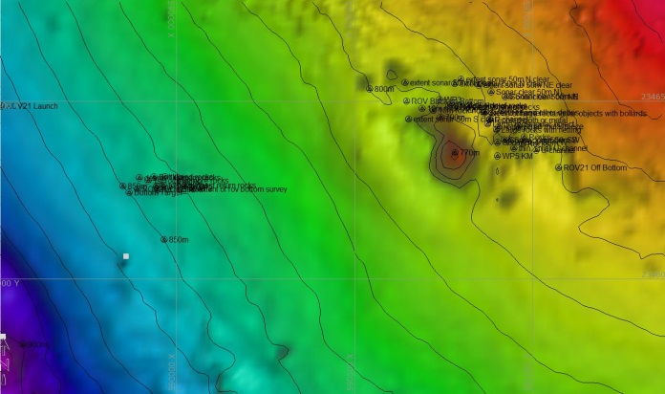 |  | 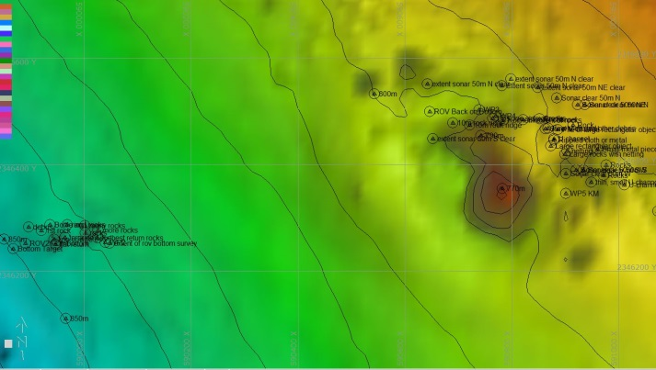
Representative Photos of the Dive
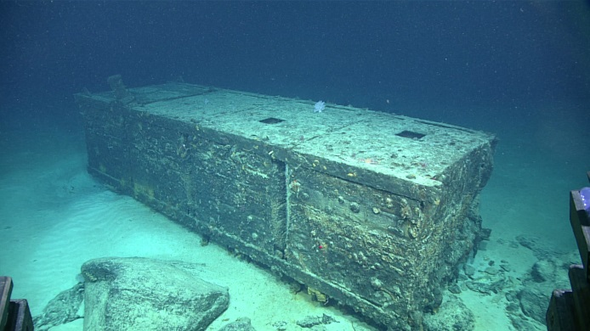 |  | 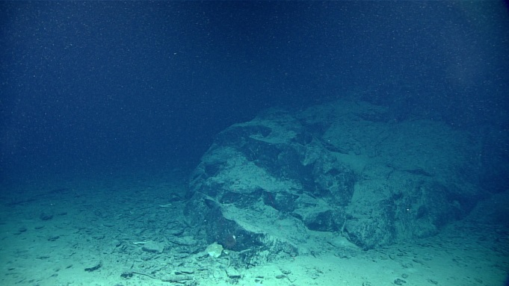
- While the Caiman targets did not turn out to be a WWII shipwreck, the survey revealed a sunken WWII era floating dock |  | - Several of the sonal anomalies targeted during this dive were revealed to be rocky outcrops.
Samples Collected
  - No samples were collected during this dive.

Please direct inquiries to:
NOAA Office of Ocean Exploration & Research
1315 East-West Highway (SSMC3 10th Floor)
Silver Spring, MD 20910
(301) 734-1014

