Okeanos Explorer ROV Dive Summary
Dive Information
General Location |  |  | 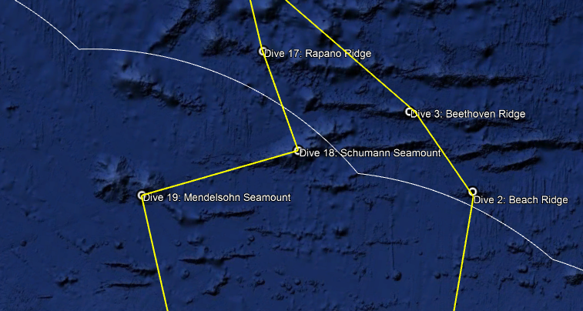
General Area Descriptor |  |  | Musicians Seamounts
Site Name |  |  | Rapano Ridge
Science Team Leads |  |  | John R. Smith/Meagan Putts
Expedition Coordinator |  |  | Kasey Cantwell
ROV Dive Supervisor |  |  | Karl McLetchie
Mapping Lead |  |  | Mike White
ROV Dive Name
Cruise |  |  | EX1708
Leg |  |  | -
Dive Number |  |  | DIVE17
Equipment Deployed
ROV |  |  | Deep Discoverer
Camera Platform |  |  | Seirios
ROV Measurements |  |  | CTD |  |  | Depth | Altitude
 |  |  | Scanning Sonar |  |  | USBL Position | Heading
 |  |  | Pitch |  |  | Roll | HD Camera 1
 |  |  | HD Camera 2 |  |  | Low Res Cam 1 | Low Res Cam 2
 |  |  | Low Res Cam 3 |  |  | Low Res Cam 4 | Low Res Cam 5
Equipment Malfunctions |  |  | DO sensor??
ROV Dive Summary  (from processed ROV data) |  |  | Dive Summary: EX1708_DIVE17  ^^^^^^^^^^^^^^^^^^^^^^^^^^^^^^^^^^^^^^^^^^^^^^^^^^^  In Water: 2017-09-23T18:24:02.857000  26°, 35.911' N ; 160°, 40.194' W  Out Water: 2017-09-24T04:22:52.561000  26°, 35.679' N ; 160°, 39.836' W  Off Bottom: 2017-09-24T01:19:28.710000  26°, 35.703' N ; 160°, 40.388' W  On Bottom: 2017-09-23T19:34:17.490000  26°, 35.817' N ; 160°, 40.126' W  Dive duration: 9:58:49  Bottom Time: 5:45:11  Max. depth: 2050.3 m
Special Notes
Scientists Involved  (please provide name, location, affiliation, email) |  |  | Name Email Affiliation  Amanda Netburn amanda.netburn@noaa.gov NOAA OER  Asako Matsumoto amatsu@gorgonian.jp Planetary Exploration Research Center, Chiba Institute of Technology  Christopher Kelley ckelley@hawaii.edu University of Hawaii  Christopher Mah brisinga@gmail.com Dept. Invertebrate Zoology, NMNH Smithsonian Institution  Dhugal Lindsay dhugal@jamstec.go.jp JAMSTEC  George Matsumoto mage@mbari.org MBARI  John Smith jrsmith@hawaii.edu University of Hawaii  Kevin Kocot kmkocot@ua.edu The University of Alabama  Meagan Putts Meagan.putts@noaa.gov University of Hawaii  Megan McCuller mccullermi@gmail.com Williams-Mystic Maritime Studies Program  Michael Vecchione vecchiom@si.edu NMFS National Systematics Lab.  Mike Ford michael.ford@noaa.gov NOAA NMFS  Nolan Barrett barrettnh@g.cofc.edu FAU Harbor Branch Oceanographic Institute  Scott France france@louisiana.edu University of Louisiana at Lafayette  Tina Molodtsova tina@ocean.ru; tina.molodtsova@gmail.com P.P.Shirshov Institute of Oceanology RAS
Purpose of the Dive |  |  | The primary objective for this dive is to characterize the distribution and abundance of benthic fauna. The dive is part of a series that will investigate the similarities and differences in community composition between seamounts and ridges in different parts of the Musicians Seamounts. A comparison of the diversity and distribution of coral and sponge communities across the seamounts to the north and to the Hawaiian Ridge and the broader North Pacific is of particular importance to understanding biogeography and connectivity of communities in the Pacific.
Description of the Dive |  |  | Benthic Exploration  The ROV Deep Discoverer (D2) touched down on bottom at time 19:33 at 2050 m water depth on a flat sedimented plain covered by a gravelly surface composed of uniform sized Mn-crusted cobbles. Anthomastus sp. and Hemicorallium sp. pink corals were seen, along with isolated large talus and boulders. One of the larger boulders or outcrops at 2049 m hosted many biologics including corals. Two squat lobsters on a dual branched black coral were observed at time 19:55 (2046 m). The cusk eel fish, Eretmichthys pinnatus, was spotted for the first time this expedition at 2043 m, followed by an especially pink and spiny squat lobster that may be a new genus at time 20:00 (2043 m). Contact was made with the base of the ridge at 2040 m where a ~30° slope ensued, along with many different types of small coral fans. A benthic jellyfish was seen predating on a coral at time 20:18 (2035 m). The first rock collection occurred at 2029 m and was a piece of angular talus near a small pillow outcrop on the slope. Intact pillow flow outcrops with talus in between, along with more and larger corals, were observed beginning at 2021 m and continuing uphill to 2018 m where mostly intact lavas were evident on a ~60° slope. The slope increased again to greater than 60° at 2013 m where low relief pillows and some talus were observed. A high density community was imaged at this depth (time 20:53), after which the slope decreased to ~30° at 2011 m and a large bamboo coral was observed at time 20:56. A contact between an elevated intact flow front ridge and a talus field was observed at 2009 m. The slope steeped to 45-50° at 2002 m where the first sea star, Hippasteria sp. of the dive was observed gorging on a Primnoid. Many more such interactions would follow on this dive. A blocky outcrop and blocky talus from it were also seen at this location. Following a large Poliopogon sp. sponge at 1999 m, a blocky columnar basalt outcrop, resembling the eroded top of a dike, was observed at 1995m and persisted for quite some time along slope. A massive blocky outcrop with vertical jointing fractures was seen at time 21:41 (1985 m). Biologics including a sea star and an Astrophiura sp. brittle star were seen together at time 21:49 (1983 m). A wide shot of corals and sponges oriented in the same direction can be found at 22:29 (1951 m). Similarly, a ledge and drop-off with many corals aligned on the edge was seen at time 22:35 (1944 m). The setting was composed of intact pillow flow units and talus. A contact with sediment and talus to massive boulders with many corals was observed at 1940 m. The first biological collection was made at 1936 m, an unknown Euplectellidae “frilly vase” sponge. An intact pillowed flow area with a jumbled appearance and some breakage at the base with surrounding talus was observed at 2325 m. The slope flattened out and larger corals and sponges became evident at 1925 m, along with intact flow units, talus, sediment, sea stars, and primnoids. A transition to a greater percentage of angular talus occurred at 1926 m and the corals were observed to be smaller. Shortly after, the slope became ~20° with sediment, talus, and small outcrops and then transitioned again to larger pillow and lobate outcrops at 1917 m. A “sculpted garden” look consisting of outcrops, talus corals (more bamboos, less and smaller primnoids), and a patchy distribution of sponges came into view at time 00:06. Perhaps the largest Acanthogorgia sp. ever seen (~0.5 m wide) was observed at time 00:11 (1916 m) and a piece was collected as biological sample #2. The second geological sample was taken at 1960 m, a piece of angular talus from an outcrop base on a ridge near the summit. Small isolated pillow outcrops with angular talus and sediment between were seen at 1903 m, along with numerous huge coral fans. Transition to mostly talus and fewer large corals took place on a broad summit ridge, and it was noted that the corals were larger to either side of the ridgeline. A sea star was seen predating on a Hemicorallium sp. that also included zoanthids at time 00:46 (1902 m). Numerous small outcrops of low relief pillow lobes, sediment, and talus along with large coral fans, many being pink coral, were observed at 1903 m along the low summit ridge slope (to either side it was >30°). An unusual wavy primnoid with large disorganized branches was observed and sampled at time 01:16 (1901 m). D2 left bottom at time 01:18 (1901 m).  Benthic dive summary and highlights follow. We found another high density coral community here including large Hemicorallium sp, Primnoidae, Acanthogorgia sp., and glass sponges. There have been many such communities here in the Musicians Seamounts. We also spotted a number of Hippasteria sp. sea stars feeding mostly on primnoids, although one was feeding on Hemicorallium sp. Other biological highlights included swimming crinoids; Eretmichthys pinnatus, cusk eel. Biological collections consisted of a “frilly vase” Euplectellidae glass sponge, possibly the largest Acanthogorgia sp. ever seen, and an unknown primnoid coral.  Mid-Water Transects  A series of mid-water transects at 800, 700, 600, 500, and 300 m took place following the benthic portion of the dive. As we approached the start of the first transect at 800 m, we could see fishes darting off into the distance to avoid the ROV. But not all of the fishes ran away, and we could see a hefty dark fish off in the distance, likely a melamphaid (bigscale), and had an incredible fangtooth (Anoplogaster sp.) come right up to the ROV camera, the first ever imaged off of the Okeanos Explorer. We also saw chaetognaths (arrowworms), sergestid shrimp, multiple species of ctenophores (comb jellies), and a Periphyllopsis sp. jellyfish during the 800 m transect. During the 700 m transect, we encountered multiple siphonophores, a large copepod that tricked us into thinking it was a jellyfish until we got a good focus on it, and an unidentified organism that may have been a nemertean worm, a highly understudied phylum in the water column. We collected some excellent imagery of a piglet squid (Helicocranchia sp. in the family Cranchiidae) and a Solmissus sp. narcomedusa. At the start of the 600 m transect, we immediately saw a very unusual ctenophore. It had a regular pattern of bright spots that were not familiar to us. This ctenophore could well be a new species. At 500m, we saw a Thalassocalyce ctenophore, a ctenophore that morphologically resembles a true jellyfish. We also saw a hatchetfish and more cyclothone. As we transited through 400 m on our way to our final transect, we saw numerous siphonophores, Arctapodema sp. jellyfish, and other types of jellyfish. Finally at 300 m, we saw several siphonophores, a ctenophore, and chaetognaths. The fauna seemed to be relatively sparse at this depth. The deep scattering layer, as detected using the EK60 sonars, appeared somewhat shallower at this site than it has been on other dives this expedition. We speculate that this could have resulted from the comparatively high concentrations of particulate matter in the water column that was observed at this site, perhaps shading the underlying water and leading to shoaling of isolumes that limit DSL depths.
Overall Map of the ROV Dive Area |  |  |  |  | Close-up Map of Main Dive Site
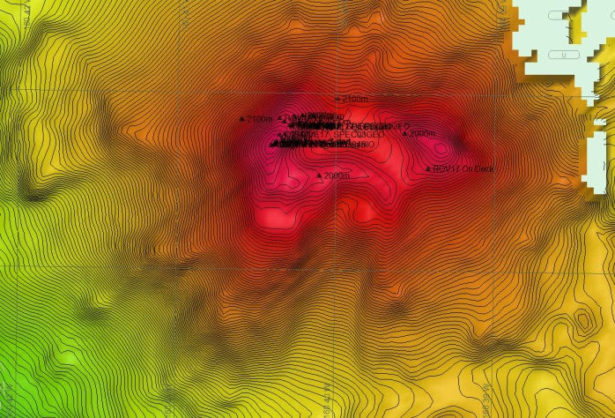 |  |  |  |  | 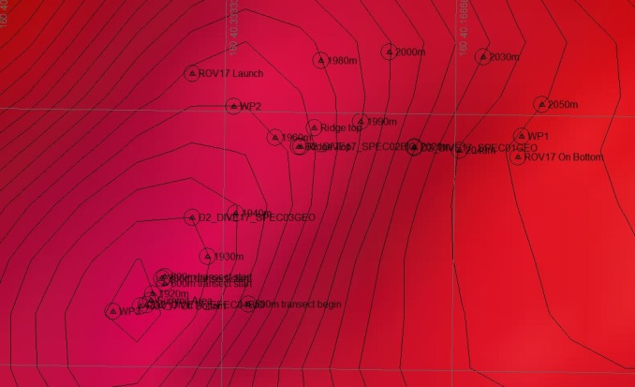
Representative Photos of the Dive
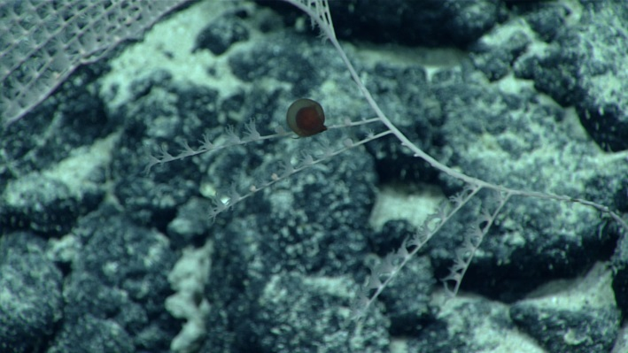 |  |  |  |  | 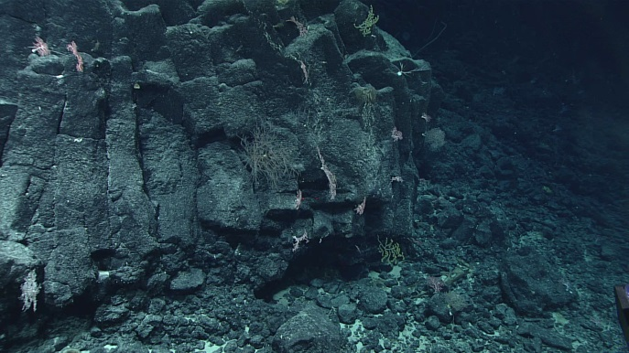
- Jellyfish predation upon an Irridogorgia colony. |  |  |  |  | - Numerous octocoral colonies on a massive columnar basalt outcrop
- 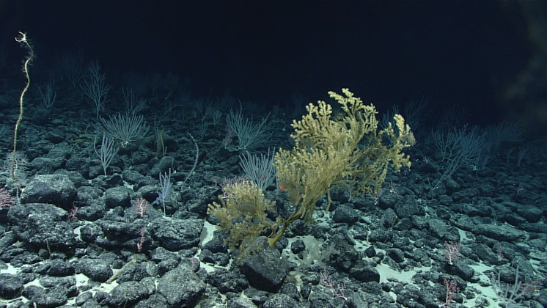 |  |  |  |  | - 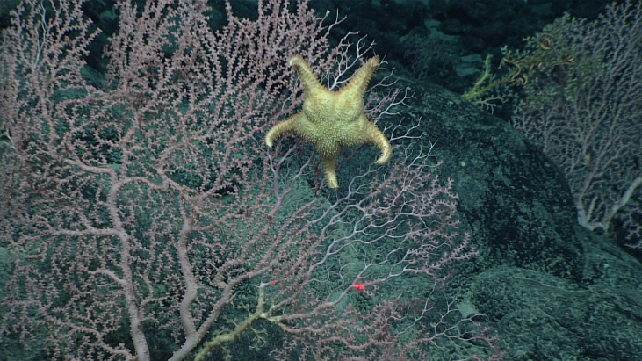
- Dense coral and sponge community on a pillow and talus substrate. |  |  |  |  | - Hippasteria sp. star predating on a Hemicorallium sp. pink coral
Samples Collected
  - Sample
Sample ID |  | EX1708_D2_DIVE17_SPEC01GEO |  |  | - 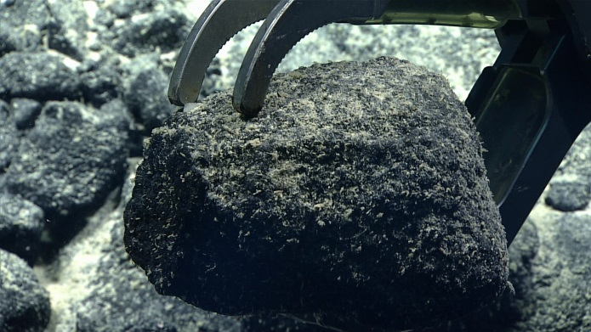
Date (UTC) |  | 9/23/2017
Time (UTC) |  | 20:27
Depth (m) |  | 2029.8
Temperature (°C) |  | 2.0
Field ID(s) |  | Mn encrusted moderately angular basalt talus near small outcrop on slope. Medium sized rock.
Commensal ID and Field Identification
Comments
Sample
Sample ID |  | EX1708_D2_DIVE17_SPEC02BIO |  |  | - 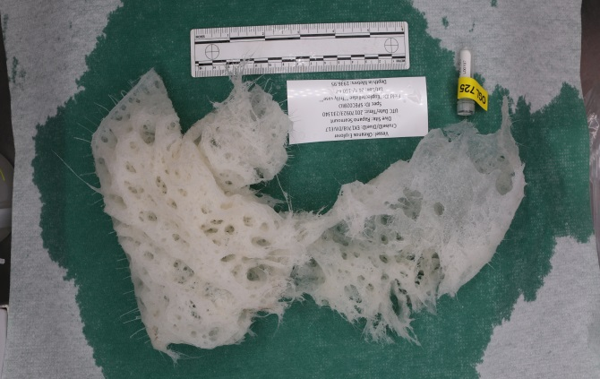
Date (UTC) |  | 9/23/2017
Time (UTC) |  | 23:14
Depth (m) |  | 1937.0
Temperature (°C) |  | 2.0
Field ID(s) |  | "Euplectellidae" "frilly vase"
Commensal ID and Field Identification |  | EX1708_D2_DIVE17_SPEC02BIO_A01 Gastropod
Comments
Sample
Sample ID |  | EX1708_D2_DIVE17_SPEC03BIO |  |  | - 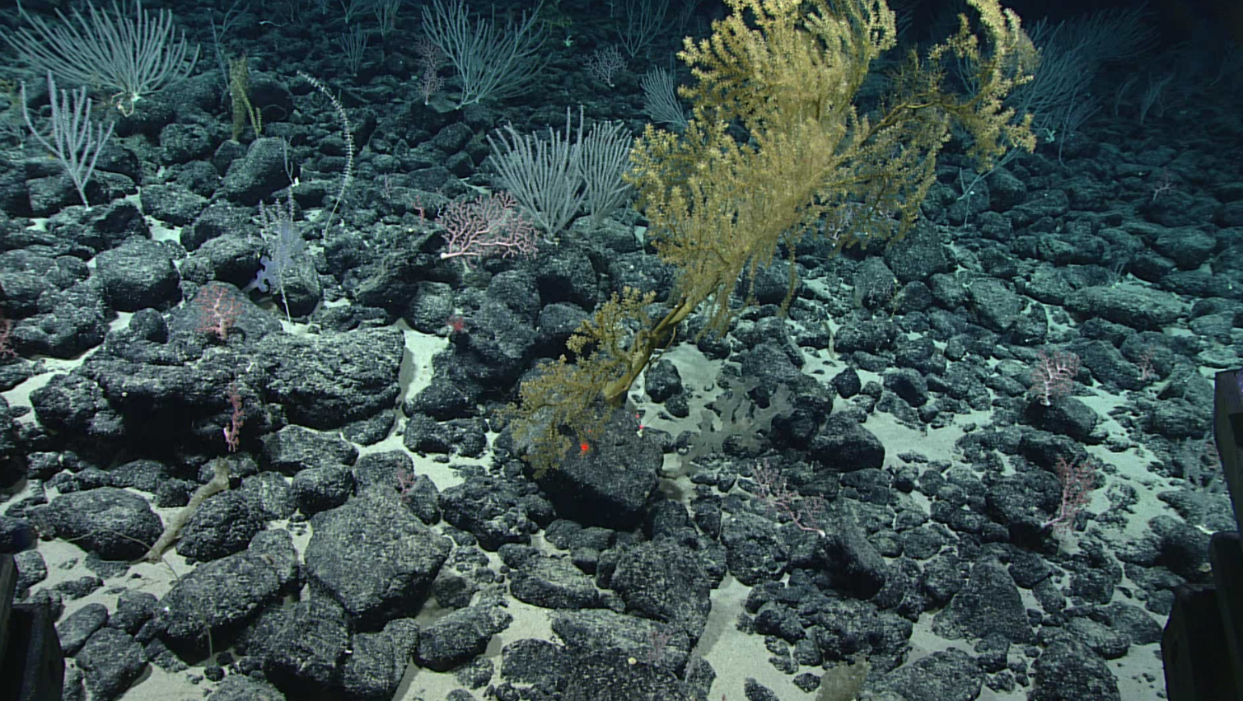
Date (UTC) |  | 9/24/2017
Time (UTC) |  | 00:20
Depth (m)
Temperature (°C)
Field ID(s) |  | Acanthogorgia sp.
Commensal ID and Field Identification |  | EX1708_D2_DIVE17_SPEC03BIO_A01 Hydrozoan  EX1708_D2_DIVE17_SPEC03BIO_A02 Aplacophoran  EX1708_D2_DIVE17_SPEC03BIO_A03 Amphipod
Comments
Sample
Sample ID | EX1708_D2_DIVE17_SPEC04GEO |  |  | - 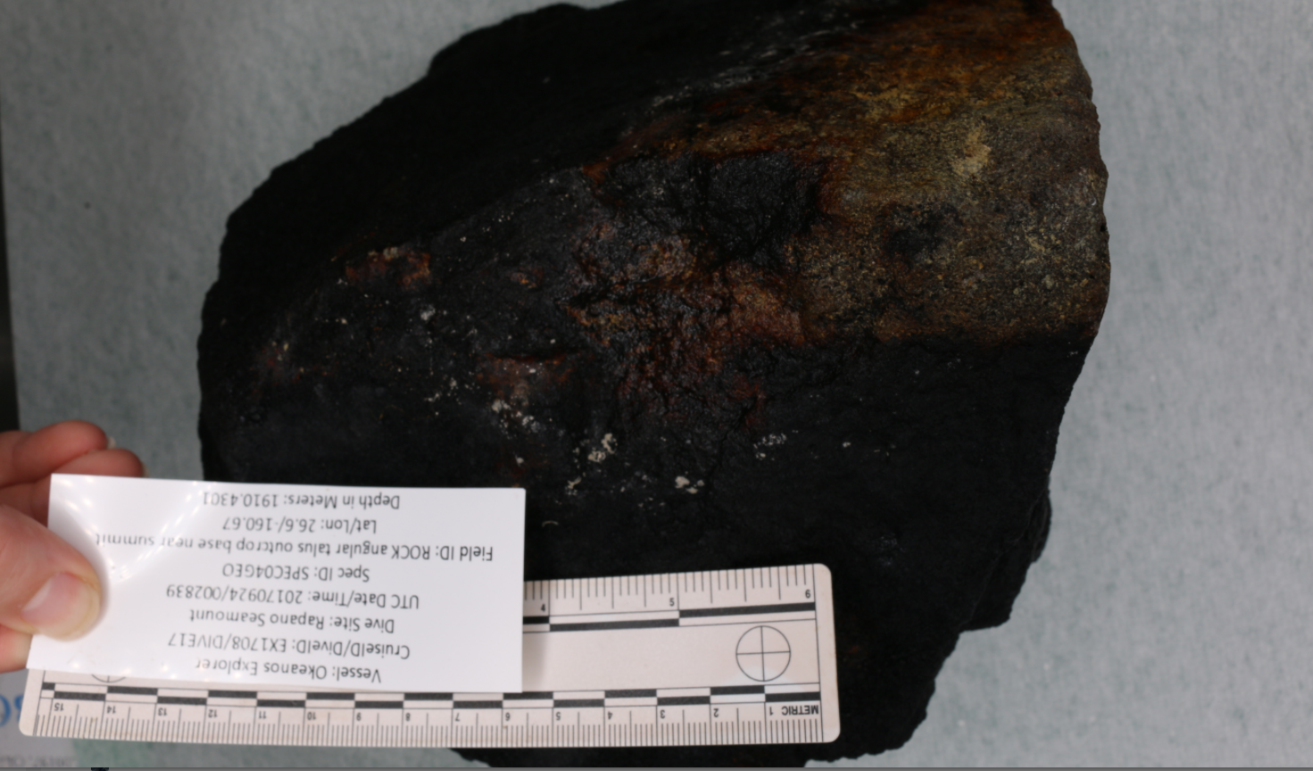
Date (UTC) | 9/24/2017
Time (UTC) | 00:29
Depth (m) | 1910.4
Temperature (°C) | 2.0
Field ID(s) | Mn-crusted angular talus from outcrop base on ridge near summit. Prismatic shape on bottom. Larger than SPEC01GEO.
Commensal ID and Field Identification | EX1708_20170924T002839_D2_DIVE17_SPEC04GEO_A01 Hemicorallium sp.
Comments
Sample
Sample ID | EX1708_D2_DIVE17_SPEC05BIO |  |  | - 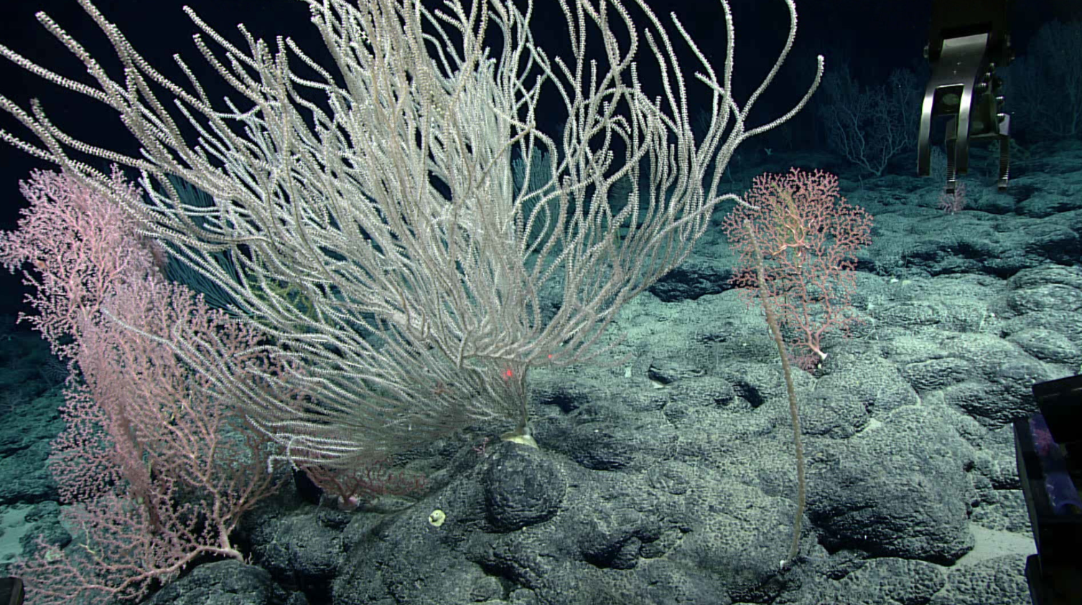
Date (UTC) | 9/24/2017
Time (UTC) | 01:17
Depth (m) | 1901.2
Temperature (°C) | 2.0
Field ID(s) | Primnoidae
Commensal ID and Field Identification
Comments
Sample
Sample ID | EX1708_D2_DIVE17_SPEC06BIO |  |  | - 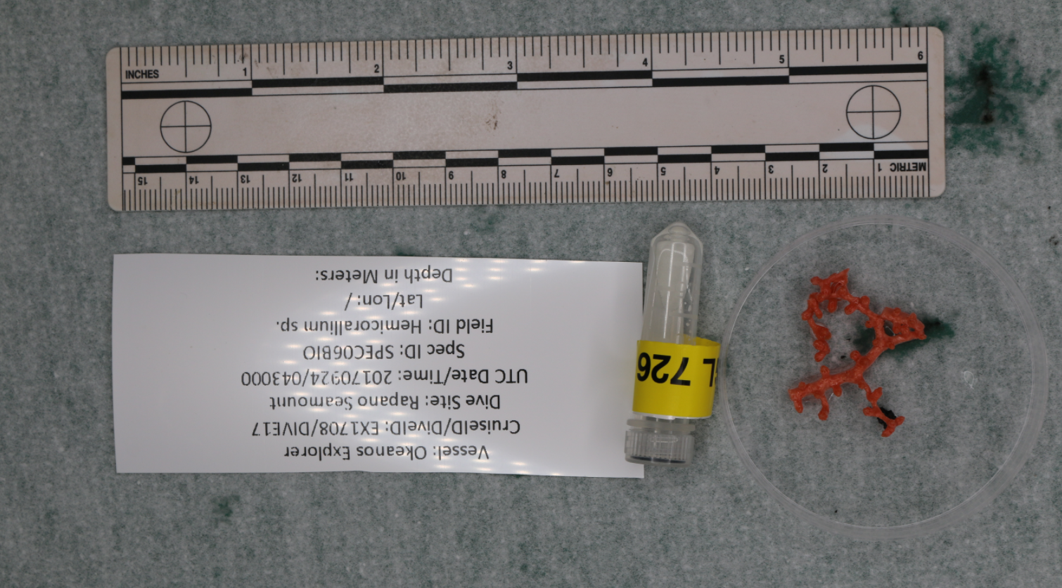
Date (UTC) | 9/24/2017
Time (UTC) | 04:30
Depth (m) | Unknown, bonus sample
Temperature (°C) | Unknown, bonus sample
Field ID(s) | Hemicorallium sp.
Commensal ID and Field Identification
Comments | Bonus sample, got caught in the scoop container

Please direct inquiries to:
NOAA Office of Ocean Exploration & Research
1315 East-West Highway (SSMC3 10th Floor)
Silver Spring, MD 20910
(301) 734-1014

