Okeanos Explorer ROV Dive Summary
Dive Information
General Location |  | 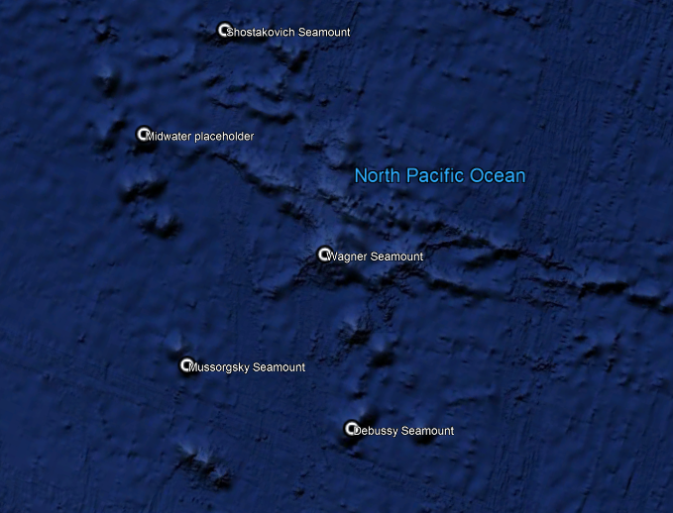
General Area Descriptor |  | Musicians Seamounts
Site Name |  | Verdi Seamount
Science Team Leads |  | John R. Smith/Meagan Putts
Expedition Coordinator |  | Kasey Cantwell
ROV Dive Supervisor |  | Karl McLetchie
Mapping Lead |  | Mike White
ROV Dive Name
Cruise |  | EX1708
Leg |  | -
Dive Number |  | DIVE09
Equipment Deployed
ROV |  | Deep Discoverer
Camera Platform |  | Seirios
ROV Measurements |  | CTD |  | Depth | Altitude
 |  | Scanning Sonar |  | USBL Position | Heading
 |  | Pitch |  | Roll | HD Camera 1
 |  | HD Camera 2 |  | Low Res Cam 1 | Low Res Cam 2
 |  | Low Res Cam 3 |  | Low Res Cam 4 | Low Res Cam 5
Equipment Malfunctions |  | Deployment delayed due to issues with the winch that shortened the overall dive time.
ROV Dive Summary  (from processed ROV data) |  | Dive Summary: EX1708_DIVE09  ^^^^^^^^^^^^^^^^^^^^^^^^^^^^^^^^^^^^^^^^^^^^^^^^^^^  In Water: 2017-09-15T20:30:15.895000  32°, 12.211' N ; 163°, 37.111' W  Out Water: 2017-09-16T02:34:03.495000  32°, 12.768' N ; 163°, 36.443' W  Off Bottom: 2017-09-16T00:52:57  32°, 12.341' N ; 163°, 36.962' W  On Bottom: 2017-09-15T22:16:16.178000  32°, 12.266' N ; 163°, 36.926' W  Dive duration: 6:3:47  Bottom Time: 2:36:40  Max. depth: 3098.3 m
Special Notes |  | Shortened dive because of problems with umbilical winch prior to dive.
Scientists Involved  (please provide name, location, affiliation, email) |  | Name Email Affiliation  Asako Matsumoto amatsu@gorgonian.jp Planetary Exploration Research Center, Chiba Institute of Technology  Bruce Mundy bruce.mundy@noaa.gov NOAA NMFS Pacific Islands Fisheries Science Center  Christopher Kelley ckelley@hawaii.edu University of Hawaii  Derek Sutcliffe Derek_sutcliffe@uri.edu URI Inner Space Center  Dhugal Lindsay dhugal@jamstec.go.jp JAMSTEC  Diva Amon divaamon@gmail.com Natural History Museum, London  Eric Mittelstaedt emittelstaedt@uidaho.edu University of Idaho  John Smith jrsmith@hawaii.edu University of Hawaii  Les Watling watling@hawaii.edu University of Hawaii at Manoa  Meagan Putts Meagan.putts@noaa.gov University of Hawaii  Mike White michael.white@noaa.gov OER  Nolan Barrett barrettnh@g.cofc.edu FAU Harbor Branch Oceanographic Institute  Scott France france@louisiana.edu University of Louisiana at Lafayette  Tina Molodtsova tina@ocean.ru; tina.molodtsova@gmail.com P.P.Shirshov Institute of Oceanology RAS  Tom Hansknecht tjhansk@comcast.net Barry Vittor and Associates, Inc. retired
Purpose of the Dive |  | This dive had two main purposes. One was to explore a deep volcanic elongate ridge feature and collect rock samples to provide clues as to the origin of the lineament and the surrounding seamounts, informing a better understanding of the geologic history of the region. Thus, it satisfies the CAPSTONE theme to “investigate the geologic history of Pacific seamounts.” The second purpose of the dive was to inform biogeographic patterns of benthic fauna throughout the Musicians Seamounts. A comparison of the diversity and distribution of biological communities (namely, corals and sponges) across the seamounts and to the Hawaiian Ridge and the broader North Pacific will help describe the biogeography and connectivity of communities in the Pacific. This dive satisfies the CAPSTONE science theme to "Identify and map vulnerable marine habitats – particularly high-density deep-sea coral and sponge communities."
Description of the Dive |  | The ROV Deep Discoverer (D2) touched down on a steep slope of 45° to 55° at 3090 m, part of the way up the flank of the volcanic ridge. Fortuitously, we arrived at the contact between a moderately sedimented talus field and low relief lava outcrops including pillowed flows and lobate lava forms. Soon after a contact with the broken up edge of a < 1 m thick lava flow unit was observed at 3091 m. The slope steepened to ~60° at 3076 m, with the substrate consisting of talus, pillow flows, and sediment pockets in between. Here, a lizard fish, Bathysaurus mollis, was observed at time stamp 22:45. Alternating patches of intact pillow flows and sedimented talus areas were observed as D2 moved up and across the flank from 3068 to 3038 m where more pronounced intact and broken pillows/talus dominated. At 3033 m, the slope magnitude decreased as D2 approached the summit. The first rock collection failed, the sample being crushed by the manipulator claw. This rock had the same look as one attempted on Dive 01 of this cruise – a jumbled yellowish matrix with fine black inclusions, presumed to be basalt. A massive lava rock outcrop with a pillowed look was observed at 3020 m, with more flow fronts of like morphology seen in the distance upslope. The first rock sample, a piece of angular talus, was collected at 3016 m from the base of an outcrop, although it was not obviously in place. There was an especially abrupt slope change to a flat top terrace covered by sediment, talus, and small rubble at 3008 m. The slope increased again to ~30° at a contact with intact pillowed flows at 3010 m. A second rock sample, also angular talus, was collected from a summit depression at 3017 m, and not taken in place. Two requested biological specimens were also collected from the same area and depth, a black coral and a bamboo coral with associates. In the few remaining minutes of the dive D2 crossed another contact from a gently sloping sedimented talus field to a fully sedimented bottom with no debris or biological organisms. As D2 left bottom from 3021 m, observation was made of another transition from this sedimented plain back to a low slope sedimented talus field. Presumably, the ROVs had last been investigating the saddle between the western and eastern bathymetric highs. In summary, two rocks were collected that should help us better understand the hot spot/mid-ocean ridge interactions. Regarding the biology observed along the dive track, we saw a moderate number of primnoid coral and black coral as well as some Hyalostyus sp. glass sponges. Despite the low abundance of corals and sponges, we saw numerous small invertebrates including polychaetes, mysid shrimps, amphipods, and isopods. In terms of fun fishes, we saw Bathysaurus mollis, Coryphaenoides sp. and a Ophidioform fish. Perhaps most importantly, a ctenophore that may be new to science was observed.
Overall Map of the ROV Dive Area |  |  | Close-up Map of Main Dive Site
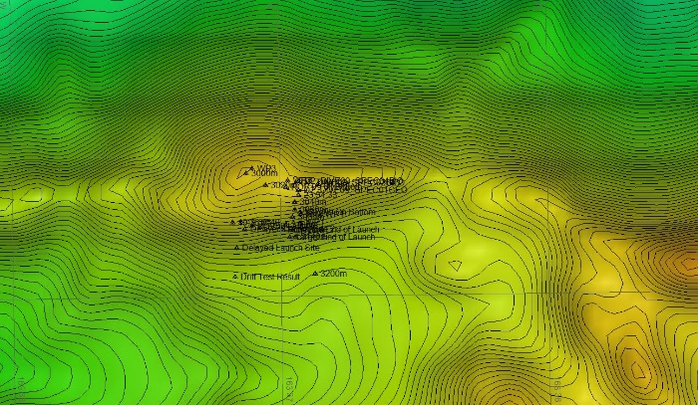 |  |  | 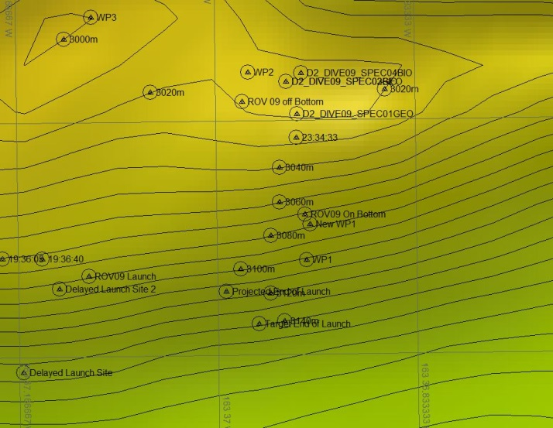
Representative Photos of the Dive
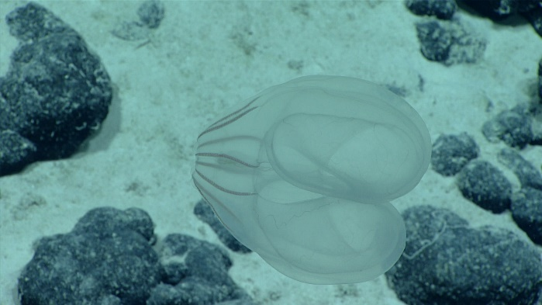 |  |  | 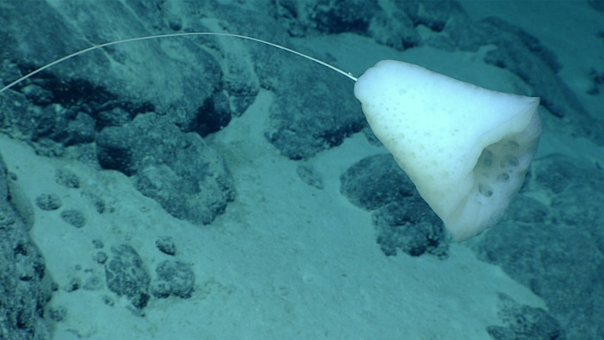
- Ctenophore that may be new to science |  |  | - Hyalostylus sp. stalked glass sponge
- 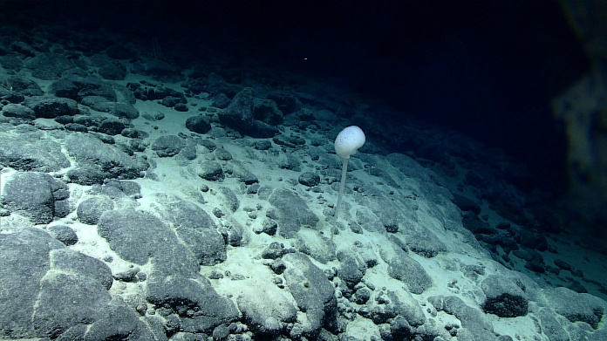 |  |  | - 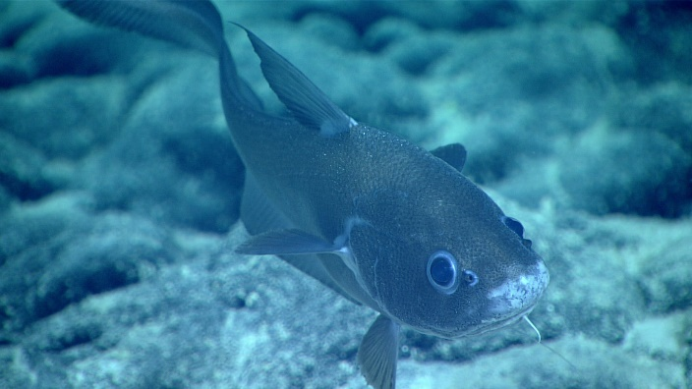
- Caulophacus sp. glass sponge on moderately sedimented talus slope |  |  | - Curious Coryphaenoides sp. Grenadier fish with parasitic copepod on fin checking out D2
Samples Collected
  - Sample
Sample ID | EX1708_D2_DIVE09_SPEC01GEO |  | - 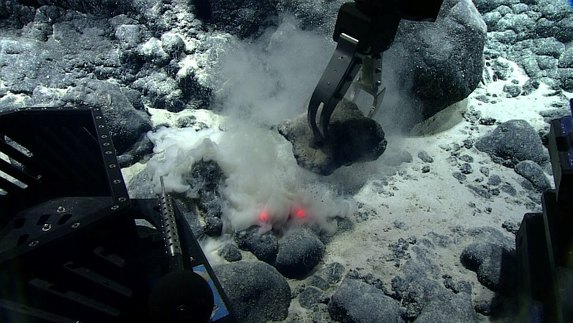
Date (UTC) | 9/15/2017
Time (UTC) | 23:51
Depth (m) | 3016.8
Temperature (°C) | 1.5
Field ID(s) | Manganese crusted basalt
Commensal ID and Field Identification
Comments
Sample
Sample ID | EX1708_D2_DIVE09_SPEC02GEO |  | - 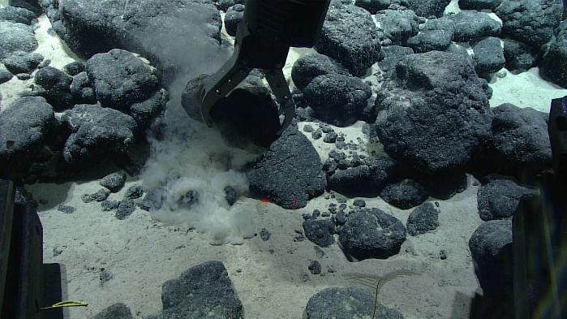
Date (UTC) | 9/16/2017
Time (UTC) | 00:23
Depth (m) | 3017.3
Temperature (°C) | 1.6
Field ID(s) | Manganese crusted basalt
Commensal ID and Field Identification
Comments
Sample
Sample ID | EX1708_D2_DIVE09_SPEC03BIO |  | - 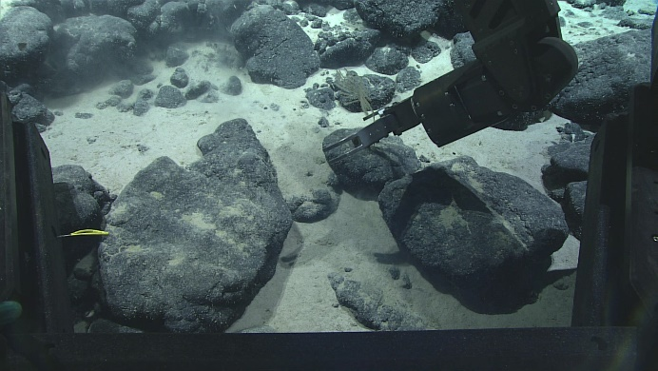
Date (UTC) | 9/16/2017
Time (UTC) | 00:27
Depth (m) | 3017.8
Temperature (°C) | 1.6
Field ID(s) | Bathypathes cf. patula
Commensal ID and Field Identification
Comments
Sample
Sample ID | EX1708_D2_DIVE09_SPEC04BIO |  | - 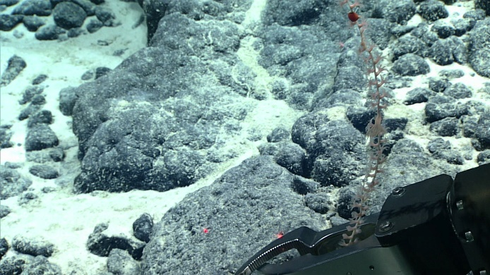
Date (UTC) | 9/16/2017
Time (UTC) | 00:43
Depth (m) | 3016.8
Temperature (°C) | 1.6
Field ID(s) | Keratoisidinae “unbranched”
Commensal ID and Field Identification | EX1708_D2_DIVE09_SPEC04BIO_A01 Actinarian “red”  EX1708_D2_DIVE09_SPEC04BIO_A02 Crinoid “yellow”
Comments

Please direct inquiries to:
NOAA Office of Ocean Exploration & Research
1315 East-West Highway (SSMC3 10th Floor)
Silver Spring, MD 20910
(301) 734-1014

