Okeanos Explorer ROV Dive Summary
Dive Information
General Location | 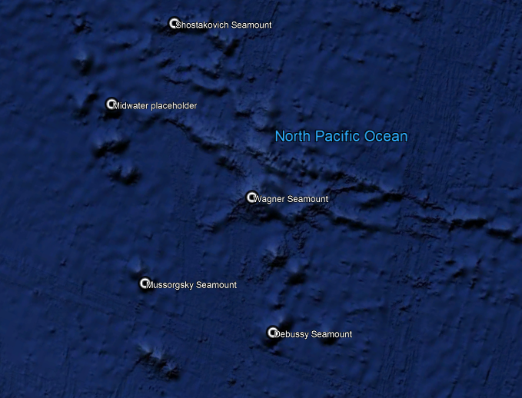
General Area Descriptor | Musicians Seamounts
Site Name | Wagner Seamount
Science Team Leads | John R. Smith/Meagan Putts
Expedition Coordinator | Kasey Cantwell
ROV Dive Supervisor | Karl McLetchie
Mapping Lead | Mike White
ROV Dive Name
Cruise | EX1708
Leg | -
Dive Number | DIVE08
Equipment Deployed
ROV | Deep Discoverer
Camera Platform | Seirios
ROV Measurements | CTD |  | Depth | Altitude
 | Scanning Sonar |  | USBL Position | Heading
 | Pitch |  | Roll | HD Camera 1
 | HD Camera 2 |  | Low Res Cam 1 | Low Res Cam 2
 | Low Res Cam 3 |  | Low Res Cam 4 | Low Res Cam 5
Equipment Malfunctions
ROV Dive Summary  (from processed ROV data) | Dive Summary: EX1708_DIVE08  ^^^^^^^^^^^^^^^^^^^^^^^^^^^^^^^^^^^^^^^^^^^^^^^^^^^  In Water: 2017-09-14T18:22:42.102000  31°, 50.962' N ; 162°, 53.742' W  Out Water: 2017-09-15T02:30:02.602000  N/A ; N/A  Off Bottom: 2017-09-15T01:17:08.427000  31°, 51.067' N ; 162°, 53.947' W  On Bottom: 2017-09-14T19:50:16.248000  31°, 51.118' N ; 162°, 53.688' W  Dive duration: 8:7:20  Bottom Time: 5:26:52  Max. depth: 2432.4 m
Special Notes
Scientists Involved  (please provide name, location, affiliation, email) | Asako Matsumoto amatsu@gorgonian.jp Planetary Exploration Research Center, Chiba Institute of Technology  Bruce Mundy bruce.mundy@noaa.gov NOAA NMFS Pacific Islands Fisheries Science Center  Christopher Kelley ckelley@hawaii.edu University of Hawaii  Christopher Mah brisinga@gmail.com Dept. Invertebrate Zoology, NMNH Smithsonian Institution  Eric Mittelstaedt emittelstaedt@uidaho.edu University of Idaho  George Matsumoto mage@mbari.org MBARI  Heather Coleman heather.coleman@noaa.gov NOAA Fisheries  John Smith jrsmith@hawaii.edu University of Hawaii  Katie Wagner katie.wagner@noaa.gov NOAA OER  Les Watling watling@hawaii.edu University of Hawaii at Manoa  Luke McCartin lmccartin@whoi.edu WHOI  Malcolm Clark malcolm.clark@niwa.co.nz NIWA  Meagan Putts Meagan.putts@noaa.gov University of Hawaii  Megan McCuller mccullermi@gmail.com Williams-Mystic Maritime Studies Program  Nolan Barrett barrettnh@g.cofc.edu FAU Harbor Branch Oceanographic Institute  Scott France france@louisiana.edu University of Louisiana at Lafayette  Tara Luke luket@stockton.edu Stockton University  Tim Shank tshank@whoi.edu WHOI  Tina Molodtsova tina@ocean.ru; tina.molodtsova@gmail.com P.P.Shirshov Institute of Oceanology RAS  Tom Hansknecht tjhansk@comcast.net Barry Vittor and Associates, Inc. retired
Purpose of the Dive | One of the main objectives of this dive was to collect representative rock samples of the feature for geochemical analysis and isotopic dating so as to examine the interaction of hot spot and mid-ocean ridge interactions. The other objective for this dive is to characterize the distribution and abundance of benthic fauna, in particular corals, to examine the diversity, biogeography, and connectivity of corals living the northern seamount group compared to those observed in the southern seamount group and to the rest of the sites visited during this expedition. A comparison of the diversity and distribution of coral and sponge communities across the seamounts to the north and to the Hawaiian Ridge and the broader North Pacific will help describe the biogeography and connectivity of communities in the Pacific. The dive satisfies the CAPSTONE science themes to “investigate the geologic history of Pacific seamounts” and to "identify and map vulnerable marine habitats – particularly high-density deep-sea coral and sponge communities."
Description of the Dive | The ROV Deep Discoverer (D2) arrived on bottom near the base of a volcanic pillow cone at a water depth of 2428 m. The seafloor here was composed of talus of various sizes including large boulders and some intact lava flow outcrops. Soon after, contact was made with an extensive sheet flow unit ~one-meter-thick at 2430 m that persisted upslope. An in place rock sample was obtained from the flow edge and does appear to be basalt with a broken edge showing alteration. Regarding biology, the dive started slow with some low density communities. As we transected up the slope of the cone feature, the community increased in density with Chrysogorgid coral, Anthomastus sp. mushroom coral, and a diversity of Antipatharians, black coral, along the way. The slope increased to 30-40° at 2024 m and a mix of sheet flow and pillow outcrops with talus were presented. A unique white sea star, likely Zorroaster sp., with a single row of upward facing spines was observed at time stamp 20:46 and a depth of 2415 m. Large, isolated boulders with abundant corals were seen atop mostly barren sheet flows at 2235 m on slopes of 40-50°. The slope again steepened at 2310 m to possibly 50-60° where mostly sheet flows were observed and little else. Following a collection of a glass sponge that may be an undescribed species at 2293 m, a contact from a ledge feature to more talus and decreasing slope was observed approximately 200 m laterally from the summit. A contact with a thick ledge of lava outcrop was observed at 2258 m just prior to reaching the summit area. Upon reaching the summit of the cone, we were surrounded by a bamboo coral forest at 2248 m. The high density community was made up of large bamboo colonies all around with numerous black coral, chrysogorgid coral, Swiftia sp., paragorgids, glass sponges, and more organisms interspersed between. We were able to collect a new species of Goniasteridae sea star predating upon a Umbellapathes sp., a new species of glass sponge, and Stoloniferan coral and Hydrozoans overgrowing a bamboo skeleton. Another contact with a thick flow unit was observed at 2338 m. After completing the planned track, it was realized that we were on a false summit and decided to pursue the real summit based on the Seirios scanning sonar. This area, a local high, was nearly flat with variable rock types and depth of 2232 m. A second rock was collected at 2230 m that turned out to be crumbly and friable and a mix of material including small black phenocrysts that may be basalt amongst a jumbled matrix of yellowish material resembling scrambled eggs, possibly being the remnants of a pyroclastic flow. There was also an attempt to collect the same type of rock occurred on Dive #01 at “Tropic of Cancer” Seamount. Two crabs were seen locking in what was determined as a mating embrace at time stamp 00:30 and 2230 m. ROV D2 moved into a depression at 2234 m that included talus, low relief outcrops, and much less biologic density with smaller organisms. A lobate outcrop with high density coral colonies was observed at 2233 m. A final coral was collected from this depth and ROV D2 left bottom from a depth of 2235 m shortly thereafter.
Overall Map of the ROV Dive Area |  | Close-up Map of Main Dive Site
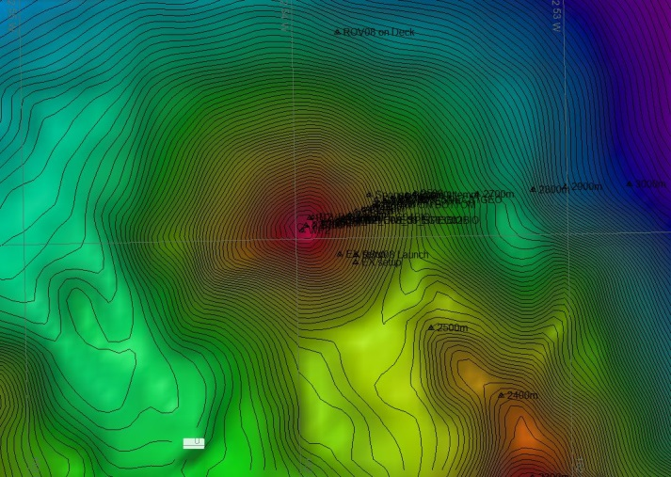 |  | 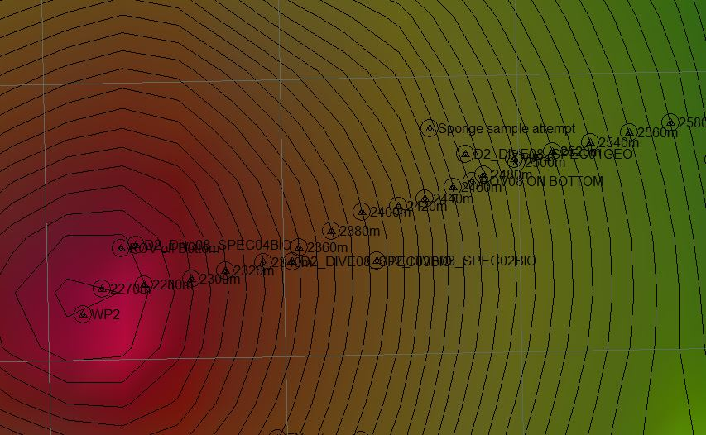
Representative Photos of the Dive
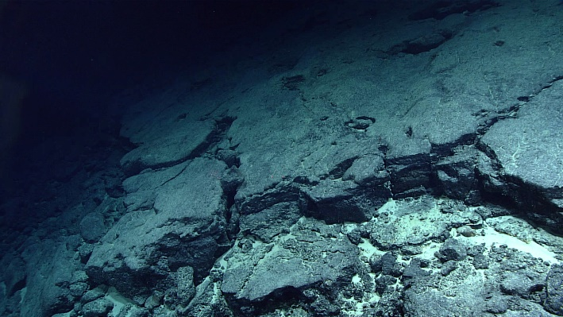 |  | 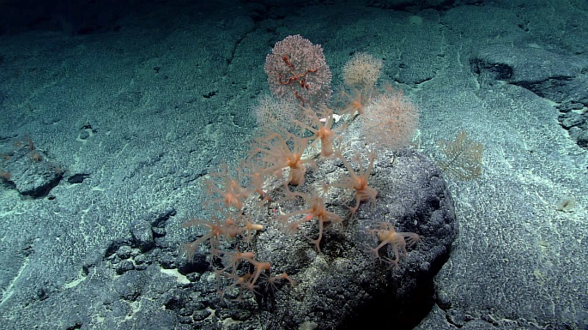
- Nearly barren of life, this lava sheet flow with broken downslope edge at the beginning of the dive is a source of talus |  | - Corals densely populating an isolated boulder resting on a smooth sheet flow unit
- 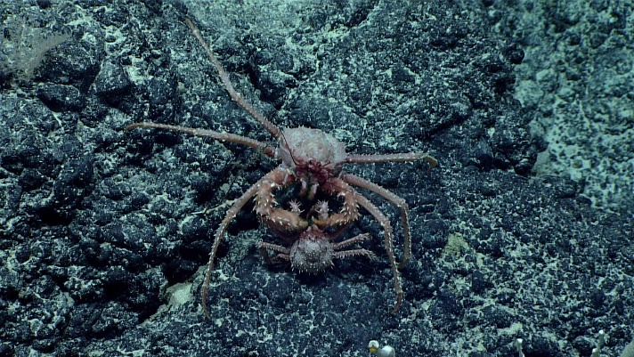 |  | - 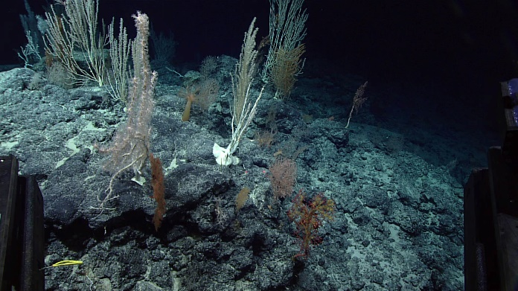
- Two crabs (Paralomis sp.) locked in a loving embrace, crustacean style |  | - Dense coral community, with some sponges, on the summit of the pillow cone
Samples Collected
  - Sample
Sample ID | EX1708_D2_DIVE08_SPEC01GEO | - 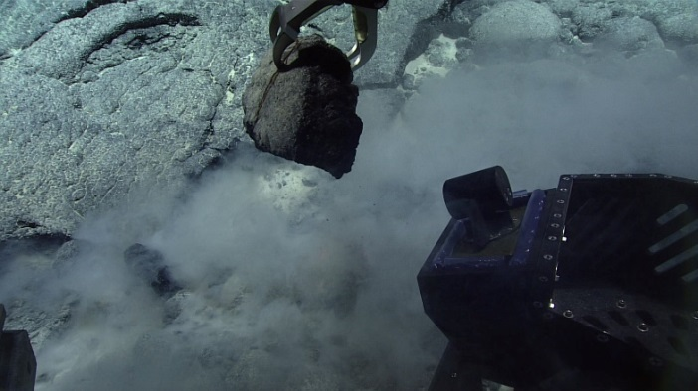
Date (UTC) | 9/14/2017
Time (UTC) | 20:29
Depth (m) | 2425.12
Temperature (°C) | 1.7
Field ID(s) | Manganese encrusted rock in place sheet flow
Commensal ID and Field Identification
Comments
Sample
Sample ID | EX1708_D2_DIVE08_SPEC02BIO | - 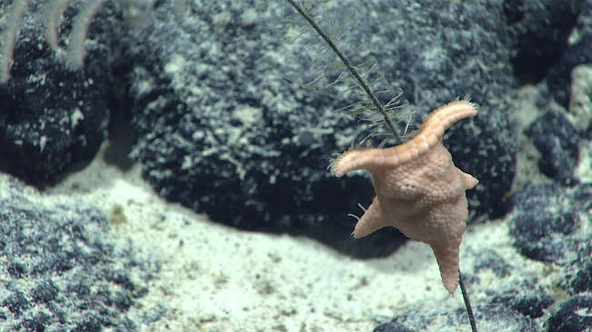
Date (UTC) | 9/14/2017
Time (UTC) | 22:33
Depth (m) | 2352.5
Temperature (°C) | 1.8
Field ID(s) | Umbellapathes sp.
Commensal ID and Field Identification | EX1708_D2_DIVE08_SPEC02BIO_A01 Manganese encrusted rock  EX1708_D2_DIVE08_SPEC02BIO_A02 Hydrozoa  EX1708_D2_DIVE08_SPEC02BIO_A03 Goniasteridae
Comments
Sample
Sample ID | EX1708_D2_DIVE08_SPEC03BIO | - 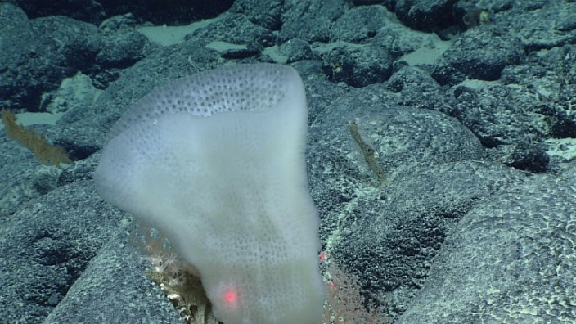
Date (UTC) | 9/14/2017
Time (UTC) | 23:21
Depth (m) | 2292.1
Temperature (°C) | 1.8
Field ID(s) | Euplectellidae
Commensal ID and Field Identification | EX1708_D2_DIVE08_SPEC03BIO_A01 Gastropoda  EX1708_D2_DIVE08_SPEC03BIO_A02 Stolonifera  EX1708_D2_DIVE08_SPEC03BIO_A03 Polychaeta  EX1708_D2_DIVE08_SPEC03BIO_A04 Amphipoda
Comments | Portion of dead sponge was collected with specimens
Sample
Sample ID | EX1708_D2_DIVE08_SPEC04GEO | - 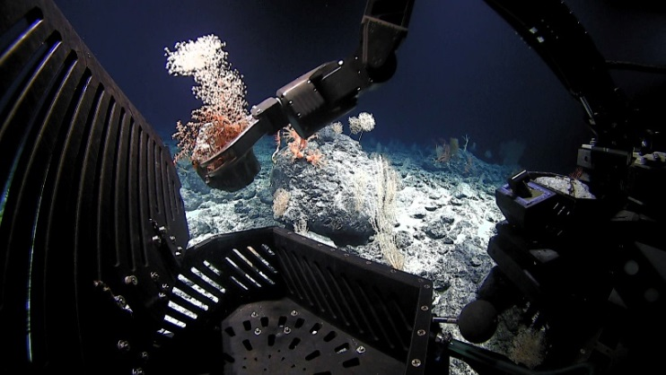
Date (UTC) | 9/15/2017
Time (UTC) | 00:04
Depth (m) | 2230.5
Temperature (°C) | 1.8
Field ID(s) | Manganese encrusted rock
Commensal ID and Field Identification
Comments | Associate corals were lost between collection and ROV recovery; no associates were collected with the rock sample
Sample
Sample ID | EX1708_D2_DIVE08_SPEC05BIO | - 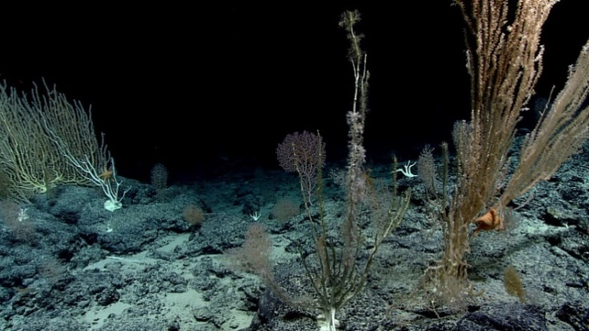
Date (UTC) | 9/15/2017
Time (UTC) | 01:07
Depth (m) | 2233.2
Temperature (°C) | 1.8
Field ID(s) | Stolonifera on bamboo
Commensal ID and Field Identification | EX1708_D2_DIVE08_SPEC05BIO_A01 Hydrozoa  EX1708_D2_DIVE08_SPEC05BIO_A02 Isididae skeleton  EX1708_D2_DIVE08_SPEC05BIO_A03 Polychaeta?
Comments

Please direct inquiries to:
NOAA Office of Ocean Exploration & Research
1315 East-West Highway (SSMC3 10th Floor)
Silver Spring, MD 20910
(301) 734-1014

