Okeanos Explorer ROV Dive Summary
Dive Information
General Location | 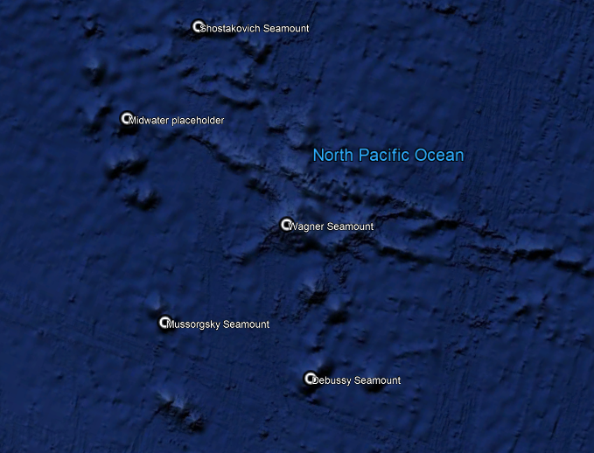
General Area Descriptor | Musicians Seamounts
Site Name | Debussy Seamount (attempt 2)
Science Team Leads | John R. Smith/Meagan Putts
Expedition Coordinator | Kasey Cantwell
ROV Dive Supervisor | Karl McLetchie
Mapping Lead | Mike White
ROV Dive Name
Cruise | EX1708
Leg | -
Dive Number | DIVE07
Equipment Deployed
ROV | Deep Discoverer
Camera Platform | Seirios
ROV Measurements | CTD |  | Depth | Altitude
 | Scanning Sonar |  | USBL Position | Heading
 | Pitch |  | Roll | HD Camera 1
 | HD Camera 2 |  | Low Res Cam 1 | Low Res Cam 2
 | Low Res Cam 3 |  | Low Res Cam 4 | Low Res Cam 5
Equipment Malfunctions | USBL for D2 pinging less frequently due to running off of battery power versus external power.
ROV Dive Summary  (from processed ROV data) | Dive Summary: EX1708_DIVE07  ^^^^^^^^^^^^^^^^^^^^^^^^^^^^^^^^^^^^^^^^^^^^^^^^^^^  In Water: 2017-09-13T22:59:32.364000  N/A ; N/A  Out Water: 2017-09-14T04:30:02.746000  N/A ; N/A  Off Bottom: 2017-09-14T03:23:02.104000  30°, 20.368' N ; 162°, 03.333' W  On Bottom: 2017-09-14T00:15:17.832000  30°, 20.446' N ; 162°, 03.269' W  Dive duration: 5:30:30  Bottom Time: 3:7:44  Max. depth: 2054.1 m
Special Notes | Dive was shortened ahead of deployment because of failed first attempt due to ground faults. Recovery was extended by two hours and planned midwater transects were canceled.
Scientists Involved  (please provide name, location, affiliation, email) | Name Email Affiliation  Amanda Netburn amanda.netburn@noaa.gov NOAA OER  Asako Matsumoto amatsu@gorgonian.jp Planetary Exploration Research Center, Chiba Institute of Technology  Bruce Mundy bruce.mundy@noaa.gov NOAA NMFS Pacific Islands Fisheries Science Center  Christopher Kelley ckelley@hawaii.edu University of Hawaii  Christopher Mah brisinga@gmail.com Dept. Invertebrate Zoology, NMNH Smithsonian Institution  Derek Sutcliffe Derek_sutcliffe@uri.edu URI Inner Space Center  John Smith jrsmith@hawaii.edu University of Hawaii  Les Watling watling@hawaii.edu University of Hawaii at Manoa  Malcolm Clark malcolm.clark@niwa.co.nz NIWA  Mashkoor Malik mashkoor.malik@noaa.gov OER  Meagan Putts Meagan.putts@noaa.gov University of Hawaii  Megan McCuller mccullermi@gmail.com Williams-Mystic Maritime Studies Program  Mike Ford michael.ford@noaa.gov NOAA NMFS  Nolan Barrett barrettnh@g.cofc.edu FAU Harbor Branch Oceanographic Institute  Scott France france@louisiana.edu University of Louisiana at Lafayette  Tara Luke luket@stockton.edu Stockton University  Tim Shank tshank@whoi.edu WHOI  Tina Molodtsova tina@ocean.ru; tina.molodtsova@gmail.com P.P.Shirshov Institute of Oceanology RAS  Tom Hansknecht tjhansk@comcast.net Barry Vittor and Associates, Inc. retired
Purpose of the Dive | This is the first of two dives that will investigate the similarities and differences in community composition between two relatively isolated seamounts (Mussorgsky and Debussy) that occupy the gap between the two main groups of the Musicians Seamounts. The primary objective for this dive was to characterize the distribution and abundance of benthic fauna, in particular corals, to examine the diversity, biogeography, and connectivity of coral living at Debussy Seamount compared to the isolated Mussorgsky Seamount and to the rest of the sites visited during this expedition. A comparison of the diversity and distribution of coral and sponge communities across the seamounts to the north and to the Hawaiian Ridge and the broader North Pacific will help describe the biogeography and connectivity of communities in the Pacific. The dive satisfies the CAPSTONE science theme to "Identify and map vulnerable marine habitats – particularly high-density deep-sea coral and sponge communities."
Description of the Dive | Following a delayed deployment, ROV Deep Discoverer (D2) arrived on bottom at a water depth of 2044 m to low relief lava flow outcrop, talus, and light colored sediment. Coral colonies abounded immediately along with some sponges, and showing great diversity. A novel find was a Asthenactis sp. sea star predating on a Acanthogorgia sp. coral at time stamp 00:47 and 2051 m depth. This was the first time this genus of sea star has been observed predating upon a coral. A large intact lava flow was found at 2047 m and was traversed. Dense corals, including numerous Primnoids, likely in the genus Narella, were observed on the nose of a massive rock outcrop forming a ledge. Another unusual sighting was that of a Bathysaurus mollis at 2031 m depth, the upper limit of its known depth range. Alternating talus fields, intact lava flow units, and combinations of both were observed from 2030 m until end of the dive. Large, inflated lobate lavas with pillowed toes were the norm, along with thinner flows adjoining them. The slope from beginning to end of the dive was almost negligible, and yet this dive possibly produced the most continuous high density coral and sponge community of the expedition to date, from start to finish. Throughout the dive, two representative rock samples and two unique bamboo coral specimens were collected as described below. D2 left bottom from a depth of 2012 m.
Overall Map of the ROV Dive Area |  | Close-up Map of Main Dive Site
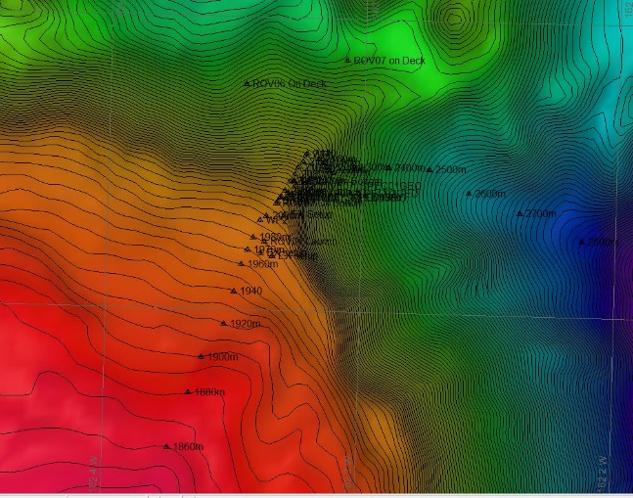 |  | 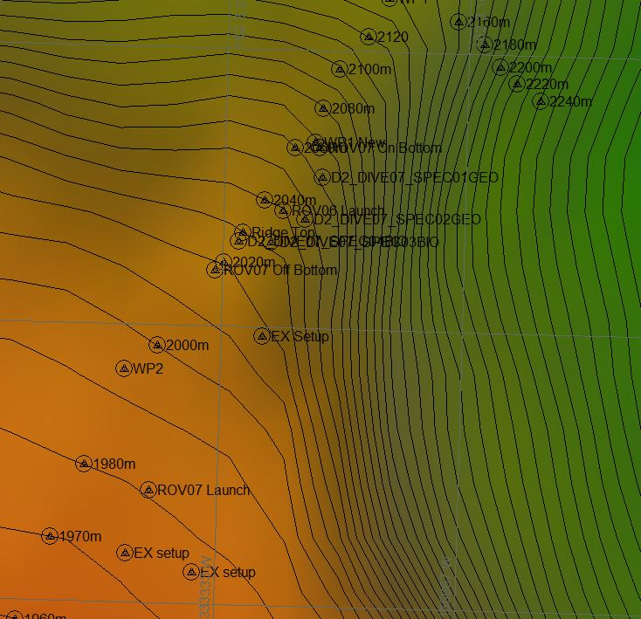
Representative Photos of the Dive
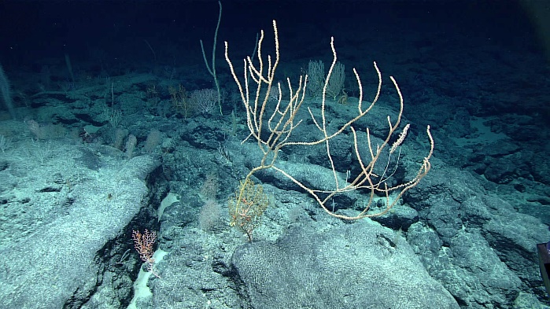 |  | 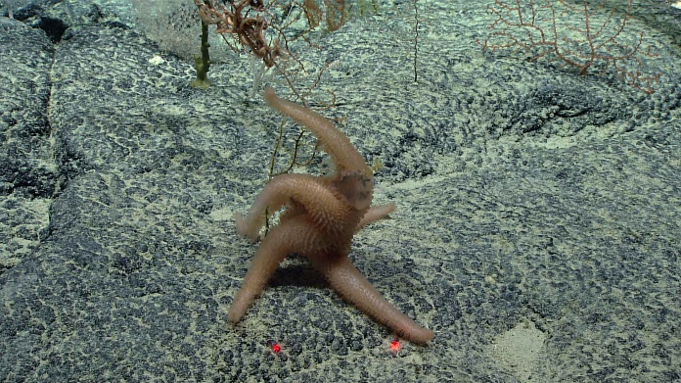
- Deep-sea coral community on lava flow outcrop that was present right at ROV touchdown site. The fun never stopped. |  | - Asthenactis sp. sea star “keepin’ on truckin’” as it devours an Acanthogorgia sp. coral. Note extended stomach and blackened coral stem and polyps inside its translucent gut.
- 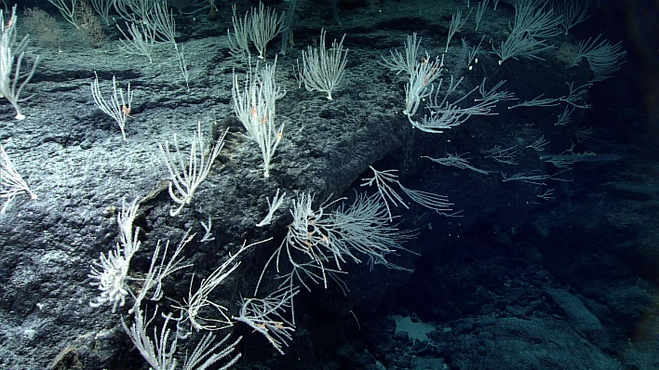 |  | - 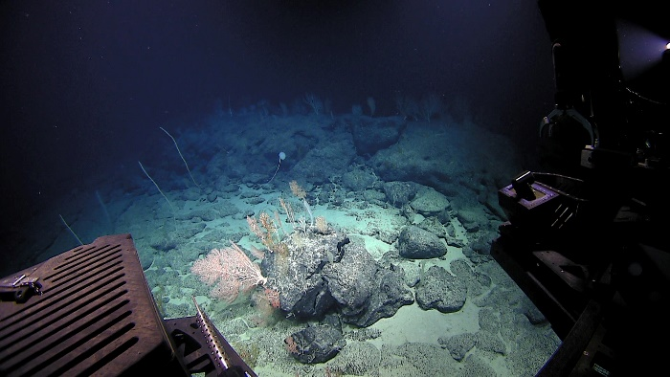
- White Primnoid coral garden on the edge of an intact lava flow outcrop |  | - Broken pillow in the process of breaking into talus with coral community along for the ride. Note line of coral trees on edge of outcrop extending into the background.
Samples Collected
  - Sample
Sample ID | EX1708_D2_DIVE07_SPEC01GEO | - 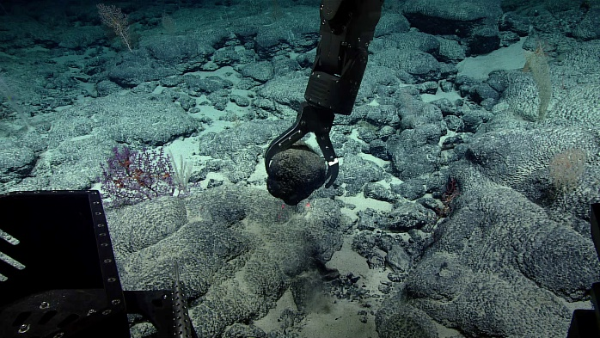
Date (UTC) | 9/14/2017
Time (UTC) | 01:17
Depth (m) | 2050.8
Temperature (°C) | 2.0
Field ID(s) | Manganese encrusted basalt
Commensal ID and Field Identification | EX1708_D2_DIVE07_SPEC01GEO_A01 Ascidian tunicate  EX1708_D2_DIVE07_SPEC01GEO_A02 Stolonifera "purple"  EX1708_D2_DIVE07_SPEC01GEO_A03 Primnoidae  EX1708_D2_DIVE07_SPEC01GEO_A04 Octocoral
Comments
Sample
Sample ID | EX1708_D2_DIVE07_SPEC02GEO | - 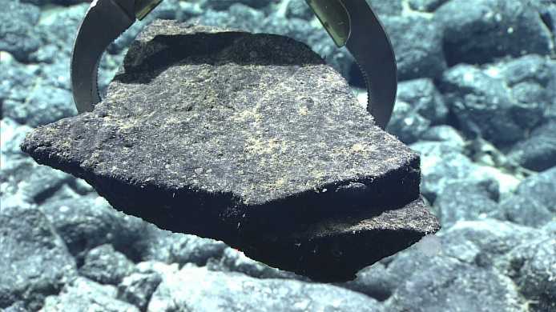
Date (UTC) | 9/14/2017
Time (UTC) | 02:11
Depth (m) | 2023.9
Temperature (°C) | 2.1
Field ID(s) | Manganese encrusted basalt
Commensal ID and Field Identification | EX1708_D2_DIVE07_SPEC02GEO_A01 Hexactinellida 1  EX1708_D2_DIVE07_SPEC02GEO_A02 Hexactinellida 2  EX1708_D2_DIVE07_SPEC02GEO_A03 Ascidian tunicate  EX1708_D2_DIVE07_SPEC02GEO_A04 Primnoidae  EX1708_D2_DIVE07_SPEC02GEO_A05 Isididae  EX1708_D2_DIVE07_SPEC02GEO_A06 Octocoral
Comments
Sample
Sample ID | EX1708_D2_DIVE07_SPEC03BIO | - 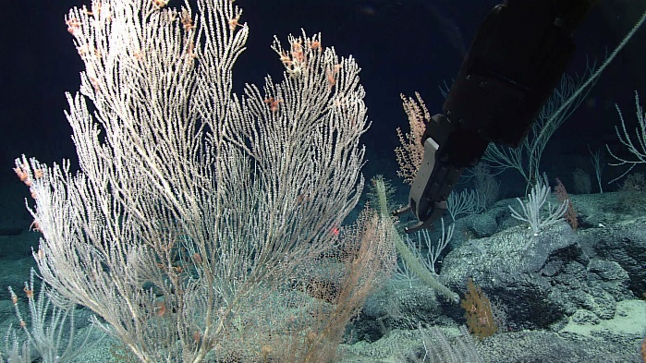
Date (UTC) | 9/14/2017
Time (UTC) | 02:42
Depth (m) | 2018.7
Temperature (°C) | 2.1
Field ID(s) | Keratoisidinae “Nodal”
Commensal ID and Field Identification
Comments
Sample
Sample ID | EX1708_D2_DIVE07_SPEC04BIO | - 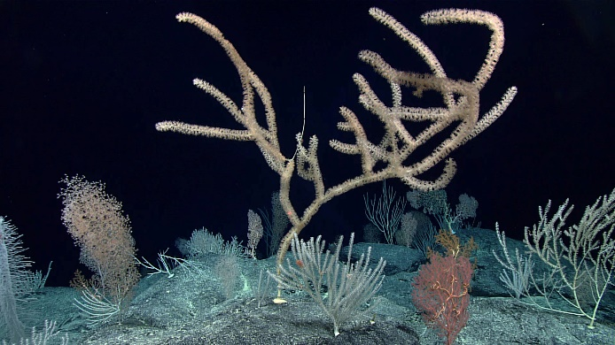
Date (UTC) | 9/14/2017
Time (UTC) | 03:11
Depth (m) | 2013.2
Temperature (°C) | 2.0
Field ID(s) | Keratoisidinae “Internodal”
Commensal ID and Field Identification
Comments

Please direct inquiries to:
NOAA Office of Ocean Exploration & Research
1315 East-West Highway (SSMC3 10th Floor)
Silver Spring, MD 20910
(301) 734-1014

