DRAFTProject Instructions

**Date Submitted:** June 5, 2017

**Platform:** NOAA Ship *Okeanos Explorer*

**Project Number:** EX-17-08

**Project Title:** Musician Seamounts (Telepresence Mapping)

**Project Dates:** August 8 - 31, 2017

**Prepared by:** ________________________ **Dated:** __________________  
 Elizabeth Lobecker, NOAA  
 Expedition Coordinator  
 Office of Ocean Exploration & Research

**Approved by:** ________________________ **Dated:** __________________  
 Craig Russell  
 Program Manager  
 Office of Ocean Exploration & Research

**Approved by:** ________________________ **Dated:** __________________  
 Captain Scott M. Sirois, NOAA  
 Commanding Officer  
 Marine Operations Center - Atlantic

I. Overview

“America’s future depends on understanding the ocean. We explore the ocean because its health and resilience are vital to our economy and to our lives. We depend on the ocean to regulate weather and climate; sustain a diversity of life; for maritime shipping and national defense; and for food, energy, medicine, and other essential services to humankind.”

*- NOAA Office of Ocean Exploration and Research Strategic Plan*

# A. Brief Summary and Project Period

This document contains project instructions for EX-17-08. Operations for this cruise include focused mapping operations and strategic mapping transits within the waters of Hawaii and in international waters in the vicinity of the Musician Seamounts chain, specifically up to ~650 nm north of Hawaii. The expedition will commence on August 8 and conclude on August 31, 2017, and will commence and conclude in Honolulu, HI. Operations will include the use of the ship’s deep water mapping systems (Kongsberg EM302 multibeam sonar, EK60 split-beam fisheries sonars, Acoustic Doppler Current Profilers: (ADCPs), and Knudsen 3260 chirp sub-bottom profiler sonar), and the ship’s high-bandwidth satellite connection for hourly data transfer, real-time ship to shore communications, real-time sonar control from shore, and real-time video streaming of sonar screens and ship's cameras.

NOAA Ship *Okeanos Explorer* systematically explores the ocean every day of every cruise to maximize public benefit from the ship’s unique capabilities. With approximately 95% of the ocean unexplored, we pursue every opportunity to map, sample, explore, and survey at planned destinations as well as during transits; “Always Exploring” is a guiding principle. An integral element of *Okeanos Explorer*’s “Always Exploring” model is the ship’s seafloor and water column mapping capabilities. The sonars, or a subset of the sonars on board, will be operated at all times 24 hours per day throughout the cruise allowing for continued exploration and seabed, water column, and/or sub-bottom data collection and selected processing.

Objectives for the expedition include:

* Conduct preliminary seafloor mapping operations to contribute to geological understanding of remote areas of the Pacific Ocean.
* Conduct mapping operations to collect key data in preparation for EX-17-08 ROV dive planning and operations.
* Identify and characterize vulnerable marine habitats - particularly potential locations for high density deep sea coral and sponge communities.
* Characterize seamounts within and adjacent to the Prime Crust Zone (PCZ). The PCZ is the area of the Pacific with the highest expected concentration of deep sea minerals, including rare metals and rare earth elements.
* Collect information on the geologic history of Central Pacific Seamounts, including those that are or may be relevant to our understanding of plate tectonics and subduction zone biology and geology.
* Provide a foundation of publicly accessible data and information products to spur further exploration, research, and management activities.
* <Add fracture zone language - consult with requestor>

Operations for this cruise will include 24 hour mapping, and continuous telepresence-based remote participation in mapping operations. Multibeam and splitbeam mapping operations will be conducted 24 hours a day throughout the cruise. Sub-bottom profile mapping will be conducted 24 hours a day at the discretion of the CO. XBT and Underway CTD sound velocity casts in support of multibeam sonar mapping operations will be conducted at an interval defined by prevailing oceanographic conditions, but not to exceed 6 hours. All mapping data will be fully processed according to standard procedures and will be archived with the National Centers for Environmental Information (NCEI).

The transit routes between port and the operating areas will maximize mapping of discrete geologic features including seamounts and ridges with little or no existing modern sonar data coverage. The routes were chosen based on the most recent version of the global bathymetric compilation dataset compiled by J.J. Becker et al (http://topex.ucsd.edu/sandwell/publications/124_MG_Becker.pdf).

This expedition will be the seventh cruise to test telepresence enabled mapping operations on *Okeanos Explorer*. Okeanos is a leader in this mode of mapping cruise operation, and continues to see rewards and success and potential for development.

The Expedition Coordinator (Elizabeth Lobecker) for the cruise will be based on shore at the Exploration Command Center (ECC) at University of New Hampshire Center for Coastal and Ocean Mapping/Joint Hydrographic Center(UNH CCOM/JHC) with regular and ongoing communications with the ship (OPS, CO) and onboard mapping lead (Amanda Bittinger).

The screens of the mapping acquisition systems (EM 302, EK 60, SBP etc.) will be broadcast 24 hours per day, and will be monitored by both onboard and onshore mapping scientists. A specially configured laptop has been prepared for remote access to all the sonar acquisition and data processing machines from shore. This setup will continue to be tested for its reliability and feasibility of controlling the mapping data acquisition and data management from shore. The raw data from all sonars will be transmitted to shore and further processing will be completed on shore. Automated bathymetric gridding will occur on the ship in order for the onboard team to monitor and ensure adequate seabed coverage. The onboard mapping lead will be the primary liaison between ship and OER operations and will attend all the shipboard daily meetings and provide daily situation reports (SITREPS) to the broader OER *Okeanos* operational team.

As telepresence mapping protocols continue to develop during this type of telepresence enabled mapping expedition, possibilities open for OER to conduct operations with nimble teams of mapping personnel onboard and most of data acquisition, processing and quality checks of mapping data being completed on shore. Value gained from this model will continue to expand as the model is tested. Initial predicted benefits include: reduction in travel costs to the ship, participation of a larger number of mapping trainees in expeditions, cruise participation from individuals who are unable to sail, enhanced rapid data processing and archival techniques, enhanced onshore partnership development opportunities, enhanced rapid data report creation, and expanded possibilities for utilizing multiple ECCs during mapping missions.

The onboard ship and mapping team will be provided with all information necessary to successfully conduct the mapping mission should the telepresence component experience significant challenges, such as lack of connectivity due to VSAT or network challenges.

# B.Days at Sea (DAS)

Of the 24 DAS scheduled for this project, 0 DAS are funded by an OMAO allocation, 8 DAS are funded by an NOS Line Office Allocation, 0 DAS are Program Funded, and 11DAS are funded by OAR Line Office Allocation. This project is estimated to exhibit a Medium Operational Tempo due to 24 hour mapping operations.

# C. Operating Area

24-hour per day mapping operations will focus as several locations in the vicinity of the Musicians Seamounts chain. Mapping operations will focus in depths generally between 250 and 6,000 meters.

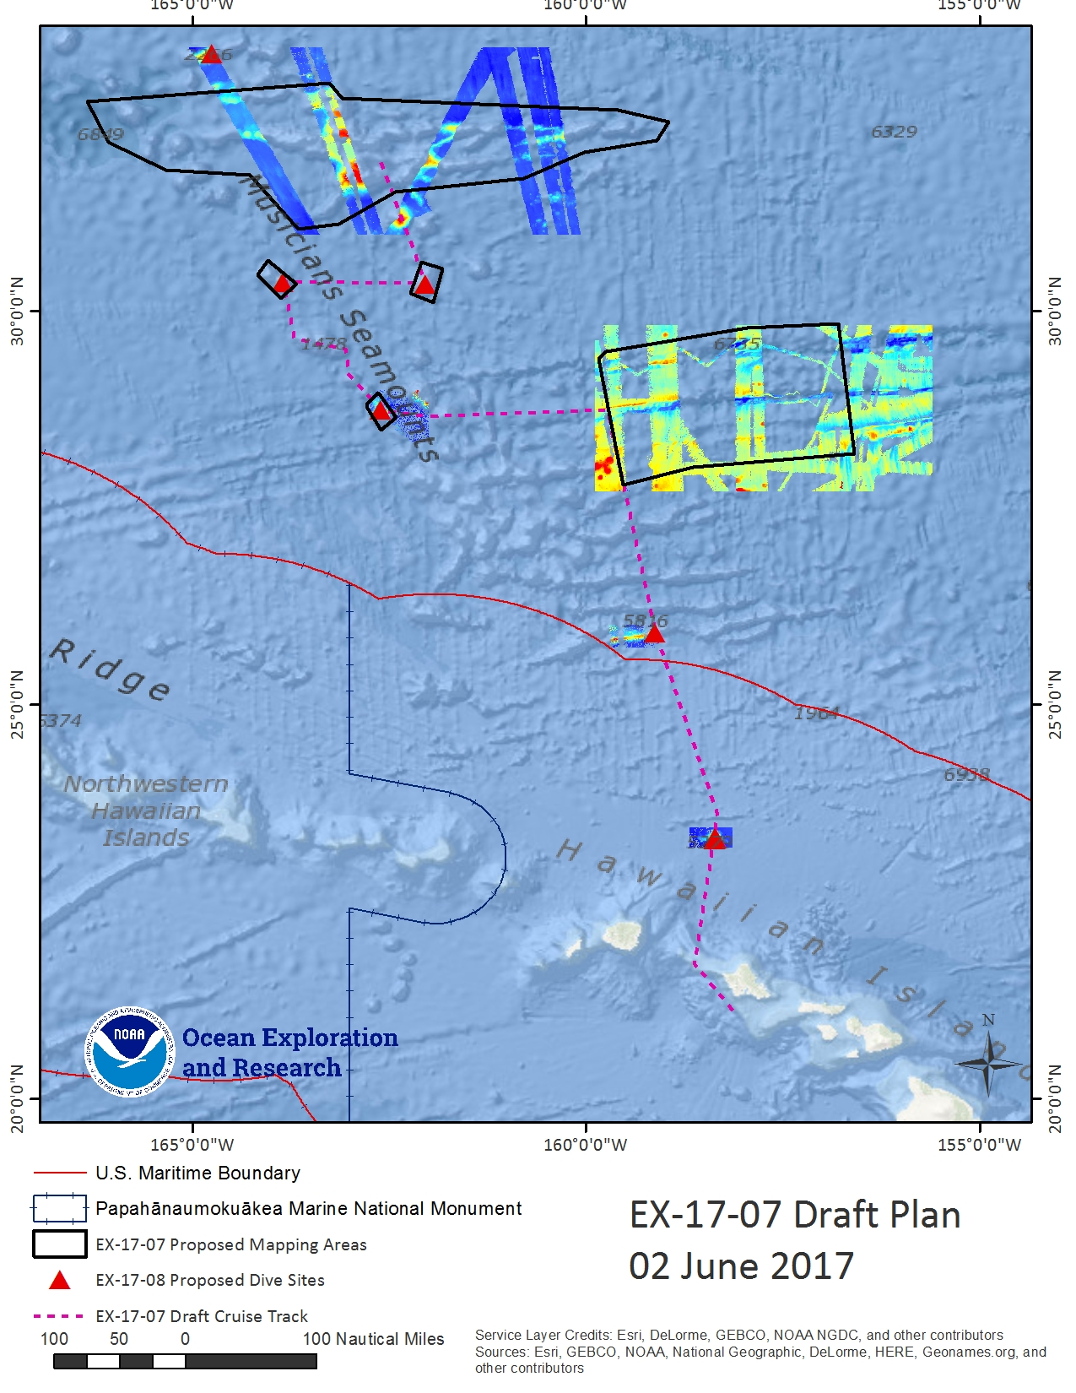

**Figure 1 (above):**Map indicating the overall operating area of *Okeanos Explorer* for EX-17-07. Existing publicly available bathymetry coverage for key mapping areas downloaded from National Centers for Environmental Information shown in background.

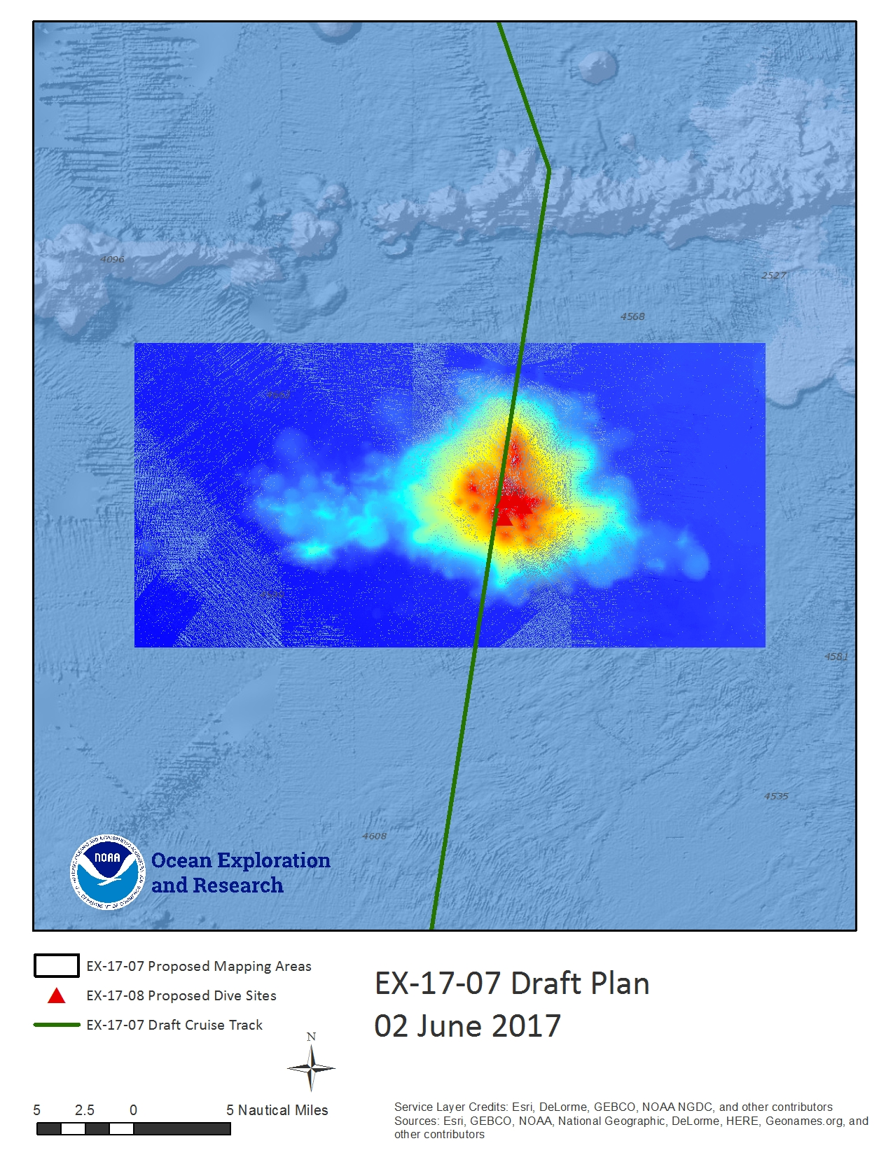

**Figure 2 (above):**Map indicating transit line over seamount with four requested ROV dives. The green line indicates the generalized cruise track, the black polygons indicate priority areas for focused mapping surveys and red triangles indicate ROV dives requested as of 02 June 2017. Existing publicly available bathymetry from National Centers for Environmental Information shown in background.

One or two survey lines will be run over summit of the unnamed seamount in FIgure 2, which is the site of 4 requested ROV dives for EX-17-08.

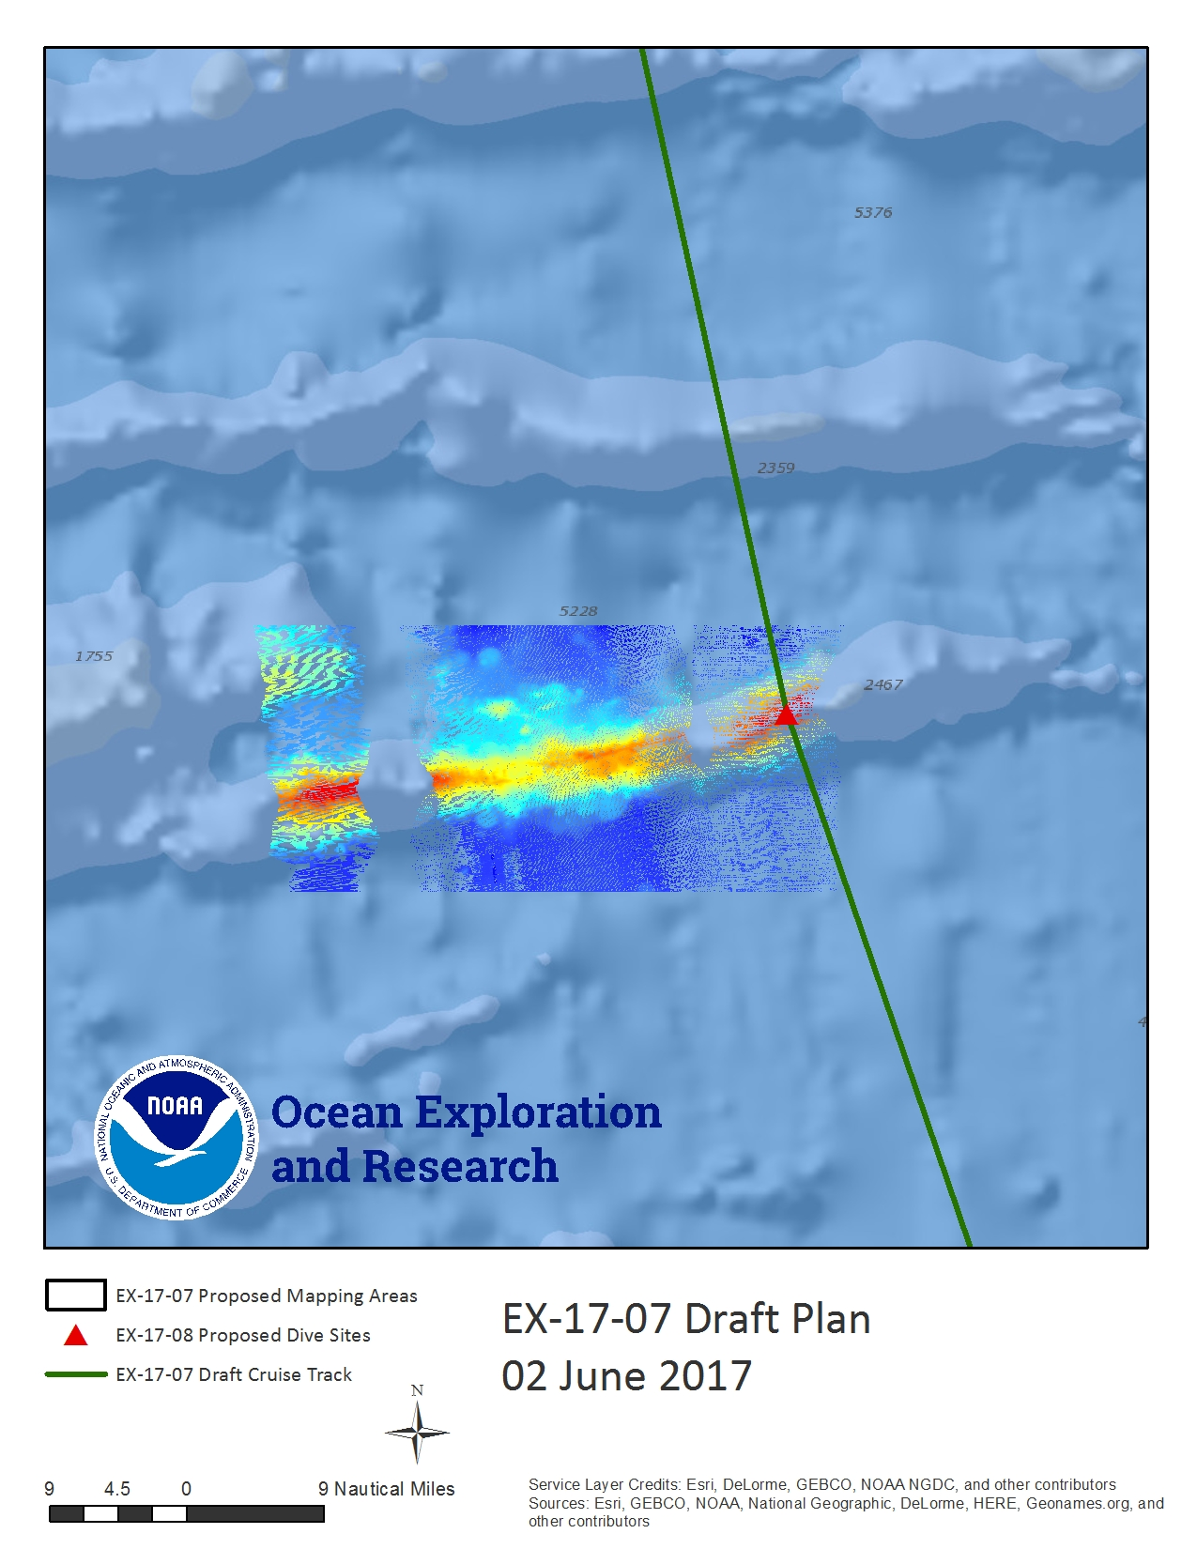

**Figure 3 (above):**Map indicating the general area focused survey area at Blackfin Ridge. The green line indicates the generalized cruise track, the black polygons indicate priority areas for focused mapping surveys and red triangles indicate ROV dives requested as of 02 June 2017. Existing publicly available bathymetry from National Centers for Environmental Information shown in background.

A pair of survey lines will be run along the ridgeline of Blackfin Ridge.

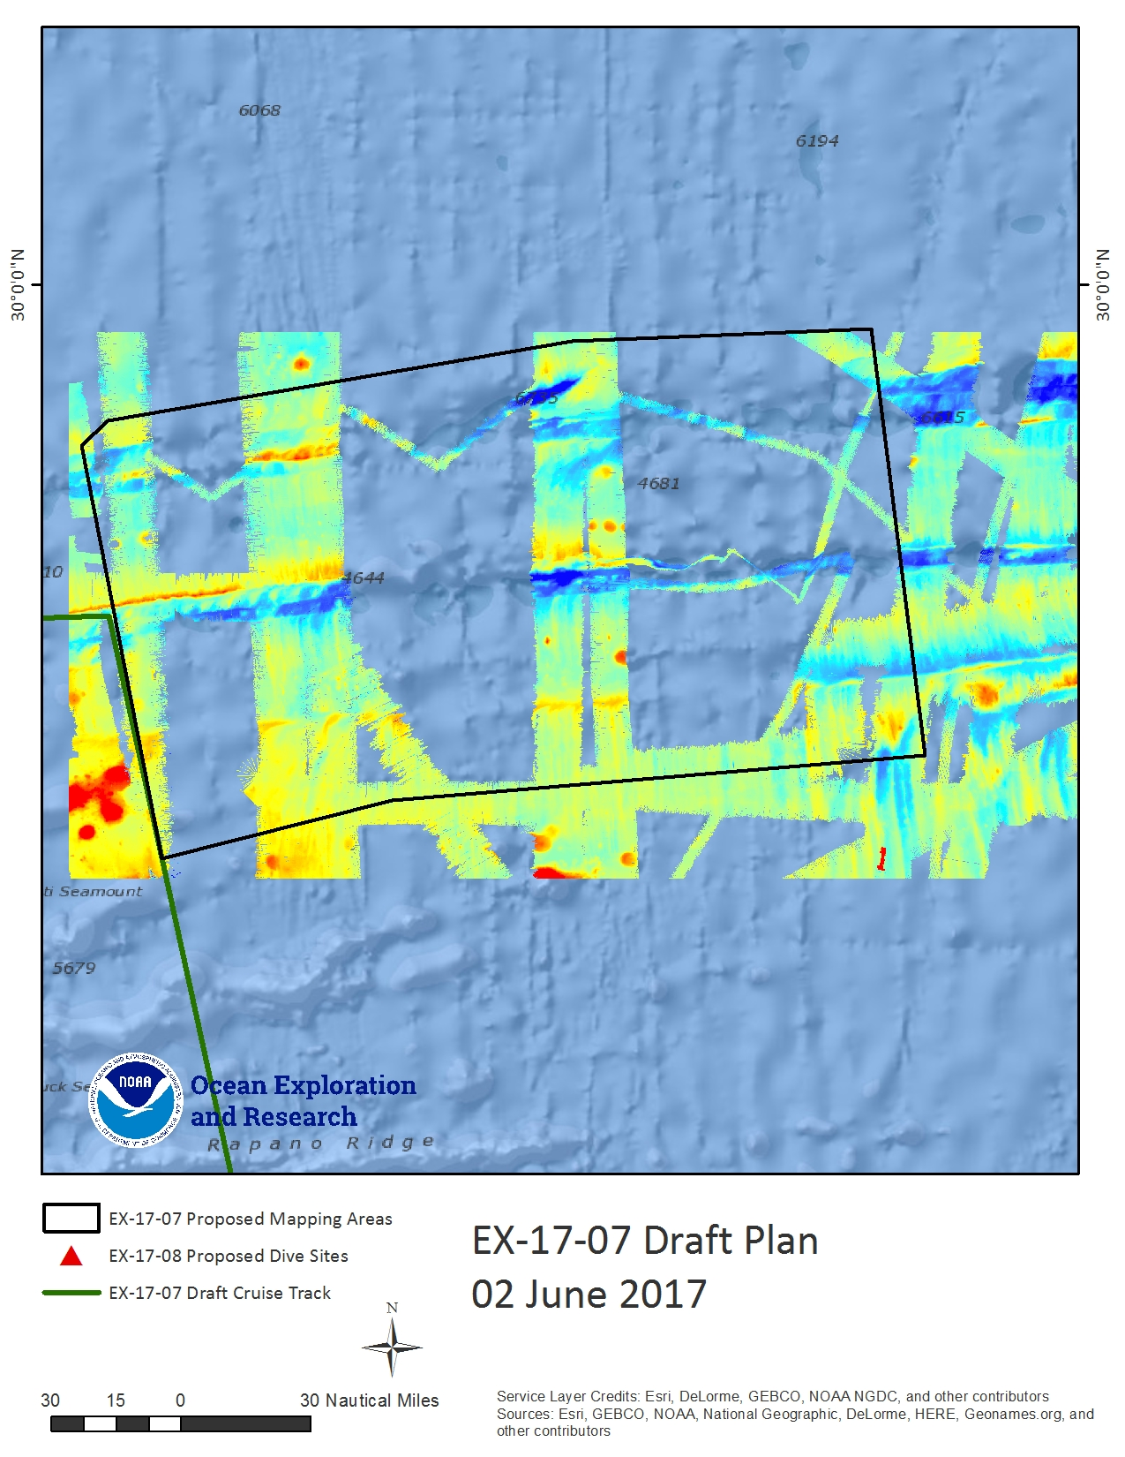

**Figure 4 (above):**Map indicating the generalized mapping area at the Murray Fracture Zone. The green line indicates the generalized cruise track, the black polygons indicate priority areas for focused mapping surveys requested as of 02 June 2017. Existing publicly available bathymetry from National Centers for Environmental Information shown in background.

The Murray Fracture Zone survey area in Figure 4 will be refined for survey priorities with further input from science and management partners in the upcoming months.

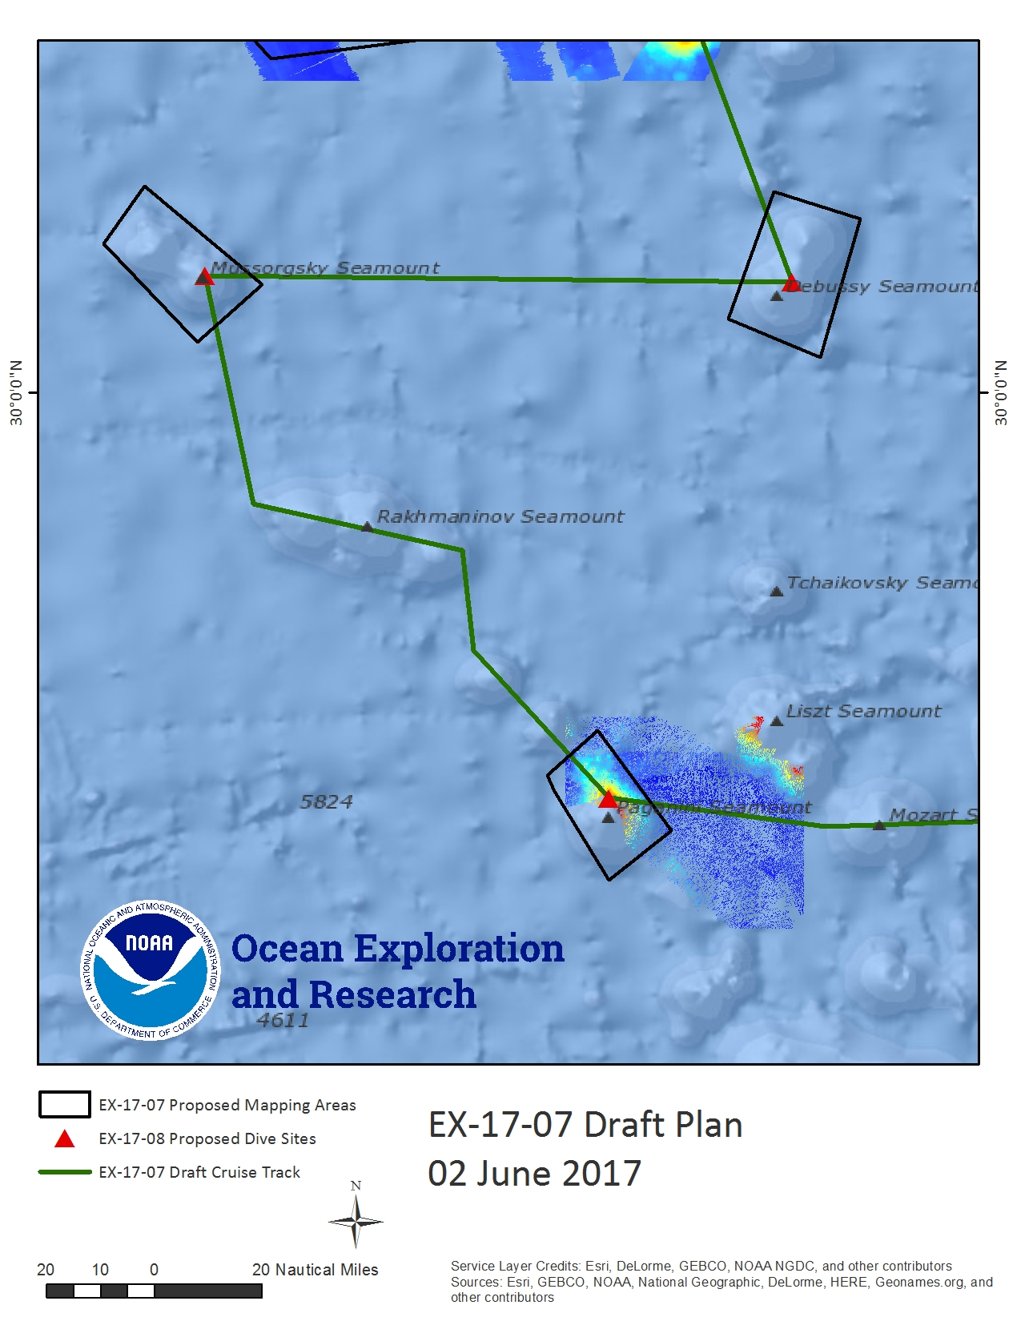 **Figure 5 (above):**Map indicating focused mapping areas at Paganini, Mussorgsky, and Debussy Seamounts. The green line indicates the generalized cruise track, the black polygons indicate priority areas for focused mapping surveys and red triangles indicate ROV dives requested as of 02 June 2017. Existing publicly available bathymetry from National Centers for Environmental Information shown in background.

The three seamounts in Figure 5 will be mapped with a focus on defining from the summits down to depths of ~ 4000m.

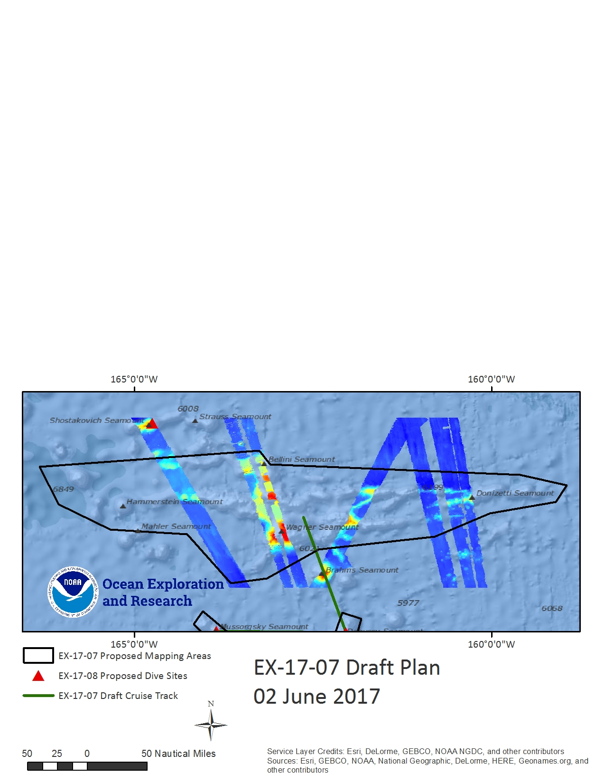

**Figure 6 (above):**Map indicating focused mapping areas at several interconnected seamounts in the Musician Seamount chain. The green line indicates the generalized cruise track, the black polygons indicate priority areas for focused mapping surveys and red triangles indicate ROV dives requested as of 02 June 2017. Existing publicly available bathymetry from National Centers for Environmental Information shown in background.

The survey area as this large grouping of seamounts within the Musician Seamounts chain will be further refined in upcoming months with input from science and management community.

|  |  |  |
| --- | --- | --- |
| EX-17-07 Generalized Cruise Track | | |
|  | **Latitude**  **(Degrees Decimal Minutes)** | **Longitude**  **(Degrees Decimal Minutes)** |

|  |  |
| --- | --- |
| 158 8.527788 W | 21 6.775758 N |
| 158 37.147176 W | 21 41.999622 N |
| 158 19.535244 W | 23 35.376432 N |
| 159 7.362846 W | 25 54.65514 N |
| 159 44.292666 W | 28 43.585236 N |
| 161 55.992066 W | 28 39.254682 N |
| 162 36.25071 W | 28 44.5707 N |
| 163 181.5165 W | 29 12.075078 N |
| 163 3.557286 W | 29 30.599142 N |
| 163 42.489216 W | 29 39.233238 N |
| 163 51.389652 W | 30 21.776916 N |
| 162 2.254212 W | 30 20.532606 N |
| 162 38.21049 W | 31 57.316482 N |

**Table 1:**EX-17-07 generalized cruise track waypoints.

# D. Summary of Objectives

**August 8 - 31, Honolulu, HI to Honolulu HI, focused seamount mapping at Musician Seamounts.**

EX-17-07 operations will occur in the U.S. EEZ and primarily in international water.

Mission objectives for EX-17-07 include a combination of mapping/operational, science, education, outreach, and data management objectives:

1. Onboard Mapping
   1. Conduct 24 hr/day mapping operations for the entirety of the cruise using EM 302 multibeam, EK 60 suite, and subbottom profiler sonars.
   2. Execute mapping line plans as defined by onshore personnel, with adjustments made in the field to obtain complete coverage as necessary.
   3. Collect high resolution mapping data from sonars in priority areas as dictated by operational needs as well as science and management community needs.
   4. Collect XBT/ UnderwayCTD (if system operational) casts as mapping data quality requires.
   5. Utilize Qimera realtime gridding functionality.
   6. Create daily standard bathymetry mapping products.
   7. Ensure all raw data from all sonars is transferred to shoreside repository hourly using automated scripts.
   8. Collect sun photometer measurements as part of Exploration Project of Opportunity (EPO).
   9. Continue to train new Survey Technician on mapping operations and Standard Operating Procedures, especially as part of telepresence mapping cruises.
   10. Average survey speeds of 8-9 kts will be utilized.
   11. Transit speeds of 9-11 kts will be utilized.
   12. Host two Explorers-in-Training who were trained onshore during EX-17-04 at the UNH Center for Coastal and Ocean Mapping.
2. Onshore mapping
   1. Train two Explorers-in-Training at the UNH CCOM/JHC in preparation for them to sail on a later mapping cruise in FY18.
   2. Conduct detailed bathymetric data processing.
   3. Write mapping data report.
   4. Generate tracklines of all sonar data types.
   5. Generate cruise map.
   6. Generate cruise statistics.
   7. Process subbottom, EK60, multibeam bottom backscatter and water column backscatter data according to SOPs.
   8. Shoreside operation of sonar computers on the ship using desktop access through NOAA OMAO supplied laptop.
   9. Test telepresence mapping workflow with OER physical scientists at UNH.
   10. Support onboard watchstanders by monitoring data collection from shore in realtime
   11. Provide data acquisition and processing troubleshooting from shore
   12. Possibly collaborate with GECBO students based at CCOM.
3. Data Management
   1. Provide a foundation of publicly accessible data and information products to spur further exploration, research, and management activities;
   2. Use daily bathymetric mapping products and SCS mailers to update Okeanos Atlas for onshore situational awareness.
4. Science
   1. Explore the diversity and distribution of benthic habitats – including bottom fish habitats, deep sea and precious coral communities and hydrothermal vents.
      1. Collect data on: habitat size and extent
   2. Collect geophysical data at sites to aid the understanding of the geologic history of Pacific seamounts.
   3. Build capacity in the scientific community and public in telepresence-based mapping exploration.
   4. Successfully conduct operations in conjunction with shore-based Exploration Command Centers and remote science team participants.
5. Remote Science/Exploration Command Centers
   1. Provide operational support and training to scientists and managers to enable remote participation in at-sea operations.
   2. Facilitate outreach and engagement activities and events at the ECCs.
   3. Test and refine ship-to-shore communications procedures that engage multiple ECCs and other remote participants.
   4. Test and refine operating procedures and products.
6. Outreach
   1. Onshore EC and EiTs participate in various UNH outreach activities based in the UNH ECC including TBD
7. Ship
   1. Possibly conduct full depth test CTD cast to confirm all sensors functional including altimeter.
   2. Continue to refine SOPs for the new VSAT.
   3. Provide a high quality stable internet connection with the new VSAT.
   4. Provide stable and reliable VoIP tele communications.
   5. Continue to train new Survey Technician and familiarize him with *Okeanos* Operations and his/her responsibilities.

# E. Participating Institutions

* National Oceanic and Atmospheric Administration (NOAA), Office of Ocean Exploration and Research (OER)–1315 East-West Hwy, Silver Spring, MD 20910 USA
* NOAA, National Oceanographic Data Center, National Coastal Data Development Center, Stennis Space Center MS, 39529 USA
* University Corporation for Atmospheric Research Joint Office for Science Support (JOSS), PO Box 3000 Boulder, CO 80307 USA
* University of Hawai’i at Manoa- 2500 Campus Rd, Honolulu, HI 96822
* University of New Hampshire (UNH) Center for Coastal and Ocean Mapping (CCOM) Jere A. Chase Ocean Engineering Lab, 24 Colovos Rd, Durham, NH 03824 USA
* Global Foundation for Ocean Exploration, P.O. Box 417, Mystic, CT 06355
* NOAA National Marine Fisheries Service, Pacific Islands Regional Office, 1845 Wasp Blvd, Honolulu, HI 96818
* NOAA National Marine Fisheries Service, Pacific Islands Fisheries Science Center, 1845 Wasp Blvd, Honolulu, HI 96818

# F. Personnel(Mission Party)

**Table 2:**Full list of shore based and sea going mission party members and their affiliations

|  |  |  |  |  |  |  |  |  |
| --- | --- | --- | --- | --- | --- | --- | --- | --- |
| # | Name (First, Last) | Title | Location during cruise | Date Aboard | Date Disembark | Gender | Affiliation | Nationality |
| ONBOARD MAPPING TEAM | | | | | | | | |
| 1 | Amanda Bittinger | Onboard Mapping Lead | Ship | 8/6 | 9/1 | F | UCAR | USA |
| 2 | Dan Freitas | Onboard Mapping Watch Lead | Ship | 8/6 | 9/1 | M | UCAR | USA |
| 3 | Elizabeth "Claudia" Thompson | Explorer in Training / Watchstander | Ship | 8/6 | 9/1 | F | UCAR | USA |
| 4 | Brandon O'Brien | Explorer in Training / Watchstander | Ship | 8/6 | 9/1 | M | UCAR | USA |
| ONSHORE MAPPING TEAM | | | | | | | | |
| 1 | Elizabeth 'Meme' Lobecker | Expedition Coordinator | UNH CCOM/JHC ECC | n/a | n/a | n/a |  |  |
| 2 | Derek Sowers | Mapping Lead | UNH CCOM/JHC ECC | n/a | n/a | n/a |  |  |
| 3 | Kelsey Lane | Explorer in Training | UNH CCOM/JHC ECC | n/a | n/a | n/a |  |  |
| 4 | Laura Almodóvar | Explorer in Training / EPP Intern | UNH CCOM/JHC ECC | n/a | n/a | n/a |  |  |
| 5 | TBD | Explorer in Training | UNH CCOM/JHC ECC | n/a | n/a | n/a |  |  |

# G. Administrative

**1. Points of Contact:**

|  |  |
| --- | --- |
| **Ship Operations** | |
| Marine Operations Center, Atlantic (MOA)  439 West York Street  Norfolk, VA 23510-1145  Telephone: (757) 441-6776  Fax: (757) 441-6495 | Chief, Operations Division, Atlantic (MOA)  LT Joe Carrier, NOAA  Telephone: (757) 441-6842  E-mail: [Chiefops.MOA@noaa.gov](mailto:Chiefops.MOA@noaa.gov) |
|  |  |
| **Mission Operations** | |
| Elizabeth 'Meme' Lobecker  Mapping Manager  NOAA Office of Ocean Exploration  and Research (ERT)  O: (603) 862-1475  C: (240) 429-7023  E-mail: [elizabeth.lobecker@noaa.gov](mailto:elizabeth.lobecker@noaa.gov) | CAPT Eric Johnson, NOAA  Commanding Officer  NOAA Ship *Okeanos Explorer*  Phone: (401) 378-8284  Email: [CO.Explorer@noaa.gov](mailto:CO.Explorer@noaa.gov)  LT Aaron Colohan, NOAA  Operations Officer  NOAA Ship Okeanos Explorer  Phone: (808) 659-9197 (Ship’s Iridium)  E-mail: [Ops.Explorer@noaa.gov](mailto:Ops.Explorer@noaa.gov) |
|  |  |
| **Other Mission Contacts** | |
| Craig Russell  Program Manager  NOAA Ocean Exploration & Research  Phone: (206) 526-4803 / (206) 518-1068  E-mail: [Craig.Russell@noaa.gov](mailto:Craig.Russell@noaa.gov) | CDR William Mowitt, Deputy Director  NOAA Ocean Exploration & Research  Phone: (301) 734-1023  E-mail: [William.Mowitt@noaa.gov](mailto:William.Mowitt@noaa.gov) |
|  | Alan Leonardi, Director  NOAA Ocean Exploration & Research  Phone: 301-734-1016/ Mobile: 202-631-1790  E-mail: alan.leonardi@noaa.gov | |
| **Vessel Shipping Address** | |
| Shipments: Send an email to the *Okeanos Explorer* Operations Officer at [OPS.Explorer@noaa.gov](mailto:OPS.Explorer@noaa.gov) indicating the size and number of items being shipped.  Items sent to Honolulu should arrive at the following address prior to COB 8/4/17.  NOAA Ship Okeanos Explorer  c/o LT Aaron Colohan  1845 Wasp Blvd, Honolulu, HI 96818 | |

**2. Diplomatic Clearances**

N/A. All data collection to occur in U.S. or international waters.

**3. Licenses and Permits**

The expedition is being planned and conducted by NOAA as an agency of the U.S. Federal government, in partnership with NOAA NMFS Pacific Islands Regional Office Marine National Monument Program.

PENDING - RENEW CE FOR 1707

Pursuant to the National Environmental Policy Act (NEPA), NOAA OER is required to include in its planning and decision-making processes appropriate and careful consideration of the potential environmental consequences of actions it proposes to fund, authorize and/or conduct. NOAA’s Administrative Order (NAO) 216-6A Companion Manual describes the agency’s specific procedures for NEPA compliance. Among these is the need to review all proposed NOAA-supported field projects for their environmental effects. A categorical exclusion (CE) worksheet has been completed for this survey, in accordance with Section 4 of the Companion Manual. This worksheet describes EX1704 and explains how it is consistent with one or more of the CE categories listed/described in Appendix E of the Companion Manual. The completed worksheet also summarizes the review conducted to determine that no extraordinary circumstances exist that would preclude the use of a CE or require preparation of an environmental assessment or environmental impact statement.

Informal consultation was initiated under Section 7 of the Endangered Species Act (ESA), requesting NOAA Fisheries’ Protected Resources Division concurrence with our biological evaluation determining that 2016 Marianas Expedition and all other planned *Okeanos Explorer* operations during the 2016-17 field season, may affect, but are not likely to adversely affect, ESA-listed marine species. The informal consultation was completed on February 3, 2016 when NOAA OER received a signed letter from the Regional Administrator of NMFS Pacific Islands Regional Office, stating that NMFS concurs with OER’s determination that conducting proposed *Okeanos Explorer* cruises are not likely to adversely affect ESA-listed marine species. Documentation is provided in appendix of this PI.

OER has completed consultation with NOAA's Habitat Conservation Division on potential impacts of our operations to Essential Fish Habit (EFH). They concurred that our operations would not adversely affect EFH provided adherence to our proposed procedures and their guidance stated in the letter. Documentation is provided in appendix of this PI.

II. Operations

The Expedition Coordinator is responsible for ensuring the scientific staff are trained in planned operations and are knowledgeable of project objectives, priorities and environmental compliance procedures. The Commanding Officer is responsible for ensuring all operations conform to the ship’s accepted practices and procedures.

A. Project Itinerary   
**(All times and dates are subject to prevailing conditions and the discretion of the Commanding Officer)**

|  |  |  |  |  |  |
| --- | --- | --- | --- | --- | --- |
| Date | | Approx Survey Time (hrs) | | Activities | |
| 8/6 |  | | Onboard mission personnel arrive to ship (flight dependent) | |
| 8/8 |  | | Depart port 0900 from Honolulu, HI, commence mapping at sea buoy | |
| 8/8 | 17 h | | Transit to unnamed seamount (Fig 2) | |
| 8/9 | 3 h | | Focused mapping at unnamed seamount | |
| 8/9 | 18 h | | Transit to Blackfin Ridge (Fig 3) | |
| 8/10 | 13 h | | Focused mapping at Blackfin Ridge | |
| 8/10 - 8/11 | 20 h | | Transit to Murray Fracture Zone | |
|  | To be refined | | Focused mapping at Murray Fracture Zone (Fig 4) | |
|  | 19 h | | Transit to Paganini Seamount (Fig 5) | |
|  | 16 h | | Focused mapping at Paganini Seamount (Fig 5) | |
|  | 22h | | Focused mapping at Mussorgsky Seamount (Fig 5) | |
|  | 22 h | | Focused mapping at Debussy Seamount (Fig 5) | |
|  | To be refined | | Focused mapping at large Musician Seamount group (Fig 6) | |
|  | 5 h | | Possible transit to Shostakovich Seamount (Fig 6) | |
|  | 20 h | | Possible focused seamount mapping at Shostakovich Seamount (Fig 6) | |
| 8/28-8/31 | 4 days | | Transit south from Shostakovich Seamount to Honolulu (1560 km / 840 nm distance estimate, 4days @ 9 kts) | |
| 8/31 |  | | Arrive sea buoy Pearl Harbor,Honolulu 0800 | |

**Table 4:** Detailed Cruise Itinerary. This is an approximate itinerary and is subject to change based on survey results, field conditions, and discretion of the CO.

# B. Staging and Destaging

Minimal staging and destaging is expected as all mission equipment will be onboard already, and the following cruise is another telepresence-enabled ROV cruise.

# C. Operations to be Conducted

1. Telepresence / Outreach Events
   1. Two live video feeds will be used throughout the cruise to provide situational awareness for onshore personnel.
2. In-Port Events
   1. There are no in-port events planned for this cruise.

# D. SCUBA Dive Plan

All dives are to be conducted in accordance with the requirements and regulations of the [NOAA Diving Program](http://www.ndc.noaa.gov/dr.html) and require the approval of the ship’s Commanding Officer.

# E. Applicable Restrictions

**Sonar Operations**

EM 302, EK 60, ADCP, and sub-bottom profiler data acquisition is planned for this cruise. All data acquisition will be conducted in accordance with established standard operating procedures under the direction of the mapping team lead. These operating procedures will include protection measures when operating in the vicinity of marine mammals, sea turtles or Endangered Species Act-listed species as described in appendices of this document. The final decision to operate and collect 24-hour sub-bottom profiler data will be at the discretion of the Commanding Officer.

III. Equipment

# A. Equipment and capabilities provided by the ship

* 2 working small boats in seaworthy and reliable working condition for mission operations and fast rescue
* ~~NOAA OER 6000 m~~ *~~Deep Discoverer~~* ~~ROV~~
* ~~NOAA~~ *~~Seirios~~* ~~Camera Platform~~
* Kongsberg Simrad EM302 MultibeamEchosounder (MBES)
* Kongsberg Simrad EK60DeepwaterEchosounders and GPTs (18, 70, 120, 200 kHz)
* Knudsen Chirp 3260 Sub-bottom profiler (SBP)
* Teledyne RDI Workhorse Mariner (300 kHz) ADCP
* Teledyne RDI Ocean Surveyor (38 kHz) ADCP
* Teledyne UnderwayCTD
* LHM Sippican XBT Mark21 System(Deep Blue probes)
* AOML Automated XBT Launcher (Deep Blue probes)
* Seabird SBE 911Plus CTD
* Seabird SBE 32 Carousel and 24 2.5 L Niskin Bottles
* Light Scattering Sensor (LSS)
* Oxidation – Reduction Potential (ORP)
* Dissolved Oxygen (DO) sensor
* Altimeter Sensor and battery pack
* MarineStar GPS
* POS/MV
* Seabird SBE-45 (Micro TSG)
* Kongsberg Dynamic Positioning-1 System
* Netshares mapping storage system
* IVS Fledermaus Software suite
* SIS Software
* Hypack Software
* Scientific Computing System (SCS)
* ECDIS
* Met/Wx Sensor Package
* Telepresence System
* VSAT High-Speed link (Comtech 9 Mbps ship to shore; 2 Mbps shore to ship)
* Cruise Information Management System (CIMS)
* Three VoIP telephone lines

# B. Equipment and capabilities provided by the scientists

* Microtops II Ozone Monitor Sunphotometer and handheld GPS required for NASA Marine Aerosols Network supplementary project.

IV. Hazardous Materials

# A. Policy and Compliance

The Expedition Coordinator is responsible for complying with FEC 07 Hazardous Materials and Hazardous Waste Management Requirements for Visiting Scientific Parties (or the OMAO procedure that supersedes it). The Expedition Coordinator and Science Team Lead will be responsible for transporting all samples and HAZMAT on and off the ship. By Federal regulations and NOAA Marine and Aviation Operations policy, the ship may not sail without a complete inventory of all hazardous materials by name and quantity, MSDS, appropriate spill cleanup materials (neutralizing agents, buffers, or absorbents) in amounts adequate to address spills of a size equal to the amount of chemical brought aboard, and chemical safety and spill response procedures. Documentation regarding those requirements will be provided by the Chief of Operations, Marine Operations Center, upon request.

Per OMAO procedure, the scientific party will include with their project instructions and provide to the CO of the respective ship 30 days before departure:

* List of chemicals by name with anticipated quantity
* List of spill response materials, including neutralizing agents, buffers, and absorbents
* Chemical safety and spill response procedures, such as excerpts of the program’s Chemical Hygiene Plan or SOPs relevant for shipboard laboratories
* For bulk quantities of chemicals in excess of 50 gallons total or in containers larger than 10 gallons each, notify ship’s Operations Officer regarding quantity, packaging and chemical to verify safe stowage is available as soon as chemical quantities are known.

Upon embarkation and prior to loading hazardous materials aboard the vessel, the scientific party will provide to the CO or their designee:

* An inventory list showing actual amount of hazardous material brought aboard
* An MSDS for each material
* Confirmation that neutralizing agents and spill equipment were brought aboard sufficient to contain and cleanup all of the hazardous material brought aboard by the program
* Confirmation that chemical safety and spill response procedures were brought aboard

Upon departure from the ship, scientific parties will provide the CO or their designee an inventory showing that all chemicals were removed from the vessel. The CO’s designee will maintain a log to track scientific party hazardous materials. MSDS will be made available to the ship’s complement, in compliance with Hazard Communication Laws.

Scientific parties are expected to manage and respond to spills of scientific hazardous materials. Overboard discharge of hazardous materials is not permitted aboard NOAA ships.

# B. Inventory

|  |  |  |
| --- | --- | --- |
| Item | Use | Approx. locations |
| 95% Denatured Ethanol (35 gallons) | Sample preservation | Wetlab, under the chemical hood |
| 10% Buffered Formalin (3 gallons) | Sample preservation | Wetlab, under the chemical hood |
| Chaos Buffer (0.5 gallons)  (4 M guanidine thiocyanate, 0.5% N-laurosylsarcosine, 25 mMTris pH 8.0, 0.1 M beta-mercaptoethanol) | Sample preservation (genetics) | Wetlab, under the chemical hood |
| Aqua Shield | Underwater Lubricant | ROV Workshop Fire Cabinet, Pit |
| Dow Corning 4 | Electrical insulating compound | ROV Workshop Fire Cabinet, Pit |
| Fluid Film Spray | Silicone Lubricant | ROV Workshop Fire Cabinet |
| Isopropanol Alcohol (35 gallons) | Solvent | ROV Workshop Fire cabinet |
| Scotchkote | Electrical insulating compound | ROV Workshop Fire cabinet |
| 3M Silicone Spray | Silicone Lubricant | ROV Workshop Fire cabinet |
| Synthetic AW Hydraulic Oil, ISO-22 | Amsoil (AWG-05) | Hanger, Pit, Vehicles |
| Tap Magic Cutting Fluid | Cutting/Machining Lubricant | ROV Workshop Fire cabinet |
| Tap Magic Heavyweight Cutting Fluid | Cutting/Machining Lubricant | ROV Workshop Fire cabinet |
| Tuff Coat M | Marine Lubricant | Winch room |
| Dow Corning Molykote 111 | Valve Lubricant and Sealant | ROV Workshop Fire cabinet, Pit |
| WD40 | Lubricant | ROV Workshop Fire cabinet |
| Loktite | Bolt adhesive | ROV Workshop Fire cabinet |
| Mineral Oil | Vitrea | Hanger, Vehicles |
| Por-15 | Paint Kit | ROV Workshop Fire cabinet |
| Univis HVI 13 | Hydraulic Fluid | Hanger, ROV *D2* |
| Ultratane | Butane fuel | ROV Workshop fire cabinet |
| Rust-oleum | Protective Enamel | ROV Workshop fire cabinet |
| Flux-Off | Soldering Flux remover | ROV Workshop fire cabinet |
| Propane | Torch Fuel | ROV Workshop fire cabinet |

# C. Chemical safety and spill response procedures

All safety and spill response procedures will be handled according to OMAO guidelines and following the manufacturers MSDS which has been provided to the ship’s ECO.

# D. Radioactive Materials

NOT APPLICABLE TO THIS CRUISE

V. Additional Projects

# A. Exploration Projects of Opportunity

**NASA Maritime Aerosol Network**

During the cruise the marine aerosol layer observations will be collected for the NASA Maritime Aerosol Network (MAN). Observations will be made by mission personnel (as time allows) with a sun photometer instrument provided by the NASA MAN program. Resulting data will be delivered to the NASA MAN primary investigator Alexander Smirnov by the expedition coordinator. All collected data will be archived and publically available at: <http://aeronet.gsfc.nasa.gov/new_web/maritime_aerosol_network.html>

Equipment resides on the ship and is stewarded by the Expedition Coordinator.

See Appendix for full Survey of Opportunity Form.

# B. NOAA Fleet Ancillary Projects

No NOAA Fleet Ancillary Projects are planned.

VI. Disposition of Data and Reports

# A. Data Responsibilities

All data acquired on *Okeanos Explorer* will be provided to the public archives without proprietary rights. All data management activities shall be executed in accordance with [NAO 212-15, Management of Environmental and Geospatial Data and Information](http://www.corporateservices.noaa.gov/ames/administrative_orders/chapter_212/212-15.html)

**Ship Responsibilities**

The Commanding Officer is responsible for all data collected for missions until those data have been transferred to mission party designees. Data transfers will be documented on NOAA Form 61-29. Reporting and sending copies of project data to NESDIS (ROSCOP form) is the responsibility of OER.

**NOAA OER Responsibilities**

The Expedition Coordinator will work with the *Okeanos Explorer* Operations Officer to ensure data pipeline protocols are followed for final archive of all data acquired on *Okeanos Explorer* without proprietary rights. See Appendix for detailed data management plans.

**Deliverables**

1. At sea
   1. Daily plans of the Day (POD)
   2. Daily situation reports (SITREPS)
   3. Daily summary bathymetry data files
   4. Raw sonar files (EM 302, EK 60, Subbottom, ADCP)
   5. Refined SOPs for all pertinent operational activities
   6. Assessments of all activities
2. Science
   1. Multibeam raw and processed data (see appendix B for the formal cruise data management plan)
   2. XBT raw and processed data
   3. EK 60 raw data
   4. Knudsen 3260 sub-bottom profiler raw data
   5. ADCP raw data
   6. Mapping data report

**Archive**

OER and ship will work together to ensure documentation and stewardship of acquired data sets in accordance with NAO 212-15. The Cruise Information Management System is the primary tool used to accomplish this activity.

VII. Meetings, Vessel Familiarization, and Project Evaluations

# A. Shipboard Meetings

A safety brief and overview of POD will occur on the Bridge each morning at 0800. As necessary and no less than every third day, daily Operations Briefing meetings will be held at 1330 in the forward lounge to review the current day, and define operations, associated requirements, and staffing needs for the following day. A Plan of the Day (POD) will be posted each evening for the next day in specified locations throughout the ship. Daily Situation Reports (SITREPS) will be posted as well and shared daily through e-mail.

**1. Pre-Project Meeting:**

The Expedition Coordinator and Commanding Officer will conduct a meeting of pertinent members of the scientific party and ship’s crew to discuss required equipment, planned operations, concerns, and establish mitigation strategies for all concerns. This meeting shall be conducted before the beginning of the project with sufficient time to allow for preparation of the ship and project personnel. The ship’s Operations Officer usually is delegated to assist the Expedition Coordinator in arranging this meeting.

**2. Vessel Familiarization Meeting:**

The Commanding Officer is responsible for ensuring scientific personnel are familiarized with applicable sections of the standing orders and vessel protocols, e.g., meals, watches, etiquette, drills, etc. A vessel familiarization meeting shall be conducted in the first 24 hours of the project’s start and is normally presented by the ship’s Operations Officer.

**3. Post-Project Meeting:**

The Commanding Officer is responsible for conducting a meeting no earlier than 24 hrs before or seven days after the completion of a project to discuss the overall success and short comings of the project. Concerns regarding safety, efficiency, and suggestions for future improvements shall be discussed and mitigations for future projects will be documented for future use. This meeting shall be attended by the ship’s officers, applicable crew, the Expedition Coordinator, and members of the scientific party and is normally arranged by the Operations Officer and Expedition Coordinator.

**4. Project Evaluation Report:**

Within seven days of the completion of the project, a Customer Satisfaction Survey is to be completed by the Expedition Coordinator. The form is available at <http://www.omao.noaa.gov/fleeteval.html>and provides a “Submit” button at the end of the form. Submitted form data is deposited into a spreadsheet used by OMAO management to analyze the information. Though the complete form is not shared with the ships, specific concerns and praises are followed up on while not divulging the identity of the evaluator.

VIII. Miscellaneous

# A. Meals and Berthing

The ship will provide meals for the scientists listed above. Meals will be served 3 times daily beginning one hour before scheduled departure, extending throughout the project, and ending two hours after the termination of the project. Since the watch schedule is split between day and night, the night watch may often miss daytime meals and will require adequate food and beverages (for example a variety of sandwich items, cheeses, fruit, milk, juices) during what are not typically meal hours. Special dietary requirements for scientific participants will be made available to the ship’s command at least twenty-one days prior to the survey (e.g., Expedition Coordinator is allergic to fin fish).

Berthing requirements, including number and gender of the scientific party, will be provided to the ship by the Expedition Coordinator. The Expedition Coordinator and Operations Officer will work together on a detailed berthing plan to accommodate the gender mix of the scientific party taking into consideration the current make-up of the ship’s complement. The Expedition Coordinator is responsible for ensuring the scientific berthing spaces are left in the condition in which they were received; for stripping bedding and linen return; and for the return of any room keys which were issued. The Expedition Coordinator is also responsible for the cleanliness of the laboratory spaces and the storage areas utilized by the scientific party, both during the cruise and at its conclusion prior to departing the ship.

All NOAA scientists will have proper travel orders when assigned to any NOAA ship. The Expedition Coordinator will ensure that all non-NOAA or non-Federal scientists aboard also have proper orders. It is the responsibility of the Expedition Coordinator to ensure that the entire scientific party has a mechanism in place to provide lodging and food and to be reimbursed for these costs in the event that the ship becomes uninhabitable and/or the galley is closed during any part of the scheduled project.

All persons boarding NOAA vessels give implied consent to comply with all safety and security policies and regulations which are administered by the Commanding Officer. All spaces and equipment on the vessel are subject to inspection or search at any time. All personnel must comply with OMAO's Drug and Alcohol Policy dated May 7, 1999 which forbids the possession and/or use of illegal drugs and alcohol aboard NOAA Vessels.

# B. Medical Forms and Emergency Contacts

The NOAA Health Services Questionnaire (NHSQ, NF 57-10-01 (3-14)) must be completed in advance by each participating scientist. The NHSQ can be obtained from the Expedition Coordinator or the NOAA website <http://www.corporateservices.noaa.gov/noaaforms/eforms/nf57-10-01.pdf>.

All NHSQs submitted after March 1, 2014 must be accompanied by [NOAA Form (NF) 57-10-02 - Tuberculosis Screening Document](http://www.moc.noaa.gov/all-ships/NOAA%20Form%2057-10-02%20(1-14)%20Tuberculosis%20Screening%20Document.pdf) in compliance with OMAO Policy 1008 (Tuberculosis Protection Program).

The completed forms should be sent to the Regional Director of Health Services at the applicable Marine Operations Center. The NHSQ and Tuberculosis Screening Document should reach the Health Services Office no later than four weeks prior to the start of the project to allow time for the participant to obtain and submit additional information should health services require it, before clearance to sail can be granted. Please contact MOC Health Services with any questions regarding eligibility or completion of either form. Ensure to fully complete each form and indicate the ship or ships the participant will be sailing on. The participant will receive an email notice when medically cleared to sail if a legible email address is provided on the NHSQ.

The participant can mail, fax, or email the forms to the contact information below. Participants should take precautions to protect their Personally Identifiable Information (PII) and medical information and ensure all correspondence adheres to DOC guidance (<http://ocio.os.doc.gov/ITPolicyandPrograms/IT_Privacy/PROD01_008240>).

The only secure email process approved by NOAA is Accellion Secure File Transfer which requires the sender to setup an account. Accellion’s Web Users Guide is a valuable aid in using this service, however to reduce cost the DOC contract doesn’t provide for automatically issuing full functioning accounts. To receive access to a “Send Tab,” after your Accellion account has been established send an email from the associated email account to [accellionAlerts@doc.gov](mailto:accellionAlerts@doc.gov) requesting access to the “Send Tab” function. They will notify you via email, usually within one business day of your approval. The “Send Tab” function will be accessible for 30 days.

**Contact Information:**

Regional Director of Health Services  
Marine Operations Center – Atlantic  
439 W. York Street  
Norfolk, VA 23510  
Telephone: (757) 441.6320  
Fax: (757) 441.3760  
E-mail: [MOA.Health.Services@noaa.gov](mailto:MOA.Health.Services@noaa.gov)

Please make sure the [medical.explorer@noaa.gov](mailto:medical.explorer@noaa.gov)email address is cc’d on all medical correspondence.

Prior to departure, the Expedition Coordinator must provide a listing of emergency contacts to the Operations Officer for all members of the scientific party, with the following information: name, address, relationship to member, and telephone number.

Emergency contact form is included as Appendix A.

# C. Shipboard Safety

Hard hats are required when working with suspended loads. Work vests are required when working near open railings and during small boat launch and recovery operations. Hard hats and work vests will be provided by the ship when required.

Wearing open-toed footwear or shoes that do not completely enclose the foot (such as sandals or clogs) outside of private berthing areas is not permitted. Steel-toed shoes are required to participate in any work dealing with suspended loads, including CTD deployments and recovery. The ship does not provide steel-toed boots. Hard hats are also required when working with suspended loads. Work vests are required when working near open railings and during small boat launch and recovery operations. Hard hats and work vests will be provided by the ship when required.

Operational Risk Management: For every operation to be conducted aboard the ship (NOAA-wide initiative), risk management procedures will be followed. For each operation, risks will be identified and assessed for probability and severity. Risk mitigation strategies/measures will be investigated and implemented where possible. After mitigation, the residual risk will have to be assessed to make Go-No Go decisions for the operations. Particularly with new operations, risk assessment will be ongoing and updated as necessary. This does not only apply to over-the-side operations, but to everyday tasks aboard the vessel that pose risk to personnel and property.

* CTD, ROV (and other pertinent) ORM documents will be followed by all personnel working onboard *Okeanos Explorer*.
* All personnel onboard are in the position of calling a halt to operations/activities in the event of a safety concern.

# D. Communications

A daily situation report (SITREP) on operations prepared by the Expedition Coordinator will be relayed to the program office. Sometimes it is necessary for the Expedition Coordinator to communicate with another vessel, aircraft, or shore facility. Through various modes of communication, the ship is able to maintain contact with the Marine Operations Center on an as needed basis. These methods will be made available to the Expedition Coordinator upon request, in order to conduct official business. The ship’s primary means of communication with the Marine Operations Center is via e-mail and the Very Small Aperture Terminal (VSAT) link. VSAT bandwidth at **9 Mbps** will be paid by OER and provided by OMAO.

Specific information on how to contact NOAA Ship *Okeanos Explorer* and all other fleet vessels can be found at [http://www.moc.noaa.gov/MOC/phone.html#EX](http://www.moc.noaa.gov/MOC/phone.html%23EX)

**Important Telephone and Facsimile Numbers and E-mail Addresses**

Ocean Exploration and Research (OER):

OER Program Administration  
Phone: (301) 734-1010  
Fax: (301) 713-4252  
E-mail: craig.russell@noaa.gov

University of New Hampshire, Center for Coastal and Ocean Mapping

Phone: (603) 862-3438  
Fax: (603) 862-0839

NOAA Ship *Okeanos Explorer* - Telephone methods listed in order of increasing expense:

*Okeanos Explorer* Cellular: (401) 713-4114  
*OkeanosExplorer*Iridium:(808) 659-9179  
OER Mission Iridium (dry lab): (808) 851-3827

EX INMARSAT B  
Line 1: 011-870-764-852-328  
Line 2: 011-870-764-852-329

Voice Over IP (VoIP) Phone:   
(541) 867-8932  
(541) 867-8933  
(541) 867-8934

E-mail: [Ops.Explorer@noaa.gov](mailto:Ops.Explorer@noaa.gov)- (mention the person’s name in SUBJECT field)

E-mail: [expeditioncoordinator.explorer@noaa.gov](mailto:expeditioncoordinator.explorer@noaa.gov) for dissemination of all hands emails by Expedition Coordinator while onboard. See ET for password.

# E. IT Security

1. Any computer that will be hooked into the ship's network must comply with the OMAO Fleet IT Security Policy 1.1 (November 4, 2005) prior to establishing a direct connection to the NOAA WAN. Requirements include, but are not limited to: Installation of the latest virus definition (.DAT) file on all systems and performance of a virus scan on each system.
2. Installation of the latest critical operating system security patches.
3. No external public Internet Service Provider (ISP) connections.

Completion of these requirements prior to boarding the ship is required.

Non-NOAA personnel using the ship's computers or connecting their own computers to the ship's network must complete NOAA’s IT Security Awareness Course within three days of embarking.

# F. Foreign National Guests Access to OMAO Facilities and Platforms

Not applicable to this cruise.