+-

DRAFT Project Instructions
Date Submitted: February 22, 2017
Platform: NOAA Ship Okeanos Explorer
Project Number: EX-17-04
Project Title: American Samoa and Cook Islands (Telepresence Mapping)
Project Dates: April 4 - 21, 2017

Prepared by: ________________________ Dated: __________________
Elizabeth Lobecker, NOAA
Expedition Coordinator
Office of Ocean Exploration & Research

Approved by: ________________________ Dated: __________________
Craig Russell
Program Manager
Office of Ocean Exploration & Research

Approved by: ________________________ Dated: __________________
Captain Scott M. Sirois, NOAA
Commanding Officer
Marine Operations Center - Atlantic

I.Overview
“America’s future depends on understanding the ocean. We explore the ocean because its health and resilience are vital to our economy and to our lives. We depend on the ocean to regulate weather and climate; sustain a diversity of life; for maritime shipping and national defense; and for food, energy, medicine, and other essential services to humankind.”
- NOAA Office of Ocean Exploration and Research Strategic Plan

A. Brief Summary and Project Period
This document contains project instructions for EX-17-04. Operations for this cruise include focused mapping operations and strategic mapping transits within the waters of Western Samoa, American Samoa, and the Cook Islands. The expedition will commence on April 4, 2017 in Apia, Western Samoa and conclude on April 21, 2017 in Pago Pago, American Samoa. Operations will include the use of the ship’s deep water mapping systems (Kongsberg EM302 multibeam sonar, EK60 split-beam fisheries sonars, Acoustic Doppler Current Profilers: (ADCPs), and Knudsen 3260 chirp sub-bottom profiler sonar), and the ship’s high-bandwidth satellite connection for hourly data transfer, real-time ship to shore communications, real-time sonar control from shore, and real-time video streaming of sonar screens and ship's cameras.
NOAA Ship Okeanos Explorer systematically explores the ocean every day of every cruise to maximize public benefit from the ship’s unique capabilities. With approximately 95% of the ocean unexplored, we pursue every opportunity to map, sample, explore, and survey at planned destinations as well as during transits; “Always Exploring” is a guiding principle. An integral element of Okeanos Explorer’s “Always Exploring” model is the ship’s seafloor and water column mapping capabilities. The sonars, or a subset of the sonars on board, will be operated at all times 24 hours per day throughout the cruise allowing for continued exploration and seabed, water column, and/or sub-bottom data collection and selected processing.
This expedition is part of a three year Campaign to Address Pacific monument Science, Technology, and Ocean NEeds (CAPSTONE) focused on systematically collecting baseline information to support science and management needs within and around the Monuments and other protected places in the Pacific, and serves as an opportunity for NOAA and the Nation to highlight the uniqueness and importance of these national symbols of ocean conservation. NOAA will continue to work with the scientific and management community to characterize unknown and poorly-known areas through telepresence-based exploration. Baseline information collected during this cruise will support and catalyze further exploration, research and management activities.
Understanding biogeographic patterns between and among the Pacific Monuments and Sanctuaries is a coordinating theme for CAPSTONE science priorities. Themes and objectives for the expedition series include:
- Conduct follow-on mapping to the previous ROV cruise EX-17-02. An overarching concept of OER's approach to exploration is that OER-collected data will lead to new scientific hypothesis. The collection of data complimentary to EX-17-02 will allow for increased hypothesis generation from scientists and managers based on initial results from EX-17-02.
- Conduct preliminary seafloor mapping operations to contribute to geological understanding of remote areas of the Pacific Ocean.
- Acquire data to support priority Monument and Sanctuaries science and management needs, including habitat surveys in recently expanded boundary areas.
- Identify and characterize vulnerable marine habitats - particularly potential locations for high density deep sea coral and sponge communities.
- Characterize seamounts adjacent to the Prime Crust Zone (PCZ). The PCZ is the area of the Pacific with the highest expected concentration of deep sea minerals, including rare metals and rare earth elements.
- Collect information on the geologic history of Central Pacific Seamounts, including those that are or may be relevant to our understanding of plate tectonics and subduction zone biology and geology.
- Provide a foundation of publicly accessible data and information products to spur further exploration, research, and management activities.
Operations for this cruise will include 24 hour mapping, and continuous telepresence-based remote participation in mapping operations. Multibeam and splitbeam mapping operations will be conducted 24 hours a day throughout the cruise. Sub-bottom profile mapping will be conducted 24 hours a day at the discretion of the CO. XBT and Underway CTD sound velocity casts in support of multibeam sonar mapping operations will be conducted at an interval defined by prevailing oceanographic conditions, but not to exceed 6 hours. All mapping data will be fully processed according to standard procedures and will be archived with the National Centers for Environmental Information (NCEI).
The transit routes between ports and the operating areas will maximize mapping of discrete geologic features including seamounts and ridges with little or no existing modern sonar data coverage. The routes were chosen based on the most recent version of the global bathymetric compilation dataset compiled by J.J. Becker et al (http://topex.ucsd.edu/sandwell/publications/124_MG_Becker.pdf).
This expedition will be the sixth cruise to test telepresence enabled mapping operations on Okeanos Explorer. Mapping efforts will include preplanned mapping surveys at seamounts and/or adjacent to islands within the national waters of three countries.
The Expedition Coordinator (Elizabeth Lobecker) for the cruise will be based on shore at the Exploration Command Center (ECC) at University of New Hampshire Center for Coastal and Ocean Mapping/Joint Hydrographic Center (UNH CCOM/JHC) with regular and ongoing communications with the ship (OPS, CO) and onboard mapping lead (Amanda Bittinger).
The screens of the mapping acquisition systems (EM 302, EK 60, SBP etc.) will be broadcast 24 hours per day, and will be monitored by both onboard and onshore mapping scientists. A specially configured laptop has been prepared for remote access to all the sonar acquisition and data processing machines from shore. This setup will continue to be tested for its reliability and feasibility of controlling the mapping data acquisition and data management from shore. The raw data from all sonars will be transmitted to shore and further processing will be completed on shore. Automated bathymetric gridding will occur on the ship in order for the onboard team to monitor and ensure adequate seabed coverage. The onboard mapping lead will be the primary liaison between ship and OER operations and will attend all the shipboard daily meetings and provide daily situation reports (SITREPS) to the broader OER Okeanos operational team.
As telepresence mapping protocols continue to develop during this type of telepresence enabled mapping expedition, possibilities open for OER to conduct operations with nimble teams of mapping personnel onboard and most of data acquisition, processing and quality checks of mapping data being completed on shore. Value gained from this model will continue to expand as the model is tested. Initial predicted benefits include: reduction in travel costs to the ship, participation of a larger number of mapping trainees in expeditions, cruise participation from individuals who are unable to sail, enhanced rapid data processing and archival techniques, enhanced onshore partnership development opportunities, enhanced rapid data report creation, and expanded possibilities for utilizing multiple ECCs during mapping missions.
The onboard ship and mapping team will be provided with all information necessary to successfully conduct the mapping mission should the telepresence component experience significant challenges, such as lack of connectivity due to VSAT or network challenges.

B.Days at Sea (DAS)
Of the 18 DAS scheduled for this project, 0 DAS are funded by an OMAO allocation, 8 DAS are funded by an NOS Line Office Allocation, 0 DAS are Program Funded, and 11DAS are funded by OAR Line Office Allocation. This project is estimated to exhibit a Medium Operational Tempo due to 24 hour mapping operations.

C. Operating Area
EX-17-04 24-hour per day mapping operations will focus in American Samoa, including within the Rose Atoll Marine National Monument and National Marine Sanctuary of American Samoa; Western Samoa; and the Cook Islands (New Zealand). Mapping operations will focus in depths generally between 250 and 6,000 meters.

Figure 1 (below):Map indicating the overall operating area of Okeanos Explorer for EX-17-04. The red line indicates the generalized cruise track, starting in Apia, moving clockwise, and ending in Pago Pago. The magenta polygons indicate the boundaries of the Rose Atoll Marine National Monument and National Marine Sanctuary of American Samoa. The green dots indicate the port locations of Pago Pago, American Samoa and Apia, Samoa. The light blue boxes indicate priority areas for focused mapping surveys. The light grey line indicates the US Maritime Limits and Boundaries.

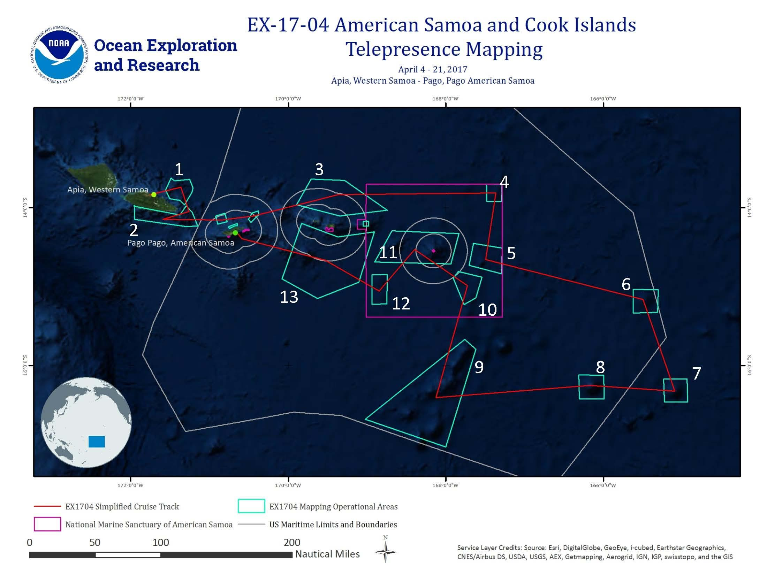

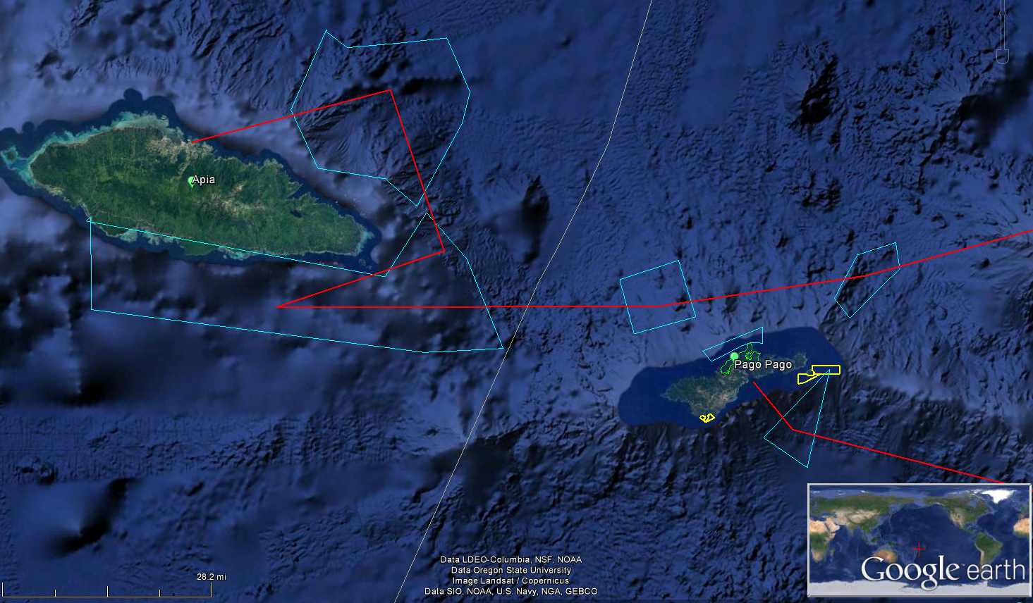
Figure 2: Close-up of focused mapping sites near Samoa and American Samoa. The red line indicates the generalized cruise track, starting in Apia, moving clockwise, and ending in Pago Pago. The yellow polygons indicate the boundaries of the National Marine Sanctuary of American Samoa. The green dots indicate the port locations of Pago Pago, American Samoa and Apia, Samoa. The light blue boxes indicate the priority areas for focused mapping surveys. The white line indicates the Exclusive Economic Zone of American Samoa and Samoa.
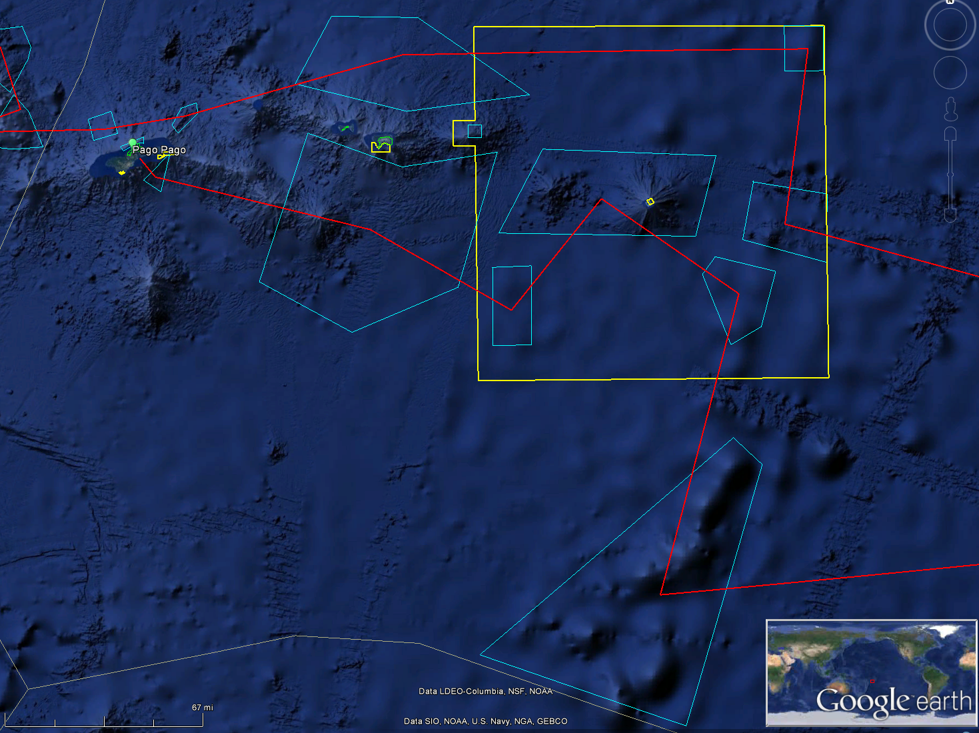
Figure 3: Close up of focused mapping in vicinity of Rose Atoll Marine National Monument and National Marine Sanctuary of American Samoa. The red line is the generalized cruise track, moving in a clockwise direction. The yellow polygons are the boundaries of the National Marine Sanctuary of American Samoa. The green labelled dots are the port locations of Pago Pago, American Samoa and Apia, Samoa. The light blue boxes are priority areas for focused mapping surveys. The white line is the Exclusive Economic Zone of American Samoa and Samoa.
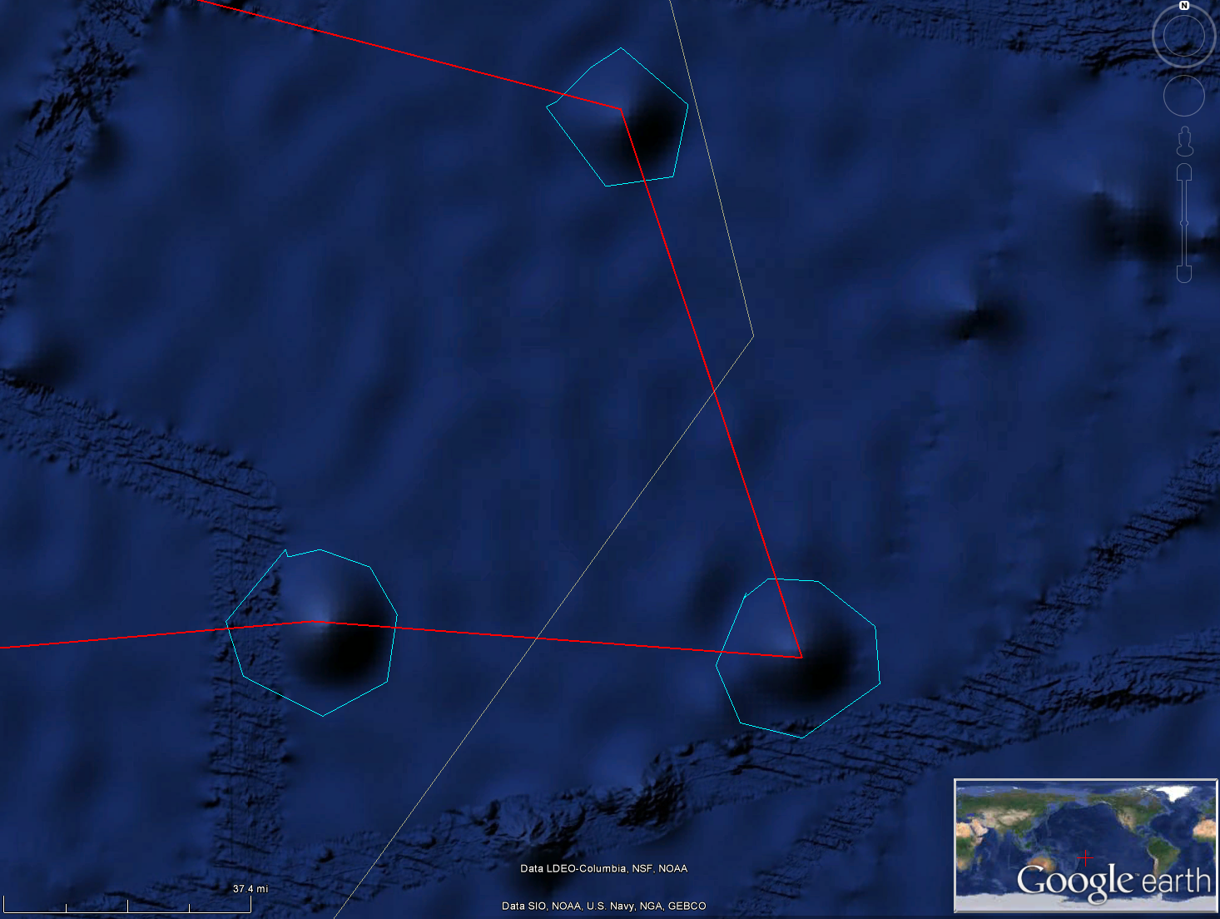
Figure 4: Close up of focused mapping at eastern edge of cruise operational area. The red line is the generalized cruise track, moving in a clockwise direction. The light blue boxes are priority areas for focused mapping surveys. The white line is the Exclusive Economic Zone of American Samoa and the Cook Islands.

EX-17-04 Generalized Cruise Track
ID | Latitude  (Degrees Decimal Minutes) | Longitude  (Degrees Decimal Minutes)
1 | 13 49.8487512 S | 171 45.2702766 W
2 | 13 44.2145964 S | 171 21.8209368 W
3 | 14 2.6536026 S | 171 15.7790952 W
4 | 14 248.738826 S | 171 35.5224882 W
5 | 14 9.2540172 S | 170 50.7435012 W
6 | 14 6.1036698 S | 170 26.5096248 W
7 | 13 49.7924556 S | 169 21.9333264 W
8 | 13 48.7233936 S | 167 21.9414396 W
9 | 14 39.299046 S | 167 29.6182566 W
10 | 15 9.8731812 S | 165 29.7216912 W
11 | 16 19.5982398 S | 165 5.4474852 W
12 | 16 15.2074842 S | 166 10.2760086 W
13 | 16 24.6294438 S | 168 7.5746784 W
14 | 14 59.1644268 S | 167 43.5627882 W
15 | 14 31.7751402 S | 168 23.8233702 W
16 | 15 3.2918232 S | 168 50.6836716 W
17 | 14 39.7832916 S | 169 31.8611022 W
18 | 14 23.4118176 S | 170 35.376447 W
19 | 14 17.9313864 S | 170 39.9017094 W
Table 1:EX-17-04 generalized cruise track waypoints.

D. Summary of Objectives
April 4 - 21, 2017 (Apia, Samoa to Pago Pago, American Samoa) Telepresence-enabled mapping operations.
EX-17-04 operations will occur in the U.S. EEZ waters of American Samoa, Samoa, and the Cook Islands. This cruise will collect baseline data and information to support priority NOAA science and management needs including within the National Marine Sanctuary of American Samoa and Rose Atoll Marine National Monument.
Mission objectives for EX-17-04 include a combination of mapping/operational, science, education, outreach, and data management objectives:
- Onboard Mapping
  - Execute mapping line plans as defined by onshore personnel, with adjustments made in the field to obtain complete coverage as necessary.
  - Collect high resolution mapping data from sonars in priority areas as dictated by operational needs as well as science and management community needs.
  - Conduct 24 hr/day mapping operations for the entirety of the cruise.
  - Mapping of areas adjacent to islands will occur during daylight hours, with a minimum depth goal of 250-300m, at the discretion of the CO. Line plans adjacent to islands will be run started with lines further offshore.
  - Collect XBT/ UnderwayCTD casts as mapping data quality requires.
  - Utilize Qimerarealtime gridding functionality.
  - Create daily standard bathymetry mapping products.
  - Ensure all raw data from all sonars is transferred to shoreside repository hourly using automated scripts.
  - Collect sun photometer measurements as part of Exploration Project of Opportunity (EPO).
  - Continue to test the integration of the new EK60 frequencies and the ADCPs.
  - Continue to train new Survey Technician on mapping operations and Standard Operating Procedures, especially as part of telepresence mapping cruises.
  - Average survey speeds of 8.5-9 kts will be utilized.
  - Transit speeds of 9-11 kts will be utilized.

- Onshore mapping
  - Train two Explorers-in-Training at the UNH CCOM/JHC in preparation for them to sail on EX-17-07, a 24 hr/day telepresence mapping cruise to occur in August 2017 at Musician Seamounts.
  - Conduct detailed bathymetric data processing.
  - Write mapping data report.
  - Generate tracklines of all sonar data types.
  - Generate cruise map.
  - Generate cruise statistics.
  - Process subbottom, EK60, multibeam bottom backscatter and water column backscatter data according to SOPs.
  - Shoreside operation of sonar computers on the ship using desktop access through NOAA OMAO supplied laptop.
  - Test telepresence mapping workflow with OER physical scientists at UNH.
  - Support onboard watchstanders by monitoring data collection from shore in realtime
  - Provide data acquisition and processing troubleshooting from shore
  - Possibly collaborate with GECBO students based at CCOM.

- Data Management
  - Provide a foundation of publicly accessible data and information products to spur further exploration, research, and management activities;
  - Use daily bathymetric mapping products and SCS mailers to update Okeanos Atlas for onshore situational awareness.
- Science
  - Potentially conduct a CTD at Vailulu'u Seamount as a result of EX-17-02 discovery of active seep in the volcanic crater.
  - Acquire data to support priority Monument and Sanctuary science and management needs.
  - Explore the diversity and distribution of benthic habitats – including bottom fish habitats, deep sea and precious coral communities and hydrothermal vents.
    - Collect data on: habitat size and extent
  - Collect geophysical data at sites to aid the understanding of the geologic history of Pacific seamounts.
  - Build capacity in the scientific community and public in telepresence-based mapping exploration.
  - Successfully conduct operations in conjunction with shore-based Exploration Command Centers and remote science team participants.

- Remote Science/Exploration Command Centers
  - Provide operational support and training to scientists and managers to enable remote participation in at-sea operations.
  - Facilitate outreach and engagement activities and events at the ECCs.
  - Test and refine ship-to-shore communications procedures that engage multiple ECCs and other remote participants.
  - Test and refine operating procedures and products.

- Outreach
  - Onshore EC and EiTs participate in various UNH outreach activities based in the UNH ECC including
    - Regional SeaPerch student ROV competition April 7.
    - OER educator workshop on April 8 at UNH.
    - UNH regional student tours on April 11 and 13.
- Ship
  - Continue to refine SOPs for the new VSAT.
  - Provide a high quality stable internet connection with the new VSAT.
  - Provide stable and reliable VoIP tele communications.
  - Continue to train new Survey Technician and familiarize him with Okeanos Operations and his/her responsibilities.
  - Conduct full depth test CTD cast to confirm all sensors functional including altimeter.

E. Participating Institutions
- GEBCO? Other colleges? UNH broader marine science community?
- National Oceanic and Atmospheric Administration (NOAA), Office of Ocean Exploration and Research (OER)–1315 East-West Hwy, Silver Spring, MD 20910 USA
- NOAA, National Oceanographic Data Center, National Coastal Data Development Center, Stennis Space Center MS, 39529 USA
- University Corporation for Atmospheric Research Joint Office for Science Support (JOSS), PO Box 3000 Boulder, CO 80307 USA
- University of Hawai’i at Manoa- 2500 Campus Rd, Honolulu, HI 96822
- University of New Hampshire (UNH) Center for Coastal and Ocean Mapping (CCOM) Jere A. Chase Ocean Engineering Lab, 24 Colovos Rd, Durham, NH 03824 USA
- Global Foundation for Ocean Exploration, P.O. Box 417, Mystic, CT 06355
- NOAA National Marine Fisheries Service, Pacific Islands Regional Office, 1845 Wasp Blvd, Honolulu, HI 96818
- NOAA National Marine Fisheries Service,Marine National Monuments Program, 1845 Wasp Blvd, Honolulu, HI 96818
- NOAANational Marine Sanctuary of American Samoa, P.O. Box 4318, Pago Pago, American Samoa 96799
- NOAA National Marine Fisheries Service,Pacific Islands Fisheries Science Center, 1845 Wasp Blvd, Honolulu, HI 96818
- Lehigh University, 27 Memorial Dr. W, Bethlehem, PA 18015
- University of California Santa Barbara, Santa Barbara, CA 93106

F. Personnel(Mission Party)
Table 2:Full list of shore based and sea going mission party members and their affiliations
# | Name (First, Last) | Title | Location during cruise | Date Aboard | Date Disembark | Gender | Affiliation | Nationality
ONBOARD MAPPING TEAM
1 | Amanda Bittinger | Onboard Mapping Lead | Ship | 4/2(?) | 4/22(?) | F | UCAR | USA
2 | Dan Freitas | Onboard Mapping Watch Lead | Ship | 4/2(?) | 4/22(?) | M | UCAR | USA
ONSHORE MAPPING TEAM
1 | Elizabeth 'Meme' Lobecker | Expedition Coordinator | UNH CCOM/JHC ECC | n/a | n/a | n/a
2 | Derek Sowers | Mapping Lead | UNH CCOM/JHC ECC | n/a | n/a | n/a
3 | Elizabeth 'Claudia' Thompson | Explorer in Training | UNH CCOM/JHC ECC | n/a | n/a | n/a
4 | Brandon O'Brien | Explorer in Training | UNH CCOM/JHC ECC | n/a | n/a | n/a

G. Administrative
1. Points of Contact:
Ship Operations
Marine Operations Center, Atlantic (MOA)  439 West York Street  Norfolk, VA 23510-1145  Telephone: (757) 441-6776  Fax: (757) 441-6495 | Chief, Operations Division, Atlantic (MOA)  LT Joe Carrier, NOAA  Telephone: (757) 441-6842  E-mail: Chiefops.MOA@noaa.gov
Mission Operations
Elizabeth 'Meme' Lobecker  Mapping Manager  NOAA Office of Ocean Exploration  and Research (ERT)  O: (603) 862-1475  C: (240) 429-7023  E-mail: elizabeth.lobecker@noaa.gov | CAPT Mark Wetzler, NOAA  Commanding Officer  NOAA Ship Okeanos Explorer  Phone: (401) 378-8284  Email: CO.Explorer@noaa.gov  LT Aaron Colohan, NOAA  Operations Officer  NOAA Ship Okeanos Explorer  Phone: (808) 659-9197 (Ship’s Iridium)  E-mail: Ops.Explorer@noaa.gov
Other Mission Contacts
Craig Russell  Program Manager  NOAA Ocean Exploration & Research  Phone: (206) 526-4803 / (206) 518-1068  E-mail: Craig.Russell@noaa.gov | CDR William Mowitt, Deputy Director  NOAA Ocean Exploration & Research  Phone: (301) 734-1023  E-mail: William.Mowitt@noaa.gov
Alan Leonardi, Director
NOAA Ocean Exploration & Research
Phone: 301-734-1016/ Mobile: 202-631-1790
E-mail: alan.leonardi@noaa.gov

Vessel Shipping Address
Shipments: Send an email to the Okeanos Explorer Operations Officer at OPS.Explorer@noaa.gov indicating the size and number of items being shipped.

The ship has recommended no packages are shipped to Apia, Samoa. All packages should be hand carried.

2. Diplomatic Clearances
This project involves Marine Scientific Research in waters under the jurisdiction of the U.S. including the territorial government of American Samoa, Samoa, and the Cook Islands.

-Permission to conduct Marine Scientific Research in the waters of Samoa was granted through a letter dated 23 January 2017, available in the appendix of this document.

Two clearances are pending:

- A request to conduct mapping operations in the territorial waters of Samoa was submitted to the Samoa Ministry of Natural Resources and the Environment on December 20.
-A request to conduct operations in the Cook Islandswas submitted in January.

3. Licenses and Permits
The expedition is being planned and conducted by NOAA as an agency of the U.S. Federal government, in partnership with NOAA NMFS Pacific Islands Regional Office Marine National Monument Program. We do not require a permit to work in the Rose Atoll Marine National Monument.

Permission to conduct operations in the National Marine Sanctuary of American Samoa was received through a permit dated 19 January 2017, available in the appendix of this document.

Outstanding permit:-A request to conduct operations in Morae Moana MPA was submitted in January

Pursuant to the National Environmental Policy Act (NEPA), NOAA OER is required to include in its planning and decision-making processes appropriate and careful consideration of the potential environmental consequences of actions it proposes to fund, authorize and/or conduct. NOAA’s Administrative Order (NAO) 216-6A Companion Manual describes the agency’s specific procedures for NEPA compliance. Among these is the need to review all proposed NOAA-supported field projects for their environmental effects. A categorical exclusion (CE) worksheet has been completed for this survey, in accordance with Section 4 of the Companion Manual. This worksheet describes EX1704 and explains how it is consistent with one or more of the CE categories listed/described in Appendix E of the Companion Manual. The completed worksheet also summarizes the review conducted to determine that no extraordinary circumstances exist that would preclude the use of a CE or require preparation of an environmental assessment or environmental impact statement.

Informal consultation was initiated under Section 7 of the Endangered Species Act (ESA), requesting NOAA Fisheries’ Protected Resources Division concurrence with our biological evaluation determining that 2016 Marianas Expedition and all other planned OkeanosExplorer operations during the 2016-17 field season, may affect, but are not likely to adversely affect, ESA-listed marine species. The informal consultation was completed on February 3, 2016 when NOAA OER received a signed letter from the Regional Administrator of NMFS Pacific Islands Regional Office, stating that NMFS concurs with OER’s determination that conducting proposed Okeanos Explorer cruises are not likely to adversely affect ESA-listed marine species (Appendix X).

OER has completed consultation with NOAA's Habitat Conservation Division on potential impacts of our operations to Essential Fish Habit (EFH). They concurred that our operations would not adversely affect EFH provided adherence to our proposed procedures and their guidance stated in the letter(Appendix X).

II. Operations
The Expedition Coordinator is responsible for ensuring the scientific staff are trained in planned operations and are knowledgeable of project objectives, priorities and environmental compliance procedures. The Commanding Officer is responsible for ensuring all operations conform to the ship’s accepted practices and procedures.
A. Project Itinerary
(All times and dates are subject to prevailing conditions and the discretion of the Commanding Officer)
Date | Activities
4/2 | Onboard mission personnel arrive to ship (flight dependent)
4/4 | Depart port in the morning from Apia, WS, commence mapping at sea buoy
4/5-4/7 | Map in Western Samoa waters, boxes 1,2
~4/7 | Cross from Western Samoa into American Samoa waters, repeat date ~ April 7
~4/7 - 4/21 | Conduct seafloor mapping operations in American Samoa including within the National Marine Sanctuary of American Samoa - Muliava Unit and the Rose Atoll Marine National Monument. Detailed timing estimates are provided in Table 5 below.
4/21 | Arrive Pago Pago, AS sea buoy 0600
4/21 | Mission personnel depart in afternoon
Table 4: Detailed Cruise Itinerary. This is an approximate itinerary and is subject to change based on survey results, field conditions, and discretion of the CO.
Polygon ID | Survey Estimate Approximate (hours) | Country, Marine Protected Area
1 | 25 | Western Samoa
2 | 30 | Western Samoa
3 | Up to 47 | American Samoa
4 | 10 | American Samoa, NMSAS
5 | 22 | American Samoa, NMSAS
6 | 11 | American Samoa
7 | 11 | Cook Islands
8 | 11 | American Samoa
9 | Up to 150 | American Samoa
10 | 20 | American Samoa, NMSAS
11 | 12 | American Samoa, NMSAS
12 | Up to 55 | American Samoa, NMSAS
13 | Up to 100 | American Samoa
Table 5. Survey time estimates for numbered polygons in Figure 1.

B. Staging and Destaging
Minimal staging and destaging is expected as all mission equipment will be onboard already, and the following cruise is another telepresence-enabled ROV cruise.

C. Operations to be Conducted
- Telepresence / Outreach Events
  - Two live video feeds will be used throughout the cruise to provide situational awareness for onshore personnel.
- In-Port Events
  - There are no in-port events planned for this cruise.

D. SCUBA Dive Plan
All dives are to be conducted in accordance with the requirements and regulations of the NOAA Diving Program and require the approval of the ship’s Commanding Officer.

E. Applicable Restrictions
Sonar Operations
EM 302, EK 60, ADCP, and sub-bottom profiler data acquisition is planned for this cruise. All data acquisition will be conducted in accordance with established standard operating procedures under the direction of the mapping team lead. These operating procedures will include protection measures when operating in the vicinity of marine mammals, sea turtles or Endangered Species Act-listed species as described in appendices of this document. The final decision to operate and collect 24-hour sub-bottom profiler data will be at the discretion of the Commanding Officer.

III. Equipment

A. Equipment and capabilities provided by the ship
- 2 working small boats in seaworthy and reliable working condition for mission operations and fast rescue
- NOAA OER 6000 m Deep Discoverer ROV
- NOAA Seirios Camera Platform
- Kongsberg Simrad EM302 MultibeamEchosounder (MBES)
- Kongsberg Simrad EK60DeepwaterEchosounders and GPTs (18, 70, 120, 200 kHz)
- Knudsen Chirp 3260 Sub-bottom profiler (SBP)
- Teledyne RDI Workhorse Mariner (300 kHz) ADCP
- Teledyne RDI Ocean Surveyor (38 kHz) ADCP
- Teledyne UnderwayCTD
- LHM Sippican XBT Mark21 System(Deep Blue probes)
- AOML Automated XBT Launcher (Deep Blue probes)
- Seabird SBE 911Plus CTD
- Seabird SBE 32 Carousel and 24 2.5 L Niskin Bottles
- Light Scattering Sensor (LSS)
- Oxidation – Reduction Potential (ORP)
- Dissolved Oxygen (DO) sensor
- Altimeter Sensor and battery pack
- MarineStar GPS
- POS/MV
- Seabird SBE-45 (Micro TSG)
- Kongsberg Dynamic Positioning-1 System
- Netshares mapping storage system
- IVS Fledermaus Software suite
- SIS Software
- Hypack Software
- Scientific Computing System (SCS)
- ECDIS
- Met/Wx Sensor Package
- Telepresence System
- VSAT High-Speed link (Comtech 9 Mbps ship to shore; 2 Mbps shore to ship)
- Cruise Information Management System (CIMS)
- Three VoIP telephone lines

B. Equipment and capabilities provided by the scientists
- Microtops II Ozone Monitor Sunphotometer and handheld GPS required for NASA Marine Aerosols Network supplementary project.

IV. Hazardous Materials

A. Policy and Compliance
The Expedition Coordinator is responsible for complying with FEC 07 Hazardous Materials and Hazardous Waste Management Requirements for Visiting Scientific Parties (or the OMAO procedure that supersedes it). The Expedition Coordinator and Science Team Lead will be responsible for transporting all samples and HAZMAT on and off the ship. By Federal regulations and NOAA Marine and Aviation Operations policy, the ship may not sail without a complete inventory of all hazardous materials by name and quantity, MSDS, appropriate spill cleanup materials (neutralizing agents, buffers, or absorbents) in amounts adequate to address spills of a size equal to the amount of chemical brought aboard, and chemical safety and spill response procedures. Documentation regarding those requirements will be provided by the Chief of Operations, Marine Operations Center, upon request.
Per OMAO procedure, the scientific party will include with their project instructions and provide to the CO of the respective ship 30 days before departure:
- List of chemicals by name with anticipated quantity
- List of spill response materials, including neutralizing agents, buffers, and absorbents
- Chemical safety and spill response procedures, such as excerpts of the program’s Chemical Hygiene Plan or SOPs relevant for shipboard laboratories
- For bulk quantities of chemicals in excess of 50 gallons total or in containers larger than 10 gallons each, notify ship’s Operations Officer regarding quantity, packaging and chemical to verify safe stowage is available as soon as chemical quantities are known.
Upon embarkation and prior to loading hazardous materials aboard the vessel, the scientific party will provide to the CO or their designee:
- An inventory list showing actual amount of hazardous material brought aboard
- An MSDS for each material
- Confirmation that neutralizing agents and spill equipment were brought aboard sufficient to contain and cleanup all of the hazardous material brought aboard by the program
- Confirmation that chemical safety and spill response procedures were brought aboard
Upon departure from the ship, scientific parties will provide the CO or their designee an inventory showing that all chemicals were removed from the vessel. The CO’s designee will maintain a log to track scientific party hazardous materials. MSDS will be made available to the ship’s complement, in compliance with Hazard Communication Laws.
Scientific parties are expected to manage and respond to spills of scientific hazardous materials. Overboard discharge of hazardous materials is not permitted aboard NOAA ships.

B. Inventory
Item | Use | Approx. locations
95% Denatured Ethanol (35 gallons) | Sample preservation | Wetlab, under the chemical hood
10% Buffered Formalin (3 gallons) | Sample preservation | Wetlab, under the chemical hood
Chaos Buffer (0.5 gallons)  (4 M guanidine thiocyanate, 0.5% N-laurosylsarcosine, 25 mMTris pH 8.0, 0.1 M beta-mercaptoethanol) | Sample preservation (genetics) | Wetlab, under the chemical hood
Aqua Shield | Underwater Lubricant | ROV Workshop Fire Cabinet, Pit
Dow Corning 4 | Electrical insulating compound | ROV Workshop Fire Cabinet, Pit
Fluid Film Spray | Silicone Lubricant | ROV Workshop Fire Cabinet
Isopropanol Alcohol (35 gallons) | Solvent | ROV Workshop Fire cabinet
Scotchkote | Electrical insulating compound | ROV Workshop Fire cabinet
3M Silicone Spray | Silicone Lubricant | ROV Workshop Fire cabinet
Synthetic AW Hydraulic Oil, ISO-22 | Amsoil (AWG-05) | Hanger, Pit, Vehicles
Tap Magic Cutting Fluid | Cutting/Machining Lubricant | ROV Workshop Fire cabinet
Tap Magic Heavyweight Cutting Fluid | Cutting/Machining Lubricant | ROV Workshop Fire cabinet
Tuff Coat M | Marine Lubricant | Winch room
Dow Corning Molykote 111 | Valve Lubricant and Sealant | ROV Workshop Fire cabinet, Pit
WD40 | Lubricant | ROV Workshop Fire cabinet
Loktite | Bolt adhesive | ROV Workshop Fire cabinet
Mineral Oil | Vitrea | Hanger, Vehicles
Por-15 | Paint Kit | ROV Workshop Fire cabinet
Univis HVI 13 | Hydraulic Fluid | Hanger, ROV D2
Ultratane | Butane fuel | ROV Workshop fire cabinet
Rust-oleum | Protective Enamel | ROV Workshop fire cabinet
Flux-Off | Soldering Flux remover | ROV Workshop fire cabinet
Propane | Torch Fuel | ROV Workshop fire cabinet

C. Chemical safety and spill response procedures
All safety and spill response procedures will be handled according to OMAO guidelines and following the manufacturers MSDS which has been provided to the ship’s ECO.

D. Radioactive Materials
NOT APPLICABLE TO THIS CRUISE

V. Additional Projects

A. Exploration Projects of Opportunity
NASA Maritime Aerosol Network
During the cruise the marine aerosol layer observations will be collected for the NASA Maritime Aerosol Network (MAN). Observations will be made by mission personnel (as time allows) with a sun photometer instrument provided by the NASA MAN program. Resulting data will be delivered to the NASA MAN primary investigator Alexander Smirnov by the expedition coordinator. All collected data will be archived and publically available at: http://aeronet.gsfc.nasa.gov/new_web/maritime_aerosol_network.html
Equipment resides on the ship and is stewarded by the Expedition Coordinator.
See Appendix F for full Survey of Opportunity Form.

B. NOAA Fleet Ancillary Projects
No NOAA Fleet Ancillary Projects are planned.

VI. Disposition of Data and Reports

A. Data Responsibilities
All data acquired on Okeanos Explorer will be provided to the public archives without proprietary rights. All data management activities shall be executed in accordance with NAO 212-15, Management of Environmental and Geospatial Data and Information
Ship Responsibilities
The Commanding Officer is responsible for all data collected for missions until those data have been transferred to mission party designees. Data transfers will be documented on NOAA Form 61-29. Reporting and sending copies of project data to NESDIS (ROSCOP form) is the responsibility of OER.
NOAA OER Responsibilities
The Expedition Coordinator will work with the Okeanos Explorer Operations Officer to ensure data pipeline protocols are followed for final archive of all data acquired on Okeanos Explorer without proprietary rights. See Appendix B for detailed data management plans.
Deliverables
- At sea
  - Daily plans of the Day (POD)
  - Daily situation reports (SITREPS)
  - Daily summary bathymetry data files
  - Raw sonar files (EM 302, EK 60, Subbottom, ADCP)
  - Refined SOPs for all pertinent operational activities
  - Assessments of all activities
- Science
  - Multibeam raw and processed data (see appendix B for the formal cruise data management plan)
  - XBT raw and processed data
  - EK 60 raw data
  - Knudsen 3260 sub-bottom profiler raw data
  - ADCP raw data
  - Mapping data report
Archive
OER and ship will work together to ensure documentation and stewardship of acquired data sets in accordance with NAO 212-15. The Cruise Information Management System is the primary tool used to accomplish this activity.

VII. Meetings, Vessel Familiarization, and Project Evaluations

A. Shipboard Meetings
A safety brief and overview of POD will occur on the Bridge each morning at 0800. As necessary, daily Operations Briefing meetings will be held at 1330 in the forward lounge to review the current day, and define operations, associated requirements, and staffing needs for the following day. A Plan of the Day (POD) will be posted each evening for the next day in specified locations throughout the ship. Daily Situation Reports (SITREPS) will be posted as well and shared daily through e-mail.
1. Pre-Project Meeting:
The Expedition Coordinator and Commanding Officer will conduct a meeting of pertinent members of the scientific party and ship’s crew to discuss required equipment, planned operations, concerns, and establish mitigation strategies for all concerns. This meeting shall be conducted before the beginning of the project with sufficient time to allow for preparation of the ship and project personnel. The ship’s Operations Officer usually is delegated to assist the Expedition Coordinator in arranging this meeting.
2. Vessel Familiarization Meeting:
The Commanding Officer is responsible for ensuring scientific personnel are familiarized with applicable sections of the standing orders and vessel protocols, e.g., meals, watches, etiquette, drills, etc. A vessel familiarization meeting shall be conducted in the first 24 hours of the project’s start and is normally presented by the ship’s Operations Officer.
3. Post-Project Meeting:
The Commanding Officer is responsible for conducting a meeting no earlier than 24 hrs before or seven days after the completion of a project to discuss the overall success and short comings of the project. Concerns regarding safety, efficiency, and suggestions for future improvements shall be discussed and mitigations for future projects will be documented for future use. This meeting shall be attended by the ship’s officers, applicable crew, the Expedition Coordinator, and members of the scientific party and is normally arranged by the Operations Officer and Expedition Coordinator.
4. Project Evaluation Report:
Within seven days of the completion of the project, a Customer Satisfaction Survey is to be completed by the Expedition Coordinator. The form is available at http://www.omao.noaa.gov/fleeteval.htmland provides a “Submit” button at the end of the form. Submitted form data is deposited into a spreadsheet used by OMAO management to analyze the information. Though the complete form is not shared with the ships, specific concerns and praises are followed up on while not divulging the identity of the evaluator.

VIII. Miscellaneous

A. Meals and Berthing
The ship will provide meals for the scientists listed above. Meals will be served 3 times daily beginning one hour before scheduled departure, extending throughout the project, and ending two hours after the termination of the project. Since the watch schedule is split between day and night, the night watch may often miss daytime meals and will require adequate food and beverages (for example a variety of sandwich items, cheeses, fruit, milk, juices) during what are not typically meal hours. Special dietary requirements for scientific participants will be made available to the ship’s command at least twenty-one days prior to the survey (e.g., Expedition Coordinator is allergic to fin fish).
Berthing requirements, including number and gender of the scientific party, will be provided to the ship by the Expedition Coordinator. The Expedition Coordinator and Operations Officer will work together on a detailed berthing plan to accommodate the gender mix of the scientific party taking into consideration the current make-up of the ship’s complement. The Expedition Coordinator is responsible for ensuring the scientific berthing spaces are left in the condition in which they were received; for stripping bedding and linen return; and for the return of any room keys which were issued. The Expedition Coordinator is also responsible for the cleanliness of the laboratory spaces and the storage areas utilized by the scientific party, both during the cruise and at its conclusion prior to departing the ship.
All NOAA scientists will have proper travel orders when assigned to any NOAA ship. The Expedition Coordinator will ensure that all non-NOAA or non-Federal scientists aboard also have proper orders. It is the responsibility of the Expedition Coordinator to ensure that the entire scientific party has a mechanism in place to provide lodging and food and to be reimbursed for these costs in the event that the ship becomes uninhabitable and/or the galley is closed during any part of the scheduled project.
All persons boarding NOAA vessels give implied consent to comply with all safety and security policies and regulations which are administered by the Commanding Officer. All spaces and equipment on the vessel are subject to inspection or search at any time. All personnel must comply with OMAO's Drug and Alcohol Policy dated May 7, 1999 which forbids the possession and/or use of illegal drugs and alcohol aboard NOAA Vessels.

B. Medical Forms and Emergency Contacts
The NOAA Health Services Questionnaire (NHSQ, NF 57-10-01 (3-14)) must be completed in advance by each participating scientist. The NHSQ can be obtained from the Expedition Coordinator or the NOAA website http://www.corporateservices.noaa.gov/noaaforms/eforms/nf57-10-01.pdf.
All NHSQs submitted after March 1, 2014 must be accompanied by NOAA Form (NF) 57-10-02 - Tuberculosis Screening Document in compliance with OMAO Policy 1008 (Tuberculosis Protection Program).
The completed forms should be sent to the Regional Director of Health Services at the applicable Marine Operations Center. The NHSQ and Tuberculosis Screening Document should reach the Health Services Office no later than four weeks prior to the start of the project to allow time for the participant to obtain and submit additional information should health services require it, before clearance to sail can be granted. Please contact MOC Health Services with any questions regarding eligibility or completion of either form. Ensure to fully complete each form and indicate the ship or ships the participant will be sailing on. The participant will receive an email notice when medically cleared to sail if a legible email address is provided on the NHSQ.
The participant can mail, fax, or email the forms to the contact information below. Participants should take precautions to protect their Personally Identifiable Information (PII) and medical information and ensure all correspondence adheres to DOC guidance (http://ocio.os.doc.gov/ITPolicyandPrograms/IT_Privacy/PROD01_008240).
The only secure email process approved by NOAA is Accellion Secure File Transfer which requires the sender to setup an account. Accellion’s Web Users Guide is a valuable aid in using this service, however to reduce cost the DOC contract doesn’t provide for automatically issuing full functioning accounts. To receive access to a “Send Tab,” after your Accellion account has been established send an email from the associated email account to accellionAlerts@doc.gov requesting access to the “Send Tab” function. They will notify you via email, usually within one business day of your approval. The “Send Tab” function will be accessible for 30 days.
Contact Information:
Regional Director of Health Services
Marine Operations Center – Atlantic
439 W. York Street
Norfolk, VA 23510
Telephone: (757) 441.6320
Fax: (757) 441.3760
E-mail: MOA.Health.Services@noaa.gov
Please make sure the medical.explorer@noaa.govemail address is cc’d on all medical correspondence.
Prior to departure, the Expedition Coordinator must provide a listing of emergency contacts to the Operations Officer for all members of the scientific party, with the following information: name, address, relationship to member, and telephone number.
Emergency contact form is included as Appendix A.

C. Shipboard Safety
Hard hats are required when working with suspended loads. Work vests are required when working near open railings and during small boat launch and recovery operations. Hard hats and work vests will be provided by the ship when required.
Wearing open-toed footwear or shoes that do not completely enclose the foot (such as sandals or clogs) outside of private berthing areas is not permitted. Steel-toed shoes are required to participate in any work dealing with suspended loads, including CTD deployments and recovery. The ship does not provide steel-toed boots. Hard hats are also required when working with suspended loads. Work vests are required when working near open railings and during small boat launch and recovery operations. Hard hats and work vests will be provided by the ship when required.
Operational Risk Management: For every operation to be conducted aboard the ship (NOAA-wide initiative), risk management procedures will be followed. For each operation, risks will be identified and assessed for probability and severity. Risk mitigation strategies/measures will be investigated and implemented where possible. After mitigation, the residual risk will have to be assessed to make Go-No Go decisions for the operations. Particularly with new operations, risk assessment will be ongoing and updated as necessary. This does not only apply to over-the-side operations, but to everyday tasks aboard the vessel that pose risk to personnel and property.
- CTD, ROV (and other pertinent) ORM documents will be followed by all personnel working onboard Okeanos Explorer.
- All personnel onboard are in the position of calling a halt to operations/activities in the event of a safety concern.

D. Communications
A daily situation report (SITREP) on operations prepared by the Expedition Coordinator will be relayed to the program office. Sometimes it is necessary for the Expedition Coordinator to communicate with another vessel, aircraft, or shore facility. Through various modes of communication, the ship is able to maintain contact with the Marine Operations Center on an as needed basis. These methods will be made available to the Expedition Coordinator upon request, in order to conduct official business. The ship’s primary means of communication with the Marine Operations Center is via e-mail and the Very Small Aperture Terminal (VSAT) link. VSAT bandwidth at 9 Mbps will be paid by OER and provided by OMAO.
Specific information on how to contact NOAA Ship Okeanos Explorer and all other fleet vessels can be found at http://www.moc.noaa.gov/MOC/phone.html#EX
Important Telephone and Facsimile Numbers and E-mail Addresses
Ocean Exploration and Research (OER):
OER Program Administration
Phone: (301) 734-1010
Fax: (301) 713-4252
E-mail: Firstname.Lastname@noaa.gov
University of New Hampshire, Center for Coastal and Ocean Mapping
Phone: (603) 862-3438
Fax: (603) 862-0839
NOAA Ship Okeanos Explorer - Telephone methods listed in order of increasing expense:
Okeanos Explorer Cellular: (401) 713-4114
OkeanosExplorerIridium:(808) 659-9179
OER Mission Iridium (dry lab): (808) 851-3827
EX INMARSAT B
Line 1: 011-870-764-852-328
Line 2: 011-870-764-852-329
Voice Over IP (VoIP) Phone:
(541) 867-8932
(541) 867-8933
(541) 867-8934
E-mail: Ops.Explorer@noaa.gov- (mention the person’s name in SUBJECT field)
E-mail: expeditioncoordinator.explorer@noaa.gov for dissemination of all hands emails by Expedition Coordinator while onboard. See ET for password.

E. IT Security
- Any computer that will be hooked into the ship's network must comply with the OMAO Fleet IT Security Policy 1.1 (November 4, 2005) prior to establishing a direct connection to the NOAA WAN. Requirements include, but are not limited to: Installation of the latest virus definition (.DAT) file on all systems and performance of a virus scan on each system.
- Installation of the latest critical operating system security patches.
- No external public Internet Service Provider (ISP) connections.
Completion of these requirements prior to boarding the ship is required.
Non-NOAA personnel using the ship's computers or connecting their own computers to the ship's network must complete NOAA’s IT Security Awareness Course within three days of embarking.

F. Foreign National Guests Access to OMAO Facilities and Platforms
Not applicable to this cruise.

Appendix A
EMERGENCY CONTACT DATA SHEET–NOAA SHIPOKEANOS EXPLORER
Scientists sailing aboard Okeanos Explorer should fill out the form found at the following link location: https://docs.google.com/a/noaa.gov/forms/d/1pcoSgPluUVxaY64CM1hJ75l1iIYirTk48G-lv37Am_k/viewformwith their emergency contact information

Appendix B: Data Management Plan

Appendix C: Categorical Exclusion

Appendix D: ESA Section Letter of Concurrence

Appendix E: EFH Consultation Letter

Appendix F: Diplomatic Clearances
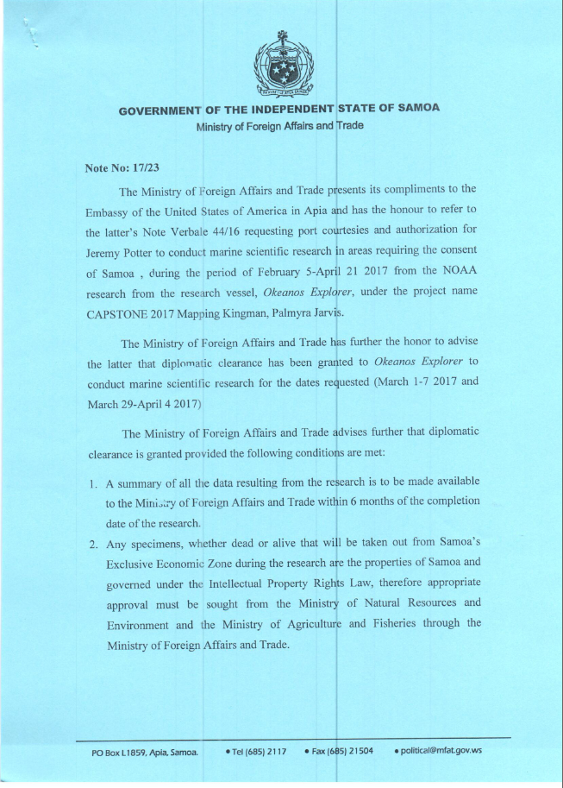
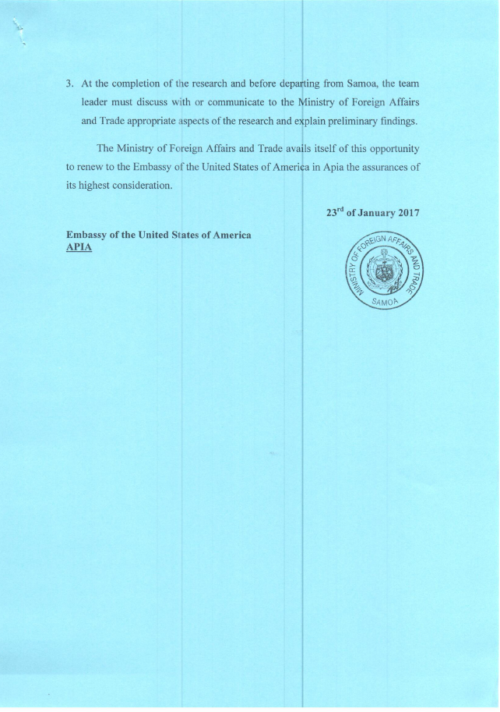

Appendix G: Permits

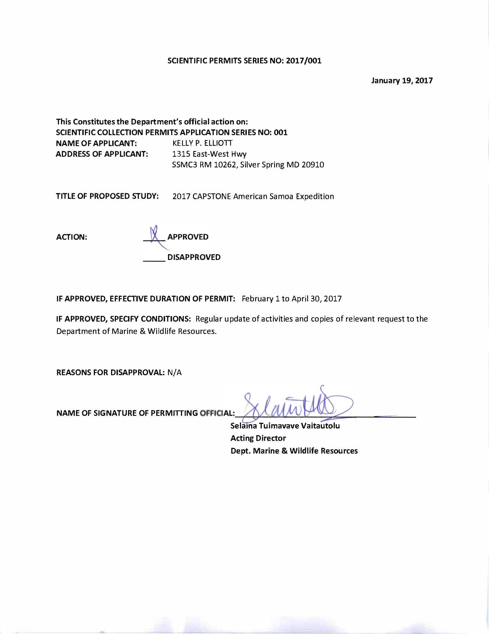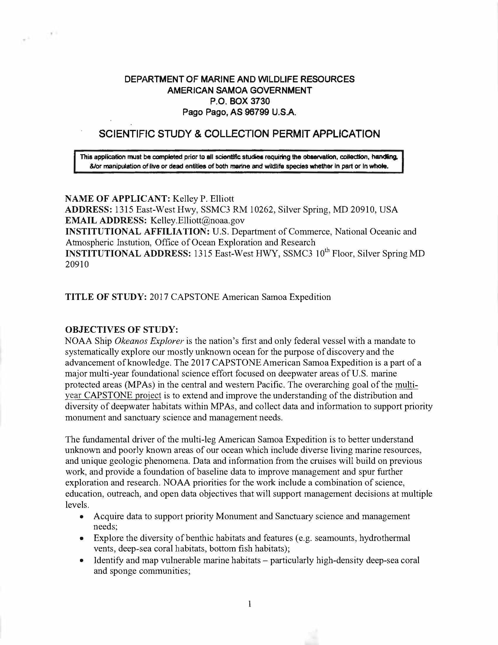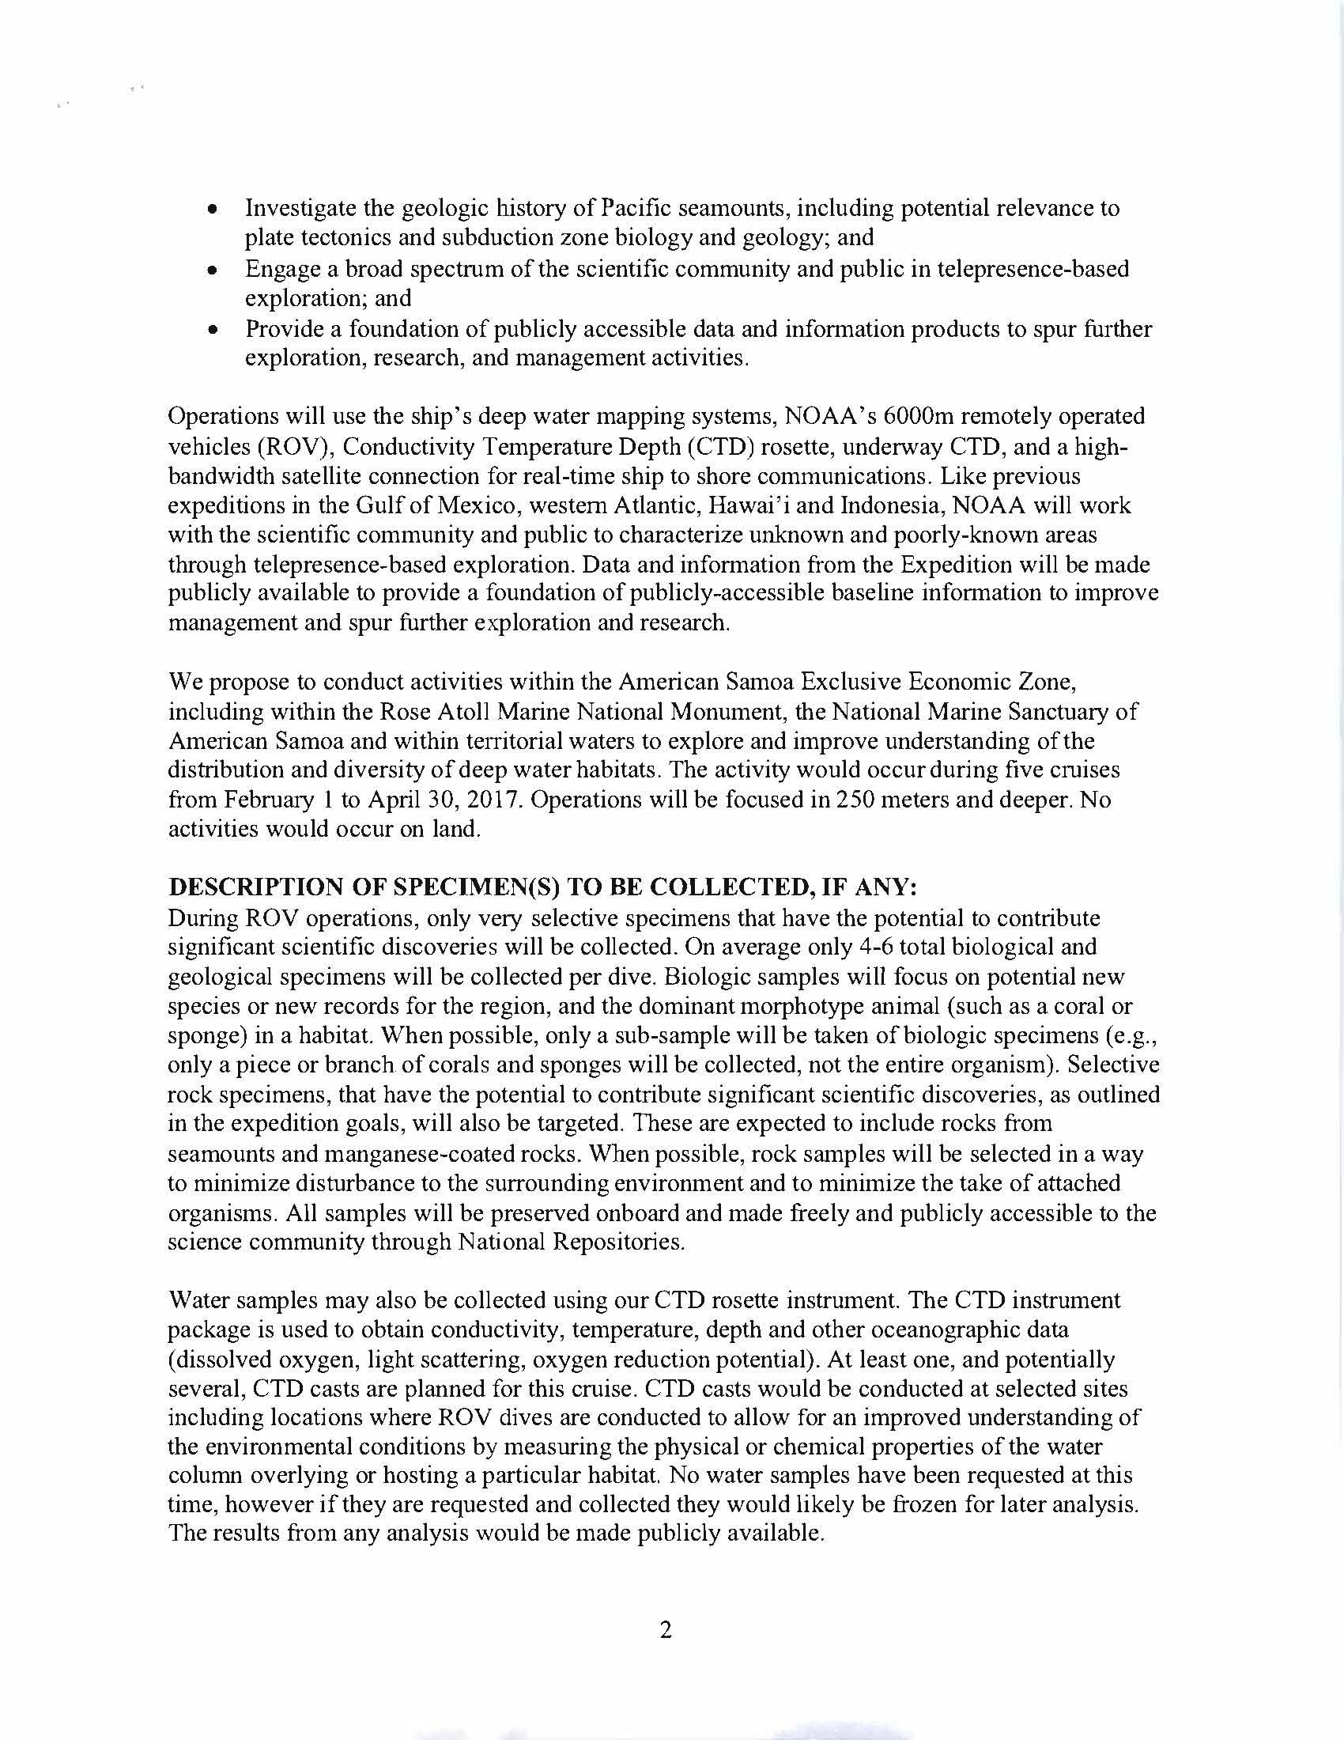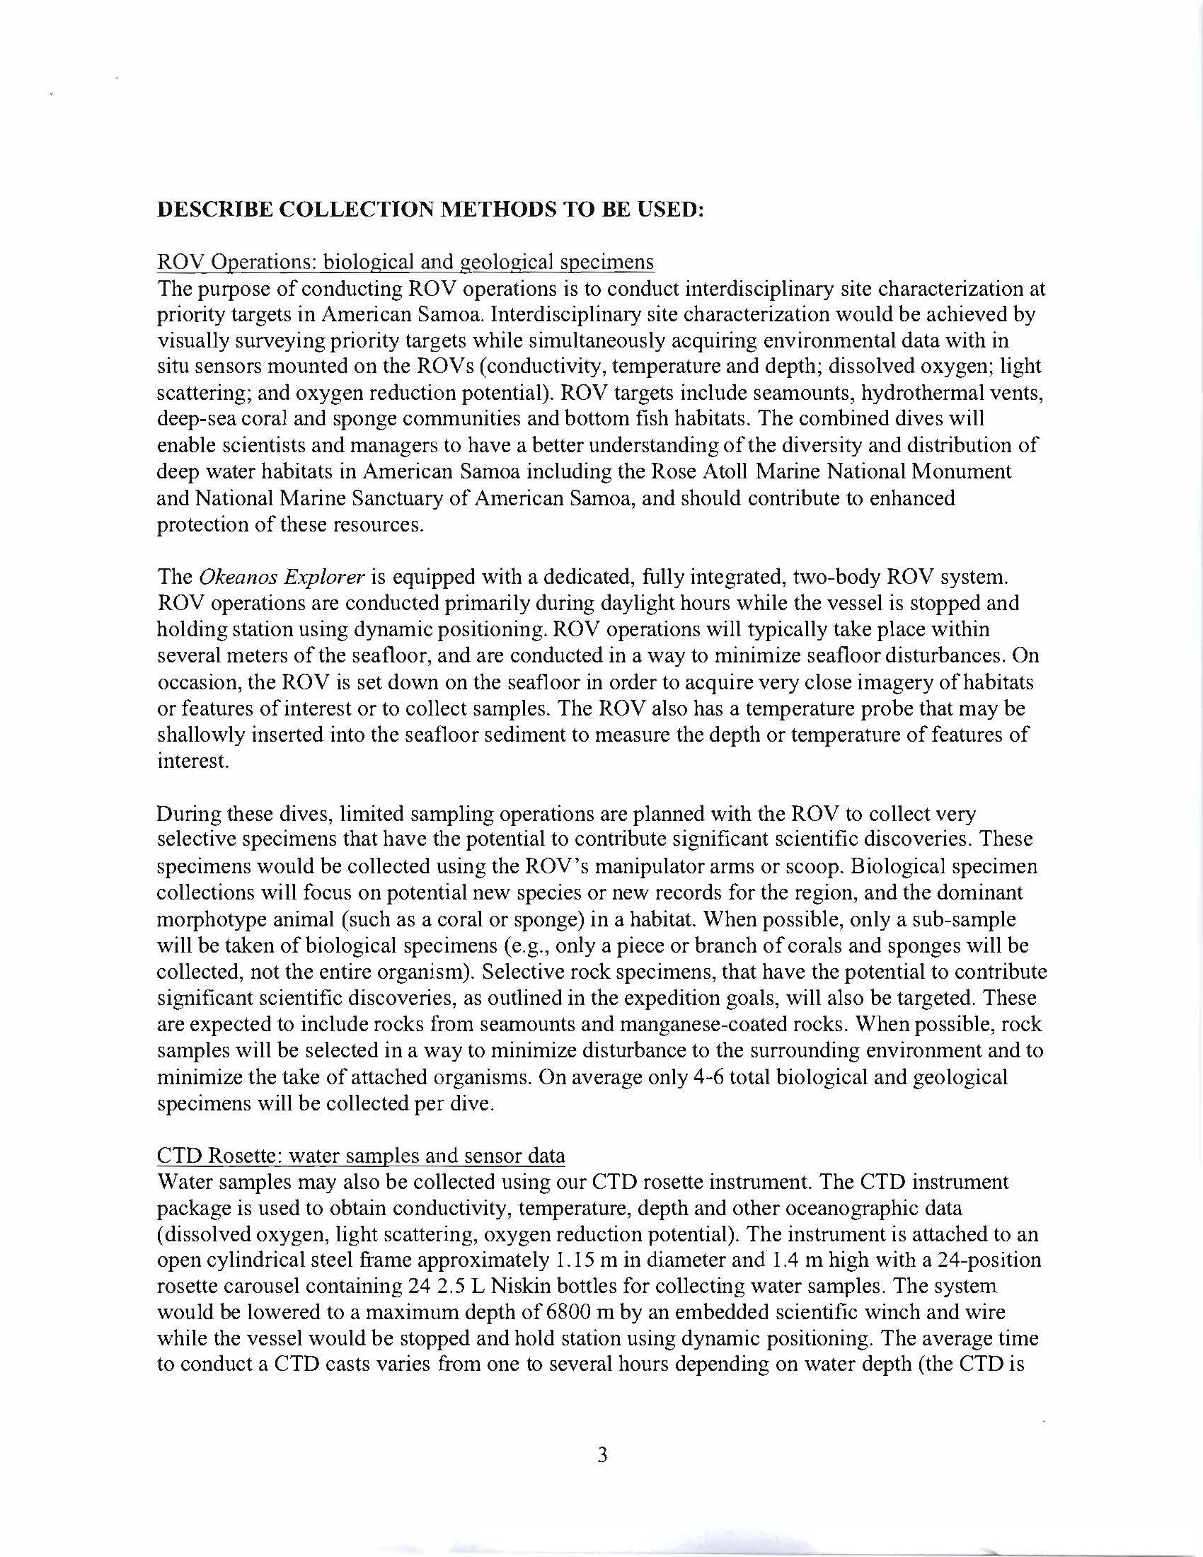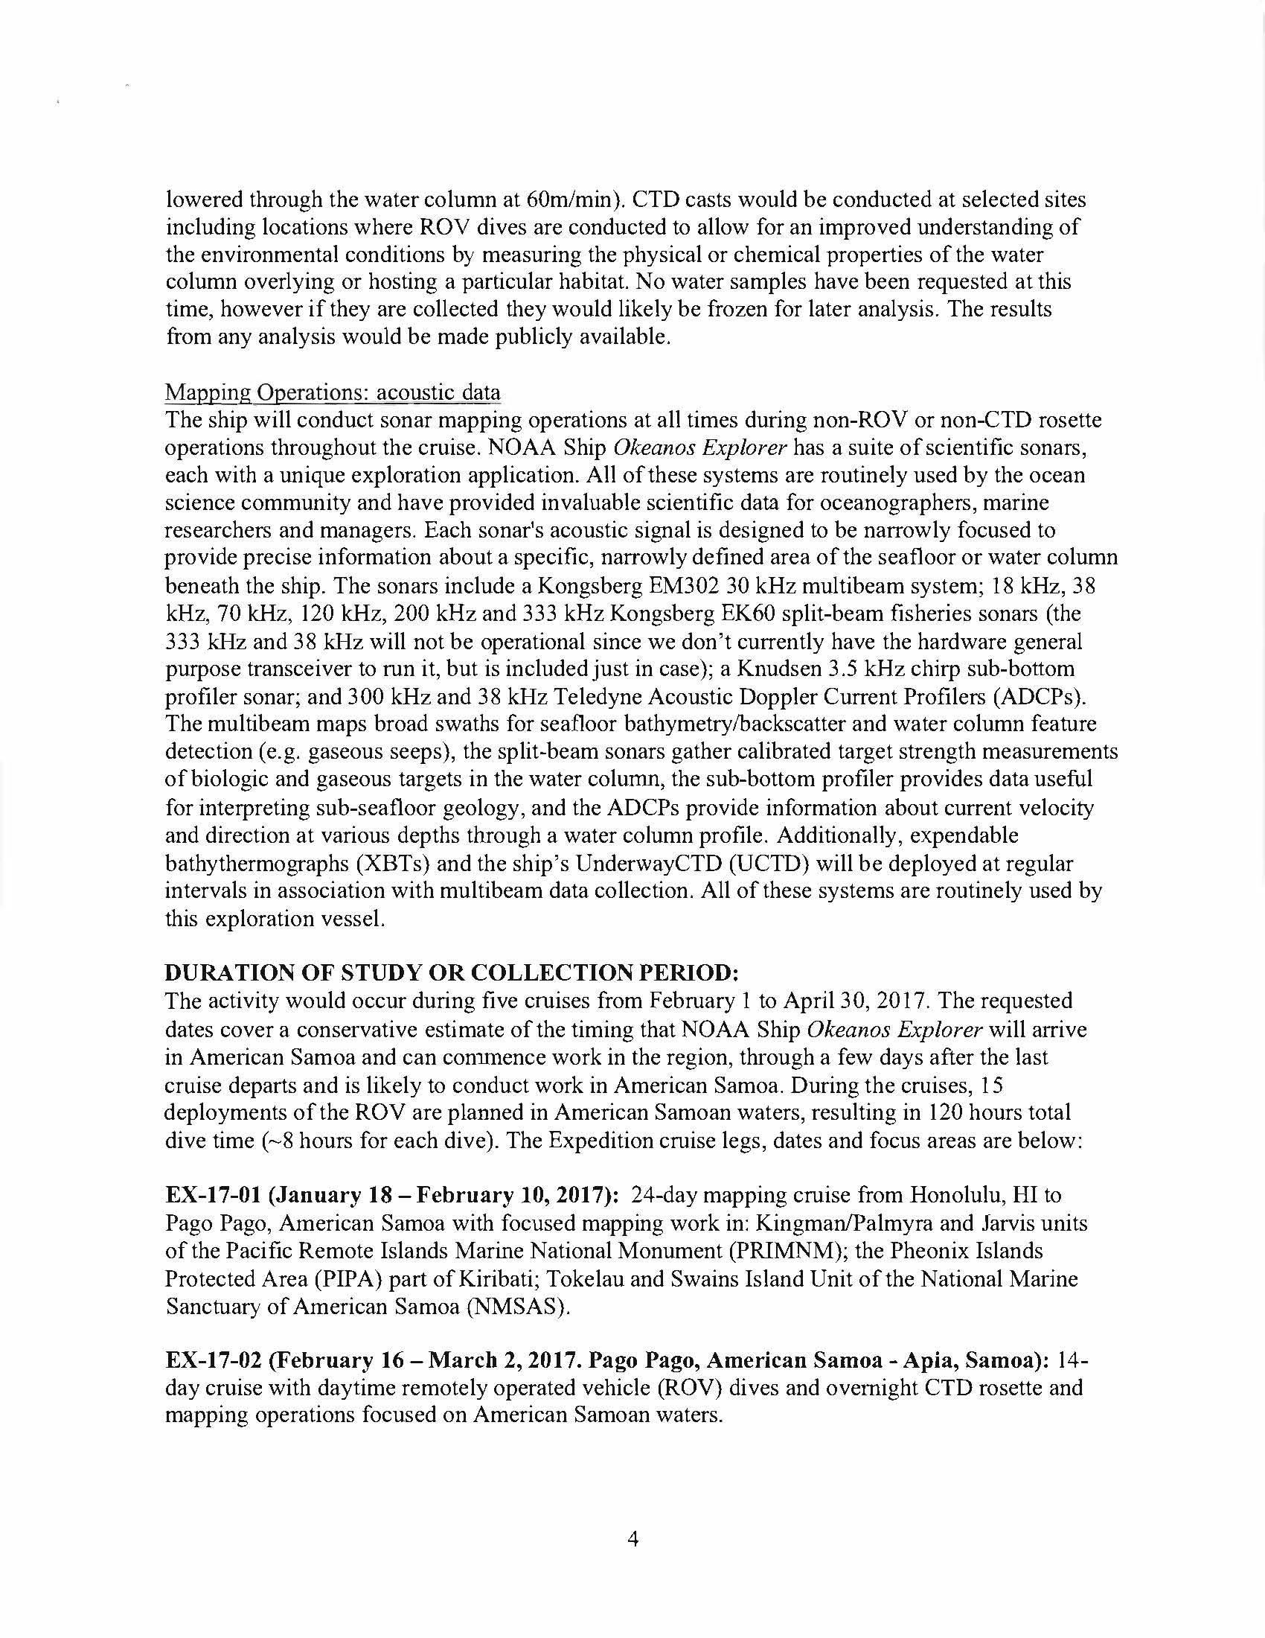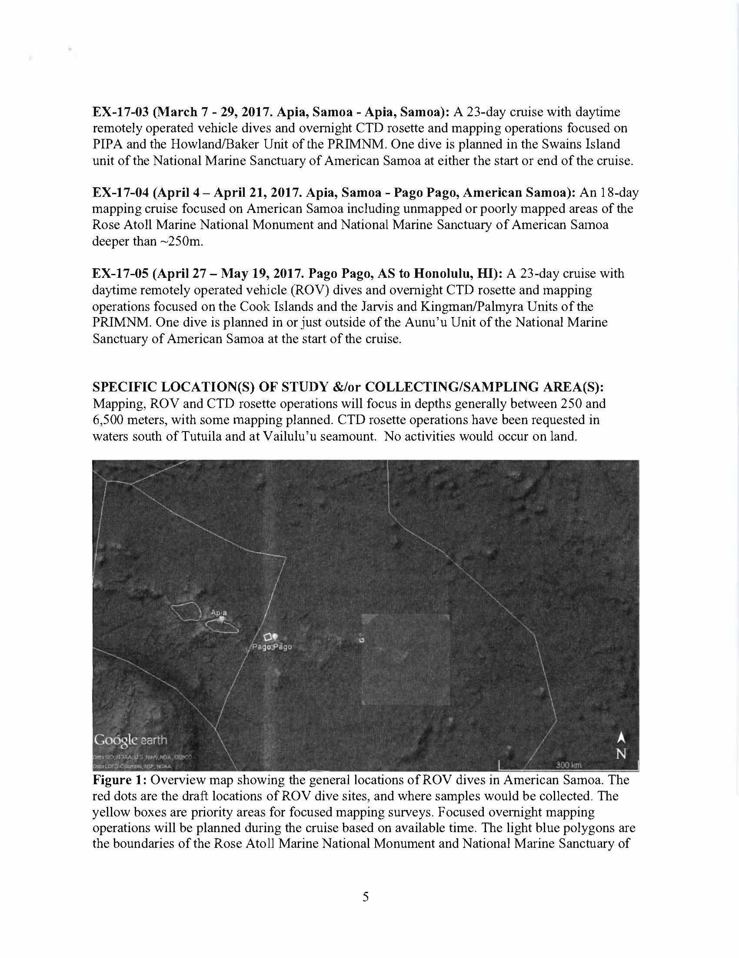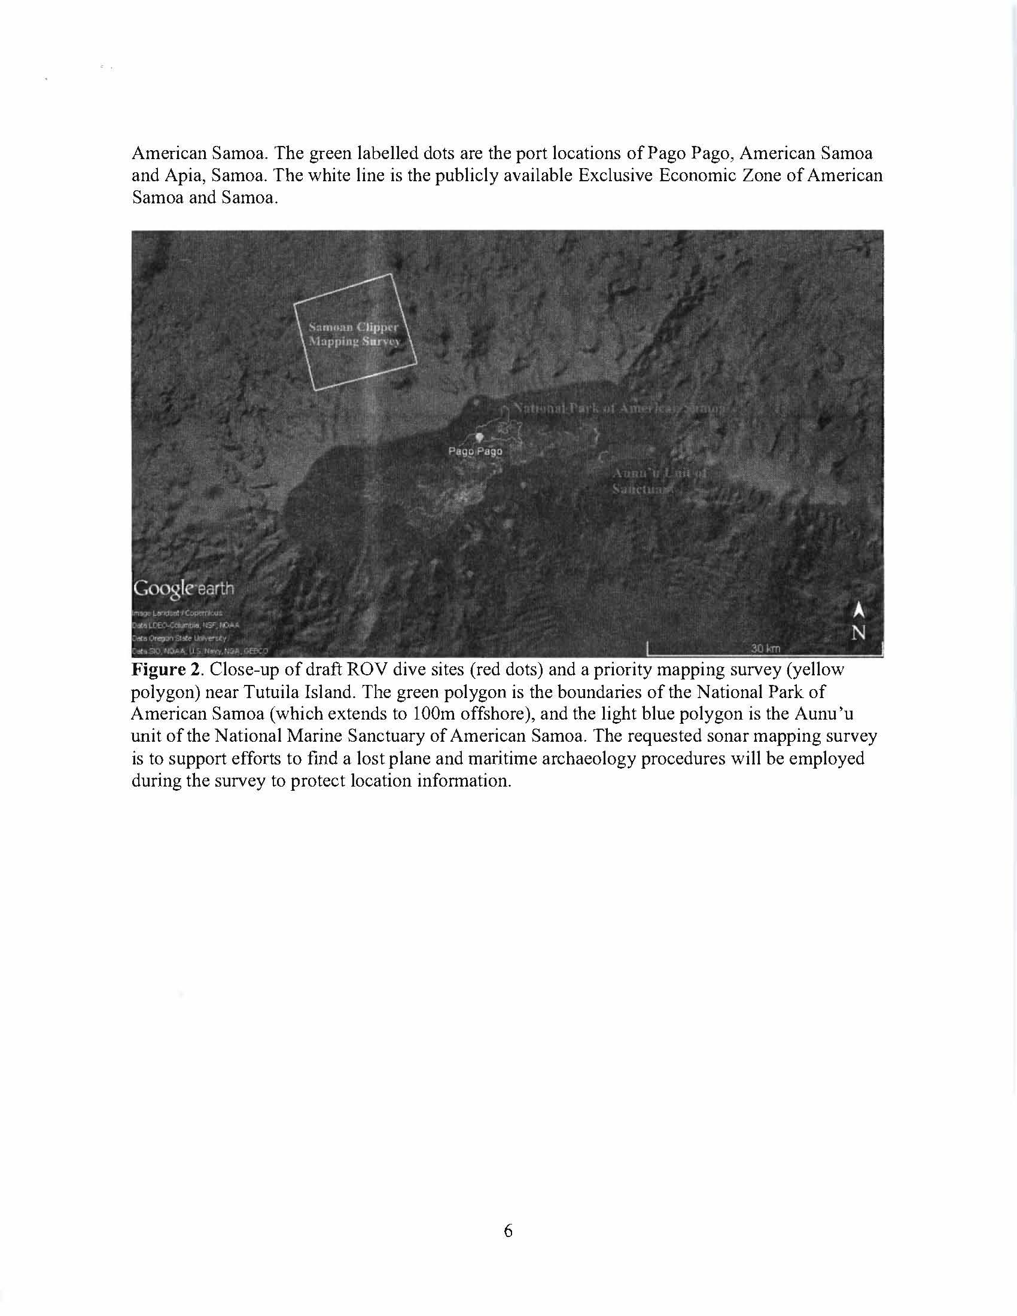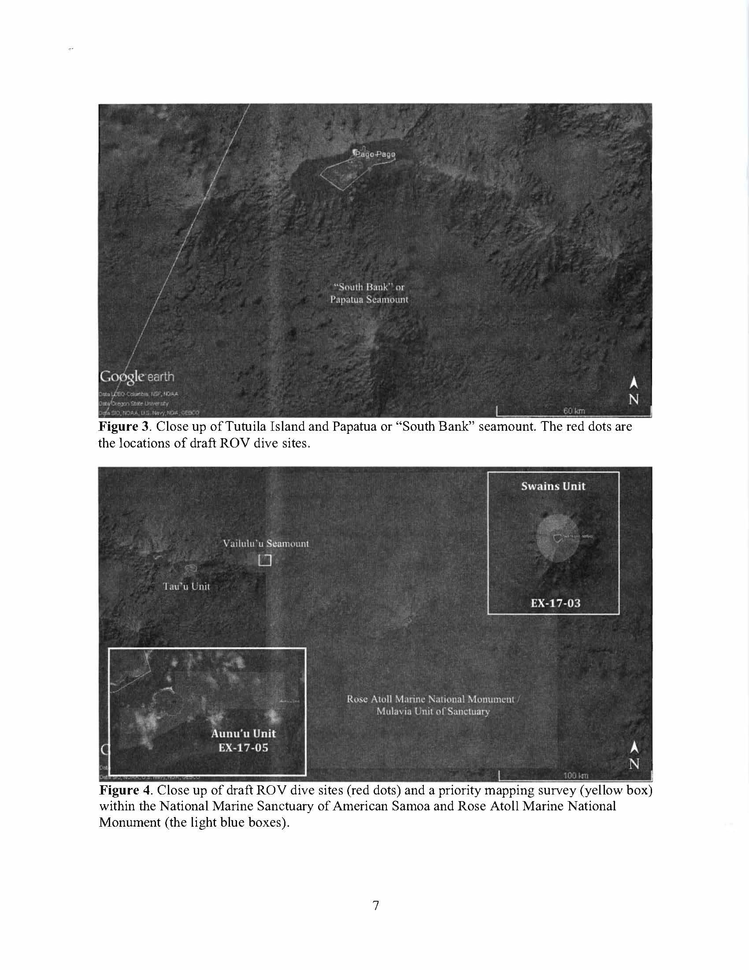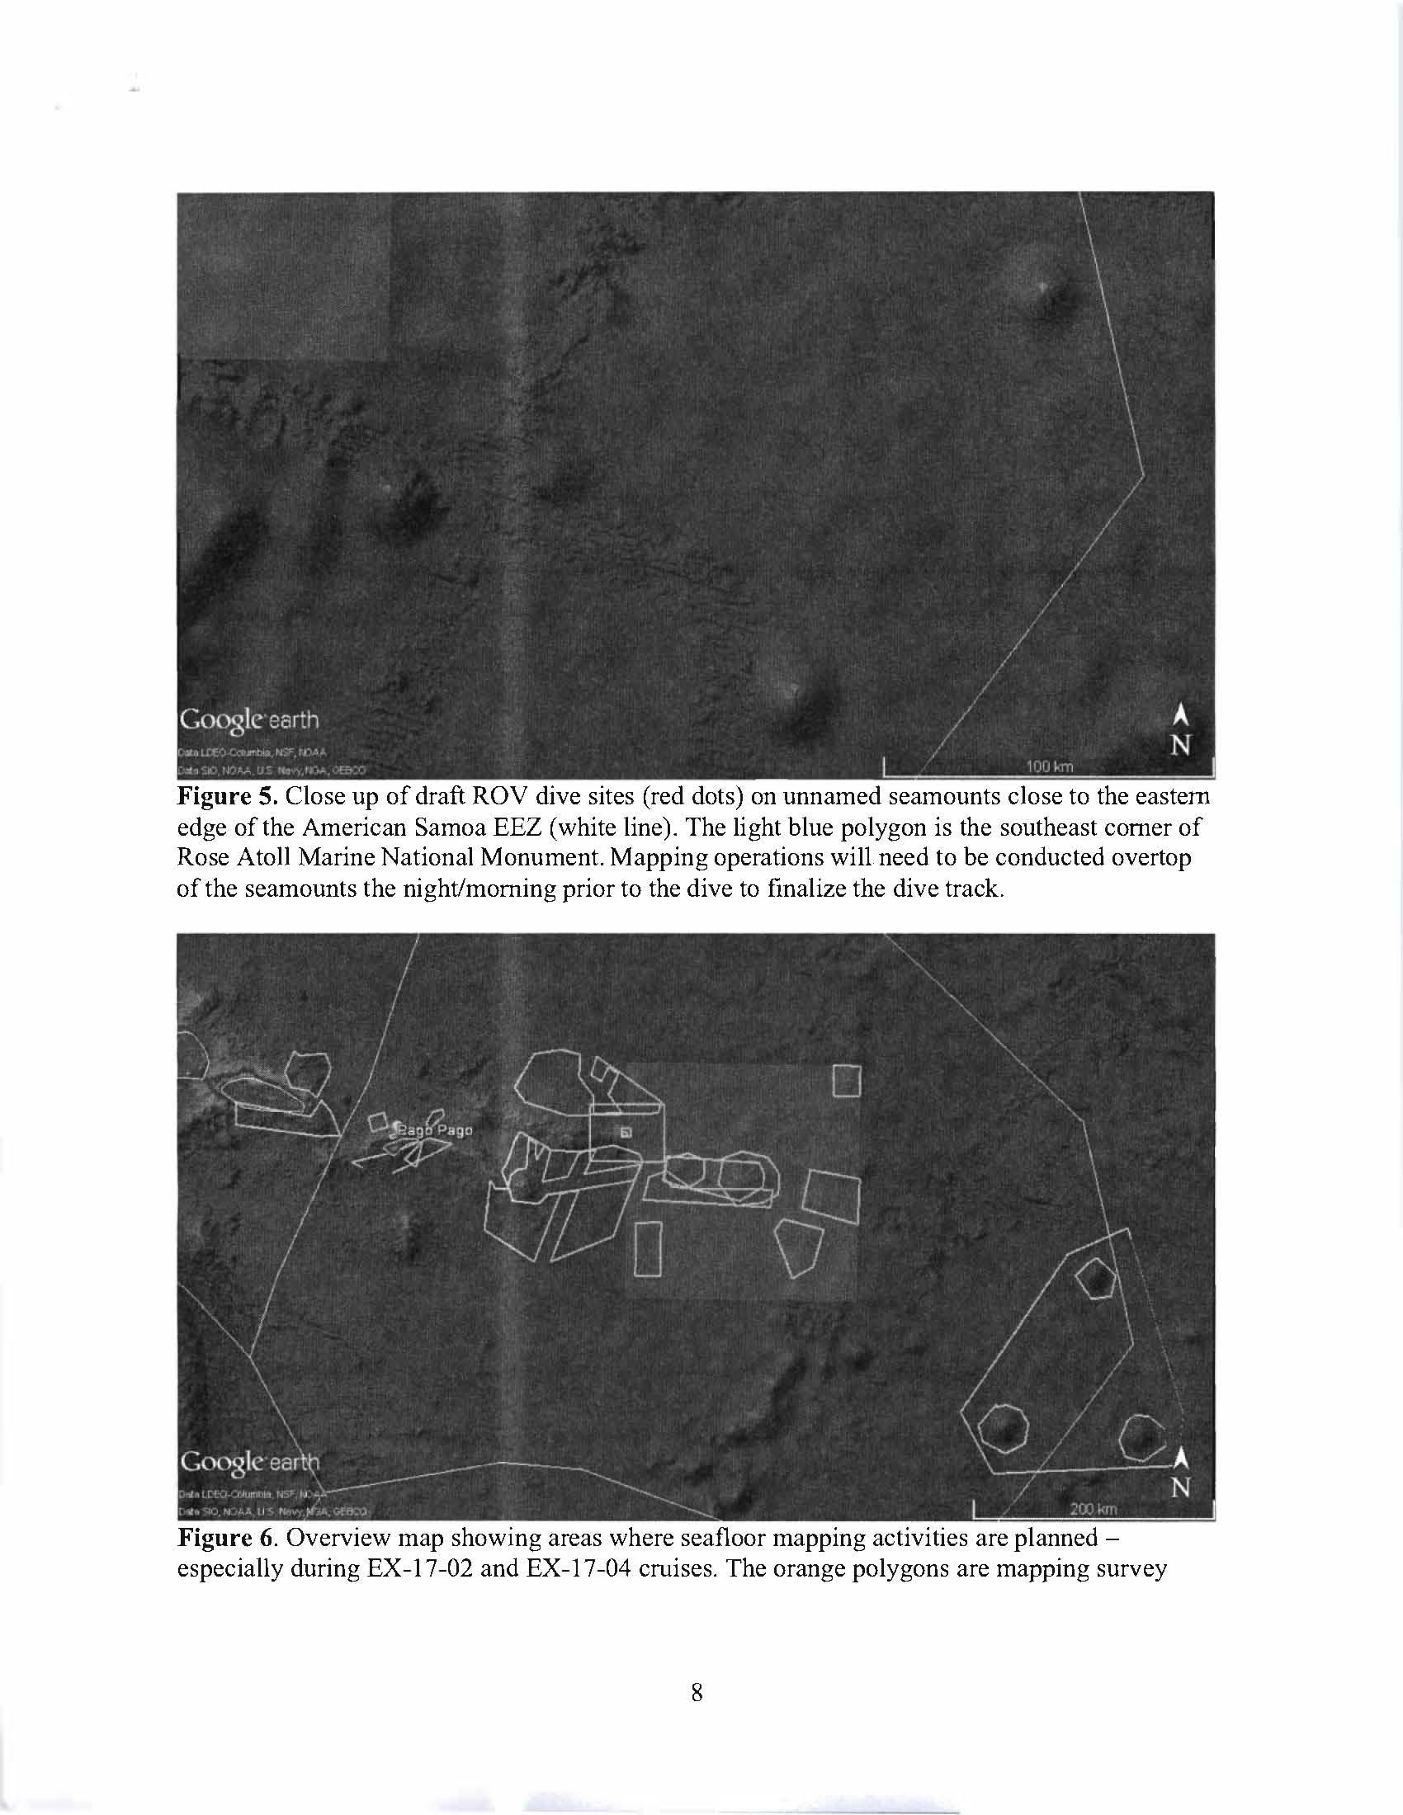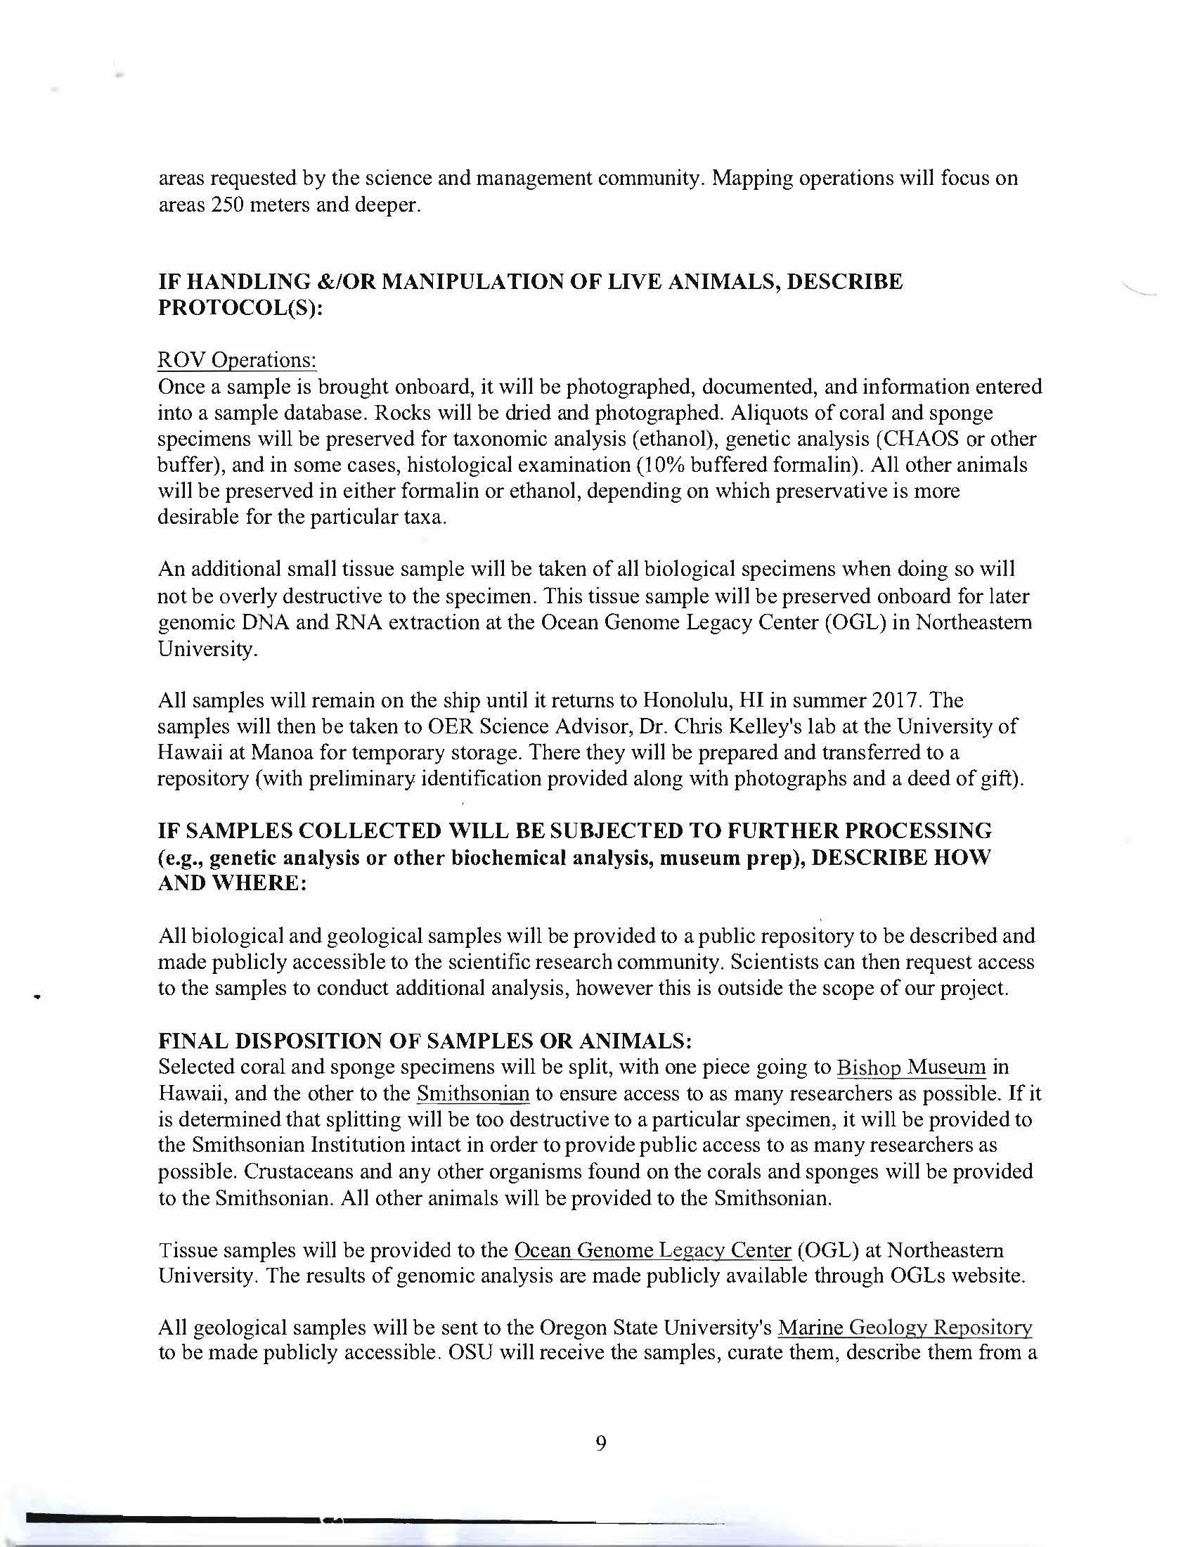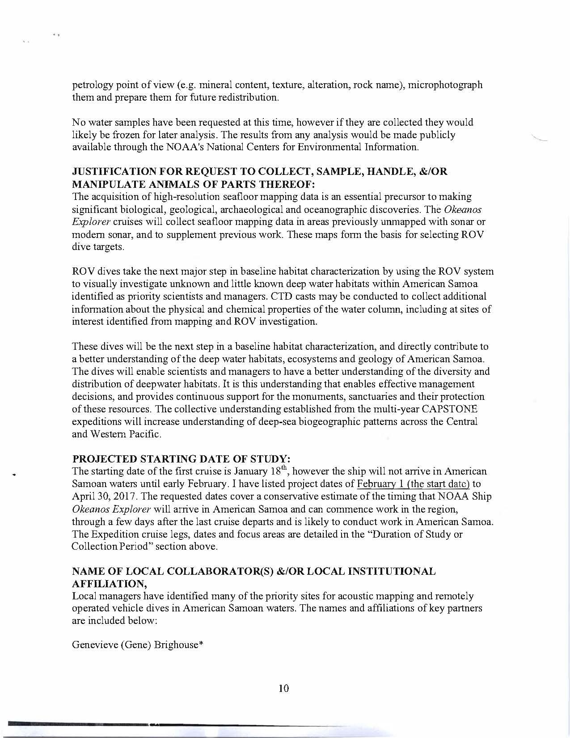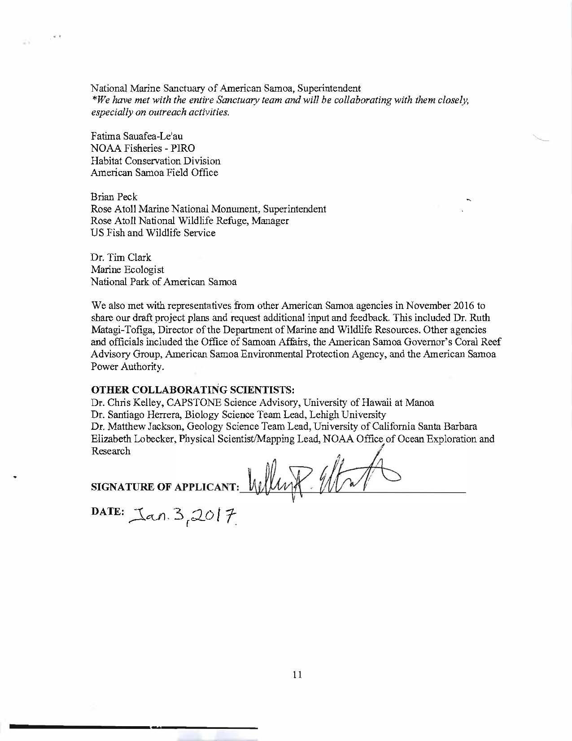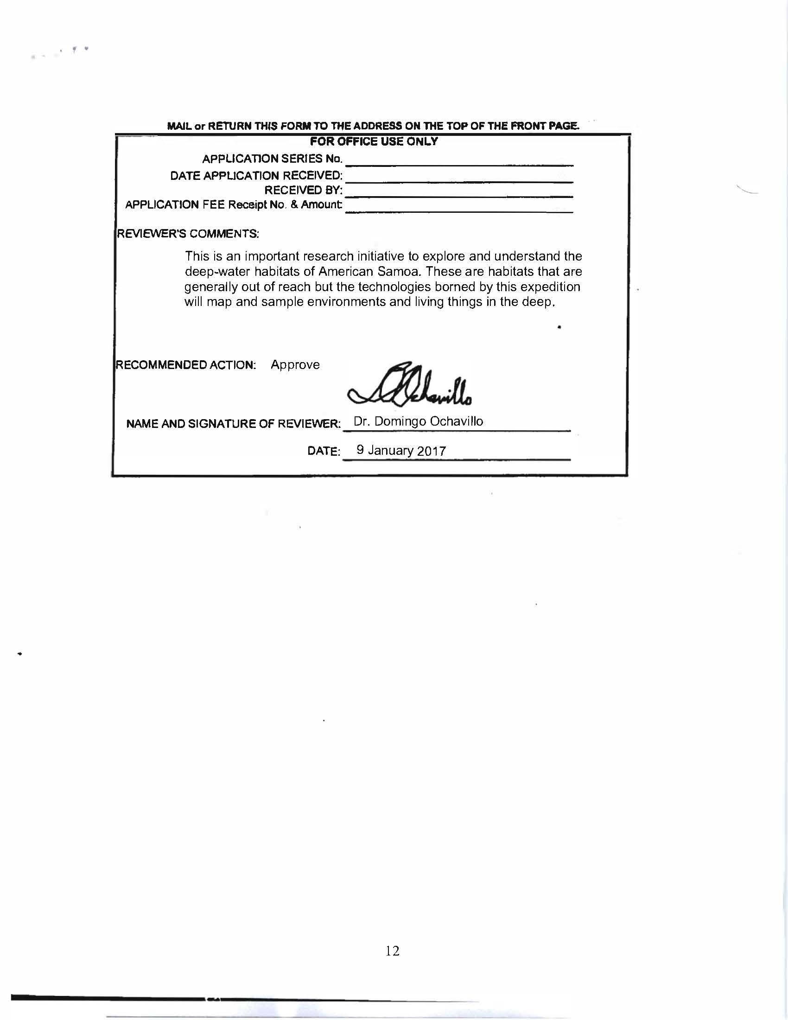

Appendix G: NASA Maritime Aerosols Network Survey of Opportunity

Survey or Project Name
Maritime Aerosol Network

Lead POC or Principle Investigator (PI & Affiliation)
POC: Dr. Alexander Smirnov

Supporting Team Members Ashore

Supporting Team Members Aboard (if required)

Activities Description(s)(Include goals, objectives and tasks)
The Maritime Aerosol Network (MAN) component of AERONET provides ship-borne aerosol optical depth measurements from the Microtops II sun photometers. These data provide an alternative to observations from islands as well as establish validation points for satellite and aerosol transport models. Since 2004, these instruments have been deployed periodically on ships of opportunity and research vessels to monitor aerosol properties over the World Oceans.

