Okeanos Explorer ROV Dive Summary
Dive Information
Dive Map |  | 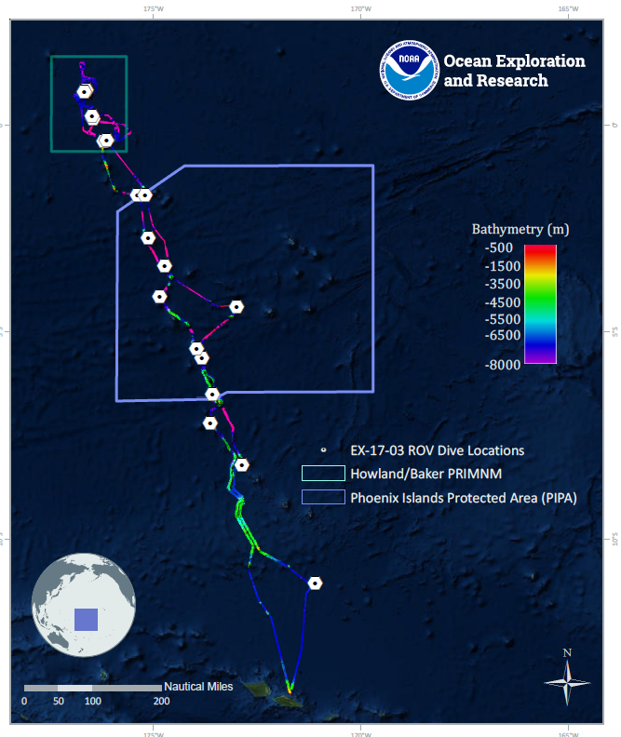
Site Name |  | unnamed seamount “Te Kaitira”
Expedition Coordinator(s) |  | Brian RC Kennedy, Nick Pawlenko
ROV Lead(s) |  | Karl McLetchie
Science Team Lead(s) |  | Amanda Demopoulos and Steven Auscavitch
General Area Descriptor |  | Phoenix Islands Protected Area (PIPA)
ROV Dive Name
Cruise |  | EX-17-03
Leg |  | 0
Dive Number |  | 19
Equipment Deployed
ROV |  | Deep Discoverer (D2)
Camera Platform |  | Seirios
ROV Measurements |  | CTD |  | Depth | Altitude
 |  | Scanning Sonar |  | USBL Position | Heading
 |  | Pitch |  | Roll | HD Camera 1
 |  | HD Camera 2 |  | Low Res Cam 1 | Low Res Cam 2
 |  | Low Res Cam 3 |  | Low Res Cam 4 | Low Res Cam 5
Equipment Malfunctions
ROV Dive Summary  (from processed ROV data) |  | Dive Summary: EX1703_DIVE19  ^^^^^^^^^^^^^^^^^^^^^^^^^^^^^^^^^^^^^^^^^^^^^^^^^^^  In Water: 2017-03-26T18:28:56.573000  08°, 12.054' S ; 172°, 52.128' W  Out Water: 2017-03-27T02:26:42.300000  08°, 11.698' S ; 172°, 52.087' W  Off Bottom: 2017-03-27T01:57:31.757000  08°, 11.816' S ; 172°, 52.063' W  On Bottom: 2017-03-26T19:24:29.168000  08°, 12.100' S ; 172°, 51.995' W  Dive duration: 7:57:45  Bottom Time: 6:33:2  Max. depth: 998.7 m
Special Notes
Scientists Involved  (please provide name, location, affiliation, email) |  | Brian Kennedy NOAA OER Brian.Kennedy@noaa.gov  Adrienne Copeland NOAA adrienne.copeland@noaa.gov  Amanda Demopoulos USGS ademopoulos@usgs.gov  Andrea Quattrini Harvey Mudd College aquattrini@g.hmc.edu  Asako Matsumoto Chiba Institute of Technology (Chitech), amatsu@gorgonian.jp  Deborah Glickson National Academies of Sciences, Engineering, and Medicine dglickson@nas.edu  Dhugal Lindsay JAMSTEC dhugal@jamstec.go.jp  Erik Cordes Temple University ecordes@temple.edu  Katharine Weathers NOAA katharine.weathers@noaa.gov  Kevin Kocot The University of Alabama kmkocot@ua.edu  Les Watling University of Hawaii at Manoa watling@hawaii.edu  Nicole Morgan Florida State University nmorgan@fsu.edu  Peter Auster Mystic Aquarium & UConn peter.auster@uconn.edu  Randi Rotjan Boston University rrotjan@bu.edu  Santiago Herrera Lehigh University sherrera@alum.mit.edu  Scott France University of Louisiana at Lafayette france@louisiana.edu  Steve Auscavitch Temple University steven.auscavitch@temple.edu  Taylor Heyl WHOI theyl@whoi.edu  Timothy Shank Woods Hole Oceanographic Institution tshank@whoi.edu  Brendan Roak Texas A&M University broark@geos.tamu.edu
Purpose of the Dive |  | The general goal of this dive is to acquire baseline information on deep sea habitats, seafloor geology, and biological communities on Ufiata Seamount in the Tokelau region. The geologic age of this feature is around 57-58Ma. The structure of this seamount might make it suitable for the deposition of cobalt-rich ferromanganese crust. It falls within an area identified by SPC as a zone of crust potential, based on sampling by a joint Japan-SOPAC deep-sea minerals program  in the 1990s.
Description of the Dive |  | The last dive for EX1703 was at Ufiata Seamount within the Tokelau seamount chain. The dive started at ~990m, at the base of a steep slope. The seafloor was composed of large and small boulders, interspersed with fine sandy sediments. When a MnFe-coated rock was collected, the manipulator scratched a mark on one of the faces, revealing a lighter color, possibly consistent with carbonate composition. The piles of boulders indicated that these might be landslide debris deposits.  We saw a few fish at the start of the dive, including an unknown cusk eel (cf., brotula, Bythitidae) and several midwater species (tentative identification: viperfish [Chauliodus], bristlemouths [Cyclothone], and unknown hatchetfish [Sternoptychidae]). Very few invertebrates were found in this area, including chrysogoriids, coralliids, stoloniferans (pale lavender), holothurians (Deimatidae), benthic siphonophore (Rhodaliidae), homolid crabs, and caridean shrimp. We saw a few additional fish before heading upslope, including cutthroat and congeriid eels (e.g., Synaphobranchidae and Bathycongrus, respectively), and an unknown fish with elongated body morphology and distinct caudal fin.  As the dive track transitioned to a steep wall, the seafloor changed to more platy morphology, with thick horizontal blocks, covered with manganese iron oxide coating. Along the rock wall, the fauna was very patchy, and included yellow demosponges and euplectellid sponges, homolid crabs holding plexaurids, anemones, and some were empty handed, a 2-tone cusk eel, and Echinus-like urchins. Corals included purple Victorgorgia, yellow cf. Acanthogorgia, yellow plexaurids, coralliids, primnoids, and a bamboo whip.  Once we arrived at the ridge and progressed up to the summit, yellow sponges and white Narella primnoids dominated the seafloor, although in low abundance. All attached fauna were found in MnFe coated cracks in the seafloor pavement. Fine sandy sediment was present within the cracks of the seafloor. Other fauna included a rattail (cf. Nezumia), squat lobsters (cf. Eumunida), scattered colonies of purple Victorgorgia, pink coralliids (collected), one bamboo whip, and scleractinians (e.g., unknown cup corals and colonial Enallopsammia and Madrepora). Homolid crabs and caridean shrimp (e.g., Heterocarpus) were the dominant megafaunal crustaceans observed throughout the dive. Some of the shrimp were > 10 cm long. Gelatinous invertebrates observed at or near the summit included a maroon colored scyphozoan jellyfish, a trachymedusa (cf. Benthocodon), and ctenophores. We saw one seastar (Astroceramus) on the pavement at the summit.  We observed the most impressive display of predatory behavior when we saw a caridean shrimp impaling and consuming a type of midwater dragonfish (cf. Stomiidae or [stareater, Astronesthinae: Astronesthes sp.]) while the fish was still alive. The shrimp removed several pieces of fish tissue and stomach contents, including a smaller fish and a worm. It was incredible to watch the feeding activity and we wondered how this shrimp was able to trap the fish in the first place.
Overall Map of the ROV Dive Area |  |  | Close-up Map of Main Dive Site
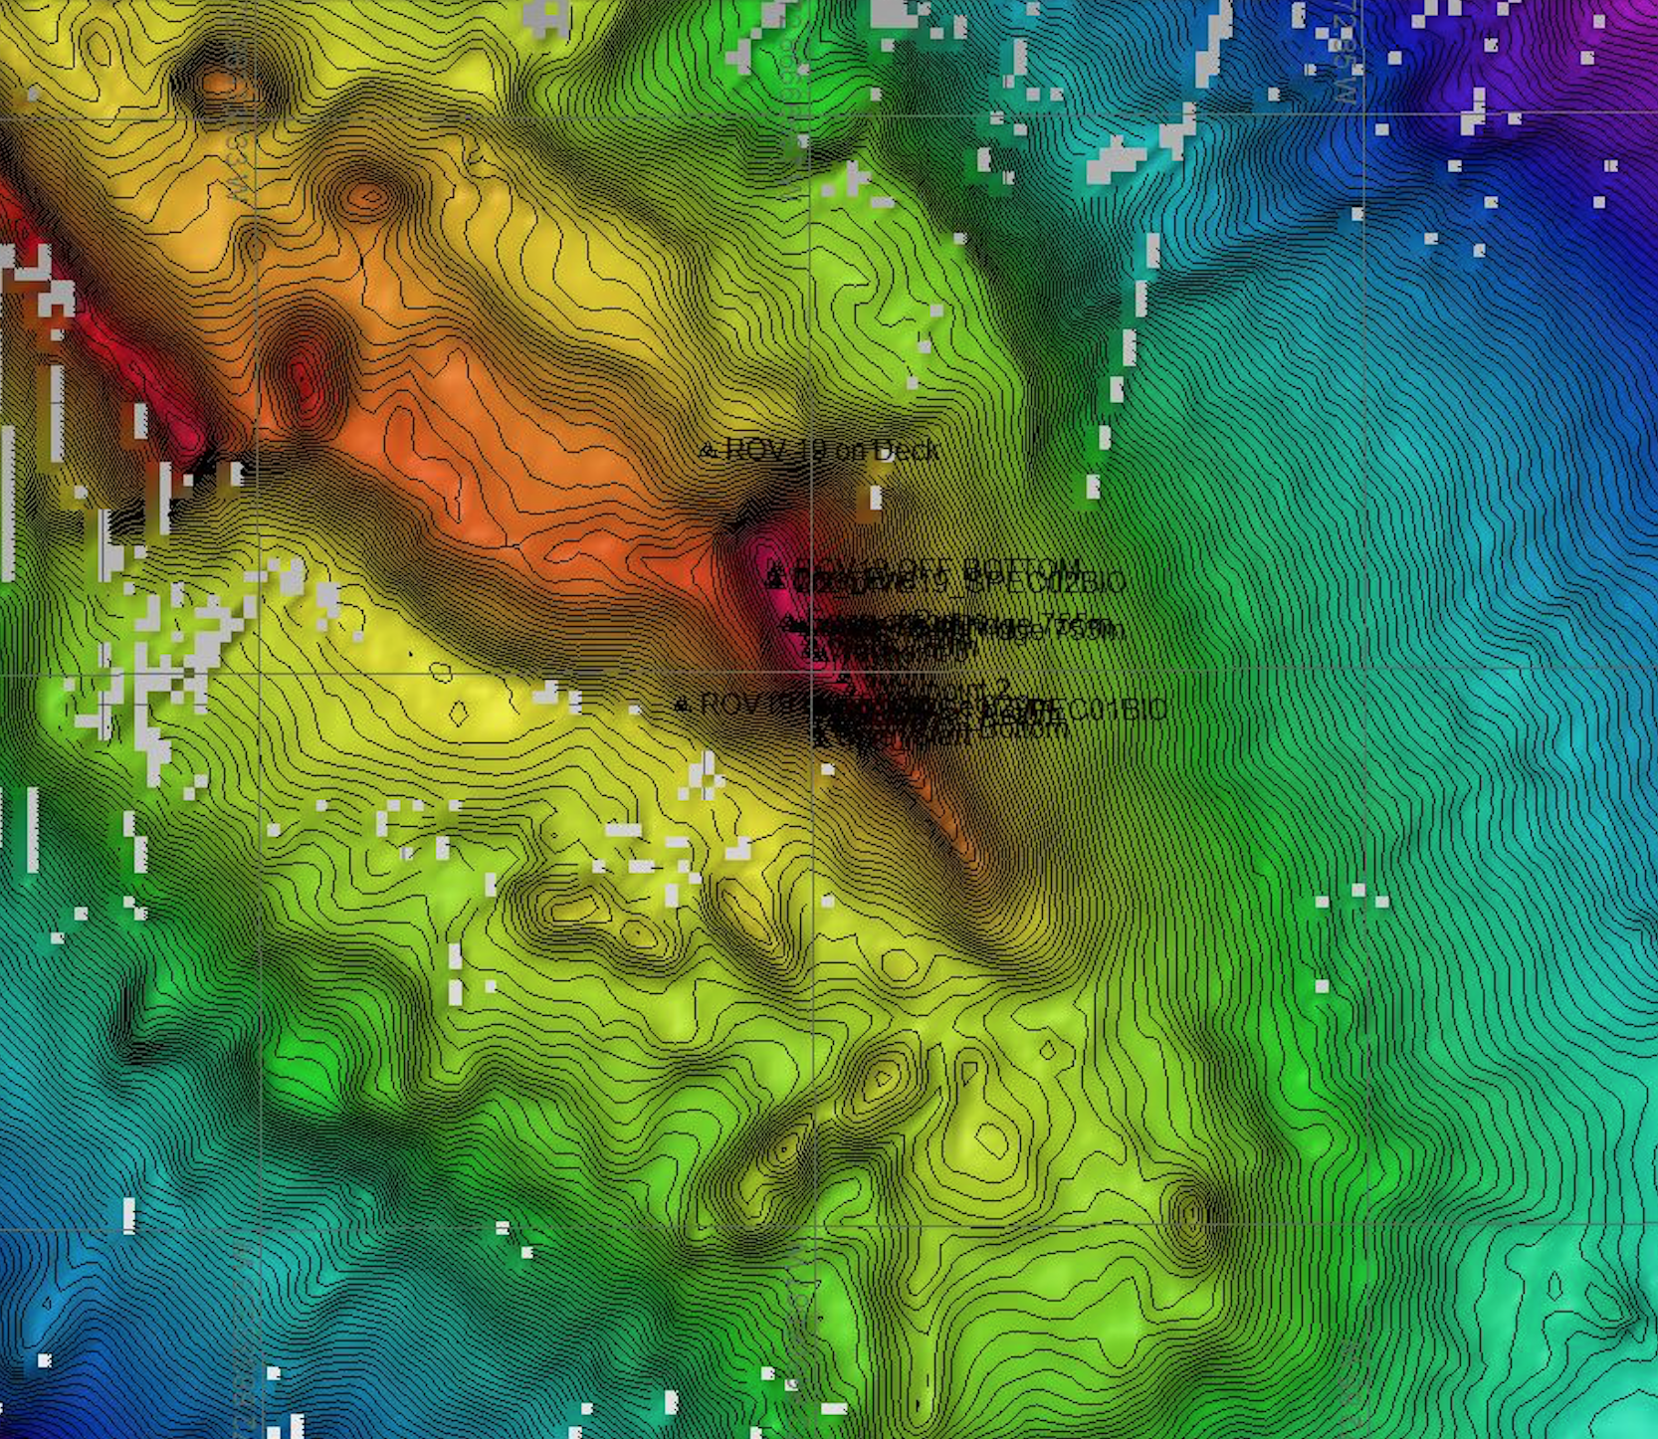 |  |  | 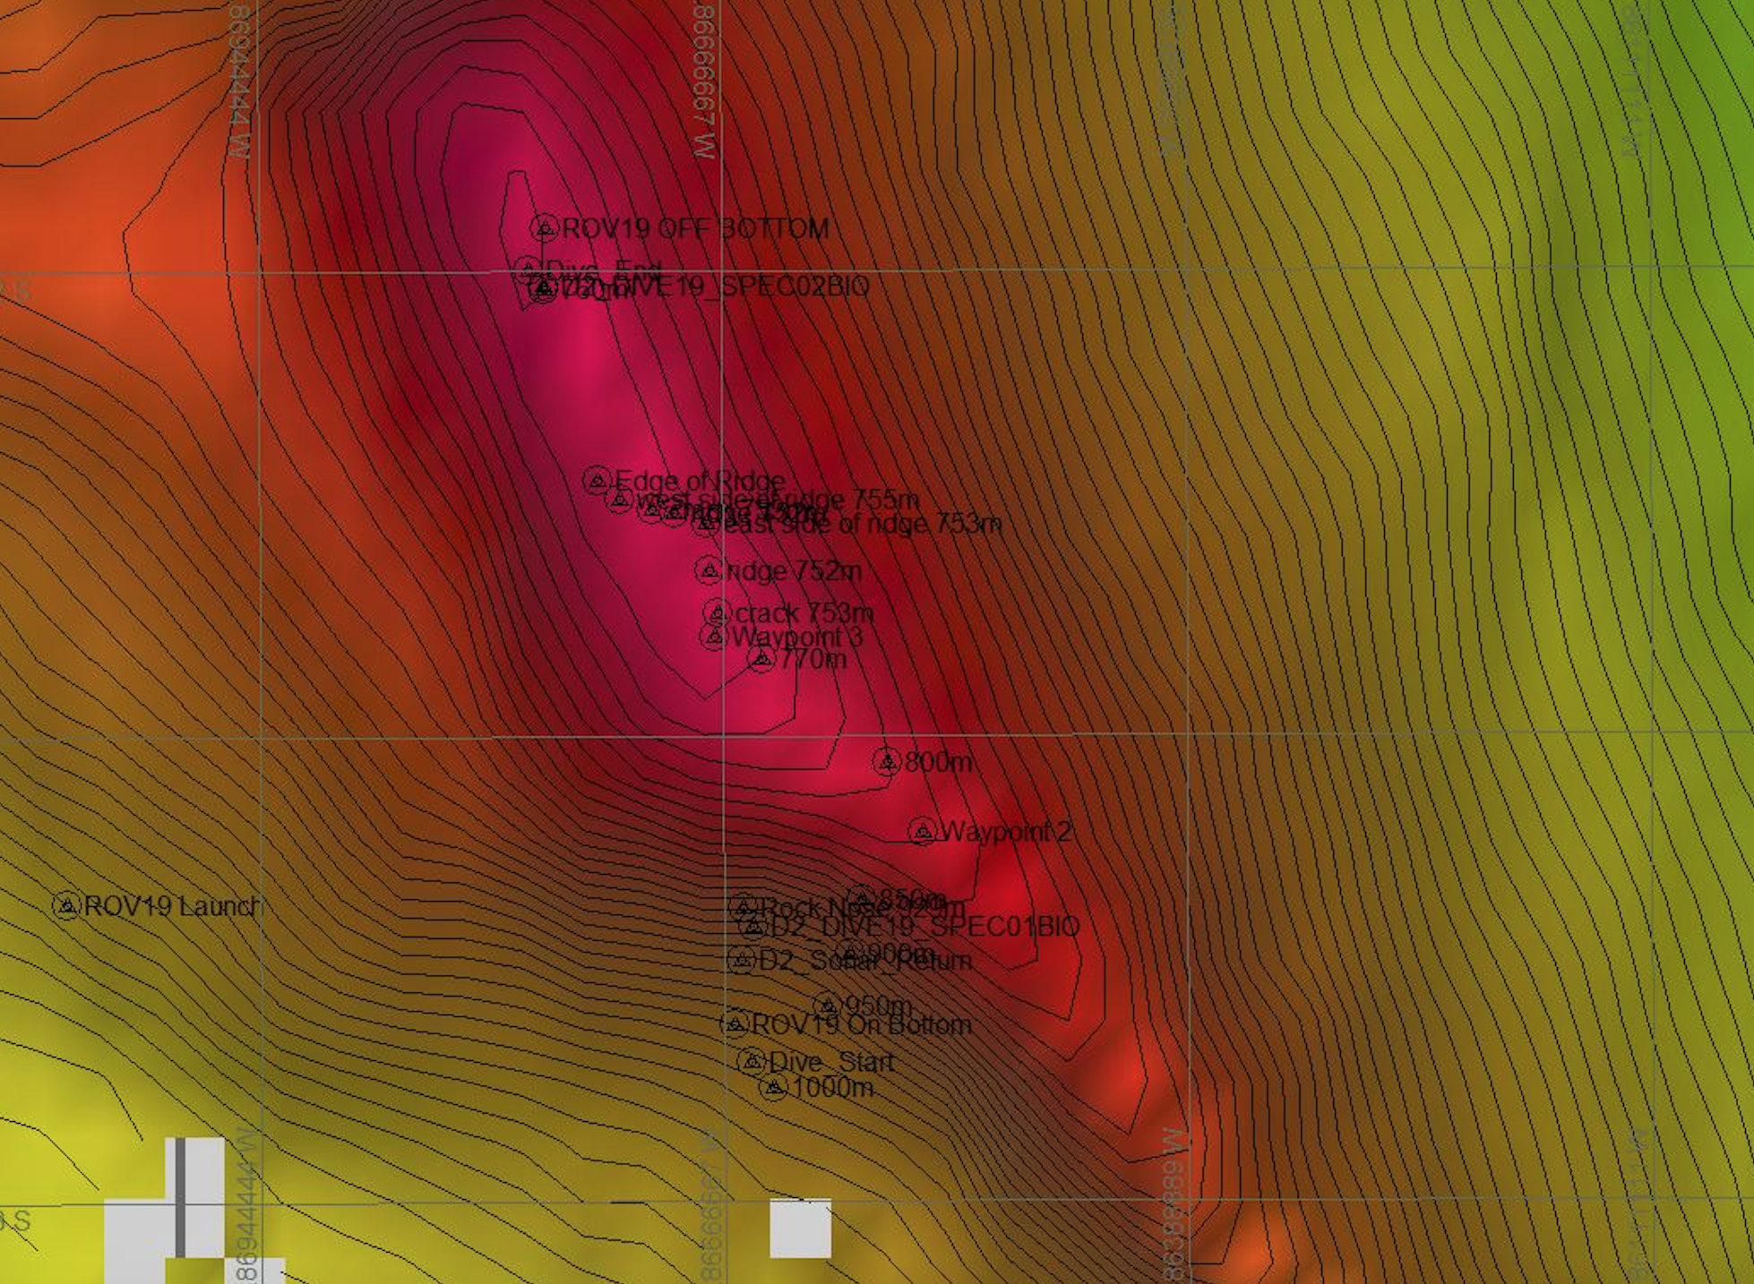
Representative Photos of the Dive
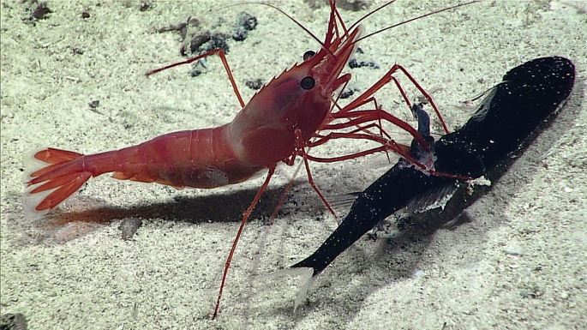 |  |  | 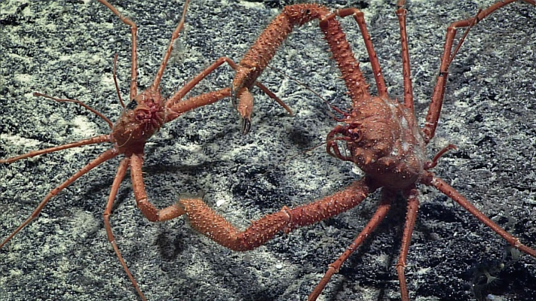
- A caridean shrimp, Heterocarpus, was observed feeding on a type of mid-water dragonfish, possible a stareater, at around 998 meters. |  |  | - Two homolid crabs were observed holding claws at around 757 meters depth. It was unclear whether this was potentially aggressive or pre-mating behavior.
Samples Collected
  - Sample
Sample ID | EX1703_20170326T204307_D2_DIVE19_SPEC01GEO |  | - 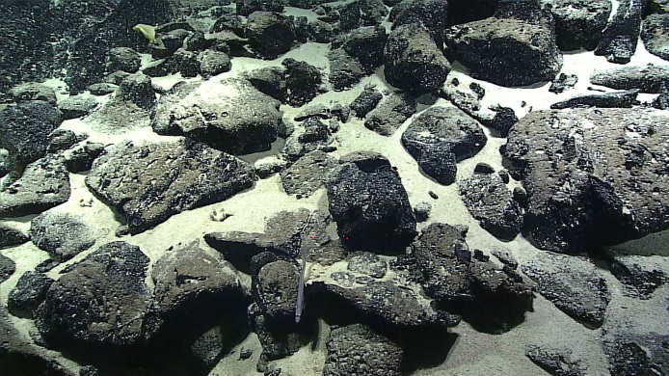
Date (UTC) | 20170326
Time (UTC) | 20:43:07
Depth (m) | 954.04
Temperature (°C) | 4.56
Field ID(s) | Fe-Mn crusted rock
Comments
Sample
Sample ID | EX1703_20170327T014445_D2_DIVE19_SPEC02BIO |  | - 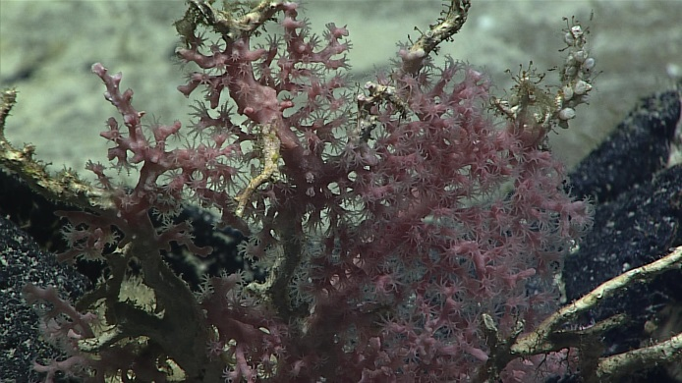
Date (UTC) | 20170327
Time (UTC) | 01:44:45
Depth (m) | 751.03
Temperature (°C) | 01:44:45
Field ID(s) | Coralliidae
Comments

Please direct inquiries to:
NOAA Office of Ocean Exploration & Research
1315 East-West Highway (SSMC3 10th Floor)
Silver Spring, MD 20910
(301) 734-1014

