Okeanos Explorer ROV Dive Summary
Dive Information
Dive Map |  | 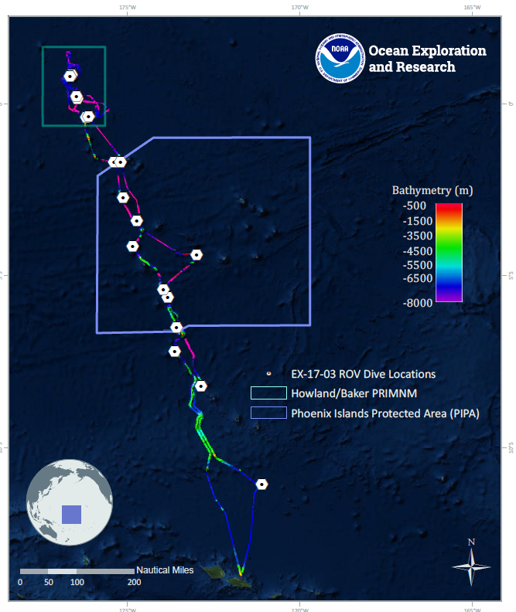
Site Name |  | unnamed seamount “Te Kaitira”
Expedition Coordinator(s) |  | Brian RC Kennedy, Nick Pawlenko
ROV Lead(s) |  | Karl McLetchie
Science Team Lead(s) |  | Amanda Demopoulos and Steven Auscavitch
General Area Descriptor |  | Phoenix Islands Protected Area (PIPA)
ROV Dive Name
Cruise |  | EX-17-03
Leg |  | 0
Dive Number |  | 18
Equipment Deployed
ROV |  | Deep Discoverer (D2)
Camera Platform |  | Seirios
ROV Measurements |  | CTD |  | Depth | Altitude
 |  | Scanning Sonar |  | USBL Position | Heading
 |  | Pitch |  | Roll | HD Camera 1
 |  | HD Camera 2 |  | Low Res Cam 1 | Low Res Cam 2
 |  | Low Res Cam 3 |  | Low Res Cam 4 | Low Res Cam 5
Equipment Malfunctions
ROV Dive Summary  (from processed ROV data) |  | Dive Summary: EX1703_DIVE18  ^^^^^^^^^^^^^^^^^^^^^^^^^^^^^^^^^^^^^^^^^^^^^^^^^^^  In Water: 2017-03-25T18:26:59.362000  06°, 29.491' S ; 173°, 35.148' W  Out Water: 2017-03-26T02:34:06.554000  06°, 29.230' S ; 173°, 34.351' W  Off Bottom: 2017-03-26T01:21:09.487000  06°, 29.446' S ; 173°, 34.827' W  On Bottom: 2017-03-25T19:37:18.590000  06°, 29.513' S ; 173°, 35.007' W  Dive duration: 8:7:7  Bottom Time: 5:43:50  Max. depth: 2104.9 m
Special Notes
Scientists Involved  (please provide name, location, affiliation, email) |  | Name Affiliation Email Address  Brian Kennedy NOAA OER Brian.Kennedy@noaa.gov  Amanda Demopoulos USGS ademopoulos@usgs.gov  Asako Matsumoto Chiba Institute of Technology (Chitech), amatsu@gorgonian.jp  Erik Cordes Temple University ecordes@temple.edu  Katharine Weathers NOAA katharine.weathers@noaa.gov  Kevin Kocot The University of Alabama kmkocot@ua.edu  Les Watling University of Hawaii at Manoa watling@hawaii.edu  Michael Parke NOAA PIFSC michael.parke@noaa.gov  Nicole Morgan Florida State University nmorgan@fsu.edu  Peter Auster Mystic Aquarium & UConn peter.auster@uconn.edu  Randi Rotjan Boston University rrotjan@bu.edu  Santiago Herrera Lehigh University sherrera@alum.mit.edu  Steve Auscavitch Temple University steven.auscavitch@temple.edu  Timothy Shank Woods Hole Oceanographic Institution tshank@whoi.edu  Tina Molodtsova P.P.Shirshov Institute of Oceanology RAS tina.molodtsova@gmail.com
Purpose of the Dive |  | The general goal of this dive is to acquire baseline information on deep sea habitats, seafloor geology, and biological communities on features around an unnamed seamount (“Te Kaitira” in Gilbertese meaning “the last”) in the Phoenix Islands Protected Area (PIPA). Our dive will survey a feature south of the seamount proper on a small, deep knoll with a summit depth of 1800m. Deep-sea environments in this area are virtually unexplored leading to poor knowledge of biological resources protected within the boundaries of the protected area. This dive will provide some perspective on biological resources (e.g. fishes, biogenic habitat) as well as geological substrate (crust precipitates) of the seamount. Understanding deep-sea coral and sponge distribution, as well as bathyal fish assemblages, are of great importance to inform management in the PIPA. The age of this seamount is not known but nearby Matai Seamount to the south is aged around 61Ma.
Description of the Dive |  | EX1703 dive #18 was our last dive within PIPA on an unnamed seamount. The dive started at ~2103m at the base of a steep wall. The seafloor was composed of scattered boulders interspersed with sandy sediments. Fauna observed attached to the boulders included corals (bamboo, chrysogorgiids, cup corals [cf. Desmophyllum], black corals (whip [cf. Stichopathes] and branched forms [Heteropathes]), xenophyophores, euplectellid sponges, stalked crinoids (Proisocrinus ruberrimus), and a cusk eel (cf. Ophediidae: Bassozetus), and a purple holothurian. Coral associates included chirostylid crabs, comatulid crinoids, and ophiuroids.  As the dive track transitioned from a gentle slope to steep wall, there was a dramatic change in the seafloor geology. The wall was composed of linear plates of hard substrate with a botryoidal texture. Fauna observed primarily were encrusting and attached forms, including a variety of hexactinellid sponges (cf. Periphragella sp.), some very large on long stalks.  Corals observed included several different chrysogorgiids (e.g., Pleurogorgia on vertical faces, Chrysogorgia), black corals (Bathypathes cf. alternata, Heteropathes, Trissopathes, Stichopathes, Stauropathes), bamboos (Jasonisis sp.), Iridogorgia spp., coralliids (e.g., Hemicorallium), Anthomastus spp., primnoids (cf. Candidella gigantea, Narella sp., Paragorgia cf. coralloides with zoanthids), and stoloniferans. Fish included multiple synaphobranchids. Other invertebrates along the steep wall included the brisingid Freyella, several yellow comatulids, red stalked crinoids (Proisocrinus ruberrimus), purple holothurian, tunicate, white squat lobsters (Munidopsis sp.), and sea urchins (aspidodiadematid with enlarged anal sac). During this portion of the dive, we encountered a large and deep crevice that was encrusted with mostly Pleurogorgia along with glass sponges and crinoids.  At around 1900 m, the terrain changed from a vertical face to a gentle ridge, and we observed a shift from Pleurogorgia-dominated coral communities to unknown primnoid colonies. Along this track, we observed a couple of cutthroat eels and one chimaera fish (Hydrolagus sp.). We also saw the largest colonies of Paragorgia (>1.5 m across), bamboo, the largest sponges, and chrysogorgiids (e.g., Metallogorgia). We sampled a Paragorgia and Pleurogorgia given of their high dominance, abundance, and their identification remains unresolved. Continuing up the ridge, we noticed another shift from coral-dominated to sponge- dominated benthic cover, including large Poliopogon (Pheronematidae), and overall reduction of current flow. We saw our second dumbo octopus (Grimpoteuthis sp.) for the expedition along this feature at ~ 1855 m. Throughout the remainder of the dive, we encountered a few large coral colonies, including Iridogorgia sp., bamboo (internodal brancher), and Paragorgia. We did not get to the summit of the feature, but reached a depth that was shallower (1786m) than our target off bottom depth (1806 m).
Overall Map of the ROV Dive Area |  |  | Close-up Map of Main Dive Site
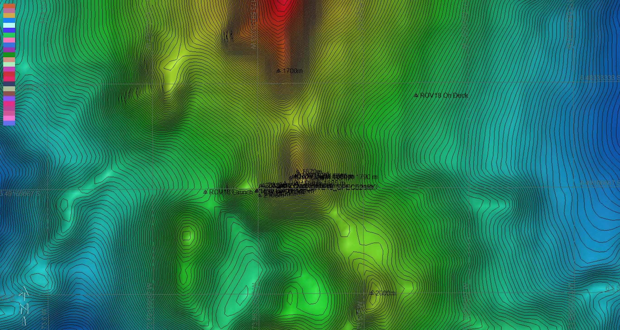 |  |  | 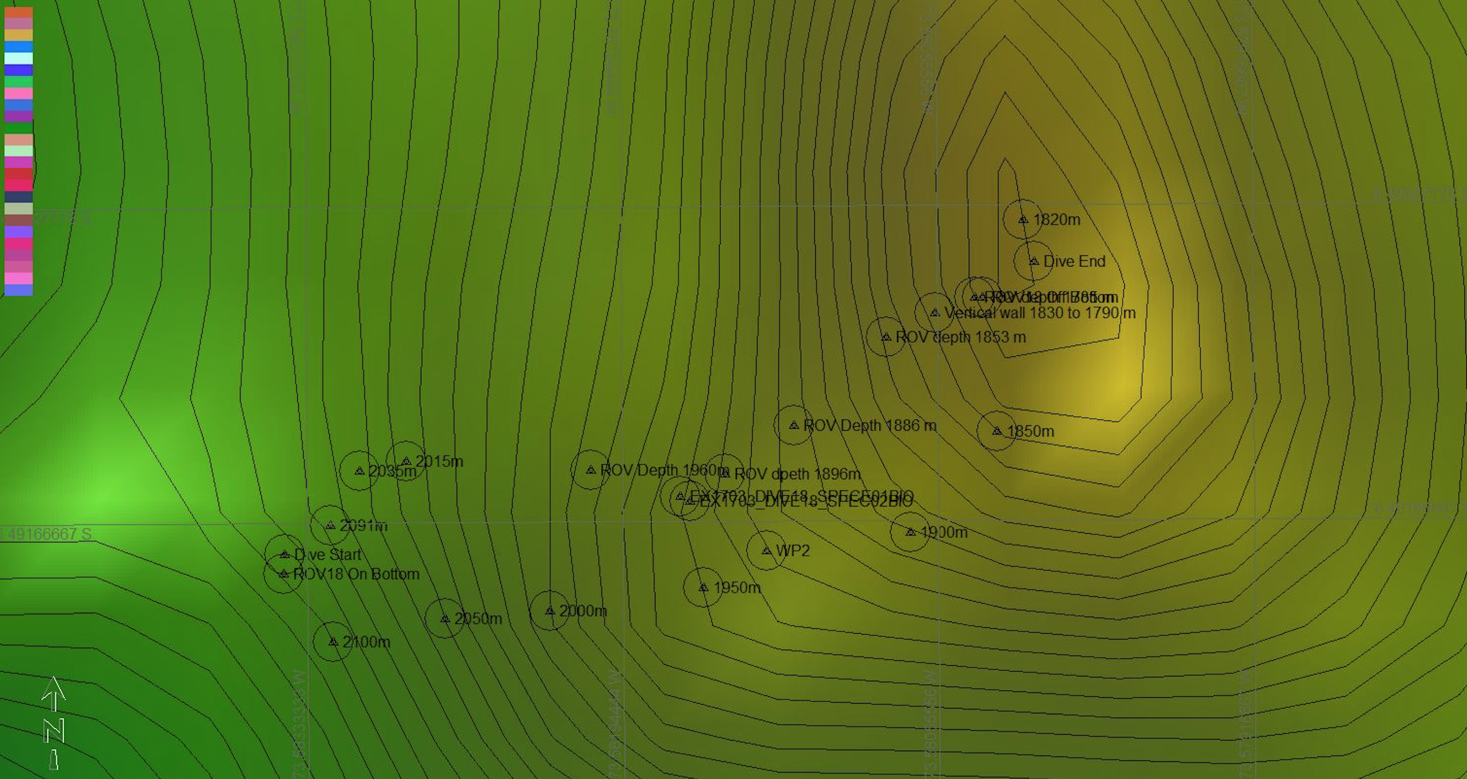
Representative Photos of the Dive
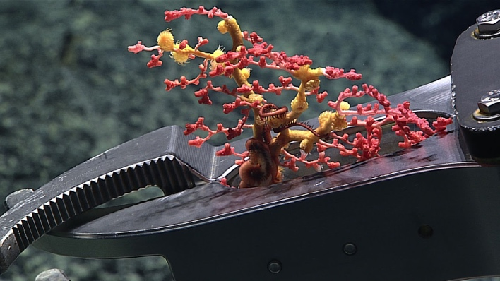 |  |  | 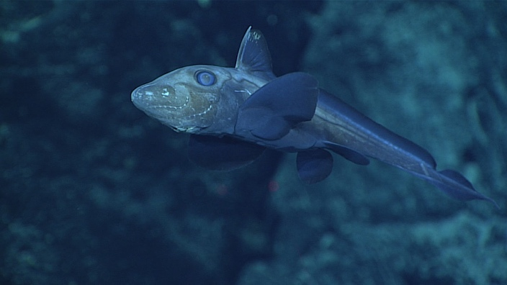
- D2 collected an bubblegum coral with encrusting zoanthid. |  |  | - For the first time this expedition, a chimaera, or ghost fish, was observed around 1853 meters. These fish are distant relatives of sharks and have skeletons made out of cartilage.
Samples Collected
  - Sample
Sample ID | EX1703_20170325T232102_D2_DIVE18_SPEC01BIO |  | - 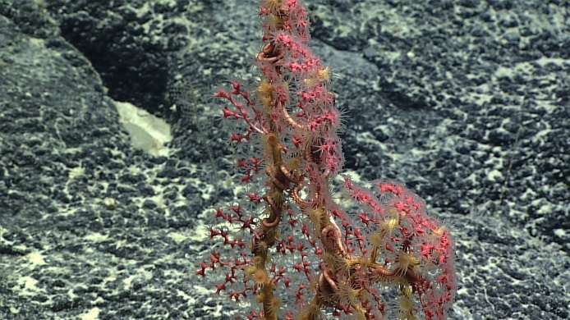
Date (UTC) | 20170325
Time (UTC) | 23:21:02
Depth (m) | 1902.028
Temperature (°C) | 2.31804
Field ID(s) | Paragorgia sp.
Comments
Sample
Sample ID | EX1703_20170325T233700_D2_DIVE18_SPEC02BIO |  | - 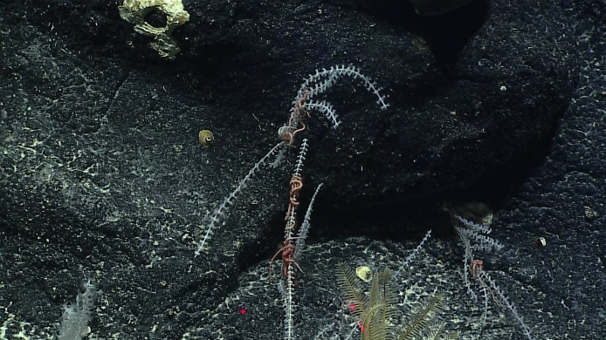
Date (UTC) | 20170325
Time (UTC) | 23:37:00
Depth (m) | 1899.482
Temperature (°C) | 2.33125
Field ID(s) | Primnoidae
Comments

Please direct inquiries to:
NOAA Office of Ocean Exploration & Research
1315 East-West Highway (SSMC3 10th Floor)
Silver Spring, MD 20910
(301) 734-1014

