Okeanos Explorer ROV Dive Summary
Dive Information
Dive Map |  | 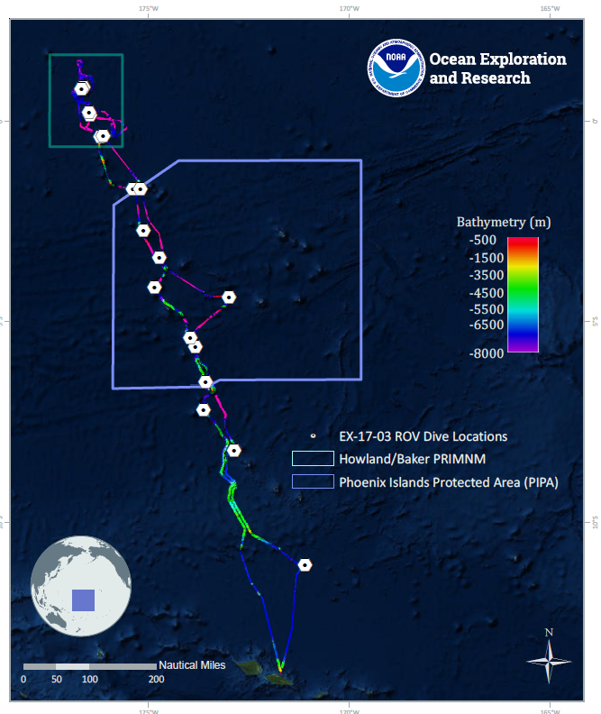
Site Name |  | unnamed seamount (Maibua in Kiribati meaning “broken in two”)
Expedition Coordinator(s) |  | Brian RC Kennedy, Nick Pawlenko
ROV Lead(s) |  | Karl McLetchie
Science Team Lead(s) |  | Amanda Demopoulos and Steven Auscavitch
General Area Descriptor |  | Phoenix Islands Protected Area (PIPA)
ROV Dive Name
Cruise |  | EX-17-03
Leg |  | 0
Dive Number |  | 17
Equipment Deployed
ROV |  | Deep Discoverer (D2)
Camera Platform |  | Seirios
ROV Measurements |  | CTD |  | Depth | Altitude
 |  | Scanning Sonar |  | USBL Position | Heading
 |  | Pitch |  | Roll | HD Camera 1
 |  | HD Camera 2 |  | Low Res Cam 1 | Low Res Cam 2
 |  | Low Res Cam 3 |  | Low Res Cam 4 | Low Res Cam 5
Equipment Malfunctions
ROV Dive Summary  (from processed ROV data) |  | Dive Summary: EX1703_DIVE17  ^^^^^^^^^^^^^^^^^^^^^^^^^^^^^^^^^^^^^^^^^^^^^^^^^^^  In Water: 2017-03-24T18:28:08.581000  05°, 24.113' S ; 173°, 57.769' W  Out Water: 2017-03-25T02:29:34.718000  05°, 24.176' S ; 173°, 57.531' W  Off Bottom: 2017-03-25T02:08:26.373000  05°, 24.197' S ; 173°, 57.494' W  On Bottom: 2017-03-24T18:57:45.415000  05°, 24.081' S ; 173°, 57.690' W  Dive duration: 8:1:26  Bottom Time: 7:10:40  Max. depth: 750.9 m
Special Notes
Scientists Involved  (please provide name, location, affiliation, email) |  | Name Affiliation Email Address  Amanda Demopoulos USGS ademopoulos@usgs.gov  Amy Baco-Taylor FLorida State University abacotaylor@fsu.edu  Andrea Quattrini Harvey Mudd College aquattrini@g.hmc.edu  Asako Matsumoto Chiba Institute of Technology (Chitech), amatsu@gorgonian.jp  Bruce Mundy NOAA NMFS Pacific Islands Fisheries Science Center bruce.mundy@noaa.gov  Christopher Kelley University of Hawaii ckelley@hawaii.edu  Erik Cordes Temple University ecordes@temple.edu  Jaymes Awbrey University of Louisiana, Lafayette jawbrey@louisiana.edu  Kevin Kocot The University of Alabama kmkocot@ua.edu  Mary Wicksten Texas A&M University Wicksten@bio.tamu.edu  Michael Parke NOAA PIFSC michael.parke@noaa.gov  Nick Pawlenko OER nikolai.f.pawlenko@noaa.gov  Santiago Herrera Lehigh University sherrera@alum.mit.edu  Scott France University of Louisiana at Lafayette france@louisiana.edu  Sonia Rowley University of Hawai'i at Manoa srowley@hawaii.edu  Steve Auscavitch Temple University steven.auscavitch@temple.edu  Timothy Shank Woods Hole Oceanographic Institution tshank@whoi.edu  Tina Molodtsova P.P.Shirshov Institute of Oceanology RAS tina.molodtsova@gmail.com
Purpose of the Dive |  | The general goal of this dive is to acquire baseline information on deep sea habitats, seafloor geology, and biological communities on features around an unnamed seamount (Maibua in Kiribati meaning “broken in two”) in the Phoenix Islands Protected Area (PIPA). Assessment of early multibeam bathymetry for this feature indicates a potential mass wasting of one side of the seamount. Our dive will track along a moderate to steep ridge from ~700m to ~400m and will be our shallowest dive to date at a PIPA feature. Deep-sea environments in this area are virtually unexplored leading to poor knowledge of biological resources protected by the reserve. This dive will provide some perspective on biological resources (e.g. fishes, biogenic habitat) as well as geological substrate (crust precipitates) of the seamount. Understanding deep-sea coral and sponge distribution as well as bathyal fish assemblages are of great importance to inform management in the PIPA. The age of seamount is not known.
Description of the Dive |  | EX1703 dive #17 was on an unnamed seamount within PIPA. The seamount has a dramatically steep slope feature on the western side, with large concavities that may have arisen from a huge mass wasting event some time in its geological history. The ROV descended to 746 m and progressed along a gradual slope composed of loose dead coral rubble covering sandy sediments. Sponges were the dominant fauna encountered early in the dive, with a few different types of tubular, vase-like hexactinellids. Other fauna observed on the sediment surface included a tunicate with red fringe, an echinothuriid urchin, and squat lobsters. Fishes observed along this flatter terrain included alfonsinos (Berycidae: Beryx), congrid eels (Bathycongrus), and oreo fish (Oreosomatidae: Neocyttus cf. acanthorhynchus).  Around 740 m depth, the dive track transitioned from coral rubble sediment to a steep wall of heavily eroded carbonate. The pilot noted that the current was moving north to south along this track. The wall was covered with high densities of comatulid crinoids. Scattered along the steep wall were different kinds of sponges, including stalked hexactinellids (e.g., Saccocalyx), lobate forms, and farreid sponges. Corals encountered on the wall included stony colonial (e.g., Enallopsammia) and solitary (e.g., Javania?) forms, pink coralliid, primnoids (large tan fans, cf. Calyptrophora), yellow plexaurids, and chrysogorgiids with ophiuroid and chirostylid crabs. Other invertebrates observed included large Heterocarpus shrimp, hermit and homolid crabs, large purple crinoids with myzostomes on cirri, large squat lobsters (cf. Eumunida), and sea stars (e.g., Pseudarchaster). One homolid crab was observed gleaning material from its anemone hat using its chelipeds. Other fishes included arrow-tooth eels (Synaphobranchidae: cf. Dysomma), codlings (Moridae: Physiculus), brotulas (Bythitidae: Diplacanthopoma, different from those observed on previous dives), and roughy (Hoplostethus).  At around 600 m depth, the track progressed along a gradually sloped ridge feature, with steep drop offs on either side of the ridge. The current switched from south to north and the wall of crinoids was replaced with a carpet of buried ophiuroids. Along the ridge, we encountered the largest coral colonies observed on the dive including many primnoid fans (cf. Paracalyptrophora), a few scattered colonies of scleractinians (cf., Enallopsammia), the largest pink coralliid of the dive, and large bamboos (cf. Jasonisis). Other corals included pink Paragorgia and a white paragorgiid (cf. Sibogagorgia sp.), different cup corals, and Anthomastus. A few of the large primnoids had large ophiuroid associates (cf. Astrocerus) with sinusoidal arms and a bumpy textured disc. Toward the end of the dive, we observed several large gold corals (~1.5 m, colonial zoanthids, cf. Kulamanamana sp.), some completely covering the host coral skeleton, and one that half covered a live bamboo colony. On this particular colony, we noted the areas of transition from live bamboo tissue to dead skeleton to live zoanthid polyps. Other invertebrates observed included an octopus with a projection on its head and 2 rows of suckers on each arm, demosponges, a salp, sea stars (Astroceramus?), stalked crinoid (Paratelecrinus), large vase sponges, and pancake urchins (echinothuriids with parasites). Along the ridge, several oreo fish were observed, plus spike fish (Triacanthodidae: cf. Hollardia goslinei), pomfrets (Bramidae: Eumegistus cf. illustris), rattail (Macrouridae: Nezumia sp.), roughy (Trachichthyidae: Hoplostethus cf. crassispinus), beardfish (Polymixiidae: Polymixia), scorpianfish (Scorpaenidae), deep-sea cardinalfish (Epigonidae: Epigonus sp.), goosefish (Lophiidae: Lophiodes sp.) and a deep-water sting ray (Plesiobatidae: Plesiobatis daviesi). Some of the fish observed had gnathiid isopod parasites attached to fins and the scales.  Throughout the dive, both along the steep slope and ridge track, we noticed several cidaroid pencil urchins, known coral predators, on large primnoid fans. Multiple areas of bare skeleton was observed in proximity to the urchins.
Overall Map of the ROV Dive Area |  |  | Close-up Map of Main Dive Site
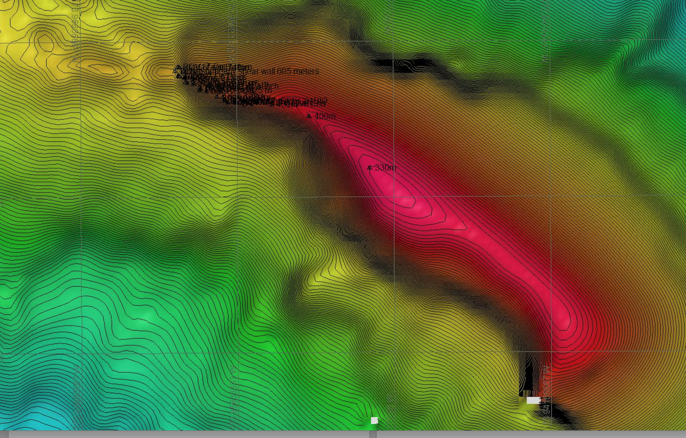 |  |  | 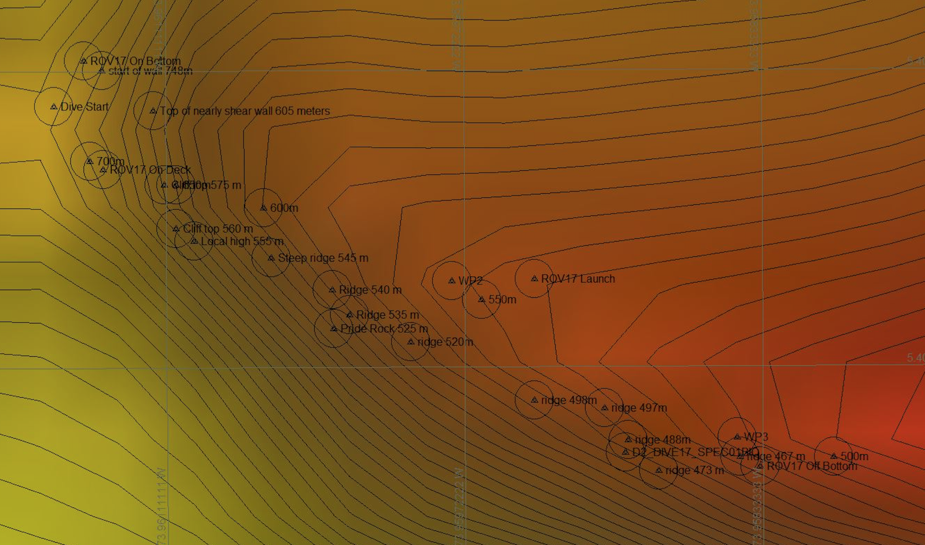
Representative Photos of the Dive
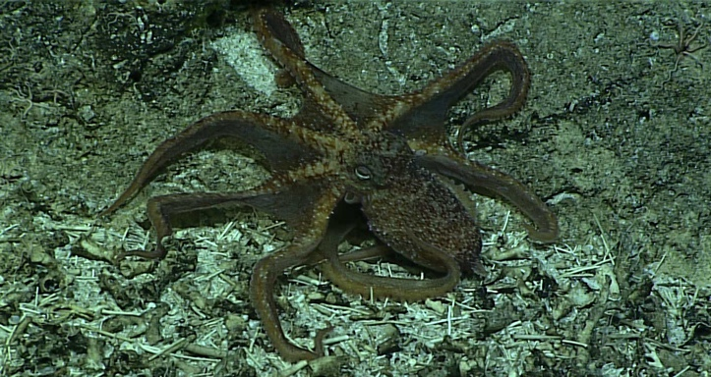 |  |  | 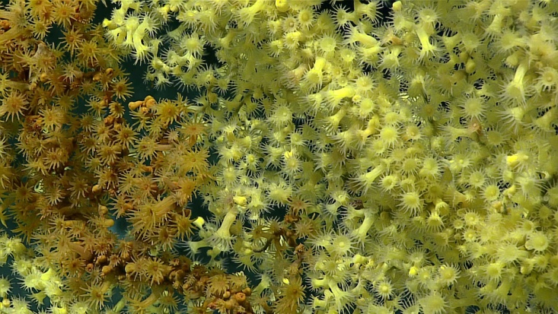
- An unknown octopus with a small node on its head was observed crawling along the seafloor around 475 meters. |  |  | - Several gold coral colonies were observed for the first time on this expedition on this dive within the Phoenix Islands Protected Area (PIPA).
Samples Collected
  - Sample
Sample ID | EX1703_20170325T013010_D2_DIVE17_SPEC01BIO |  | - 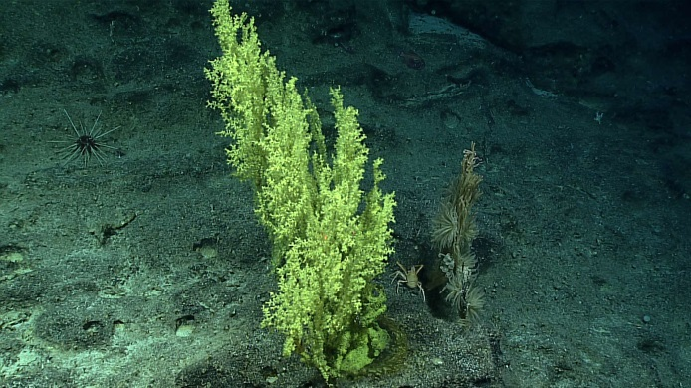
Date (UTC) | 20170325
Time (UTC) | 01:30:10
Depth (m) | 489.84
Temperature (°C) | 8.26
Field ID(s) | Zoantharia
Comments

Please direct inquiries to:
NOAA Office of Ocean Exploration & Research
1315 East-West Highway (SSMC3 10th Floor)
Silver Spring, MD 20910
(301) 734-1014

