Okeanos Explorer ROV Dive Summary
Dive Information
Dive Map |  | 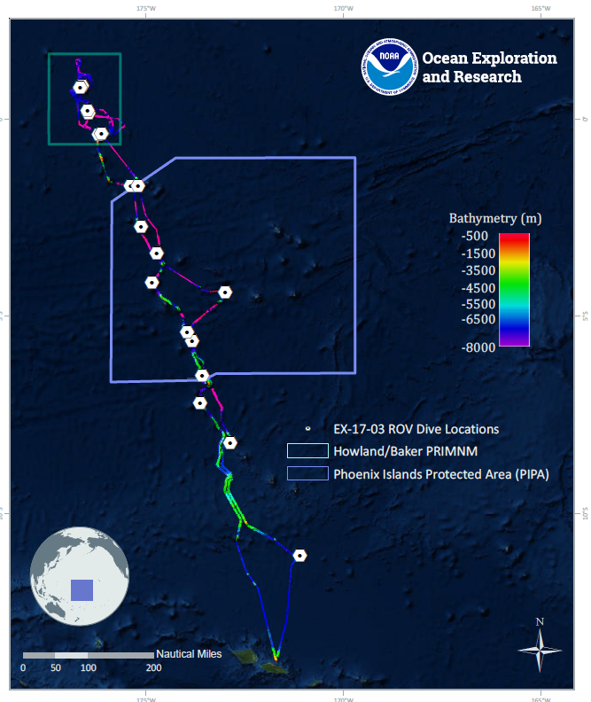
Site Name |  | Hadal Trough “Kinono”
Expedition Coordinator(s) |  | Brian RC Kennedy, Nick Pawlenko
ROV Lead(s) |  | Karl McLetchie
Science Team Lead(s) |  | Amanda Demopoulos and Steven Auscavitch
General Area Descriptor |  | Phoenix Islands Protected Area
ROV Dive Name
Cruise |  | EX-17-03
Leg |  | 0
Dive Number |  | 16
Equipment Deployed
ROV |  | Deep Discoverer (D2)
Camera Platform |  | Seirios
ROV Measurements |  | CTD |  | Depth | Altitude
 |  | Scanning Sonar |  | USBL Position | Heading
 |  | Pitch |  | Roll | HD Camera 1
 |  | HD Camera 2 |  | Low Res Cam 1 | Low Res Cam 2
 |  | Low Res Cam 3 |  | Low Res Cam 4 | Low Res Cam 5
Equipment Malfunctions
ROV Dive Summary  (from processed ROV data) |  | Dive Summary: EX1703_DIVE16  ^^^^^^^^^^^^^^^^^^^^^^^^^^^^^^^^^^^^^^^^^^^^^^^^^^^  In Water: 2017-03-23T18:30:40.309000  04°, 22.525' S ; 172°, 59.763' W  Out Water: 2017-03-24T04:21:39.338000  04°, 22.604' S ; 172°, 59.532' W  Off Bottom: 2017-03-24T01:09:44.779000  04°, 22.629' S ; 172°, 59.817' W  On Bottom: 2017-03-23T21:31:44.681000  04°, 22.512' S ; 172°, 59.870' W  Dive duration: 9:50:59  Bottom Time: 3:38:0  Max. depth: 5862.9 m
Special Notes
Scientists Involved  (please provide name, location, affiliation, email) |  | Name Affiliation Email Address  Abby Lapointe University of Hawaii abbylap@hawaii.edu  Amanda Demopoulos USGS ademopoulos@usgs.gov  Asako Matsumoto Chiba Institute of Technology (Chitech), amatsu@gorgonian.jp  Benjamin Frable Scripps Institution of Oceanography bfrable@ucsd.edu  Bruce Mundy NOAA NMFS Pacific Islands Fisheries Science Center bruce.mundy@noaa.gov  Christopher Kelley University of Hawaii ckelley@hawaii.edu  Jaymes Awbrey University of Louisiana, Lafayette jawbrey@louisiana.edu  Jill Bourque US Geological Survey Wetland and Aquatic Research Center jbourque@usgs.gov  Les Watling University of Hawaii at Manoa watling@hawaii.edu  Natalie Summers University of Hawaii at Manoa nsummers@hawaii.edu  Nolan Barrett FAU Harbor Branch Oceanographic Institute barrettnh@g.cofc.edu  Peter Auster Mystic Aquarium & UConn peter.auster@uconn.edu  Randi Rotjan Boston University rrotjan@bu.edu  Santiago Herrera Lehigh University sherrera@alum.mit.edu  Scott France University of Louisiana at Lafayette france@louisiana.edu  Steve Auscavitch Temple University steven.auscavitch@temple.edu  Taylor Heyl WHOI theyl@whoi.edu  Timothy Shank Woods Hole Oceanographic Institution tshank@whoi.edu  Tina Molodtsova P.P.Shirshov Institute of Oceanology RAS tina.molodtsova@gmail.com  Witting Jan Sea Education Association jwitting@sea.edu  Brendan Roak Texas A&M University broark@geos.tamu.edu
Purpose of the Dive |  | The general goal of this dive is to acquire baseline information on deep sea habitats, seafloor geology, and biological communities at hadal depths in the Phoenix Islands Protected Area (PIPA). We will be diving in one of the few non-trench associated hadal zones in the Pacific Ocean. Most hadal environments are virtually unexplored and there is little understanding of what resources might be protected at such depths. This dive will provide some perspective on biological resources (e.g. fishes, biogenic structures) as well as seafloor geology at these depths. The geological processes for formation of the Nova-Canton Trough could also be associated with the formation of this this hadal trough in the Phoenix Islands.
Description of the Dive |  | EX1703 dive # 16 was our deepest dive for the expedition, descending to 5862m in a deep trough feature, southwest of the Phoenix Islands. The seafloor was composed of scattered and emplaced rocks coated in manganese iron oxide crust, with brown sediment drape occurring in patches. The sediment appeared more organic rich and darker in color than on our previous dives in the region, speckled with calcareous foram tests.  This dive should be nicknamed “white house, black market”. Throughout the dive, both on the steep slope and sedimented ledge at the end of the dive, we encountered taxa that lacked pigmentation, which contrasted with the dark color of the seafloor. We observed white anemones, holothurians, brisingids (Freyastera- some with swollen arms filled with gonads), cladorhizid sponges (2 species), comatulid crinoids with eggs, solitary hydroid, stalked sponges with amphipod associates (Stegocephalidae), slit shell gastropod (Anatomidae: Anatoma sp.), sea pigs (unknown Elpidiidae), pentagonal ophiuroid, and a branching bryozoan. We also saw a large amphipod (e.g., Epimeriidae), red caridean shrimp, carnivorous tunicates, large pink mysid shrimps, fan-shaped xenophyophores, brown globe forams (cf. Komokioidea), long, mud tube with a white polychaete inside (cf. Onuphidae), and a cusk eel (Ophidiidae: Alcockia rostrata or Bathyonus caudalis).  We observed some unexpected fauna, including priapulids feeding on the sediment surface, large purple holothurians (Psychropotes), and a rare monoplacophoran mollusc. At the end of the dive, along a sedimented plateau composed of hard pavement, we saw a white seapen (cf. Umbellula) and collected the only black coral (cf. Abyssopathes sp.) observed on the dive, at ~ 5775 m.
Overall Map of the ROV Dive Area |  |  | Close-up Map of Main Dive Site
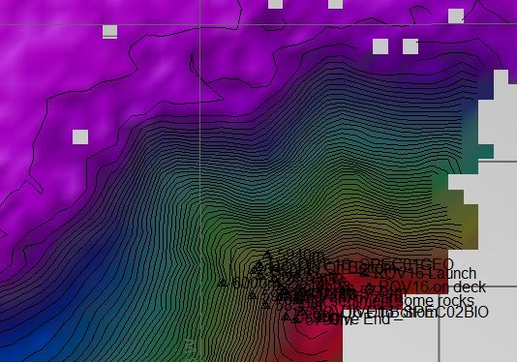 |  |  | 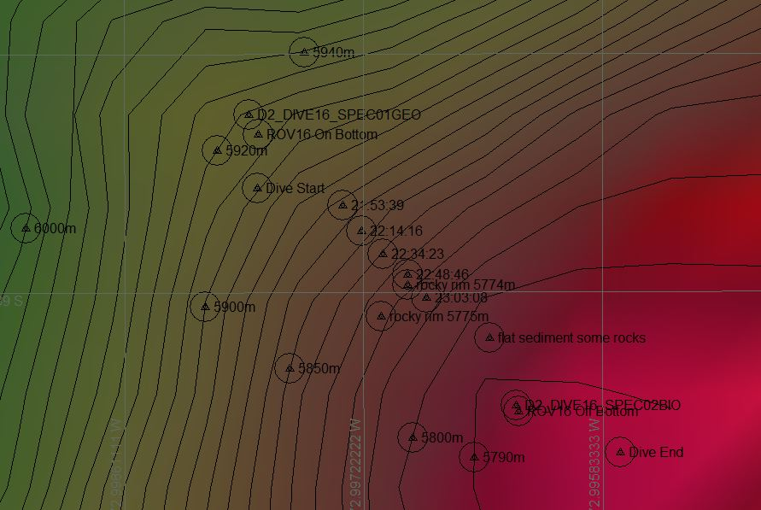
Representative Photos of the Dive
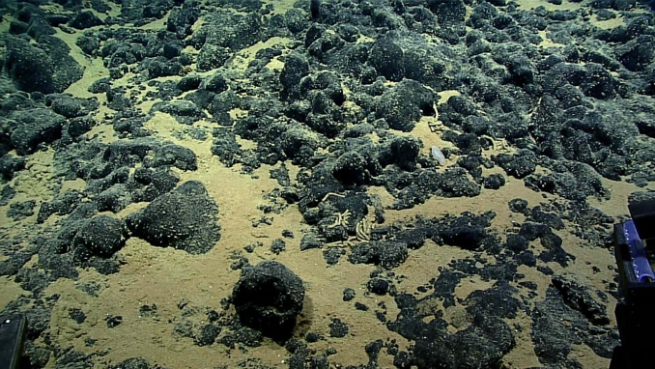 |  |  | 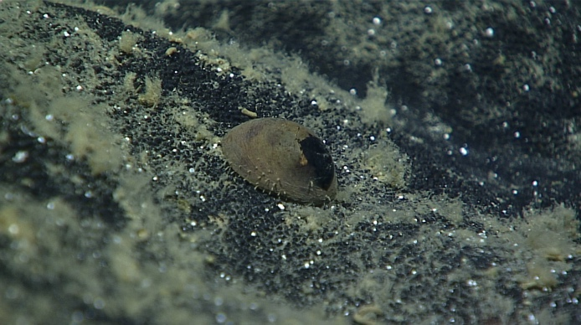
- The seafloor was composed of scattered and emplaced rocks coated in manganese iron oxide crust, with brown sediment drape occurring in patches. |  |  | - Possibly a monoplacophoran mollusc
Samples Collected
  - Sample
Sample ID | EX1703_20170323T214437_D2_DIVE16_SPEC01GEO |  | - 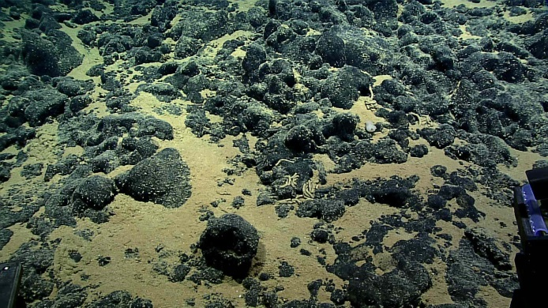
Date (UTC) | 20170323
Time (UTC) | 21:44:37
Depth (m) | 5859.54
Temperature (°C) | 1.37
Field ID(s) | Mn-Coated Rock
Comments
Sample
Sample ID | EX1703_20170324T010307_D2_DIVE16_SPEC02BIO |  | - 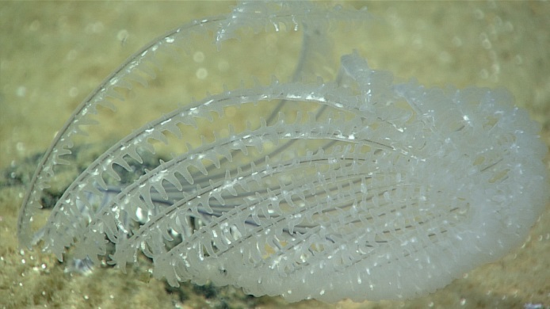
Date (UTC) | 20170324
Time (UTC) | 01:03:07
Depth (m) | 5772.36
Temperature (°C) | 1.35
Field ID(s) | Antipatharia
Comments

Please direct inquiries to:
NOAA Office of Ocean Exploration & Research
1315 East-West Highway (SSMC3 10th Floor)
Silver Spring, MD 20910
(301) 734-1014

