Okeanos Explorer ROV Dive Summary
Dive Information
Dive Map |  | 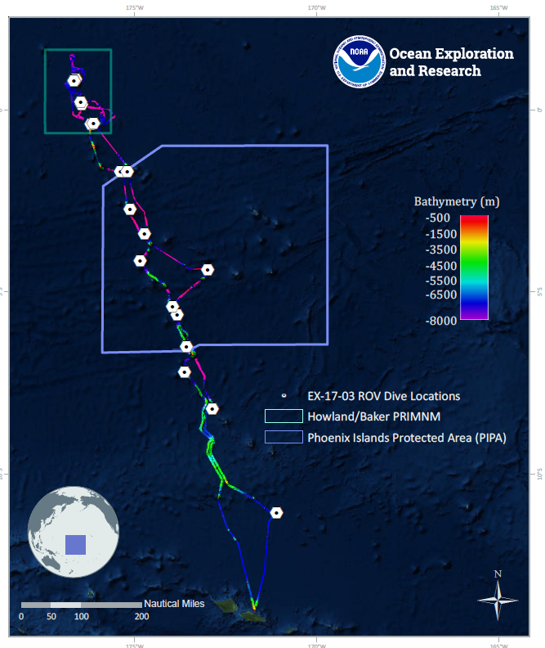
Site Name |  | Unnamed Seamount “Teutana Seamount”
Expedition Coordinator(s) |  | Brian RC Kennedy, Nick Pawlenko
ROV Lead(s) |  | Karl McLetchie
Science Team Lead(s) |  | Amanda Demopoulos and Steven Auscavitch
General Area Descriptor |  | Phoenix Islands Protected Area
ROV Dive Name
Cruise |  | EX-17-03
Leg |  | 0
Dive Number |  | 15
Equipment Deployed
ROV |  | Deep Discoverer (D2)
Camera Platform |  | Seirios
ROV Measurements |  | CTD |  | Depth | Altitude
 |  | Scanning Sonar |  | USBL Position | Heading
 |  | Pitch |  | Roll | HD Camera 1
 |  | HD Camera 2 |  | Low Res Cam 1 | Low Res Cam 2
 |  | Low Res Cam 3 |  | Low Res Cam 4 | Low Res Cam 5
Equipment Malfunctions
ROV Dive Summary  (from processed ROV data) |  | Dive Summary: EX1703_DIVE15  ^^^^^^^^^^^^^^^^^^^^^^^^^^^^^^^^^^^^^^^^^^^^^^^^^^^  In Water: 2017-03-22T18:37:30.067000  03°, 23.976' S ; 174°, 44.221' W  Out Water: 2017-03-23T01:08:14.864000  03°, 24.054' S ; 174°, 43.792' W  Off Bottom: 2017-03-23T00:26:01.395000  03°, 24.087' S ; 174°, 43.927' W  On Bottom: 2017-03-22T19:28:29.461000  03°, 23.971' S ; 174°, 44.146' W  Dive duration: 6:30:44  Bottom Time: 4:57:31  Max. depth: 1325.4 m
Special Notes
Scientists Involved  (please provide name, location, affiliation, email) |  | Name Affiliation Email Address  Amanda Demopoulos USGS ademopoulos@usgs.gov  Amy Baco-Taylor FLorida State University abacotaylor@fsu.edu  Bruce Mundy NOAA NMFS Pacific Islands Fisheries Science Center bruce.mundy@noaa.gov  Chris Mah Dept. of Invertebrate Zoology, NMNH Smithsonian Institution brisinga@gmail.com  Erik Cordes Temple University ecordes@temple.edu  Jill Bourque US Geological Survey Wetland and Aquatic Research Center jbourque@usgs.gov  Les Watling University of Hawaii at Manoa watling@hawaii.edu  Michael Parke NOAA PIFSC michael.parke@noaa.gov  Nicole Morgan Florida State University nmorgan@fsu.edu  Randi Rotjan Boston University rrotjan@bu.edu  Santiago Herrera Lehigh University sherrera@alum.mit.edu  Scott France University of Louisiana at Lafayette france@louisiana.edu  Sonia Rowley University of Hawai'i at Manoa srowley@hawaii.edu  Steve Auscavitch Temple University steven.auscavitch@temple.edu  Taylor Heyl WHOI theyl@whoi.edu  Timothy Shank Woods Hole Oceanographic Institution tshank@whoi.edu
Purpose of the Dive |  | The general goal of this dive is to acquire baseline information on deep sea habitats, seafloor geology, and biological communities on features around the tentatively-named “Teutana Seamount” (“a little” in Kiribati), in the Phoenix Islands Protected Area (PIPA). Deep-sea environments on seamounts in PIPA are virtually unexplored leading to poor knowledge of any biological resources protected by the reserve. This dive will provide some perspective on biological resources (e.g. fishes, biogenic habitat) as well as geological resources (crust precipitates) of the seamount. Understanding deep-sea coral and sponge distribution as well as bathyal fish communities is important to inform management in the Phoenix Islands Protected Area. The age of this seamount has not been determined from rock dating.
Description of the Dive |  | EX1703 dive #15 was on an unnamed seamount and our 6th dive within the Phoenix Islands Protected Area. The dive track started at 1323m on a sedimented slope with scattered boulders and progressed along a steep pinnacle to a depth of 982 m. Pilots noted that the current was moderate, flowing from north to south. The seafloor transitioned from large boulders and blocks, interspersed with sediment to large boulders and continuous rock pavements with thin sediment drape. Along the steep slope, the rock had a crustal appearance, and seemed to have failed in several areas, revealing the smooth, underlying pavement.  Fishes encountered on the dive included cusk eels (Ophidiidae: cf. Bassozetus, Spectrunculus), rattails (Bathygadidae: Gadomus sp., Macrouridae: cf. Nezumia, Coryphaenoides), deep-sea spiny eels (Halosauridae: Aldrovandia spp.), tripod fish (Ipnopidae: Bathypterois atricolor), velvet whalefish (Barbourisiidae: Barbourisia rufa), brotula (Bythitidae: Diplacanthopoma), oreo fish (Oreosomatidae: Neocyttus cf. acanthorhynchus), arrow-tooth eel (Ilyophinae: Ilyophis sp.), and cutthroat eels (Synaphobranchidae: Synaphobranchus spp.).  Yellow plexaurids (cf. Paramuricea-collected), bottlebrush chrysogorgiids (cf. Chrysogorgia), and large primnoids (cf. Paracalyptrophora, Calyptrophora) were observed on large rocky slabs. Other corals observed along the steep slope included sea pens (Umbellula), colonial scleractinians (cf. Enallopsammia sp.), cup corals, bamboo whips, precious corals (cf. Hemicorallium, Pleurocorallium cf. porcellanum), other primnoids (Narella), plexaurids (Paracis sp.), chrysogorgiids (Iridogorgia), Victorgorgia, and Bathypathes.  Several Walteria glass sponges were observed during the first part of the dive from 1323 to ~1200 m, and they were notably covered with associates, including ctenophores, crinoids, ophiuroids, and shrimp. Unknown goniasterid or odontasterid seastars were observed feeding on Walteria sponges. We also encountered Evoplosoma seastars feeding on a very large primnoid (cf. Calyptrophora), with bare coral skeleton present in proximity to the seastar. Other sponges included large vase-like Euplectellidae and other globe-shaped glass sponges. Additional invertebrates observed on the exposed rock surfaces and on the sediment surface included a few different types of holothurians, seastars (Henricia), a phrynocrinid sea lily, anemones, shrimps, hermit crab, a dandelion benthic siphonophore, echinothuriid sea urchin, a homolid crab with a plexaurid hat on a large coralliid, and goniasterid seastars on exposed rocks.
Overall Map of the ROV Dive Area |  |  | Close-up Map of Main Dive Site
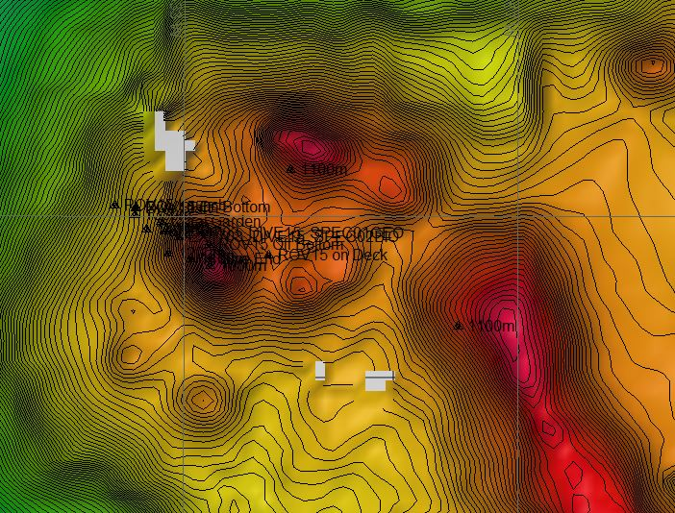 |  |  | 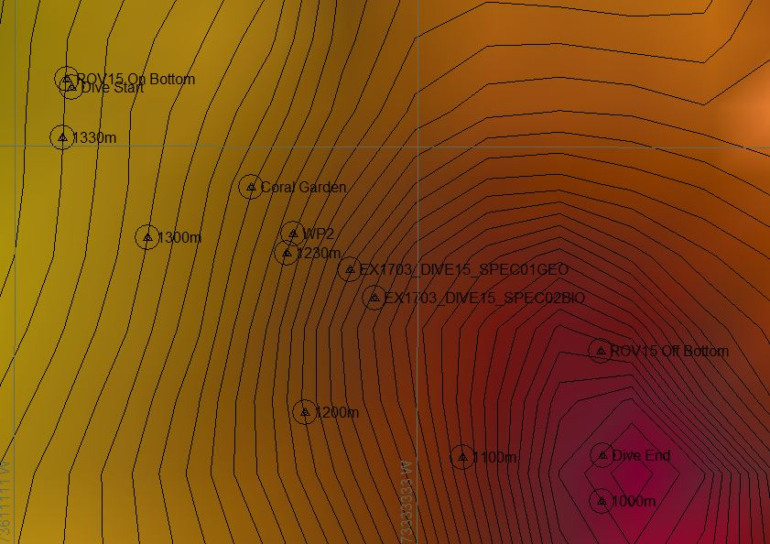
Representative Photos of the Dive
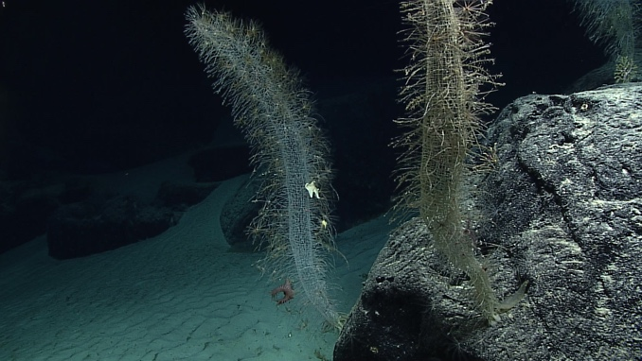 |  |  | 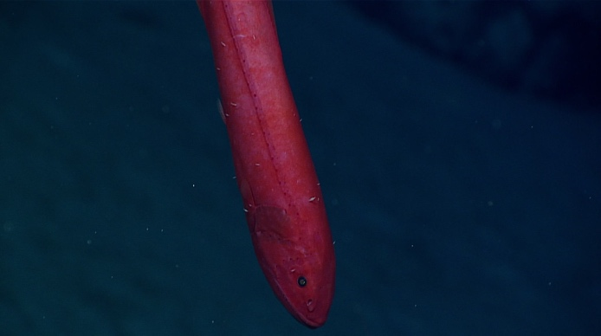
- Several Walteria glass sponges were observed during the first part of the dive from 1323 to ~1200 m |  |  | - A velvet whalefish seen during the dive
Samples Collected
  - Sample
Sample ID | EX1703_20170322T223742_D2_DIVE15_SPEC01GEO |  | - 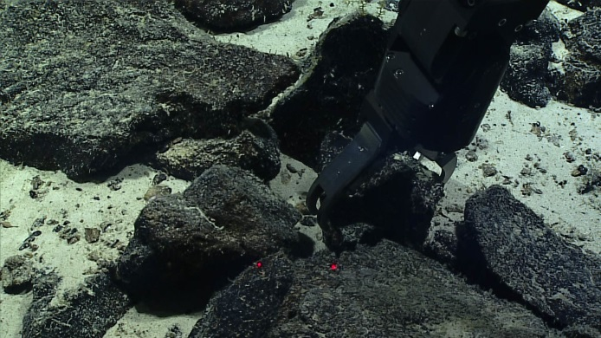
Date (UTC) | 20170322
Time (UTC) | 22:37:42
Depth (m) | 1172.13
Temperature (°C) | 3.94
Field ID(s) | Mn-crusted basalt
Comments
Sample
Sample ID | EX1703_20170322T232658_D2_DIVE15_SPEC02BIO |  | - 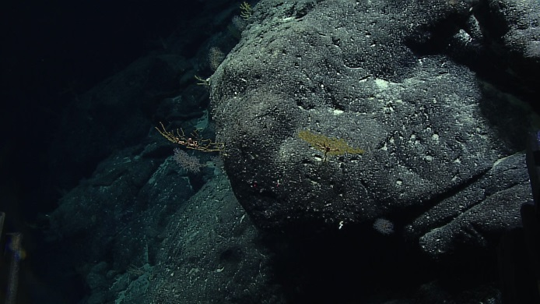
Date (UTC) | 20170322
Time (UTC) | 23:26:58
Depth (m) | 1117.73
Temperature (°C) | 3.97
Field ID(s) | Plexauridae
Comments

Please direct inquiries to:
NOAA Office of Ocean Exploration & Research
1315 East-West Highway (SSMC3 10th Floor)
Silver Spring, MD 20910
(301) 734-1014

