Okeanos Explorer ROV Dive Summary
Dive Information
Dive Map |  | 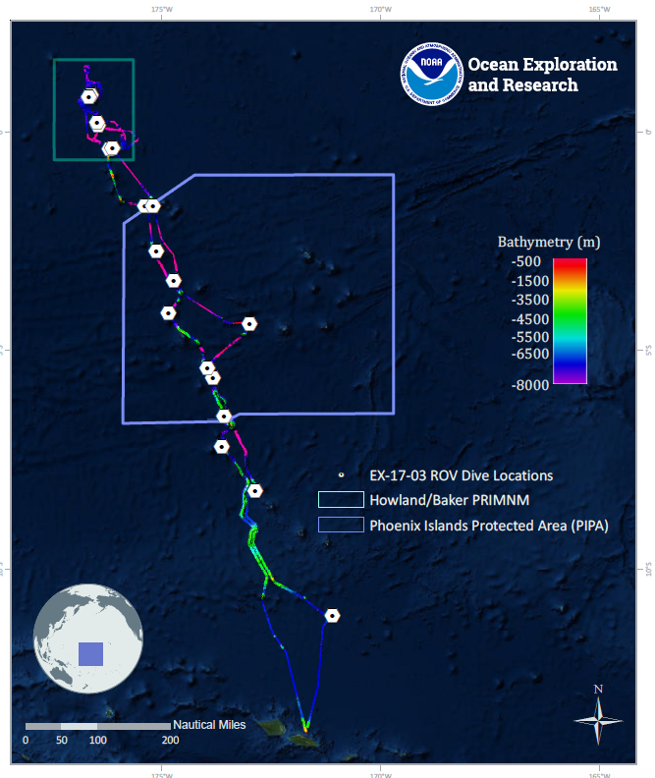
Site Name |  | Unnamed Seamount West of Winslow Reef PIPA
Expedition Coordinator(s) |  | Brian RC Kennedy, Nick Pawlenko
ROV Lead(s) |  | Karl McLetchie
Science Team Lead(s) |  | Amanda Demopoulos and Steven Auscavitch
General Area Descriptor |  | Phoenix Islands Protected Area
ROV Dive Name
Cruise |  | EX-17-03
Leg |  | 0
Dive Number |  | 14
Equipment Deployed
ROV |  | Deep Discoverer (D2)
Camera Platform |  | Seirios
ROV Measurements |  | CTD |  | Depth | Altitude
 |  | Scanning Sonar |  | USBL Position | Heading
 |  | Pitch |  | Roll | HD Camera 1
 |  | HD Camera 2 |  | Low Res Cam 1 | Low Res Cam 2
 |  | Low Res Cam 3 |  | Low Res Cam 4 | Low Res Cam 5
Equipment Malfunctions
ROV Dive Summary  (from processed ROV data) |  | Dive Summary: EX1703_DIVE14  ^^^^^^^^^^^^^^^^^^^^^^^^^^^^^^^^^^^^^^^^^^^^^^^^^^^  In Water: 2017-03-21T18:25:30.076000  01°, 42.025' S ; 175°, 12.483' W  Out Water: 2017-03-22T02:26:21.932000  01°, 42.209' S ; 175°, 11.971' W  Off Bottom: 2017-03-22T01:42:08.303000  01°, 42.207' S ; 175°, 12.136' W  On Bottom: 2017-03-21T19:38:09.203000  01°, 42.259' S ; 175°, 12.340' W  Dive duration: 8:0:51  Bottom Time: 6:3:59  Max. depth: 1535.5 m
Special Notes
Scientists Involved  (please provide name, location, affiliation, email) |  | Name Affiliation Email Address  Amanda Demopoulos USGS ademopoulos@usgs.gov  Amanda Netburn NOAA OER amanda.netburn@noaa.gov  Asako Matsumoto Chiba Institute of Technology (Chitech), amatsu@gorgonian.jp  Bruce Mundy NOAA NMFS Pacific Islands Fisheries Science Center bruce.mundy@noaa.gov  Deborah Glickson National Academies of Sciences, Engineering, and Medicine dglickson@nas.edu  Erik Cordes Temple University ecordes@temple.edu  Jaymes Awbrey University of Louisiana, Lafayette jawbrey@louisiana.edu  Jill Bourque US Geological Survey Wetland and Aquatic Research Center jbourque@usgs.gov  Kevin Kocot The University of Alabama kmkocot@ua.edu  Les Watling University of Hawaii at Manoa watling@hawaii.edu  Michael Parke NOAA PIFSC michael.parke@noaa.gov  Natalie Summers University of Hawaii at Manoa nsummers@hawaii.edu  Peter Auster Mystic Aquarium & UConn peter.auster@uconn.edu  Randi Rotjan Boston University rrotjan@bu.edu  Santiago Herrera Lehigh University sherrera@alum.mit.edu  Scott France University of Louisiana at Lafayette france@louisiana.edu  Steve Auscavitch Temple University steven.auscavitch@temple.edu  Taylor Heyl WHOI theyl@whoi.edu  Timothy Shank Woods Hole Oceanographic Institution tshank@whoi.edu  Tina Molodtsova P.P.Shirshov Institute of Oceanology RAS tina.molodtsova@gmail.com  Brendan Roak Texas A&M University broark@geos.tamu.edu
Purpose of the Dive |  | The general goal of this dive is to acquire baseline information on deep sea habitats, seafloor geology, and biological communities on features around Winslow Reef in the Phoenix Islands Protected Area (PIPA). Deep-sea environments around Winslow Reef are virtually unexplored leading to poor knowledge of biological resources protected by the reserves. This dive will provide some perspective on biological resources (e.g. fishes, biogenic habitat) as well as geological resources (crust precipitates) of the seamount. Understanding deep-sea coral distribution as well as bathyal fish communities is of great importance to inform management in the Phoenix Islands Protected Area and a nearby seamount in the US EEZ. The age of this seamount is not known.
Description of the Dive |  | EX1703 dive #14 was on an unnamed seamount within the Winslow Reef Area, Phoenix Islands Protected Area. The dive track started on a sedimented seafloor at 1535m and progressed up a steep slope. Throughout the dive, we observed several live and dead Walteria-like glass sponges, loaded with associates, including ophiuroids, crinoids, barnacles, shrimp, ctenophores, and sometimes a goniasterid sea star. Other sponges included cf. Tretopleura and encrusting sponges.  Iridogorgia cf. magnispiralis was the dominant octocoral present and several colonies were very large (~3.7 m). Other corals observed included chrysogorgiids (cf. Chrysogorgia, Metallogorgia, and an unknown planar form), sea pens (3 species: Umbellula, Pennatulidae, and unknown), primnoids (cf. Narella, Callogorgia), Anthomastus, bamboo (whip and a yellow nodal branching type), yellow plexaurid, stoloniferans, acanthogorgiids, pink coralliid (Hemicorallium sp.), black coral (Bathypathes), and stony corals (cf. Enallopsammia, Madrepora, and unknown cup corals). Additional associates included chirostylid squat lobsters (e.g., Gastroptychus sp.) and Glyptelasma barnacles on dead coral skeleton.  Fish included cusk eels (Ophediidae: Bassozetus, Spectrunculus, Monomitopus?), rattails (Macrouridae: cf. Nezumia and unknown), codling (Moridae: Lepidion), deep-sea spiny eels (Halosauridae: unknown), cutthroat eels (Synaphobranchidae: Synaphobranchus affinis), and an unknown black fish, possibly a whalefish (Cetomimidae).  Other invertebrates observed included a blind lobster (Polychelidae), stalked crinoids (Proisocrinus ruberrimus), holothurians (Synallactidae?), sea stars (Pythonaster, Hymenaster, Henricia, Zoroasteridae, unknown Goniasteridae, Benthopectinidae), sea urchins (echinothuriids with paddle-shaped spines and aspidodiadematids), homolid crab with anemone associate, and xenophyophores. One of the highlights of the dive was observing a dumbo octopus (Grimpoteuthis) take flight during the first part of the dive. The octopus had a damaged arm and fin. In addition, we observed some examples of carnivory, including pycnogonids (Colossendeis sp.) feeding on an anemone, goniasterid sea stars feeding on sponges, and gastropods on a crinoid and corals.
Overall Map of the ROV Dive Area |  |  | Close-up Map of Main Dive Site
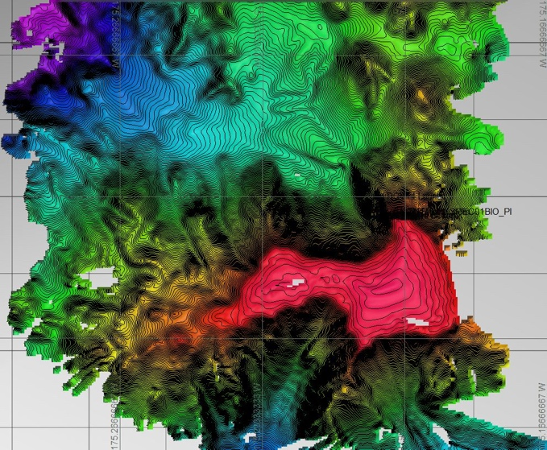 |  |  | 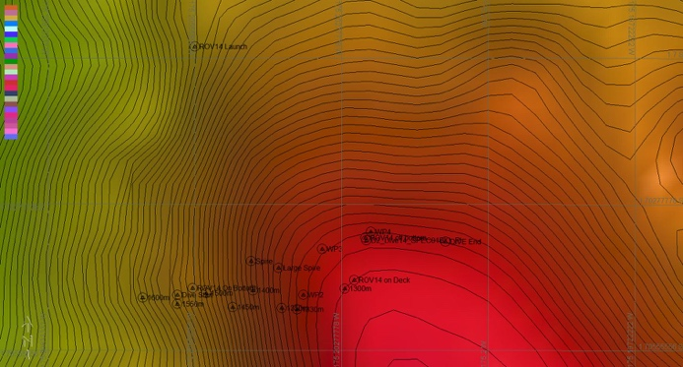
Representative Photos of the Dive
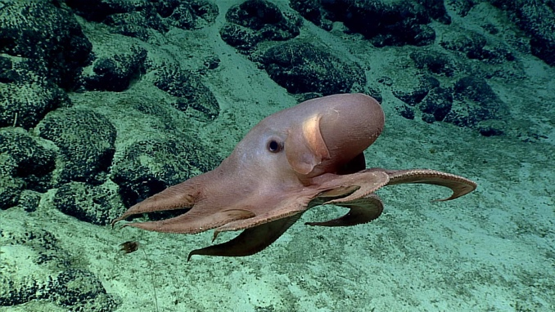 |  |  | 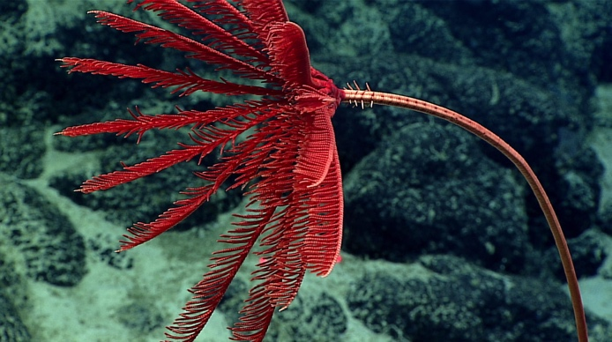
- A Dumbo octopus encountered during the dive |  |  | - A stalked crinoid
Samples Collected
  - Sample
Sample ID | EX1703_20170322T013359_D2_DIVE14_SPEC01BIO |  | - 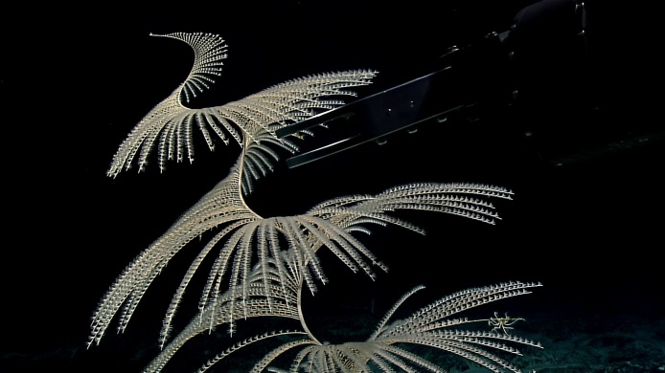
Date (UTC) | 20170322
Time (UTC) | 01:33:59
Depth (m) | 1304.41
Temperature (°C) | 3.4
Field ID(s) | Iridogorgia sp.
Comments

Please direct inquiries to:
NOAA Office of Ocean Exploration & Research
1315 East-West Highway (SSMC3 10th Floor)
Silver Spring, MD 20910
(301) 734-1014

