Okeanos Explorer ROV Dive Summary
Dive Information
Dive Map |  | 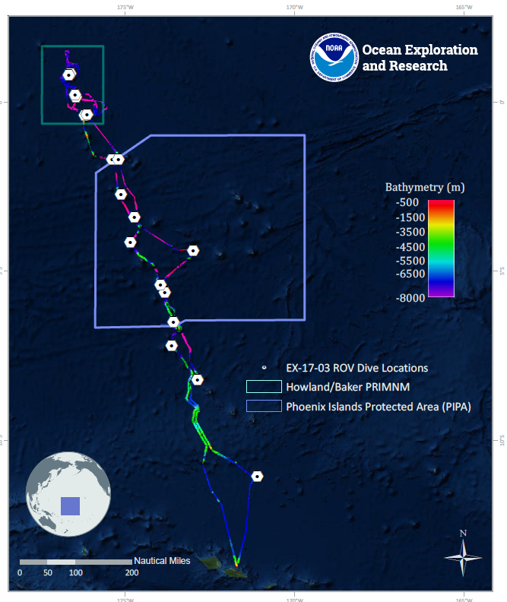
Site Name |  | Titov 2
Expedition Coordinator(s) |  | Brian RC Kennedy, Nick Pawlenko
ROV Lead(s) |  | Karl McLetchie
Science Team Lead(s) |  | Amanda Demopoulos and Steven Auscavitch
General Area Descriptor |  | Pacific Remote Islands Marine National Monument
ROV Dive Name
Cruise |  | EX-17-03
Leg |  | 0
Dive Number |  | 13
Equipment Deployed
ROV |  | Deep Discoverer (D2)
Camera Platform |  | Seirios
ROV Measurements |  | CTD |  | Depth | Altitude
 |  | Scanning Sonar |  | USBL Position | Heading
 |  | Pitch |  | Roll | HD Camera 1
 |  | HD Camera 2 |  | Low Res Cam 1 | Low Res Cam 2
 |  | Low Res Cam 3 |  | Low Res Cam 4 | Low Res Cam 5
Equipment Malfunctions
ROV Dive Summary  (from processed ROV data) |  | Dive Summary: EX1703_DIVE13  ^^^^^^^^^^^^^^^^^^^^^^^^^^^^^^^^^^^^^^^^^^^^^^^^^^^  In Water: 2017-03-20T18:45:43.299000  00°, 22.695' S ; 176°, 08.077' W  Out Water: 2017-03-21T02:40:09.227000  00°, 22.453' S ; 176°, 07.811' W  Off Bottom: 2017-03-21T01:52:56.706000  00°, 22.514' S ; 176°, 07.914' W  On Bottom: 2017-03-20T19:38:10.227000  00°, 22.680' S ; 176°, 07.972' W  Dive duration: 7:54:25  Bottom Time: 6:14:46  Max. depth: 1226.7 m
Special Notes
Scientists Involved  (please provide name, location, affiliation, email) |  | Name Affiliation Email Address  Abby Lapointe University of Hawaii abbylap@hawaii.edu  Amanda Demopoulos USGS ademopoulos@usgs.gov  Amanda Netburn NOAA OER amanda.netburn@noaa.gov  Amy Baco-Taylor FLorida State University abacotaylor@fsu.edu  Andrea Quattrini Harvey Mudd College aquattrini@g.hmc.edu  Asako Matsumoto Chiba Institute of Technology (Chitech), amatsu@gorgonian.jp  Bruce Mundy NOAA NMFS Pacific Islands Fisheries Science Center bruce.mundy@noaa.gov  Erik Cordes Temple University ecordes@temple.edu  Jaymes Awbrey University of Louisiana, Lafayette jawbrey@louisiana.edu  Les Watling University of Hawaii at Manoa watling@hawaii.edu  Mary Wicksten Texas A&M University Wicksten@bio.tamu.edu  Michael Parke NOAA PIFSC michael.parke@noaa.gov  Nicole Morgan Florida State University nmorgan@fsu.edu  Santiago Herrera Lehigh University sherrera@alum.mit.edu  Scott France University of Louisiana at Lafayette france@louisiana.edu  Steve Auscavitch Temple University steven.auscavitch@temple.edu  Timothy Shank Woods Hole Oceanographic Institution tshank@whoi.edu  Tina Molodtsova P.P.Shirshov Institute of Oceanology RAS tina.molodtsova@gmail.com  Mike Ford NOAA NMFS michael.ford@noaa.gov
Purpose of the Dive |  | The general goal of this dive is to acquire baseline information on deep sea habitats, seafloor geology, and biological communities on Titov Seamount in the Howland & Baker Unit of the Pacific Remote Islands Marine National Monument. Deep-sea environments around the Howland & Baker Islands are virtually unexplored leading to poor knowledge of biological resources protected by these reserves. This expedition has already explored the western ridge of Titov Seamount (Dive07) at a depth of 1890-1740m. This dive will provide some perspective on biological resources (fishes, biogenic habitat) as well as geological resources (crust precipitates) of the seamount. Understanding deep-sea coral distribution as well as bathyal fish communities is of great importance to inform management in the area. The age of Titov Seamount is not known.
Description of the Dive |  | EX1703 dive # 13 was our second dive at Titov Seamount. The dive track started at the base of a steep, sedimented slope at 1227 m. Immediately, we encountered a rattail previously unobserved on the expedition (Macrouridae/Bathygadinae: Gadomus) and also observed synaphobranchid eels (e.g., Synaphobranchus affinis). Other fish observed on the dive included several cusk eels (Ophidiidae: Spectrunculus sp., Dicrolene sp.), rattails (Coryphaenoides sp.; Nezumia?), goosefish (Lophiidae: Sladenia cf. zhui), brotula (Bythitidae: Diplacanthopoma), oreo fish (Oreosomatidae: Neocyttus cf. acanthorhynchus), tripod fish (Ipnopidae: Bathypterois cf. atricolor), deep-sea spiny eels (Halosauridae: Aldrovandia), and bristlemouths (Gonostomatidae). On the scattered manganese iron oxide coated boulders and rock substrate, we observed primnoids (cf. Narella) and plexaurids, generally oriented perpendicular to the current flow, which was north to south at the base of the slope.  As the ROV progressed upslope, the sedimented seafloor was bordered by exposed rock, and several coral colonies were observed attached to the hard substrate. On the rock fringe, we saw large primnoids (Callogorgia, Thouarella?), chrysogorgiids (Iridogorgia spp., Metallogorgia, and unknown), Anthomastus, Paragorgia, Isididae, Coralliidae, Victorgorgia, Bathypathes, Stichopathes, cf. Enallopsammia, stoloniferans, cup corals, and pennatulids. Other fauna included crinoids (Atelecrinidae), holothurians (Laetmogonidae?, Elpidiidae), sponges (Euplectellidae, Euretidae: Lefroyella, unknown demosponges, encrusting sponges), seastars (Zoroasteridae: Zoroaster, Benthopectinidae: Cheiraster?, Goniasteridae: Rosaster?), urchins (Echinothuriidae, Aspidodiadematidae), red crabs (Chaceon), tunicate, squat lobster (Eumunididae: Eumunida, Munididae: Munida), xenophyophores, nematocarcinids, and a benthic colonial siphonophore.  Along the crest of the seamount, several large boulders and rock features looked like coral gardens, with multiple colonies of deep-sea corals, some sponges, and associates. The hard substrate was dominated by yellow plexaurids (cf. Paramuricea-collected) and primnoids (Thouarella?). Throughout the dive, suspended particulate material was observed, possibly indicative of sufficient food supply to sustain these corals. Coral and sponge associates included euryalid serpent stars (ophiuroids), barnacles (verrucamorphs), anemones, polychaetes, amphipods, shrimp (Bathypalaemonella), and egg cases (cf. cephalopods).
Overall Map of the ROV Dive Area |  |  | Close-up Map of Main Dive Site
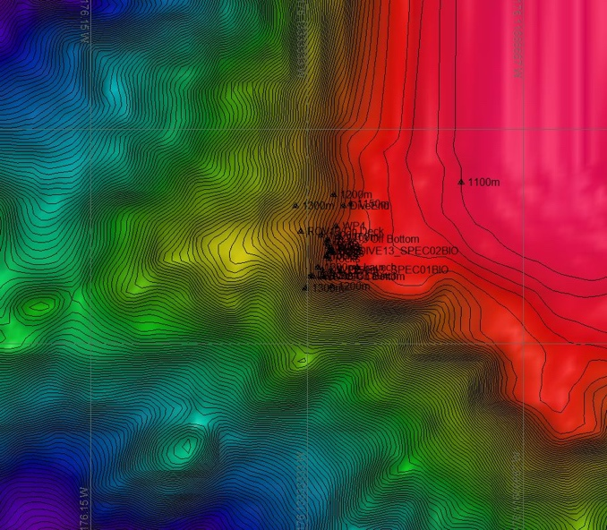 |  |  | 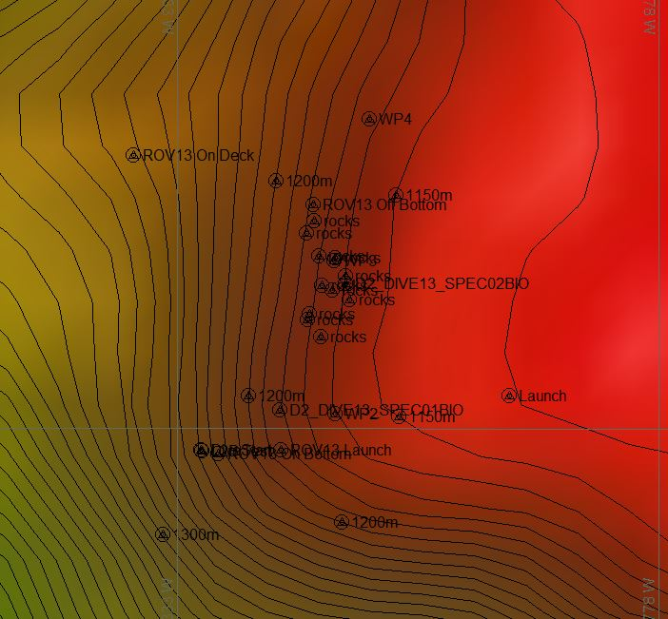
Representative Photos of the Dive
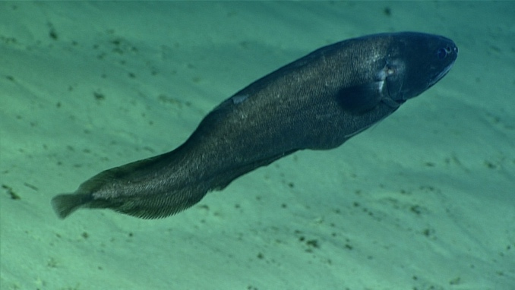 |  |  | 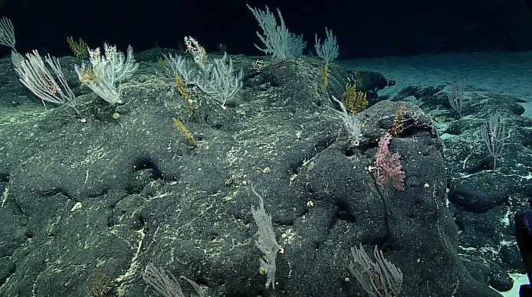
- Cusk Eel swims over a sedimented slope |  |  | - Sessile fauna growing on a Mn crusted rock.
Samples Collected
  - Sample
Sample ID | EX1703_20170320T211059_D2_DIVE13_SPEC01BIO |  | - 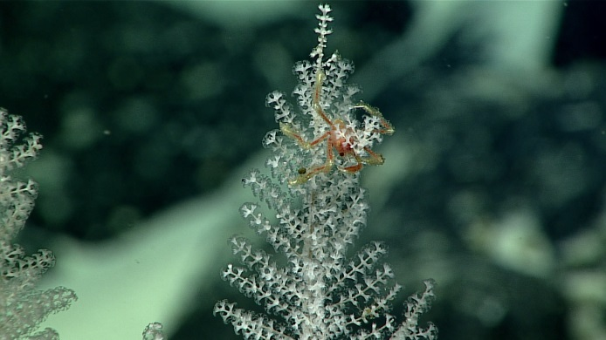
Date (UTC) | 20170320
Time (UTC) | 01:33:44
Depth (m) | 1179.89
Temperature (°C) | 4
Field ID(s) | Thouarella sp
Comments
Sample
Sample ID | EX1703_20170321T003156_D2_DIVE13_SPEC02BIO |  | - 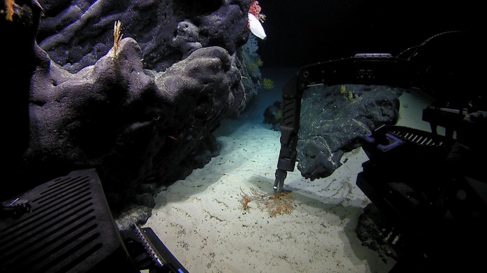
Date (UTC) | 20170320
Time (UTC) | 21:10:59
Depth (m) | 1142.22
Temperature (°C) | 4.18
Field ID(s) | Plexauridae
Comments

Please direct inquiries to:
NOAA Office of Ocean Exploration & Research
1315 East-West Highway (SSMC3 10th Floor)
Silver Spring, MD 20910
(301) 734-1014

