Okeanos Explorer ROV Dive Summary
Dive Information
Dive Map |  | 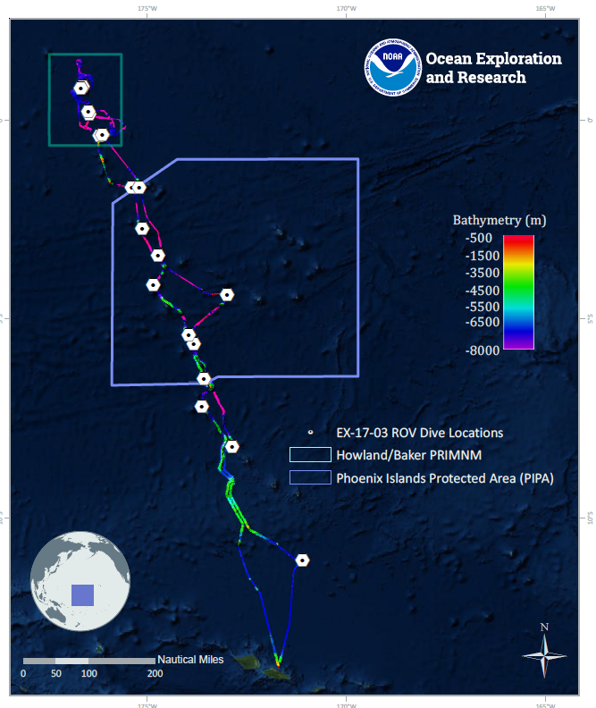
Site Name |  | Baker Islands Deep
Expedition Coordinator(s) |  | Brian RC Kennedy, Nick Pawlenko
ROV Lead(s) |  | Karl McLetchie
Science Team Lead(s) |  | Amanda Demopoulos and Steven Auscavitch
General Area Descriptor |  | Pacific Remote Islands Marine National Monument (PRIMNM)
ROV Dive Name
Cruise |  | EX-17-03
Leg |  | 0
Dive Number |  | 12
Equipment Deployed
ROV |  | Deep Discoverer (D2)
Camera Platform |  | Seirios
ROV Measurements |  | CTD |  | Depth | Altitude
 |  | Scanning Sonar |  | USBL Position | Heading
 |  | Pitch |  | Roll | HD Camera 1
 |  | HD Camera 2 |  | Low Res Cam 1 | Low Res Cam 2
 |  | Low Res Cam 3 |  | Low Res Cam 4 | Low Res Cam 5
Equipment Malfunctions
ROV Dive Summary  (from processed ROV data) |  | Dive Summary: EX1703_DIVE12  ^^^^^^^^^^^^^^^^^^^^^^^^^^^^^^^^^^^^^^^^^^^^^^^^^^^  In Water: 2017-03-19T18:23:57.293000  00°, 08.848' N ; 176°, 27.614' W  Out Water: 2017-03-20T02:29:27.003000  00°, 08.939' N ; 176°, 27.151' W  Off Bottom: 2017-03-20T01:40:10.914000  00°, 08.924' N ; 176°, 27.368' W  On Bottom: 2017-03-19T19:34:02.505000  00°, 08.849' N ; 176°, 27.641' W  Dive duration: 8:5:29  Bottom Time: 6:6:8  Max. depth: 1858.7 m
Special Notes
Scientists Involved  (please provide name, location, affiliation, email) |  | Name Affiliation Email Address  Amanda Demopoulos USGS ademopoulos@usgs.gov  Asako Matsumoto Chiba Institute of Technology (Chitech), amatsu@gorgonian.jp  Christopher Kelley University of Hawaii ckelley@hawaii.edu  Deborah Glickson National Academies of Sciences, Engineering, and Medicine dglickson@nas.edu  Erin Easton Ecology and Sustainable Management of Oceanic Islands erineeaston@gmail.com  Jill Bourque US Geological Survey Wetland and Aquatic Research Center jbourque@usgs.gov  Les Watling University of Hawaii at Manoa watling@hawaii.edu  Scott France University of Louisiana at Lafayette france@louisiana.edu  Steve Auscavitch Temple University steven.auscavitch@temple.edu  Timothy Shank Woods Hole Oceanographic Institution tshank@whoi.edu
Purpose of the Dive |  | The general goal of this dive is to acquire baseline information on deep sea habitats, seafloor geology, and biological communities on Baker Island in the Howland & Baker Unit of the Pacific Remote Islands Marine National Monument. Deep-sea environments around Howland & Baker Islands are virtually unexplored leading to poor knowledge of biological resources protected by these reserves. The previous Dive08 (this cruise) explored shallow and carbonate karstic terrain as well as upper bathyal fish communities <600m depth. This dive will provide some perspective on biological resources as well as geological foundations of the island. Understanding deep-sea coral distribution as well as bathyal fish communities is of great importance to inform management in the area. Additionally, the age of Baker Island is not known, nor has any record of rock dredging in the area been reported.
Description of the Dive |  | EX1703 dive # 12 was along a steep slope on a south ridge of Baker Island. The dive started at 1858m and the seafloor was composed of large boulders with exposed rock surfaces interspersed with sandy sediments. Several large boulders appeared as if they had been transported downslope via mass wasting events. There were columnar basalts observed along the slope, covered with thick manganese iron-oxide crust, some of which had a botryoidal texture (i.e., globular appearance).  As we transited up a steep slope, we encountered several fish species, including multiple cusk eels (Ophidiidae: Bassozetus, unknown Ophidiidae), batfish (Ogcocephalidae: cf. Halicmetus niger), rattails (Macrouridae: Coryphaenoides cf. armatus), brotula (Bythitidae: Diplacanthopoma), cutthroat eel (Synaphobranchidae), hake (Moridae: Lepidion), and several deep-sea spiny eels (Halosauridae: Halosaurus). Corals observed included black corals (Stichopathes and an unknown whip), chrysogorgiids (Iridogorgia cf. magnispiralis, Metallogorgia), Anthomastus tahinodus, bamboos (whips, cf. Eknomisis, cf. Jasonisis), cup corals, Victorgorgia, primnoid, paragorgiid, and yellow plexaurids. We also saw the colonial hydroid, Solanderia, with a possible egg case, a large polychaete, and isopod. Seastars (Pteraster, juvenile pterasterid, unknown goniasterid), urchins (aspidodiadematid, echinothuriids, cidarid), and holothurians (elpidiid, unknown purple specimen) were observed on rocks or the sediment surface. Other taxa observed included a few different types of sponges including Cladorhizidae, Euplectellidae, encrusting sponges, and a field of unknown dead hexactinellids, anemones (Hormathiidae), pectinid bivalves, stalked crinoids (Paratelecrinus sp.), and xenophyophores on the sediment and rock surfaces. Associates included ophiocanthids, polynoid and sabellid polychaetes, crinoids, and mysid shrimp. We saw a sea spider (cf. Colossendeis) eating a cup coral, which had not been observed by the scientists before. The dive ended on a short pinnacle composed of a basalt pavement seafloor. We observed and collected small snips of an unknown bifurcated bamboo near the peak of this feature.
Overall Map of the ROV Dive Area |  |  | Close-up Map of Main Dive Site
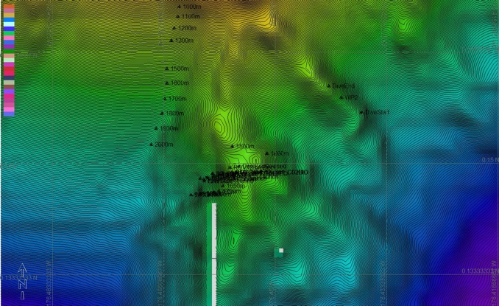
Representative Photos of the Dive
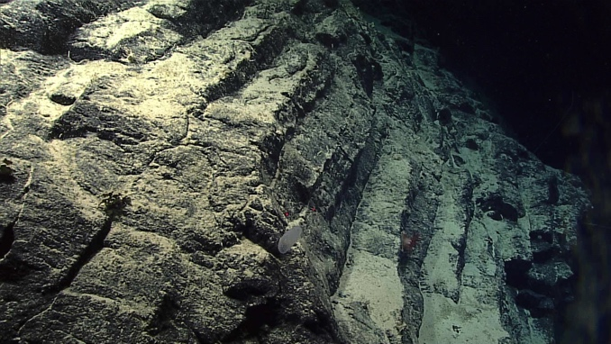 |  |  | 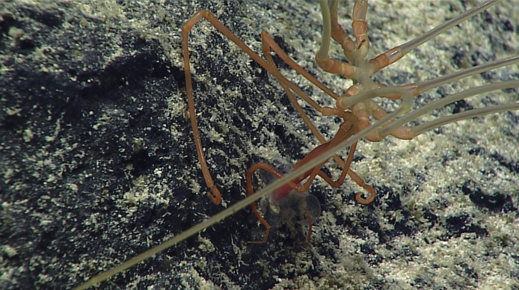
- Mn crusted rock with patches of sediment was common throughout the dive |  |  | - a sea spider (cf. Colossendeis) eats a cup coral
Samples Collected
  - Sample
Sample ID | EX1703_20170319T214245_D2_DIVE12_SPEC01GEO |  | - 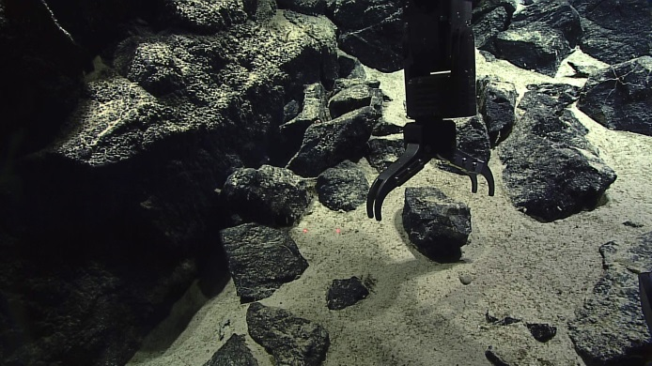
Date (UTC) | 20170319
Time (UTC) | 21:42:45
Depth (m) | 1760.22
Temperature (°C) | 2.57
Field ID(s) | Mn-crusted basalt
Comments
Sample
Sample ID | EX1703_20170320T012841_D2_DIVE12_SPEC02BIO |  | - 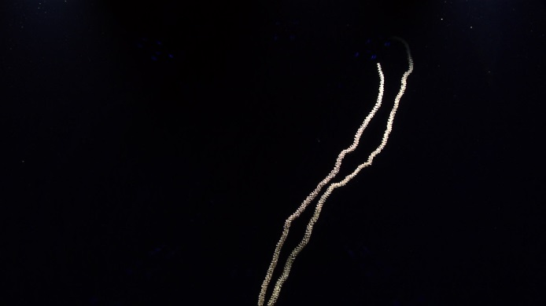
Date (UTC) | 20170320
Time (UTC) | 01:28:41
Depth (m) | 1495.54
Temperature (°C) | 3.01
Field ID(s) | Isididae
Comments
Sample
Sample ID | EX1703_20170320T013344_D2_DIVE12_SPEC03BIO |  | - 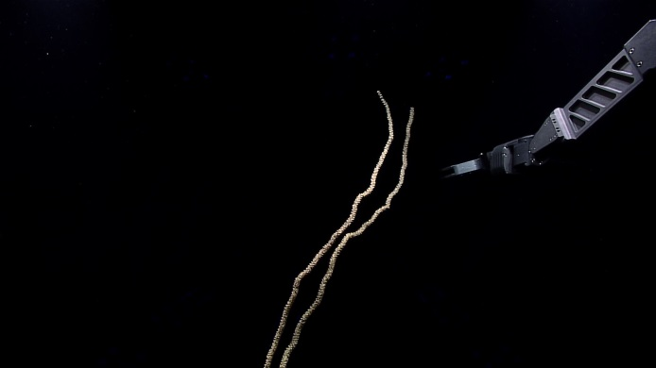
Date (UTC) | 20170320
Time (UTC) | 01:28:41
Depth (m) | 1495.68
Temperature (°C) | 2.99
Field ID(s) | Isididae
Comments

Please direct inquiries to:
NOAA Office of Ocean Exploration & Research
1315 East-West Highway (SSMC3 10th Floor)
Silver Spring, MD 20910
(301) 734-1014

