Okeanos Explorer ROV Dive Summary
Dive Information
Dive Map |  | 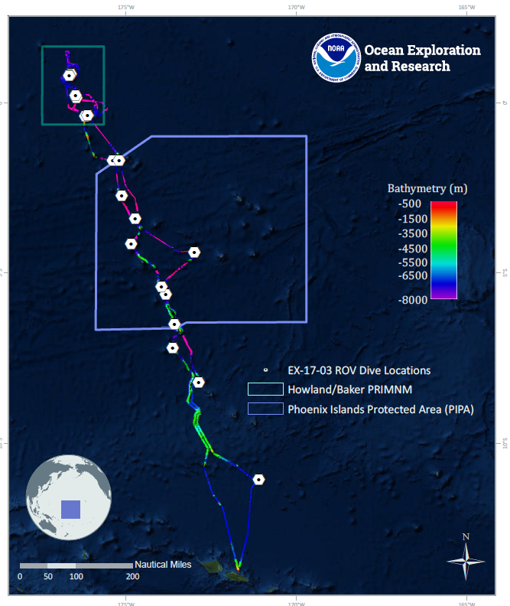
Site Name |  | Howland Deep 2
Expedition Coordinator(s) |  | Brian RC Kennedy, Nick Pawlenko
ROV Lead(s) |  | Karl McLetchie
Science Team Lead(s) |  | Amanda Demopoulos and Steven Auscavitch
General Area Descriptor |  | Pacific Remote Islands Marine National Monument
ROV Dive Name
Cruise |  | EX-17-03
Leg |  | 0
Dive Number |  | 11
Equipment Deployed
ROV |  | Deep Discoverer (D2)
Camera Platform |  | Seirios
ROV Measurements |  | CTD |  | Depth | Altitude
 |  | Scanning Sonar |  | USBL Position | Heading
 |  | Pitch |  | Roll | HD Camera 1
 |  | HD Camera 2 |  | Low Res Cam 1 | Low Res Cam 2
 |  | Low Res Cam 3 |  | Low Res Cam 4 | Low Res Cam 5
Equipment Malfunctions
ROV Dive Summary  (from processed ROV data) |  | Dive Summary: EX1703_DIVE11  ^^^^^^^^^^^^^^^^^^^^^^^^^^^^^^^^^^^^^^^^^^^^^^^^^^^  In Water: 2017-03-18T18:33:46.437000  00°, 48.032' N ; 176°, 40.513' W  Out Water: 2017-03-19T02:41:14.323000  00°, 48.441' N ; 176°, 40.048' W  Off Bottom: 2017-03-19T01:25:50.371000  00°, 48.390' N ; 176°, 40.238' W  On Bottom: 2017-03-18T19:56:33.804000  00°, 48.247' N ; 176°, 40.452' W  Dive duration: 8:7:27  Bottom Time: 5:35:16  Max. depth: 2226.9 m
Special Notes
Scientists Involved  (please provide name, location, affiliation, email) |  | Name Affiliation Email Address  Abby Lapointe University of Hawaii abbylap@hawaii.edu  Amanda Demopoulos USGS ademopoulos@usgs.gov  Asako Matsumoto Chiba Institute of Technology (Chitech), amatsu@gorgonian.jp  Chris Mah Dept. of Invertebrate Zoology, NMNH Smithsonian Institution brisinga@gmail.com  Christopher Kelley University of Hawaii ckelley@hawaii.edu  Dhugal Lindsay JAMSTEC dhugal@jamstec.go.jp  Erik Cordes Temple University ecordes@temple.edu  Nolan Barrett FAU Harbor Branch Oceanographic Institute barrettnh@g.cofc.edu  Scott France University of Louisiana at Lafayette france@louisiana.edu  Shirley Pomponi HBOI-FAU CIOERT spomponi@fau.edu  Steve Auscavitch Temple University steven.auscavitch@temple.edu
Purpose of the Dive |  | The goal of this dive is to acquire baseline information on deep sea habitats, seafloor geology, and biological communities on Howland Island in the Howland & Baker Unit of the Pacific Remote Islands Marine National Monument. Deep-sea environments around Howland & Baker Islands are virtually unexplored leading to poor knowledge of biological resources protected by these reserves. Previous Dive09 (this cruise) explored a steep slope downslope from this large ridge. This dive will carry on where the previous dive left off to survey the remainder of the ridge crest, including taking a closer look at a diversity of octocorals at the dive start location. Understanding deep-sea coral biological resources as well as bathyal fish communities is of great importance to inform management in the area.
Description of the Dive |  | EX1703 dive #11 continued our dive tract remaining from dive #9, transiting a ridge feature from 2227 to 2084 m depth. The seafloor at the start of the dive was a sedimented plateau surrounded by exposed, high profile rock features. Along the ridge track, we observed a sedimented slope with a perimeter of rocky ledges, which was interspersed by rock boulders. There were areas toward the end of the dive with continuous hard-rock pavement and with high profile, exposed rocky substrate.  We started the dive at the base of the ridge, on a plateau with several large coral colonies. We collected a piece from an unknown chrysogorgiid that had a width of 1.5m. Other corals encountered along the ridge included chrysogorgiids (Chrysogorgia, Iridogorgia, and unknown), primnoids (cf. Calyptrophora, Narella), seapens (Anthoptilum or Kophobelemnon), black corals (cf. Stichopathes, Heteropathes, Umbellapathes), bamboos (cf. Jasonisis [large colonies], Orstomisis, whip, unknown internodal branching form), Anthomastus cf. tahinodus, Paragorgia cf. coralloides, plexaurids, and Victorgorgia. We observed typical coral and sponge associates, including crinoids (e.g., Paratelecrinus), ophiuroids, ctenophores (Tjalfiella sp.), shrimp, unknown worms, and aplacophorans. One new “associate” observed was a cirrate octopod egg case attached to a paragorgiid octocoral. The case was cracked open, revealing the chorion, which may expand as the octopus embryo develops. We noted that other empty brown cases were observed on dive 9 at a similar depth, attached to a colonial hydroid (Solanderia). Other invertebrates observed, either attached to the rocks or on the sediment surface, included a few different types of holothurians (e.g., Mesothuria or Pseudostichopus), sea stars (Goniasteridae: cf. Calliaster sp., new species [collected], brisingids), solitary hydroid, hexactinellid sponges (Euplectellidae: Dictyaulus or Regadrella, unknown Corbitellinae with shrimp within the vase, Walteria sp., Heterorete, Chonelasma), a hermit crab with a zoanthid house, nematocarcinid shrimp with stilt-like legs, xenophyophores, stalked crinoids (cf. Bathycrinus), an asteroschema on the rock surface without a host (unusual), sea urchins (aspidodiadematids, echinothuriids), a gastropod (Gaza sp.) and a sea spider (cf. Colossendeis sp.). Along the ridge, we observed at least 3 fish species, including a few individuals of Halosaurs (Halosauridae: cf. Halosaurus) and cusk eels (Ophediidae: Porogadus cf. miles, Bassozetus).
Overall Map of the ROV Dive Area |  |  | Close-up Map of Main Dive Site
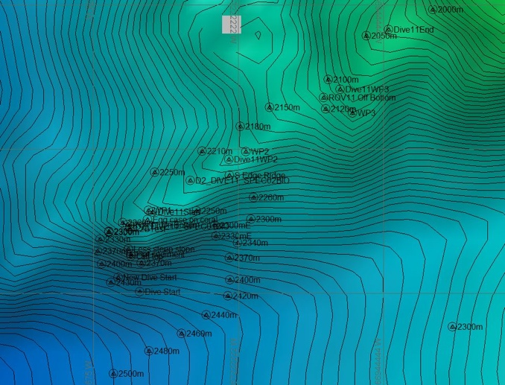 |  |  | 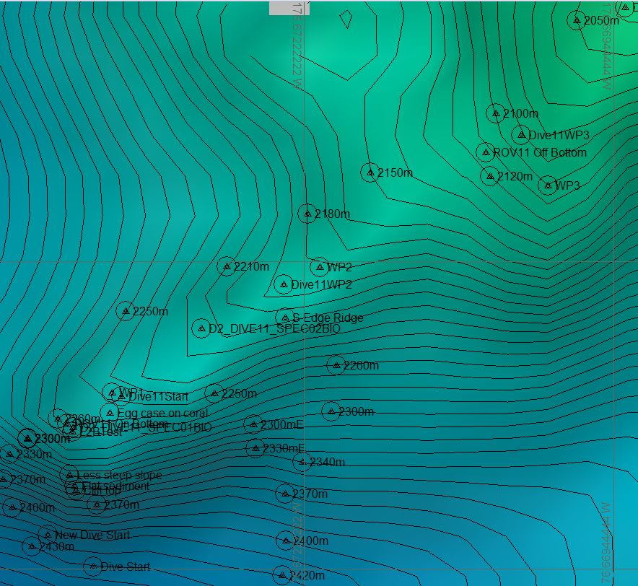
Representative Photos of the Dive
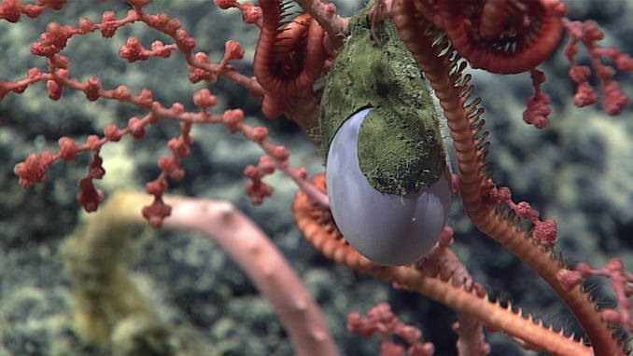 |  |  | 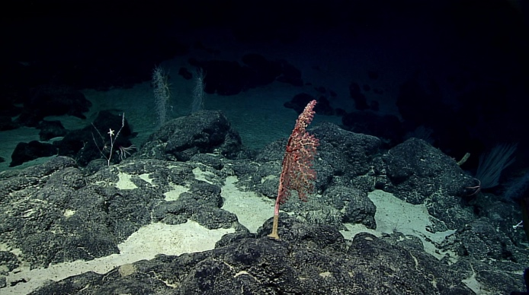
- A partially hatched octopus egg |  |  | - An octocoral and several sponges that were characteristic on the dive
Samples Collected
  - Sample
Sample ID | EX1703_20170318T204428_D2_DIVE11_SPEC01BIO |  | - 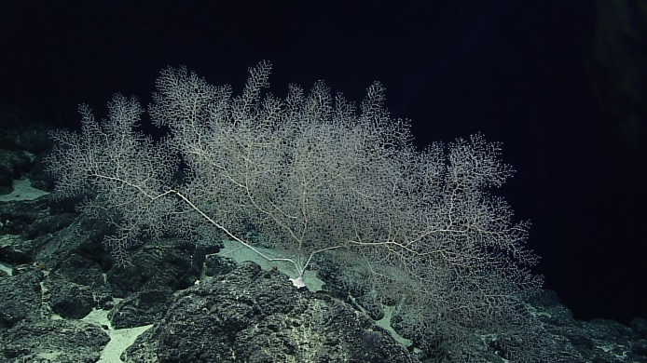
Date (UTC) | 20170318
Time (UTC) | 20:44:28
Depth (m) | 2226.58
Temperature (°C) | 2.14
Field ID(s) | Chrysogorgiidae
Comments
Sample
Sample ID | EX1703_20170318T231238_D2_DIVE11_SPEC02BIO |  | - 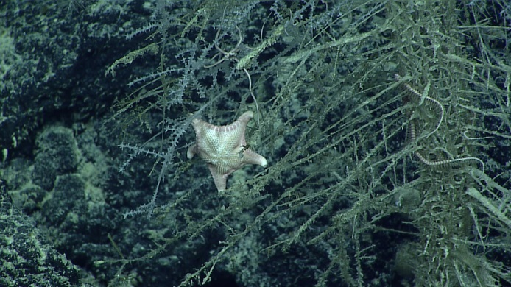
Date (UTC) | 20170318
Time (UTC) | 23:12:38
Depth (m) | 2175.43
Temperature (°C) | 2.15
Field ID(s) | Goniasteridae
Comments

Please direct inquiries to:
NOAA Office of Ocean Exploration & Research
1315 East-West Highway (SSMC3 10th Floor)
Silver Spring, MD 20910
(301) 734-1014

