Okeanos Explorer ROV Dive Summary
Dive Information
Dive Map |  | 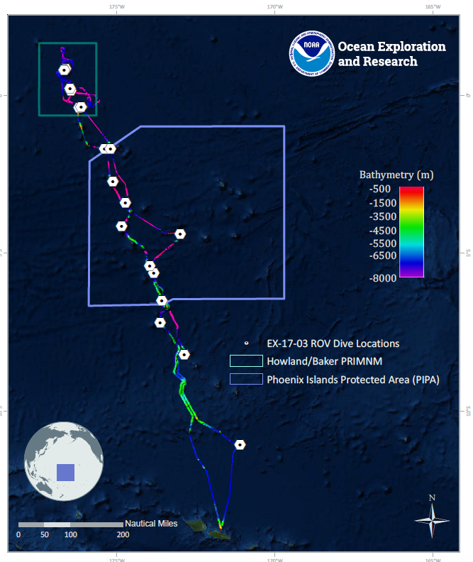
Site Name |  | Howland Island Shallow
Expedition Coordinator(s) |  | Brian RC Kennedy, Nick Pawlenko
ROV Lead(s) |  | Karl McLetchie
Science Team Lead(s) |  | Amanda Demopoulos and Steven Auscavitch
General Area Descriptor |  | Pacific Remote Islands Marine National Monument
ROV Dive Name
Cruise |  | EX-17-03
Leg |  | 0
Dive Number |  | 10
Equipment Deployed
ROV |  | Deep Discoverer (D2)
Camera Platform |  | Seirios
ROV Measurements |  | CTD |  | Depth | Altitude
 |  | Scanning Sonar |  | USBL Position | Heading
 |  | Pitch |  | Roll | HD Camera 1
 |  | HD Camera 2 |  | Low Res Cam 1 | Low Res Cam 2
 |  | Low Res Cam 3 |  | Low Res Cam 4 | Low Res Cam 5
Equipment Malfunctions
ROV Dive Summary  (from processed ROV data) |  | Dive Summary: EX1703_DIVE10  ^^^^^^^^^^^^^^^^^^^^^^^^^^^^^^^^^^^^^^^^^^^^^^^^^^^  In Water: 2017-03-17T19:05:02.914000  00°, 50.134' N ; 176°, 37.614' W  Out Water: 2017-03-18T02:29:02.976000  00°, 49.909' N ; 176°, 37.567' W  Off Bottom: 2017-03-18T02:04:17.034000  00°, 49.888' N ; 176°, 37.623' W  On Bottom: 2017-03-17T19:55:39.023000  00°, 50.095' N ; 176°, 37.525' W  Dive duration: 7:24:0  Bottom Time: 6:8:38  Max. depth: 587.7 m
Special Notes
Scientists Involved  (please provide name, location, affiliation, email) |  | Name Affiliation Email Address  Amanda Demopoulos USGS ademopoulos@usgs.gov  Bruce Mundy NOAA NMFS Pacific Islands Fisheries Science Center bruce.mundy@noaa.gov  Chris Mah Dept. of Invertebrate Zoology, NMNH Smithsonian Institution brisinga@gmail.com  Christopher Kelley University of Hawaii ckelley@hawaii.edu  Deborah Glickson National Academies of Sciences, Engineering, and Medicine dglickson@nas.edu  Erik Cordes Temple University ecordes@temple.edu  Erin Easton Ecology and Sustainable Management of Oceanic Islands erineeaston@gmail.com  Jaymes Awbrey University of Louisiana, Lafayette jawbrey@louisiana.edu  Jill Bourque US Geological Survey Wetland and Aquatic Research Center jbourque@usgs.gov  Kevin Kocot The University of Alabama kmkocot@ua.edu  Les Watling University of Hawaii at Manoa watling@hawaii.edu  Michael Parke NOAA PIFSC michael.parke@noaa.gov  Natalie Summers University of Hawaii at Manoa nsummers@hawaii.edu  Nicole Morgan Florida State University nmorgan@fsu.edu  Peter Auster Mystic Aquarium & UConn peter.auster@uconn.edu  Scott France University of Louisiana at Lafayette france@louisiana.edu  Shirley Pomponi HBOI-FAU CIOERT spomponi@fau.edu  Steve Auscavitch Temple University steven.auscavitch@temple.edu  Timothy Shank Woods Hole Oceanographic Institution tshank@whoi.edu
Purpose of the Dive |  | The goal of this dive is to acquire baseline information on deep sea habitats, seafloor geology, and biological communities on Howland Island in the Howland & Baker Unit of the Pacific Remote Islands Marine National Monument. Deep-sea environments around Howland & Baker Islands are virtually unexplored leading to poor knowledge of biological resources protected by these reserves. This dive will target shallower depths (<600m) of Howland Island to examine deep-sea coral, sponge, and fish communities and contrast those observations to a similar dive profile at Baker Is. Understanding deep-sea coral habitat distribution as well as fish communities is of great importance to inform management in the area. This feature has been dated to 70-74MY old (*see Koppers et al 2007 Geochem. Geophys. Geosyst.)
Description of the Dive |  | EX1703 dive 10 traversed the north slope of Howland Island. This was our 4th dive within the Pacific Remote Islands Marine National Monument. This dive traversed a depth range of 357-587 m in order to improve understanding of commercially important fish, as well as protected species, within the region. During descent, we noted several swimmers (small fish and crustaceans) in the water column, as well as high concentrations of particulate organic matter. We also noted a number of medusa (cf. Narcomedusae: Aegina), pyrosomes, and siphonophores.  The dive track started at the base of a relatively steep slope, progressed upslope to about 415 m, then followed the depth contour for a few hundred meters, then ascended to the 340m contour and traversed along that contour until the end of the dive. We observed a very high diversity of fishes, with approximately 38 taxa recorded. Specific fishes included midwater fishes (myctophids), and demersal species: goosefish (Lophiomus or Lophiodes spp.), sea toads (Chaunax spp.), codlings (Moridae: Physiculus sp.s), oreo fish (Oreosomatidae: Neocyttus cf. acanthorhynchus), scorpionfish (Bembridae: Bembradium sp., Pontinus sp.), rattails (Macrouridae: Nezumia sp., Coelorinchus spp.), tonguefish (Cynoglossidae: Symphurus spp.), congers (Congeridae: Gnathophis, Myrocongridae: Myroconger sp.), pearlfish (Carapidae: Tetragondacnus spilotus), dragonet (Callionymidae: Synchiropus sp.), roughy (Hoplostethus cf. crassispinus), sharks (Echinorhinus cookei and Carcharhinus sp.), greeneyes (Chlorophthalmidae: Chlorophthalmus sp.), deep-sea cardinal fish (Epigonidae: cf. Epigonus atherinoides), green-spotted duck billed fish (Chrionema chryseres), snake eels (Ophichthidae: Ophichthus), cusk eels (Ophediidae: Neobythites sp.), spikefish (Triacanthodidae: cf. Paratriacanthodes and unknown), armored sea robin (Triglidae: Satyrichthys or Scalicus sp.), grappos (Callanthiidae: Grammatonotus sp.), amberjack (Seriola sp.), dory (Zeniontidae: Cyttomimus sp.), boar fish (Antigonia), and “ocean bass” (Synagrops). The two pearlfish observed are representatives from a recently described genus and represent range extensions; they were previously only reported near Indonesia. A few fish species were observed with ectoparasitic gnathiid isopods attached.  And now for something completely different.  During the transit upslope, the rock face resembled features on Baker Island, with heavily eroded karstic terrain, interspersed with sedimented channels. Large patches of sediment were composed of small carbonate rocks with coral and shell fragments. Several different corals were observed clinging to vertical and near vertical rock ledges, including the precious coral, Coralliidae: cf. Pleurocorallium, Corallium, Hemicorallium, scleractinians (white and yellow Enallopsammia, a few cup coral species), plexaurids (Paracis sp. and cf. Swiftia), bamboos (branching and whip), primnoids (cf. Calyptrophora, collected, Callogorgia cf. formosa), acanthogorgiid, black corals (cf. Stichopathes, Bathypathes, Parantipathes?, Hexapathes?, and unknown black coral with long, extended branches), and colonial hydroid (Solanderia?). Dense colonies of Stichopathes and Callogorgia were observed on gently sloping sedimented terrain. We also noticed several tubes, both large and small in size, on the sedimented slope, that lacked an obvious inhabitant.  Coral associates observed included some of the largest ophiuroids (asteroschematids), chirostylids, shrimps, solitary hydroid, and amphipods. Along the rock walls, on the sediment surface, and within burrows, we observed several different kinds of squat lobsters, Galatheidae, shrimp (Heterocarpus), sea urchins (Benthopectinidae: Caenopedina cf. pulchella), several sponges (demosponges-collected one), a large hermit crab with anemone house, homolid crab without biological camouflage, a shy octopus hiding out in the sediment, and a portunid crab swimming and moving along the sediment. Underneath eroded carbonate overhangs, we saw limid bivalves. In one of the rock ledges, we observed the proboscis of spoonworm, Echiura, moving around in the water column, possibly suspension feeding.  Seastars encountered on the dive included Tarsastrocles verrilli, cookie stars (cf. Goniasteridae: Plinthaster), coral predator (Goniasteridae: Circeaster sandrae), slime star (Pterasteridae: Pteraster obesus), Asterinidae: Tremaster mirabilis (several), and Goniasteridae: Mediaster.
Overall Map of the ROV Dive Area |  |  | Close-up Map of Main Dive Site
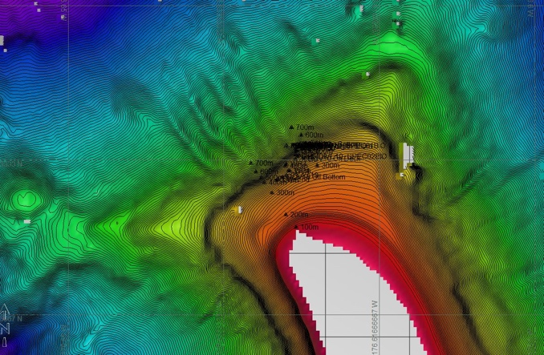 |  |  | 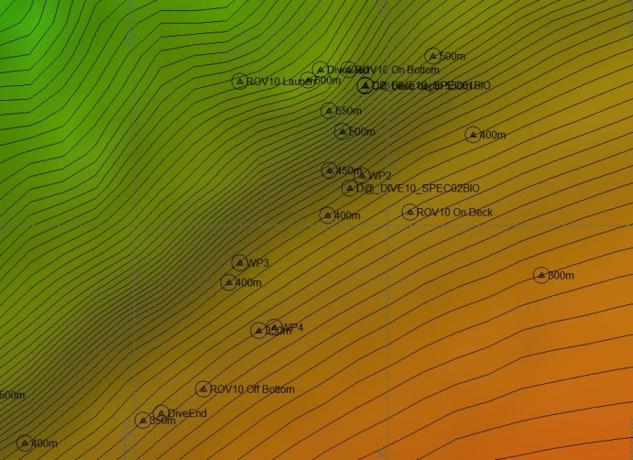
Representative Photos of the Dive
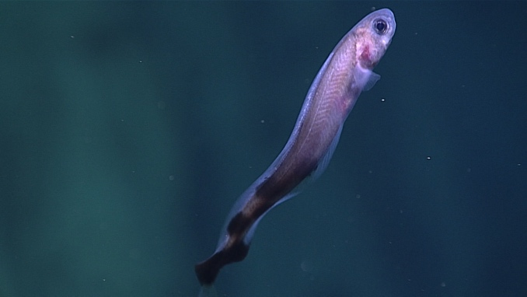 |  |  | 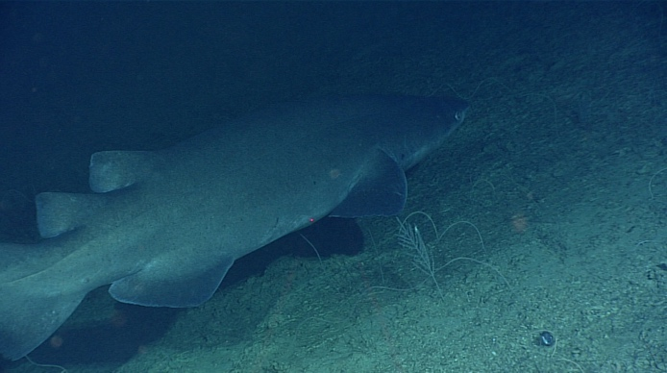
- This is the first image of Tetragondacnus spilotus seen alive and represents a significant range extension |  |  | - This Echinorhinus cookei was one of several sharks seen during the dive
Samples Collected
  - Sample
Sample ID | EX1703_20170317T210958_D2_DIVE10_SPEC01BIO |  | - 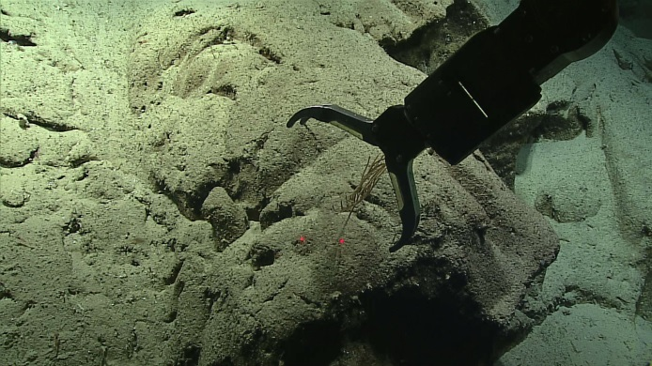
Date (UTC) | 20170317
Time (UTC) | 21:09:58
Depth (m) | 544.54
Temperature (°C) | 6.85
Field ID(s) | Calyptrophora sp.
Comments
Sample
Sample ID | EX1703_20170317T235520_D2_DIVE10_SPEC02BIO |  | - 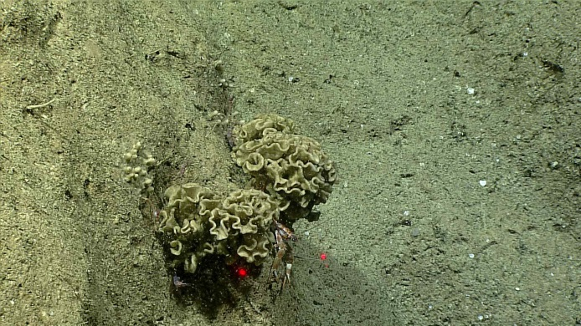
Date (UTC) | 20170317
Time (UTC) | 23:55:20
Depth (m) | 424.5
Temperature (°C) | 9.65
Field ID(s) | Demospongiae
Comments

Please direct inquiries to:
NOAA Office of Ocean Exploration & Research
1315 East-West Highway (SSMC3 10th Floor)
Silver Spring, MD 20910
(301) 734-1014

