Okeanos Explorer ROV Dive Summary
Dive Information
Dive Map |  | 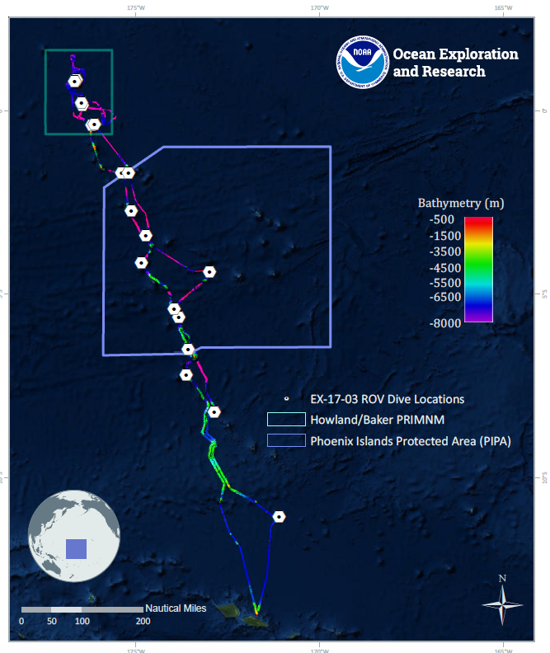
Site Name |  | Howland Island Deep 1
Expedition Coordinator(s) |  | Brian RC Kennedy, Nick Pawlenko
ROV Lead(s) |  | Karl McLetchie
Science Team Lead(s) |  | Amanda Demopoulos and Steven Auscavitch
General Area Descriptor |  | Pacific Remote Islands Marine National Monument
ROV Dive Name
Cruise |  | EX-17-03
Leg |  | 0
Dive Number |  | 09
Equipment Deployed
ROV |  | Deep Discoverer (D2)
Camera Platform |  | Seirios
ROV Measurements |  | CTD |  | Depth | Altitude
 |  | Scanning Sonar |  | USBL Position | Heading
 |  | Pitch |  | Roll | HD Camera 1
 |  | HD Camera 2 |  | Low Res Cam 1 | Low Res Cam 2
 |  | Low Res Cam 3 |  | Low Res Cam 4 | Low Res Cam 5
Equipment Malfunctions
ROV Dive Summary  (from processed ROV data) |  | Dive Summary: EX1703_DIVE09  ^^^^^^^^^^^^^^^^^^^^^^^^^^^^^^^^^^^^^^^^^^^^^^^^^^^  In Water: 2017-03-16T18:38:54.250000  00°, 48.139' N ; 176°, 40.481' W  Out Water: 2017-03-17T02:30:01.491000  N/A ; N/A  Off Bottom: 2017-03-17T01:15:08.573000  00°, 48.252' N ; 176°, 40.447' W  On Bottom: 2017-03-16T20:07:11.706000  00°, 48.155' N ; 176°, 40.435' W  Dive duration: 7:51:7  Bottom Time: 5:7:56  Max. depth: 2420.1 m
Special Notes
Scientists Involved  (please provide name, location, affiliation, email) |  | Name Affiliation Email Address  Amanda Demopoulos USGS ademopoulos@usgs.gov  Asako Matsumoto Chiba Institute of Technology (Chitech), amatsu@gorgonian.jp  Bruce Mundy NOAA NMFS Pacific Islands Fisheries Science Center bruce.mundy@noaa.gov  Chris Mah Dept. of Invertebrate Zoology, NMNH Smithsonian Institution brisinga@gmail.com  Christopher Kelley University of Hawaii ckelley@hawaii.edu  Dhugal Lindsay JAMSTEC dhugal@jamstec.go.jp  Erik Cordes Temple University ecordes@temple.edu  Jill Bourque US Geological Survey Wetland and Aquatic Research Center jbourque@usgs.gov  John Smith University of Hawaii/SOEST jrsmith@hawaii.edu  Kevin Kocot The University of Alabama kmkocot@ua.edu  Mary Wicksten Texas A&M University Wicksten@bio.tamu.edu  Natalie Summers University of Hawaii at Manoa nsummers@hawaii.edu  Nolan Barrett FAU Harbor Branch Oceanographic Institute barrettnh@g.cofc.edu  Scott France University of Louisiana at Lafayette france@louisiana.edu  Shirley Pomponi HBOI-FAU CIOERT spomponi@fau.edu  Steve Auscavitch Temple University steven.auscavitch@temple.edu
Purpose of the Dive |  | The goal of this dive is to acquire baseline information on deep sea habitats, seafloor geology, and biological communities on Howland Island in the Howland & Baker Unit of the Pacific Remote Islands Marine National Monument. Deep-sea environments around Howland & Baker Islands are virtually unexplored leading to poor knowledge of biological resources protected by these reserves. Two dives will be conducted at Howland Island, one deep (this dive) and one shallow (following day). Understanding deep-sea coral biological resources as well as bathyal fish communities is of great importance to inform management in the area. This feature has been dated to 70-74MY old (*see Koppers et al 2007 Geochem. Geophys. Geosyst.)
Description of the Dive |  | EX1703 dive 9 was our deepest of the expedition, starting at a depth of 2420 on a sedimented slope. There were several exposed rock features but most of the seafloor was composed of sandy sediments. As we transited upslope, the pilot noted a relatively high current. We observed a few different fish species along the sedimented slope, including spiny eels (Halosouridae: Aldrovandia spp.), cusk eels (Ophidiidae: Bassozetus), rattails (Macrouridae: Kumba?, Coryphaenoides), and an unknown snailfish (Liparidae) representing a new record for this region. Several of the fish observed had gnathiids and other isopod ectoparasites, which was also observed at the shallow dive at Baker Island. Other animals found on the sediment surface and rock debris included xenophyophores, holothurians, brachiopods, hexactinellid sponges, stalked crinoids, a pycnogonid, a brisingid seastar, and scaleworms (Polychaeta: Polynoidae).  At 2366 m, the ROV encountered a steep wall composed of intact and collapsed pillow lava. Few fish were observed along the wall, including rattails (Macrouridae: Coryphaenoides) and cusk eels (Ophidiidae: Bassozetus and unknown). Several glass sponges were observed, including vase-type euplectellids and Walteria-like branched sponges (e.g., Walteria cf. flemingi). We collected two sponges, a carnivorous sponge (Cladorhizidae) and a Walteria-like hexactinellid, both with multiple associates (polychaete, ctenophores, ophiuroid, hydroids, aplacophorans, amphipods, crinoids). Scattered corals occurred on the steep face, including an unusual planar chrysogorgid (with aplacophoran associate), cup corals, black corals (Bathypathes and Stichopathes), single stalk bamboo colony and stoloniferans. We observed and tried to collect an unknown goniasterid seastar, occurring deeper than any previous record (2332 m), but unfortunately were unable to collect it. We also saw a purple seastar (Pterasteridae: Hymenaster).  At the peak of the steep slope, the terrain transitioned to a flatter feature with local topographic highs, including large boulders. This area represented a plateau before the start of the main ridgeline. The boulders and exposed rocks were populated with the largest and most diverse corals that we had seen on the entire dive. We imaged a few different species of primnoids (e.g., Narella?), paragorgiids, branched bamboo corals (internodal [Keratoisis and Eknomisis], and nodal [Jasonisis or Orstomisis]), hydroid (Solanderia), and huge chrysgorgiids (~1.5 m wide). Each of the large colonies had at least one associate, including ophiuroids, chyrostylids, zoanthids, and crinoids. If possible, it will be interesting to continue this dive upslope to see if these multiple fan colonies continue up along the ridgeline.
Overall Map of the ROV Dive Area |  |  | Close-up Map of Main Dive Site
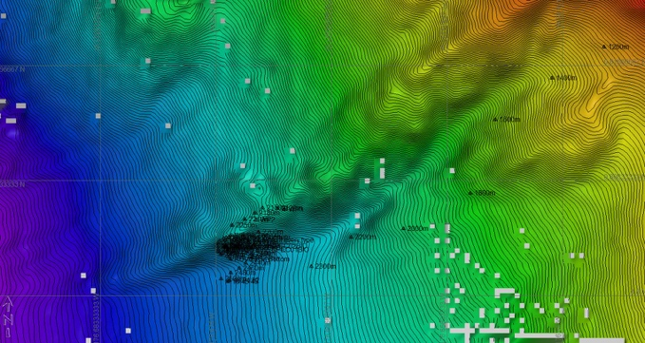 |  |  | 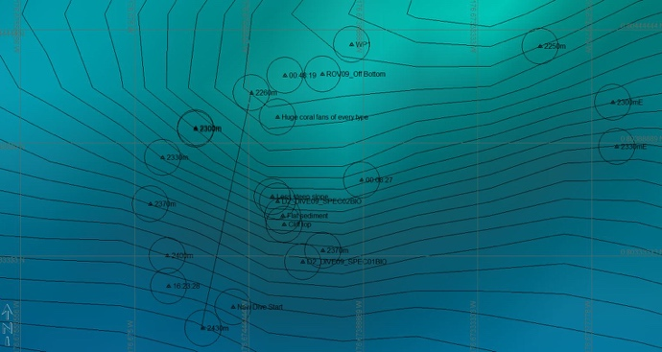
Representative Photos of the Dive
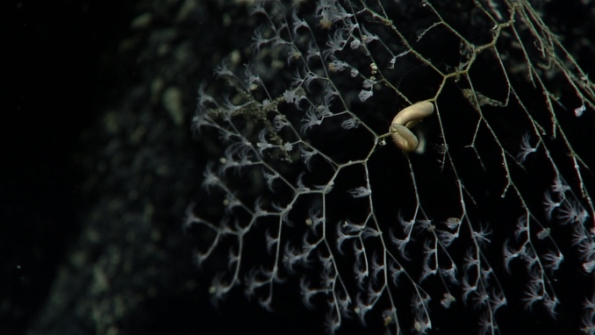 |  |  | 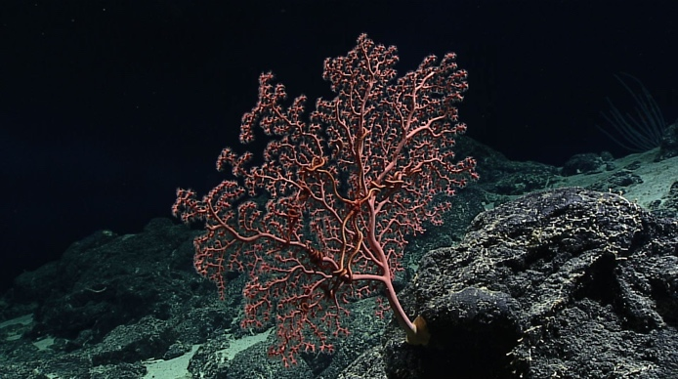
- An unusual planer chrysogorgiidae with an aplacophoran |  |  | - A large Paragorgiidae
Samples Collected
  - Sample
Sample ID | EX1703_20170316T213634_D2_DIVE09_SPEC01BIO |  | - 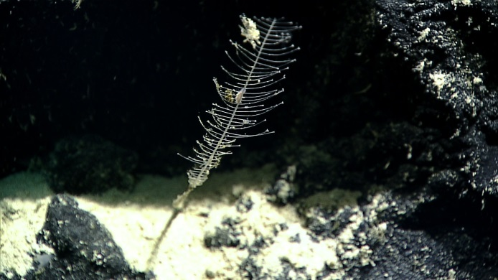
Date (UTC) | 20170316
Time (UTC) | 21:36:34
Depth (m) | 2346.35
Temperature (°C) | 1.87
Field ID(s) | Cladorhizidae
Comments
Sample
Sample ID | EX1703_20170316T234328_D2_DIVE09_SPEC02BIO |  | - 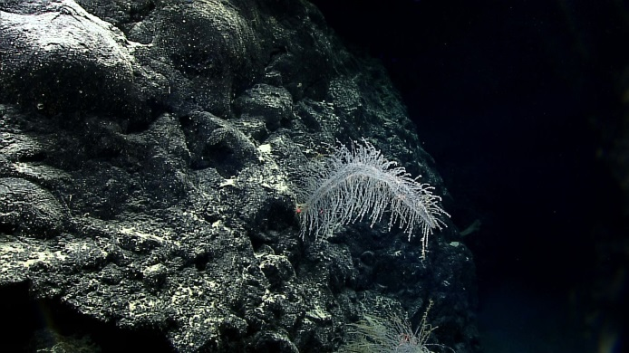
Date (UTC) | 20170316
Time (UTC) | 23:43:28
Depth (m) | 2290.07
Temperature (°C) | 1.95
Field ID(s) | Walteria sp.
Comments

Please direct inquiries to:
NOAA Office of Ocean Exploration & Research
1315 East-West Highway (SSMC3 10th Floor)
Silver Spring, MD 20910
(301) 734-1014

