Okeanos Explorer ROV Dive Summary
Dive Information
Dive Map |  | 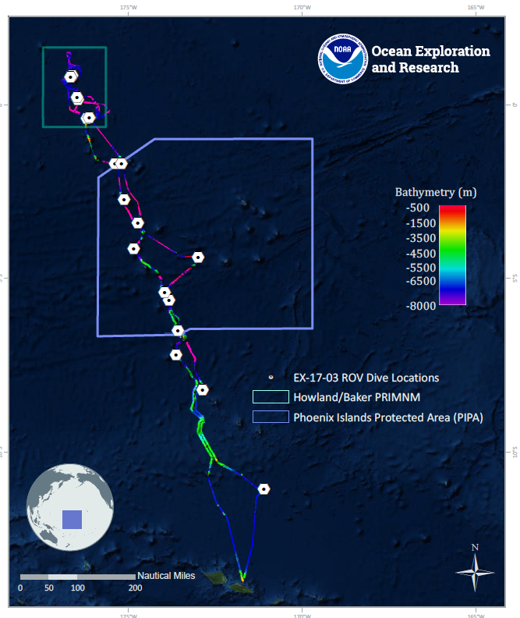
Site Name |  | Baker Island Shallow
Expedition Coordinator(s) |  | Brian RC Kennedy, Nick Pawlenko
ROV Lead(s) |  | Karl McLetchie
Science Team Lead(s) |  | Amanda Demopoulos and Steven Auscavitch
General Area Descriptor |  | Pacific Remote Islands Marine National Monument
ROV Dive Name
Cruise |  | EX-17-03
Leg |  | 0
Dive Number |  | 08
Equipment Deployed
ROV |  | Deep Discoverer (D2)
Camera Platform |  | Seirios
ROV Measurements |  | CTD |  | Depth | Altitude
 |  | Scanning Sonar |  | USBL Position | Heading
 |  | Pitch |  | Roll | HD Camera 1
 |  | HD Camera 2 |  | Low Res Cam 1 | Low Res Cam 2
 |  | Low Res Cam 3 |  | Low Res Cam 4 | Low Res Cam 5
Equipment Malfunctions
ROV Dive Summary  (from processed ROV data) |  | Dive Summary: EX1703_DIVE08  ^^^^^^^^^^^^^^^^^^^^^^^^^^^^^^^^^^^^^^^^^^^^^^^^^^^  In Water: 2017-03-15T19:14:08.386000  00°, 12.783' N ; 176°, 29.094' W  Out Water: 2017-03-16T02:39:47.879000  00°, 12.689' N ; 176°, 29.201' W  Off Bottom: 2017-03-16T02:10:21.574000  00°, 12.713' N ; 176°, 29.075' W  On Bottom: 2017-03-15T20:02:57.797000  00°, 12.729' N ; 176°, 29.192' W  Dive duration: 7:25:39  Bottom Time: 6:7:23  Max. depth: 725.5 m
Special Notes
Scientists Involved  (please provide name, location, affiliation, email) |  | Name Affiliation Email Address  Amanda Demopoulos USGS ademopoulos@usgs.gov  Andrea Quattrini Harvey Mudd College aquattrini@g.hmc.edu  Asako Matsumoto Chiba Institute of Technology (Chitech), amatsu@gorgonian.jp  Bruce Mundy NOAA NMFS Pacific Islands Fisheries Science Center bruce.mundy@noaa.gov  Christopher Kelley University of Hawaii ckelley@hawaii.edu  Deborah Glickson National Academies of Sciences, Engineering, and Medicine dglickson@nas.edu  Erik Cordes Temple University ecordes@temple.edu  Michael Parke NOAA PIFSC michael.parke@noaa.gov  Peter Auster Mystic Aquarium & UConn peter.auster@uconn.edu  Shirley Pomponi HBOI-FAU CIOERT spomponi@fau.edu  Sonia Rowley University of Hawai'i at Manoa srowley@hawaii.edu  Steve Auscavitch Temple University steven.auscavitch@temple.edu  Tara Harmer Luke Stockton University luket@stockton.edu  Timothy Shank Woods Hole Oceanographic Institution tshank@whoi.edu  Tina Molodtsova P.P.Shirshov Institute of Oceanology RAS tina.molodtsova@gmail.com  Mike Ford NOAA NMFS michael.ford@noaa.gov  Brendan Roak Texas A&M University broark@geos.tamu.edu
Purpose of the Dive |  | The goal of this dive is to acquire baseline information on deep sea habitats, seafloor geology, and biological communities on Baker Island in the Howland & Baker Unit of the Pacific Remote Islands Marine National Monument. Deep-sea environments around Howland & Baker Islands are virtually unexplored leading to poor knowledge of biological resources protected by these reserves.
Description of the Dive |  | EX1703 dive # 8 was along the NW ridge of Baker Island. The ROV descended to 725m and the seafloor was characterized by a steep rock wall with a sedimented slope at the base. Specific fishes observed on the dive included midwater myctophids and gonostomatids, plus oreo fish (Neocyttus sp.), beard fish (Polymixia sp.), conger eels (Bathycongrus?), alfonsinos (Beryx splendens), cusk eels (Pycnocraspedum spp., Neobythites, Benthocometes?), roughy (Hoplostethus spp.), goosefish (Lophiomus or Lophioides sp.), lanternfish (Neoscopelus), tonguefish (Symphurus spp.), rattails (Nezumia, Coelorinchus, Diplacanthopoma), deep-sea cardinalfish (Epigonus), green-spotted duckbill fish (Chrionema chryseres), snake eels (Ophichthus?), Randall’s snapper (Randallichthys filamentosus?), distant relative to the dory (Cyttomimus sp.), lanternbelly (Synagrops sp.), greeneye (Chlorophthalmus sp.), dogtooth tuna (Gymnosarda unicolor), spikefish (Triacanthodidae), sea toad (Chaunax sp.) and amberjack (Seriola sp.). While we have infrequently observed ectoparasites on very few fishes thus far, on this dive there were several fishes (Pycnocraspedum sp., other cusk eel, lophiids) that had ectoparasites (e.g., gnathiid isopods) attached to the skin, including different fins, mouth, and behind the eye.  As the ROV progressed up a very steep slope, several coral taxa were observed isidids (whips and Keratoisis), cup corals (multiple species), mushroom coral (Anthomastus), black corals (Bathypathes, Lillipathes?, Umbellapathes), unknown plexaurids (Acanthogorgia?), unknown primnoids, Victorgorgia?, Swiftia?, Chrysogorgia, and colonial scleractinians (Enallopsammia?, Madrepora).  Other invertebrates observed included 2 homolids, one holding onto a dead colonial scleractinian skeleton and one with a sponge, encrusting sponges with zoanthids, barrel sponges, an unusual branched sponge (Walteria-like), demosponges, corallimorpharian with pink tips on the tentacles, large Heterocarpus shrimps, red crabs (Chaceon sp.), seastars (Circeaster pullus?, Ceremaster, Cheiraster, Henricia, Tremaster mirabilis), sea urchins (echinothuriids), majid crabs with white and orange banded legs (Cyrtomaia?), hermit crabs with anemone houses, and comatulid feather stars.  Along the steep karst-like rock wall, there were several eroded channels and caverns, some of which hid limid bivalves (Acesta?) with tiny cup corals attached to the shells, an octopus, spiny sea urchins, and squat lobsters. These dramatic, cathedral-like rock features, continued up the slope to about 423m, where the seafloor leveled out to a sedimented plain. We will have a dive at a similar depth range on Howland Island coming up soon, so it will be interesting to see if we observe similar patterns in the geology, the biology and ecology.
Overall Map of the ROV Dive Area |  |  | Close-up Map of Main Dive Site
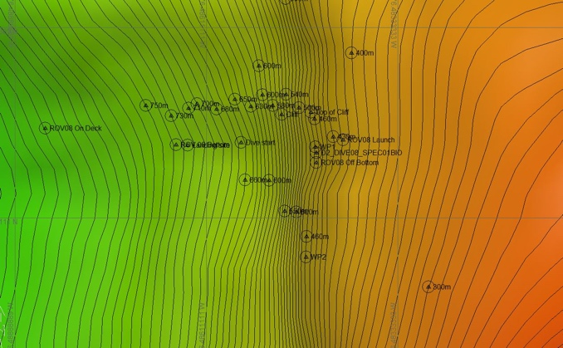 |  |  | 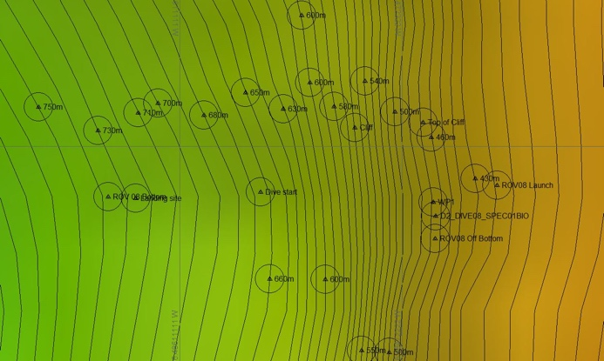
Representative Photos of the Dive
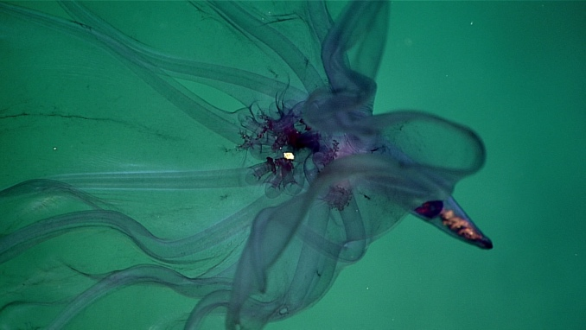 |  |  | 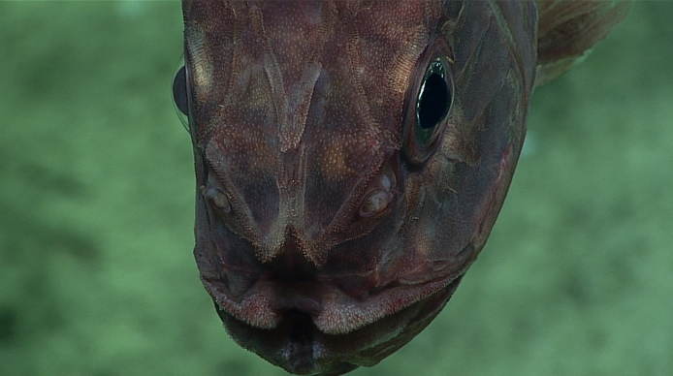
- A pelagic holothurian |  |  | - A roughy get up close and personal
Samples Collected
  - Sample
Sample ID | EX1703_20170316T015221_D2_DIVE08_SPEC01BIO |  | - 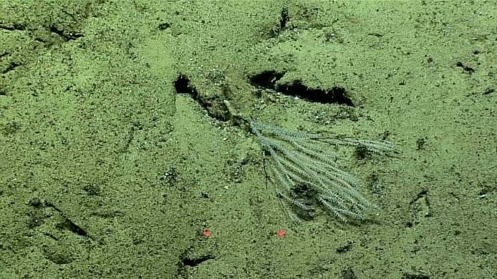
Date (UTC) | 20170316
Time (UTC) | 01:52:21
Depth (m) | 436.54
Temperature (°C) | 8.45
Field ID(s) | Primnoidae
Comments

Please direct inquiries to:
NOAA Office of Ocean Exploration & Research
1315 East-West Highway (SSMC3 10th Floor)
Silver Spring, MD 20910
(301) 734-1014

