Okeanos Explorer ROV Dive Summary
Dive Information
Dive Map |  | 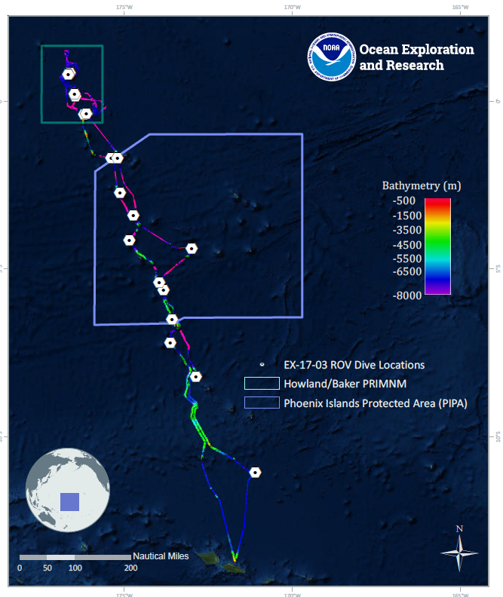
Site Name |  | Titov Seamount 1
Expedition Coordinator(s) |  | Brian RC Kennedy, Nick Pawlenko
ROV Lead(s) |  | Karl McLetchie
Science Team Lead(s) |  | Amanda Demopoulos and Steven Auscavitch
General Area Descriptor |  | Pacific Remote Islands Marine National Monument
ROV Dive Name
Cruise |  | EX-17-03
Leg |  | 0
Dive Number |  | 07
Equipment Deployed
ROV |  | Deep Discoverer (D2)
Camera Platform |  | Seirios
ROV Measurements |  | CTD |  | Depth | Altitude
 |  | Scanning Sonar |  | USBL Position | Heading
 |  | Pitch |  | Roll | HD Camera 1
 |  | HD Camera 2 |  | Low Res Cam 1 | Low Res Cam 2
 |  | Low Res Cam 3 |  | Low Res Cam 4 | Low Res Cam 5
Equipment Malfunctions
ROV Dive Summary  (from processed ROV data) |  | Dive Summary: EX1703_DIVE07  ^^^^^^^^^^^^^^^^^^^^^^^^^^^^^^^^^^^^^^^^^^^^^^^^^^^  In Water: 2017-03-14T18:27:45.880000  00°, 23.329' S ; 176°, 12.054' W  Out Water: 2017-03-15T02:31:43.308000  00°, 23.279' S ; 176°, 11.898' W  Off Bottom: 2017-03-15T01:18:14.284000  00°, 23.288' S ; 176°, 11.966' W  On Bottom: 2017-03-14T19:49:46.555000  00°, 23.219' S ; 176°, 12.148' W  Dive duration: 8:3:57  Bottom Time: 5:28:27  Max. depth: 1879.2 m
Special Notes
Scientists Involved  (please provide name, location, affiliation, email) |  | Name Affiliation Email Address  Amanda Demopoulos USGS ademopoulos@usgs.gov  Andrea Quattrini Harvey Mudd College aquattrini@g.hmc.edu  Asako Matsumoto Chiba Institute of Technology (Chitech), amatsu@gorgonian.jp  Bruce Mundy NOAA NMFS Pacific Islands Fisheries Science Center bruce.mundy@noaa.gov  Chris Mah Dept. of Invertebrate Zoology, NMNH Smithsonian Institution brisinga@gmail.com  Christopher Kelley University of Hawaii ckelley@hawaii.edu  Deborah Glickson National Academies of Sciences, Engineering, and Medicine dglickson@nas.edu  Erik Cordes Temple University ecordes@temple.edu  Jaymes Awbrey University of Louisiana, Lafayette jawbrey@louisiana.edu  Jill Bourque US Geological Survey Wetland and Aquatic Research Center jbourque@usgs.gov  Michael Parke NOAA PIFSC michael.parke@noaa.gov  Natalie Summers University of Hawaii at Manoa nsummers@hawaii.edu  Nolan Barrett FAU Harbor Branch Oceanographic Institute barrettnh@g.cofc.edu  Peter Auster Mystic Aquarium & UConn peter.auster@uconn.edu  Randi Rotjan Boston University rrotjan@bu.edu  Scott France University of Louisiana at Lafayette france@louisiana.edu  Steve Auscavitch Temple University steven.auscavitch@temple.edu  Timothy Shank Woods Hole Oceanographic Institution tshank@whoi.edu  Tina Molodtsova P.P.Shirshov Institute of Oceanology RAS tina.molodtsova@gmail.com
Purpose of the Dive |  | The goal of this dive is to acquire baseline information on deep sea habitats, seafloor geology, and biological communities on Titov Seamount in the Howland & Baker Unit of the Pacific Remote Islands Marine National Monument. Titov Seamount will be the first feature surveyed in the Howland & Baker Unit of PRIMNM. Titov is a crescent-shaped flat-topped guyot with a prominent ridge protruding from the western flank. Deep-sea environments around Howland & Baker islands are virtually unexplored leading to poor knowledge of biological resources protected by these reserves. In addition, this feature does not have a geologic age yet assigned to it.
Description of the Dive |  | Our first dive within the Pacific Remote Islands Marine National Monument was at Titov Seamount. The ROV descended to 1869m and the seafloor was characterized by steep rocky slope, with sediment channels and small rock debris. The presence of the rounded rock debris piles indicated some type of upper slope failure had occurred some time ago.  Several fish were observed at the beginning of the dive around the base of the slope: cusk eels (Bassozetus), rattails (Trachonurus and Coryphaenoides), and spiny eels (Aldrovandia). Given the presence of large patches of sandy sediment, there is likely sufficient infaunal prey for these fish to feed on at the base of the slope. Transiting upslope, we observed several comatulid and stalked crinoids, aspidodiadematid urchins, anemone/corallimorpharian, chiton, carnivorous tunicate, a cerianthid (with purple polychaete), seastars (Hymenaster, Radiaster), sponges (large vase-like euplectellids), and a hermit crab with a shiny shell. The stalked red crinoids (Proisocrinus ruberrimus?) had myzostomes attached to the arms and hydroids at the base. We also saw a new crinoid (Paratelecrinus) for the expedition, which had long arms with no pinnules near the tips. Corals attached to the rocks included Anthomastus, an unknown plexaurid, Victorgorgia, Stichopathes, isidids (whip and nodal branching forms [e.g., Jasonisis], Metallogorgia, Iridogorgia magnispiralis, and a cup coral.  The slope transitioned from large rock features with sediment patches to steep rock slabs with very little sediment. We saw several dead coral bases attached to rock surfaces. Multiple new coral species were observed, including a long bamboo whip (4m, “long bone?”), a few Callogorgia (collected), plexaurids (yellow with a white skeleton and red form), Swiftia? (collected), Iridogorgia (new species only observed at Necker Ridge), unknown chrysogorgiid (collected), Bathypathes, and Paragorgia coralloides? encrusted with zoanthids.  At ~ 1705m, the dive track transitioned to the ridgeline, which was composed of continuous smooth rock with no sediment drape. While we noticed relatively dense particulate organic matter in the water column throughout the dive, this increased as we progressed up the ridge. Along this track, there were several stalked hexactinellid sponges, Iridogorgia new sp., and yellow comatulids. We saw several ophiuroids (Ophioplinthaca) leaping off a dead bamboo skeleton onto the rock ridge below.  Toward the end of the dive, the seafloor pavement transitioned to exposed rock boulders and mounds interspersed with large patches of sandy sediment. Here we saw additional colonies of Callogorgia, antipatharians (yellow whips and new branched form), Paragorgia?, Victorgorgia, isidids (candelabra and whip forms), primnoid (Candidella?), and juvenile Metallogorgia. Holothurians and Umbellula seapens were found on the sediments. During the dive, we saw two separate carnivorous seastars (Calliaster?) feeding on bamboo coral. Coral associates observed included crinoids, ophiuroids (including Asteroschema), barnacles, amphipods, and chirostylid crabs (Gastroptychus cf. iaspis).  Overall, while the dive had low densities of taxa, we observed a high diversity of corals (26 spp), coral associates, and other invertebrate taxa (32spp.)
Overall Map of the ROV Dive Area |  |  | Close-up Map of Main Dive Site
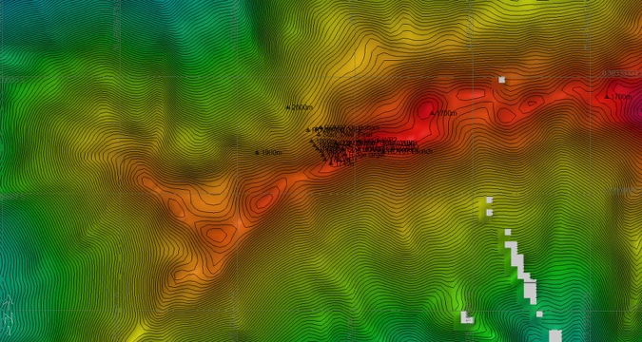 |  |  | 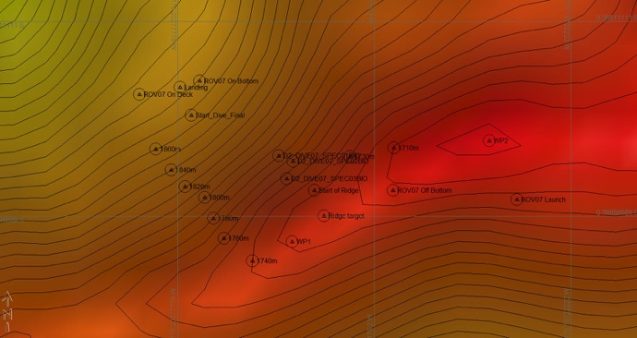
Representative Photos of the Dive
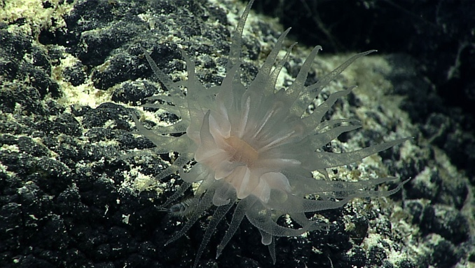 |  |  | 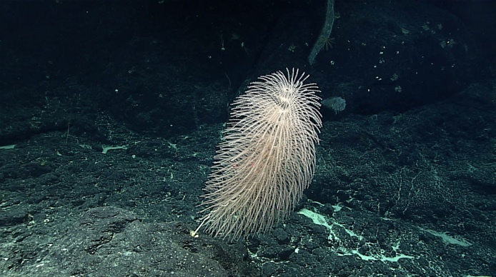
- A cup coral on Mn- crusted rocks |  |  | - One of serval Iridogorgias seen during the dive
Samples Collected
  - Sample
Sample ID | EX1703_20170314T222807_D2_DIVE07_SPEC01BIO |  | - 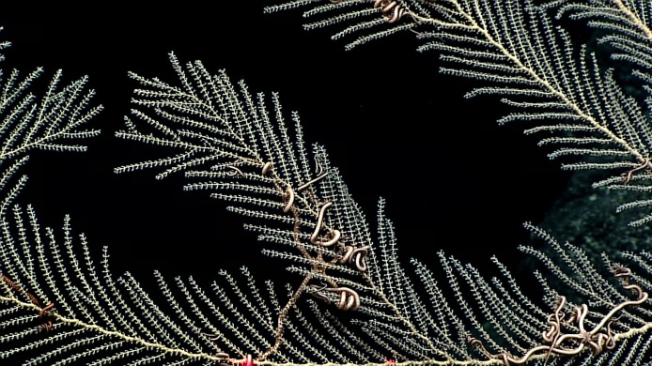
Date (UTC) | 20170314
Time (UTC) | 22:28:07
Depth (m) | 1759.66
Temperature (°C) | 2.58
Field ID(s) | Callogorgia
Comments
Sample
Sample ID | EX1703_20170314T224756_D2_DIVE07_SPEC02BIO |  | - 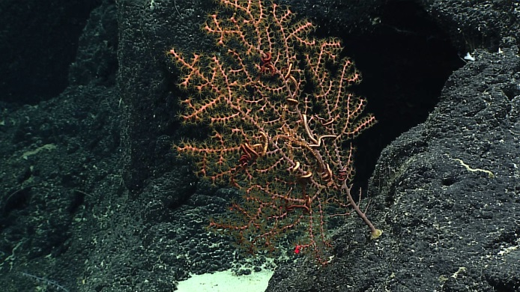
Date (UTC) | 20170314
Time (UTC) | 22:47:56
Depth (m) | 1747.7
Temperature (°C) | 2.64
Field ID(s) | Swiftia sp.
Comments
Sample
Sample ID | EX1703_20170314T232337_D2_DIVE07_SPEC03BIO |  | - 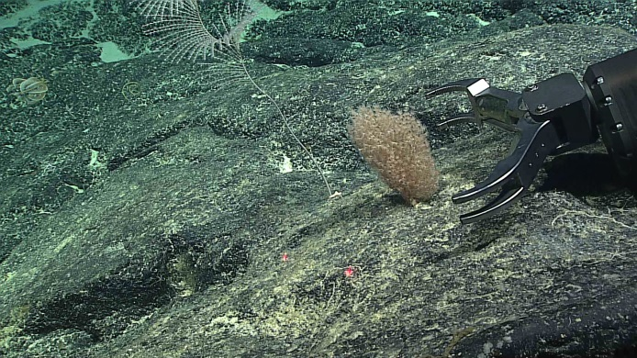
Date (UTC) | 20170314
Time (UTC) | 23:23:37
Depth (m) | 1719.6
Temperature (°C) | 2.72
Field ID(s) | Chrysogorgidae
Comments

Please direct inquiries to:
NOAA Office of Ocean Exploration & Research
1315 East-West Highway (SSMC3 10th Floor)
Silver Spring, MD 20910
(301) 734-1014

