Okeanos Explorer ROV Dive Summary
Dive Information
Dive Map |  | 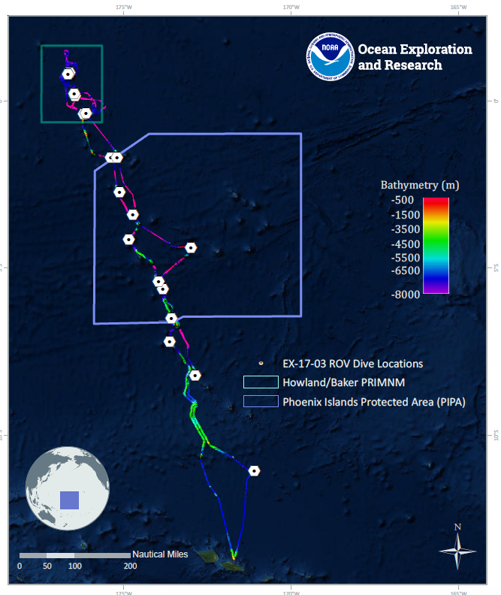
Site Name |  | Unnamed Seamount West of Winslow Reef
Expedition Coordinator(s) |  | Brian RC Kennedy, Nick Pawlenko
ROV Lead(s) |  | Karl McLetchie
Science Team Lead(s) |  | Amanda Demopoulos and Steven Auscavitch
General Area Descriptor |  | US EEZ around Howland and Baker Islands
ROV Dive Name
Cruise |  | EX-17-03
Leg |  | 0
Dive Number |  | 06
Equipment Deployed
ROV |  | Deep Discoverer (D2)
Camera Platform |  | Seirios
ROV Measurements |  | CTD |  | Depth | Altitude
 |  | Scanning Sonar |  | USBL Position | Heading
 |  | Pitch |  | Roll | HD Camera 1
 |  | HD Camera 2 |  | Low Res Cam 1 | Low Res Cam 2
 |  | Low Res Cam 3 |  | Low Res Cam 4 | Low Res Cam 5
Equipment Malfunctions
ROV Dive Summary  (from processed ROV data) |  | Dive Summary: EX1703_DIVE06  ^^^^^^^^^^^^^^^^^^^^^^^^^^^^^^^^^^^^^^^^^^^^^^^^^^^  In Water: 2017-03-13T18:25:37.688000  01°, 41.965' S ; 175°, 23.563' W  Out Water: 2017-03-14T02:50:41.378000  01°, 41.850' S ; 175°, 23.525' W  Off Bottom: 2017-03-14T01:47:03.849000  01°, 41.868' S ; 175°, 23.508' W  On Bottom: 2017-03-13T19:24:11.533000  01°, 41.898' S ; 175°, 23.732' W  Dive duration: 8:25:3  Bottom Time: 6:22:52  Max. depth: 1560.9 m
Special Notes
Scientists Involved  (please provide name, location, affiliation, email) |  | Abby Lapointe University of Hawaii abbylap@hawaii.edu  Adrienne Copeland NOAA adrienne.copeland@noaa.gov  Amanda Demopoulos USGS ademopoulos@usgs.gov  Amanda Netburn NOAA OER amanda.netburn@noaa.gov  Andrea Quattrini Harvey Mudd College aquattrini@g.hmc.edu  Bruce Mundy NOAA NMFS Pacific Islands Fisheries Science Center bruce.mundy@noaa.gov  Christopher Kelley University of Hawaii ckelley@hawaii.edu  Erik Cordes Temple University ecordes@temple.edu  Jaymes Awbrey University of Louisiana, Lafayette jawbrey@louisiana.edu  Jill Bourque US Geological Survey Wetland and Aquatic Research Center jbourque@usgs.gov  John Smith University of Hawaii/SOEST jrsmith@hawaii.edu  Kevin Kocot The University of Alabama kmkocot@ua.edu  Michael Parke NOAA PIFSC michael.parke@noaa.gov  Natalie Summers University of Hawaii at Manoa nsummers@hawaii.edu  Nicole Morgan Florida State University nmorgan@fsu.edu  Nolan Barrett FAU Harbor Branch Oceanographic Institute barrettnh@g.cofc.edu  Randi Rotjan Boston University rrotjan@bu.edu  Scott France University of Louisiana at Lafayette france@louisiana.edu  Shirley Pomponi HBOI-FAU CIOERT spomponi@fau.edu  Steve Auscavitch Temple University steven.auscavitch@temple.edu  Tara Harmer Luke Stockton University luket@stockton.edu  Taylor Heyl WHOI theyl@whoi.edu  Timothy Shank Woods Hole Oceanographic Institution tshank@whoi.edu  Tina Molodtsova P.P.Shirshov Institute of Oceanology RAS tina.molodtsova@gmail.com  Brendan Roak Texas A&M University broark@geos.tamu.edu  Kristen Mello University of New Hampshire klx97@wildcats.unh.edu
Purpose of the Dive |  | The goal of this dive is to acquire baseline information on deep sea habitats, seafloor geology, and biological communities on an unnamed seamount in the Winslow Reef complex. Winslow Reef proper lies within the Phoenix Islands Protected Area (PIPA). This feature appears to be part of the complex but lies across the US-Kiribati EEZ boundaries. Deep-sea environments inthe US EEZ around Howland & Baker Unit of the PRIMNM are virtually unexplored leading to poor knowledge of biological resources protected by these reserves.
Description of the Dive |  | EX1703 dive #6 was at an unnamed seamount west of Winslow Reef complex, within the US EEZ. The ROV descended to 1560 m depth and immediately encountered a steep slope with areas of sediment channels. Moving upslope, we observed several fishes, including cusk eels (Dicrolene, Bassozetus), brotula (Diplacanthopoma), slickhead (Alepocephalidae), and a cutthroat eel (Synaphobranchus, possibly a gravid female). Several large bamboo colonies were found attached to boulders, as well as large euplectellid sponges (Saccocalyx?), Metallogorgia? (juvenile), Iridogorgia spp. (I. magnispiralis and I. bella?), Anthomastus, xenophyophores, and a seastar (Zoroaster spinulosus?).  The dive track transitioned to a sedimented gradual slope, where typical sediment dwellers were observed: high densities of seapens (Umbellula, Halipteris?), aspidodiadematid and echinothuriid (Hygrosoma?) urchins, holothurians, sea spider (pycnogonid), few spiny eels (Halosauridae: Halosauropsis?, Aldrovandia), and tripod fish (Bathypterois cf. atricolor).  The final segment of the dive was characterized by sedimented ledges punctuated by high profile rocks and large boulders. Additional fauna encountered on this heterogeneous terrain included different bamboo species (Lepidisis? whip with amphipod associate and a branched form [collected]), zoanthids growing on a dead bamboo skeleton, black coral whips (Stichopathes), encrusting sponges, and a brisingid seastar. Additional fishes included a male halosaur, unknown cusk eels, and cutthroat eels. There were several dead bamboo skeletons and bases scattered throughout the beginning and end of the dive. We collected one base attached to manganese crust to estimate the coral age. We also continued to see the unknown yellow isidid (bamboo coral) observed at the beginning of the dive, so we collected a piece for identification.  At the summit (~1366 m), we traversed exposed rock interspersed with patches of sediment. Here we saw the largest bamboo colonies with crinoids and several squat lobsters (Chirostylidae: Gastroptychus) attached to the rocks. On a topographic high, we found a very large, green-blue plexaurid with several associates (crinoids, ophiuroids). Because we were uncertain about the family-level identification of this coral and new observation, we collected a piece, with associates (crinoids and ophiuroids), for further study. There was a seastar at the base of the colony (Korethrasteridae, Peribolaster? or Remaster?) that was new to the expedition.  This dive was characterized by the relatively high densities of one species of branched bamboo, with remarkably large colonies occurring at the summit. Given their size, and likely old age, there may be long-term environmental stability at this seamount, including adequate food supply, sufficient currents, and minimal direct human impact. However, the large density of dead bamboo bases and rock debris fields down slope may be indicative of periodic disturbance events, including landslides.
Overall Map of the ROV Dive Area |  |  | Close-up Map of Main Dive Site
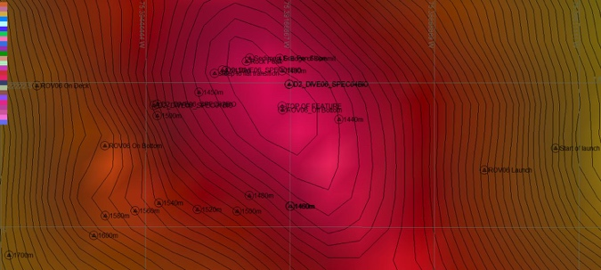 |  |  | 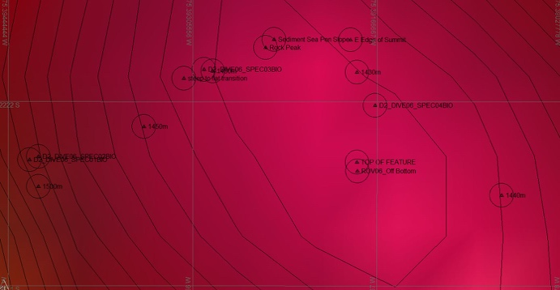
Representative Photos of the Dive
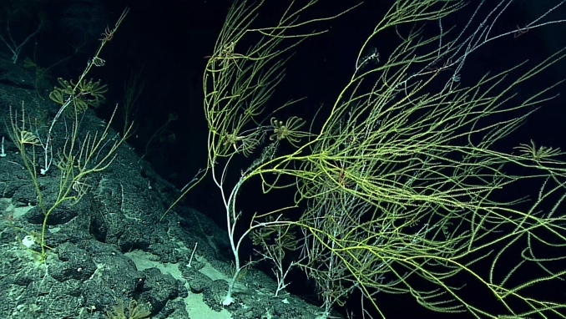 |  |  | 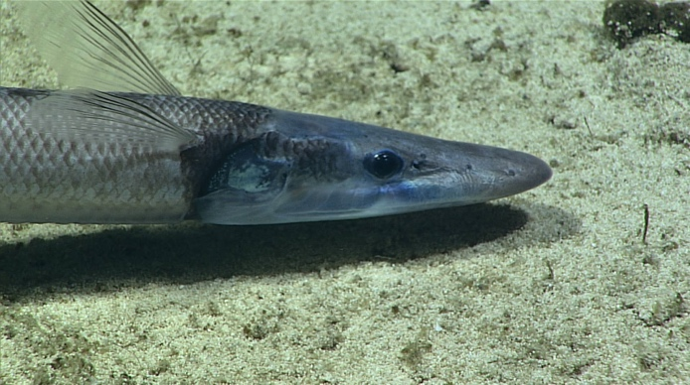
- One of the many brambly Bamboo corals that were common at this location |  |  | - One of several halosaurs imaged throughout the dive
Samples Collected
  - Sample
Sample ID | EX1703_20170313T214841_D2_DIVE06_SPEC01BIO |  | - 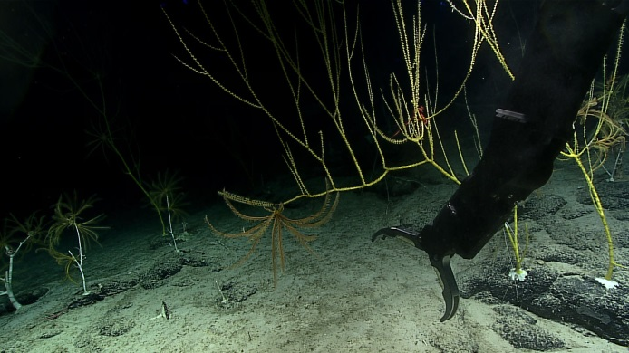
Date (UTC) | 20170313
Time (UTC) | 21:48:41
Depth (m) | 1510.22
Temperature (°C) | 3.18
Field ID(s) | Isididae branched
Comments | S1 Clade?
Sample |  |  |  |  |  | Sample
Sample ID | EX1703_20170313T220926_D2_DIVE06_SPEC02BIO |  | - 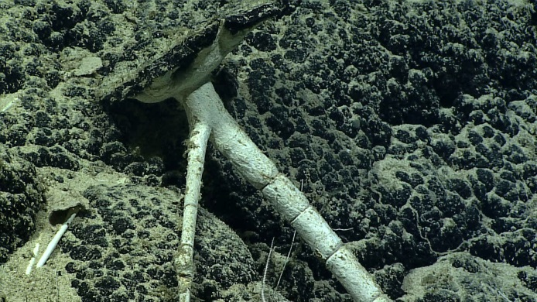
Date (UTC) | 20170313
Time (UTC) | 22:09:26
Depth (m) | 1512.57
Temperature (°C) | 3.20
Field ID(s) | Isididae
Comments | Dead skeleton
Sample |  |  |  |  |  | Sample
Sample ID | EX1703_20170313T232218_D2_DIVE06_SPEC03BIO |  | - 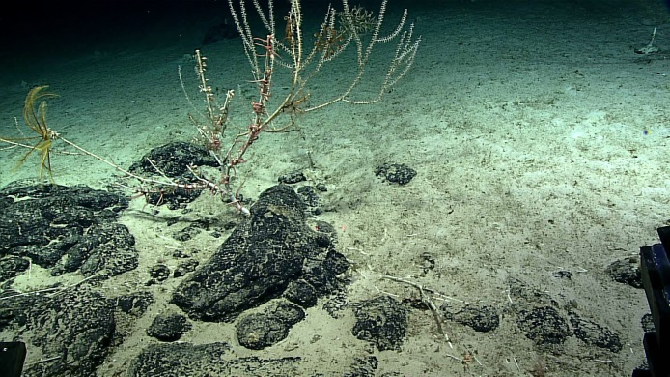
Date (UTC) | 20170313
Time (UTC) | 23:22:18
Depth (m) | 1431.36
Temperature (°C) | 3.25
Field ID(s) | Isididae
Comments
Sample |  |  |  |  |  | Sample
Sample ID | EX1703_20170314T013208_D2_DIVE06_SPEC04BIO |  | - 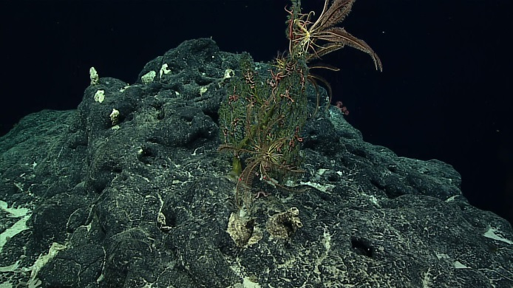
Date (UTC) | 20170314
Time (UTC) | 01:32:08
Depth (m) | 1370
Temperature (°C) | 3.31
Field ID(s) | Plexauridae
Comments

Please direct inquiries to:
NOAA Office of Ocean Exploration & Research
1315 East-West Highway (SSMC3 10th Floor)
Silver Spring, MD 20910
(301) 734-1014

