Okeanos Explorer ROV Dive Summary
Dive Information
Dive Map |  | 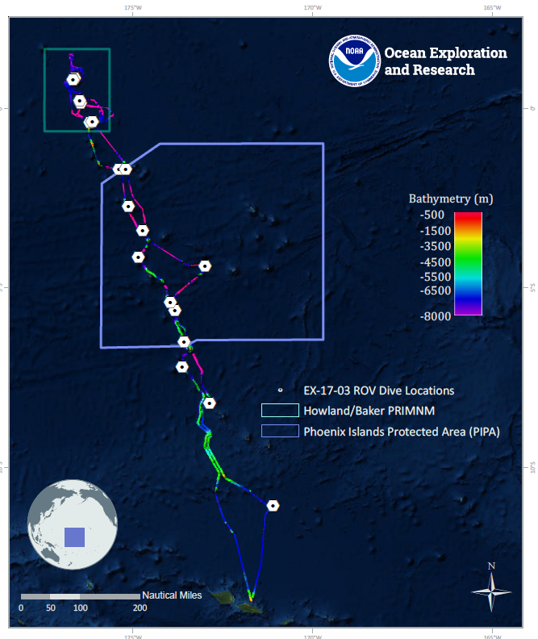
Site Name |  | Polo Seamount
Expedition Coordinator(s) |  | Brian RC Kennedy, Nick Pawlenko
ROV Lead(s) |  | Karl McLetchie
Science Team Lead(s) |  | Amanda Demopoulos and Steven Auscavitch
General Area Descriptor |  | Phoenix Islands Protected Area
ROV Dive Name
Cruise |  | EX-17-03
Leg |  | 0
Dive Number |  | 05
Equipment Deployed
ROV |  | Deep Discoverer (D2)
Camera Platform |  | Seirios
ROV Measurements |  | CTD |  | Depth | Altitude
 |  | Scanning Sonar |  | USBL Position | Heading
 |  | Pitch |  | Roll | HD Camera 1
 |  | HD Camera 2 |  | Low Res Cam 1 | Low Res Cam 2
 |  | Low Res Cam 3 |  | Low Res Cam 4 | Low Res Cam 5
Equipment Malfunctions
ROV Dive Summary  (from processed ROV data) |  | Dive Summary: EX1703_DIVE05  ^^^^^^^^^^^^^^^^^^^^^^^^^^^^^^^^^^^^^^^^^^^^^^^^^^^  In Water: 2017-03-12T18:29:00.845000  02°, 43.722' S ; 175°, 07.995' W  Out Water: 2017-03-13T02:45:52.390000  02°, 43.811' S ; 175°, 07.607' W  Off Bottom: 2017-03-13T01:29:47.965000  02°, 43.804' S ; 175°, 07.596' W  On Bottom: 2017-03-12T19:45:29.869000  02°, 43.683' S ; 175°, 07.864' W  Dive duration: 8:16:51  Bottom Time: 5:44:18  Max. depth: 2140.7 m
Special Notes
Scientists Involved  (please provide name, location, affiliation, email) |  | Name Affiliation Email Address  Amanda Demopoulos USGS ademopoulos@usgs.gov  Andrea Quattrini Harvey Mudd College aquattrini@g.hmc.edu  Asako Matsumoto Chiba Institute of Technology (Chitech), amatsu@gorgonian.jp  Christopher Kelley University of Hawaii ckelley@hawaii.edu  Erik Cordes Temple University ecordes@temple.edu  Jill Bourque US Geological Survey Wetland and Aquatic Research Center jbourque@usgs.gov  Les Watling University of Hawaii at Manoa watling@hawaii.edu  Michael Parke NOAA PIFSC michael.parke@noaa.gov  Nolan Barrett FAU Harbor Branch Oceanographic Institute barrettnh@g.cofc.edu  Randi Rotjan Boston University rrotjan@bu.edu  Shirley Pomponi HBOI-FAU CIOERT spomponi@fau.edu  Steve Auscavitch Temple University steven.auscavitch@temple.edu  Tara Harmer Luke Stockton University luket@stockton.edu  Taylor Heyl WHOI theyl@whoi.edu  Timothy Shank Woods Hole Oceanographic Institution tshank@whoi.edu  Tina Molodtsova P.P.Shirshov Institute of Oceanology RAS tina.molodtsova@gmail.com  Witting Jan Sea Education Association jwitting@sea.edu
Purpose of the Dive |  | The goal of this dive is to acquire baseline information on deep sea habitats, seafloor geology, and biological communities on Polo Seamount in the Phoenix Islands Protected Area (PIPA). Deep-sea environments in PIPA are virtually unexplored leading to poor knowledge of biological resources protected by the MPA.
Description of the Dive |  | EX1703 dive 5 was on Polo Seamount in the Tokelau Seamount Chain, and our third dive within the Phoenix Islands Protected Area. This was our deepest dive for the expedition so far, starting at 2134m and ending at 1834m. We noticed a fair amount of particulate organic matter in the water column on the descent, which was also observed during previous dives at Carondelet Reef (dive 3) and the unnamed seamount (dive 4). The dive started within a sedimented canyon-like feature and transited up a low-grade slope. Along the sedimented seafloor, we observed sea urchins (aspidodiadematid, Phrissocystis), possible cup corals, xenophyophores, nematocarcinid shrimp, holothurians (>2 species), 2 tripod fish (Bathypterois atricolor, one with an aegid parasite), a bythidid (Diplacanthopoma sp.), 2 rattails (Coryphaenoides sp.), zoroasterid seastar, and a seapen with a purple polychaete. A few large boulders were encountered with several attached fauna (corallimorpharian, black coral [Bathypathes?], crinoid, and tunicates with polychaete and anemone associates).  At approximately 2100m, the seafloor transitioned to steep exposed rock encrusted with manganese iron oxide. As we progressed up the rock face, additional corals were added to our observation list: Chrysogorgia spp., Iridogorgia, Metallogorgia, isidids (with nodal-branching [collected], internodal branching, and whip forms), coralliids (Hemicorallium?, other), Paragorgia coralloides, Pleurogorgia, primnoids (whips, Narella?, Candidella gigantea?, other), Victorgorgia, plexaurid (Paramuricea?), Anthomastus sp., and black corals (Parantipathes, Bathypathes, Stichopathes). Other invertebrates observed along the steep slope included coral associates (barnacles-Glyptelasma sp., crinoids, zoanthiids, chirostylids, amphipods), stalked crinoids (Hyocrinida, Guillecrinus, Proisocrinus ruberrimus?), tunicates, holothurians, seastars (brisingids, Henricia, Cheiraster, Asthenactis), hormathid anemones, and sponges (various hexactinellids). Almost every vertical rock face from 2002 to 1837 m was covered with high densities of corals, including mostly Pleurogorgia, and other unknown fan corals. Close to the summit of the knoll, we saw a large morid fish (Lepidion sp.) and halosaurid (Aldrovandia sp.). On the steep slope, pilots remarked that the current was variable and generally from the NE to the SW.  We ended the dive within 15m from the top of the knoll, but the seafloor leading to the peak was covered with corals and sponges. It was interesting to note that taxa densities and diversity appeared to increase toward the summit, at the same depths where similar patterns were observed on Carondelet Reef (dive 3). While it is difficult to generalize these patterns based on only 2 dives, it will be useful to conduct dives at similar depth ranges on other seamounts to examine if this pattern holds true.
Overall Map of the ROV Dive Area |  |  | Close-up Map of Main Dive Site
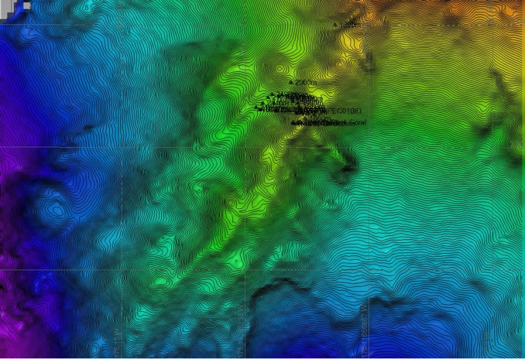 |  |  | 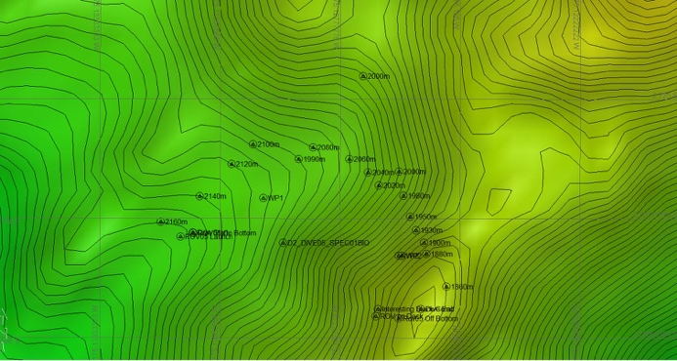
Representative Photos of the Dive
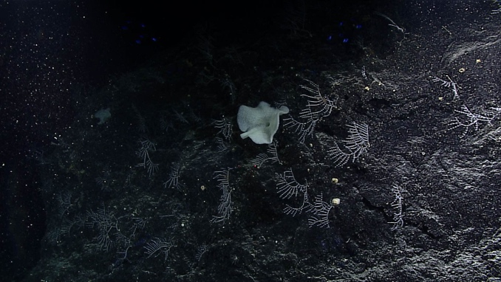 |  |  | 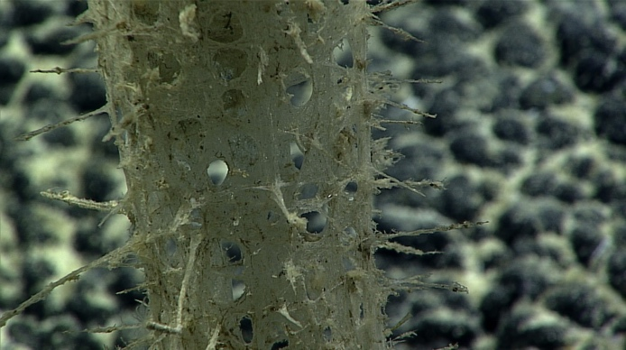
- Coral community seen near the end of the dive |  |  | - Glass Sponge
Samples Collected
  - Sample
Sample ID | EX1703_20170312T222950_D2_DIVE05_SPEC01BIO |  | - 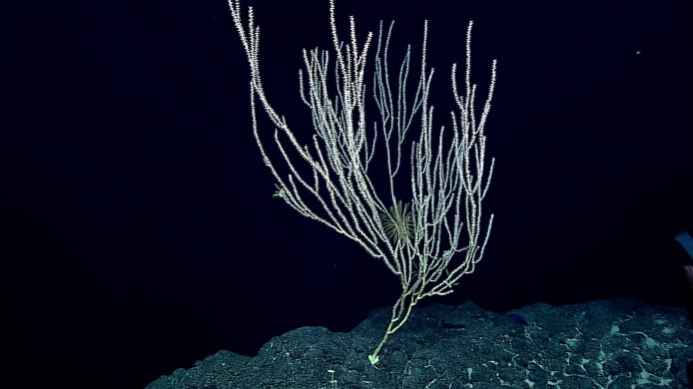
Date (UTC) | 20170312
Time (UTC) | 22:29:50
Depth (m) | 2050.86
Temperature (°C) | 2.2
Field ID(s) | Isididae - branching-unknown
Comments

Please direct inquiries to:
NOAA Office of Ocean Exploration & Research
1315 East-West Highway (SSMC3 10th Floor)
Silver Spring, MD 20910
(301) 734-1014

