Okeanos Explorer ROV Dive Summary
Dive Information
Dive Map |  | 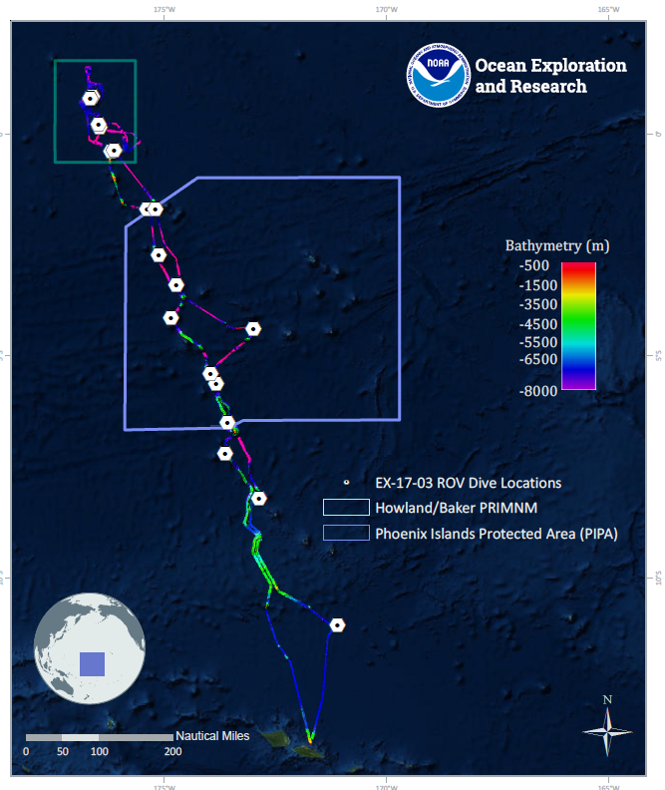
Site Name |  | Unnamed seamount 1 PIPA (Athena)
Expedition Coordinator(s) |  | Brian RC Kennedy, Nick Pawlenko
ROV Lead(s) |  | Karl McLetchie
Science Team Lead(s) |  | Amanda Demopoulos and Steven Auscavitch
General Area Descriptor |  | Phoenix Islands Protected Area
ROV Dive Name
Cruise |  | EX-17-03
Leg |  | 0
Dive Number |  | 04
Equipment Deployed
ROV |  | Deep Discoverer (D2)
Camera Platform |  | Seirios
ROV Measurements |  | CTD |  | Depth | Altitude
 |  | Scanning Sonar |  | USBL Position | Heading
 |  | Pitch |  | Roll | HD Camera 1
 |  | HD Camera 2 |  | Low Res Cam 1 | Low Res Cam 2
 |  | Low Res Cam 3 |  | Low Res Cam 4 | Low Res Cam 5
Equipment Malfunctions
ROV Dive Summary  (from processed ROV data) |  | Dive Summary: EX1703_DIVE04  ^^^^^^^^^^^^^^^^^^^^^^^^^^^^^^^^^^^^^^^^^^^^^^^^^^^  In Water: 2017-03-11T18:23:57.873000  04°, 09.023' S ; 174°, 51.182' W  Out Water: 2017-03-12T02:33:24.656000  04°, 08.814' S ; 174°, 51.198' W  Off Bottom: 2017-03-12T01:59:54.675000  04°, 08.815' S ; 174°, 51.126' W  On Bottom: 2017-03-11T19:15:59.828000  04°, 09.016' S ; 174°, 51.260' W  Dive duration: 8:9:26  Bottom Time: 6:43:54  Max. depth: 1228.2 m
Special Notes
Scientists Involved  (please provide name, location, affiliation, email) |  | Name Affiliation Email Address  Abby Lapointe University of Hawaii abbylap@hawaii.edu  Amanda Demopoulos USGS ademopoulos@usgs.gov  Amy Baco-Taylor FLorida State University abacotaylor@fsu.edu  Andrea Quattrini Harvey Mudd College aquattrini@g.hmc.edu  Asako Matsumoto Chiba Institute of Technology (Chitech), amatsu@gorgonian.jp  Chris Mah Dept. of Invertebrate Zoology, NMNH Smithsonian Institution brisinga@gmail.com  Christopher Kelley University of Hawaii ckelley@hawaii.edu  Erik Cordes Temple University ecordes@temple.edu  Jill Bourque US Geological Survey Wetland and Aquatic Research Center jbourque@usgs.gov  Ken Sulak USGS emeritus ksulak@usgs.gov  Les Watling University of Hawaii at Manoa watling@hawaii.edu  Malcolm Clark NIWA New Zealand malcolm.clark@niwa.co.nz  Michael Parke NOAA PIFSC michael.parke@noaa.gov  Nolan Barrett FAU Harbor Branch Oceanographic Institute barrettnh@g.cofc.edu  Randi Rotjan Boston University rrotjan@bu.edu  Santiago Herrera Lehigh University sherrera@alum.mit.edu  Steve Auscavitch Temple University steven.auscavitch@temple.edu  Tara Harmer Luke Stockton University luket@stockton.edu  Taylor Heyl WHOI theyl@whoi.edu  Timothy Shank Woods Hole Oceanographic Institution tshank@whoi.edu  Tina Molodtsova P.P.Shirshov Institute of Oceanology RAS tina.molodtsova@gmail.com  Witting Jan Sea Education Association jwitting@sea.edu
Purpose of the Dive |  | The goal of this dive is to acquire baseline information on deep sea habitats, seafloor geology, and biological communities on seamounts in the Phoenix Islands Protected Area (PIPA). This will be the second feature in the EX1703 expedition that will lie within the boundaries of PIPA. Deep-sea environments in PIPA are virtually unexplored leading to poor knowledge of biological resources protected by the MPA. This feature has a summit depth of ~1050m with three prominent ridges to the east, west, and south. The summit cap is approx. 250m in diameter.
Description of the Dive |  | EX1703 dive number 4 was at an unnamed seamount in the Tokelau Seamount Chain, and our second dive within the Phoenix Islands Protected Area. The dive started at 1228 m and continued up a steep slope. We noticed a fair amount of particulate organic matter in the water column on the descent, which was also observed during the previous dive at Carondelet Reef. At the base of the slope (1228m), the pilots noted a weak current to the southeast, and the dominant substrate was steep exposed manganese-coated rock with patches of sediment. Periodically, we saw xenophyophores on the sediment surface. We also immediately encountered several corals attached to rocks (Iridogorgia magnispiralis, plexaurid [Paramuricea?], branched and unbranched chrysogorgiids) and sea pens within the sediment (Umbellula, Protoptilum?, and halipterid). Heading upslope, we added a few more coral species to our roster, including a bamboo whip, at least 2 different primnoids, Victorgorgia?, numerous white octocorals (Coralliidae: cf. Pleurocorallium kishinouye), Paragorgia?, stoloniferans, and Anthomastus. Numerous colonies of a suspected coralliid, cf. Pleurocorallium kishinouye, a known precious coral, were observed on the rock slabs.  Several species of fish were observed along the steep slope: synaphobranchids, ophidiids (e.g., Lamprogrammus, Monomitopus?), bythidiids (Diplacanthopoma), chiasmodontid (Chiasmodon?), and a goosefish (Sladenia). Coral and sponge associates included chirostylids, ophiuroids (e.g., Asteroschema), crinoids, amphipods, polychaetes, and shrimp. Other invertebrates observed on the steep slope included seastars (brisingids, Asthenactis?, Zoroaster?, Tremaster mirabilis, Mediaster?, purple form buried in the sediment), long-spined urchins (Aspidodiadema?), echinothurids, hexactinellid sponges (e.g., euplectellids), stalked crinoids (Phrynocrinidae, collected, and at least one other species), and Relicanthus sp. “anemones”. Pelagic organisms were more abundant on this dive, and included ctenophores, siphonophores, black medusae (Vampyrocrossota childressi?), pelagic holothurian (Pelagothuria natatrix?), 2 Chiroteuthis squids (one holding on to another squid), plus several midwater fish (gonostomatids?). We also collected a rock with at least 1 colony of the abundant white coral (cf. Pleurocorallium kishinouye) and a snip from the purple coral (Victorgorgia?).  The south approach to the summit revealed large pavement blocks that were very fragmented, with little sediment drape. We moved around the east, north, and west sectors of the summit, and also turned out the ROV lights to see if that revealed any fishes. The lights-out experiment was not productive, but we did see a few more fishes (tripodfish [ipnopid: Bathypterois atricolor], Holcomycteronus sp.?, synaphobranchids), another Chrysogorgia sp. with associates, blind lobster (polychelid), isopods (cirolanids), and a Phormosoma urchin with puffy spines.  Notable observations included homolid crabs gripping sponges, hydroids, or anemones, and Chrysogorgia with possible squid egg cases (at least 3 colonies observed). Overall, we observed several taxa similar to our dive on Swains Island, plus a few new species. Several fish observations represent new records for Kiribati and overall, we improved understanding of deep-sea corals, sponges, and fishes found within PIPA.
Overall Map of the ROV Dive Area |  |  | Close-up Map of Main Dive Site
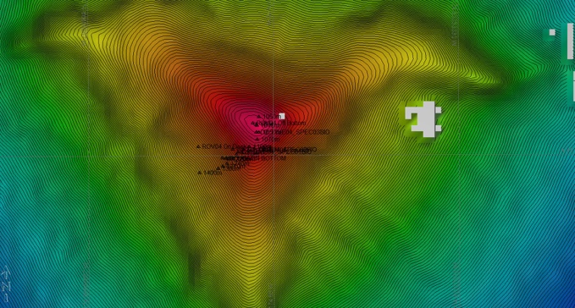 |  |  | 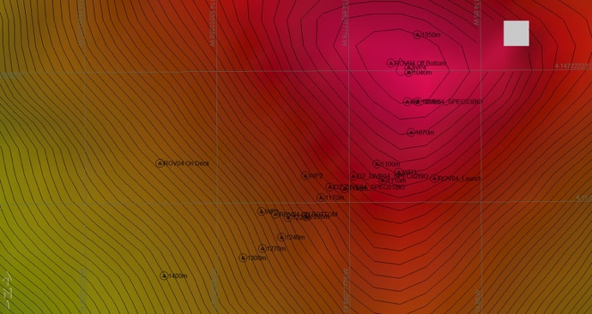
Representative Photos of the Dive
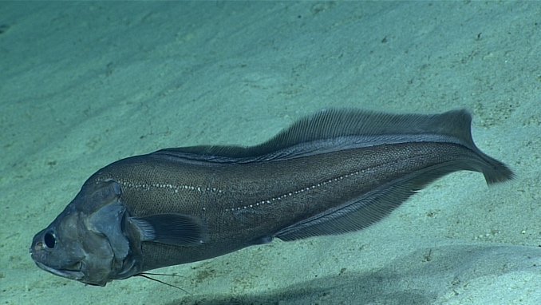 |  |  | 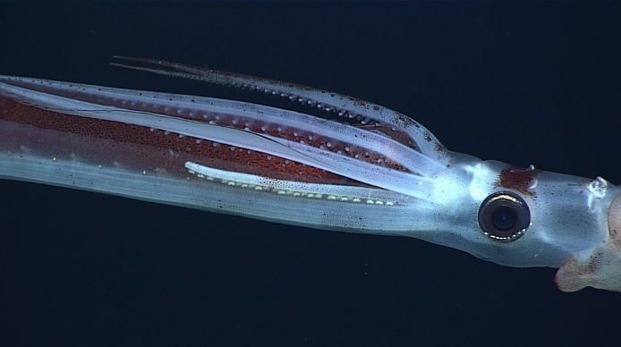
- Cusk Eel |  |  | - Squid (Chiroteuthis sp.) holding onto another squid; it remains unclear whether this is active predation or mating behavior
Samples Collected
  - Sample
Sample ID | EX1703_20170311T212533_D2_DIVE04_SPEC01BIO |  | - 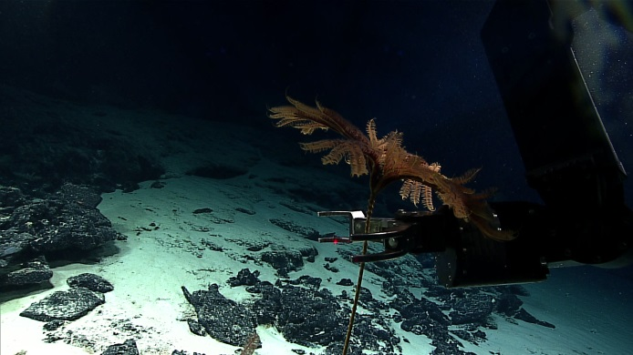
Date (UTC) | 20170311
Time (UTC) | 21:25:33
Depth (m) | 1154.07
Temperature (°C) | 3.93
Field ID(s) | Phrynocrinidae
Comments
Sample
Sample ID | EX1703_20170311T220523_D2_DIVE04_SPEC02BIO |  | - 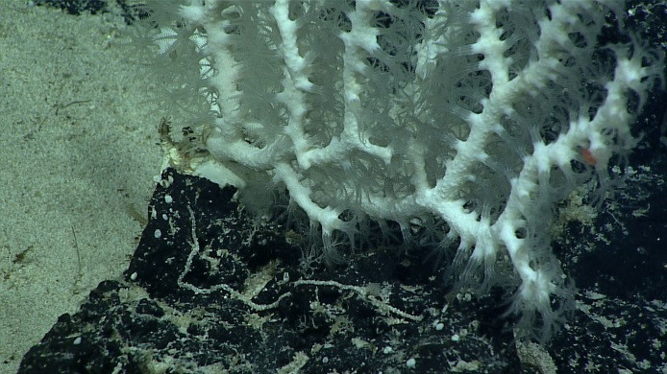
Date (UTC) | 20170311
Time (UTC) | 22:05:23
Depth (m) | 1126.99
Temperature (°C) | 4.15
Field ID(s) | Sibogagorgia sp.
Comments
Sample
Sample ID | EX1703_20170312T001022_D2_DIVE04_SPEC03BIO |  | - 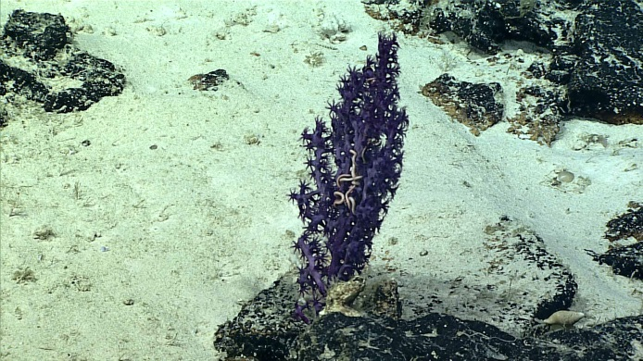
Date (UTC) | 20170312
Time (UTC) | 00:10:22
Depth (m) | 1043.3
Temperature (°C) | 4.32
Field ID(s) | Victorgorgia sp.
Comments

Please direct inquiries to:
NOAA Office of Ocean Exploration & Research
1315 East-West Highway (SSMC3 10th Floor)
Silver Spring, MD 20910
(301) 734-1014

