Okeanos Explorer ROV Dive Summary
Dive Information
Dive Map |  | 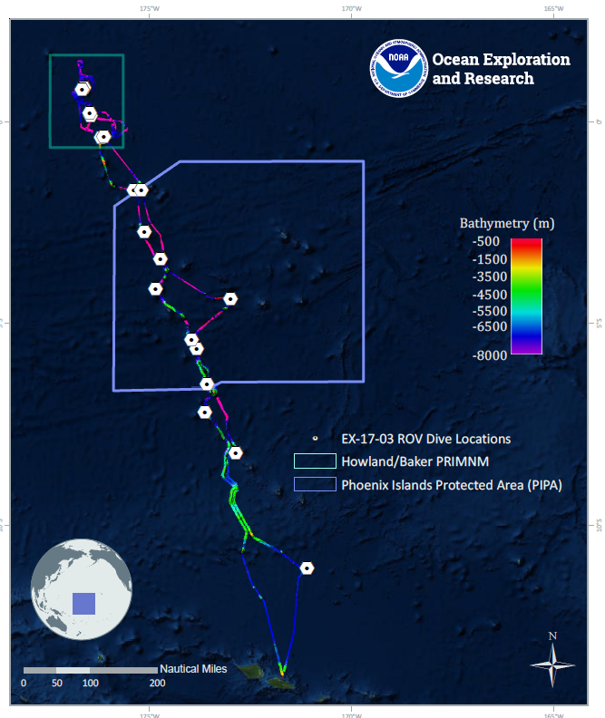
Site Name |  | Carondelet Reef
Expedition Coordinator(s) |  | Brian RC Kennedy, Nick Pawlenko
ROV Lead(s) |  | Karl McLetchie
Science Team Lead(s) |  | Amanda Demopoulos and Steven Auscavitch
General Area Descriptor |  | Phoenix Islands Protected Area
ROV Dive Name
Cruise |  | EX-17-03
Leg |  | 0
Dive Number |  | 03
Equipment Deployed
ROV |  | Deep Discoverer (D2)
Camera Platform |  | Seirios
ROV Measurements |  | CTD |  | Depth | Altitude
 |  | Scanning Sonar |  | USBL Position | Heading
 |  | Pitch |  | Roll | HD Camera 1
 |  | HD Camera 2 |  | Low Res Cam 1 | Low Res Cam 2
 |  | Low Res Cam 3 |  | Low Res Cam 4 | Low Res Cam 5
Equipment Malfunctions
ROV Dive Summary  (from processed ROV data) |  | Dive Summary: EX1703_DIVE03  ^^^^^^^^^^^^^^^^^^^^^^^^^^^^^^^^^^^^^^^^^^^^^^^^^^^  In Water: 2017-03-10T18:25:08.463000  05°, 38.029' S ; 173°, 50.379' W  Out Water: 2017-03-11T02:34:14.648000  05°, 37.629' S ; 173°, 50.105' W  Off Bottom: 2017-03-11T01:37:19.059000  05°, 37.685' S ; 173°, 50.365' W  On Bottom: 2017-03-10T19:36:06.783000  05°, 37.936' S ; 173°, 50.260' W  Dive duration: 8:9:6  Bottom Time: 6:1:12  Max. depth: 1842.3 m
Special Notes
Scientists Involved  (please provide name, location, affiliation, email) |  | Name Affiliation Email Address  Abby Lapointe University of Hawaii abbylap@hawaii.edu  Allen Andrews NOAA Fisheries - PIFSC allen.andrews@noaa.gov  Amanda Demopoulos USGS ademopoulos@usgs.gov  Amanda Netburn NOAA OER amanda.netburn@noaa.gov  Amy Baco-Taylor FLorida State University abacotaylor@fsu.edu  Andrea Pierce UnderWater World Guam apierce@aquariumteam.com  Asako Matsumoto Chiba Institute of Technology (Chitech), amatsu@gorgonian.jp  Bruce Mundy NOAA NMFS Pacific Islands Fisheries Science Center bruce.mundy@noaa.gov  Christopher Kelley University of Hawaii ckelley@hawaii.edu  Erik Cordes Temple University ecordes@temple.edu  Jaymes Awbrey University of Louisiana, Lafayette jawbrey@louisiana.edu  Jill Bourque US Geological Survey Wetland and Aquatic Research Center jbourque@usgs.gov  Ken Sulak USGS emeritus ksulak@usgs.gov  Les Watling University of Hawaii at Manoa watling@hawaii.edu  Michael Parke NOAA PIFSC michael.parke@noaa.gov  Natalie Summers University of Hawaii at Manoa nsummers@hawaii.edu  Nicole Morgan Florida State University nmorgan@fsu.edu  Peter Auster Mystic Aquarium & UConn peter.auster@uconn.edu  Randi Rotjan Boston University rrotjan@bu.edu  Santiago Herrera Lehigh University sherrera@alum.mit.edu  Scott France University of Louisiana at Lafayette france@louisiana.edu  Steve Auscavitch Temple University steven.auscavitch@temple.edu  Taylor Heyl WHOI theyl@whoi.edu  Tina Molodtsova P.P.Shirshov Institute of Oceanology RAS tina.molodtsova@gmail.com  Mike Ford NOAA NMFS michael.ford@noaa.gov
Purpose of the Dive |  | The goal of this dive is to acquire baseline information on deep sea habitats, seafloor geology, and biological communities in the Carondelet Reef area in the Phoenix Islands Protected Area (PIPA). This will be the first feature in the EX1703 expedition that will lie within the boundaries of PIPA. Deep-sea environments in PIPA are virtually unexplored leading to poor knowledge of biological resources protected by the MPA. This feature has a summit depth of <5m, capped by a submerged reef complex. The base lies at a depth of 5300m.
Description of the Dive |  | The third dive of EX1703 was the most biologically diverse of all the dives thus far of the expedition. The dive track was on the southwest ridge of Carondelet Reef, the first dive for the cruise within the Phoenix Islands Protected Area (PIPA) and the first deep dive ever on Carondelet Reef. Our primary objective was to descend to 1840 m and traverse up a steep slope up to approximately 1630 m, then ascend along a more gradual ridge, up to 1587m. Throughout the dive, we planned to document corals, fishes, sponges and other invertebrates, while recording the dominant terrain type.  We documented at least 32 species of corals, 21+ species of other invertebrates, including coral and sponge associates, and 5 species of fishes. The start of the dive, which traversed a vertical wall, was very speciose. Within the first 20 m of vertical water depth, we encountered at least 11 species of corals (Paragorgia sp. [collected specimen], 2 types of chrysogorgiids [some with eggs], 1 Iridogorgia, Hemicorallium?, 4 black corals [3 branched forms [Trissopathes?, Stauropathes?, Bathypathes sp.] and whips [Stichopathes?], 2 isidids), 2 sponges, and several associates (e.g., ophiuroids, crinoids, amphipods, anemones, chirostylids, hydroids, barnacles). Hemicorallium is a known precious coral and the first one observed on the dives thus far. Several large bamboo colonies were observed attached to steep rock faces. Most of the fan corals were oriented perpendicular to the dominant current, which was flowing from NW to SE. As the dive continued upslope, we saw many of the same species of corals, plus a few new ones: Bathypathes? sp. (yellow), rock pens (Anthoptilum), Umbellula, Pleurogorgia, stoloniferans, Iridogorgia magnispiralis, Anthomastus tahinodus, acanthogorgiids, Isidella sp., and Umbellapathes?. Cup corals were the only scleractinians documented on the entire dive. Five species and 5 individuals of fish were observed throughout the dive: Synaphobranchus spp (2), Unknown Synaphobranchidae (1 sp.), batfish (Ogcocephalidae), and a bristlemouth (Gonostomatidae). The synaphobranchids were not observed on previous dives within American Samoa at similar depths.  As we moved to gently sloped terrain (~1700 m water depth), there were more sedimented ledges and rock fissures filled with sediment. The substrate had several extremely long (>1 m) bamboo coral whips (Clade B1?). We also observed a large bamboo colony, possibly the largest ever observed, estimated to be 300 years old, with several tendrils that attached the skeleton to the substrate, securing its position on a steep rock ledge. We successfully sampled a similar isidid adjacent to the old one to confirm identification. Following this collection, we collected an unknown sponge from the family Euretidae with associates (crinoid and ophiuroids). Other sponges observed included hexactinellids: euplectellid, Poliopogon sp., Amphidiscella sp.?, and Tretopleura sp. The underside of rock ledges were often populated by small colonies of Pleurogorgia. Notable non-coral observations included predation by a seastar (Circeaster pullus) on a bamboo whip (Clade B1), homolid crab with an anemone clasped by its posterior limbs, a benthic siphonophore (Rhodaliidae?) that resembled a pipe organ, and an enormous (~17 cm) nemertean moving its head along the rocky seafloor.  Our observations directly help the management of biological resources within PIPA, given nothing was previously known about the deep-sea fauna within the protected area. Future dives will enable us to clarify if the diversity and abundance of fauna present on Carondelet Reef is representative of the broader region.  Images: big bamboo coral with tendrils, rock with lots of corals in view, seastar eating bamboo whip, batfish, and big nemertean.
Overall Map of the ROV Dive Area |  |  | Close-up Map of Main Dive Site
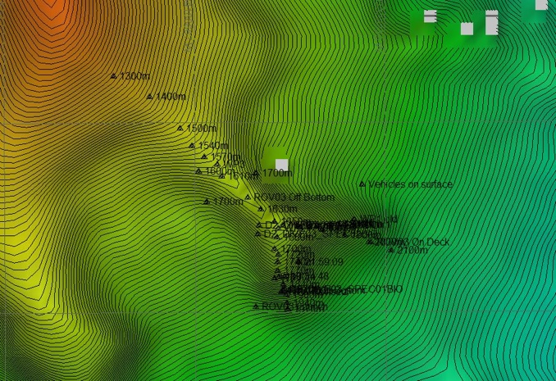 |  |  | 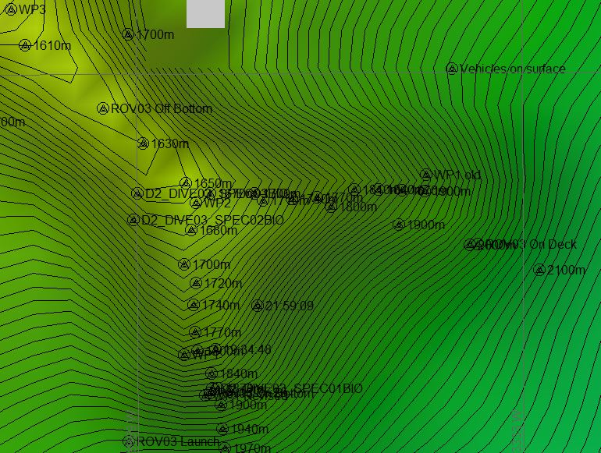
Representative Photos of the Dive
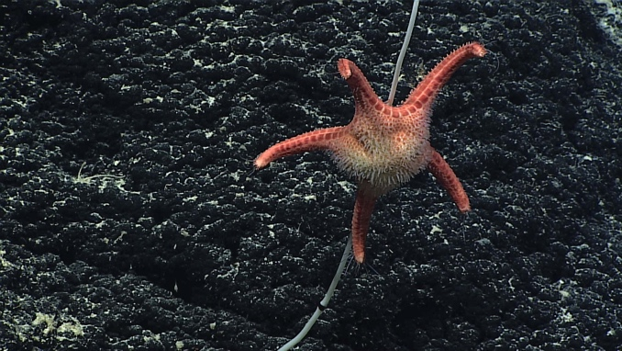 |  |  | 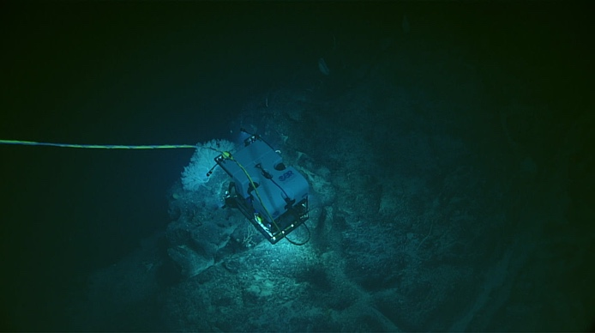
- seastar (Circeaster pullus) feeding on a bamboo whip (Clade B1) |  |  | - D2 looks at an unknown large big bamboo coral with tendrils
Samples Collected
  - Sample
Sample ID | EX1703_20170310T201405_D2_DIVE03_SPEC01BIO |  | - 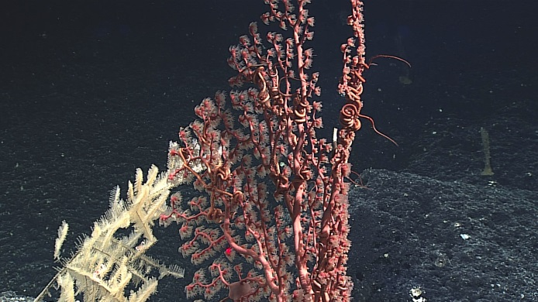
Date (UTC) | 20170310
Time (UTC) | 20:14:05
Depth (m) | 1841.11
Temperature (°C) | 2.37
Field ID(s) | Paragorgia sp.
Comments
Sample
Sample ID | EX1703_20170311T001717_D2_DIVE03_SPEC02BIO |  | - 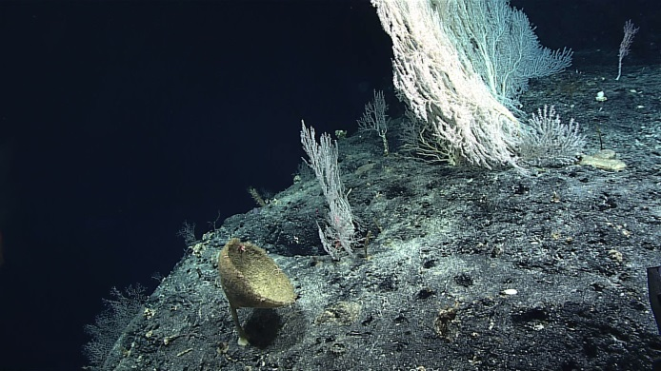
Date (UTC) | 20170311
Time (UTC) | 00:17:17
Depth (m) | 1636.383
Temperature (°C) | 2.55
Field ID(s) | Isididae
Comments
Sample
Sample ID | EX1703_20170311T004803_D2_DIVE03_SPEC03BIO |  | - 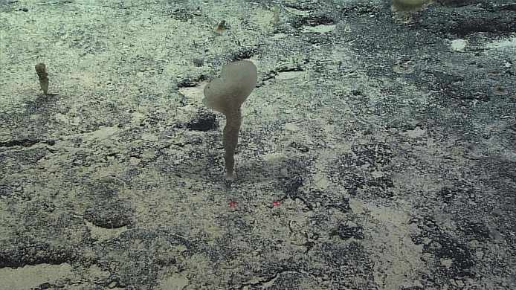
Date (UTC) | 20170311
Time (UTC) | 00:48:03
Depth (m) | 1624.78
Temperature (°C) | 2.56
Field ID(s) | Hexactinellida
Comments

Please direct inquiries to:
NOAA Office of Ocean Exploration & Research
1315 East-West Highway (SSMC3 10th Floor)
Silver Spring, MD 20910
(301) 734-1014

