Okeanos Explorer ROV Dive Summary
Dive Information
Dive Map |  | 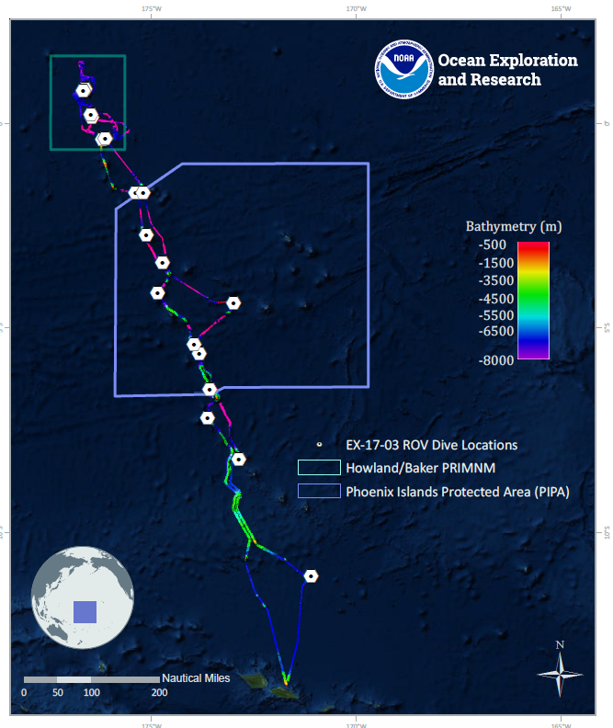
Site Name |  | Pao Pao
Expedition Coordinator(s) |  | Brian RC Kennedy, Nick Pawlenko
ROV Lead(s) |  | Karl McLetchie
Science Team Lead(s) |  | Amanda Demopoulos and Steven Auscavitch
General Area Descriptor |  | Tokelau Seamount Chain inside the Tokelau EEZ
ROV Dive Name
Cruise |  | EX-17-03
Leg |  | 0
Dive Number |  | 02
Equipment Deployed
ROV |  | Deep Discoverer (D2)
Camera Platform |  | Seirios
ROV Measurements |  | CTD |  | Depth | Altitude
 |  | Scanning Sonar |  | USBL Position | Heading
 |  | Pitch |  | Roll | HD Camera 1
 |  | HD Camera 2 |  | Low Res Cam 1 | Low Res Cam 2
 |  | Low Res Cam 3 |  | Low Res Cam 4 | Low Res Cam 5
Equipment Malfunctions
ROV Dive Summary  (from processed ROV data) |  | Dive Summary: EX1703_DIVE02  ^^^^^^^^^^^^^^^^^^^^^^^^^^^^^^^^^^^^^^^^^^^^^^^^^^^  In Water: 2017-03-09T18:22:32.689000  07°, 11.473' S ; 173°, 38.202' W  Out Water: 2017-03-10T02:34:26.183000  07°, 11.747' S ; 173°, 38.068' W  Off Bottom: 2017-03-10T02:22:16.531000  07°, 11.763' S ; 173°, 38.058' W  On Bottom: 2017-03-09T19:06:30.122000  07°, 11.405' S ; 173°, 38.085' W  Dive duration: 8:11:53  Bottom Time: 7:15:46  Max. depth: 535.6 m
Special Notes
Scientists Involved  (please provide name, location, affiliation, email) |  | Name Affiliation Email Address  Amanda Demopoulos USGS ademopoulos@usgs.gov  Amanda Netburn NOAA OER amanda.netburn@noaa.gov  Andrea Quattrini Harvey Mudd College aquattrini@g.hmc.edu  Asako Matsumoto Chiba Institute of Technology (Chitech), amatsu@gorgonian.jp  Benjamin Frable Scripps Institution of Oceanography bfrable@ucsd.edu  Bruce Mundy NOAA NMFS Pacific Islands Fisheries Science Center bruce.mundy@noaa.gov  Chris Mah Dept. of Invertebrate Zoology, NMNH Smithsonian Institution brisinga@gmail.com  Christopher Kelley University of Hawaii ckelley@hawaii.edu  Erik Cordes Temple University ecordes@temple.edu  Jill Bourque US Geological Survey Wetland and Aquatic Research Center jbourque@usgs.gov  John Smith University of Hawaii/SOEST jrsmith@hawaii.edu  Les Watling University of Hawaii at Manoa watling@hawaii.edu  Malcolm Clark NIWA New Zealand malcolm.clark@niwa.co.nz  Michael Parke NOAA PIFSC michael.parke@noaa.gov  Natalie Summers University of Hawaii at Manoa nsummers@hawaii.edu  Peter Auster Mystic Aquarium & UConn peter.auster@uconn.edu  Randi Rotjan Boston University rrotjan@bu.edu  Santiago Herrera Lehigh University sherrera@alum.mit.edu  Scott France University of Louisiana at Lafayette france@louisiana.edu  Sonia Rowley University of Hawai'i at Manoa srowley@hawaii.edu  Steve Auscavitch Temple University steven.auscavitch@temple.edu  Tara Harmer Luke Stockton University luket@stockton.edu  Taylor Heyl WHOI theyl@whoi.edu  Timothy Shank Woods Hole Oceanographic Institution tshank@whoi.edu  Tina Molodtsova P.P.Shirshov Institute of Oceanology RAS tina.molodtsova@gmail.com
Purpose of the Dive |  | The goal of this dive is to acquire baseline information on deep sea habitats, seafloor geology, and biological communities at Pao Pao Seamount in the Tokelau Seamount Chain. This feature has a summit depth of 300m, with the base at almost 6000 m. The seamount has had some rock dredging, but as far as is known, there has been no dedicated biological survey or sampling.
Description of the Dive |  | Today’s dive on Pao Pao Seamount revealed exciting insights into the fish and invertebrate communities within the Tokelau seamount chain. The dive started at ~ 544 m, heading SW up a steep slope along the NE side of the seamount. The substrate was composed of exposed hard rock with some areas of thick sediment drape. Numerous pteropod shells were found within the sediments. As we headed upslope, there were several species of fish, including epigonids, scorpaenids, 2 types of sharks [Hexanchus sp. and Echinorhinus cookei], spike fish (triacanthodids), green spotted duck fish (Chrionema chryseres), groppo (Grammotonotus), zeniontids, boar fish (Antigonia sp.), Randall’s snapper (Randallichthys filamentosus), and unknown black and white-striped fish. The slope was populated with several coral species, including scleractinians (Enallopsammia?, Madrepora, cup corals), octocorals (plexaurids, isidids, primnoids, acanthogorgiids, stoloniferans) and antipatharians (Stichopathes sp. and cf. Dendropathes). Polyps of the bamboo whip (Cladarisis sp.?) were loaded with eggs, located throughout the colony. There were several large plexaurid and primnoid colonies that were covered with various associates and we collected a piece of each one for analysis. In addition, a large Madrepora bush-shaped colony was observed attached to a dead “black” coral skeleton. The dead skeleton’s age was estimated at 1200 years old, based on the 10 cm diameter of the base. Other invertebrates observed included seastars (cf. Lophaster, goniasterids), sponges (demospongiae [Corallistes?, large barrel form], chirostylids, and crinoids (both comatulids and stalked forms).  When we reached WP2, we headed up a gradual slope to the summit, which corresponded to a dramatic change in the substrate type and fauna encountered. The steep rock ledges and sedimented slope transitioned to a relatively flat carbonate pavement, interspersed with pits and caves filled with sediments. Patches of several individual sea stars (Tremaster mirabilis), Swiftia (plexaurid) colonies, and pencil urchins (cidaroids) characterized the transition area. A pencil urchin was observed feeding on a Narella? octocoral, and several Narella? colonies had visible bare skeleton on the branches, indicating recent predation. We collected some Narella? tissue with associates for identification. We noted several hermit crabs with gastropod shell homes, but also observed one with an anemone house. Multiple large and small boarfish (Antigonia sp.) were associated with the pits and depressions. The current was notably stronger in this zone, thus, these fish maybe using the pits as refuges from the swift currents. Other fish encountered on the way to the summit included 8 barred grouper (Hyporthodus octofasciatus), deep-water snappers (Etelis sp., Pristipomoides sp.), amberjack (Seriola dumerili), deep-water sting ray, yellow eels (Myrocongridae?), Pontinus sp. (scorpionfish), groppo (Grammatonotus sp.), hogfish/wrasses (Polylepion russelli), and left-eye flounder (Bothidae). The 8 barred groupers, amberjacks, and snappers represent important commercial fishes for the region. In addition to the multiple fish species, we saw some different invertebrates at the summit, including an octopus, quill worms, brachiopods, and yellow scleractinians (Eguchipsammia?). At the summit, we saw some fishing line, which represented the first trash observed on the dives thus far. Throughout the dive, there was an obvious lack of precious corals present, in contrast to previous CAPSTONE dives within NW Hawaiian Islands.
Overall Map of the ROV Dive Area |  |  | Close-up Map of Main Dive Site
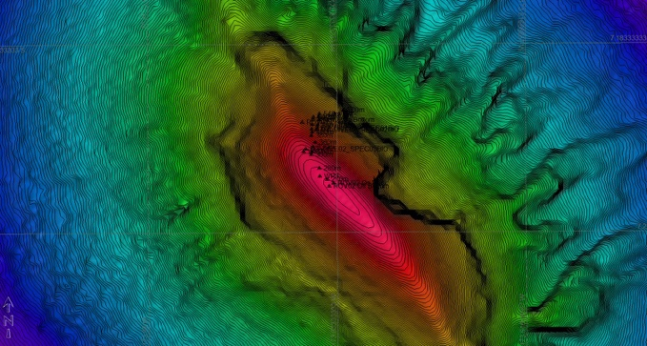 |  |  | 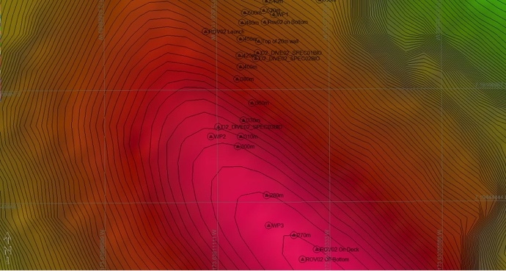
Representative Photos of the Dive
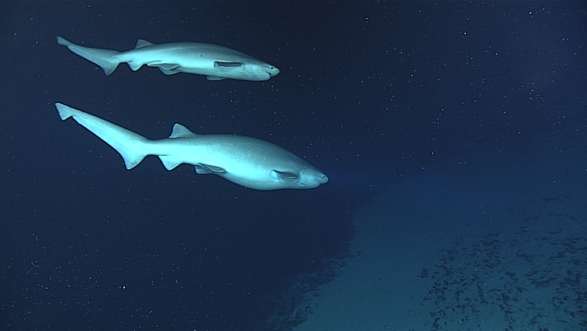 |  |  | 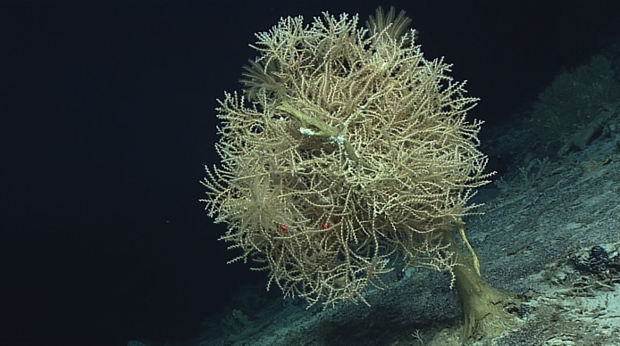
- A male and female pair of six gill sharks |  |  | - colony of Madrepora (stony coral) perched on old coral stalk
Samples Collected
  - Sample
Sample ID | EX1703_20170309T211255_D2_DIVE02_SPEC01BIO |  | - 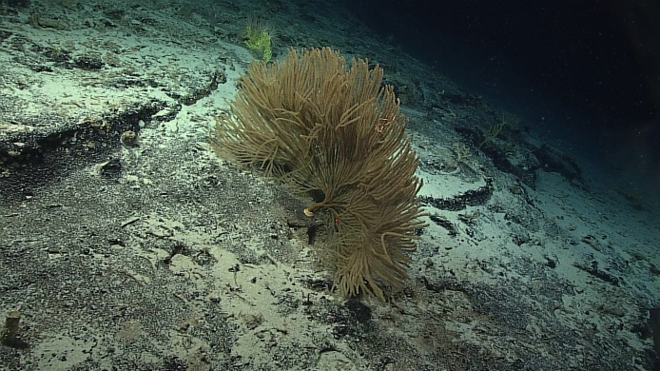
Date (UTC) | 20170309
Time (UTC) | 21:12:55
Depth (m) | 464.3595
Temperature (°C) | 8.22081
Field ID(s) | Primnoidae
Comments
Sample
Sample ID | EX1703_20170309T215423_D2_DIVE02_SPEC02BIO |  | - 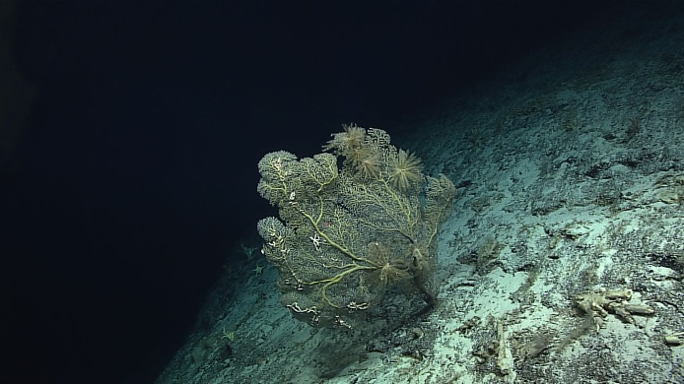
Date (UTC) | 20170309
Time (UTC) | 21:54:23
Depth (m) | 449.2919
Temperature (°C) | 8.84476
Field ID(s) | Plexauridae
Comments | With ophiuroids
Sample
Sample ID | EX1703_20170309T233130_D2_DIVE02_SPEC03BIO |  | - 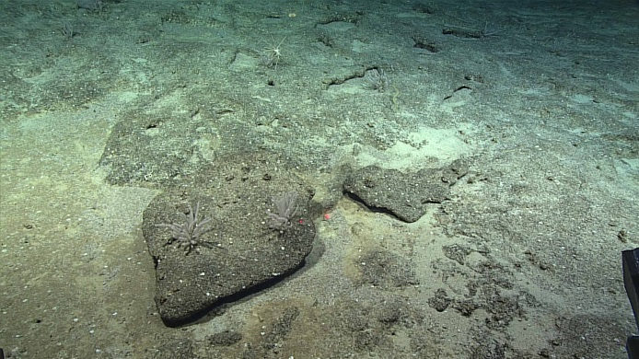
Date (UTC) | 20170309
Time (UTC) | 23:31:30
Depth (m) | 327.0098
Temperature (°C) | 12.13801
Field ID(s) | Narella sp.
Comments

Please direct inquiries to:
NOAA Office of Ocean Exploration & Research
1315 East-West Highway (SSMC3 10th Floor)
Silver Spring, MD 20910
(301) 734-1014

