Okeanos Explorer ROV Dive Summary
Dive Information
Dive Map |  | 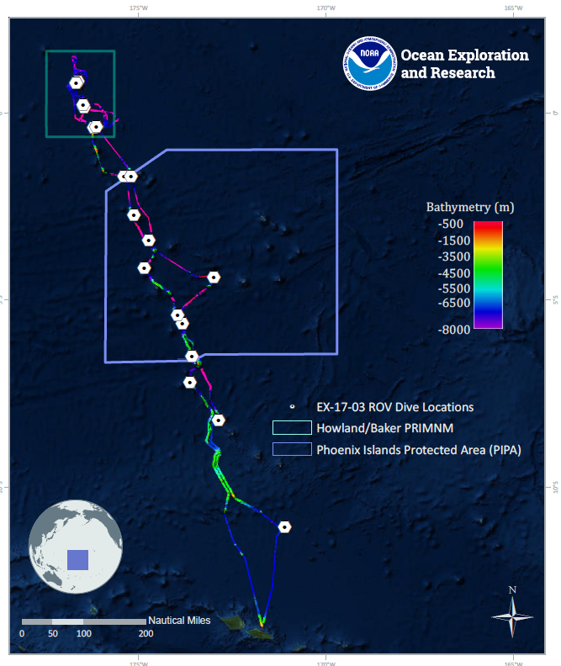
Site Name |  | Swains Atoll
Expedition Coordinator(s) |  | Brian RC Kennedy, Nick Pawlenko
ROV Lead(s) |  | Karl McLetchie
Science Team Lead(s) |  | Amanda Demopoulos and Steven Auscavitch
General Area Descriptor |  | National Marine Sanctuary of American Samoa Swains Atoll unit
ROV Dive Name
Cruise |  | EX-17-03
Leg |  | 0
Dive Number |  | 01
Equipment Deployed
ROV |  | Deep Discoverer (D2)
Camera Platform |  | Seirios
ROV Measurements |  | CTD |  | Depth | Altitude
 |  | Scanning Sonar |  | USBL Position | Heading
 |  | Pitch |  | Roll | HD Camera 1
 |  | HD Camera 2 |  | Low Res Cam 1 | Low Res Cam 2
 |  | Low Res Cam 3 |  | Low Res Cam 4 | Low Res Cam 5
Equipment Malfunctions |  | The dissolved Oxygen sensor reading on ROV was suspect.
ROV Dive Summary  (from processed ROV data) |  | Dive Summary: EX1703_DIVE01  ^^^^^^^^^^^^^^^^^^^^^^^^^^^^^^^^^^^^^^^^^^^^^^^^^^^  In Water: 2017-03-07T18:35:39.481000  11°, 02.729' S ; 171°, 06.606' W  Out Water: 2017-03-08T02:35:56.278000  11°, 02.843' S ; 171°, 06.414' W  Off Bottom: 2017-03-08T02:03:30.868000  11°, 02.858' S ; 171°, 06.378' W  On Bottom: 2017-03-07T19:33:43.266000  11°, 02.868' S ; 171°, 06.666' W  Dive duration: 8:0:16  Bottom Time: 6:29:47  Max. depth: 1161.3 m
Special Notes
Scientists Involved  (please provide name, location, affiliation, email) |  | Name Affiliation Email Address  Abby Lapointe University of Hawaii abbylap@hawaii.edu  Amanda Demopoulos USGS ademopoulos@usgs.gov  Amy Baco-Taylor FLorida State University abacotaylor@fsu.edu  Andrea Quattrini Harvey Mudd College aquattrini@g.hmc.edu  Asako Matsumoto Chiba Institute of Technology (Chitech), amatsu@gorgonian.jp  Bruce Mundy NOAA NMFS Pacific Islands Fisheries Science Center bruce.mundy@noaa.gov  Chris Mah Dept. of Invertebrate Zoology, NMNH Smithsonian Institution brisinga@gmail.com  Christopher Kelley University of Hawaii ckelley@hawaii.edu  Del Bohnenstiehl North Carolina State University drbohnen@ncsu.edu  Erik Cordes Temple University ecordes@temple.edu  Jill Bourque US Geological Survey Wetland and Aquatic Research Center jbourque@usgs.gov  John Smith University of Hawaii/SOEST jrsmith@hawaii.edu  Kevin Kocot The University of Alabama kmkocot@ua.edu  Les Watling University of Hawaii at Manoa watling@hawaii.edu  Matthew Jackson UC Santa Barbara jackson@geol.ucsb.edu  Nolan Barrett FAU Harbor Branch Oceanographic Institute barrettnh@g.cofc.edu  Santiago Herrera Lehigh University sherrera@alum.mit.edu  Scott France University of Louisiana at Lafayette france@louisiana.edu  Steve Auscavitch Temple University steven.auscavitch@temple.edu  Tara Harmer Luke Stockton University luket@stockton.edu  Taylor Heyl WHOI theyl@whoi.edu  Timothy Shank Woods Hole Oceanographic Institution tshank@whoi.edu  Reinhard Andrew University of California Santa Barbara reinhard@umail.ucsb.edu
Purpose of the Dive |  | The goal of this dive is to acquire baseline information on deep sea habitats, seafloor geology, and biological communities at the Swains Island region of the National Marine Sanctuary of American Samoa. Geological interests include sampling basalt rocks for dating the age of this feature.
Description of the Dive |  | The first dive of EX1703 was off Swains Island, within American Samoa Unit, National Marine Sanctuary. The dive started at 1143m along a steep slope. Extensive pillow basalt outcrops and fragments were observed throughout the dive. However, rocks were cemented to the seafloor, making them impossible to collect. The dominant substrate was coated in manganese iron oxide and interspersed with patches of thin sediment drape. The complex rock substrate was populated with several scleractinians, including Enallopsammia spp. (at least two species), cup corals, as well as octocorals: Victorgorgia cf. nuttingi, plexaurids, acanthogorgiids, Chrysogorgia sp. (some with egg masses), and isidid (unbranched whip split into 2 bases), and antipatharians: whips, e.g., Stichopathes sp. Much of the rock surfaces were covered with anemones or possibly corallimorphs. Fishes encountered on the steep slope included alepocephalids (slick head), halosaurs, and ophidiids. Shrimp (Heterocarpus, Nematocarcinus), polychelid (blind lobster), paguroids (hermit the crab), as well as a few Deimatidae holothurians were observed on the rock surface or sediment patches. There were several hexactinellid sponges throughout the dive, including Rossellidae, possibly Poliopogon, and Tretopleura sp. We also observed and collected an Aspidoscopulia sp., which represented a new record for this region. Coral associates included chirostylid crabs and ophiuroids. There was quite a bit of dead manganese-coated scleractinian debris in sediment patches interspersed within the rock outcrops. At 1114m, we encountered a large boulder field that was covered in multiple species of corals, a notable transition from patchy to high-density cover. Prior to the transition from the slope transect to the ridge track, we observed a long, skinny squid (Chiroteuthis sp., either C. picteti or C. spoeli) with long tentacles and large eyes, swimming in the water column.  Starting at ~1100 m, our dive track transitioned to the ridge transect. While the ridge initially appeared to have a gradual slope, it was punctuated by large mounds of pillow lava and boulders, often covered with abundant encrusting fauna. We saw several fishes that were not observed along the slope, including an anglerfish (Sladenia sp.), conger eels, oilfish (Ruvettus pretiosus), rattails (macrourids), black scorpion fish (Scorpaenidae), cusk eels (synaphobranchids), and bristlemouths (gonostomatids). New coral observations included the black coral, Parantipathes?, stoloniferans sp. (cf. Clavularia and a white morph), Madrepora sp., and Anthomastus sp. We saw a very large (>1m tall) black coral (Antipathes?), with hermit crab associates and encrusting zoanthiids. Additional fauna encountered along the ridge included the hexactinellid sponge, Bolosoma, sea urchins (Sperosoma sp.?), and at least one swimming polychaete. We only observed Asteroid seastars along the slope, including the cookie star (Ceramaster), Asthenactis, and a brisingid, all perched on the side of rock faces. One notable “associate” was a homolid-type crab found on several corals and on the rocks, often holding a hydroid or black coral with its back legs, potentially serving as camouflage. Throughout the dive, we saw several Enallopsammia sp. that were similar sizes, suggesting a single recruitment event, possibly following disturbance.  Based on feedback from the shore-side scientists, this dive had apparently higher diversity and abundance of corals and other taxa compared to other dives conducted in the region. However, the depth range was not covered by these previous dives, so follow up surveys at similar depths will improve our understanding of the relationship between depth and the distribution and connectivity of fauna within the region.
Overall Map of the ROV Dive Area |  |  | Close-up Map of Main Dive Site
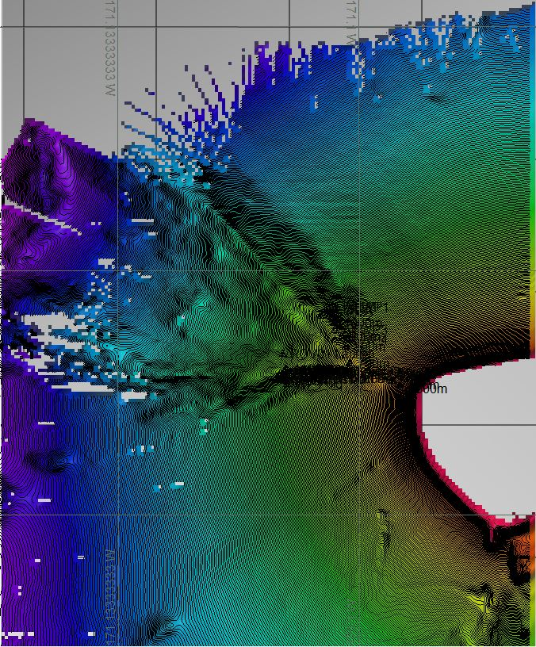 |  |  | 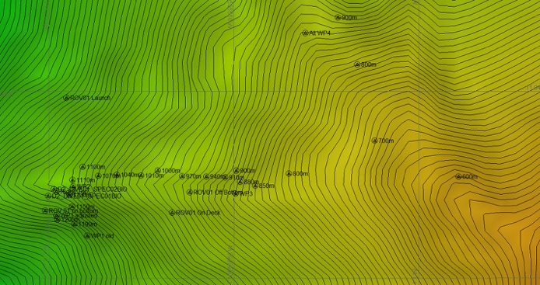
Representative Photos of the Dive
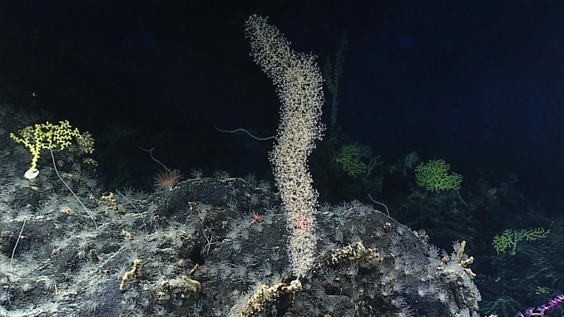 |  |  | 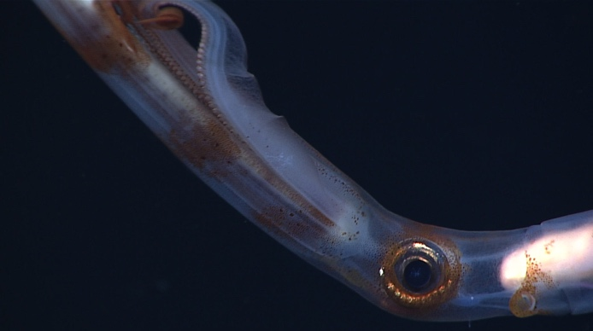
- Example of the high-density community documented near Swains Island |  |  | - we observed a long, skinny squid (Chiroteuthis sp., either C. picteti or C. spoeli) with long tentacles and large eyes, swimming in the water column
Samples Collected
  - Sample
Sample ID | EX1703_20170307T205042_D2_DIVE01_SPEC01BIO |  | - 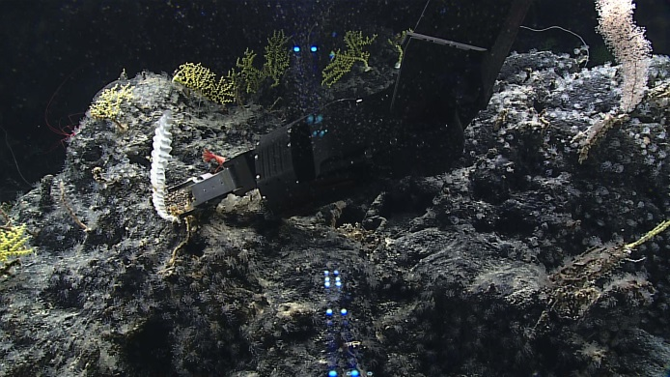
Date (UTC) | 20170307
Time (UTC) | 20:50:42
Depth (m) | 1111.81
Temperature (°C) | 4.13148
Field ID(s) | Hexactinellid Sponge
Comments | (Poss. Farreidae)
Sample
Sample ID | EX1703_20170307T214200_D2_DIVE01_SPEC02BIO |  | - 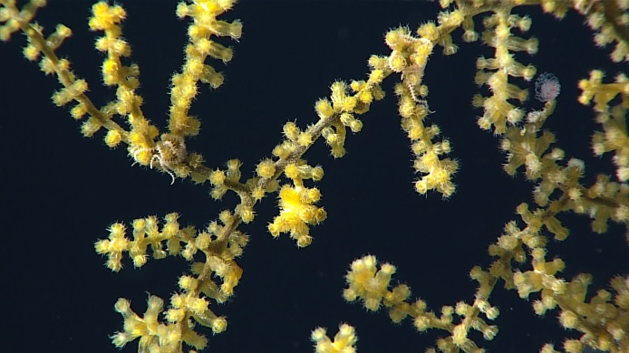
Date (UTC) | 20170307
Time (UTC) | 21:42:00
Depth (m) | 1100.645
Temperature (°C) | 4.15573
Field ID(s) | Acanthogorgiidae
Comments

Please direct inquiries to:
NOAA Office of Ocean Exploration & Research
1315 East-West Highway (SSMC3 10th Floor)
Silver Spring, MD 20910
(301) 734-1014

