Okeanos Explorer ROV Dive Summary
Dive Information
Dive Map | 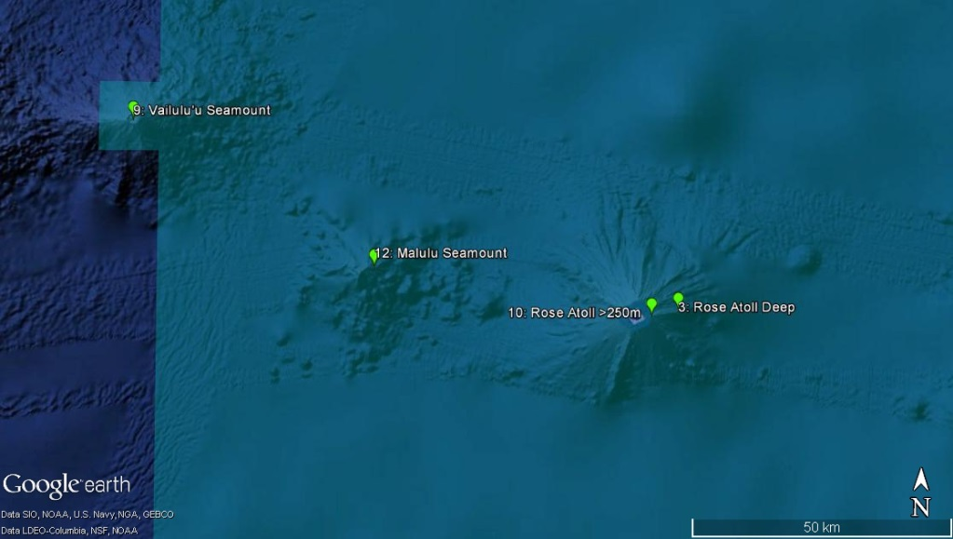
Site Name | Malulu seamount
ROV Lead(s) | Karl McLetchie
Expedition Coordinator(s) / Mapping Lead | Kelley Elliott / Meme Lobecker
Science Team Lead(s) | Santiago Herrera (Biology) and Matt Jackson (Geology)
General Area Descriptor | Eastern American Samoa (between Vailulu’u seamount and Rose atoll)
ROV Dive Name
Cruise | EX1702
Leg
Dive Number | 12
Equipment Deployed
ROV | Deep Discoverer (D2)
Camera Platform | Seirios
ROV Measurements | CTD | Depth | Altitude
 | Scanning Sonar | USBL Position | Heading
 | Pitch | Roll | HD Camera 1
 | HD Camera 2 | Low Res Cam 1 | Low Res Cam 2
 | Low Res Cam 3 | Low Res Cam 4 | Low Res Cam 5
 | LSS | ORP
Equipment Malfunctions
ROV Dive Summary  (from processed ROV data) | In Water: 2017-02-27T19:34:34.456000  14°, 27.892' S ; 168°, 38.472' W  Out Water: 2017-02-28T05:29:00.542000  14°, 28.324' S ; 168°, 37.935' W  Off Bottom: 2017-02-28T02:16:29.021000  14°, 28.172' S ; 168°, 38.191' W  On Bottom: 2017-02-27T21:18:17.529000  14°, 28.127' S ; 168°, 38.335' W  Dive duration: 9:54:26  Bottom Time: 4:58:11  Max. depth: 2469.9 m
Special Notes

Scientists Involved  (please provide name, location, affiliation, email) |  | Asako Matsumoto, PERC, Chiba Institute of Technology, Japan  Chris Mah, NMNH Smithsonian Institution  Deborah Glickson , National Academies of Sciences, Engineering, and Medicine  Matthew Jackson, UC Santa Barbara  Santiago Herrera, Lehigh University  Tara Harmer Luke, Stockton University  Timothy Shank, Woods Hole Oceanographic Institution  Tina Molodtsova, P.P. Shirshov Institute of Oceanology RAS  Bruce Mundy, NOAA PIFSC  Christopher Kelley, University of Hawaii  John Smith, University of Hawaii/SOEST  Joseph O'Malley, NOAA PIFSC  Scott France, University of Louisiana at Lafayette  Steve Auscavitch, Temple University  For Midwater Transects:  Santiago Herrera, Lehigh University  Dhugal Lindsay, Japan Agency for Marine-Earth Science and Technology  Collin Closek, Stanford University  Elizabeth Andruszkiewicz, Stanford University  Russ Hopcroft University of Alaska Fairbanks  Cornelia Jaspers, Technical University of Denmark  Heather Judkins, University of South Florida St. Petersburg  Alistair Grinham, University of Queensland  Brennan Phillips, Harvard University  Dick Young, University of Hawaii  Amanda Netburn, CIOERT at FAU/NOAA OER  Mike Ford, NOAA NMFS  Marsh Youngbluth, Harbor Branch Oceanographic Institute
Purpose of the Dive |  | The goal of this dive is to generate baseline information on deep sea habitats and biological communities, particularly deep-sea coral communities, to better understand their diversity and distribution and support management needs of the Rose Atoll Marine National Monument. Water column transects are also planned during this dive to obtain information on animals living in the largest unexplored biome on the planet.  The dive will begin around 2500 m, near the summit of Malulu seamount, as shown in the bathymetry map. The ROV will climb to the summit and then continue moving along the flat top of the summit. After the ROV comes off bottom at approximately 2430m, the ROV will ascend to 2000 m to start the water column exploration portion of the dive. A 10-minute transect will be conducted at each of the following depths, while moving the ROV at 0.1 knots: 2000m, 1500m, 1200m, 900m, 700m, 500m and the depth of the scattering layer identified in EK60 data. The EK60 sonar will be on for the duration of these transects, and the 38 kHz ADCP will also be run if it does not cause interference.  From a geological standpoint, Malulu seamount is thought to be an older seamount linked to another, non-Samoa hotspot. Rose Atoll to the east (sampled in an earlier dive during this cruise) and Malulu seamount are key in defining the Cook-Austral hotspot tracks back in time, and as such an age on a volcanic rock is needed from Malulu seamount. Without an age, it is not possible to truly define plate motion for the time frame represented by this volcano.
Description of the Dive |  | Malulu seamount lies in the eastern region of the Samoan islands. The bathymetry reveals that the seamount has a roughly conical shape; additionally, the seamount is host to 5 or 6 smaller conical cones, which may represent a rejuvenate stage of volcanism. These smaller cones were avoided during the dive planning efforts. One hypothesis is that Malulu seamount is an ancient volcano that formed by a different, non-Samoan hotspot. This hypothesis can be tested by obtaining basaltic samples to obtain age-dates and geochemical data.  The dive track was designed to target the northwest face of the volcanic structure, near the summit of the volcano. The ROV will move upslope and summit a gently sloping ridge that exhibits a gentle slope to the seamount summit.  The following geological description provides a chronological summary of the major geological features, or changes in the geology of the ocean floor, over the course of the dive:  21:00:00 UTC. The ROV arrived on bottom. The field of view reveals a FE (ferromanganese encrusted) surface. Perhaps 1 to 2% of the bottom is covered with sediment. The slope of the surface is estimated ~30 degrees. Panning to the left, the ROV shows evidence for FE cobbles and pebbles, but all appear to be welded into the substrate.  21:22:04. The sediment cover increases to a light dusting on the FE surface that covers perhaps 30% of the surface. A 0.5 m wide, 0.1 to 0.2 m deep, gulley has a higher concentration of cobbles and pebbles, all welded to the substrate.  21:54:10. The ROV has moved perhaps 20 or 30 meters since arrival on bottom and the field of view is similar to the observation made as 21:22:04.  22:14:31. A loose rock (lying on top of a sponge stem) lies on top of the FE substrate that has dominated the field of view since the ROV landed on bottom. The rock turned out to be unsuitable for collection.  22:32:19. Two light-colored pieces of pumice came into view. Their light color suggests a young age, as ferromanganese has not yet covered their surface. The pumice is likely to have come from a nearby subduction zone system, because Malulu is an extinct volcano and active Samoan volcanoes are not known to generate pumice.  22:36:07. Dozens of sponge stocks litter the surface. Sediment cover is 50% of the field of view. A FE cobble lies in the field of view and was sampled, and was the first geological sample of the expedition (placed in port rock box). D2_DIVE12_SPEC03GEO  22:49:45. The view from Seirios shows that the D2 ROV is climbing a steep surface (more than 30 degrees) that has grooves that run up and down the slope. These are either the product of erosive processes (gulleys) or are FE magmatic features including dikes or elongate pillows.  22:53:00. An outcrop perhaps 1 or 2 meters high has significant positive topography relative to the surfaces that the ROV has revealed up until this point. It appears to be a FE volcanic feature.  23:08:11. The ROV continues to move upslope on a steep slope and layered deposits come into view. This could represent FE volcaniclastic debris.  23:18:55. At the base of a relatively steep face that is several meters high, several cobbles lie in the sediment. All are welded to the substrate. The steep face has the appearance of being volcanic breccia.  23:38:25. A steep slope (over 30 degrees) dominates the field of view and is covered with a dusting of light colored sediment. The topography is quite similar to that observed earlier in the dive, but panning right is the steeper face that was observed in the 23:18:55 observation. Clear pillow structures are not evident, and have not been evident during this dive.  23:45:07. A smooth, inclined (> 30 degrees) surface with structures that appear to have the structure of FE pillows. Gulleys continue to be clear in the FE substrate. A light dusting of light colored sediment is pervasive. FE cobbles continue to be welded to the seamount, making it difficult to obtain an additional rock sample.  00:00:29. The substrate is relatively smooth as the ROV continues up a steep (30 to 40 degrees) slope. Cobbles (up to 30 cm in diameter) are present on the slope, but are well cemented to the substrate. This could have been a talus deposit, but the talus has been completely welded to the surface.  00:11:56. The steepest slope yet is coming into view, perhaps 45 degrees. The sediment on the slope is light colored and fills much of the field of view, in spite of the steep slope. The slope appears to be composed of volcaniclastics (much like most of the sloped surfaces observed on this dive).  00:27:21. FE cobbles are welded into the volcaniclastic debris that is prevalent on the steep slope. One FE cobble is found to be loose. It was sampled and became the second geologic sample of the expedition (starboard rock box). D2_DIVE12_SPEC05GEO  00:15:14. The surface is relatively smooth and devoid of cobbles, but the low-lying areas that are perhaps 10 to 15 cm deeper than the surrounding surfaces. All surfaces are ferromanganese encrusted.  00:54:13. The substrate appears to host welded cobbles, consistent with being either a volcaniclastic deposit or a talus deposit that has been covered with ferromanganese.  02:34:49. The topography is a bit rougher than before, and the ROV has summited a gently sloping ridge that trends to the summit of the seamount. The slope is more gentle than we have observed for the entire ROV dive; for the past hour or so, all rocks that have been prodded by the ROV have been welded to the bottom thus far.  01:41:23. The surface is relatively flat and no sediment is present. The ROV appears to have reached the ridge that trends to the summit. All surfaces are covered with thick ferromanganese crusts. The surfaces are rough and composed of numerous cobbles that are welded (with ferromanganese) to the surface.  01:52:21. The ROV pilot managed to push a cobble loose with the claw. This sample is from the ridge that that heads to the summit; the sample constitutes the third geologic sample of the expedition (rock placed in starboard box). D2_DIVE12_SPEC07GEO  02:01:58. Panning to the left of the summiting ridge, there is more abundant sediment with ripples. The ridge top exhibits very little sediment, and the right side of the ridge has very little sediment. Thus, the bottom current is likely to flow from right to left relative to the ROV track.  The biological perspective is as follows:  Landed on ~35 degree slope, observed a couple of large brisingids (one with swelling of arms indicating parasite infection, possibly snails or barnacles). Imaged a Bolosoma with yellow stalk, large oscula (likely new species) with shrimp. There were also several dead sponge stalks with ophiacanthid ophiuroids wrapped around them (not observed on living sponge stalks). Collected potential new species of sponge Bolosoma (20170227 21:48:39; D2_DIVE12_SPEC01BIO, 2461m).  Observed and collected a goniasterid cookie star (same one observed at this depth on Rose Atoll), very likely new species, very few of these sea stars occur below 1000m (20170227 22:08:51; D2_DIVE12_SPEC02BIO; 2457m).  Encountered several more brisingid seastars with possible parasitism. Also observed a significant abundance of large Bolosoma, in addition to dead stalks with ophiuroids wrapped around them. Also observed a couple of yellow crinoids (maybe the same observed at Rose Atoll). Found large dead sponge skeletons encrusted with iron manganese (just like we observed at the same depth range on Rose Atoll), intermixed with non-encrusted Bolosoma-like sponge stalks. Collected rock (20170227 22:43:51; D2_DIVE12_SPEC03GEO; 2449).  Observed a Callophacus (stalk inserts on the side of the sponge) different from the Bolosoma with yellow stalk (stalk insert on the underside of the sponge). Living Callophacus had 3 ophiuroids, likely the same as the ones observed on dead stalks. Stalked Bolosoma sponges seem to be oriented ‘facing’ upslope, similarly all ophiuroids observed on sponge stalks were facing upslope (upslope here facing S-SW). Current coming from up upslope, all this indicates that dominant currents are moving to the N-NE.  Observed a dead Chrysogorgia skeleton with little colonization, only some small snails (indicating that the coral tissue likely died recently). Observed the same ‘Lepidisis’ bamboo coral whip collected at 2448m in Dive 03 Rose Atoll Deep. Found a live Chrysogorgia with 1 associate squat lobster. Collected a specimen of the golden Pleurogorgia morphospecies with hydroid associates on it (20170227 22:43:51; D2_DIVE12_SPEC03GEO; 2449m).  Observed several more Bolosoma sponges with yellow stalks (most abundant animals on this slope so far) 23:45 2440 m. Observed another Pleurogorgia and Chrysogorgia with squat lobster associate at 22:58 2429 m. Continued to see an abundance of sponges Bolosoma as well as some Pleurogorgia and Chrysogorgia colonies. Sediment cover increased as well as slope (45 degrees) at 0:21 2402m. Found more brisingids of similar morphology. Imaged a couple of sea cucumbers. Collected rock (20170227 22:43:51; D2_DIVE12_SPEC03GEO; 2449m).  Observed a Pleurogorgia sea fan perpendicular to the SE moving current 00:40 2392m. Coral had couple of crinoids. Observed many more Bolosoma, brisingid sea stars, ophiuroids wrapped around dead coral skeletons that are still attached to hard rock.  Found another Pleurogorgia sea fan perpendicular to the SE moving current 00:52 2379m, this one had an ophiacanthid ophiuroid on it (clinging to bare skeleton), also had several hydroid and crinoid associates. Encountered and sampled a Pseudochrysogorgia octocoral (same morph as the one from Rose Atoll) with a gravid squat lobster associate at 01:11 2371m (20170228 01:20:53; D2_DIVE12_SPEC06BIO; 2361m).  Observed several brisingid seastars on top rocks, bamboo whip, Bathypathes black coral, cookie star 01:26 2361m. More Bolosoma sponges, Pleurogorgia (2 hydroids associated), Pseudochrysogorgia, ophiuroids on many dead sponge stalks (2350m 01:41). Saw a Chrysogorgia with squat lobster associate as well as 4 benthic ctenophores 01:47 2350m.  Reached what appeared to be the top ridge of the seamount 01:50 2351m. Found many more Bolosoma, brisingids, ophiuroids on dead sponge stalks, and a few Pseudochrysogorgia. Encountered a very large (taller than 3m) bamboo whip with no needle sclerites in polyps 02:01 2349m). Saw rippled sediment 02:03 indicating a current moving from the S-SE.  Bolosoma were the dominant benthic species during this dive. 2334m 02:19 end of seafloor component of the dive. Transitioned into the mid-water portion of this dive 02:23.  Mid-water transects (10 min transects at 0.1 knots)  1500 m  Red mysiid shrimp, several trachymedusas.  1200 m  Started at 03:26. Larvacean, polychaete worm, carnivorous tunicate (convergent morphology to a medusa), and Erina? siphonophore. Ended at 03:41.  900 m  Started at 03:54. Fish (most abundant vertebrate on the planet), siphonophore, arrow worm chaetognat, and hydromedusae. Ended at 04:04.  700m  Started at 04:13. Larvacean, siphonophore, shrimp, ctenophore. End of transect 04:24.  600m  Started at 04:29. Rhizarians, euphausid krill, siphonophore, ctenophore, medusa. Ended at 04:39.  500m  Started at 04:47. Ctenophore, several medusae, narcomedusae (jellyfish predator), Rhizarian. Ended at 04:57.  375m  Started at 05:02 Rhizarian, euphausid krill, siphonophore. Encountering surface currents to the south west (matching the ADCP data from the ship). Larvacean. Ended at 05:13.  Mid-water transects summary (from Amanda Netburn)  The water column, though 95-99% of the total inhabitable volume of the planet, remains one of the most poorly explored environments. Especially in remote areas of the globe like the Pacific Islands, there have been very few opportunities to explore the deep water column, and this expedition provided a rare opportunity to do so in this unique region of the ocean.  After we completed the benthic portion of the Malulu dive, we conducted several hours of exploration in the midwater. We conducted 10 minute transects at a series of depths- 1500, 1200, 900, 700, 600, 500, and 375 m. These depths were chosen based on features revealed by the CTD data collected by the Deep Discoverer on the way down to the seafloor at the start of the dive.  For this dive, we had a unique opportunity to bring together a group of midwater experts to participate in the dive at the University of Hawaii Exploration Command Center. These scientists were in Hawaii for an Oceanography conference and an upcoming workshop on water column exploration. The group contained experts in cephalopods (squids and octopuses), fishes, jellyfish, and other zooplankton.  We made many fascinating observations throughout this dive, including multiple individuals of an undescribed lobate ctenophore (comb jelly), large numbers of Halicreatid medusa, particularly in the deeper transects, and high numbers of the Prayid siphonophore (colonial jellyfish) in the shallowest transect at 375 m. We encountered a high diversity of single-celled Rhizaria, each with a different characteristic shape. There were many sightings that were likely first records in the southern hemisphere. These included a species of sea tadpole (larvacean oikopleurid), a carnivorous planktonic sea squirt, a medusoid comb jellyfish (Thalassocalycida), another comb jelly in the family Lampoctenidae, and the physonect siphonophore Erenna. In just a couple of hours, we made all of these and newer observations, demonstrating the utility of ROV-based exploration to understanding the diversity and distributions of these notoriously challenging animals to study.
Overall Map of the ROV Dive Area |  |  | Close-up Map of Main Dive Site
Representative Photos of the Dive
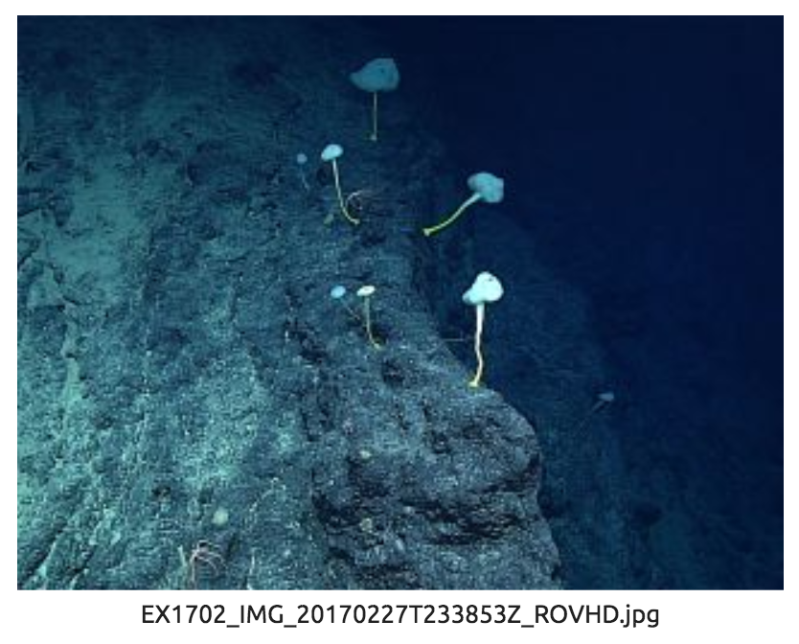 |  |  | 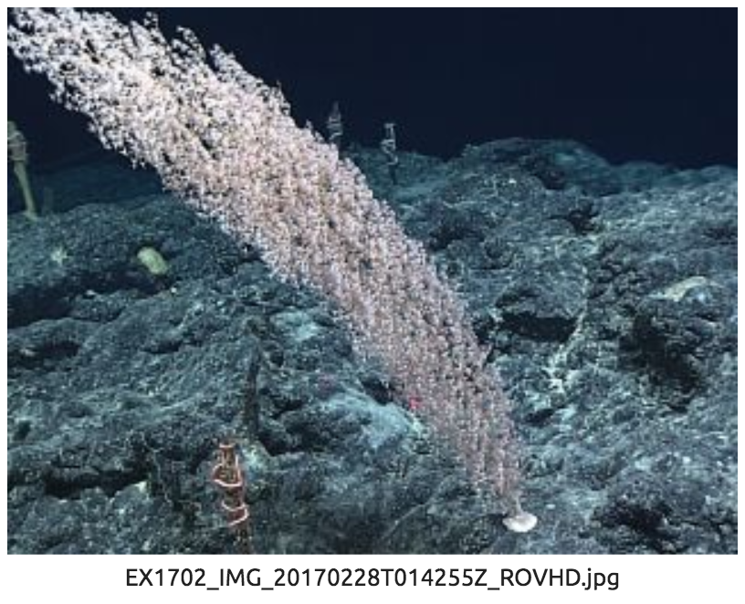
- Ferromanganese encrusted slope with several living Bolosoma glass sponges |  |  | - Seamount summit with a Chrysogorgia coral and several dead sponge stalks with ophiuroids.
Samples Collected
  - Sample
Sample ID | D2_DIVE12_SPEC01BIO |  | - 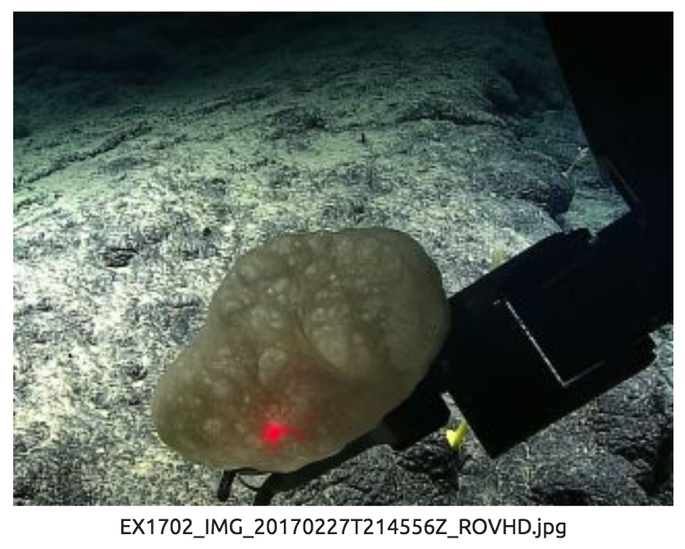
Date (UTC) | 20170227
Time (UTC) | 21:48:39
Depth (m) | 2460.0819
Temperature (°C) | 1.93030
Field ID(s) | Sponge (potential new species)
Comments
Sample
Sample ID | D2_DIVE12_SPEC02BIO |  | - 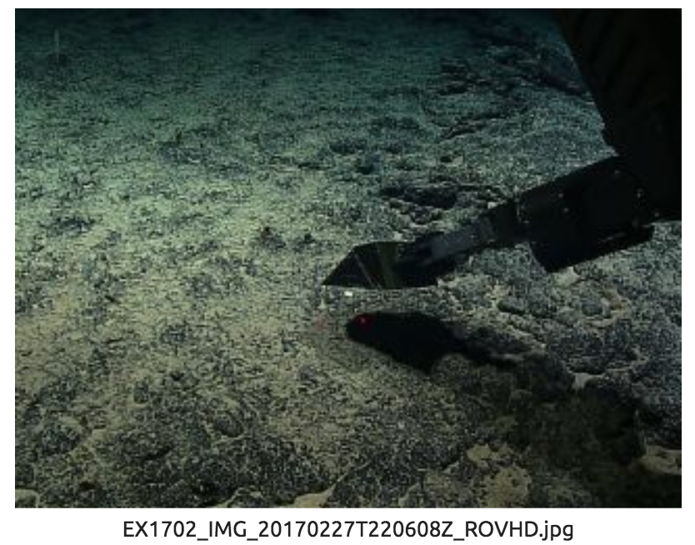
Date (UTC) | 20170227
Time (UTC) | 22:08:51
Depth (m) | 2457.5245
Temperature (°C) | 1.91712
Field ID(s) | Goniasterid cookie star (potential new species)
Comments
Sample
Sample ID | D2_DIVE12_SPEC03GEO |  | - 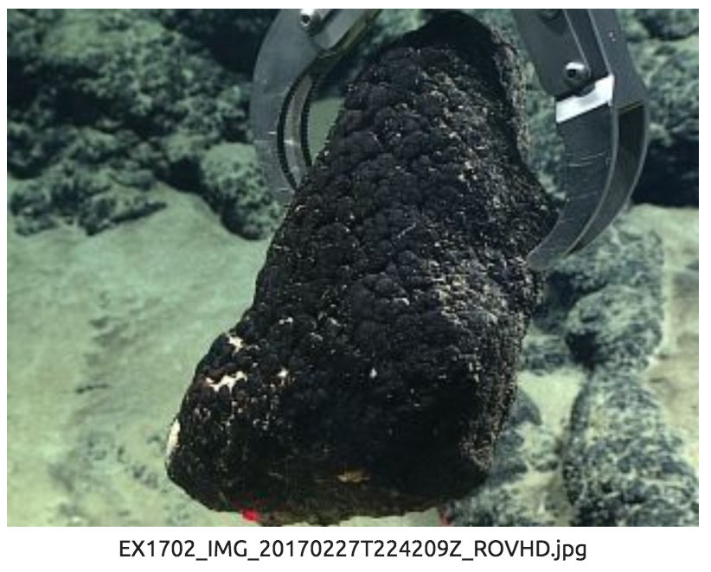
Date (UTC) | 20170227
Time (UTC) | 22:43:51
Depth (m) | 2448.9156
Temperature (°C) | 1.88915
Field ID(s) | Rock
Comments
Sample
Sample ID | D2_DIVE12_SPEC04BIO |  | - 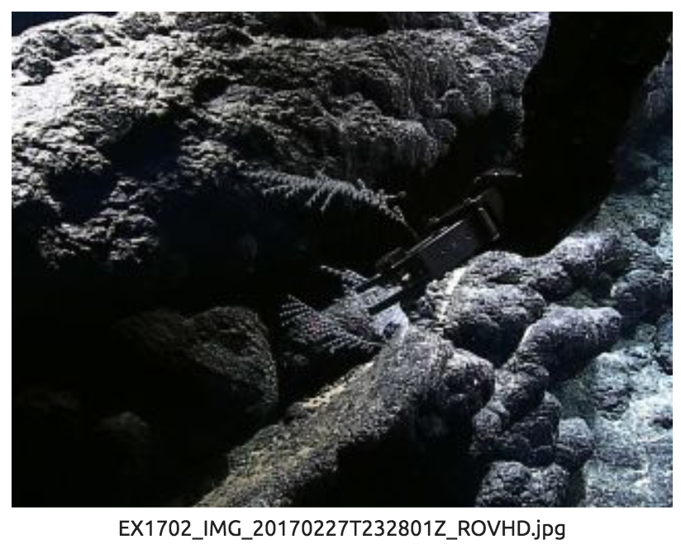
Date (UTC) | 20170227
Time (UTC) | 23:34:05
Depth (m) | 2437.6107
Temperature (°C) | 1.88102
Field ID(s) | Pleurogorgia (golden) with hydroids
Comments
Sample
Sample ID | D2_DIVE12_SPEC05GEO
Date (UTC) | 20170228 |  | 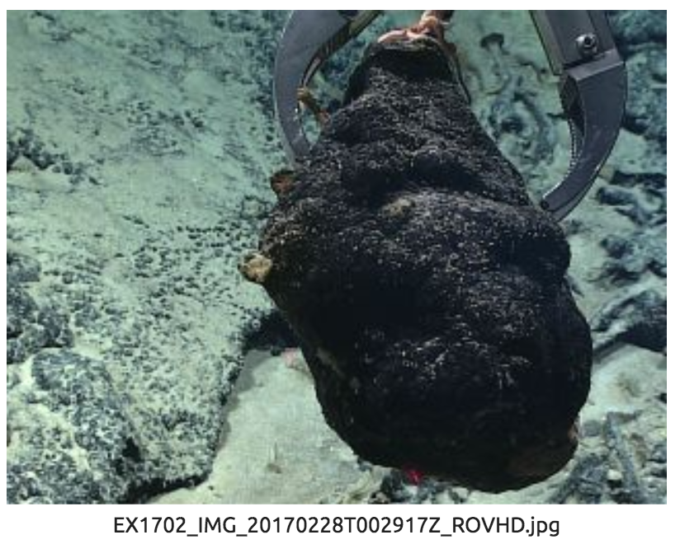
Time (UTC) | 00:35:32
Depth (m) | 2382.5742
Temperature (°C) | 1.86111
Field ID(s) | Rock with ophiuroid wrapped around sponge stalk
Comments
Sample
Sample ID | D2_DIVE12_SPEC06BIO |  | - 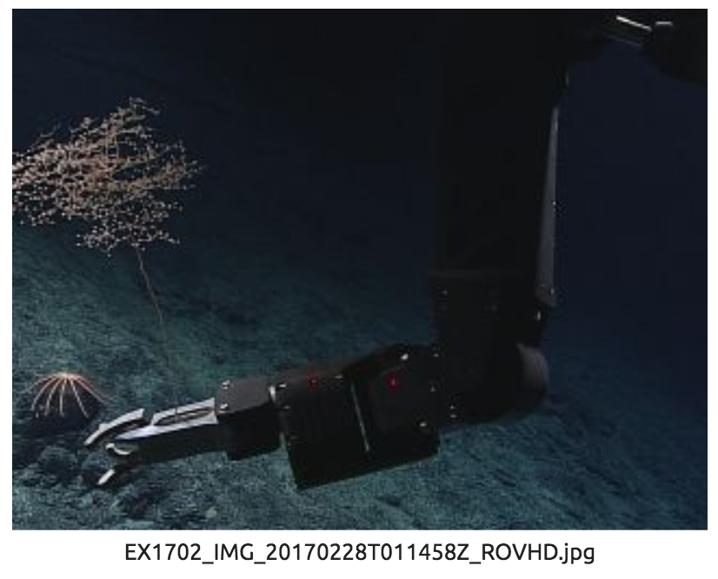
Date (UTC) | 20170228
Time (UTC) | 01:20:53
Depth (m) | 2361.7238
Temperature (°C) | 1.88915
Field ID(s) | cf. Pseudochrysogorgia w/ chirostylid squat lobster
Comments
Sample
Sample ID | D2_DIVE12_SPEC07GEO |  | - 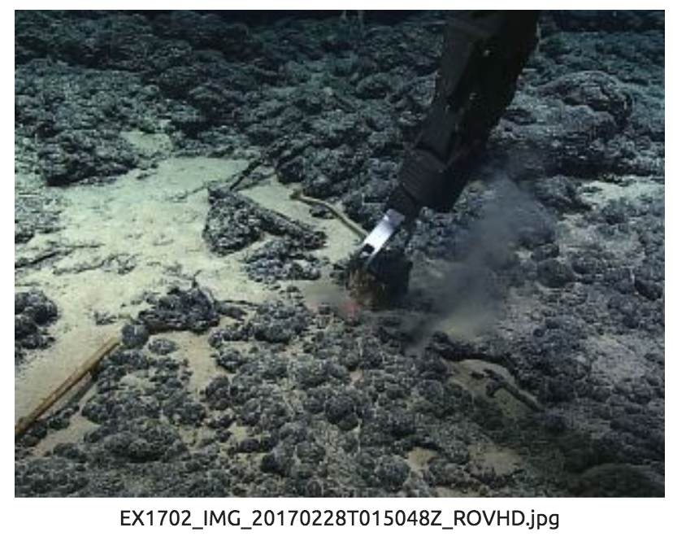
Date (UTC) | 20170228
Time (UTC) | 01:52:03
Depth (m) | 2340.7705
Temperature (°C) | 1.85781
Field ID(s) | rock
Comments

Please direct inquiries to:
NOAA Office of Ocean Exploration & Research
1315 East-West Highway (SSMC3 10th Floor)
Silver Spring, MD 20910
(301) 734-1014

