Dive Information
Okeanos Explorer ROV Dive Summary
Dive Map |  | 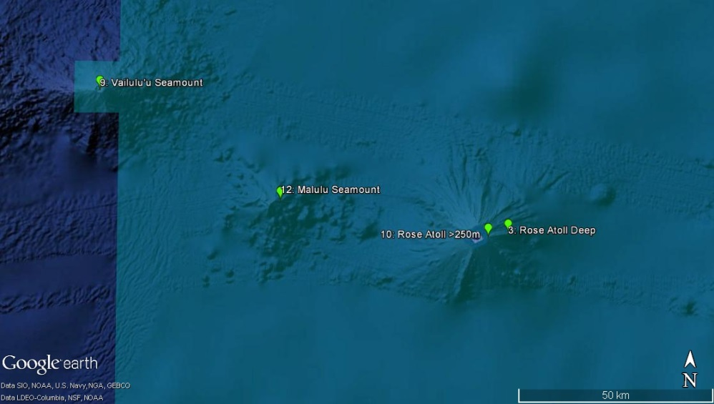
Site Name |  | Rose Atoll (shallow dive on east flank)
ROV Lead(s) |  | Karl McLetchie
Expedition Coordinator(s) / Mapping Lead |  | Kelley Elliott / Meme Lobecker
Science Team Lead(s) |  | Santiago Herrera (Biology) and Matt Jackson (Geology)
General Area Descriptor |  | Eastern Samoan region (easternmost island in American Samoa)
ROV Dive Name
Cruise |  | EX1702
Leg
Dive Number |  | 10
Equipment Deployed
ROV |  | Deep Discoverer (D2)
Camera Platform |  | Seirios
ROV Measurements |  | CTD |  | Depth | Altitude
 |  | Scanning Sonar |  | USBL Position | Heading
 |  | Pitch |  | Roll | HD Camera 1
 |  | HD Camera 2 |  | Low Res Cam 1 | Low Res Cam 2
 |  | Low Res Cam 3 |  | Low Res Cam 4 | Low Res Cam 5
 |  | LSS |  | ORP
Equipment Malfunctions |  | None
ROV Dive Summary  (from processed ROV data) |  | In Water: 2017-02-25T19:26:23.774000  14°, 32.505' S ; 168°, 07.700' W  Out Water: 2017-02-26T03:30:46.671000  14°, 32.898' S ; 168°, 07.924' W  Off Bottom: 2017-02-26T03:13:39.239000  14°, 32.879' S ; 168°, 07.949' W  On Bottom: 2017-02-25T20:26:03.561000  14°, 32.747' S ; 168°, 07.645' W  Dive duration: 8:4:22  Bottom Time: 6:47:35  Max. depth: 678.4 m
Special Notes
Scientists Involved  (please provide name, location, affiliation, email) |  | Asako Matsumoto, PERC/Chiba Institute of Technology, Japan  Bruce Mundy, NOAA NMFS Pacific Islands Fisheries Science Center  Christopher Kelley, University of Hawaii  Deborah Glickson, National Academies of Sciences, Engineering, and Medicine  Joseph O'Malley, NOAA/NMFS/PIFSC/FRMD/LHP  Les Watling, University of Hawaii at Manoa  Matthew Jackson , UC Santa Barbara  Santiago Herrera, Lehigh University  Scott France, University of Louisiana at Lafayette  Sonia Rowley, University of Hawai'i at Manoa  Tara Harmer Luke, Stockton University
Purpose of the Dive |  | The goal of this dive was to generate baseline information on deep biological communities, including bottom fish and precious corals habitats, to better understand their diversity and structure with the goal of supporting management needs of the Rose Atoll Marine National Monument.  The dive began around 700 m deep on a prominent ridge extending from the eastern region of the Rose Atoll, as shown in the bathymetry map. We started on the ridge crest, and then continued moving upslope to a depth of ~250 m.  From a geological standpoint, Rose Atoll is thought to be an older seamount linked to the Cook-Austral Islands instead of Samoa. Malulu to the west (to be sampled in a later dive during this cruise) and Rose Atoll are key in defining the Cook-Austral hotspot tracks back in time, and as such an age on a volcanic rock is needed from Rose Atoll. Without an age, it is not possible to truly define plate motion for the time frame represented by this volcano.
Description of the Dive |  | Rose Atoll lies in the eastern region of the Samoan islands. However, its atoll morphology defies expectation: the eastern Samoan islands are predicted by the hotspot model to be the youngest volcanic islands, but Rose atoll has the morphological appearance of being quite old, and this calls into question Rose atoll’s relationship with the Samoan hotspot. Indeed, existing work shows that the geochemistry of dredged lavas from the deep flanks of Rose atoll are not consistent with an origin at the Samoan hotspot. One hypothesis is that Rose atoll is an ancient volcano that formed over one of the hotspots in the Cook-Austral volcanic lineament. This hypothesis can be tested by obtaining basaltic samples to obtain age-dates and geochemical data.  The dive track was designed to target the shallow (<750 m) buttressing ridge on the eastern side of the hotspot; the deeper portions of this ridge were explored on a prior dive (Dive 03). The ROV track was designed to move progressively upslope, along a series of new volcanic features, and finish at a depth of ~250 m.  The following geological description provides a chronological summary of the major geological features, or changes in the geology of the ocean floor, over the course of the dive:  20:24:00 UTC. The ROV arrived on bottom. Ferromanganese encrusted (FE) sediments (or basalt) were visible (~50% of bottom cover) and light colored sediment, similar in color to the light colored sediment visible on previous dives of this expedition, is also visible and cover perhaps 50% of the field of view. Notably there are possible basalt clasts that are welded to the bottom, but it is not possible to sample them as they are “welded” to the seafloor.  20:31:26. Scleractinian stony coral visible (at ~677 meters; ROV location is 14 degrees, 32.7415 S, 168 degrees, -07.6133 W), morphologically similar to the deep sea corals that have been the focus of Jess Adkins’ research at Caltech.  20:35:27. The FE material has the morphology of basalt flows, possibly even pillow structures; however, it is not possible to rule out the possibility that the substrate is simply FE carbonate from a submerged reef. The FE materials exhibit some very different morphologies, including 10 to 20 cm tall “pinnacles”, which may represent erosive features or chemical weathering features (consistent with a carbonate origin). As the ROV is at only 677 m water depth, it is possible that this portion of the volcano was sub-aerial prior to volcanic subsidence; thus, the hypothesis of a carbonate (submerged reef) deposit is supported.  20:48:47. A pile of FE cobbles and pebbles, located in a relatively narrow (meters) region between what appear to be flows, have a partial cover of light sediment. Unfortunately, the ROV claw did not find any loose rock material for sampling.  21:04:59. A loose 30 cm FE cobble was tapped by the ROV. However, it looks like a ferromanganese crust with sediment, not a pillow basalt fragment, and the rock was left on the seafloor.  21:08:37. More smooth pillow structures are visible along a relatively steep slope (from perhaps 15 degrees ranging up to [on relatively small ledges] approximately 50 degrees).  21:22:40. A FE outcrop, several meters in diameter, rises above the surrounding seafloor. The outcrop appears to be (at least partially) composed of volcanic breccia that has been welded together by ferromanganese. However, due to the FE cover on all surfaces, it is not possible to conclusively rule out coral protoliths (in lieu of basalt) in the breccia.  21:24:54. Two scleractinian coral are visible (< 1 meter apart), a living one and a fossil. Both are at ~660 m water depth.  21:40:50. The ROV is moving upslope and smoother FE surfaces come into view, possibly submarine flows. Perhaps 5 to 10 meters upslope the slope steepens to ~30 or 40 degrees and the flow structures look like young flows on Pu’u O’o that have spilled over a steep ledge. Alternatively, these structures could represent coral that has been incised by weathering and subsequently encrusted with ferromanganese.  22:12:25. The FE surface has a reef structure; sub-aerially exposed corals in the nearby Cook Island weather to produce morphologies like that which are observed here. Smoother surfaces sloping at ~20 to 30 degrees dominate the field of view. Of course, a definite assessment of the substrate composition cannot be made without exposing the material that is “hidden” beneath the FE material. If this was once a shallow reef, it would suggest that the volcano has subsided 500 to 600 meters.  22:43:47. The ROV shows more FE smooth surfaces with occasional 5 to 10 cm wide “fissures” that host a dusting of light-colored sediment.  23:28:37. Smoother surfaces continue to dominate the field of view. However, some cobbles, possibly basaltic in origin, are present in the field of view, but the ROV passed over them too rapidly and a sampling opportunity was lost.  23:30:25. A 40 to 50 degree slope is visible in the field of view. Rougher surfaces are present, and these surfaces are incised by gullies, consistent with being weathered coral.  23:34:52. A rounded and elongate FE cobble, perhaps 30 cm (long axis length), is tapped by the ROV and the cobble is loose. No other cobbles are present nearby (there is an angular block, but it is “welded” to the substrate). A small red/pink crab was observed on the rock. This cobble is only the second loose rock encountered thus far, and is the first geological sample of the expedition (it was placed in starboard rock box): D2_DIVE10_SPEC03GEO.  23:46:00. Steeper, rougher terrain is observed in the field of view, and the outcrops are nearly vertical walls of outcrops. Gullies are visible at the ~1 m and the ~10 cm length scales.  23:52:11. Spectacular (chemical weathering?) morphologies are observed on the rock surfaces. The morphology of the substrate looks very much like a carbonate that has undergone partial dissolution, then covered in ferromanganese.  23:56:27. More carbonate-like deposits enter the field of view, and they have large scale and small scale morphology that is very similar to that which is seen during sub-aerial carbonate weathering and partial dissolution. The surface morphology is variably rough (and steep), but these substrates are juxtaposed with smoother (and less steep) sections.  00:08:27. The terrain is exceptionally steep over a relatively long distance. The slope is perhaps 50 to 70 degrees and continues for tens of meters. The same carbonate morphology is observed in the substrate. A deep (3 meters perhaps) and narrow (approximately 1 meter) fissure has come into view; it runs for perhaps 10’s of meters upslope.  00:25:09. The ROV has moved away from the long fissure for a view to the south, where the carbonate nature of the rock has become more evident. A light-colored sediment covers <2% of the surface. At this point it seems that the ferromanganese covering is minimal in many (most) surfaces, and the light tan color of the carbonate is apparent. However, this may also be a function of the lighting.  00:30:36. The ROV has moved back to the fissure, and the relatively narrow fissure has opened up to form a wide fissure (perhaps 5 or 10 meters). The water has become more turbid, which may relate to debris raining down from the reef of the atoll, and this debris is channeled down through the fissure.  00:50:40. The ROV’s field of view shows relatively smooth surfaces that are gently sloped (perhaps 10 degrees). The surface appears to be minimally coated with ferromanganese, with most surfaces showing exposed carbonate. It appears that, over the past 30 minutes to 1 hour, the conditions have changed such that either the formation or the preservation of ferromanganese encrustations are no longer favored.  00:52:53. FE scleractinian coral (dead) are observed.  00:57:57. Another dead scleractinian at 388 m water depth.  01:05:20. Another scleractinian at 385 m water depth.  01:05:43. The ferromanganese coat is rarely visible now and the carbonate on the substrate is not clearly visible at the surface. Occasionally, FE carbonate is visible, and this material tends to be elevated and form mini- “buttes” on the carbonate substrate; this may owe to the ferromanganese preserving the underlying carbonate from dissolution.  01:35:58. Smooth carbonate surfaces dominate the substrate. Dissolution of carbonate has resulted in complex and elaborate “sculptures”, including nearly “hollowed out” boulders, pinnacles, and overhanging ledges that jut out horizontally into the water. Sediment cover is minimal.  01:47:31. Carbonate lithologies define the substrate. Some evidence for ferromanganese coatings exist in some areas, again primarily in the elevated areas on the otherwise relatively smooth and flat surface.  01:59:29. The surface is defined by coral dissolution features that have generated numerous gullies that are a few cm to 10 cm wide. The gullies are shallow (5 to 10 cm) and filled with sediment; the sediment thus covers 30 to 50% of the surface in the field of view.  02:17:21. Carbonate cobbles are present on the carbonate substrate. One such coral became the second geological sample of the dive, and host to a coral: D2_DIVE10_SPEC05GEO.  02:56:18. Carbonate cobbles continue to be present on the carbonate substrate. One such carbonate cobble became the third geological sample of the dive, and is also host to a lovely coral: D2_DIVE10_SPEC06GEO.  03:09:26: Four living scleractinians are observed, clustered together under a starfish, at 313 m water depth. These coral are a striking yellow color.  03:10:00. The remainder of the dive continues to be dominated by shallow, submerged reef carbonate. Surprisingly little sediment is observed on the substrate.  The biological perspective is as follows:  Landed at 20:27 678 m on top of the ridge. Sloping ferromanganese encrusted terrain with light sediment cover. Observed a greeneye fish (Chlorophthalmus), cup corals, few dead sponges, a small Moridae codling, a mushroom coral Anthomastus (same morphospecies as in Vailulu’u?). Observed a dandelion siphonophore, a pycnogonid sea spider, a rattail, several comatulid crinoids (purple Telocrinidae, central part moving quite a bit). Observed conger eel at 21:16 653m (Bathyconger). Several cup corals and scorpion fish at 21:25 660m. Two additional species of crinoid and a cideroid (lacking skin on spines) urchin (possible predator of crinoid feather stars). Encountered solitary hydroid at 21:47 648 m (same morphospecies as in Vailulu’u?). Spotted couple of deep-water cardinal fish.  Encountered steeper terrain 21:56 644 m (vertical wall), rapidly transitioned into less steep slope. Observed a Hyalonema potbelly sponge, a couple more cideroid urchins. At 636 m 22:07 observed the first living colonial scleractinian coral likely Enallopsammia sp. After this, there was a lower abundance of organisms on the smooth surface of a gentler slope (626m 22:18).  At 622m 22:30 collected unusual Hexactinellid Corbitellinae sponge (likely new species). During collection observed a hermit crab and a polychaete worm on the sponge as associates; also, two eels living in the sponge! They swam away (20170225 22:38:11; D2_DIVE10_SPEC01BIO; 623 m).  Observed several colonies of black coral Parantipathes? at 619m 22:44. Also saw several large anemones, and an Anthomastus. Further ahead observed an abundance of small black coral colonies Parantipathes sp?, collected specimen at 610m 22:55 (D2_DIVE10_SPEC02BIO; 611 m).  Encountered a meter-tall bamboo coral with no spines in tentacles 602 m 23:15. Observed several more colonies of Parantipathes sp? black coral at 594 m 23:19, also a different species of scorpion fish. Collected a rock (20170225 23:42:16; D2_DIVE10_SPEC03GEO; 568 m).  Imaged a large Coronaster sunstar at 23:52 540 m. Observed a Ortomisis? bamboo coral fan at23:56 525m. Further upslope encountered an Enallopsamia coral 23:57 524m. Substrate was composed of large outcrops of carbonates encrusted with ferromanganese crust (00:01 520 m). Imaged another Ortomisis? bamboo coral at 00:11 481m and several whip bamboo corals with small polyps in a large deep fissure in the carbonate substrate at 472m 00:18.  Encountered yellow crinoids at 450m 00:22. Observed shimmering water (thermocline) between 450-400 meters. Saw different species of Anthomastus (same morphospecies as the one observed in Ta’U). Current was coming from an approximate direction of 225 degrees (392m 00:49). At this point observed a cup coral similar to the one observed on Ta’u. Encountered an octopus 388m 00:59, and two morphospecies of cup corals (all of these animals look like the ones in Ta’U). Imaged a cookie star (different from the white morphospecies seem in previous dives). Observed shimmering water at this depth. At 01:12 370 m imaged a Dendrophyllia scleractinian coral with ophiuroid associate and squat lobster (same morphospecies as in Ta’U). Encountered many more Anthomastus here. Community here is similar to the communities on Ta’U, yellow crinoids, white and purple cup corals, yellow crinoids, and Anthomastus.  Observed a yellow demosponge growing flat on top of rocks. At 361 m 01:38 observed may rows of barnacles on rocks, as well as several basket stars Gorgonocephalus? Observed shimmering water here as well. Collected basket star (20170226 01:43:52; D2_DIVE10_SPEC04BIO; 362).  Encountered a school of large Etelis snapper fish at 350m 01:54. At 347m 01:59 observed really abundant soft octocorals and Acanthogorgid octocorals. Saw scorpion fish, hundreds of soft octocorals and chrysogorgiid-like octocorals. Collected rock with soft coral on it (20170226 02:20:54; D2_DIVE10_SPEC05GEO; 325).  At 02:30 we were advised by the bridge that we could not reach WP3 because it would put us too close to the shore. Minimum possible depth for the ROV was 310 meters. Started to make detailed observations of fish. Continued to see hundreds of colonies of the same soft octocoral species. At 02:40 315m stopped seeing the great abundance of soft corals, transitioned into a community of many small yellow scleractinians and small white sponges in an area of shimmering water and small cobbles. Collected a rock with scleractinian and sponge (20170226 03:02:05; D2_DIVE10_SPEC06GEO; 315 m).  Observed several fish species, including: Grouper Hypothordus octofasciatus  Grammatonotus (Callanthiidae), Polylepion (Labridae), Antigonia (Caproidae), Ostichthys (Holocentridae), and Pontinus (Scorpaenidae).  Observed very abundant small yellow scleractinian corals over a smooth terrain, gentle slope. Last observation we did was of a scleractinian been predated by a Astroceramus seastar, followed by a yellow snapper. Ended the dive at 03:16.
Overall Map of the ROV Dive Area |  |  | Close-up Map of Main Dive Site
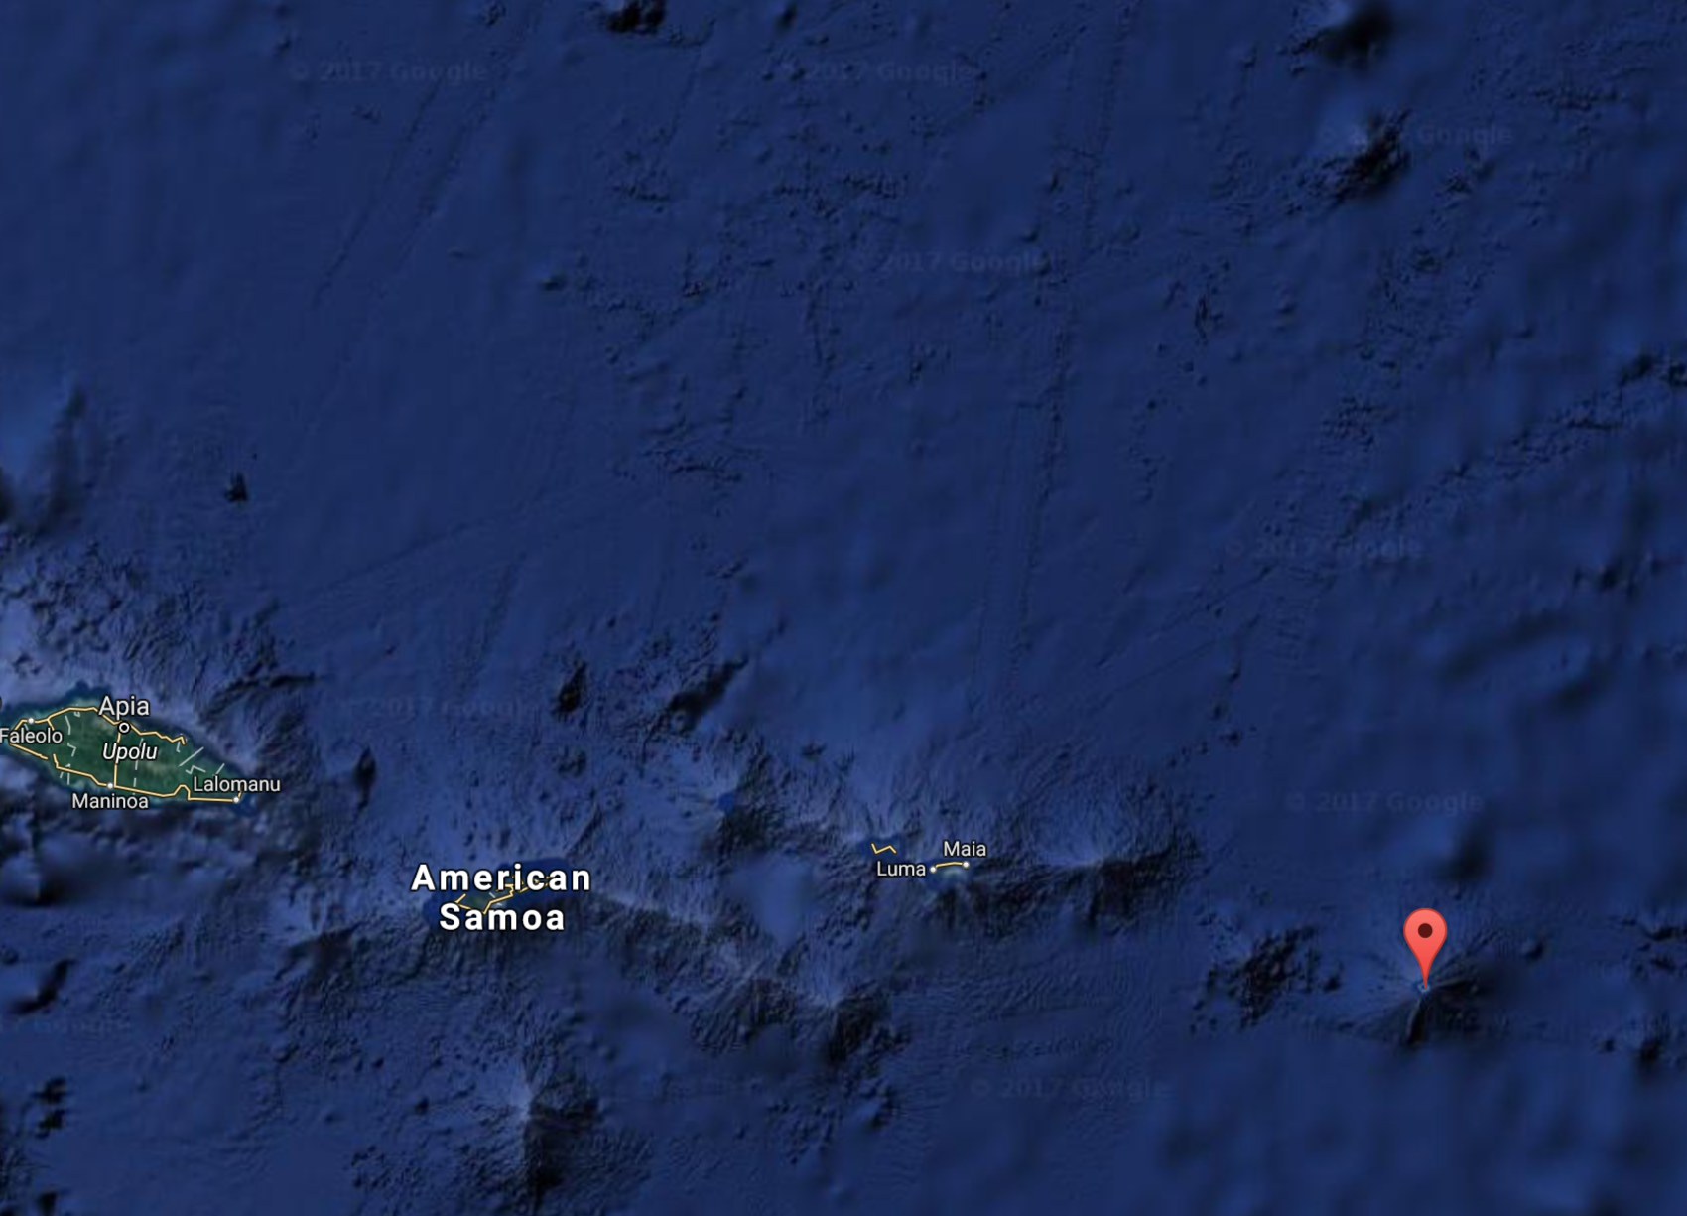 |  |  | 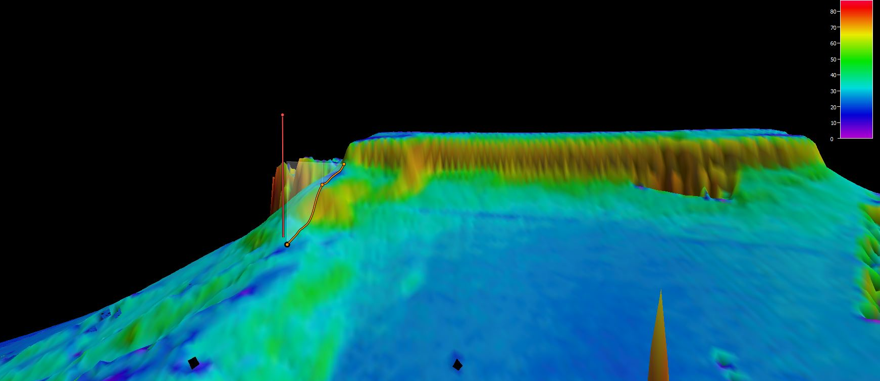
Representative Photos of the Dive
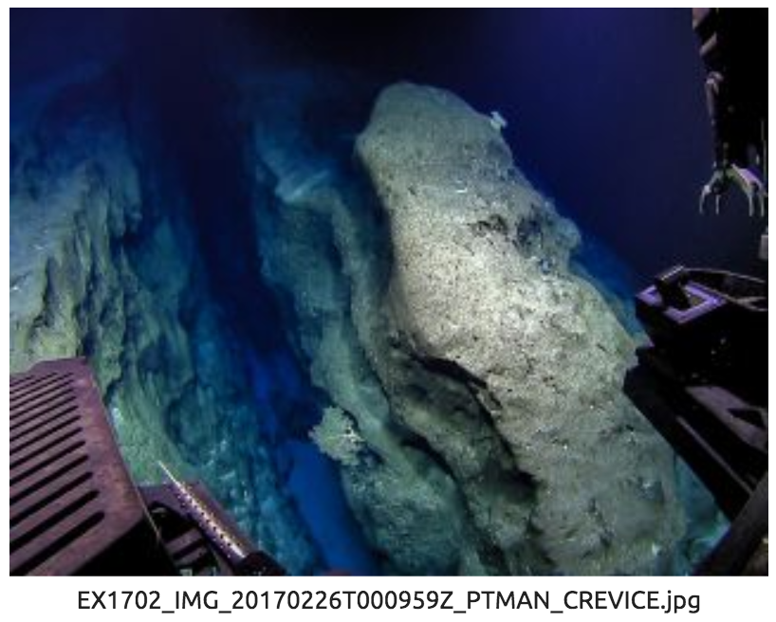 |  |  | 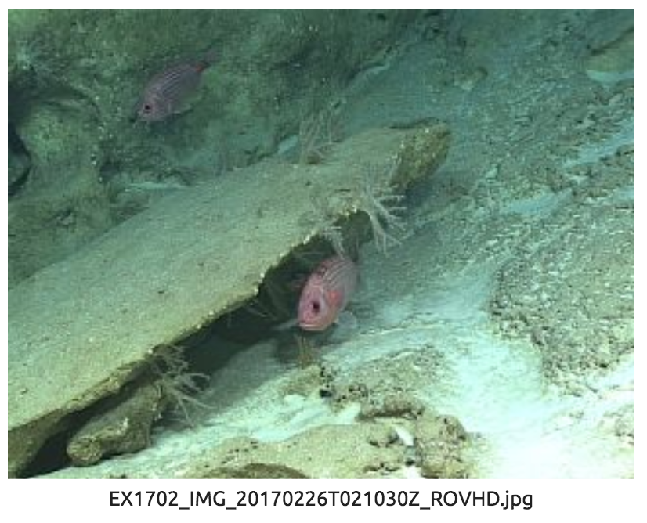
Carbonate outcrops split by longitudinal fissures. |  |  | Snappers and soft octocorals over carbonate terrain.
Samples Collected
Sample
Sample ID | D2_DIVE10_SPEC01BIO |  | 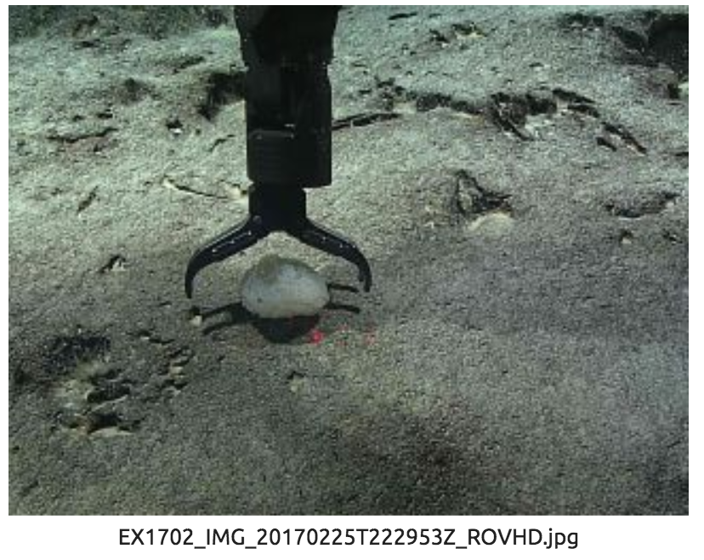
Date (UTC) | 20170225
Time (UTC) | 22:38:11
Depth (m) | 623.388
Temperature (°C) | 6.25730
Field ID(s) | Hexactinellida sponge
Comments
Sample
Sample ID | D2_DIVE10_SPEC02BIO |  | 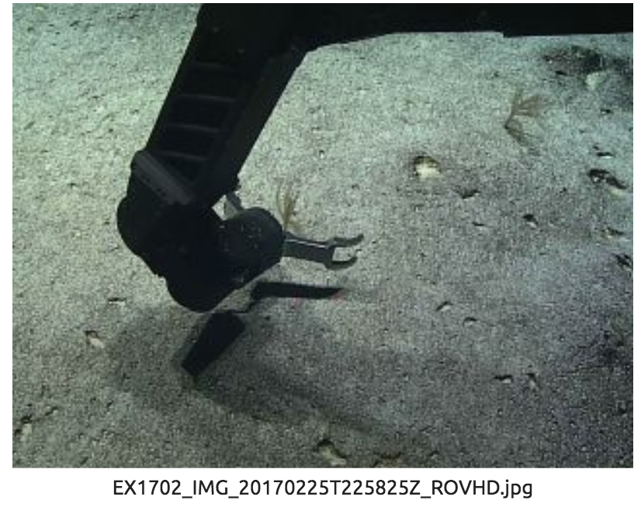
Date (UTC) | 20170225
Time (UTC) | 23:05:47
Depth (m) | 610.9940
Temperature (°C) | 6.33438
Field ID(s) | Antipatharia
Comments
Sample
Sample ID | D2_DIVE10_SPEC03GEO |  | 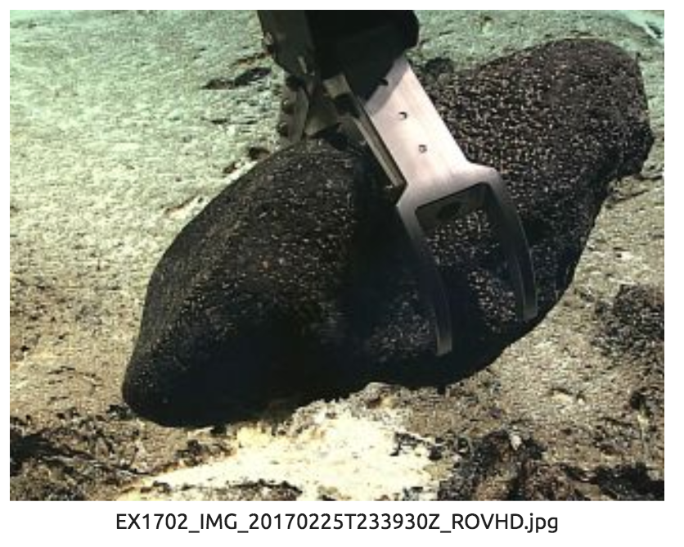
Date (UTC) | 20170225
Time (UTC) | 23:42:16
Depth (m) | 568.0900
Temperature (°C) | 6.93560
Field ID(s) | rock
Comments
Sample
Sample ID | D2_DIVE10_SPEC04BIO |  | 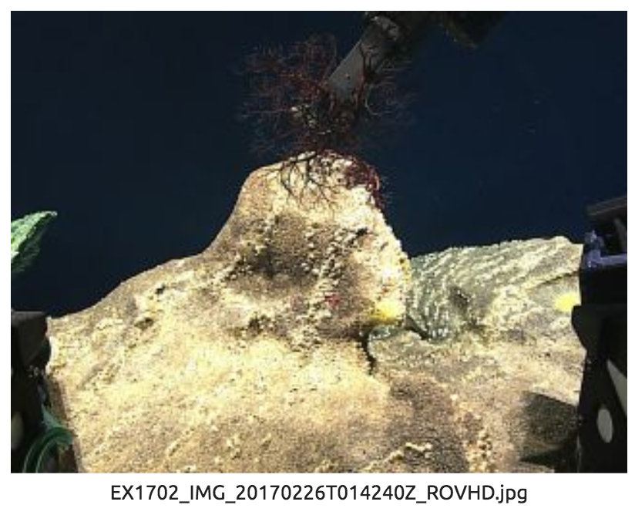
Date (UTC) | 20170226
Time (UTC) | 01:43:52
Depth (m) | 361.5599
Temperature (°C) | 14.67788
Field ID(s) | Gorgonocephalus?
Comments
Sample
Sample ID | D2_DIVE10_SPEC05GEO
Date (UTC) | 20170226 |  | 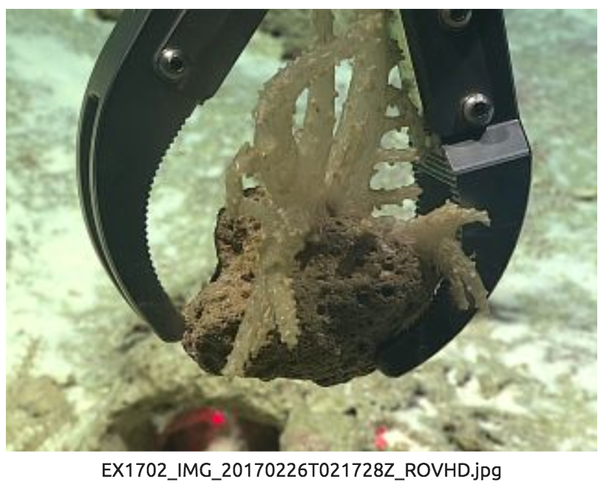
Time (UTC) | 02:20:54
Depth (m) | 325.4760
Temperature (°C) | 16.68620
Field ID(s) | Rock with associate soft octocoral
Comments
Sample
Sample ID | D2_DIVE10_SPEC06GEO |  | 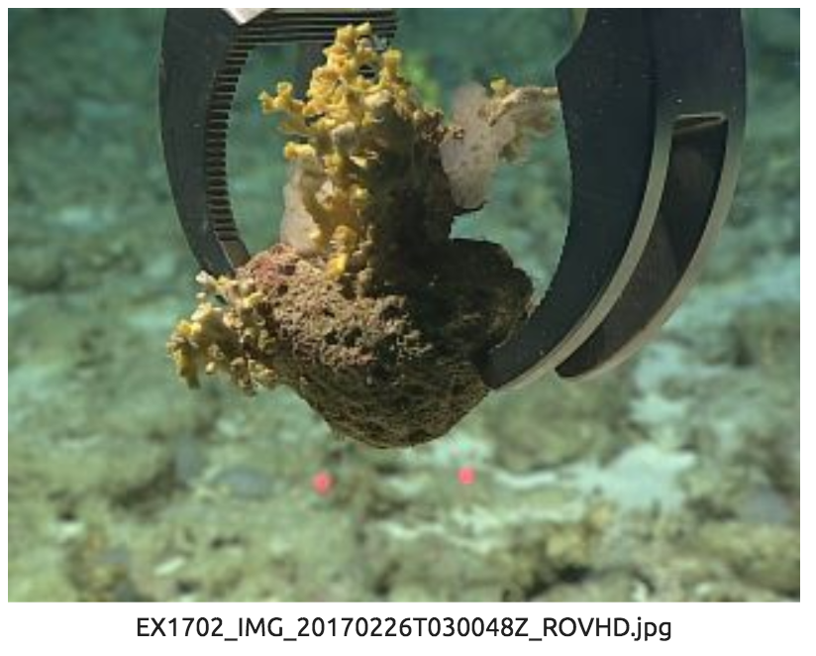
Date (UTC) | 20170226
Time (UTC) | 03:02:05
Depth (m) | 315.2899
Temperature (°C) | 16.97638
Field ID(s) | Rock with scleractinian and sponge
Comments | Rock had pink spots (likely calcareous algae)

Please direct inquiries to:
NOAA Office of Ocean Exploration & Research
1315 East-West Highway (SSMC3 10th Floor)
Silver Spring, MD 20910
(301) 734-1014

