Okeanos Explorer ROV Dive Summary
Dive Information
Dive Map | 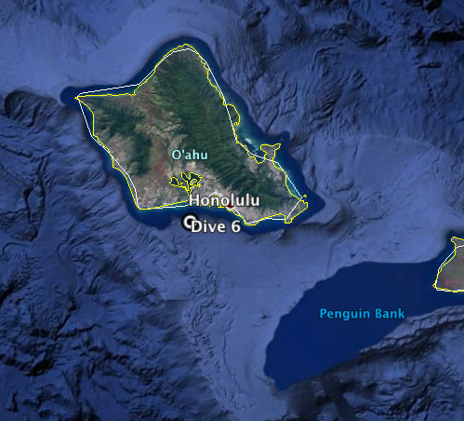
Site Name | Three Piece Japanese Midget Submarine
Expedition Coordinator(s) | Brian RC Kennedy
ROV Lead(s) | Karl McLetchie
Science Team Lead(s) | Frank Cantelas and James Delgado
General Area Descriptor | South of Oahu
ROV Dive Name
Cruise | EX-16-08
Leg | 0
Dive Number | 6
Equipment Deployed
ROV | Deep Discoverer (D2)
Camera Platform | Seirios
ROV Measurements | CTD |  | Depth | Altitude
 | Scanning Sonar |  | USBL Position | Heading
 | Pitch |  | Roll | HD Camera 1
 | HD Camera 2 |  | Low Res Cam 1 | Low Res Cam 2
 | Low Res Cam 3 |  | Low Res Cam 4 | Low Res Cam 5
Equipment Malfunctions
ROV Dive Summary  (from processed ROV data) | Dive Summary: EX1608_DIVE06  ^^^^^^^^^^^^^^^^^^^^^^^^^^^^^^^^^^^^^^^^^^^^^^^^^^^  In Water: 2016-12-07T20:43:07.315000  21°, 15.958' N ; 157°, 57.898' W  Out Water: 2016-12-08T00:22:28.989000  21°, 15.829' N ; 157°, 57.812' W  Off Bottom: 2016-12-07T23:54:15.094000  21°, 15.875' N ; 157°, 57.935' W  On Bottom: 2016-12-07T20:59:02.265000  21°, 15.956' N ; 157°, 57.854' W  Dive duration: 3:39:21  Bottom Time: 2:55:12  Max. depth: 371.0 m
Special Notes | The position of this wreck is project and cannot be distributed without permission
Scientists Involved  (please provide name, location, affiliation, email) | Shore based scientist were not recorded
Purpose of the Dive | Document the condition of the three-piece Japanese Midget Submarine that was lost on December 7th 1941 and participant in the ceremonies associated with of the 75th anniversary of the attack on Pearl Harbor.
Description of the Dive | On December 7, 2016, NOAA dove on the wrecks of the Japanese mini submarines that was involved in the attack on Pearl Harbor in 1941, this dive focused on the wreck known as the three-piece. A team of maritime archaeologists and scientists from NOAA’s Office of National Marine Sanctuaries and Office of Ocean Exploration and Research used the remotely operated vehicle (ROV) Deep Discoverer on NOAA Ship Okeanos Explorer to document the condition of the wreck sites and record and live-stream video of the exploration.  This was the first time the public was able to view live underwater exploration of this wreck. The live video of the historic dives received over 1.5 million views. Throughout the dive, maritime archaeologists aboard the ship and in land-based Exploration Command Centers described the exploration and the submarines’ historic role in the Pearl Harbor attacks.
Overall Map of the ROV Dive Area |  | Close-up Map of Main Dive Site
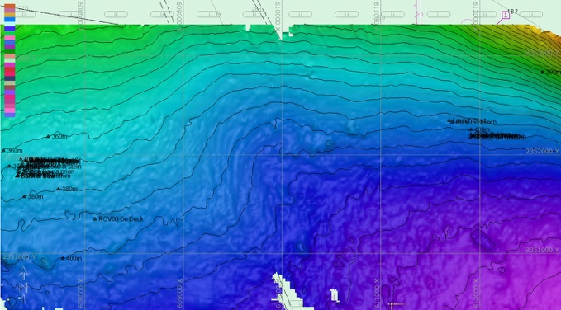 |  | 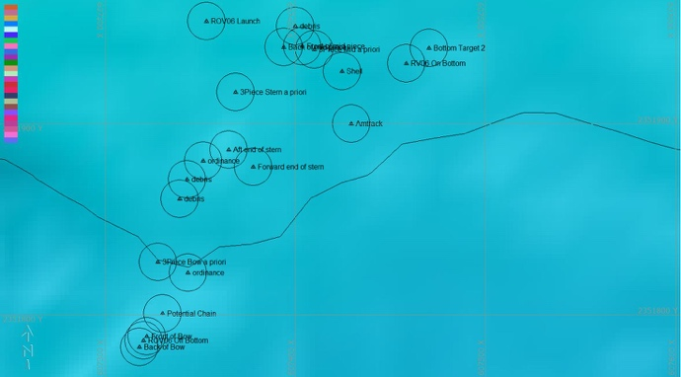
Representative Photos of the Dive
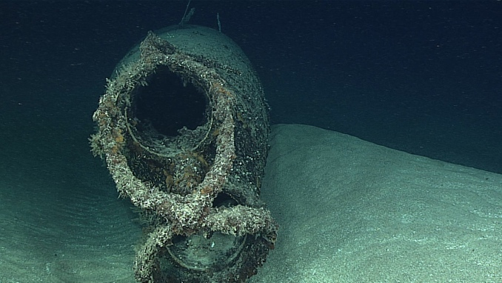 |  | 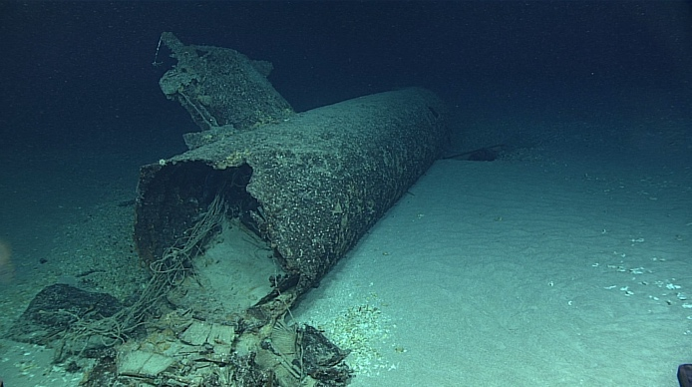
- The figure 8 torpedo guard on the bow |  | - The center section of the submarine

Please direct inquiries to:
NOAA Office of Ocean Exploration & Research
1315 East-West Highway (SSMC3 10th Floor)
Silver Spring, MD 20910
(301) 734-1014

