Okeanos Explorer ROV Dive Summary
Dive Information
Dive Map | 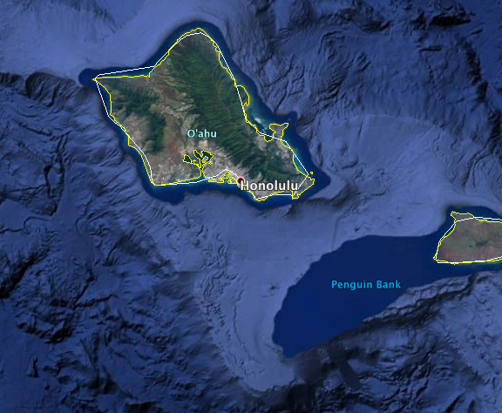
Site Name | Ward Midet Submarine
Expedition Coordinator(s) | Brian RC Kennedy
ROV Lead(s) | Karl McLetchie
Science Team Lead(s) | Frank Cantelas and James Delgado
General Area Descriptor | South of Oahu
ROV Dive Name
Cruise | EX-16-08
Leg | 0
Dive Number | 5
Equipment Deployed
ROV | Deep Discoverer (D2)
Camera Platform | Seirios
ROV Measurements | CTD |  | Depth | Altitude
 | Scanning Sonar |  | USBL Position | Heading
 | Pitch |  | Roll | HD Camera 1
 | HD Camera 2 |  | Low Res Cam 1 | Low Res Cam 2
 | Low Res Cam 3 |  | Low Res Cam 4 | Low Res Cam 5
Equipment Malfunctions
ROV Dive Summary  (from processed ROV data) | Redacted to protect the position of the wreck
Special Notes | The position of the wreck is protected and can be disturbed only with permission
Scientists Involved  (please provide name, location, affiliation, email) | Shore Based Scientist were not recorded
Purpose of the Dive | Document the condition of the Japanese Midget Submarine that was sunk by the USS Ward on December 7th 1941 and participant in the ceremonies associated with of the 75th anniversary of the attack on Pearl Harbor.
Description of the Dive | On December 7, 2016, NOAA dove on the wrecks of the Japanese mini submarine that was involved in the attack on Pearl Harbor in 1941, which was sunk by the USS Ward prior to the attack. A team of maritime archaeologists and scientists from NOAA’s Office of National Marine Sanctuaries and Office of Ocean Exploration and Research used the remotely operated vehicle (ROV) Deep Discoverer on NOAA Ship Okeanos Explorer to document the condition of the wreck sites and record and live-stream video of the exploration.  This was the first time the public was able to view live underwater exploration of the mini submarines. The live video of the historic dive received over 1.5 million views. Throughout the dive, maritime archaeologists aboard the ship and in land-based Exploration Command Centers described the exploration and the submarines’ historic role in the Pearl Harbor attacks.  Some notable observations of the submarine sunk by the USS Ward since it was last explored in 2014 include:  - The mini submarine’s physical condition has changed considerably. The hull plating is deteriorating and the forward section has separated from the midsection.  - Significant biological growth has occurred.  - The interior of the bow is now exposed but has not filled with silt. There appears to be no coral growth inside the sub.  - The aft ends of the torpedo tubes and firing mechanisms were visible through the gap, reminding us both of the deadly intent of the mission and the mission’s failure.  - The lower propeller blades are showing increased deterioration due to increasing stress of contact with the seafloor.  - The periscope faces forward with handles in the up position, and the periscope was stowed, not raised. This information contributes to the knowledge of what likely happened when the sub was struck. A USS Ward crewman had stated that the periscope had swiveled away, probably as the order was given for the sub to dive. However, the USS Ward fired a four-inch shell that smashed through the conning tower, sinking the mini sub and two-person crew. Before that happened, the commander had quickly stowed the periscope, indicating he knew they had been spotted and were in peril.
Overall Map of the ROV Dive Area |  | Close-up Map of Main Dive Site
Redacted to protect the position of the wreck |  | Redacted to protect the position of the wreck
Representative Photos of the Dive
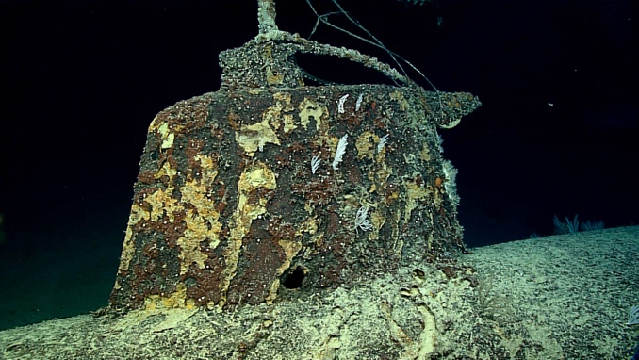 |  | 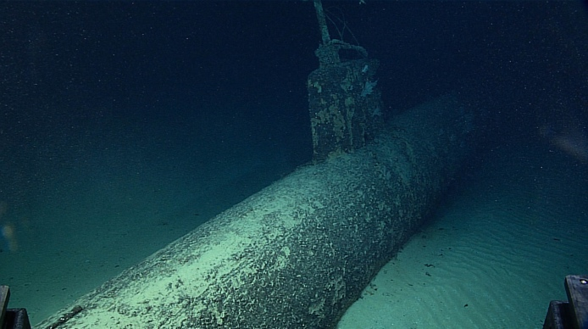
- The shell hole that sunk the Midget sub is clearly visible at the base of the conning tower. |  | - The Ward Midget south of Pearl Harbor

Please direct inquiries to:
NOAA Office of Ocean Exploration & Research
1315 East-West Highway (SSMC3 10th Floor)
Silver Spring, MD 20910
(301) 734-1014

