Okeanos Explorer ROV Dive Summary
Dive Information
Dive Map | 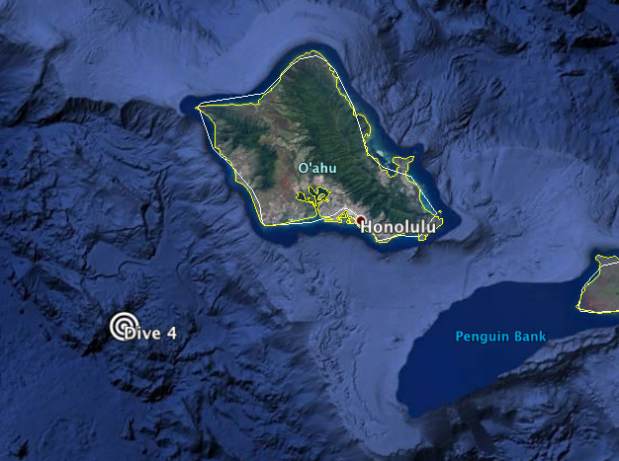
Site Name | Deep Engineering test
Expedition Coordinator(s) | Brian RC Kennedy
ROV Lead(s) | Karl McLetchie
Science Team Lead(s) | Frank Cantelas and James Delgado
General Area Descriptor | South of Oahu
ROV Dive Name
Cruise | EX-16-08
Leg | 0
Dive Number | 4
Equipment Deployed
ROV | Deep Discoverer (D2)
Camera Platform | Seirios
ROV Measurements | CTD |  | Depth | Altitude
 | Scanning Sonar |  | USBL Position | Heading
 | Pitch |  | Roll | HD Camera 1
 | HD Camera 2 |  | Low Res Cam 1 | Low Res Cam 2
 | Low Res Cam 3 |  | Low Res Cam 4 | Low Res Cam 5
Equipment Malfunctions
ROV Dive Summary  (from processed ROV data) | Dive Summary: EX1608_DIVE04  ^^^^^^^^^^^^^^^^^^^^^^^^^^^^^^^^^^^^^^^^^^^^^^^^^^^  In Water: 2016-12-06T23:53:10.434000  21°, 03.193' N ; 158°, 27.539' W  Out Water: 2016-12-07T03:41:54.288000  21°, 03.268' N ; 158°, 28.055' W  Dive duration: 3:48:43  Bottom Time: N/A  Max. depth: 3305.0 m
Special Notes
Scientists Involved  (please provide name, location, affiliation, email) | none
Purpose of the Dive | Deep water test of ROV systems and traction winch
Description of the Dive | This dive was devoted to engineering trials of the ROV and Telepresence systems. The ROV was lowered to 3305 meters to pressure test the ROV and assess the traction winch. The ROV never made bottom contact.
Overall Map of the ROV Dive Area |  | Close-up Map of Main Dive Site
None |  | None
Representative Photos of the Dive
None |  | None
- NA |  | - NA

Please direct inquiries to:
NOAA Office of Ocean Exploration & Research
1315 East-West Highway (SSMC3 10th Floor)
Silver Spring, MD 20910
(301) 734-1014

