Okeanos Explorer ROV Dive Summary
Dive Information
Dive Map | 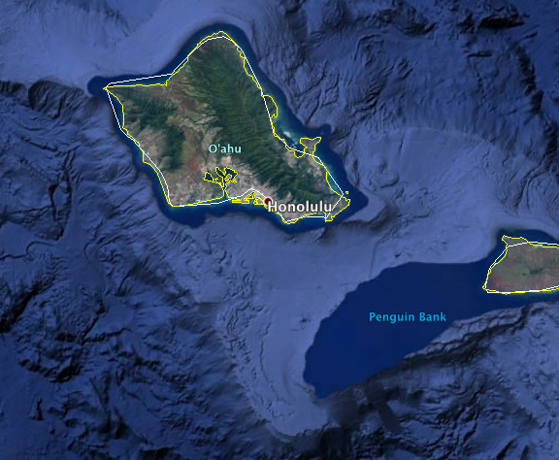
Site Name | S-19
Expedition Coordinator(s) | Brian RC Kennedy
ROV Lead(s) | Karl McLetchie
Science Team Lead(s) | Frank Cantelas and James Delgado
General Area Descriptor | South of Oahu
ROV Dive Name
Cruise | EX-16-08
Leg | 0
Dive Number | 3
Equipment Deployed
ROV | Deep Discoverer (D2)
Camera Platform | Seirios
ROV Measurements | CTD |  | Depth | Altitude
 | Scanning Sonar |  | USBL Position | Heading
 | Pitch |  | Roll | HD Camera 1
 | HD Camera 2 |  | Low Res Cam 1 | Low Res Cam 2
 | Low Res Cam 3 |  | Low Res Cam 4 | Low Res Cam 5
Equipment Malfunctions | The DP failed causing the dive to be aborted early.
ROV Dive Summary  (from processed ROV data) | Redacted to protect the position of the wreck
Special Notes | The position of this wreck is protected. Distribution of the position is by permission only.
Scientists Involved  (please provide name, location, affiliation, email) | Shore based science participants were not recorded.
Purpose of the Dive | Engineering trials of ship and ROV systems
Description of the Dive | This dive was devoted to engineering trials of the ROV and Telepresence systems. After the completion of the engineering objectives the ROV explored the World War 1 submarine wreck of the S-19. Shortly after making visual contact with the wreck the ship started experiencing problems with the DP system and the dive had to be aborted for safety reasons.
Overall Map of the ROV Dive Area |  | Close-up Map of Main Dive Site
Redacted to protect the position of the wreck |  | Redacted to protect the position of the wreck
Representative Photos of the Dive
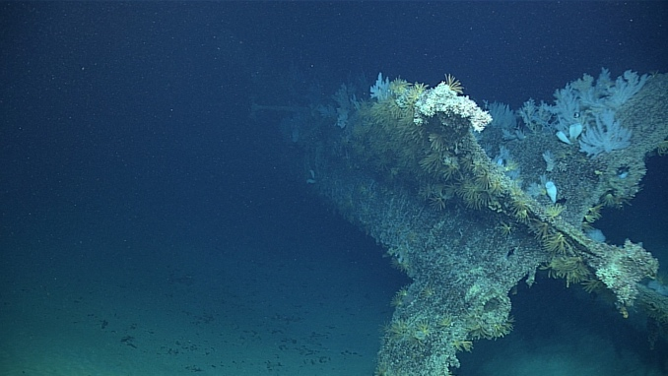 |  | 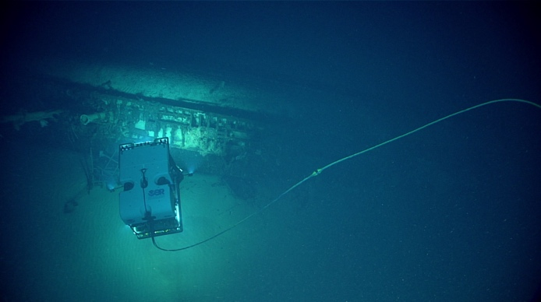
- The stern of the S-19 |  | - The ROV images the S-19

Please direct inquiries to:
NOAA Office of Ocean Exploration & Research
1315 East-West Highway (SSMC3 10th Floor)
Silver Spring, MD 20910
(301) 734-1014

