Okeanos Explorer ROV Dive Summary
Dive Information
Dive Map | 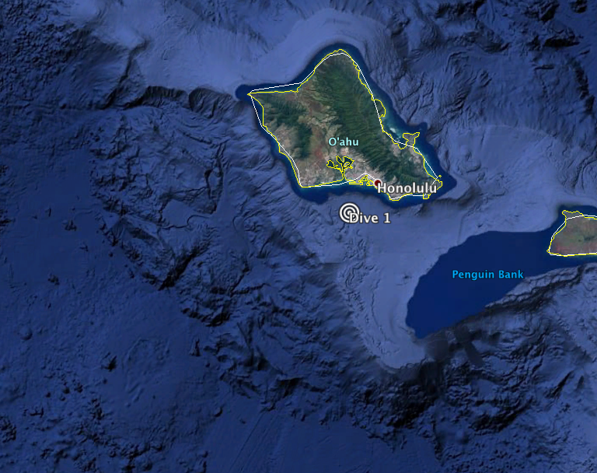
Site Name | Engineering Dive Site 1
Expedition Coordinator(s) | Brian RC Kennedy
ROV Lead(s) | Karl McLetchie
Science Team Lead(s) | None
General Area Descriptor | South of Oahu
ROV Dive Name
Cruise | EX-16-08
Leg | 0
Dive Number | Dive 1
Equipment Deployed
ROV | Deep Discoverer (D2)
Camera Platform | Seirios
ROV Measurements | CTD |  | Depth | Altitude
 | Scanning Sonar |  | USBL Position | Heading
 | Pitch |  | Roll | HD Camera 1
 | HD Camera 2 |  | Low Res Cam 1 | Low Res Cam 2
 | Low Res Cam 3 |  | Low Res Cam 4 | Low Res Cam 5
Equipment Malfunctions
ROV Dive Summary  (from processed ROV data) | Dive Summary: EX1608_DIVE01  ^^^^^^^^^^^^^^^^^^^^^^^^^^^^^^^^^^^^^^^^^^^^^^^^^^^  In Water: 2016-12-03T18:31:16.719000  21°, 13.025' N ; 157°, 57.047' W  Out Water: 2016-12-03T22:31:26.777000  21°, 13.079' N ; 157°, 56.819' W  Off Bottom: 2016-12-03T22:11:38.025000  21°, 13.018' N ; 157°, 57.008' W  On Bottom: 2016-12-03T18:51:26.168000  21°, 12.996' N ; 157°, 56.947' W  Dive duration: 4:0:10  Bottom Time: 3:20:11  Max. depth: 511.5 m
Special Notes
Scientists Involved  (please provide name, location, affiliation, email) | None
Purpose of the Dive | Engineering trials of ship and ROV systems
Description of the Dive | This dive was devoted to engineering trials of the ROV and Telepresence systems. No exploration was conducted during the dive.
Overall Map of the ROV Dive Area |  | Close-up Map of Main Dive Site
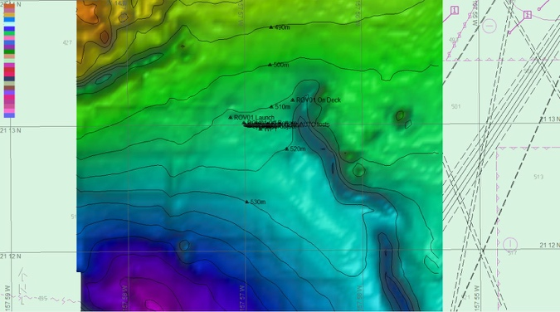 |  | 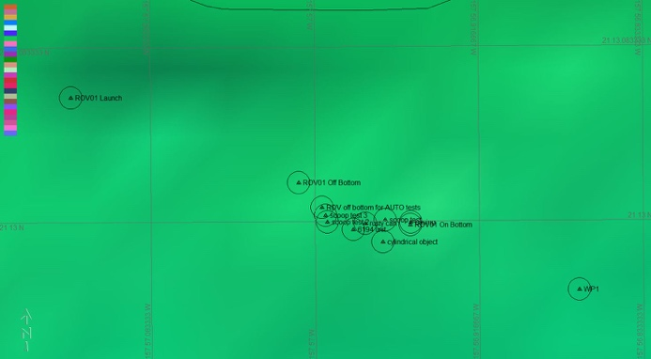
Representative Photos of the Dive
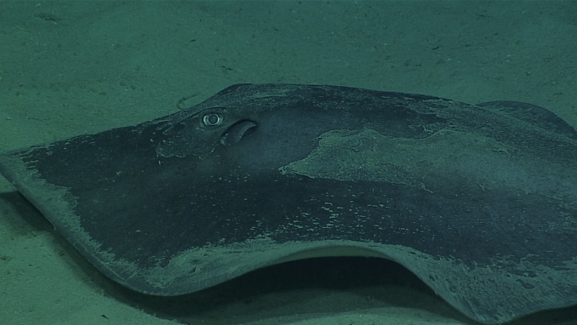 |  | 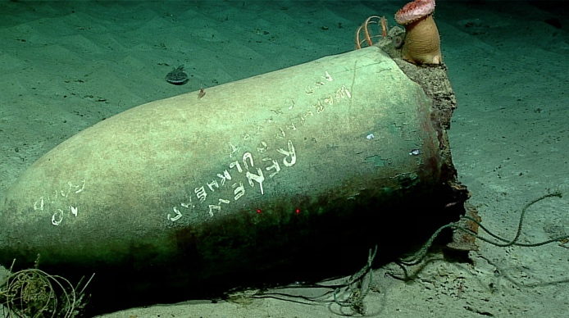
- Stingray seen during the dive |  | - Several pieces of anthropogenic debris were seen throughout the dive.
Samples Collected

Please direct inquiries to:
NOAA Office of Ocean Exploration & Research
1315 East-West Highway (SSMC3 10th Floor)
Silver Spring, MD 20910
(301) 734-1014

