DRAFT Project Instructions

**Date Submitted:** TBD

**Platform:** NOAA Ship *Okeanos Explorer*

**Project Number:** EX-16-07

**Project Title:** CAPSTONE Wake Island PRI MNM (Mapping)

**Project Dates:** Aug 25 - Sept 11, 2016

**Prepared by:** ________________________ **Dated:** __________________  
 Elizabeth Lobecker, NOAA  
 Expedition Coordinator  
 Office of Ocean Exploration & Research

**Approved by:** ________________________ **Dated:** __________________  
 Craig Russell  
 Program Manager  
 Office of Ocean Exploration & Research

**Approved by:** ________________________ **Dated:** __________________  
 Captain Scott M. Sirois, NOAA  
 Commanding Officer  
 Marine Operations Center - Atlantic

I.OVERVIEW

# A.Brief Summary and Project Period

From August 25 to September 11 2016, NOAA and partners will conduct a telepresence-enabled ocean exploration cruise on [NOAA Ship *Okeanos Explorer*](http://oceanexplorer.noaa.gov/okeanos/about.html) to collect critical baseline information in and around the Wake Island Unit of the Pacific Remote Islands Marine National Monument (PRIMNM). EX-16-07 will commence in Kwajalein, Marshall Islands, with operations beginning on August 25 and conclude in Honolulu, Hawaii on September 11. Exploration operations for this cruise will focus on collecting seafloor mapping data over several seamounts within the Wake Island Unit of PRIMNM, and conducting targeted mapping exploration transits between the start and end ports and the working grounds. This expedition will help establish a baseline of information in the region to catalyze further exploration, research and management activities. This expedition is part of a three year Campaign to Address Pacific monument Science, Technology, and Ocean Needs ([CAPSTONE](http://oceanexplorer.noaa.gov/okeanos/explorations/capstone/welcome.html)) focused on systematically collecting baseline information to support science and management needs within and around the Monuments and other protected places in the Pacific, and serves as an opportunity for NOAA and the Nation to highlight the uniqueness and importance of these national symbols of ocean conservation. NOAA will work with the scientific and management community to characterize unknown and poorly-known areas through telepresence-based exploration.

Understanding biogeographic patterns between and among the Pacific Monuments and Sanctuaries is a coordinating theme for CAPSTONE science priorities. Themes and objectives for the expedition series include:

* Acquire data to support priority Monument and Sanctuaries science and management needs, including habitat surveys in recently expanded boundary areas;
* Identify and characterize vulnerable marine habitats - particularly potential locations for high density deep sea coral and sponge communities;
* Characterize seamounts within the Prime Crust Zone (PCZ). The PCZ is the area of the Pacific with the highest expected concentration of deep sea minerals, including rare metals and rare earth elements;
* Collect information on the geologic history of Central Pacific Seamounts, including those that are or may be relevant to our understanding of plate tectonics and subduction zone biology and geology; and
* Provide a foundation of publicly accessible data and information products to spur further exploration, research, and management activities.

Originally created by Presidential Proclamation 8336 of January 6, 2009, Pacific Remote Islands Marine National Monument (PRIMNM) boundaries were expanded by Presidential Proclamation 9173, dated September 29, 2014. The expansion includes waters adjacent to Jarvis and Wake Islands, and Johnston Atoll.Wake Island is the northernmost atoll in the Marshall Islands geological ridge, and according to the US Fish & Wildlife Service, is perhaps the oldest living atoll in the world. The Wake Island Unit of PRIMNM contains 406,307 km2 of ocean area within the US Exclusive Economic Zone.

Earlier this year, EX-16-04 focused on ocean mapping of the Wake Island unit of PRIMNM for exploratory baseline characterization. Additionally, EX-16-06 will be a combined ROV and mapping expedition with a focus on the Wake Island unit of PRIMNM. Prior to OER’s 2016 CAPSTONE expeditions, very little multibeam surveying had been completed in this region. Therefore, EX-16-04, EX-16-06, and EX-16-07 will be the most ambitious effort to date to systematically explore this very large US marine protected area. At the successful completion of this cruise, nearly all major seamounts within Wake Island Unit will have been mapped, leaving a lasting contribution to the understanding of this important marine area.

Operations will include 24 hour/day mapping operations using the ship’s deep water mapping systems (Kongsberg EM302 multibeam sonar, EK60 split-beam fisheries sonars, ADCPs, and Knudsen 3260 chirp sub-bottom profiler sonar), CTD rosette, and the ship’s high-bandwidth satellite connection for real-time ship to shore communications. Operations for this cruise will include 24 hour mapping, and continuous telepresence-based remote participation in mapping operations. Multibeam and singlebeam mapping operations will be conducted 24 hours a day throughout the cruise. Sub-bottom profile mapping will be conducted 24 hours a day at the discretion of the CO. XBT sound velocity casts in support of multibeam sonar mapping operations will be conducted at an interval defined by prevailing oceanographic conditions, but not to exceed 6 hours. All mapping data will be fully processed according to standard onboard procedures and will be archived with the National Centers for Environmental Information (NCEI).

NOAA Ship *Okeanos Explorer* systematically explores the ocean every day of every cruise to maximize public benefit from the ship’s unique capabilities. With 95% of the ocean unexplored, we pursue every opportunity to map, sample, explore, and survey at planned destinations as well as during transits; “Always Exploring” is a guiding principle. An integral element of *Okeanos Explorer’s* “Always Exploring” model is the ship’s seafloor and water column mapping capabilities, and the ability to transmit new environmental baseline information to shore in near real time.

The transit routes between ports and the operating area will maximize mapping of discrete geologic features including seamounts and ridges with little or no existing modern sonar data coverage. The routes were chosen based on the most recent version of the global bathymetric compilation dataset compiled by J.J. Becker et al (http://topex.ucsd.edu/sandwell/publications/124_MG_Becker.pdf).

This expedition will be the fourth cruise to test telepresence enabled mapping operations on Okeanos Explorer. This will be the most dynamic of the four cruises thus far, with mapping efforts to include preplanned mapping surveys over several distinct seamounts within the Wake Island Unit of PRIMNM. In this test, the Expedition Coordinator for the cruise (Elizabeth Lobecker) will be based on shore at the Exploration Command Center (ECC) at University of New Hampshire Center for Coastal and Ocean Mapping / Joint Hydrographic Center (UNH CCOM/JHC) with regular and ongoing communications with the ship (OPS, CO) and onboard mapping lead (Amanda Bittinger).

The screens of the mapping acquisition systems (EM 302, EK 60, SBP etc.) will be broadcast 24 hours per day, and will be monitored by both onboard and onshore mapping scientists. A specially configured laptop has been prepared for remote access to all the sonar acquisition and data processing machines from shore. This setup will be extensively tested for its reliability and feasibility of controlling themapping data acquisition from shore. The raw data will be transmitted to shore and further processing will be completed on shore. The onboard mapping lead will be the primary liaison between ship and OER operations and will be attending all the shipboard daily meetings and providing daily situation reports (SITREPS) to the onshore Expedition Coordinator, who will in turn communicate the daily SITREPS to the broader OER Okeanos operational team.

The protocols developed during this test telepresence enabled mapping expedition will open the possibility of the ship conducting operations with periodic minimal in-person participation onboard with most of data acquisition, processing and quality checks of mapping data being completed on shore. Value gained from this model will continue to expand as the model is tested. Initial predicted benefits include: reduction in travel costs to the ship, participation of a larger number of mapping trainees in expeditions, cruise participation from individuals who are unable to sail, enhanced rapid data processing and archival techniques, enhanced onshore partnership development opportunities, enhanced rapid data report creation, and expanded possibilities for utilizing multiple ECCs during mapping missions.

The onboard ship and mapping team will be provided with all information necessary to successfully conduct the mapping mission should the telepresence component experience significant challenges, such as lack of connectivity due to VSAT or network challenges.

# B.Days at Sea (DAS)

Of the 19 DAS scheduled for this project, X DAS are funded by an OMAO allocation, XX DAS are funded by an OAR Line Office Allocation, X DAS are Program Funded, and X DAS are other agency funded. This project is estimated to exhibit a Medium Operational Tempo due to 24 hour mapping operations.

# C. Operating Area

EX-16-07 of the CAPSTONE Expeditions is a 24 hour mapping cruise that will focus on previously unmapped sites around the Marshall Islands, within the Wake Island Unit of PRIMNM, in international waters during transit to Honolulu, and briefly Johnston Atoll Unit of PRIMNM (U.S. waters) during transit to Honolulu.

Mapping operations will focus in depths generally between 250 and 6,000 meters.

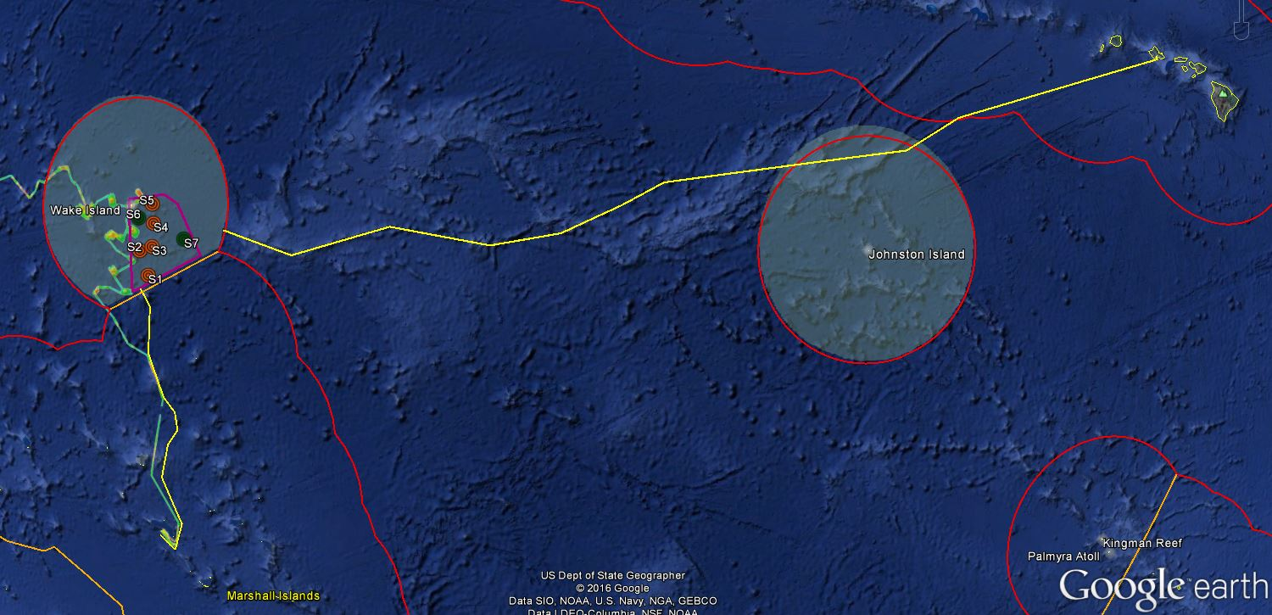

**Figure 1:**Map indicating the overall operating area of *Okeanos Explorer* for EX-16-07. The yellow lines are estimated transit lines (may change slightly). The pink polygon is the focused seamount mapping area within the Wake Island Unit of PRIMNM. Red polygons indicate U.S. EEZ areas. Shaded circles indicate PRIMNM units.

|  |  |  |
| --- | --- | --- |
| Overall Operating Area Bounding Coordinates | | |
| ID | **Latitude** | **Longitude** |
| NW corner | 19 42.5 N | 166 23.0 E |
| NE corner | 19 38.3 N | 168 34.6 E |
| SE corner | 17 44.2 N | 169 13.4 E |
| SW corner | 16 34.1 N | 166 45.0 E |

**Table 1:** Bounding coordinates of the pink general operating area shown in Figure 1.

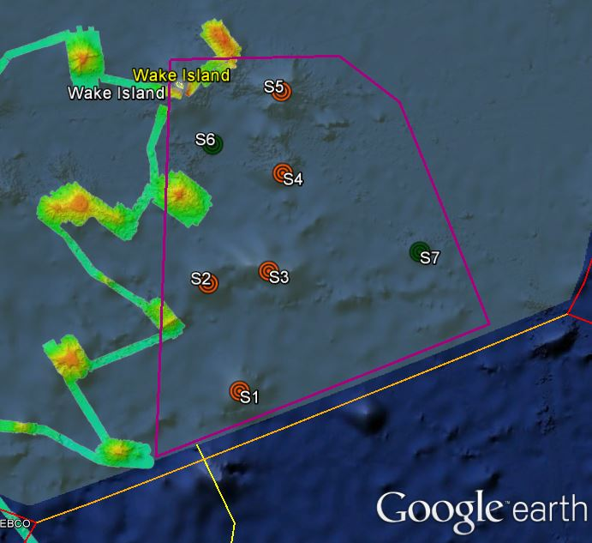

**Figure 2:**Map indicating the locations of focused mapping operations for EX-16-07 the U.S. EEZ, the red polygon is the boundary of the Wake Island Unitof PRIMNM. The pink polygon is the focused seamount mapping area. Orange targets are first priority, larger seamounts (S1-S5), green targets are secondary priority, smaller seamounts (S6, S7). Background data layer shown is existing *Okeanos* bathymetry coverage collected during EX-16-04.

|  |  |  |
| --- | --- | --- |
| Seamount Locations | | |
| ID | **Latitude** | **Longitude** |
| Priority 1 Seamounts |  |  |
| S1 | 17 6.996N | 167 18.167E |
| S2 | 17 52.348N | 166 59.143E |
| S3 | 18 0.163N | 167 26.700E |
| S4 | 18 43.392N | 167 29.415E |
| S5 | 19 19.118N | 167 25.673E |
| Priority 2 Seamounts |  |  |
| S6 | 18 53.016N | 166 55.497E |
| S7 | 18 14.424N | 168 36.965E |

Detailed survey plans for Hypack and ECDIS for each focused seamount survey will be provided in advance of the cruise.

Tables of transit line coordinates will be provided as transit plans are finalized.

# D. Summary of Objectives

**August 25 - September 11 (Kwajalein, Marshall Islands to Honolulu, Hawaii) Telepresence-enabled mapping operations**

EX-16-07 operations will be focused primarily within the US EEZ, with transits occurring through international waters. This cruise will collect baseline data and information to support priority NOAA science and management needs.

Mission objectives for EX-16-07 include a combination of mapping/operational, science, education, outreach, and data management objectives:

1. Conduct 24 mapping operations for duration of the cruise
   1. Collect high resolution mapping data from sonars in priority areas as dictated by operational needs as well as science and management community needs
   2. Collect bathymetric, seafloor backscatter, and water column backscatter data
   3. Subbottom sonar 24 hour data collection will be at the discretion of the CO
   4. Collect XBT casts at regular intervals no longer than 6 hours, as data quality requires, during mapping operations.
   5. Average survey speeds of 8.5-9 kts will be utilized.
   6. Onboard creation of daily standard mapping products.
   7. Collection of sun photometer measurements as part of survey of opportunity.
   8. Continue to test the integration of the new EK60 frequencies and the ADCPs.
2. Map previously unmapped seamount seamounts within Wake Island Unit of PRIMNM.
   1. Seven seamounts are proposed for focused mapping operations. They are listed S1 - S7 in this document, with S1 being the highest priority and S7 being the lowest. The higher priority seamounts are the larger, unmapped seamounts in the southeastern portion of Wake Island Unit of PRIMNM, and the lower priority seamounts are smaller.
   2. Characterization of seamounts within the Prime Crust Zone (PCZ). The PCZ is the area of the Pacific with the highest expected concentration of deep sea minerals, including rare metals and rare earth elements.
   3. Collect information on the geologic history of Central Pacific Seamounts, including those that are or may be relevant to our understanding of plate tectonics and subduction zone biology and geology.
3. Utilize transit fromKwajalein to the survey working grounds, and from the survey working grounds to Honolulu, to conduct exploratory mapping operations.
   1. Transit points will map significant geologic features, primarily seamounts and ridges, along a line not deviating far from the direct circle route.
   2. Average transit speeds of 10 - 10.5 kts will be utilized, however a more conservative 9-9.5 kts will be used for transit time calculation.
4. Telepresence enabled mapping operations (VSAT 10mbps ship to shore; 1.54 mbps shore to ship)
   1. Maintain two live video streams from ship to shore
      1. The primary stream will be the multibeam mapping display
      2. The secondary stream will be the split EK60/Knudsen screen, Hypack line monitoring screen, or other relevant screens, including sonar processing computers or onboard video cameras as necessary.
   2. Hourly data transfer to shore to include all raw sonar files including multibeam (.all and .wcd) , spit beam, and subbottom.
   3. Daily transfer to shore of multibeam daily summary products
   4. Explore telepresence enabled mapping possibilities for potential offering to individuals who may not have the ability to sail for a variety of reasons
5. Shoreside operation of sonar computers on the ship using desktop access through NOAA OMAO supplied laptop.
   1. Test telepresence mapping workflow with expedition coordinator based on shore (OER Physcial Scientist at UNH)
   2. Provide training in operating sonar computers to onshore Explorers in Training
   3. Support onboard watchstanders by monitoring data collection from shore in realtime
   4. Provide data acquisition and processing troubleshooting from shore.
6. Science
   1. Acquire mapping data to support priority Monument and Sanctuaries science and management needs
   2. Collect mapping data to be used to generate baseline characterization maps to explore the diversity and distribution of benthic habitats –including bottom fish habitats, deep sea and precious coral communities, hydrothermal vent communities, mud volcanoes, trench and subduction zone habitats
   3. Collect acoustic mapping data at sites to aid the understanding of the geologic history of the Pacific seamounts
   4. Successfully conduct operations in conjunction with shore-based Exploration Command Centers and remote science team participants
   5. Create and provide input into standard science products to provide a foundation of publicly accessible data and information products to spur further exploration, research, and management activities.
7. Conduct blue water SCUBA dive on the hull within two days of departing Kwajalein.
8. Conduct emergency drills. Drills may include some or all of the following as determined by CO:
   1. Fire/Damage Control
   2. Abandon Ship
   3. Man-Over-Board
   4. Steering Casualty
   5. Oil Spill/ Hazmat spill.
9. Conduct water column sound velocity profile measurements via XBT.
   1. Water column sound velocity casts will be collected at regular intervals of no more than 6 hours in support of multibeam sonar operations
10. Train onboard personnel in data collection and processing procedures as needed (continuous throughout cruise).
    1. Continue training of two onboard Explorers-in-Training who have each sailed with the ship earlier in the FY16 field season.
11. The longstanding NASA marine aerosols network survey of opportunity will continue for the cruise.
12. Data Management
    1. Provide a foundation of publicly accessible data and information products to spur further exploration, research, and management activities
    2. Provide daily products to shore for operational decision making purposes
    3. Ensure Underwater Cultural Heritage (UCH) data protection protocols are followed, if relevant
13. Outreach
    1. Basic live interactions may occur (TBD)
14. Education
    1. Host two EiTs onshore at the UNH CCOM/JHC
       1. Provide enhanced data processing training opportunities
    2. Host two at-sea EiTs on the ship
       1. Provide traditional offshore EiT experience including at-sea operations related to deep water sonar data acquisition and processing techniques
15. Ship
    1. Continue to refine SOPs for the New VSAT
    2. Provide high a high quality stable internet connection with the new VSAT.

# E. Participating Institutions

* National Oceanic and Atmospheric Administration (NOAA), Office of Ocean Exploration and Research (OER)–1315 East-West Hwy, Silver Spring, MD 20910 USA
* NOAA, National Oceanographic Data Center, National Coastal Data Development Center, Stennis Space Center MS, 39529 USA
* NOAA, Office of Coast Survey, Hydrographic Surveys Division, Atlantic Hydrographic Branch, 439 W. York St., Bldg 2, Norfolk, VA 23510 USA
* University Corporation for Atmospheric Research Joint Office for Science Support (JOSS), PO Box 3000 Boulder, CO 80307 USA
* University of Hawai’i at Manoa- 2500 Campus Rd, Honolulu, HI 96822
* University of New Hampshire (UNH) Center for Coastal and Ocean Mapping (CCOM) Jere A. Chase Ocean Engineering Lab, 24 Colovos Rd, Durham, NH 03824 USA
* NOAA National Marine Fisheries Service, Pacific Islands Regional Office, 1845 Wasp Blvd, Honolulu, HI 96818
* NOAA National Marine Fisheries Service,Marine National Monuments Program, 1845 Wasp Blvd, Honolulu, HI 96818
* NOAA National Marine Fisheries Service,Pacific Islands Fisheries Science Center, 1845 Wasp Blvd, Honolulu, HI 96818

# F. Personnel(Mission Party)

**Table 2:**Full list of shore based and sea going mission party members and their affiliations

|  |  |  |  |  |  |  |
| --- | --- | --- | --- | --- | --- | --- |
| Name (First, Last) | Title | Location during cruise | Area of Interest |  | Affiliation | Nationality |
| Onshore Personnel |  |  |  |  |  |  |
| Elizabeth 'Meme' Lobecker | Expedition Coordinator | University of New Hampshire | Mapping |  | NOAA OER (ERT, Inc.) | USA |
| Mashkoor Malik | Onshore Mapping Support | NOAA Silver Spring - OER | Mapping |  | NOAA OER | USA |
| Lindsay McKenna | Onshore Mapping Support | University of New Hampshire | Mapping |  | NOAA OER (ERT Inc.) | USA |
| Derek Sowers | Onshore Mapping Support | University of New Hampshire | Mapping |  | NOAA OER (ERT Inc.) | USA |
| Caroline Cooper | Explorer in Training | University of New Hampshire | Marine Biology / Interdisciplinary |  | UCAR | USA |
| Chloe Baskin-Arboleda | Explorer in Training | University of New Hampshire | Oceanography |  | UCAR | USA |
| Name (First, Last) | **Title** | **Date Aboard** | **Date Disembark** | **Gender** | **Affiliation** | **Nationality** |
| Onboard Personnel |  |  |  |  |  |  |
| Amanda Bittinger | Onboard Mapping Lead / Mapping Watch Lead | 8/22 or 8/23 | 9/12 | F | UCAR | USA |
| Daniel Freitas | Mapping Watch Lead | Already onboard from previous cruise | 9/12 | M | UCAR | USA |
| Annie Raymond | Mapping Watch Lead / Physical Scientist | 8/22 or 8/23 | 9/12 | F | NOAA OCS | USA |
| Megan Putts | Explorer in Training / Watch Stander | 8/22 or 8/23 | 9/12 | M | UCAR | USA |
| Calder Atta | Explorer in Training / Watch Stander | 8/22 or 8/23 | 9/12 | M | UCAR | USA |

# G. Administrative

**1. Points of Contact:**

|  |  |  |
| --- | --- | --- |
| **Ship Operations** | | |
| Marine Operations Center, Atlantic (MOA)  439 West York Street  Norfolk, VA 23510-1145  Telephone: (757) 441-6776  Fax: (757) 441-6495 | Chief, Operations Division, Atlantic (MOA)  LCDR Don Beaucage, NOAA  Telephone: (757) 441-6842  E-mail: [Chiefops.MOA@noaa.gov](mailto:Chiefops.MOA@noaa.gov) | |
|  |  | |
| **Mission Operations** | | |
| Elizabeth 'Meme' Lobecker  Expedition Coordinator / Mapping Lead  NOAA Office of Ocean Exploration  and Research (ERT)  O: (603) 862-1475  C: 401-662-9297  E-mail: [elizabeth.lobecker@noaa.gov](mailto:elizabeth.lobecker@noaa.gov) | CDR Mark Wetzler, NOAA  Commanding Officer  NOAA Ship *Okeanos Explorer*  Phone: (401) 378-8284  Email: [CO.Explorer@noaa.gov](mailto:CO.Explorer@noaa.gov) | |
| Derek Sowers  E-mail: derek.sowers@noaa.gov  O: (603) 862-0369  C: (714) 321-6084  Onshore mapping support - UNH  Mashkoor Malik  E-mail: mashkoor.malik@noaa.gov  (O): (301) 734-1012  Onshore mapping support - NOAA Silver Spring  Lindsay McKenna  E-mail: lindsay.mckenna@noaa.gov  O: (603) 862-5246  Onshore mapping support - UNH | LTJG Aaron Colohan, NOAA  Operations Officer  NOAA Ship *Okeanos Explorer*  Phone: (808) 659-9197 (Ship’s Iridium)  E-mail: [Ops.Explorer@noaa.gov](mailto:Ops.Explorer@noaa.gov)  Amanda Bittinger  Onboard Mapping Lead  amandabittinger@yahoo.com  Dan Freitas  Onboard Mapping Watchstander  dcfreitasconsult@gmail.com  Annie Raymond  Onboard Mapping Watchstander  Annemieke.raymond@noaa.gov | |
| **Other Mission Contacts** | | |
| Craig Russell  Program Manager  NOAA Ocean Exploration & Research  Phone: (206) 526-4803 / (206) 518-1068  E-mail: [Craig.Russell@noaa.gov](mailto:Craig.Russell@noaa.gov) | John McDonough, Deputy Director  NOAA Ocean Exploration & Research  Phone: (301) 734-1023 / (240) 676-5206  E-mail: [John.McDonough@noaa.gov](mailto:John.McDonough@noaa.gov) | |
| Jeremy Potter  Expeditions Director  NOAA Office of Ocean Exploration and Research  Phone: (301) 734-1145 / (240) 215-7101  E-mail: jeremy.potter@noaa.gov | | Alan Leonardi, Director  NOAA Ocean Exploration & Research  Phone: 301-734-1016/ Mobile: 202-631-1790  E-mail: alan.leonardi@noaa.gov | |
| **Vessel Shipping Address** | | |
| **Shipments:** Send an email to the *Okeanos Explorer* Operations Officer at [OPS.Explorer@noaa.gov](mailto:OPS.Explorer@noaa.gov) indicating the size and number of items being shipped.  Items sent to Kwajalein should arrive at the following address prior to COB August 20, 2016.  Kwajalein Range Services, LLC  Shipping and Receiving ATTN: NOAA Ship *Okeanos Explorer*/Operations Officer  993 Lagoon Rd  Kwajalein, MH 96555  [(805) 355-2163](tel:%28805%29%20355-2163) | | |

**2. Diplomatic Clearances**

This project involves Marine Scientific Research in waters under the jurisdiction of the Republic of the Marshall Islands. Diplomatic clearance has been approved under US Diplomatic Note 15-105 (Appendix E).

**3. Licenses and Permits**

The expedition is being planned and conducted by NOAA as an agency of the U.S. Federal government, in partnership with NOAA NMFS Pacific Islands Regional Office Marine National Monument Program. We do not require a permit to work in the PRIMNM.

In order to support or conduct Marine Scientific Research within the U.S. EEZ, work funded, authorized and/or conducted by NOAA must be compliant with the National Environmental Policy Act (NEPA). NOAA Administrative Order (NAO) 216-6 describes NOAA’s specific obligations with regard to NEPA compliance. Among these is the need to review all NOAA-supported projects with respect to their environmental consequences. In compliance with NAO 216-6 and NEPA, a memorandum describing the project’s scientific sensors’ possible effects on the environment has been submitted for the project. As expected with ocean research with limited time or presence in the marine environment, the project has been determined to not have the potential to result in any lasting changes to the environment. As defined in Sections 5.05 and 6.03.c.3 (a) of NAO 216-6, this is a research project of limited size or magnitude or with only short-term effects on the environment and for which any cumulative effects are negligible, and as such, the project is categorically excluded from the need to prepare a full-scale NEPA environmental assessment. The categorical exclusion met the requirements of NOA 216-6 and NEPA, and authorizes the Marine Scientific Research conducted for the project.

Additionally, informal consultation was initiated under Section 7 of the Endangered Species Act (ESA), requesting NOAA Fisheries’ Protected Resources Division concurrence with our biological evaluation determining that 2016 Marianas Expedition and all other planned *OkeanosExplorer* operations during the 2016-17 field season, may affect, but are not likely to adversely affect, ESA-listed marine species. The informal consultation was completed on February 3, 2016 when NOAA OER received a signed letter from the Regional Administrator of NMFS Pacific Islands Regional Office, stating that NMFS concurs with OER’s determination that conducting proposed *Okeanos Explorer* cruises are not likely to adversely affect ESA-listed marine species.

The appendices of these project instructions contains all relevant documentation regarding licenses and permits, including categorical exclusion and ESA consultation.

II. OPERATIONS

The Expedition Coordinator is responsible for ensuring the scientific staff are trained in planned operations and are knowledgeable of project objectives, priorities and environmental compliance procedures. The Commanding Officer is responsible for ensuring all operations conform to the ship’s accepted practices and procedures.

A. Project Itinerary   
**(All times and dates are subject to prevailing conditions and the discretion of the Commanding Officer)**

|  |  |
| --- | --- |
| Date | Activities |
| 8/22 & 8/23 | Mission personnel arrive to ship in Kwajalein |
| 8/24 | Mission personnel safety training and mapping orientation |
| 8/25 | Depart Kwajalein for survey working grounds, commence exploration transit mapping immediately upon exiting port |
| 8/25 - 8/28 | Exploration mapping transit to working grounds@ 10 - 10.5 kts |
| 8/28 | Commence exploration mapping activities in priority mapping areas, speed: 8.5-9 kts |
| 8/28 - 9/3 | Continue exploration mapping activities in priority mapping areas, speed: 8.5-9 kts |
| 9/3 | Commence transit exploration mapping to Honolulu, HI @ 10-10.5 kts |
| 9/11 | Arrive in port, Honolulu, HI |
| 9/12 | Mission personnel depart from Honolulu, HI |

**Table 4:** Detailed Cruise Itinerary   
This is an approximate itinerary and is subject to change.

# B. Staging and Destaging

Not applicable.

# C. Operations to be Conducted

1. **Telepresence / Outreach Events**
   1. Two live video feeds will be used throughout the cruise to provide situational awareness for onshore personnel, including the mapping lead and Explorers-In-Training.
   2. Telepresence interactions will not be scheduled for specific times, but are expected to occur throughout the cruise between onshore personnel at the UNH ECC and onboard mapping watchstanders.
2. **In-Port Events**
   1. None scheduled.

# D. SCUBA Dive Plan

All dives are to be conducted in accordance with the requirements and regulations of the [NOAA Diving Program](http://www.ndc.noaa.gov/dr.html) and require the approval of the ship’s Commanding Officer. One blue water SCUBA dive is planned by ship's divers to inspect the hull, within two days of leaving port.

# E. Applicable Restrictions

**Sonar Operations**

EM 302, EK 60, ADCP, and sub-bottom profiler data acquisition is planned for this cruise. All data acquisition will be conducted in accordance with established standard operating procedures under the direction of the mapping team lead. These operating procedures will include protection measures when operating in the vicinity of marine mammals, sea turtles or Endangered Species Act-listed species as described in appendices of this document. The final decision to operate and collect 24-hour sub-bottom profiler data will be at the discretion of the Commanding Officer.

III. EQUIPMENT

# A. Equipment and capabilities provided by the ship

* Kongsberg Simrad EM302 MultibeamEchosounder (MBES)
* Kongsberg Simrad EK60DeepwaterEchosounders and GPTs (18, 70, 120, 200 kHz)
* Knudsen Chirp 3260 Sub-bottom profiler (SBP)
* Teledyne RDI Workhorse Mariner (300 kHz) ADCP
* Teledyne RDI Ocean Surveyor (38 kHz) ADCP
* Teledyne UnderwayCTD
* LHM Sippican XBT (Deep Blue probes)
* Seabird SBE 911Plus CTD
* Seabird SBE 32 Carousel and 24 2.5 L Niskin Bottles
* Light Scattering Sensor (LSS)
* Oxidation – Reduction Potential (ORP)
* Dissolved Oxygen (DO) sensor
* Altimeter Sensor and battery pack
* CNAV GPS
* POS/MV
* Seabird SBE-45 (Micro TSG)
* Kongsberg Dynamic Positioning-1 System
* NetApps mapping storage system
* CARIS HIPS Software
* IVS Fledermaus Software
* SIS Software
* Hypack Software
* Scientific Computing System (SCS)
* ECDIS
* Met/Wx Sensor Package
* Telepresence System
* VSAT High-Speed link (Comtech 20 Mbps ship to shore; 2 Mbps shore to ship)
* Cruise Information Management System (CIMS)
* Three VoIP telephone lines

# B. Equipment and capabilities provided by the scientists

* Microtops II Ozone Monitor Sunphotometer and handheld GPS required for NASA Marine Aerosols Network supplementary project.

IV. HAZARDOUS MATERIALS

# A. Policy and Compliance

The Expedition Coordinator is responsible for complying with FEC 07 Hazardous Materials and Hazardous Waste Management Requirements for Visiting Scientific Parties (or the OMAO procedure that supersedes it). The Expedition Coordinator and Science Team Lead will be responsible for transporting all samples and HAZMAT on and off the ship. By Federal regulations and NOAA Marine and Aviation Operations policy, the ship may not sail without a complete inventory of all hazardous materials by name and quantity, MSDS, appropriate spill cleanup materials (neutralizing agents, buffers, or absorbents) in amounts adequate to address spills of a size equal to the amount of chemical brought aboard, and chemical safety and spill response procedures. Documentation regarding those requirements will be provided by the Chief of Operations, Marine Operations Center, upon request.

Per OMAO procedure, the scientific party will include with their project instructions and provide to the CO of the respective ship 30 days before departure:

* List of chemicals by name with anticipated quantity
* List of spill response materials, including neutralizing agents, buffers, and absorbents
* Chemical safety and spill response procedures, such as excerpts of the program’s Chemical Hygiene Plan or SOPs relevant for shipboard laboratories
* For bulk quantities of chemicals in excess of 50 gallons total or in containers larger than 10 gallons each, notify ship’s Operations Officer regarding quantity, packaging and chemical to verify safe stowage is available as soon as chemical quantities are known.

Upon embarkation and prior to loading hazardous materials aboard the vessel, the scientific party will provide to the CO or their designee:

* An inventory list showing actual amount of hazardous material brought aboard
* An MSDS for each material
* Confirmation that neutralizing agents and spill equipment were brought aboard sufficient to contain and cleanup all of the hazardous material brought aboard by the program
* Confirmation that chemical safety and spill response procedures were brought aboard

Upon departure from the ship, scientific parties will provide the CO or their designee an inventory showing that all chemicals were removed from the vessel. The CO’s designee will maintain a log to track scientific party hazardous materials. MSDS will be made available to the ship’s complement, in compliance with Hazard Communication Laws.

Scientific parties are expected to manage and respond to spills of scientific hazardous materials. Overboard discharge of hazardous materials is not permitted aboard NOAA ships.

# B. Inventory

|  |  |  |
| --- | --- | --- |
| Item | Use | Approx. locations |
| 95% Denatured Ethanol (10 gallons) | Sample preservation | Wetlab, under the chemical hood |
| 10% Buffered Formalin (3 gallons) | Sample preservation | Wetlab, under the chemical hood |
| Chaos Buffer (0.5 gallons)  (4 M guanidine thiocyanate, 0.5% N-laurosyl sarcosine, 25 mMTris pH 8.0, 0.1 M beta-mercaptoethanol) | Sample preservation (genetics) | Wetlab, under the chemical hood |
| Aqua Shield | Underwater Lubricant | ROV Workshop Fire Cabinet, Pit |
| Dow Corning 4 | Electrical insulating compound | ROV Workshop Fire Cabinet, Pit |
| Fluid Film Spray | Silicone Lubricant | ROV Workshop Fire Cabinet |
| Isopropanol Alcohol | Solvent | ROV Workshop Fire cabinet |
| Scotchkote | Electrical insulating compound | ROV Workshop Fire cabinet |
| 3M Silicone Spray | Silicone Lubricant | ROV Workshop Fire cabinet |
| Synthetic AW Hydraulic Oil, ISO-22 | Amsoil (AWG-05) | Hanger, Pit, Vehicles |
| Tap Magic Cutting Fluid | Cutting/Machining Lubricant | ROV Workshop Fire cabinet |
| Tap Magic Heavyweight Cutting Fluid | Cutting/Machining Lubricant | ROV Workshop Fire cabinet |
| Tuff Coat M | Marine Lubricant | ROV Workshop Fire cabinet |
| Dow Corning Molykote 111 | Valve Lubricant and Sealant | ROV Workshop Fire cabinet, Pit |
| WD40 | Lubricant | ROV Workshop Fire cabinet |
| Loktite | Bolt adhesive | ROV Workshop Fire cabinet |
| Mineral Oil | Vitrea | Hanger, Vehicles |
| Por-15 | Paint Kit | ROV Workshop Fire cabinet |
| Univis HVI 13 | Hydraulic Fluid | Hanger, ROV *D2* |
| Ultratane | Butane fuel | ROV Workshop fire cabinet |
| Rust-oleum | Protective Enamel | ROV Workshop fire cabinet |
| Flux-Off | Soldering Flux remover | ROV Workshop fire cabinet |
| Propane | Torch Fuel | ROV Workshop fire cabinet |

# C. Chemical safety and spill response procedures

All safety and spill response procedures will be handled according to OMAO guidelines and following the manufacturers MSDS which has been provided to the ship’s ECO.

# D. Radioactive Materials

NOT APPLICABLE TO THIS CRUISE

V. ADDITIONAL PROJECTS

# A. Supplementary Projects

**NASA Maritime Aerosol Network**

During the cruise the marine aerosol layer observations will be collected for the NASA Maritime Aerosol Network (MAN). Observations will be made by mission personnel (as time allows) with a sun photometer instrument provided by the NASA MAN program. Resulting data will be delivered to the NASA MAN primary investigator Alexander Smirnov by the expedition coordinator. All collected data will be archived and publically available at: <http://aeronet.gsfc.nasa.gov/new_web/maritime_aerosol_network.html>

Equipment resides on the ship and is stewarded by the Expedition Coordinator.

See Appendix F for full Survey of Opportunity Form.

# B. NOAA Fleet Ancillary Projects

No NOAA Fleet Ancillary Projects are planned.

VI. DISPOSITION OF DATA AND REPORTS

# A. Data Responsibilities

All data acquired on *Okeanos Explorer* will be provided to the public archives without proprietary rights. All data management activities shall be executed in accordance with [NAO 212-15, Management of Environmental and Geospatial Data and Information](http://www.corporateservices.noaa.gov/ames/administrative_orders/chapter_212/212-15.html)

**Ship Responsibilities**

The Commanding Officer is responsible for all data collected for missions until those data have been transferred to mission party designees. Data transfers will be documented on NOAA Form 61-29. Reporting and sending copies of project data to NESDIS (ROSCOP form) is the responsibility of OER.

**NOAA OER Responsibilities**

The Expedition Coordinator will work with the *Okeanos Explorer* Operations Officer to ensure data pipeline protocols are followed for final archive of all data acquired on *Okeanos Explorer* without proprietary rights. See Appendix B for detailed data management plans.

**Deliverables**

1. At sea
   1. Daily plans of the Day (POD)
   2. Daily situation reports (SITREPS)
   3. Daily summary bathymetry data files
   4. Raw sonar files (EM 302, EK 60, Subbottom, ADCP)
   5. Refined SOPs for all pertinent operational activities
   6. Assessments of all activities
2. Science
   1. Multibeam raw and processed data (see appendix B for the formal cruise data management plan)
   2. XBT raw and processed data
   3. EK 60 raw data
   4. Knudsen 3260 sub-bottom profiler raw data
   5. ADCP raw data
   6. Mapping data report

**Archive**

OER and ship will work together to ensure documentation and stewardship of acquired data sets in accordance with NAO 212-15. The Cruise Information Management System is the primary tool used to accomplish this activity.

VII. Meetings, Vessel Familiarization, and Project Evaluations

# A. Shipboard Meetings

A safety brief and overview of POD will occur on the Bridge each morning at 0800. Daily Operations Briefing meetings will be held at 1330 in the forward lounge to review the current day, and define operations, associated requirements, and staffing needs for the following day. A Plan of the Day (POD) will be posted each evening for the next day in specified locations throughout the ship. Daily Situation Reports (SITREPS) will be posted as well and shared daily through e-mail.

**1. Pre-Project Meeting:**

The Expedition Coordinator and Commanding Officer will conduct a meeting of pertinent members of the scientific party and ship’s crew to discuss required equipment, planned operations, concerns, and establish mitigation strategies for all concerns. This meeting shall be conducted before the beginning of the project with sufficient time to allow for preparation of the ship and project personnel. The ship’s Operations Officer usually is delegated to assist the Expedition Coordinator in arranging this meeting.

**2. Vessel Familiarization Meeting:**

The Commanding Officer is responsible for ensuring scientific personnel are familiarized with applicable sections of the standing orders and vessel protocols, e.g., meals, watches, etiquette, drills, etc. A vessel familiarization meeting shall be conducted in the first 24 hours of the project’s start and is normally presented by the ship’s Operations Officer.

**3. Post-Project Meeting:**

The Commanding Officer is responsible for conducting a meeting no earlier than 24 hrs before or seven days after the completion of a project to discuss the overall success and short comings of the project. Concerns regarding safety, efficiency, and suggestions for future improvements shall be discussed and mitigations for future projects will be documented for future use. This meeting shall be attended by the ship’s officers, applicable crew, the Expedition Coordinator, and members of the scientific party and is normally arranged by the Operations Officer and Expedition Coordinator.

**4. Project Evaluation Report:**

Within seven days of the completion of the project, a Customer Satisfaction Survey is to be completed by the Expedition Coordinator. The form is available at <http://www.omao.noaa.gov/fleeteval.html>and provides a “Submit” button at the end of the form. Submitted form data is deposited into a spreadsheet used by OMAO management to analyze the information. Though the complete form is not shared with the ships, specific concerns and praises are followed up on while not divulging the identity of the evaluator.

VIII. MISCELLANEOUS

# A. Meals and Berthing

The ship will provide meals for the scientists listed above. Meals will be served 3 times daily beginning one hour before scheduled departure, extending throughout the project, and ending two hours after the termination of the project. Since the watch schedule is split between day and night, the night watch may often miss daytime meals and will require adequate food and beverages (for example a variety of sandwich items, cheeses, fruit, milk, juices) during what are not typically meal hours. Special dietary requirements for scientific participants will be made available to the ship’s command at least twenty-one days prior to the survey (e.g., Expedition Coordinator is allergic to fin fish).

Berthing requirements, including number and gender of the scientific party, will be provided to the ship by the Expedition Coordinator. The Expedition Coordinator and Operations Officer will work together on a detailed berthing plan to accommodate the gender mix of the scientific party taking into consideration the current make-up of the ship’s complement. The Expedition Coordinator is responsible for ensuring the scientific berthing spaces are left in the condition in which they were received; for stripping bedding and linen return; and for the return of any room keys which were issued. The Expedition Coordinator is also responsible for the cleanliness of the laboratory spaces and the storage areas utilized by the scientific party, both during the cruise and at its conclusion prior to departing the ship.

All NOAA scientists will have proper travel orders when assigned to any NOAA ship. The Expedition Coordinator will ensure that all non-NOAA or non-Federal scientists aboard also have proper orders. It is the responsibility of the Expedition Coordinator to ensure that the entire scientific party has a mechanism in place to provide lodging and food and to be reimbursed for these costs in the event that the ship becomes uninhabitable and/or the galley is closed during any part of the scheduled project.

All persons boarding NOAA vessels give implied consent to comply with all safety and security policies and regulations which are administered by the Commanding Officer. All spaces and equipment on the vessel are subject to inspection or search at any time. All personnel must comply with OMAO's Drug and Alcohol Policy dated May 7, 1999 which forbids the possession and/or use of illegal drugs and alcohol aboard NOAA Vessels.

# B. Medical Forms and Emergency Contacts

The NOAA Health Services Questionnaire (NHSQ, NF 57-10-01 (3-14)) must be completed in advance by each participating scientist. The NHSQ can be obtained from the Expedition Coordinator or the NOAA website <http://www.corporateservices.noaa.gov/noaaforms/eforms/nf57-10-01.pdf>.

All NHSQs submitted after March 1, 2014 must be accompanied by [NOAA Form (NF) 57-10-02 - Tuberculosis Screening Document](http://www.moc.noaa.gov/all-ships/NOAA%20Form%2057-10-02%20(1-14)%20Tuberculosis%20Screening%20Document.pdf) in compliance with OMAO Policy 1008 (Tuberculosis Protection Program).

The completed forms should be sent to the Regional Director of Health Services at the applicable Marine Operations Center. The NHSQ and Tuberculosis Screening Document should reach the Health Services Office no later than four weeks prior to the start of the project to allow time for the participant to obtain and submit additional information should health services require it, before clearance to sail can be granted. Please contact MOC Health Services with any questions regarding eligibility or completion of either form. Ensure to fully complete each form and indicate the ship or ships the participant will be sailing on. The participant will receive an email notice when medically cleared to sail if a legible email address is provided on the NHSQ.

The participant can mail, fax, or email the forms to the contact information below. Participants should take precautions to protect their Personally Identifiable Information (PII) and medical information and ensure all correspondence adheres to DOC guidance (<http://ocio.os.doc.gov/ITPolicyandPrograms/IT_Privacy/PROD01_008240>).

The only secure email process approved by NOAA is Accellion Secure File Transfer which requires the sender to setup an account. Accellion’s Web Users Guide is a valuable aid in using this service, however to reduce cost the DOC contract doesn’t provide for automatically issuing full functioning accounts. To receive access to a “Send Tab,” after your Accellion account has been established send an email from the associated email account to [accellionAlerts@doc.gov](mailto:accellionAlerts@doc.gov) requesting access to the “Send Tab” function. They will notify you via email, usually within one business day of your approval. The “Send Tab” function will be accessible for 30 days.

**Contact Information:**

Regional Director of Health Services  
Marine Operations Center – Atlantic  
439 W. York Street  
Norfolk, VA 23510  
Telephone: (757) 441.6320  
Fax: (757) 441.3760  
E-mail: [MOA.Health.Services@noaa.gov](mailto:MOA.Health.Services@noaa.gov)

Please make sure the [medical.explorer@noaa.gov](mailto:medical.explorer@noaa.gov)email address is cc’d on all medical correspondence.

Prior to departure, the Expedition Coordinator must provide a listing of emergency contacts to the Operations Officer for all members of the scientific party, with the following information: name, address, relationship to member, and telephone number.

Emergency contact form is included as Appendix A.

# C. Shipboard Safety

Hard hats are required when working with suspended loads. Work vests are required when working near open railings and during small boat launch and recovery operations. Hard hats and work vests will be provided by the ship when required.

Wearing open-toed footwear or shoes that do not completely enclose the foot (such as sandals or clogs) outside of private berthing areas is not permitted. Steel-toed shoes are required to participate in any work dealing with suspended loads, including CTD deployments and recovery. The ship does not provide steel-toed boots. Hard hats are also required when working with suspended loads. Work vests are required when working near open railings and during small boat launch and recovery operations. Hard hats and work vests will be provided by the ship when required.

Operational Risk Management: For every operation to be conducted aboard the ship (NOAA-wide initiative), risk management procedures will be followed. For each operation, risks will be identified and assessed for probability and severity. Risk mitigation strategies/measures will be investigated and implemented where possible. After mitigation, the residual risk will have to be assessed to make Go-No Go decisions for the operations. Particularly with new operations, risk assessment will be ongoing and updated as necessary. This does not only apply to over-the-side operations, but to everyday tasks aboard the vessel that pose risk to personnel and property.

* CTD, ROV (and other pertinent) ORM documents will be followed by all personnel working onboard *Okeanos Explorer*.
* All personnel onboard are in the position of calling a halt to operations/activities in the event of a safety concern.

# D. Communications

A daily situation report (SITREP) on operations prepared by the Expedition Coordinator will be relayed to the program office. Sometimes it is necessary for the Expedition Coordinator to communicate with another vessel, aircraft, or shore facility. Through various modes of communication, the ship is able to maintain contact with the Marine Operations Center on an as needed basis. These methods will be made available to the Expedition Coordinator upon request, in order to conduct official business. The ship’s primary means of communication with the Marine Operations Center is via e-mail and the Very Small Aperture Terminal (VSAT) link. VSAT bandwidth at 15Mbps will be paid by OER and provided by OMAO.

Specific information on how to contact NOAA Ship *Okeanos Explorer* and all other fleet vessels can be found at [http://www.moc.noaa.gov/MOC/phone.html#EX](http://www.moc.noaa.gov/MOC/phone.html%23EX)

**Important Telephone and Facsimile Numbers and E-mail Addresses**

Ocean Exploration and Research (OER):

OER Program Administration  
Phone: (301) 734-1010  
Fax: (301) 713-4252  
E-mail: Firstname.Lastname@noaa.gov

University of New Hampshire, Center for Coastal and Ocean Mapping

Phone: (603) 862-3438  
Fax: (603) 862-0839

NOAA Ship *Okeanos Explorer* - Telephone methods listed in order of increasing expense:

*Okeanos Explorer* Cellular: (401) 713-4114  
*OkeanosExplorer*Iridium:(808) 659-9179  
OER Mission Iridium (dry lab): (808) 851-3827

EX INMARSAT B  
Line 1: 011-870-764-852-328  
Line 2: 011-870-764-852-329

Voice Over IP (VoIP) Phone:   
(541) 867-8932  
(541) 867-8933  
(541) 867-8934

E-mail: [Ops.Explorer@noaa.gov](mailto:Ops.Explorer@noaa.gov)- (mention the person’s name in SUBJECT field)

E-mail: [expeditioncoordinator.explorer@noaa.gov](mailto:expeditioncoordinator.explorer@noaa.gov) for dissemination of all hands emails by Expedition Coordinator while onboard. See ET for password.

# E. IT Security

1. Any computer that will be hooked into the ship's network must comply with the OMAO Fleet IT Security Policy 1.1 (November 4, 2005) prior to establishing a direct connection to the NOAA WAN. Requirements include, but are not limited to: Installation of the latest virus definition (.DAT) file on all systems and performance of a virus scan on each system.
2. Installation of the latest critical operating system security patches.
3. No external public Internet Service Provider (ISP) connections.

Completion of these requirements prior to boarding the ship is required.

Non-NOAA personnel using the ship's computers or connecting their own computers to the ship's network must complete NOAA’s IT Security Awareness Course within three days of embarking.

# F. Foreign National Guests Access to OMAO Facilities and Platforms

Not applicable to this cruise.

Appendix A

**EMERGENCY CONTACT DATA SHEET–NOAA SHIP*OKEANOS EXPLORER***

Scientists sailing aboard *Okeanos Explorer* should fill out the form found at the following link location: <https://docs.google.com/a/noaa.gov/forms/d/1pcoSgPluUVxaY64CM1hJ75l1iIYirTk48G-lv37Am_k/viewform>with their emergency contact information

Appendix B: Data Management Plan

Appendix C: Categorical Exclusion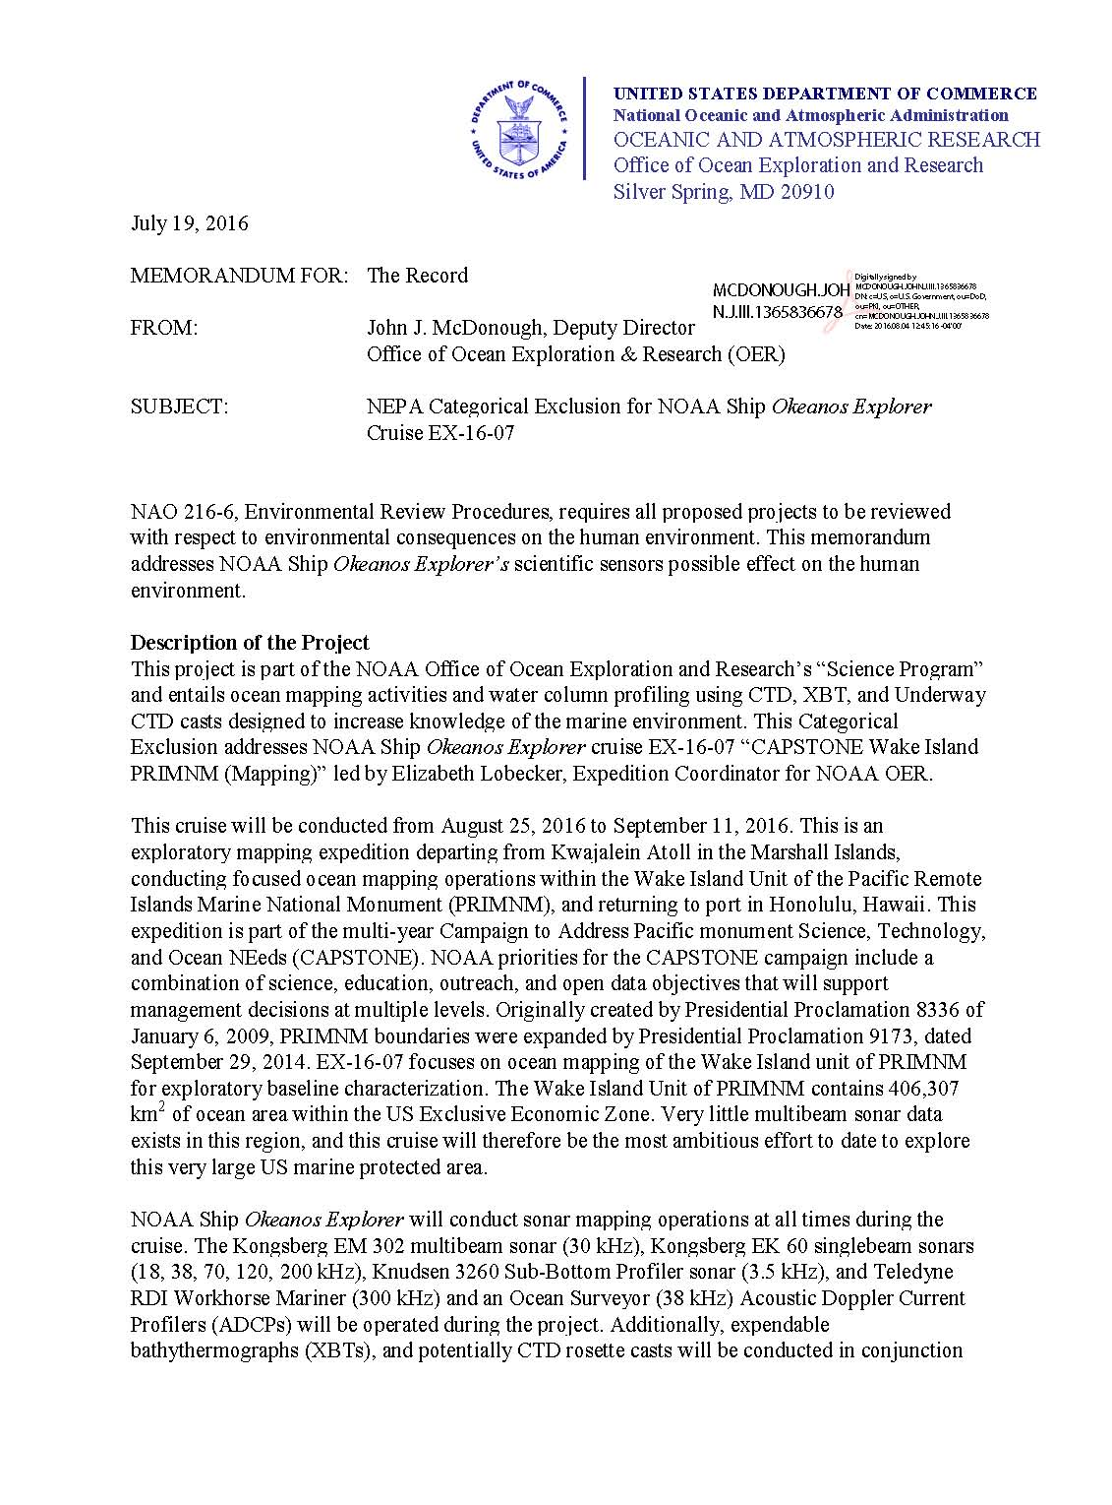

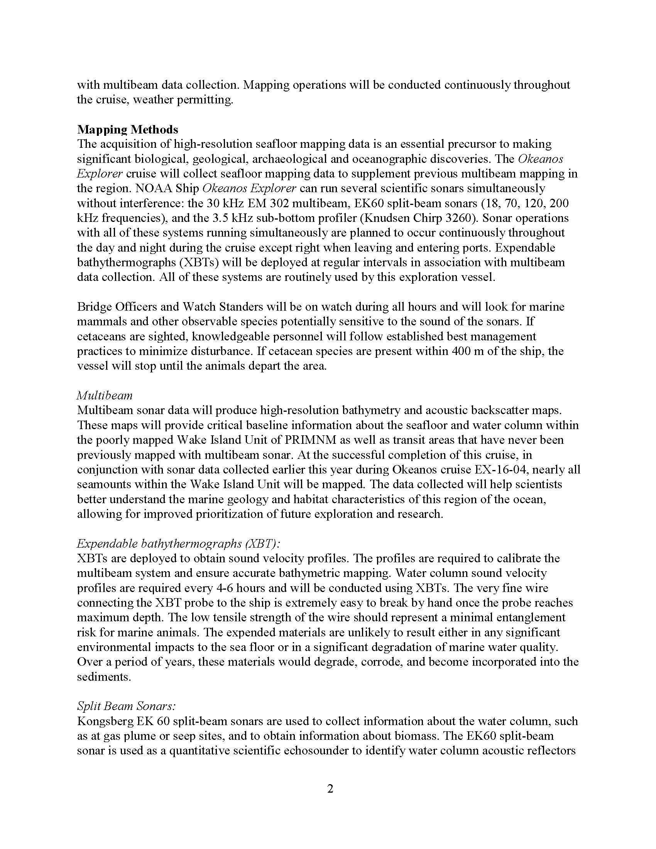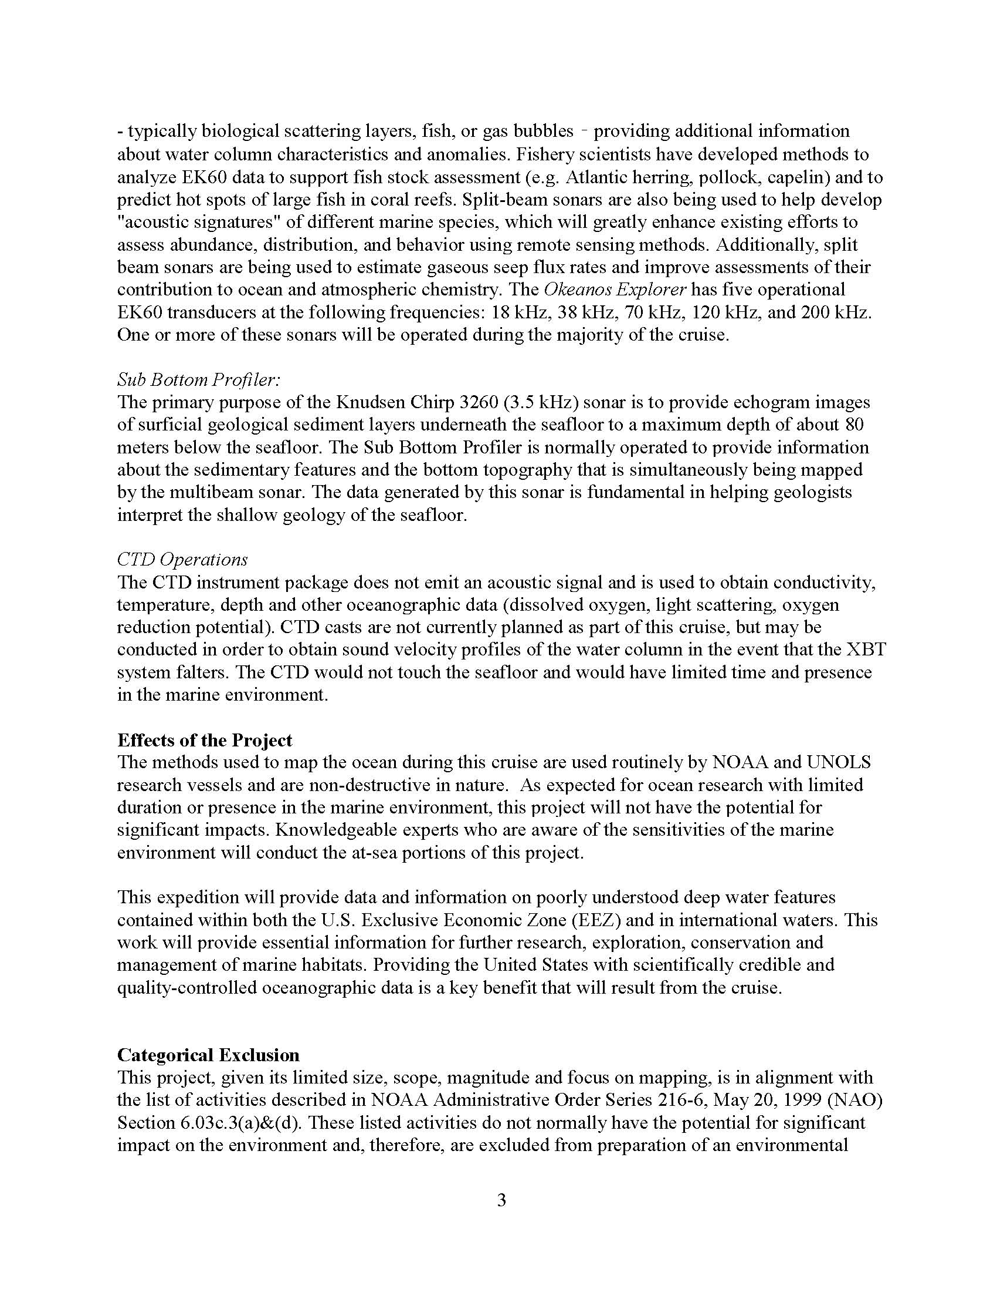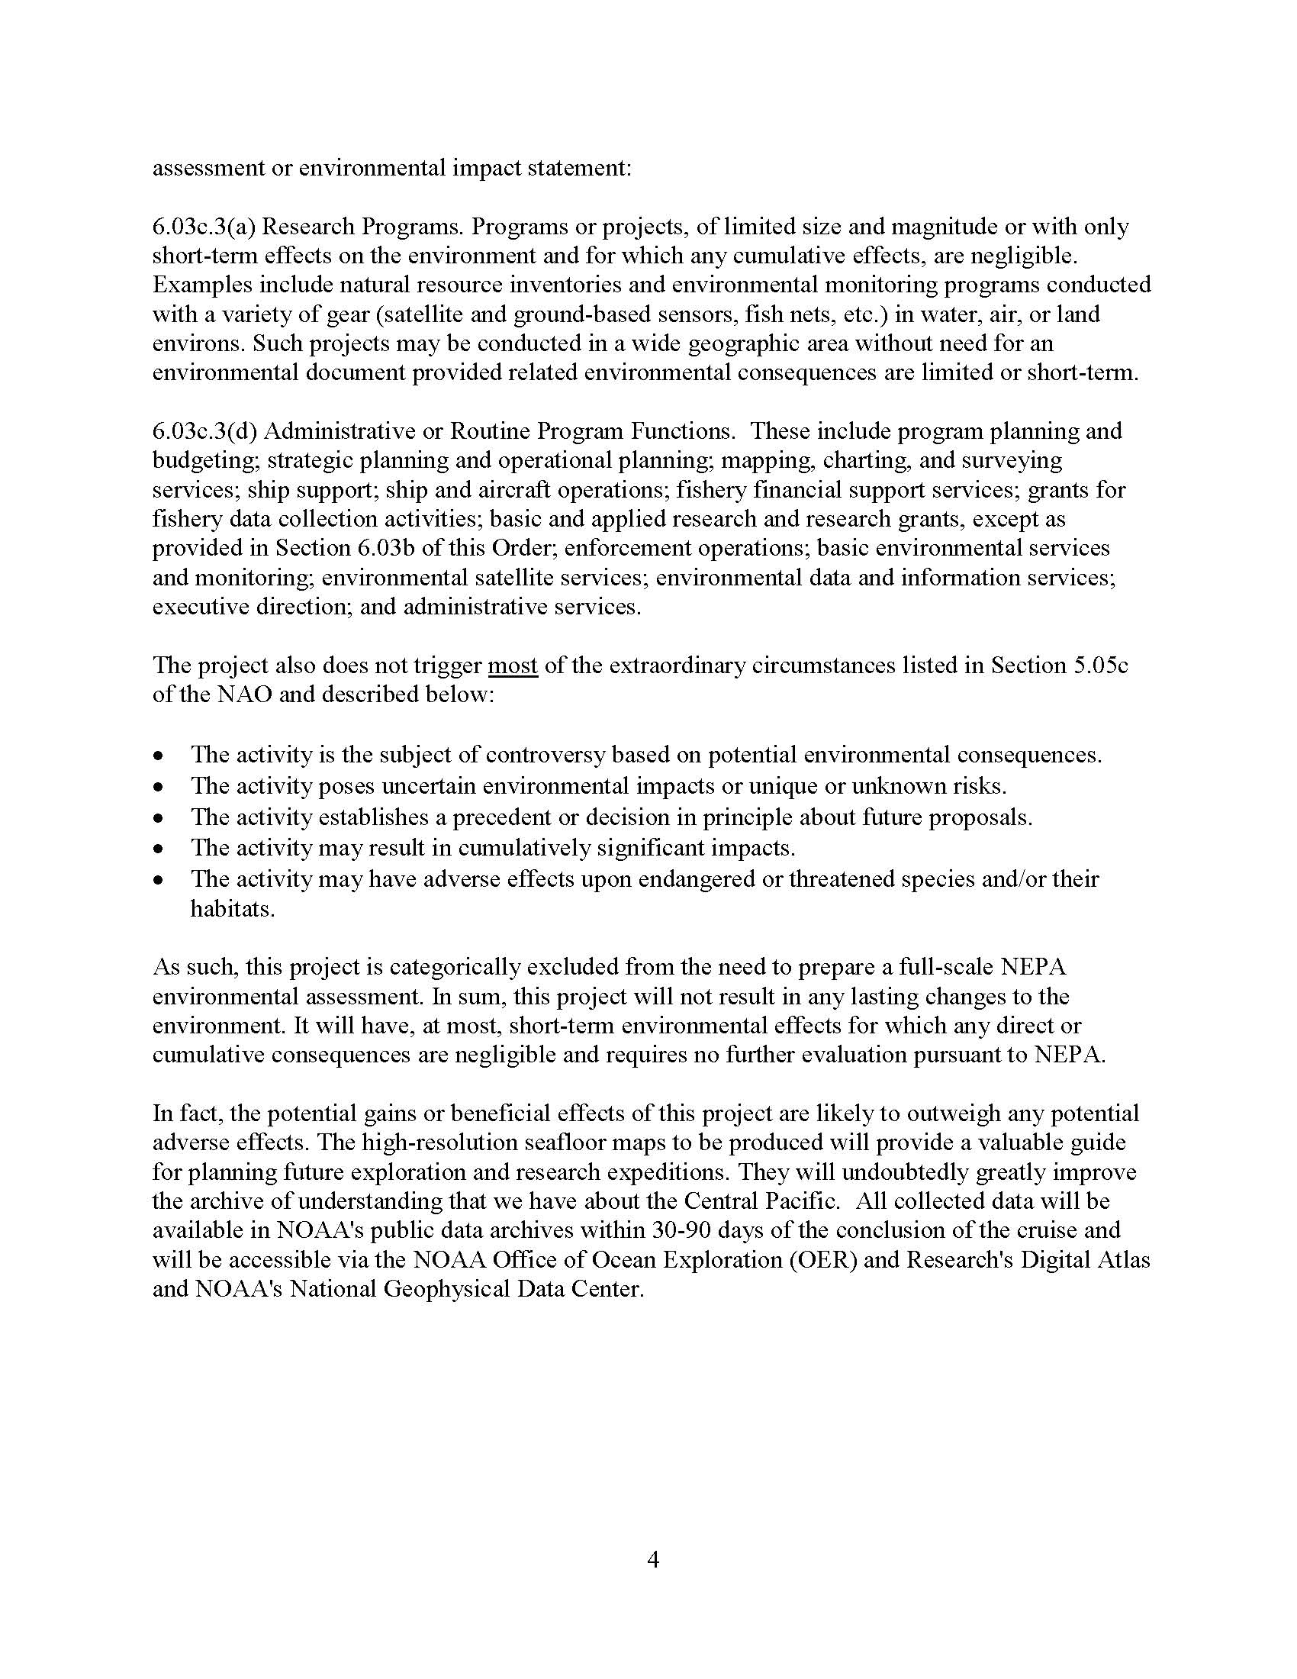

Appendix D: ESA Section 7 Initiation Letter, Biological Evaluation and Letter of Concurrence

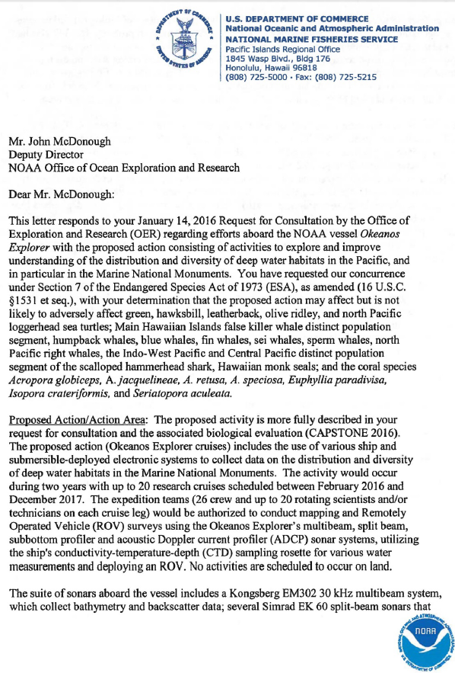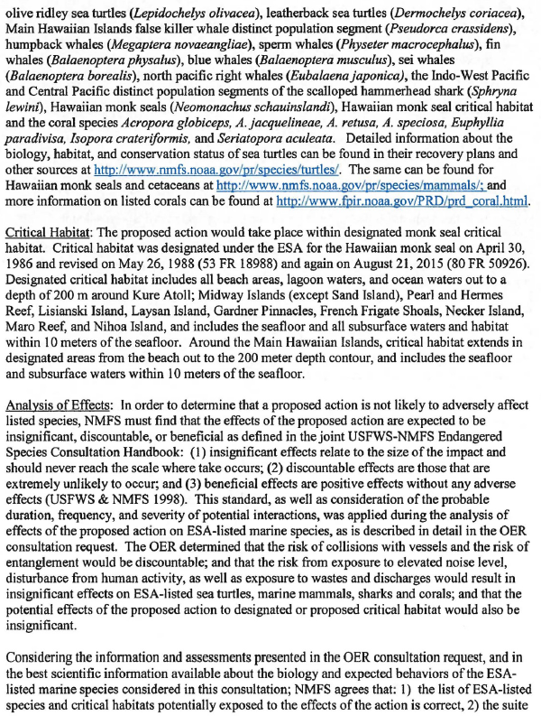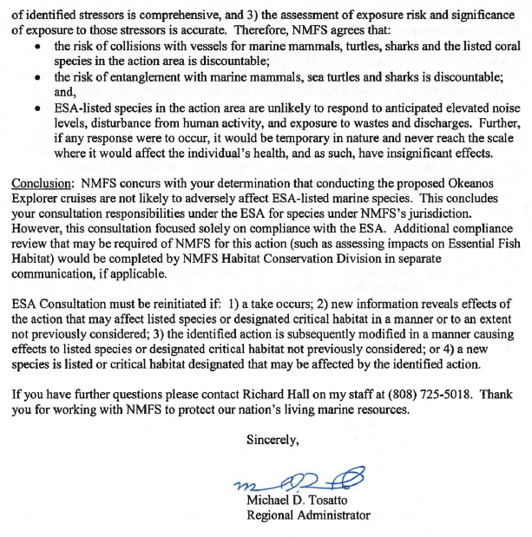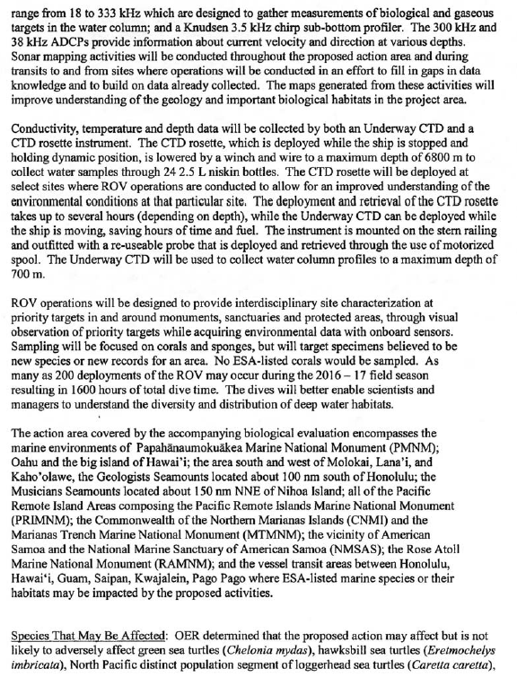

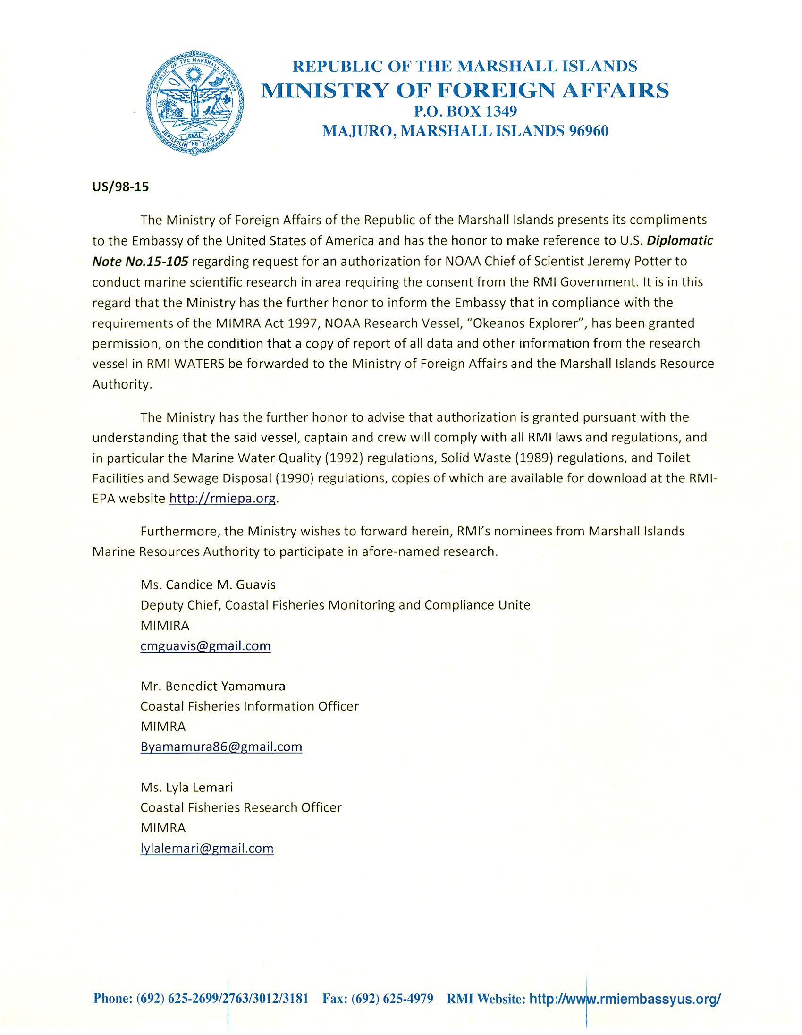Appendix E: Diplomatic Note No. 15-105

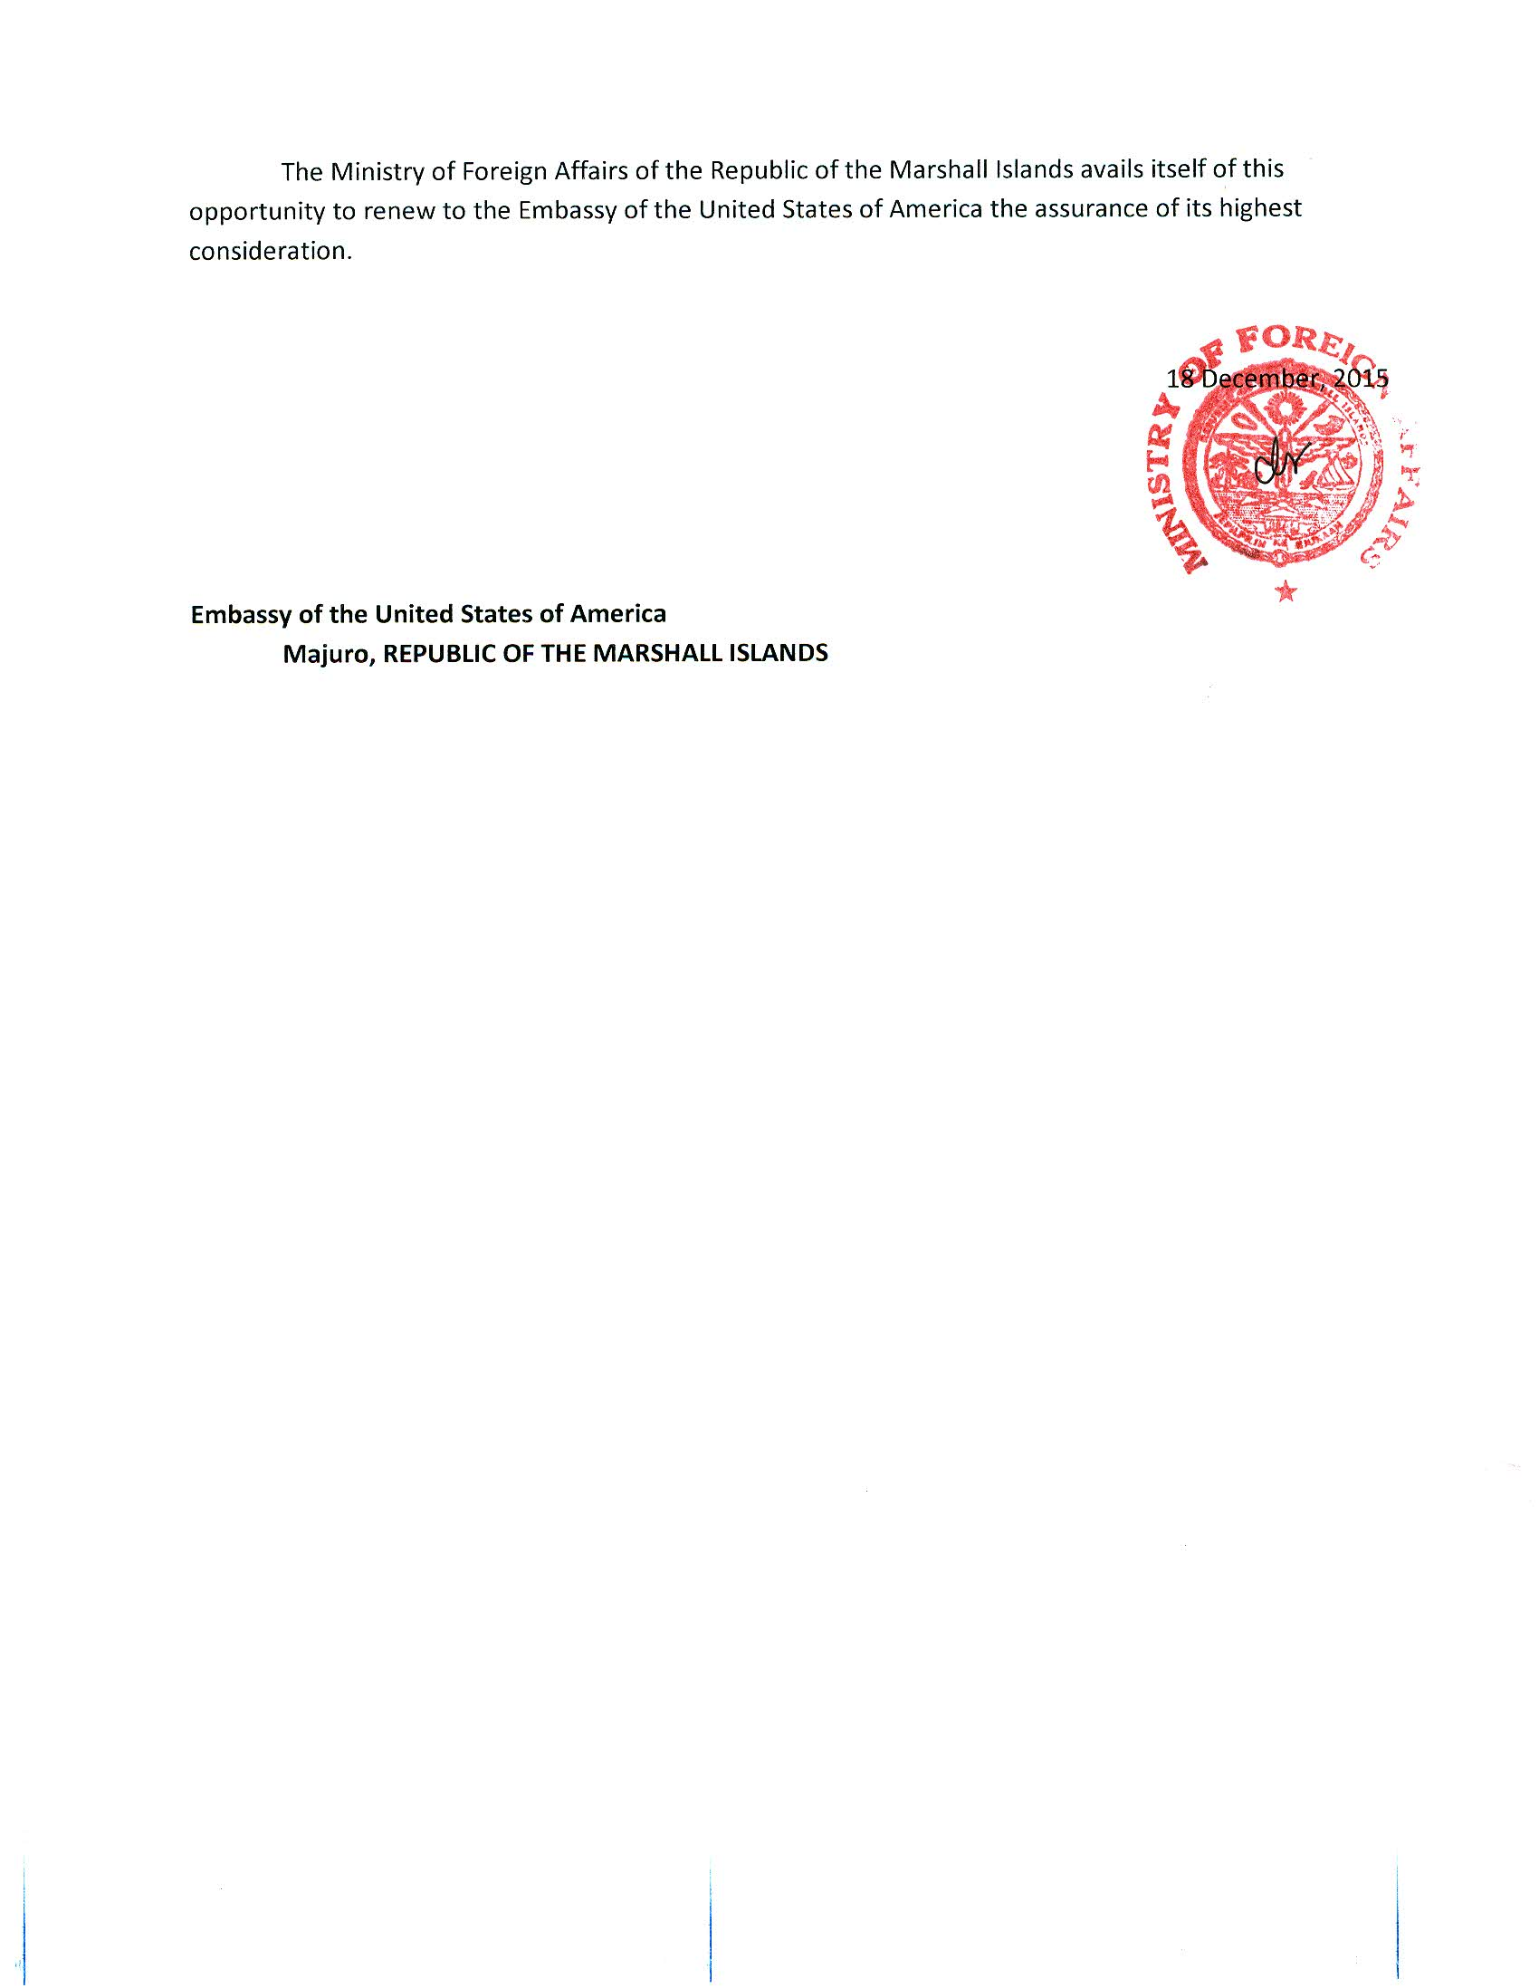

Appendix F: NASA Maritime Aerosols Network Survey of Opportunity

# Survey or Project Name

Maritime Aerosol Network

# Lead POC or Principle Investigator (PI & Affiliation)

POC: Dr. Alexander Smirnov

# Supporting Team Members Ashore

# Supporting Team Members Aboard (if required)

# Activities Description(s)(Include goals, objectives and tasks)

The Maritime Aerosol Network (MAN) component of AERONET provides ship-borne aerosol optical depth measurements from the Microtops II sun photometers. These data provide an alternative to observations from islands as well as establish validation points for satellite and aerosol transport models. Since 2004, these instruments have been deployed periodically on ships of opportunity and research vessels to monitor aerosol properties over the World Oceans.