Okeanos Explorer ROV Dive Summary
Dive Information
Dive Map |  | 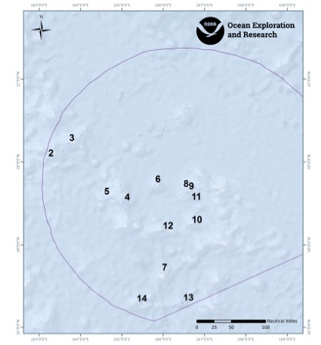
Site Name |  | Revolver Seamount (unofficial name)
Expedition Coordinator(s) |  | Brian RC Kennedy
ROV Lead(s) |  | Dan Rogers
Science Team Lead(s) |  | Chris Kelley and Jasper Konter
General Area Descriptor |  | Wake Atoll unit of PRMNM
ROV Dive Name
Cruise |  | EX-16-06
Leg |  | 0
Dive Number |  | 12
Equipment Deployed
ROV |  | Deep Discoverer (D2)
Camera Platform |  | Seirios
ROV Measurements |  | CTD |  | Depth | Altitude
 |  | Scanning Sonar |  | USBL Position | Heading
 |  | Pitch |  | Roll | HD Camera 1
 |  | HD Camera 2 |  | Low Res Cam 1 | Low Res Cam 2
 |  | Low Res Cam 3 |  | Low Res Cam 4 | Low Res Cam 5
Equipment Malfunctions |  | none
ROV Dive Summary  (from processed ROV data) |  | Dive Summary: EX1606_DIVE12  ^^^^^^^^^^^^^^^^^^^^^^^^^^^^^^^^^^^^^^^^^^^^^^^^^^^  In Water: 2016-08-13T20:23:28.579000  18°, 19.321' N ; 165°, 58.650' E  Out Water: 2016-08-14T04:26:55.513000  18°, 19.459' N ; 165°, 59.075' E  Off Bottom: 2016-08-14T03:45:58.151000  18°, 19.598' N ; 165°, 58.867' E  On Bottom: 2016-08-13T21:13:24.344000  18°, 19.184' N ; 165°, 58.742' E  Dive duration: 8:3:26  Bottom Time: 6:32:33  Max. depth: 1266.6 m
Special Notes
Scientists Involved  (please provide name, location, affiliation, email) |  | Name Affiliation Email  Jasper Konter University of Hawaii jkonter@hawaii.edu  Kelley Chris University of Hawaii ckelley@hawaii.edu  Asako Matsumoto Planetary Exploration Research Center (PERC), Chiba Institute of Technology amatsu@gorgonian.jp  Christopher Mah National Museum of Natural HIstory (Smithsonian) brisinga@gmail.com  Les Watling University of Hawaii at Manoa watling@hawaii.edu  Michael Vecchione NOAA/NMFS/NSL vecchiom@si.edu  Nolan Barrett HBOI-FAU barrettnh@g.cofc.edu  Sonia Rowley University of Hawaii at Manoa srowley@hawaii.edu  Tina Molodtsova P.P.Shirshov Institute of Oceanology RAS tina@ocean.ru
Purpose of the Dive |  | The guyot is located approximately 70 miles southwest of Wake Island and was unofficially dubbed Revolver Seamount, for its appearance on a multibeam map. The objective of the dive was to survey a volcanic cone located on the flat summit of the seamount. The current thinking is that these could have formed as a result of rejuvenated volcanism (after the seamount formed a coral reef on top). This dive should provide data and samples for use in determining the geologic history of this seamount, which is unknown, as is the geologic history of most seamounts in this area of the Pacific. Often, corals and sponges prefer topographic highs, which these cones represent. The cone selected for the dive site is open on the east side forming ridges on the south and north sides. The ROV will survey up the south ridge of the cone for deepwater corals and sponges. This dive is one of the shallowest dives on a guyot in the monument since the track is above the main flat summit. The dive start and end points are at 1269 m and 1150 m.
Description of the Dive |  | The vehicles reached the bottom at 21:12UTC at a depth of 1266m. As indicated above, the dive track ran along the crest of the cone that is situated on the southeastern edge of the guyot top, and the cone appears to have partly slumped down the edge of the guyot. Given the cone’s location on top of the presumed carbonate and/or pelagic sediment platform, erosion and sedimentary processes occurred prior to the cone’s eruption. Therefore, it is presumed to represent post-erosional (or rejuvenated) volcanism.  The dive started just above the base of the cone, so the exact contact with the surrounding guyot top was not directly established. At the landing site, the seafloor appeared to consist of Mn coated cobbles and boulders possibly representing pillow lavas, with a few small pockets of little sand. Right at the landing site, a loose angular rock (instead of the rounder, larger pillow shapes) was collected, which in the lab appears to contain fragments of carbonate and potentially volcanoclastic material. If the pillow lavas are truly present this would argue for a significant confining water pressure (i.e., at depth in the ocean). The ridge continued upward until we reached a local high around 23.30. On top, a few more layered structures were observed, but due to their heavy Mn crust it was impossible to tell if these were sheet flow lavas, or volcanoclastic deposits (from shallow eruptions). After descending a short way, the ridge continued up, however the underlying rocks changed to defining a large sequence of relatively thick layers (0.1-1m). It was not until we collected our second rock sample, which lost some of its Mn during collection that it was clear the layers consist of an orange-tan material. This is likely volcanoclastic material, deposited as sediment, resulting from the explosive interaction of magma with shallow ocean water. This material continued up the rest of the dive track as layers dipping away from the crest to the west and northwest eventually. In the lab, a piece of the Mn crust was missing, exposing some carbonate in the first dive sample. This would argue for a shallow water eruption generating volcanoclastic sediment, while the presence of carbonate fragments suggests the reef was present when the eruption occurred. The dive ended on the summit of the cone, leaving bottom around 1130m.  Although today’s dive was in a depth that we considered optimal for animals, the density was low but the diversity was relatively high. Sponges included species in the genera Walteria, Dictyaulus, Poliopogon, Farrea, Bolosoma, Tretopleura, Atlantisella, Saccocalyx, and possibly Bathydorus (sample collected but not examined yet). Coral genera included Paragorgia, Hemicorallium, Narella, Calyptrophora, Victorgorgia, Paramuricea?, Iridogorgia, Acanthogorgia, and Trissopathes, and a B clade isidid, while other cnidarians included the hydrozoan Solanderia sp, Anthomastus sp, the sea pens Umbellula sp and Anthoptilum sp, a tube anemone (Cerianthus sp), and both anemones and zoanthids. Arthropods and echinoderms included shrimp, a polychelid lobster, a homolid carrying a single anemone, amphipods, a mannopsid isopod, various seastars including brisingids, a Henricia sp, and a soon to be described genus of goniasterid, crinoids all of which were feather stars, holothuroideans (Hansenothuria sp), and an urchin (Caenopedina sp). Fish were present as well, mainly eels that included an unusual synaphobranchid or possibly the juvenile phase of something well known, a sorceress eel (Venifica sp), ophidiids (including a very unusual species), macrourids, an alepocephalid, a Barbourisia sp, and several tripod fish (Bathypterois atricolor).
Overall Map of the ROV Dive Area |  |  | Close-up Map of Main Dive Site
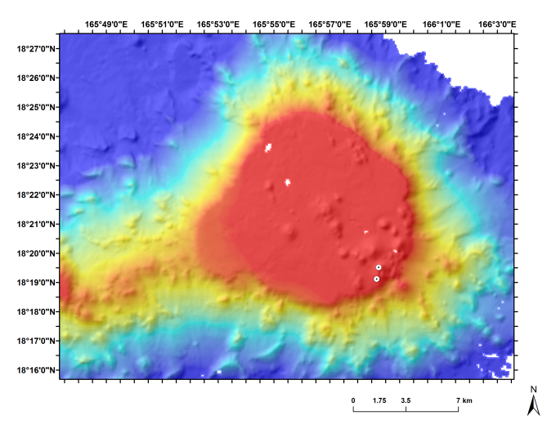 |  |  | 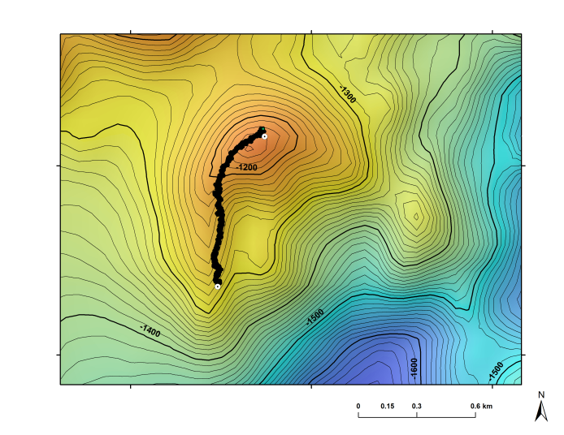
Overview map of the dive site. |  |  | Closeup map of the dive site showing the tracking data.
Representative Photos of the Dive
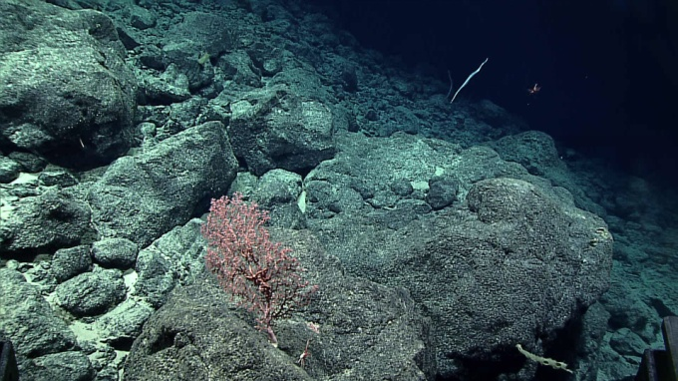 |  |  | 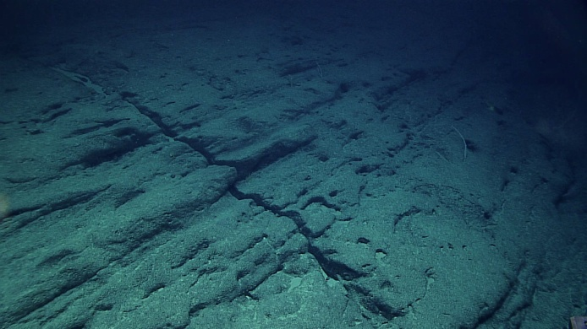
- Image of the base of the cone near the drop location. |  |  | - Image near the summit of the cone showing what appear to be volcanoclastic layers.
Samples Collected
  - Sample
Sample ID | D2_DIVE12_SPEC01GEO |  | - 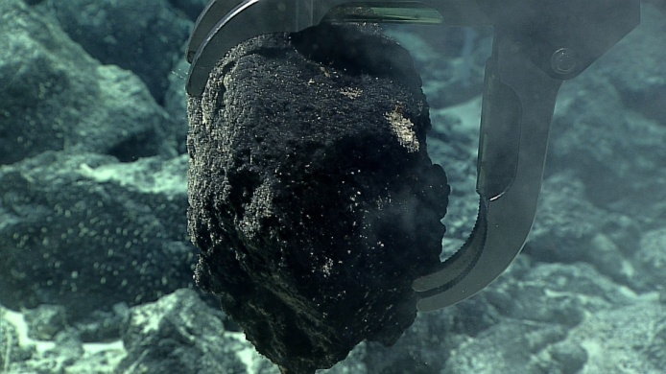
Date (UTC) | 20160813
Time (UTC) | 21:23:23
Depth (m) | 1266.4993
Temperature (°C) | 3.2902
Field ID(s) | Mn crusted rock
Comments
Sample
Sample ID | D2_DIVE12_SPEC02BIO |  | - 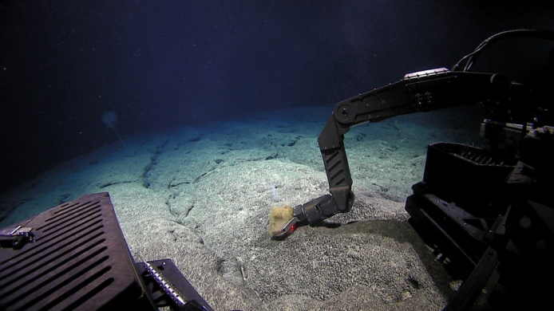
Date (UTC) | 20160814
Time (UTC) | 0:14:52
Depth (m) | 1215.3696
Temperature (°C) | 3.50741
Field ID(s) | Unknown sponge
Comments | Commensal seastar and 4 polychaete worms
Sample
Sample ID | D2_DIVE12_SPEC03GEO |  | - 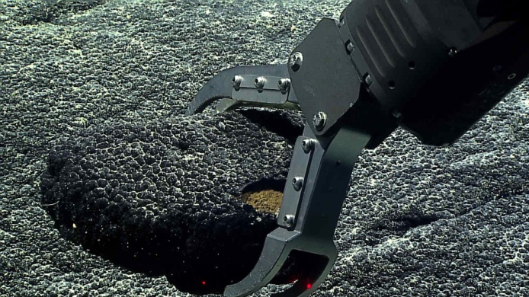
Date (UTC) | 20160814
Time (UTC) | 2:11:49
Depth (m) | 1169.3849
Temperature (°C) | 3.55305
Field ID(s) | mn crusted rock likely volcaniclastic
Comments
Sample
Sample ID | D2_DIVE12_SPEC04BIO |  | - 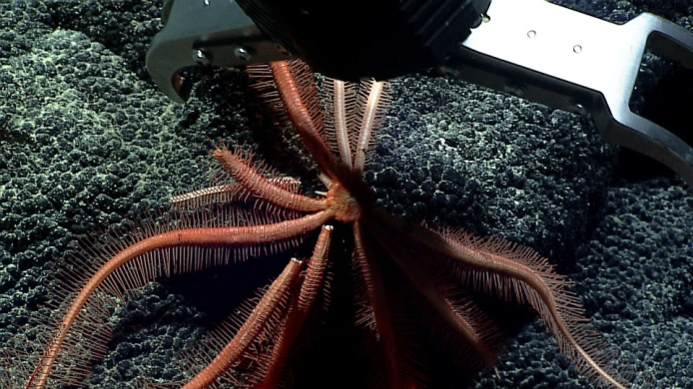
Date (UTC) | 20160814
Time (UTC) | 3:43:26
Depth (m) | 1142.5695
Temperature (°C) | 3.59086
Field ID(s) | Brisingid seastar
Comments | Only disc and part of one arm were recovered.

Please direct inquiries to:
NOAA Office of Ocean Exploration & Research
1315 East-West Highway (SSMC3 10th Floor)
Silver Spring, MD 20910
(301) 734-1014

