Okeanos Explorer ROV Dive Summary
Dive Information
Dive Map |  | 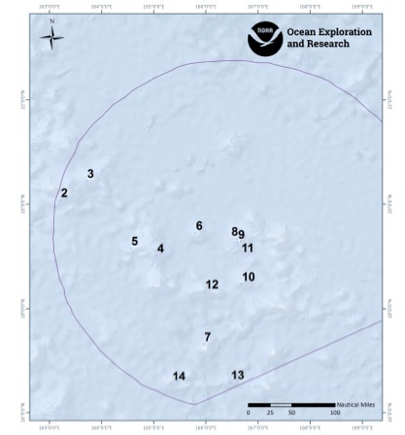
Site Name |  | Un-named guyot south of Wake Island
Expedition Coordinator(s) |  | Brian RC Kennedy
ROV Lead(s) |  | Dan Rogers
Science Team Lead(s) |  | Chris Kelley and Jasper Konter
General Area Descriptor |  | Wake Atoll Unit of the PRIMNM
ROV Dive Name
Cruise |  | EX-16-06
Leg |  | 0
Dive Number |  | 10
Equipment Deployed
ROV |  | Deep Discoverer (D2)
Camera Platform |  | Seirios
ROV Measurements |  | CTD |  | Depth | Altitude
 |  | Scanning Sonar |  | USBL Position | Heading
 |  | Pitch |  | Roll | HD Camera 1
 |  | HD Camera 2 |  | Low Res Cam 1 | Low Res Cam 2
 |  | Low Res Cam 3 |  | Low Res Cam 4 | Low Res Cam 5
Equipment Malfunctions |  | none
ROV Dive Summary  (from processed ROV data) |  | Dive Summary: EX1606_DIVE10  ^^^^^^^^^^^^^^^^^^^^^^^^^^^^^^^^^^^^^^^^^^^^^^^^^^^  In Water: 2016-08-11T20:23:53.004000  18°, 28.031' N ; 166°, 40.577' E  Out Water: 2016-08-12T04:34:35.450000  18°, 28.454' N ; 166°, 41.279' E  Off Bottom: 2016-08-12T03:41:56.195000  18°, 28.363' N ; 166°, 40.975' E  On Bottom: 2016-08-11T21:18:23.246000  18°, 28.040' N ; 166°, 40.725' E  Dive duration: 8:10:42  Bottom Time: 6:23:32  Max. depth: 1514.5 m
Special Notes
Scientists Involved  (please provide name, location, affiliation, email) |  | Name Affliation Email  Jasper Konter University of Hawaii jkonter@hawaii.edu  Kelley Chris University of Hawaii ckelley@hawaii.edu  Andrea Quattrini Harvey Mudd College aquattrini@g.hmc.edu  Asako Matsumoto Planetary Exploration Research Center (PERC), Chiba Institute of Technology amatsu@gorgonian.jp  Charles Wahle NOAA MPA Center charles.wahle@noaa.gov  Deborah Glickson Harbor Branch Oceanographic Institute dglickson@fau.edu  Diva Amon University of Hawaii divaamon@gmail.com  Les Watling University of Hawaii at Manoa watling@hawaii.edu  Scott France University of Louisiana at Lafayette france@louisiana.edu  Tina Molodtsova P.P.Shirshov Institute of Oceanology RAS tina@ocean.ru  Patty Fryer University of Hawaii pfryer@soest.hawaii.edu  Abby Lapointe University of Hawaii abbylap@hawaii.edu
Purpose of the Dive |  | The objective of the dive was similar to other dives conducted on guyot rift zone ridges and was to survey the deepwater coral and sponge community in the depth range for Mn crust formation. The survey aimed to increase our knowledge of the animals that are potentially at risk from deep sea mining activities in the future and documenting Mn crust communities is a major CAPSTONE priority. A second objective of this dive was to provide data and samples for use in determining the geologic history of this seamount. This geology of the seamounts in this area of the Pacific is poorly understood. The dive start and end points were a bit shallower than most of our previous guyot dives being 1500 m and 1400 m, respectively, to specifically investigate this depth range on an otherwise similar feature (southwestern rift zone off a guyot).
Description of the Dive |  | The ROV arrived at the seafloor around 21:15UTC. The target area for this dive was another southwestern rift zone, but explored at a shallower depth than previous dives, starting from 1517m. This particular seamount is located roughly 50nm south of Wake Island, and was unofficially name “Manoa” (Kelley, pers. comm.) just for the purpose of this cruise. Its morphology again defines a flat-topped guyot with a summit near 1200m, and today’s dive focuses on one of the rift zones projecting SW from the central plateau.  Similar to previous dives in deeper waters, this dive featured mainly volcanic rocks, thickly coated in Mn, on the seafloor. The dive track led up the side of the ridge obliquely, and along this track the seafloor consisted mainly of massive deposits of Mn crust, likely well over an inch thick, blanketing what looked like pillow lavas. In rare locations, some of the underlying material was exposed under the Mn crust, through small broken down sections. Between some of the more massive areas some small pockets of broken rocks were present, and still near the landing site (1507m) we sampled the first geologic specimen. As the vehicles moved further upslope, more collapse features were observed, initially smaller often circular or oval areas that showed rubble instead of a smooth Mn surface, later near the ridge crest as significant straight-lined fractures with vertical offsets. In the rubble next to the cracks, we observed both volcanic rocks with Mn coating, and smaller pebble-sized rocks that may simply represent nodules (laying in light-colored sand). As we moved over the first local high point along the rift zone, we noticed slightly increased sediment (including current ripples in deeper pockets). As the vehicles approached the last climb, more solid terrain was encountered, consisting of thickly Mn-coated volcanic rocks (pillows) with several along-ridge fractures that displayed collapse features off the eastern or western flanks. We collected a second rock right beside one of these fractures (1415m). The dive continued up hill, where the ridge crest became the location for Mn-coated pebbles in sand, and hard rocks along the edges. Eventually, this gave way again to another fracture along the ridge, with a collapse feature along one side. We nearly completed the entire dive track, leaving bottom around 1355m.  With respect to animals, the dive site could be characterized as being an old, high density, moderate diversity community dominated by large Hemicorallium sp and primnoid colonies with smaller-sized colonies of Acanthogorgia sp. Amongst these corals were occasional colonies of isidids including Ecknomisis sp and an unbranched Clade B species. Black corals included Trissopathes sp and an unusual Stauropathes sp that was collected. Chrysogorgiids were only represented by a handful of Iridogorgia magnaspiralis. Sponges included Poliopogon sp including a Poliopogon sp 2, Semperella sp, Tretopleura sp, Lefroyella sp, Saccocalyx sp, and a handful of farreids and colonies of Caulophacus sp. Noticable changes in the fauna occurred between different substrate types, and secondly between the edges of the ridge compared to its true crest. Arthropods included shrimp (aristeids and Nematocarcinus sp), squat lobsters (chrirostylids and Munidopsis sp), a polychelid lobster, and barnacles such as large scalpellids seen on an Eknomisis sp and large balanoids tentatively identified as Striatobalanus amaryllis on the rocks. Echinoderms included ophiuroids, urchins (Sperosoma obscurum?), feather stars (Sarametra sp and other commatulids), seastars (Evoplosoma sp that was collected, Peltaster cycloplax? an unidentified white seastar) and a few holothurians. Finally only a few species of fishes were observed that included a macrourid (Kumba sp), halosaurs (Aldrovandia sp, and synaphobranchid eels (Synaphobranchus sp).
Overall Map of the ROV Dive Area |  |  | Close-up Map of Main Dive Site
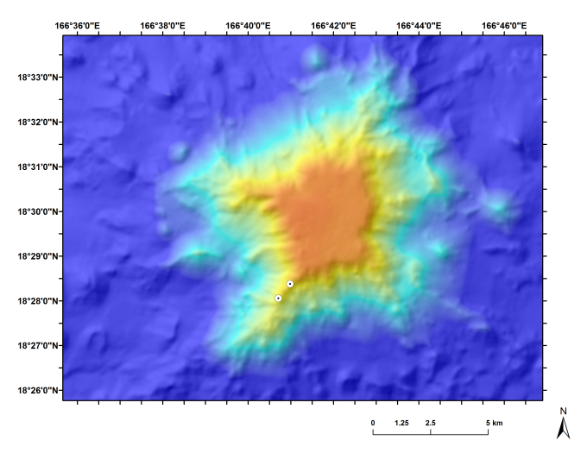 |  |  | 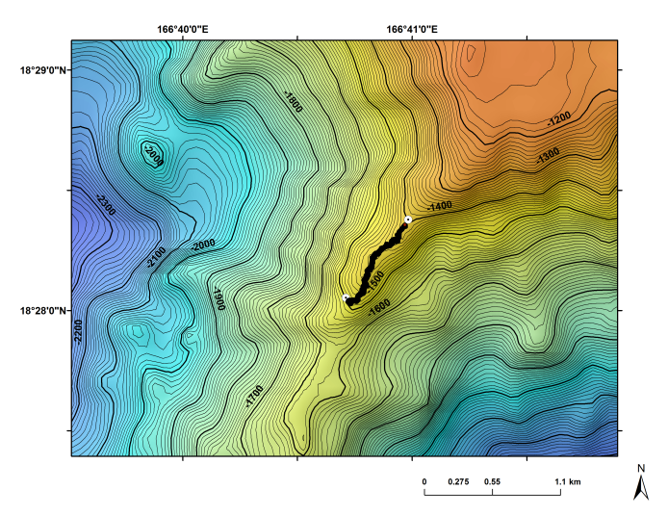
Overview map of the dive site. |  |  | Map showing the actual dive track on this site.
Representative Photos of the Dive
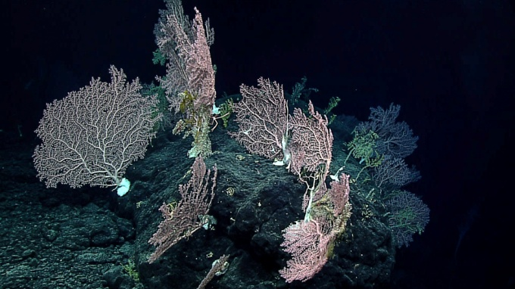 |  |  | 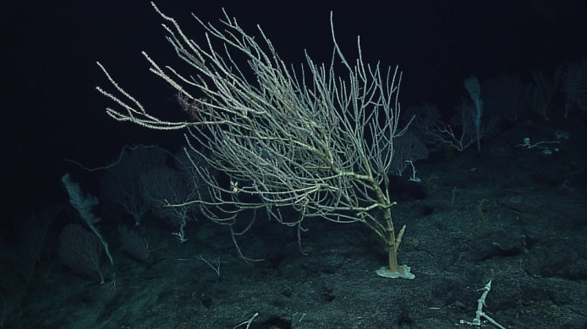
- Old high density community of corals and sponges dominated by Hemicorallium sp that was found on the dive site. |  |  | - Large Eknomisis sp colonies (pictured) as well as extremely large primnoids were other members of the community.
Samples Collected
  - Sample
Sample ID | D2_DIVE10_SPEC01GEO |  | - 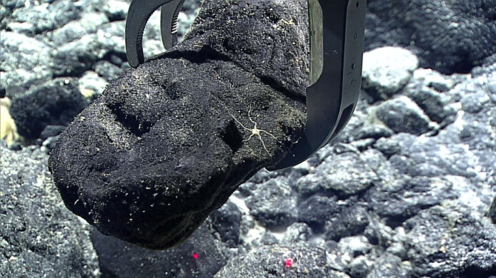
Date (UTC) | 20160811
Time (UTC) | 21:46:43
Depth (m) | 1507.308
Temperature (°C) | 2.84161
Field ID(s) | Mn crusted rock
Comments
Sample
Sample ID | D2_DIVE10_SPEC02BIO |  | - 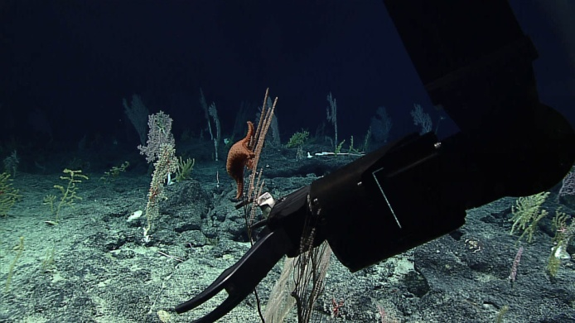
Date (UTC) | 20160812
Time (UTC) | 1:18:33
Depth (m) | 1408.993
Temperature (°C) | 2.72654
Field ID(s) | Paracalyptrophora sp.
Comments | Commensal Evoplosoma sp. seastar
Sample
Sample ID | D2_DIVE10_SPEC03BIO |  | - 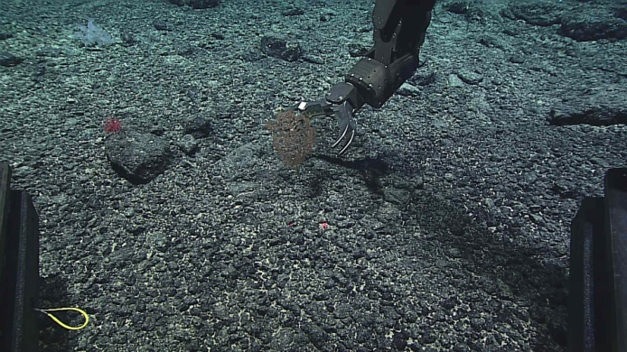
Date (UTC) | 20160812
Time (UTC) | 2:19:41
Depth (m) | 1414.827
Temperature (°C) | 2.83988
Field ID(s) | Stauropathes
Comments | 2 commensal squat lobsters and collected with a rock (SPEC05GEO)
Sample
Sample ID | D2_DIVE10_SPEC04GEO |  | - 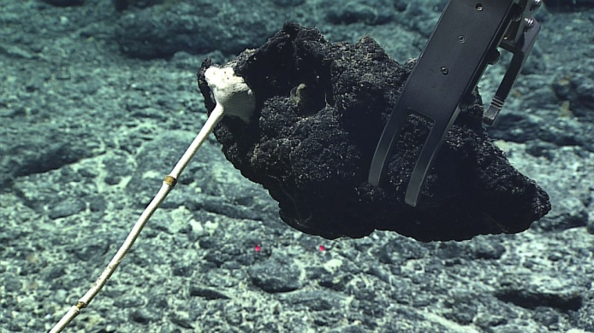
Date (UTC) | 20160812
Time (UTC) | 2:31:28
Depth (m) | 1414.774
Temperature (°C) | 2.87375
Field ID(s) | Mn crusted rock
Comments
Sample
Sample ID | D2_DIVE10_SPEC05GEO |  | - 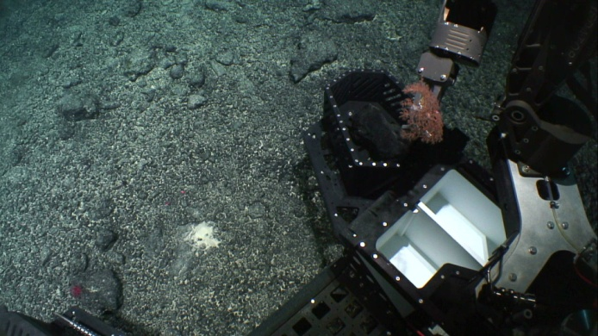
Date (UTC) | 20160812
Time (UTC) | 2:19:41
Depth (m) | 1414.827
Temperature (°C) | 2.83988
Field ID(s) | Mn pebble with unknown core
Comments | Collected incidentally with SPEC03BIO
Please direct inquiries to:
NOAA Office of Ocean Exploration & Research
1315 East-West Highway (SSMC3 10th Floor)
Silver Spring, MD 20910
(301) 734-1014

