Okeanos Explorer ROV Dive Summary
Dive Information
Dive Map |  | 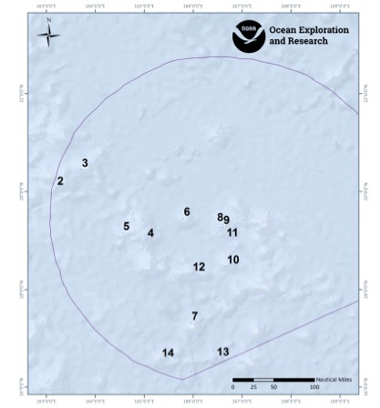
Site Name |  | Amakasu Maru No.1 Wreck Site
Expedition Coordinator(s) |  | Brian RC Kennedy
ROV Lead(s) |  | Dan Rogers
Science Team Lead(s) |  | Chris Kelley and Jasper Konter
General Area Descriptor |  | Wake Atoll Unit of the PRIMNM
ROV Dive Name
Cruise |  | EX-16-06
Leg |  | 0
Dive Number |  | 09
Equipment Deployed
ROV |  | Deep Discoverer (D2)
Camera Platform |  | Seirios
ROV Measurements |  | CTD |  | Depth | Altitude
 |  | Scanning Sonar |  | USBL Position | Heading
 |  | Pitch |  | Roll | HD Camera 1
 |  | HD Camera 2 |  | Low Res Cam 1 | Low Res Cam 2
 |  | Low Res Cam 3 |  | Low Res Cam 4 | Low Res Cam 5
Equipment Malfunctions |  | none
ROV Dive Summary  (from processed ROV data) |  | Dive Summary: EX1606_DIVE09  ^^^^^^^^^^^^^^^^^^^^^^^^^^^^^^^^^^^^^^^^^^^^^^^^^^^  In Water: 2016-08-10T20:17:15.639000  Out Water: 2016-08-11T06:35:52.383000  Off Bottom: 2016-08-11T05:56:08.945000  On Bottom: 2016-08-10T21:07:01.940000  Dive duration: 10:18:36  Bottom Time: 8:49:7  Max. depth:
Special Notes |  | The position information for this dive has been removed to protect the location of the wreck
Scientists Involved  (please provide name, location, affiliation, email) |  | Name Affiliation Email  Jasper Konter University of Hawaii jkonter@hawaii.edu  Kelley Chris University of Hawaii ckelley@hawaii.edu  Andrea Quattrini Harvey Mudd College aquattrini@g.hmc.edu  Asako Matsumoto Planetary Exploration Research Center (PERC), Chiba Institute of Technology amatsu@gorgonian.jp  Bruce Mundy NOAA NMFS PIFSC bruce.mundy@noaa.gov  Charles Wahle NOAA MPA Center charles.wahle@noaa.gov  David Jourdan Nauticos dave@nauticos.com  Diva Amon University of Hawaii divaamon@gmail.com  Hans Van Tilburg NOAA ONMS hans.vantilburg@noaa.gov  Nicole Morgan Florida State University nmorgan@fsu.edu  Scott France University of Louisiana at Lafayette france@louisiana.edu  Abby Lapointe University of Hawaii abbylap@hawaii.edu  Wendy Coble DPAA wendy.m.coble.civ@mail.mil  Frank Cantelas NOAA OER frank.cantelas@noaa.gov  Rachel Matheny Maritime Heritage Program rachel.matheny@noaa.gov  Tony Tully ttully@technicalcareers.com
Purpose of the Dive |  | The purpose of this dive was to groundtruch a target extracted from multibeam sonar believed to be the wreck of the Japanese destroyer Hayate sunk during the battle of Wake. If the target turned out to be the Hayate, then the objectives were to complete a preliminary characterization of the wreck that would confirm its identity, record its condition, document battle damage, and record the marine communities on the site. This characterization would include 1) locating the major sections and determine or confirm the vessel broke apart, 2) complete a transit around the perimeter to record diagnostic features (guns, torpedo tubes, depth charges, superstructure, stacks and elements of the hull) that will aid a positive identification, 3) carefully record battle damage and its extent, 4) assess the overall condition and state of preservation, and 5) note the marine biological communities associated with the wreck.  If the target turned out to be a different wreck, then the characterization above would still be carried out and if time remained, 2 additional backup targets would be investigated to see if they could be the Hayate.
Description of the Dive |  | Our primary target appeared to have the correct dimensions in multibeam data for the Japanese destroyer Hayate (just short of 100m), as well as height from the surrounding seafloor (10m or so). The vehicles landed approximately 100m from the target around 21:00UTC. The seafloor consisted of mainly sand with occasional cobbles and boulders, all carbonate derivatives from the reef. Along the way to the target we observed steep terrain with sand and cobbles (to boulders) with a few pieces of debris, suspected to be wooden planks (presumably from the ship’s deck).  At approximately 21:22, the vehicles arrived at the target location and acquired an image on sonar. We expected to first encounter the stern of the wreck but instead encountered the bow and conducted a low level visual survey down the starboard side, ascending over the transom and recording an overhead view on return from stern to bow. Prevailing current prevented the D2 survey of the port side. As soon as the survey started, features varied from the expected destroyer revealing that the vessel was not the Kamikaze-class HAYATE, but the Japanese peace-time converted water carrier AMAKASU MARU NO. 1. The AMAKASU MARU, launched in August 1939, was a 1,913-ton, 271-foot long, 40-foot beam, Type D merchant vessel, the first of her class of 40 similar vessels built prior to the war. On December 24th 1942, soon after departing from the Japanese garrison on Wake Island, the AMAKASU MARU was torpedoed by the USS TRITON SS-201, going down with 12 of her crew. Diagnostic features which confirm the identity of the merchant ship include:  • Engine aft design with bridge well forward  • Single-screw single rudder design  • Masts at forecastle and poop  • Kingposts near bridge  • Welded-bead ship name on bow and transom (Japanese and English)  The vessel sits upright on top sand and some large rocks with a slight (~10deg) list to starboard. A fore-and-aft split along the starboard bow is mirrored on port by a large hull depression. Two large holes on the lower port hull may be either torpedo damage or rock/bottom impact damage (one source records TRITON’s torpedo hits on port side). A large boulder immediately aft or the propeller appears to have displaced the rudder, which is horizontal atop the boulder. Topside superstructure shows damage which may be associated with hull impact/sinking/deterioration. Masts have fallen; stack is fallen and flattened, cabin spaces deformed, wooden deck eroded/missing. The cargo hold contains large steel rectangular containers (possibly water tanks?). Two deck guns have been fitted fore and aft. There is a significant amount of sediment on the deck and in the holds. Rusticles show abundant growth at numerous locations.  Since the primary goal of this dive was archeology, the dive spent less time on biological observations. Leading up to the discovery of the wreck, a significant number of fish were observed, including halosaurs, macrourids, and pearl fish (Pyromodon sp). At the wreck, the hull and remains of the deck and superstructure were found to have a number of different invertebrates including sponges (Hyalonema sp and Dictyaulus sp), gorgonians including Iridogorgia sp, Acanthogorgia sp, and other unidentified species., anemones, particularly species in the family Hormathiidae, and fishes (Neoscopelus sp, Sladenia sp, and an ophidiid).  With all archaeology objectives successfully completed on this particular wreck, the ROV was then towed to the secondary target approximately 1 mile to the east. Similar to the first site, the seafloor leading up to the target consisted of sand with carbonate cobbles and boulders. After tracking across a steep slope consisting of this same material for about 100m, the feature identified in multibeam data was found to be an extremely steep, rocky outcrop. The rocks appeared layered, but the overall nearly 80m structure appeared to have been weathered. The carbonate was covered with a thin veneer of Mn coating, but the uneven surface of shell and coral fragments was visible. Given the overall rounded shape of this structure, it may be the result of subaerial weathering (karst). Alternatively, it could be a very large displaced block that broke off from a shallower part of the sediment cover of this volcano. This site again hosted several fish on the sandy bottom, including a catshark, and some sponges and corals on the hard rock. However, no time was taken to characterize any of these animals very well. Instead, the decision was made to tow the ROV again to the third and final target site.  Similar to the first and second site, the seafloor again consisted of sand with carbonate cobbles and boulders. This target also turned out to be a large rocky formation. The rock were layered carbonates, with presumably coral and shell fragments, covered in a thin veneer of Mn. Weathering seems to be the best explanation again for the overall shape of the formation, as well as the uneven surfaces.  On this site, we found mainly fish on the sandy bottom again. On the large, rock, there was one species of sponge, several types of corals, and a large anemone. Just before the end of the dive, we sampled a primnoid coral that showed odd clusters of polyps on its branches (Paracalyptrophora?).
Overall Map of the ROV Dive Area |  |  | Close-up Map of Main Dive Site
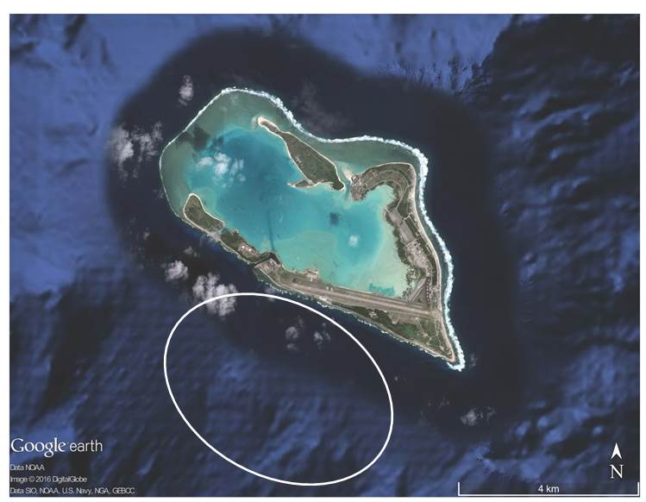
Overall map of the Hayate site.
Representative Photos of the Dive
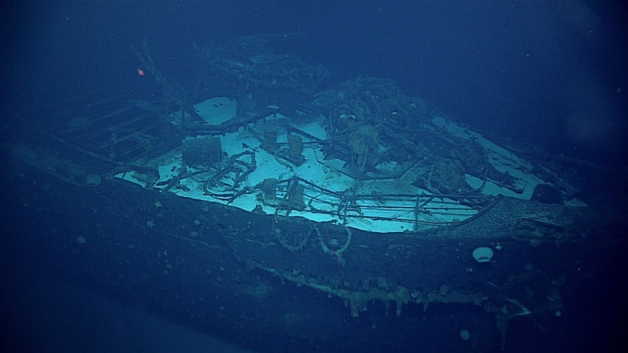 |  |  | 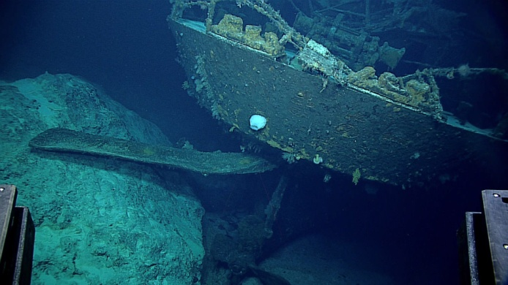
- Bow of the Amakasu Maru. |  |  | - Stern of the Amakasu Maru
Samples Collected
  - Sample
Sample ID | D2_DIVE09_SPEC01BIO |  | - 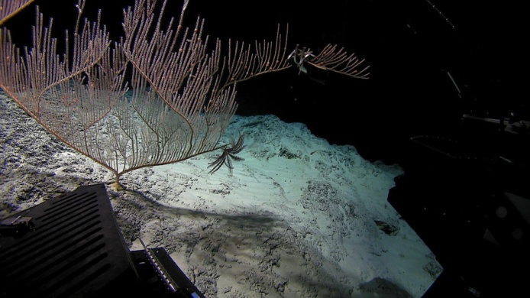
Date (UTC) | 20160811
Time (UTC) | NA
Depth (m) | NA
Temperature (°C) | NA
Field ID(s) | Calyptrophora sp
Comments | SCS evet did not record the snapshot.

Please direct inquiries to:
NOAA Office of Ocean Exploration & Research
1315 East-West Highway (SSMC3 10th Floor)
Silver Spring, MD 20910
(301) 734-1014

